PRODUCT CONCEPT
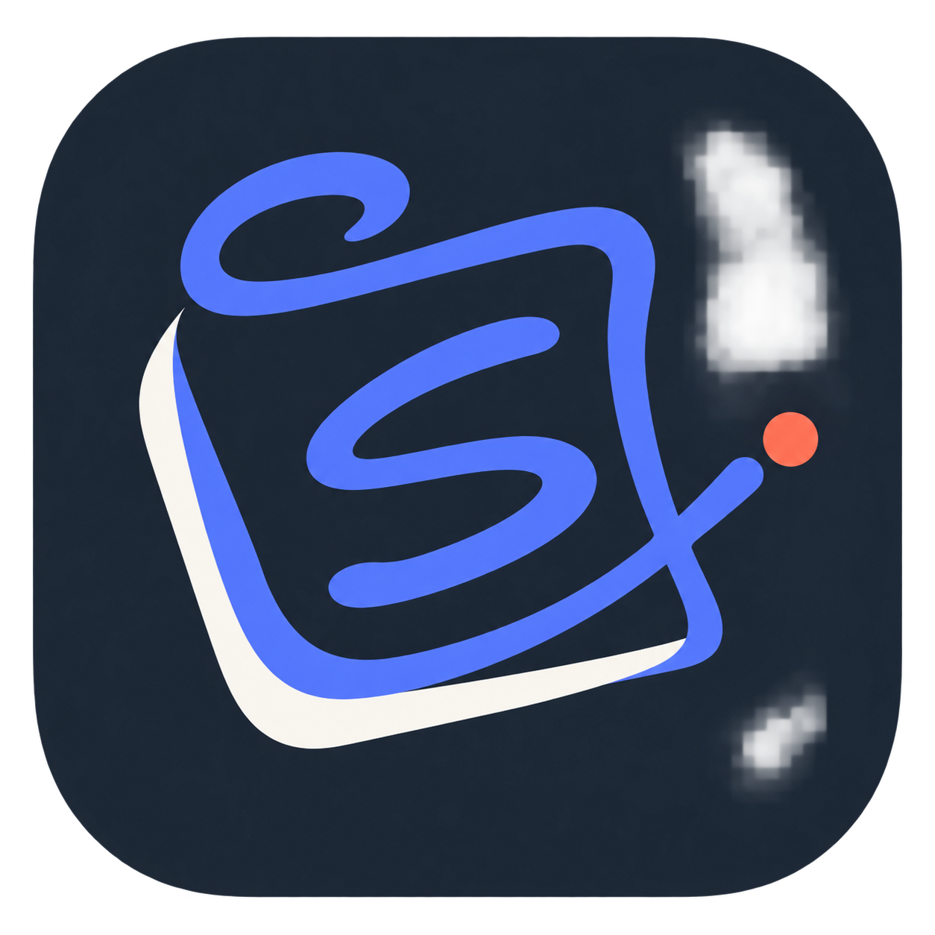

Scribble
  - A private digital deskpad for capturing the working day
THE IDEA Open it, put something down, and get back to work. Scribble provides one always-ready surface for typed notes, pen input, dictation, pasted content and quick reminders - without forcing the user to file or classify anything first.

Proposal purpose
A simple concept proposal for discussion and early validation. It defines the user problem, the recommended deskpad experience, initial feature scope, visual theme and privacy principles.
Prototype focus Windows desktop first, local-only storage, zero-administration capture
Primary user Anyone who currently scatters temporary notes across Notepad, email, Teams, sticky notes and paper
Status Early concept - proposed for prototype and user testing

1. The opportunity
People do not lack places to store information. They have too many places, each asking them to decide what a thought is before they capture it. Small notes end up spread across Notepad files, unsent emails, Teams chats, sticky notes and task lists.
PRODUCT PROMISE Scribble separates capture from organisation. The user can record a thought immediately and decide what to do with it later.

The experience
- Summon the deskpad from a tray icon or global keyboard shortcut.
- Click anywhere to type, write with a pen, dictate, paste or drag in content.
- Move and resize notes freely, with optional snap-to-grid alignment.
- Create a new pad whenever a fresh surface is needed; older pads remain searchable in the Drawer.
- Dismiss the deskpad instantly and return to the application underneath.
- Use Organise only when ready to group ideas, identify actions or prepare content for export.
The product should feel like looking down at the same pad on a desk: familiar, forgiving and exactly as it was left.

Three simple spaces
Deskpad The active, intentionally messy surface for today.
Drawer Older pads and swept-away notes, retained locally and searchable.
Organise A review space for grouping, summarising and exporting selected material without changing the originals.

2. Recommended deskpad
The deskpad should use a very light 24 px dot-grid. It provides enough structure for snapping and visual alignment without feeling like graph paper, a spreadsheet or a formal whiteboard.
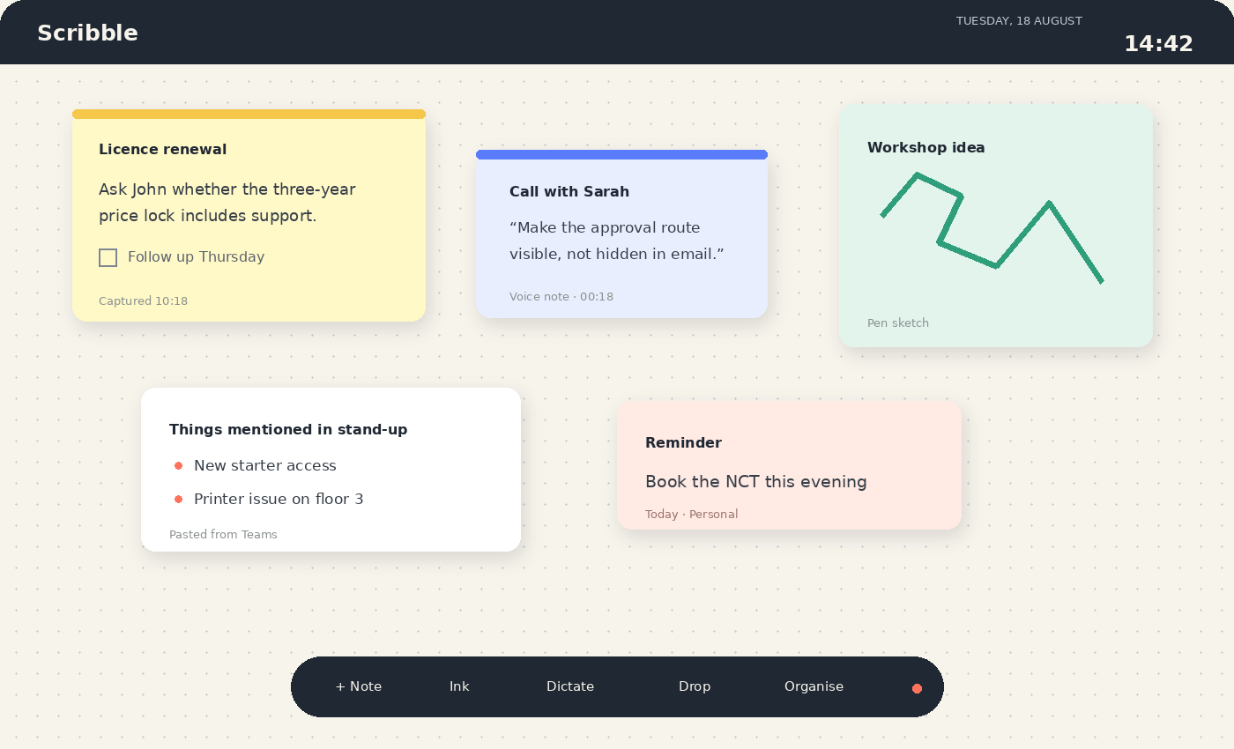
Illustrative desktop deskpad - early visual direction

Interface choices
- Top bar: product mark, pad name, live date and clock, plus access to search and settings.
- Canvas: warm off-white surface with a restrained dot-grid; zoom and pan only when needed.
- Notes: subtle colour categories, soft elevation and generous spacing. Colour communicates context but is never mandatory.
- Floating capture bar: Note, Ink, Dictate, Drop and Organise. It can collapse when not in use.
- Grid behaviour: snap on by default, hold Alt while dragging for free placement, and offer Align/Tidy as deliberate actions.
- Date and clock: useful ambient context, shown quietly in the top-right and hidden from exports or presentation mode.
DESIGN DECISION Use dots rather than lines. Lines imply a document; dots imply a surface. The result should feel calm and tactile, not like another corporate productivity dashboard.

3. Initial capability set
The first prototype should prove that Scribble is faster and less mentally demanding than the user's current workarounds.
Area | Prototype capability | Later consideration
Capture | Click-to-type notes, pen layer, dictation, paste, screenshots, drag-and-drop files and links | Camera capture and browser share target
Surface | Multiple pads, drag, resize, zoom, snap-to-grid, align and tidy | Reusable pad templates
Recall | Automatic timestamps, local search, recent pads and Drawer | Semantic local search
Organise | User-selected notes grouped into topics, actions, decisions and reminders | On-device AI-assisted summaries
Output | Copy, Markdown, text, image and export bundle | Explicit user-approved integrations
Protection | Encrypted local data, app lock, retention settings and secure export | Enterprise configuration policy

Important boundaries
- No account, cloud synchronisation or collaboration in the base product.
- No mandatory title, folder, project, tag, priority or due date.
- No automatic screen, email or Teams monitoring.
- Nothing leaves the device unless the user deliberately exports or invokes an approved integration.
- AI suggestions never overwrite original material and never take external action without confirmation.

4. Visual identity and theme
Scribble should feel calm, human and trustworthy. The visual system combines the warmth of paper with the clarity of a modern desktop application. It avoids both office-grey formality and overly playful sticky-note styling.
Token | Hex | Use
Graphite | #202833 | Top bar, primary text and dark mode foundation
Scribble Blue | #5B7CFA | Brand stroke, focus, selection and primary actions
Paper | #F7F4EC | Deskpad background; warmer and softer than pure white
Coral | #FF725E | Capture state, reminder accent and active endpoint
Ink Mint | #2F9E7A | Pen, positive state and secondary note category
Grid Grey | #CED3D1 | Dot-grid and quiet structural lines

Icon direction
 | The continuous blue stroke suggests both a handwritten S and a loose writing surface. The coral endpoint represents a live thought being captured. The shape is deliberately distinct from pencils, checkmarks and conventional sticky-note icons.

Typography
Interface Aptos or Inter: neutral, highly legible and familiar on Windows.
Handwritten accent Reserved for tiny brand moments only. User notes remain in a clear interface typeface unless they are genuine pen input.

5. Trust, privacy and AI
The trust proposition is part of the product, not an implementation detail. Scribble may hold names, phone numbers, meeting comments, operational incidents or commercially sensitive fragments.
- Local-only processing and storage in the standard edition, with no account or background telemetry.
- Application-layer encryption, protected key storage and compatibility with device encryption such as BitLocker.
- Configurable auto-lock, retention, complete export and complete deletion.
- Signed application and update packages, dependency scanning and a maintained software bill of materials.
- Clear privacy notice, data-flow diagram, threat model and DPIA screening for organisational deployment.
- Optional AI labelled wherever it appears, with the original content preserved and every change reviewed by the user.
AI POSITION The prototype does not need cloud AI. Organisation can begin with deterministic rules and optional on-device models. Any later cloud capability should be a separate, explicitly governed feature rather than a hidden dependency.

6. Proposed next step
Build a focused Windows prototype and test it against real working days. The key measure is not how many features Scribble contains; it is whether users reliably capture more information while spending less time deciding where it belongs.
- Validate the summon-and-dismiss overlay interaction.
- Test click-to-type, drag-and-drop, snap-to-grid and pen input on real hardware.
- Observe whether multiple pads plus the Drawer are enough organisation.
- Test the deskpad for one working week before adding integrations.
- Use feedback to decide whether local AI organisation creates genuine value.
RECOMMENDATION Proceed with a deliberately small prototype. Protect the core principle throughout: capture first, organise later.

