Lab Outcomes:
- Explain why jQuery was created, which native browser features replaced it, and why legacy code is still everywhere.
- Read a jQuery script and translate each call into its native DOM equivalent.
- Port a legacy script to modern native JavaScript without changing what it does.
- Explain what TypeScript adds to JavaScript, and what is removed again before the browser runs it.
- Configure the TypeScript compiler (tsconfig.json, strict) and build .ts files into public/.
- Use type annotations, interfaces (structural typing), union types with null narrowing, and generics.
- Read a compiler error and fix the code, instead of discovering the bug in the browser.
1. Introduction
This lab extends the web-engineering-lab project from Lab 4 and has two parts. In Part A you will meet a feedback-form validator written in jQuery — the kind of code you will be asked to maintain in real jobs — read it, translate it, and port it to native JavaScript. In Part B you will convert the whole project to TypeScript, so that a whole class of mistakes is caught before the page ever runs.
Work through each step in order and ask me for help rather than skipping a step. Bring your own laptop; all work is committed to your personal Git repository, so complete every step yourself. This is the last lab in which AI coding assistants are not permitted — from Week 6 they are allowed, but must be declared.
2. Tools and Software Required
Node.js, npm, VS Code, Live Server and Git are already set up from earlier labs. The two new items are the TypeScript compiler and the jQuery library.
Tool | What it is used for | Official source
TypeScript (npm package typescript) | Type-checks .ts files and compiles them to plain JavaScript with the tsc command. | typescriptlang.org
jQuery 3.7.1 | The legacy library used only in Part A, loaded from a CDN so there is nothing to install. | code.jquery.com
Chrome DevTools | The Network panel shows which files a page downloads; the Console shows runtime errors. | built into Google Chrome
VS Code, Live Server, Git | Reused from earlier labs. VS Code underlines type errors as you type. | see Labs 1 to 4

3. Part A: Reading Legacy jQuery
When jQuery appeared in 2006, browsers disagreed on basic DOM features and the built-in API was verbose, so $("#id") and a handful of helpers became the standard way to write front-end code. Since then the browser itself has caught up: querySelector, classList, fetch and CSS transitions do natively what jQuery once did. jQuery is still present on a large share of deployed websites, so your job is rarely to choose it — it is to read it, change it safely, and port it away when asked. In maintenance work you keep behaviour identical; in a new (greenfield) project you simply start native.
jQuery | Native JavaScript | Note
$(document).ready(fn) | type="module" script, or DOMContentLoaded | Modules already wait for the page.
$("#id"), $(".x") | querySelector, querySelectorAll | jQuery wraps; native returns elements.
.val() | .value | On form fields.
.text("…") | .textContent = "…" | Safe; no HTML parsing.
.addClass .toggleClass | classList.add classList.toggle | Same idea as Lab 4.
.data("day") | dataset.day | Reads data-day.
.on("click", sel, fn) | addEventListener + closest() | Event delegation, as in Lab 4.
$.ajax, $.get | fetch | Covered in a later lab.
.fadeIn() | CSS transition | Animation belongs in CSS.

Step 1: In public/index.html, add novalidate to the form tag. Browsers otherwise stop a submit with their own pop-up before your script runs, and you want to show your own messages. The required attributes stay: they still tell assistive technology which fields are required.
<form novalidate>

Step 2: Create public/legacy-feedback.js with the script below — type it in, do not paste — and load it after jQuery by adding two script tags at the end of body. Pin the version: this very script stops working on jQuery 4, which removed $.trim.
$(document).ready(function () {
var $form = $("form");

$form.on("submit", function (e) {
e.preventDefault();

var name = $.trim($("#name").val());
var email = $.trim($("#email").val());
var ok = true;

$(".error").remove();

if (name === "") {
$("#name").after('<span class="error" role="alert">Please enter your name.</span>');
ok = false;
}
if (email.indexOf("@") === -1) {
$("#email").after('<span class="error" role="alert">Please enter a valid email address.</span>');
ok = false;
}

if (ok) {
$("#status").text("Thanks, " + name + "! Your feedback was received.").hide().fadeIn(400);
$form[0].reset();
}
});
});

<script src="https://code.jquery.com/jquery-3.7.1.min.js"></script>
<script src="legacy-feedback.js"></script>

Step 3: Open the page with Live Server. Submit the empty form and read the messages; then fill in both fields and submit again. Open the DevTools Network panel, reload, and find the jquery-3.7.1.min.js request.
Step 4: Create LEGACY-NOTES.md. For each of these six calls, write the native equivalent: $(document).ready, $("#name").val(), .after(html), $(".error").remove(), .text(…).hide().fadeIn(400), and $form[0].reset().
Step 5: In the same file, list three “legacy smells” in the script — habits modern JavaScript has replaced (look at the keyword used for variables, $.trim, how the HTML is built, and indexOf).
4. Part A: Porting to Native JavaScript
A port keeps behaviour and replaces the mechanism. Work from your translation table, one call at a time, and test after the change. Note that fadeIn has no one-line native twin: the safe port is to drop it, and add a CSS transition later if the animation matters.
Step 1: Create public/feedback.js: the same validator in native JavaScript, written as a module (arrow functions, const, includes, trim, and DOM methods instead of jQuery).
const form = document.querySelector("form");
const nameInput = form.querySelector("#name");
const emailInput = form.querySelector("#email");
const status = document.querySelector("#status");

function showError(input, message) {
const error = document.createElement("span");
error.className = "error";
error.setAttribute("role", "alert");
error.textContent = message;
input.setAttribute("aria-invalid", "true");
input.after(error);
}

function clearErrors() {
form.querySelectorAll(".error").forEach((el) => el.remove());
form.querySelectorAll("[aria-invalid]").forEach((el) => el.removeAttribute("aria-invalid"));
}

form.addEventListener("submit", (event) => {
event.preventDefault();
clearErrors();

const name = nameInput.value.trim();
const email = emailInput.value.trim();
let valid = true;

if (name === "") {
showError(nameInput, "Please enter your name.");
valid = false;
}
if (!email.includes("@")) {
showError(emailInput, "Please enter a valid email address.");
valid = false;
}

if (valid) {
status.textContent = `Thanks, ${name}! Your feedback was received.`;
form.reset();
}
});

Step 2: In index.html, remove the jQuery tag and the legacy-feedback.js tag, add the line below after the main.js module tag, and delete legacy-feedback.js (Git remembers it).
<script type="module" src="feedback.js"></script>

Step 3: The script marks invalid fields and inserts messages, so style them. In styles.css, add an error colour token to :root, and two rules to the components layer.
--color-error: light-dark(oklch(45% 0.2 25), oklch(75% 0.15 25));

.error {
display: block;
color: var(--color-error);
}

input[aria-invalid="true"] {
border-color: var(--color-error);
}

Step 4: Reload and repeat the tests from Part A. The behaviour must match (except the fade), and the Network panel must no longer list jQuery. An empty submit should look like Figure 1.
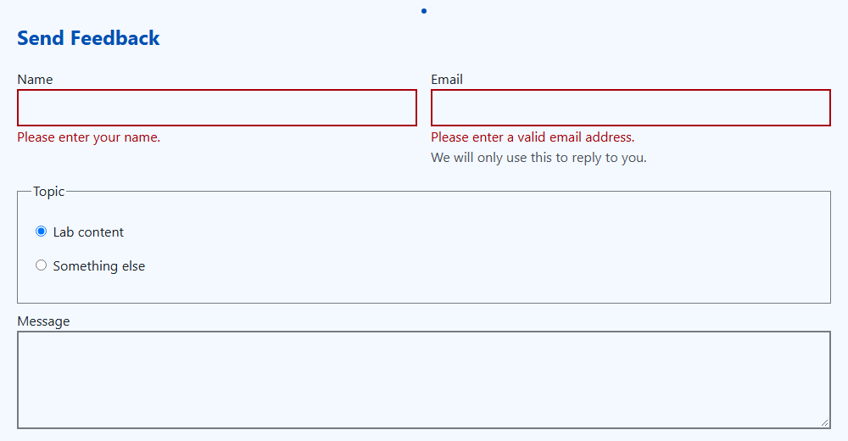
Figure 1: Expected result — the native validator after an empty submit
5. Part B: TypeScript Foundations
TypeScript is JavaScript plus a type system. You describe what each value is, and the compiler checks the whole program before anything runs. Browsers cannot run TypeScript: the compiler checks your .ts files and then erases the types, leaving ordinary JavaScript in public/ (Figure 2). The types cost you nothing at runtime — their value is that mistakes show up as red underlines in the editor, not as bugs in front of a user.
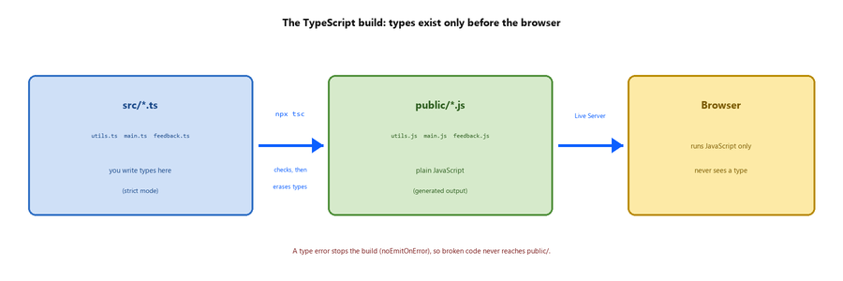
Figure 2: Source in src/, compiled JavaScript in public/
Idea | Example | What it protects against
Annotation | ms: number, ): Promise<void> | Passing the wrong kind of value.
Inference | const count = 0 is a number | Needing to annotate everything.
Interface | interface Slot { day: string; … } | Misspelled or missing properties.
Union with null | HTMLElement | null | Using an element that may not exist.
Generic | getRequired<T extends Element>() | Writing one function per element type.

Step 1: Install the compiler as a development dependency and add two scripts to package.json: build compiles, and typecheck only checks.
npm install --save-dev typescript

"build": "tsc",
"typecheck": "tsc --noEmit"

Step 2: Create tsconfig.json in the project root. strict turns on the checks that matter most; rootDir and outDir send src/*.ts to public/*.js; noEmitOnError refuses to output JavaScript when there is a type error.
{
"compilerOptions": {
"target": "ES2022",
"module": "ES2022",
"moduleResolution": "bundler",
"lib": ["ES2022", "DOM", "DOM.Iterable"],
"strict": true,
"rootDir": "src",
"outDir": "public",
"noEmitOnError": true
},
"include": ["src"]
}

Step 3: Create a src/ folder and move the three scripts into it as TypeScript, using git mv so history is kept. Run npm run typecheck and read the first few errors: they are the compiler pointing at real weak spots (a querySelector result that might be null, parameters with no type).
git mv public/main.js src/main.ts
git mv public/utils.js src/utils.ts
git mv public/feedback.js src/feedback.ts
npm run typecheck

Step 4: Rewrite src/utils.ts with types. Slot describes one office-hours slot. getRequired is generic: the caller says which element type to expect, and a missing element becomes a clear error instead of a silent null.
export interface Slot {
day: string;
start: string;
end: string;
room: string;
}

export const delay = (ms: number): Promise<void> =>
new Promise((resolve) => setTimeout(resolve, ms));

export function makeCounter(): () => number {
let count = 0;
return () => ++count;
}

export function getRequired<T extends Element>(
selector: string,
root: ParentNode = document,
): T {
const element = root.querySelector<T>(selector);
if (element === null) {
throw new Error(`Missing element: ${selector}`);
}
return element;
}

export function describeSlot(slot: Slot): string {
return `${slot.day} ${slot.start}–${slot.end}, ${slot.room}`;
}

Step 5: TypeScript checks the shape of a value, not its name — structural typing. Add these three lines temporarily at the bottom of main.ts: the first call is accepted because the object has every property Slot needs, the second is rejected. Read the error, then delete the lines.
const booking = { day: "Monday", start: "10:00", end: "11:00", room: "Room 214", id: 1 };
describeSlot(booking);
describeSlot({ day: "Monday" });

Step 6: Type src/main.ts. Every “might be missing” value is narrowed before use: event.target is EventTarget | null, so instanceof Element proves it is an element; closest may return null; find may return undefined.
import { delay, makeCounter, getRequired, describeSlot, type Slot } from "./utils.js";

const slots: Slot[] = [
{ day: "Monday", start: "10:00", end: "11:00", room: "Room 214" },
{ day: "Wednesday", start: "14:00", end: "15:00", room: "Room 214" },
];

const status = getRequired<HTMLParagraphElement>("#status");
const tbody = getRequired<HTMLTableSectionElement>("#schedule tbody");
const nextBooking = makeCounter();

tbody.addEventListener("click", async (event: MouseEvent) => {
const target = event.target;
if (!(target instanceof Element)) return;

const button = target.closest<HTMLButtonElement>("button[data-day]");
const row = target.closest("tr");
if (button === null || row === null) return;

const slot = slots.find((s) => s.day === button.dataset.day);
if (slot === undefined) return;

status.textContent = `Updating ${slot.day}…`;
await delay(1000);

const booked = row.classList.toggle("selected");
const count = document.querySelectorAll("#schedule tr.selected").length;
status.textContent = booked
? `Booking #${nextBooking()} confirmed: ${describeSlot(slot)}. ${count} of ${slots.length} slots booked.`
: `Booking for ${slot.day} cancelled. ${count} of ${slots.length} slots booked.`;
});

Step 7: Type src/feedback.ts in the same way: the imported getRequired replaces every unchecked querySelector, helper functions get typed parameters and return types, and the submit handler body stays as it was.
import { getRequired } from "./utils.js";

const form = getRequired<HTMLFormElement>("form");
const nameInput = getRequired<HTMLInputElement>("#name", form);
const emailInput = getRequired<HTMLInputElement>("#email", form);
const status = getRequired<HTMLParagraphElement>("#status");

function showError(input: HTMLInputElement, message: string): void {
const error = document.createElement("span");
error.className = "error";
error.setAttribute("role", "alert");
error.textContent = message;
input.setAttribute("aria-invalid", "true");
input.after(error);
}

function clearErrors(): void {
form.querySelectorAll(".error").forEach((el) => el.remove());
form.querySelectorAll("[aria-invalid]").forEach((el) => el.removeAttribute("aria-invalid"));
}

form.addEventListener("submit", (event: SubmitEvent) => {
/* body unchanged from feedback.js */
});

Step 8: Run npm run build; fresh .js files appear in public/. Reload with Live Server — the page must behave exactly as before. Then break something on purpose: change delay(1000) to delay("1000"), run the build, read the error, and fix it.
6. Checking Your Work
Step 1: In the browser: submit the empty form, submit a valid one, and book a slot with the keyboard. The Console must show no red errors, and npm run typecheck must print nothing.
Step 2: Run Lighthouse (Accessibility only). The score must still be 100 — the error colour passes contrast in both modes, and the messages use role="alert". Take a screenshot as evidence.
Class Activity
Complete these tasks during the lab. Keep evidence (Lighthouse screenshot and GitHub link) — your instructor may ask to see it.
Task 1: Add novalidate to the form, create legacy-feedback.js, load jQuery 3.7.1 and the script, and test the form.
Task 2: In LEGACY-NOTES.md, give the native equivalent of six jQuery calls and name three legacy smells.
Task 3: Create feedback.js as a native port, swap the script tags, and confirm in the Network panel that jQuery is gone.
Task 4: Add the --color-error token and the .error and input[aria-invalid] rules, and compare your result with Figure 1.
Task 5: Install typescript, add the build and typecheck scripts, and create tsconfig.json with strict enabled.
Task 6: Move the three scripts to src/ as .ts, run npm run typecheck, and record two of the errors you see in your notes.
Task 7: Type utils.ts: annotate delay and makeCounter, and write the generic getRequired<T extends Element>().
Task 8: Add the Slot interface and describeSlot, then demonstrate structural typing with the booking object and read the error.
Task 9: Type main.ts, narrowing event.target, closest() and find() before using them.
Task 10: Type feedback.ts with typed helper functions and getRequired.
Task 11: Run npm run build, confirm the page works, then cause and fix one deliberate type error.
Task 12: Check the page with the keyboard and Lighthouse (score 100), then commit src/, public/ and tsconfig.json to web-engineering-lab and push to GitHub.
Lab Assessment Criteria:
Lab 05 Marks distribution
 | ER1 | ER8 | RR1 | RR5
Task | 2 points | 4 points | 2 points | 2 points

Lab 05 Rubric Evaluation Guideline:
# | Qualities & Criteria | 0 < Poor <= 4 | 4.1 < Satisfactory <= 7 | 7.1 < Excellent <= 10
ER1 | Task/Program Completion | Minimal or no task functionality was achieved. | Some tasks were completed but a few have errors or incomplete functionality. | All tasks were completed without any errors.
# | Qualities & Criteria | 0 < Poor <= 4 | 4.1 < Satisfactory <= 7 | 7.1 < Excellent <= 10
ER8 | Question & Answer | Answers some questions but not confidently or based on lab task knowledge. | Answers most questions confidently and based on lab task knowledge. | Answers all questions confidently and demonstrates a deep understanding of the given lab task.
# | Qualities & Criteria | 0 < Poor <= 4 | 4.1 < Satisfactory <= 7 | 7.1 < Excellent <= 10
RR1 | Report Structure and Clarity | Report is poorly organised, difficult to navigate, and lacks professional formatting. | Report is mostly organised but may have some minor structural issues or formatting inconsistencies. | Report is well-organised with a clear logical flow, easy navigation, and professional formatting.
# | Qualities & Criteria | 0 < Poor <= 4 | 4.1 < Satisfactory <= 7 | 7.1 < Excellent <= 10
RR5 | Originality and Acknowledgement | Report contains significant plagiarism (copying content without attribution) or improper paraphrasing of external sources. | Report mostly contains original content, but there may be instances of paraphrasing or borrowing information without proper citation. | Report content is entirely original with proper citations and references for any external information used.

