**The University of Northampton**

Web Development I

**Submitted by:**

Name: Punam Dahal

UN ID: 17421487

**Contents**

1. Introduction

2. Sketches

2.1 Sketches of Home page

2.2 Sketches of CV page

2.3 Sketches of Bio page

2.4 Sketches of Contact page

3. Wireframes

3.1 Wireframes of Home page

3.2 Wireframes of CV page

3.3 Wireframes of Bio page

3.4 Wireframes of Contact page

3.4 Wireframes of Mobile designs

4. Designs

5. Time taken for the project

6. Conclusion

1. Introduction

This project is about creating a portfolio of me. I researched on other various portfolio pages before designing one for me. Considering their good aspects, I noted some key points like images relating page contents, short description relating the images, and colour combinations are very important in designing a proper and user-interactive page. I used a shade of silver colour for header and footer and black in section, constituting a dark theme.

2. Sketches

Firstly, I made several rough sketches to design my portfolio. I made many sketches so to compare them and select the best sketch for the design.

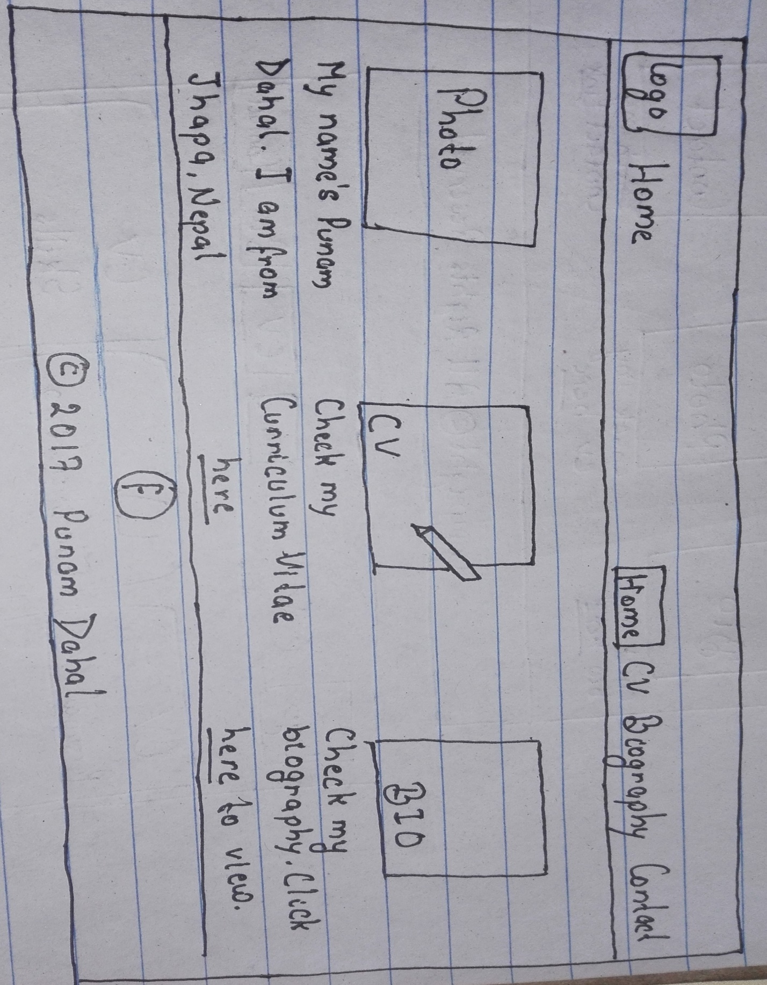 2.1 Sketches of Home page

This is my final sketch for home page.

2.2 Sketches of CV page

This is the final sketch for my CV page.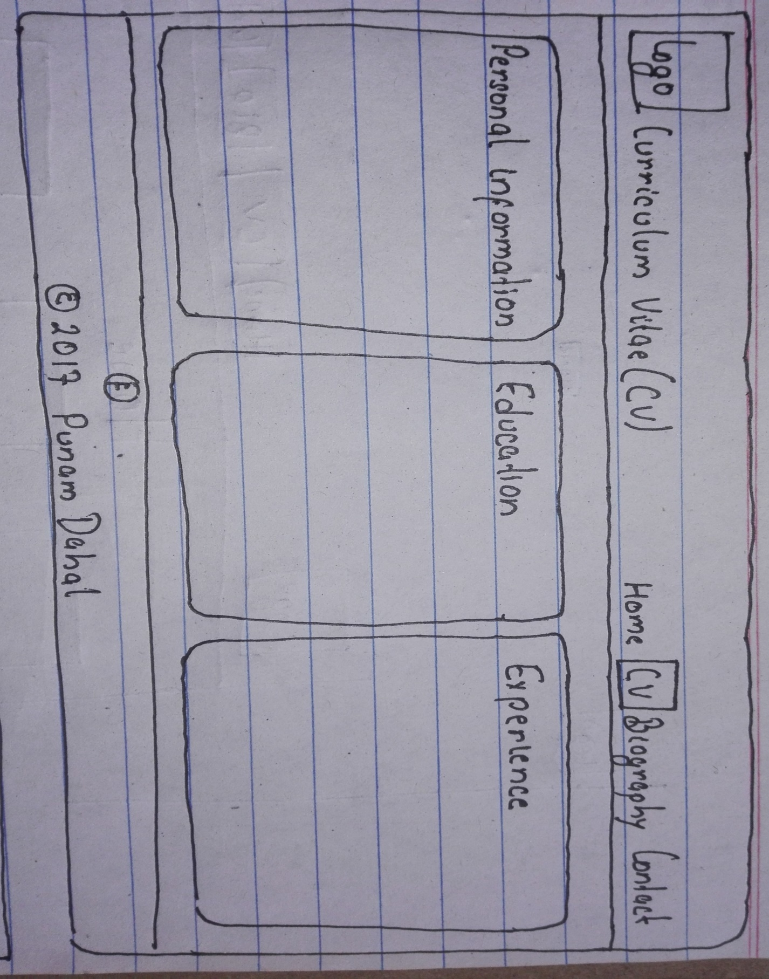

2.3 Sketch of Bio page

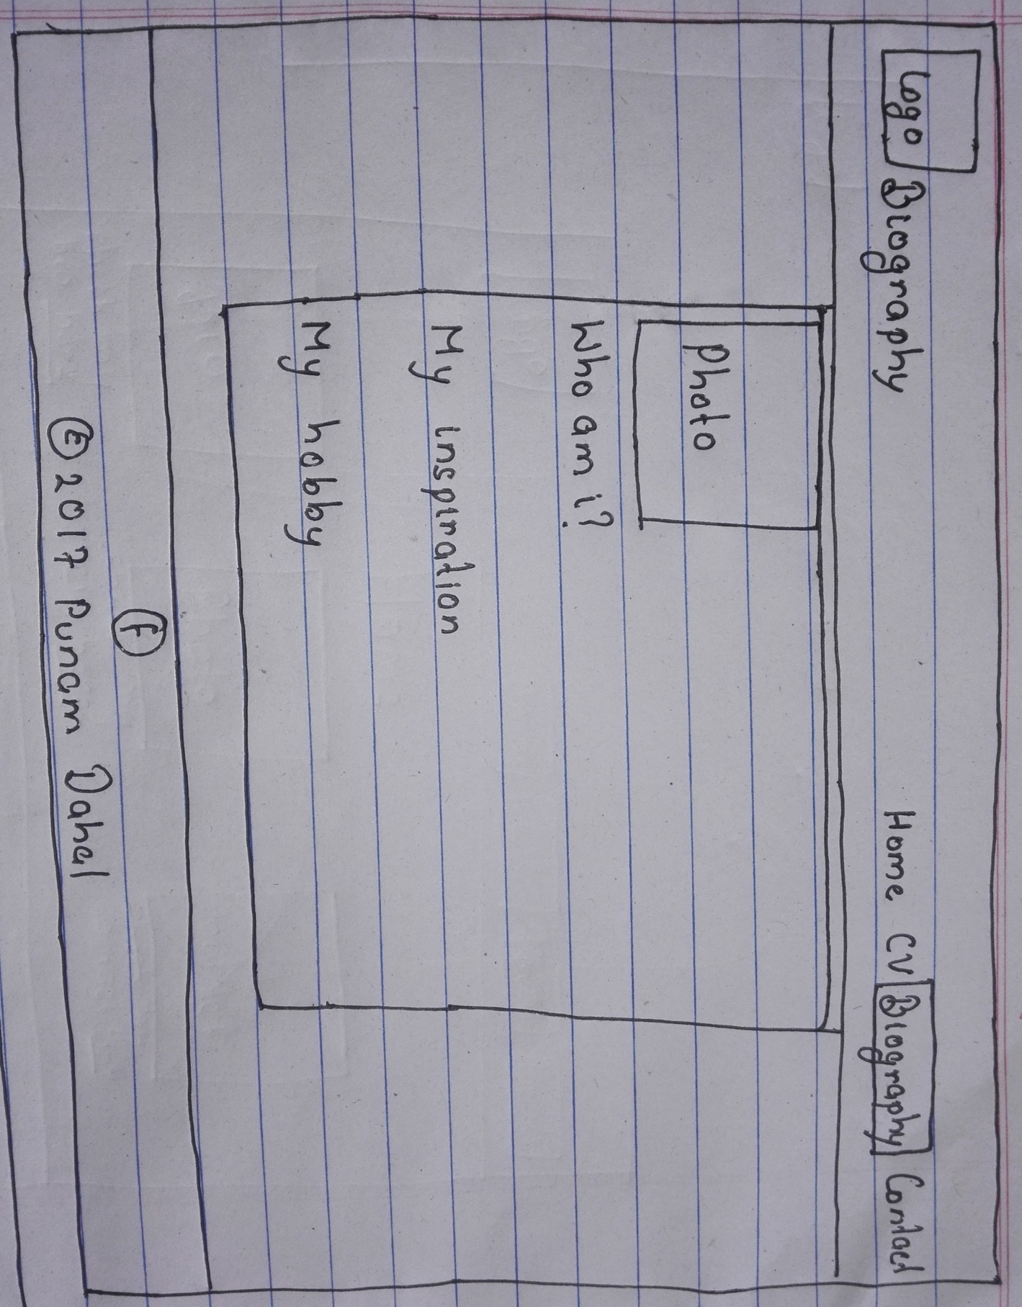This is the final sketch for my Bio page.

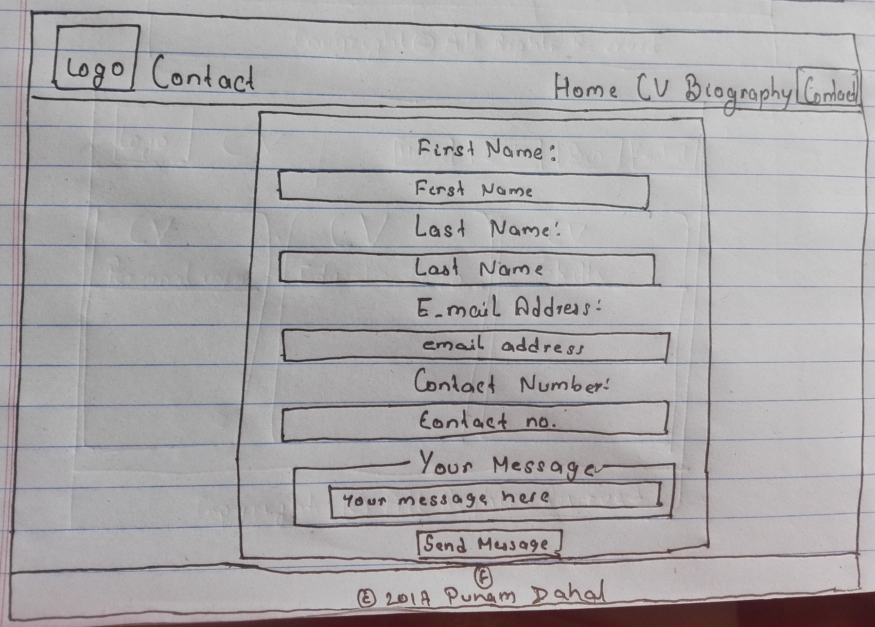2.4 Sketches of Contact page

This is the final sketch for my Contact page.

3. Wireframes

After completion of sketches, I made simple wireframes considering the sketches to make it easy to give final look to the design of portfolio.

3.1 Wireframe of Home page

This is the wireframe of home page.

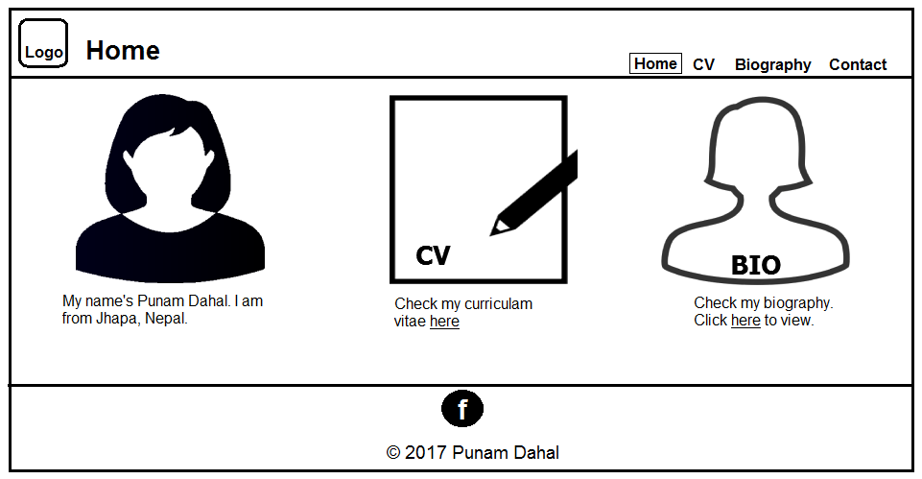

3.2 Wireframe of CV page

The wireframe of CV page is as below.

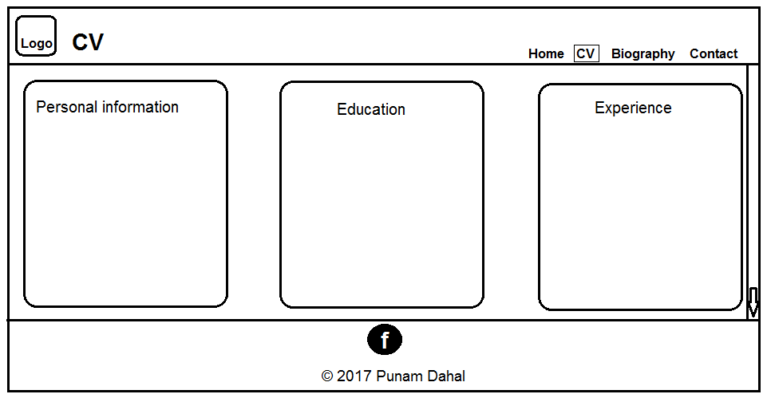

3.3 Wireframe of Bio page

This is the wireframe of Bio page.

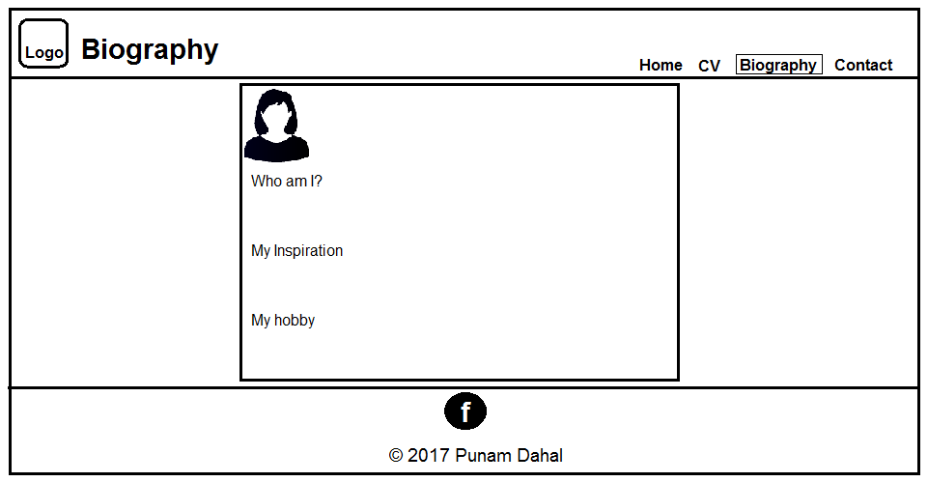

3.4 Wireframe of Contact page

This is the wireframe of Contact page of the portfolio.

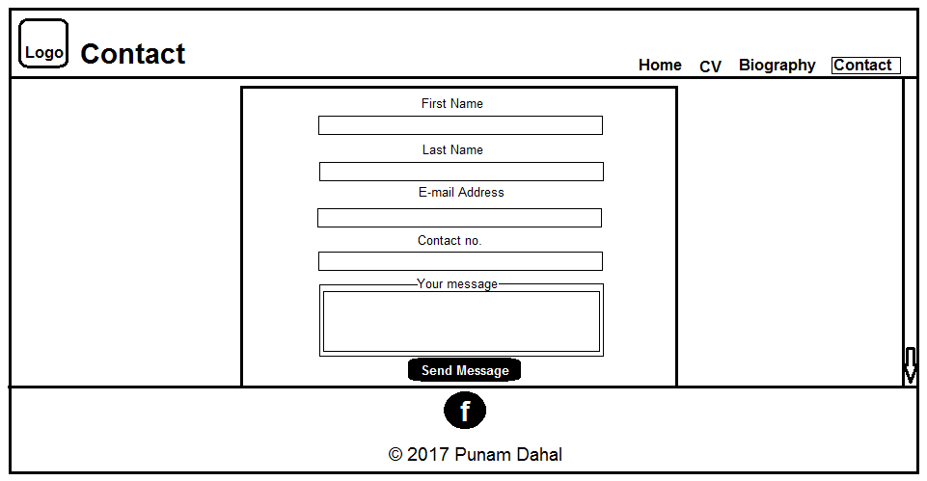

4. Design

4.1 Design of Home page

This is the design of the home page of the portfolio. It contains three pictures containing personal name and address, CV and Bio.

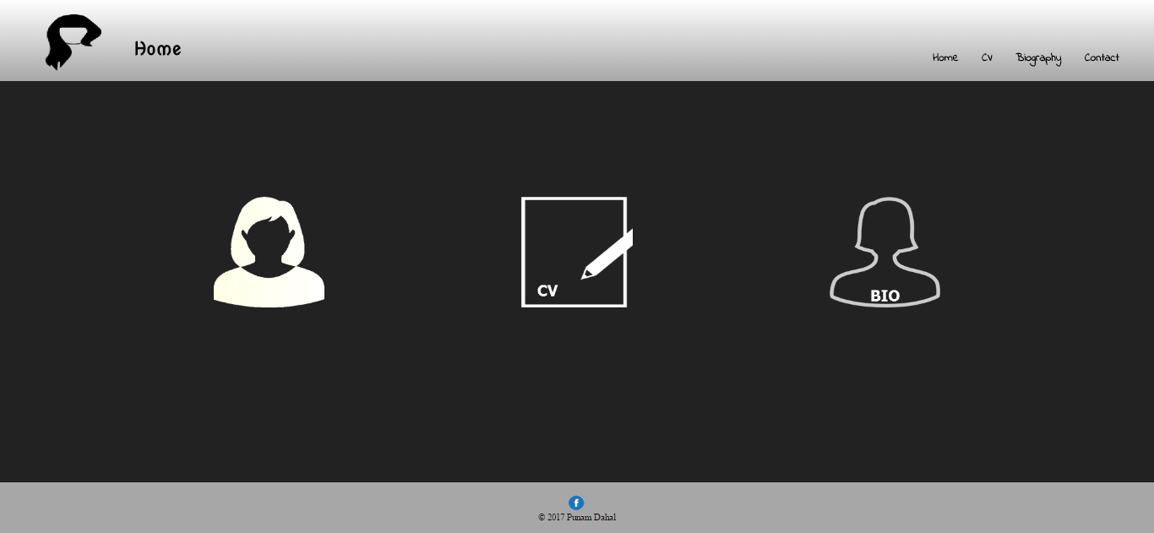

4.2 Design of CV page

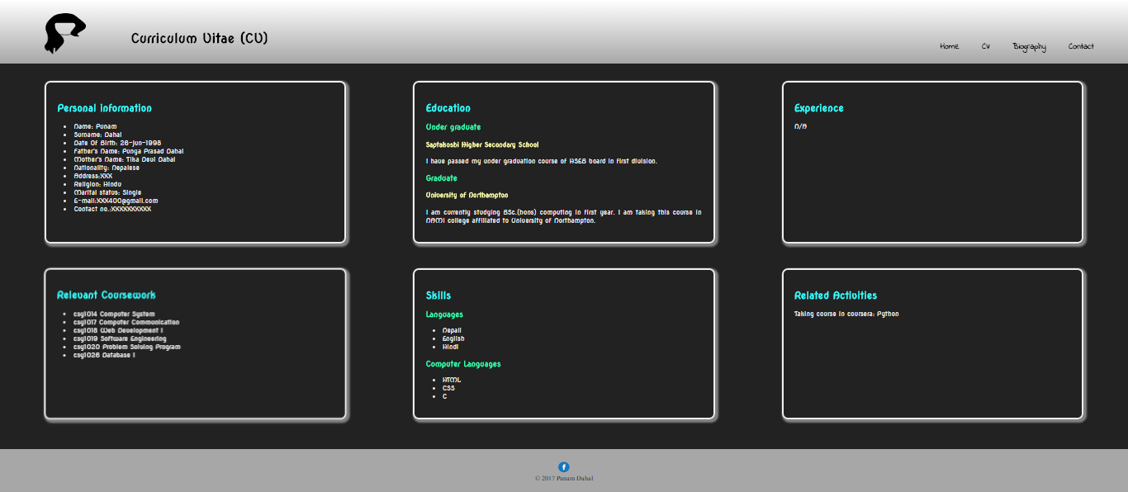 This is the design of CV page of my portfolio. It contains brief about my personal information, education, experience, related coursework, skills and related activities.

4.3 Design of Bio page

This is the design of Bio page of my portfolio. It contains a brief biography about me and describes about me, my inspiration and my hobby.

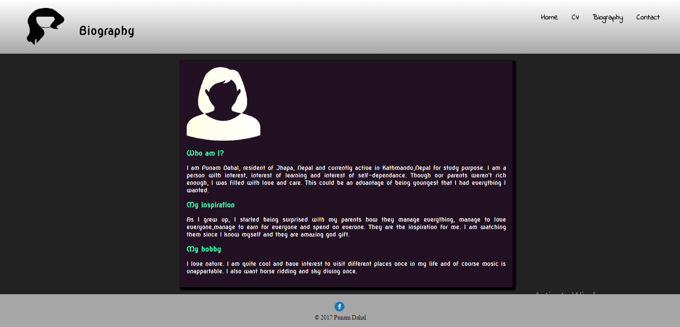

4.4 Design of Contact page

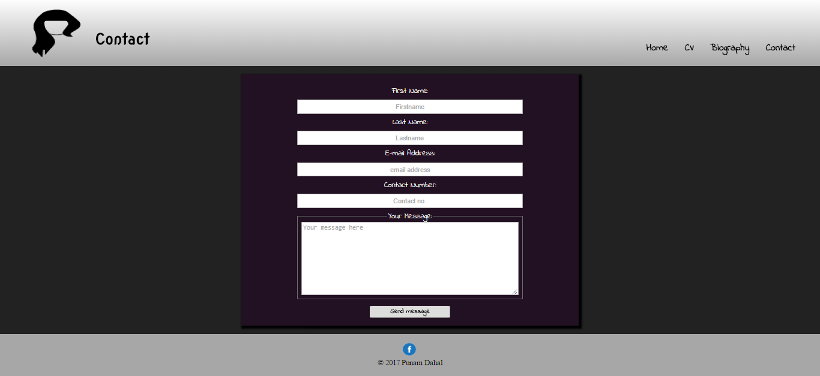 This is the design of Contact page of my portfolio. It contains a form that the user needs to feel in order to contact me. The form includes fields for first name, last name, e-mail address, contact number and a section for the message that the user wants to deliver to me.

Mobile Design:

I have also made the wireframes and designs for mobiles. So the portfolio is applicable in mobile frames.

Wireframe for home page: Wireframe for CV page:

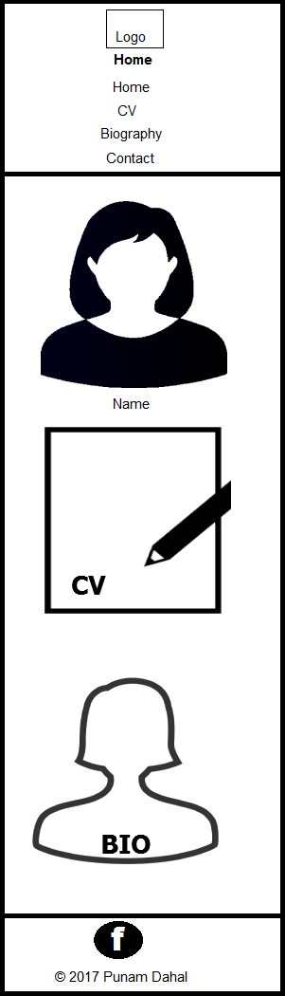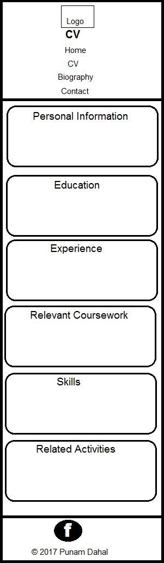

Wireframe of Bio Page: Wireframe for Contact page:

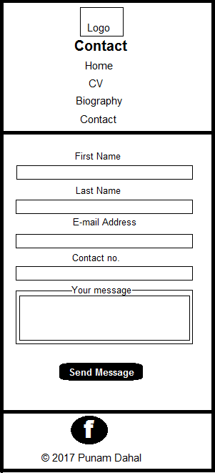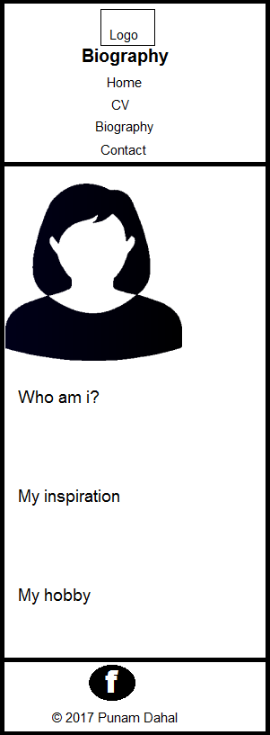

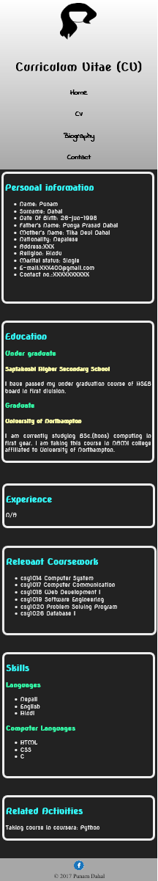Design of home page: Design for CV page:

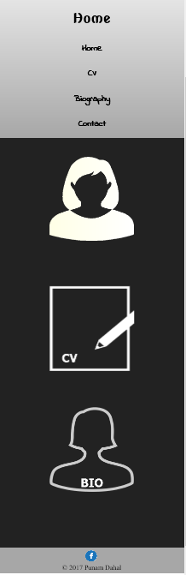

Design for Bio page: Design for Contact page:

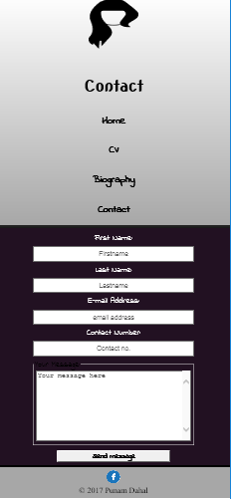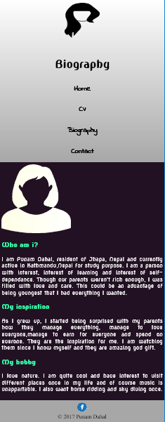

5. Time taken for the project

The completion of this project took around 8 weeks.

6. Conclusion

I thought of designs of different pages, took a look at other portfolio pages and finally drew some sketches. I changed sketches for home page and CV page in the process. I drew wireframes from those sketches. During the process, I researched on colour combinations for good design. Finally, I made the portfolio implementing my findings.