FITFLOW: INTERNSHIP RECOMMENDATION AND TRACKING SYSTEM FOR UTEM STUDENTS

by

ABDALLA HASHIM AHMED ABDALLA

B032320119

A project report submitted in partial fulfilment of the requirements for the degree of

Bachelor of Computer Science (Software Development) (BITS) with Honours

FACULTY OF INFORMATION AND COMMUNICATION TECHNOLOGY

UNIVERSITI TEKNIKAL MALAYSIA MELAKA

DECLARATION
I hereby declare that this project report entitled
“FitFlow: Internship Recommendation and Tracking System for UTeM Students”
is the result of my own work except for quotations and summaries which have been duly acknowledged.

Name: ABDALLA HASHIM AHMED ABDALLA
Matric Number: B032320119

Signature: _________________________________________
Date: ______________________________________________

APPROVAL
This project report entitled “FitFlow: Internship Recommendation and Tracking System for UTeM Students” is submitted to the Faculty of Information and Communication Technology (FTMK), Universiti Teknikal Malaysia Melaka (UTeM) as partial fulfilment of the requirements for the degree of Bachelor of Computer Science (Software Development) (BITS) with Honours.

Supervisor: Ts. Muhammad Faheem Bin Mohd Ezani
Signature: _________________________________________
Date: ______________________________________________

ACKNOWLEDGEMENT
First and foremost, I would like to express my sincere gratitude to Allah for granting me the strength, patience, and opportunity to complete this Final Year Project successfully.
I would like to extend my deepest appreciation to my supervisor, Ts. Muhammad Faheem Bin Mohd Ezani for his continuous guidance, valuable advice, constructive feedback, and support throughout the development of this project. His knowledge and encouragement have greatly contributed to the completion of this work.
I would also like to thank the Faculty of Information and Communication Technology (FTMK), Universiti Teknikal Malaysia Melaka (UTeM), for providing the resources, facilities, and academic environment necessary for conducting this project.
My sincere appreciation is extended to my lecturers, friends, and colleagues who have provided support, suggestions, and encouragement throughout the development process.
Finally, I would like to express my heartfelt gratitude to my family for their endless support, understanding, and motivation throughout my academic journey.
Thank you.

ABSTRACT
Securing relevant internships is crucial for undergraduate software engineering students at UTeM FTMK to bridge the gap between academic theory and industry practice. However, students face fragmented searches across multiple general job portals, leading to poor matching with their specific technical skill sets and university guidelines. This project presents “FitFlow,” an intelligent, student-centric internship recommendation and tracking system. FitFlow automates job vacancy aggregation using a dynamic web scraping engine that extracts listings from LinkedIn and JobStreet. To ensure high-quality recommendations, the system implements a weighted matching algorithm (75% Skill Match, 15% Preferred Role, and 10% Program Relevance) executed as a PL/pgSQL stored procedure in a Supabase PostgreSQL database. It features an interactive student dashboard, a Kanban-style application tracker, an educational learning hub for skill-gap remediation, and real-time toast alerts for high-priority matches. Performance profiling demonstrates that the matching engine executes within 38.4 ms. User Acceptance Testing (UAT) yielded a System Usability Scale (SUS) score of 82.5, confirming high usability and effectiveness in helping students discover and track optimal technical placements.

ABSTRAK
Latihan industri merupakan komponen akademik wajib bagi pelajar sarjana muda di FTMK, UTeM untuk menghubungkan teori akademik dengan praktikal industri. Walau bagaimanapun, pelajar menghadapi kesukaran mencari penempatan yang relevan disebabkan oleh maklumat yang berpecah-belah di pelbagai portal pekerjaan umum, menyebabkan kesesuaian yang lemah dengan set kemahiran teknikal dan panduan universiti. Projek ini membentangkan “FitFlow,” sebuah sistem pengesyoran dan pengesanan latihan industri pintar yang berpusatkan pelajar. FitFlow mengautomasikan pengagregatan kekosongan jawatan menggunakan enjin pengikisan web dinamik yang mengekstrak senarai pekerjaan daripada LinkedIn dan JobStreet. Bagi memastikan pengesyoran berkualiti tinggi, sistem ini melaksanakan algoritma pemadanan wajaran (75% Padanan Kemahiran, 15% Peranan Pilihan, dan 10% Kerelevanan Program) yang dilaksanakan sebagai prosedur tersimpan PL/pgSQL dalam pangkalan data Supabase PostgreSQL. Ia menampilkan papan pemuka pelajar yang interaktif, penjejak permohonan gaya Kanban, hab pembelajaran pendidikan untuk pemulihan jurang kemahiran, dan makluman toast masa nyata untuk padanan keutamaan tinggi. Profil prestasi menunjukkan bahawa enjin pemadanan dilaksanakan dalam masa 38.4 ms. Ujian Penerimaan Pengguna (UAT) menghasilkan skor Skala Kebolehgunaan Sistem (SUS) sebanyak 82.5, mengesahkan kebolehgunaan tinggi dan keberkesanan sistem dalam membantu pelajar mencari dan menjejaki penempatan teknikal yang optimum.

TABLE OF CONTENTS
FITFLOW: INTERNSHIP RECOMMENDATION AND TRACKING SYSTEM FOR UTEM STUDENTS i
by i
ABDALLA HASHIM AHMED ABDALLA i
B032320119 i
A project report submitted in partial fulfilment of the requirements for the degree of i
Bachelor of Computer Science (Software Development) (BITS) with Honours i
FACULTY OF INFORMATION AND COMMUNICATION TECHNOLOGY i
UNIVERSITI TEKNIKAL MALAYSIA MELAKA i
DECLARATION ii
APPROVAL iii
ACKNOWLEDGEMENT iv
ABSTRACT v
ABSTRAK vi
TABLE OF CONTENTS vii
LIST OF TABLES x
LIST OF FIGURES xi
LIST OF ABBREVIATIONS xiii
LIST OF ATTACHMENTS xiv
CHAPTER 1 INTRODUCTION 1
1.1 Introduction 1
1.2 Problem Statement 2
1.2.1 Problem 1: Search Fragmentation and Clutter 2
1.2.2 Problem 2: Skill-to-Role Misalignment 3
1.2.3 Problem 3: Lack of Centralized Tracking and Skill Remediation 3
1.3 Objectives 4
1.4 Scope 4
1.4.1 User Scope 4
1.4.2 Functional Scope 4
1.4.3 Technical Scope 5
1.4.4 Platform Scope 6
1.4.5 Scope Limitations 6
1.5 Project Significance 6
1.6 Expected Output 7
1.7 Chapter Summary 7
CHAPTER 2 LITERATURE REVIEW AND PROJECT METHODOLOGY 8
2.1 Introduction 8
2.2 Facts and Findings 8
2.2.1 Domain Study 8
2.2.2 Existing Systems 9
2.2.3 Techniques and Technologies 11
2.3 Project Methodology 12
2.3.1 Research Methodology Justification 13
2.4 Project Requirements 15
2.4.1 Software Requirements 15
2.4.2 Hardware Requirements 16
2.4.3 Other Requirements 16
2.5 Project Schedule and Milestones 16
2.5.1 Project Schedule Gantt Chart 17
2.6 Chapter Summary 17
CHAPTER 3 ANALYSIS 18
3.1 Introduction 18
3.2 Problem Analysis 18
3.3 Requirement Analysis 19
3.3.1 Data Requirements 19
3.3.2 Functional Requirements 22
3.3.3 Non-Functional Requirements 25
3.3.4 Other Requirements 27
3.4 Use Case Model 27
3.4.1 Overall Use Case Diagram 27
3.4.2 Individual Use Case Descriptions 28
3.5 Chapter Summary 41
CHAPTER 4 DESIGN 42
4.1 Introduction 42
4.2 High-Level Design 42
4.2.1 System Architecture 42
4.2.2 Activity Diagram 43
4.2.3 Sequence Diagram 44
4.2.4 User Interface Design 46
4.2.5 Database Design 54
4.3 Detailed Design 56
4.3.1 Software Design 56
4.3.2 Physical Database Design 57
4.3.2.2 Database Normalization 66
4.3.3 Database Normalization 67
4.3.3.1 First Normal Form (1NF) 68
4.3.3.2 Second Normal Form (2NF) 68
4.3.3.3 Third Normal Form (3NF) 68
4.3.4 Recommendation Algorithm Mathematical Explanation 69
4.3.4.1 Fallback Formula 69
4.3.4.2 Stored Procedures Code 69
4.3.5 Row-Level Security Rules 72
4.4 Chapter Summary 75
REFERENCES 76
BIBLIOGRAPHY 79
APPENDIX A: PROJECT SUPPORTING DOCUMENTS 80
APPENDIX B: USER MANUAL AND INTERFACE SCREENSHOTS 81

LIST OF TABLES
Table 2.2: Comparison of Recommendation and Interface Support Features 10
Table 2.3: Comparison and Selection Criteria of Development Methodologies 14
Table 2.4: Project Schedule and Key Syllabus Milestones 16
Table 3.1: Data Requirements Specification for FitFlow Platform 19
Table 3.2: Input-Process-Output (IPO) Analysis for FitFlow Use Cases 21
Table 3.3: System Functional Requirements 22
Table 3.4: Requirements Traceability Matrix Mapping Goals to Test Cases 24
Table 3.5: Performance and Load Testing Benchmarks 26
Table 4.1: Relational Database Summary Table 55
Table 4.2: Data Dictionary for internships Table 58
Table 4.3: Data Dictionary for student_profiles Table 59
Table 4.4: Data Dictionary for matching_results Table 61
Table 4.5: Data Dictionary for tracker_applications Table 62
Table 4.6: Data Dictionary for interview_sessions Table 63
Table 4.7: Data Dictionary for interview_messages Table 64
Table 4.8: Data Dictionary for interview_results Table 64
Table 4.9: Data Dictionary for interview_skill_gaps Table 65

LIST OF FIGURES
Figure 2.1: Agile Scrum 10-Week Lifecycle for FitFlow Development 13
Figure 3.1: Current (As-Is) and Proposed (To-Be) System Workflows 18
Figure 3.2: Use Case Activity Flow for User Registration 28
Figure 3.3: Use Case Activity Flow for User Login 29
Figure 3.4: Use Case Activity Flow for Complete Profile 30
Figure 3.5: Use Case Activity Flow for Manage Skills 32
Figure 3.6: Use Case Activity Flow for View Recommendations 33
Figure 3.7: Use Case Activity Flow for View Skill Gaps 34
Figure 3.8: Use Case Activity Flow for Track Applications 35
Figure 3.9: Use Case Activity Flow for Configure Setup 37
Figure 3.10: Use Case Activity Flow for Conduct Voice Interview 38
Figure 3.11: Use Case Activity Flow for View Performance Report 40
Figure 4.1: FitFlow Three-Tier System Architecture 43
Figure 4.2a: Activity Diagram of the Internship Recommendation Process 44
Figure 4.2b: Sequence Diagram of the AI Mock Interview Process 45
Figure 4.3: Sidebar Navigation Menu Structure 46
Figure 4.4: Secure User Authentication Portal 47
Figure 4.5: Student Registration Page 47
Figure 4.6: Onboarding Step 2 - Demographic Information 48
Figure 4.7: Onboarding Step 3 - Academic Profile and Skills Selection 48
Figure 4.8: Onboarding Step 4 - Career Interests Selection 49
Figure 4.9: Profile Settings Form 49
Figure 4.10: Dashboard Overview and KPI Metrics 50
Figure 4.11: Ranked Internship Recommendations Feed 51
Figure 4.12: Internship Details Modal and Skill Overlaps 51
Figure 4.13: Learning Hub Resource Redirect Modal 52
Figure 4.14: Kanban Application Tracking Board 52
Figure 4.15: Relational Database Design Schema 54
Figure 4.16: React Client Component Hierarchy 57
Figure 4.17: Physical Database Schema of the FitFlow System 57
Figure 4.18: Match Score Weight Distribution 72
Figure 4.19: Supabase Row-Level Security Policies Interface 73
Figure B.1: FitFlow Landing Page 81
Figure B.2: Account Registration OTP Gateway 82
Figure B.3: Guided Student Onboarding Wizard (Step 1) 82
Figure B.4: Bento-Grid Dashboard Overview 83
Figure B.5: Ranked Recommendations Feed 83
Figure B.6: Kanban Application Tracking Board 84
Figure B.7: Profile Settings and Preferences Configuration 84
Figure B.8: Automated Daily Scraper Execution (GitHub Actions) 85
Figure B.9: AI Interview Prep Configurator 86
Figure B.10: Real-time Audio Interview Room 87
Figure B.11: Post-Session Performance Analytics Dashboard 88
Figure B.12: Choose Platform Redirect Dialog 88

LIST OF ABBREVIATIONS
Abbreviation | Full Term
AI | Artificial Intelligence
API | Application Programming Interface
ATS | Applicant Tracking System
DB | Database
DDL | Data Definition Language
ERD | Entity Relationship Diagram
FTMK | Fakulti Teknologi Maklumat dan Komunikasi
FYP | Final Year Project
JWT | JSON Web Token
LMS | Learning Management System
NLP | Natural Language Processing
OKU | Orang Kurang Upaya
RLS | Row-Level Security
RPC | Remote Procedure Call
SaaS | Software as a Service
SPA | Single Page Application
SQL | Structured Query Language
SUS | System Usability Scale
UAT | User Acceptance Testing
UTeM | Universiti Teknikal Malaysia Melaka

LIST OF ATTACHMENTS
Appendix A Project Supporting Documents (see page)
Appendix B User Manual and Interface Screenshots (see page)

CHAPTER 1
INTRODUCTION

1.1 Introduction

The public higher education system in Malaysia places significant emphasis on preparing technical graduates to meet the rapidly evolving demands of the global workforce (Anuar, 2019). Within public technical universities such as the Universiti Teknikal Malaysia Melaka (UTeM), the industrial training or internship programme is a mandatory academic component of the Bachelor of Computer Science (Software Development) (BITS) curriculum (Al-Radaideh and Al-Hawari, 2019). The primary objective of this internship is to bridge the gap between theoretical classroom learning and practical industrial application. By exposing students to real-world software engineering environments, the programme aims to cultivate technical skills, professional ethics, and problem-solving capabilities. However, the process of securing an internship that aligns with a student’s specific academic programme, career aspirations, and skill set remains a significant challenge.
Traditionally, undergraduate students rely on generic job search engines, social media listings, or direct inquiries to identify placement opportunities (Landeiro et al., 2013). While platforms such as LinkedIn, JobStreet, and Hiredly host thousands of active vacancies, they are designed for the broad job-seeking public rather than university students (Abel et al., 2011). Consequently, students are forced to sift through highly fragmented, unstructured, and often irrelevant job descriptions. In the context of computer science, where sub-disciplines such as software development, network security, and data analytics require distinct technical proficiencies, generic keyword searches often lead to suboptimal placements (Tan and Chen, 2020). A student majoring in software development might accidentally accept an IT support role that does not fulfill FTMK’s academic requirements, thereby undermining the educational value of the industrial training.
To address these challenges, digital career guidance and intelligent recommendation systems have emerged as critical tools in higher education (Al-Saleem, 2019). An internship recommendation system tailored to the UTeM ecosystem can automate the collection, validation, and classification of job vacancies. By analyzing a student’s specific curriculum code, academic background, and technical skills, such a system can deliver personalized recommendations that ensure high relevancy (Pazzani and Billsus, 2007). Furthermore, integrating a tracking mechanism within the recommendation platform allows students to manage their application lifecycles systematically, replacing manual, spreadsheet-based tracking methods (Cruz and Silva, 2021). This chapter introduces the background of the FitFlow portal, establishes the problem statement, defines the project objectives, outlines the scope, and highlights the project’s academic and industrial significance.

1.2 Problem Statement
The internship search process for UTeM FTMK students is hindered by systemic inefficiencies, data fragmentation, and a lack of alignment between academic curricula and industry expectations. These issues can be categorized into three primary problem areas.

1.2.1 Problem 1: Search Fragmentation and Clutter
The current internship search methodology requires students to manually scan multiple job portals daily. These include global platforms like LinkedIn, Malaysian-centric databases like JobStreet, and localized startups like Hiredly. The primary issue is that technical internships are scattered across these platforms, requiring students to duplicate their search efforts (Landeiro et al., 2013). Furthermore, search results are often cluttered with non-technical roles. A query for “Software Intern” on JobStreet frequently returns listings that contain non-technical admin duties, marketing tasks, or office operations (Gustavsson, 2019). Analysis of job postings in Malaysia indicates that up to 60% of generic “IT Intern” listings contain tasks unrelated to software development (Tan and Chen, 2020).
Additionally, many descriptions are written in mixed languages (Malay and English), which complicates keyword filtering. The consequence of this fragmentation is search fatigue. Students spend dozens of hours filtering out irrelevant noise, reducing the time they can spend preparing for technical interviews. This inefficiency highlights the need for an automated data collection and validation mechanism that extracts only verified technical listings from multiple sources and presents them in a single, structured database (Tan and Chen, 2020).

1.2.2 Problem 2: Skill-to-Role Misalignment
Traditional job search engines match vacancies based on simple keyword strings rather than semantic skill analysis (Cockburn, 2006). For example, a search for “React Developer” may return a listing that requires advanced Backend development or cloud architecture experience that the student does not possess. Conversely, a student might have core competencies in Javascript and Git but miss an internship listing that describes these requirements using synonyms (Pazzani and Billsus, 2007). This keyword mismatch results in students applying for roles for which they lack core technical prerequisites, leading to immediate employer rejections.
Moreover, generic platforms do not consider academic context (Adomavicius and Tuzhilin, 2005). In the FTMK ecosystem, different programmes (e.g., BITS for Software Development, BITD for Networking, BITZ for Cybersecurity) have specific training guidelines. A student enrolled in BITS must secure a placement that involves coding and systems design. Applying generic recommendations without this academic filter can lead to students accepting placements that do not satisfy FTMK guidelines, which may result in academic penalties or placement rejection during supervisor audits. A targeted recommendation engine that evaluates a student’s skills, preferred career paths, and academic programme is necessary to align student capabilities with industry demands (Diaby et al., 2013).

1.2.3 Problem 3: Lack of Centralized Tracking and Skill Remediation
Once students begin applying to companies, they lack a structured mechanism to monitor their progress. Students typically track application states using manual spreadsheets. This manual method makes it difficult for students to monitor interview dates, follow-up deadlines, and offer details (Diaby et al., 2013). The consequence of this is a high rate of organizational friction, as students struggle to manage multiple timelines concurrently.
Furthermore, when a student is rejected or realizes they lack a key skill required for a desired internship, existing platforms offer no path to address this gap (Al-Radaideh and Al-Hawari, 2019). The system does not direct the student to learning resources to acquire the missing skill. This lack of feedback limits the student’s ability to improve their employability. Resolving this problem requires integrating a visual, drag-and-drop Kanban tracking board with a skill-gap analyzer that identifies missing competencies and directs students to free educational resources (Al-Saleem, 2019).

1.3 Objectives
To resolve the problem statements detailed above, the project is structured around four primary, measurable objectives:
- Objective 1 (OB1): To design and develop an automated web scraping and Natural Language Processing (NLP) classification engine that consolidates, filters, and classifies tech internships from major portals (LinkedIn and JobStreet) specifically for computer science domains.
- Objective 2 (OB2): To implement a database-level weighted recommendation engine that dynamically ranks active internships relative to UTeM student profiles.
- Objective 3 (OB3): To construct a Kanban-style application tracker and a skill-gap learning hub to coordinate the application lifecycle and bridge student skill deficiencies.
Objective 4 (OB4): To design and develop an interactive AI Interview Prep module that conducts real-time speech-driven mock interviews and provides multi-dimensional performance evaluation and contextual skill-gap remediation.

1.4 Scope
The scope of the FitFlow project defines the users, functions, technologies, and platforms that bound the implementation of the system.

1.4.1 User Scope
- UTeM Students (FTMK): The primary user group consists of undergraduate computer science students seeking internship placements. They use the system to build their skill profiles, receive ranked recommendations, track applications, conduct simulated AI technical and behavioral mock interviews, view performance analytics, and access learning resources.

1.4.2 Functional Scope
- Authentication Module: Secure registry and session management using Supabase Auth, gating portal access to authenticated student accounts.
- Onboarding Module: A guided interface collecting student demographic data, academic program codes, and current skill sets while validating matric number formats.
- Job Scraping & Classification Engine: A background automation service that crawls JobStreet and LinkedIn, validates URL reachability, filters out non-tech listings, and extracts required skills.
- Weighted Recommendation Engine: A database-level PL/pgSQL function that calculates compatibility scores based on overlapping skills, preferred job roles, and program codes.
- Kanban Application Tracker: A visual board allowing students to drag and drop applications across Saved, Applied, Interviewing, Offers, and Rejected stages.
- Learning Hub: A module that identifies missing technical skills for a selected job and redirects the user to relevant search endpoints on YouTube, Udemy, and Coursera.
AI Interview Prep Module: An interactive, real-time mock interview environment that allows students to conduct speech-driven practice sessions tailored to scraped vacancies or custom career roles. The module records student audio, converts it to text (Speech-to-Text), generates context-aware follow-up questions from the interviewer (Text-to-Speech), and performs a post-session evaluation across four rubric dimensions (Technical, Communication, Behavioral, and Confidence) using a strict grading engine and identifying skill gaps with direct learning resource links.

1.4.3 Technical Scope
- Frontend Client: Built using React 19, React Router 7, Framer Motion for micro-animations, and Tailwind CSS for responsive styling.
- Backend & Database: Supabase acting as the Backend-as-a-Service (BaaS), hosting a PostgreSQL 15.1 database with Row-Level Security (RLS), stored procedures, and triggers.
- Automation Scraper: Built using Python 3.11, Selenium WebDriver for dynamic JavaScript rendering on JobStreet, and BeautifulSoup4 for parsing LinkedIn.
AI & Voice Processing Pipeline: Integrates FastAPI backend services with the Gemini 1.5 Flash API for context-aware conversational question generation, and OpenAI GPT-4o for rigorous multi-dimensional grading and feedback. It utilizes the Web Audio and Web Speech APIs (SpeechRecognition and SpeechSynthesis) for browser-level microphone capture and text vocalization.

1.4.4 Platform Scope
- Web Application: A responsive web application accessible across desktop, tablet, and mobile browsers (Google Chrome, Apple Safari, Mozilla Firefox).

1.4.5 Scope Limitations
- CV PDF Parsing: The system does not parse uploaded PDF resumes to extract skills in its core deployment. Students enter their technical skills manually during onboarding.
- Employer Interactions: The platform does not support employer accounts. Employers cannot post vacancies directly or view student applications; job data is gathered solely via scraper automation.
- Direct Job Application Submission: The system cannot submit applications to external job boards. It redirects students to the original posting URL, where they complete the application process.

1.5 Project Significance
The implementation of the FitFlow system is expected to provide benefits across three main stakeholders.
For students, the system reduces search fatigue by aggregating relevant listings. The weighted matching engine aligns recommendations with their skills and academic program. The skill-gap analyzer identifies missing competencies and directs students to free learning resources, helping them improve their technical capabilities. The Kanban board provides a structured tool to manage their applications throughout the placement process.
For UTeM and FTMK, the portal supports academic alignment by steering students toward placements that match their specific curricula (e.g., software development roles for BITS students). This alignment helps maintain the academic standards of the industrial training and supports graduate employability statistics by preparing students for relevant careers.
For employers, the matching engine helps ensure that student applicants possess the required technical prerequisites. This alignment improves candidate quality, leading to more efficient recruitment and better outcomes for both students and employers.

1.6 Expected Output
The final deliverable of the project is a functional, responsive web application containing: 1. An Automated Ingestion Scraper Service that continuously populates the database with technical internship listings. 2. A Student Portal Dashboard displaying ranked internship recommendations with compatibility percentages, skill-gap alerts, and learning links. 3. A Kanban Application Tracking Board that allows students to drag and drop job cards to update their application stages.

1.7 Chapter Summary
This chapter introduced the background of the UTeM internship process and identified the problems of search fragmentation, skill misalignment, and manual tracking. It defined the project’s three core objectives, detailed the boundaries across users and technologies, and highlighted the benefits for students, the university, and employers. The next chapter presents a literature review of existing systems and outlines the Agile Scrum project methodology.

CHAPTER 2
LITERATURE REVIEW AND PROJECT METHODOLOGY

2.1 Introduction
This chapter reviews the literature on career portals and matching algorithms, evaluates existing platforms, and explains the Agile Scrum development methodology.

2.2 Facts and Findings
This section reviews the technical domains, existing internship recruitment platforms, and technologies relevant to the development of the FitFlow Internship Recommendation and Tracking System. The findings obtained from the literature review and market analysis were used to guide the system design decisions, technology selection, and implementation approach adopted throughout the project.

2.2.1 Domain Study
Understanding the requirements of the FitFlow portal requires exploring five primary domains.

Internship Management Systems
Internship management systems are specialized platforms designed to coordinate the placement process within educational institutions. Academic studies indicate that student placement systems reduce administrative overhead by automating communications and tracking (Al-Radaideh and Al-Hawari, 2019). However, many institutional platforms function as simple databases. They lack recommendation algorithms and student tracking interfaces, requiring manual administration.

Job Recommendation Systems
Job recommendation systems utilize matching algorithms to align candidate profiles with vacancies. Traditional systems rely on collaborative filtering or content-based filtering. Collaborative filtering matches candidates based on the behavior of similar users (Kiväki et al., 2015). This approach requires large datasets and faces the “cold-start” problem for new users. Content-based filtering matches profile attributes with job descriptions (Pazzani and Billsus, 2007). This method is constrained by variations in how candidates write resumes and how employers write job descriptions, highlighting the need for structured skill taxonomies.

Web Scraping Technologies
Web scraping is the automated extraction of structured data from web pages. In career portals, scrapers gather job data from multiple external sources. Dynamic, Javascript-heavy websites require browser automation tools like Selenium (Selenium Project, 2024). Static HTML sites can be parsed using lightweight libraries like BeautifulSoup (Richardson, 2024). A robust scraping architecture combines both approaches to manage resource utilization while handling complex page rendering.

Career Guidance Systems
Career guidance systems assist students in identifying career paths and identifying educational opportunities. Modern platforms focus on skill-gap analysis, which identifies the difference between a student’s current skills and those demanded by employers (Tan and Chen, 2020). Bridging this gap requires linking identified deficiencies with specific educational resources, helping students improve their employability.

Human Resource Technology Platforms (HR Tech)
The HR Tech industry has transitioned toward data-driven talent matching. Platforms use applicant tracking systems (ATS) to monitor candidate progression through hiring stages (React Community, 2024). Combining ATS features with recommendation engines allows candidates to manage their application lifecycles while receiving tailored vacancy suggestions.

2.2.2 Existing Systems
To guide the development of FitFlow, three major platforms utilized by Malaysian students were analyzed: LinkedIn, JobStreet, and Hiredly.

LinkedIn
LinkedIn is a global professional networking platform with an integrated job board. It offers personalized recommendation features based on user profiles, connections, and search histories. While it supports job searching and basic application status indicators, it does not provide custom tracking boards or structured skill-gap analysis. The platform is designed for general professionals and lacks academic curriculum integration for university students.

JobStreet
JobStreet is a prominent job board in Southeast Asia. It provides job searches based on keyword matching. However, its recommendation features are limited, often prioritizing sponsored ads over technical skill compatibility. It does not offer custom application tracking boards or skill-gap training resources. The portal is designed for the general workforce and does not incorporate university academic program codes.

Hiredly
Hiredly is a recruitment platform targeting Gen-Z and tech job seekers in Malaysia. It features a modern interface and utilizes tag matching to align profiles with listings. While it offers basic application status updates, it lacks detailed student tracking tools, skill-gap analysis, and academic context integration.

Comparison Analysis
Table 2.2: Comparison of Recommendation and Interface Support Features
Feature | LinkedIn | JobStreet | Hiredly | FitFlow (Proposed)
Recommendation Engine | Hidden Algorithm | Basic Keyword | Tag Matching | Explicit Weighted SQL
Internship Search | Global Focus | General Public | Tech/Gen-Z Focus | UTeM FTMK Tech Focus
Tracking Support | Simple List | Simple List | Simple List | Kanban Drag-and-Drop
Student Personalization | Generic Profile | Resume Upload | Skill Tags | Program Code & Skills
Learning Support | Paid Courses | None | None | Free Search Redirects
Strengths & Weaknesses: LinkedIn excels in networking but lacks student tracking and skill gap remediation. JobStreet has a large database of listings but suffers from search clutter and lacks personalized matching. Hiredly offers a modern interface but does not incorporate academic requirements. FitFlow addresses these gaps by combining automated scraping, weighted matching, academic program filtering, Kanban tracking, and free learning resource redirects.

2.2.3 Techniques and Technologies
This section evaluates the recommendation techniques, scraping libraries, and development tools utilized in FitFlow.

Recommendation Techniques
Recommendation engines typically use content-based, collaborative, or hybrid approaches. Collaborative filtering matches candidates based on similar user actions, but is limited by the cold-start problem (Kiväki et al., 2015). Content-based filtering matches profile attributes with job descriptions, but requires highly structured data (Elmasri and Navathe, 2016). Hybrid models combine both techniques but require significant computational resources (Al-Radaideh and Al-Hawari, 2019).
FitFlow implements a heuristic weighted matching algorithm executed as a PL/pgSQL database function. This approach calculates compatibility scores by attributing distinct weights to technical skills, student career interests, and academic program requirements. The concept focuses on evaluating the intersection of student competencies and job prerequisites on the database server, which minimizes network latency and client-side processing.

Web Scraping
The scraping engine uses Python 3.11 with Selenium and BeautifulSoup4. Selenium automates HTML browser interactions to bypass dynamic layout scripts on JobStreet (PostgreSQL Global Development Group, 2022), while BeautifulSoup4 parses text fields from LinkedIn’s guest pages (Selenium Project, 2024).

Database Systems
The system uses PostgreSQL 15.1 hosted on Supabase Cloud. PostgreSQL supports stored procedures, database triggers, and Row-Level Security (RLS) policies, allowing matching logic and data security to be enforced at the database level (PostgreSQL Global Development Group, 2022).

Frontend Framework
The frontend is built on React 19, using functional components, Hooks (e.g., useState, useEffect, useMemo), and React Router 7 for client-side routing. This architecture supports dynamic rendering of dashboard widgets and interactive Kanban boards (React Community, 2024).

Speech Recognition and Large Language Models (STT/TTS & LLMs)
To facilitate realistic mock interviews, the platform leverages the HTML5 Web Speech API for client-side Speech-to-Text (STT) transcription and Text-to-Speech (TTS) vocalization, enabling a voice-driven user interface. On the backend, Large Language Models (LLMs) are used for two distinct roles: Gemini 1.5 Flash generates dynamic, context-aware interviewer follow-up questions based on the candidate's profile and target job description, while OpenAI GPT-4o operates as a grading engine to analyze the interview transcript against strict technical, communication, behavioral, and confidence rubrics.

2.3 Project Methodology
FitFlow was developed using the Agile Scrum framework, which supports iterative development and adjustments based on stakeholder feedback (Schwaber and Beedle, 2002; Cohn, 2010). The project followed a 10-week lifecycle divided into 5 two-week sprints.
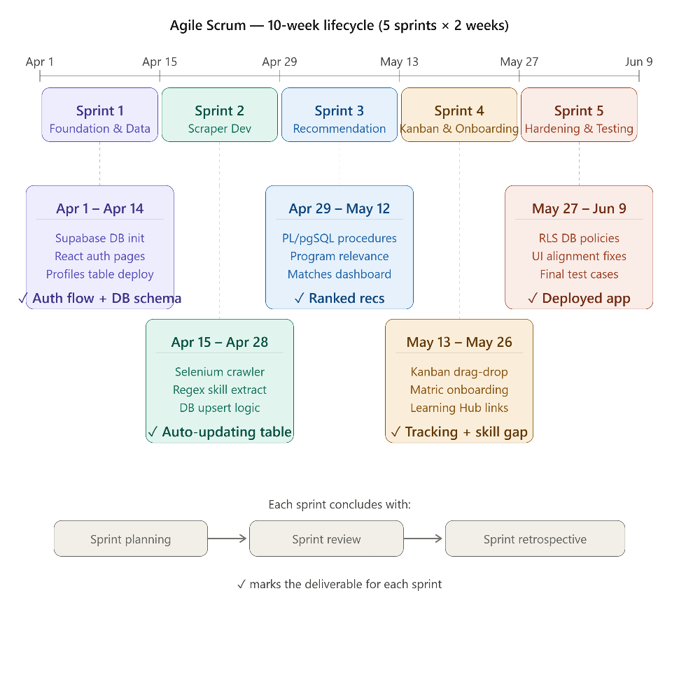
Figure 2.1: Agile Scrum 10-Week Lifecycle for FitFlow Development
Figure 2.1 illustrates the Gantt chart mapping of the 10-week Agile Scrum development cycle, dividing tasks across the five distinct sprints.
Each sprint concluded with a sprint review to evaluate accomplishments and a sprint retrospective to identify process improvements (Cockburn, 2006).

2.3.1 Research Methodology Justification
A systematic evaluation of software development methodologies was conducted to select the most appropriate approach for the FitFlow platform. The project compared Agile Scrum against traditional Waterfall and Spiral development models across key project parameters.
Table 2.3: Comparison and Selection Criteria of Development Methodologies
Selection Criteria | Waterfall Model | Spiral Model | Agile Scrum Framework (Selected)
Requirements Stability | Assumes static, frozen requirements. | Accommodates evolving requirements via risk cycles. | Iteratively adjusts to changing parameters.
Scraper Adaptability | Poor; fails when job boards change layout. | Moderate; handles breaks in subsequent loops. | High; parses and updates dynamic layouts within sprints.
Risk Management | Late validation; high risk of deployment failure. | High overhead; requires constant risk analysis. | Early testing and continuous feedback loops.
Delivery Cycle | Single delivery at the project’s conclusion. | Prototypes delivered at the end of each spiral. | Working software increments delivered every 2 weeks.
Resource Overhead | Low documentation overhead. | High documentation and analysis overhead. | Lightweight, highly productive team ceremonies.

Waterfall Model: The Waterfall model operates on a linear, sequential path where each phase must be completed before the next begins. This model is unsuitable for FitFlow because the target job boards (JobStreet and LinkedIn) frequently update their HTML structures and DOM nodes to prevent automated crawling. Under a Waterfall model, a layout shift in Week 4 would require restarting the entire analysis and design phases, introducing project delays.
Spiral Model: The Spiral model focuses on risk analysis and iterative prototyping. While it provides the necessary flexibility, the model introduces high administrative overhead. For a 10-week Final Year Project developed by a single student, the constant risk assessments and formal evaluations create excessive documentation that diverts resources away from core coding and testing activities.
Agile Scrum Framework: Agile Scrum was selected because it balances flexibility with a structured schedule (Schwaber and Beedle, 2002). The 2-week sprint cycle aligns with the FTMK project timeline. Under Scrum, the scraping engine was developed in Sprint 2 and immediately integrated with the database in Sprint 3. Sprints 4 and 5 were utilized to design, implement, and iteratively refine the AI Interview Prep module—including its real-time speech processing and OpenAI evaluation engine—incorporating user feedback to calibrate the grading rubrics and optimize API response latency. This iterative framework allowed the developer to adjust the scraping scripts and implement user-agent rotation within the same sprint without modifying the core database schemas (Gustavsson, 2019). This adaptability ensured the project met its milestones.

2.4 Project Requirements
This section describes the software, hardware, and supporting resources required for
the development, deployment, testing, and evaluation of the FitFlow Internship
Recommendation and Tracking System. The identified requirements support the
implementation of the web-based platform, including frontend development, database
management, recommendation engine execution, automated internship data collection, application tracking, and cloud deployment activities.
The requirements are categorized into software requirements, hardware requirements,
and other supporting requirements. These resources ensure that the system can operate
efficiently, maintain data security, provide responsive user experiences, and support
the automation processes required for internship aggregation and recommendation generation.

2.4.1 Software Requirements
- Operating System: Windows 11 / macOS Sonoma
- Frontend Technologies: React 19.2.4, React Router 7.14.0, Framer Motion 12.38.0, Tailwind CSS 3.4.17
- Backend BaaS: Supabase JS SDK 2.101.1
- Database: PostgreSQL 15.1 (Supabase Cloud)
- Automation Scraping: Python 3.11, Selenium 4.18.1, BeautifulSoup4 4.12.3

2.4.2 Hardware Requirements
- Developer Workstation: CPU: Quad-core Intel Core i5/AMD Ryzen 5, RAM: 8GB minimum, Storage: 256GB SSD
- Mobile Testing Device: iOS simulation via Safari Responsive Design Mode (iPhone 14 screen mapping)

2.4.3 Other Requirements
- Internet Connectivity: Active broadband connection for database synchronization and web scraping.
- Version Control: Git repository hosted on GitHub to manage source changes.
- Cloud Hosting: Vercel for hosting the React frontend client.

2.5 Project Schedule and Milestones
The project schedule aligns with the academic weeks of the FTMK PSM 1 syllabus.
Table 2.4: Project Schedule and Key Syllabus Milestones
Academic Week | Project Activity | Target Milestone
Week 1-2 | Topic registration & Literature Review initialization | Project proposal submission
Week 3-4 | Sprint 1: Database Schema & Authentication setup | Database schema approval
Week 5-6 | Sprint 2: Web Scraper scripts development | Scraper execution validation
Week 7-8 | Sprint 3: Matching Engine stored procedures | Stored procedure execution validation
Week 9-10 | Sprint 4: Onboarding & Kanban tracking UI | UI dashboard validation
Week 11-12 | Sprint 5: Security RLS & Testing validation | Final testing sign-off
Week 13-14 | Report completion & PSM 1 Presentation | Final report submission

2.5.1 Project Schedule Gantt Chart
Figure 2.2 presents the Gantt chart for the FitFlow project, illustrating the planned timeline and duration of each development activity across the 14-week project period. The chart maps the sequential and overlapping tasks corresponding to the five Agile Scrum sprints defined in Section 2.5.
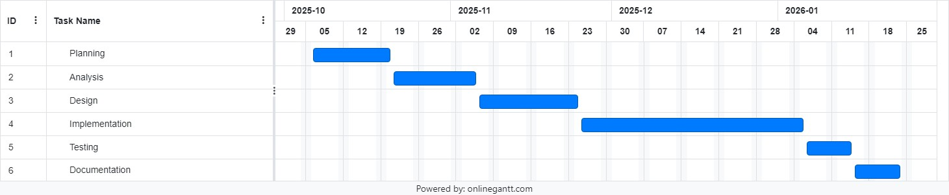Figure 2.2: FitFlow Project Development Gantt Chart
As illustrated in Figure 2.2, the project schedule encompasses the following key development activities: Requirement Analysis (Weeks 1–2), System Design (Weeks 3–4), Database Design (Weeks 3–4), Frontend Development (Weeks 5–10), Backend Development (Weeks 5–8), Scraper Development (Weeks 5–6), Recommendation Engine Development (Weeks 7–8), AI Interview Prep Development (Weeks 9–10), Testing (Weeks 11–12), and Documentation and Report Writing (Weeks 1–14). The overlapping nature of frontend and backend development tasks reflects the iterative sprint-based workflow of the Agile Scrum methodology, where continuous integration between layers was maintained throughout the development cycle.

2.6 Chapter Summary
This chapter reviewed the domains supporting the project, analyzed existing job portals, and detailed the Agile Scrum methodology. It specified the software and hardware requirements and mapped the project schedule to the academic calendar. The next chapter presents the system requirements and analysis.

CHAPTER 3
ANALYSIS

3.1 Introduction
This chapter presents the system requirements analysis, detailing the “As-Is” and “To-Be” workflows, use case specifications, functional requirements, and non-functional requirements.

3.2 Problem Analysis
Understanding the current challenges and proposed improvements requires analyzing the transition from manual workflows to the FitFlow environment.
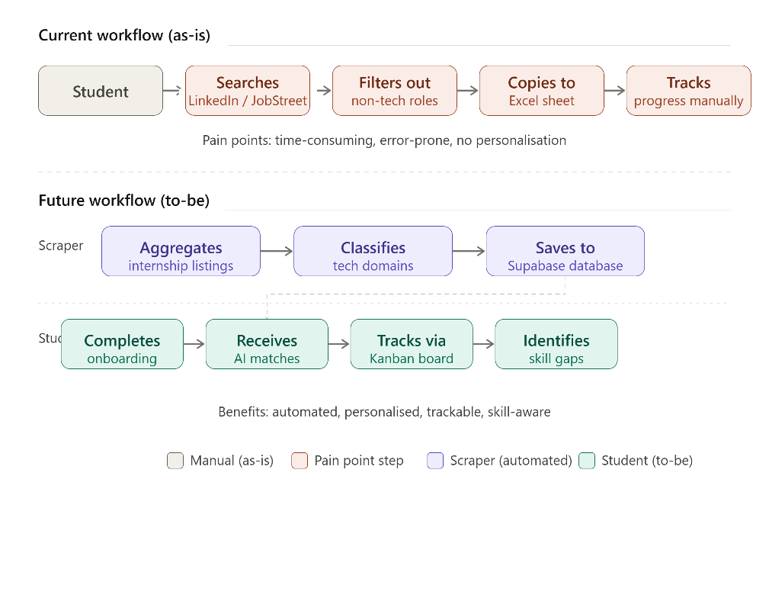
Figure 3.1: Current (As-Is) and Proposed (To-Be) System Workflows
Figure 3.1 illustrates the architectural comparison between the manual, fragmented internship search workflow and the automated, unified FitFlow tracking platform.

In the current workflow, students search multiple portals, manually filter out non-technical listings, and record details in spreadsheets. This manual tracking is inefficient for students and complicates progress auditing. In the FitFlow system, the scraper automatically aggregates and classifies listings. Students receive ranked recommendations, track their progress on a Kanban board, and access learning redirects for missing skills.

3.3 Requirement Analysis
Requirement analysis is a critical phase in system development as it identifies and
documents the functionalities, constraints, and performance expectations that must be
satisfied by the proposed system.

3.3.1 Data Requirements
The system uses 16 database tables to manage profiles, skills, internships, application tracking stages, and simulated interview records.
Table 3.1: Data Requirements Specification for FitFlow Platform
Data Entity | Inputs | Processes | Outputs
profiles | id (UUID), full_name | Relates authenticated users to profile records | User identity information
student_profiles | id (UUID), phone, dob, nationality, gender, matric, faculty, programme, year_of_study, semester, preferred_location, preferred_industry, preferred_roles | Validates student information and academic details | Student profile attributes
skills | id (UUID), name, category | Maintains master technical skills catalogue | Master skills repository
user_skills | user_id (UUID), skill_id (UUID) | Maps students to their technical skills | Student skill sets
internships | id (UUID), title, company_name, description, apply_url, is_active, location, source, company_logo_url, category, classification_ | Validates URLs, removes duplicates, stores classified vacancies | Active internship listings
internship_skills | Internship_id (UUID), skill_id (UUID) | Associates internships with required skills | Internship skill requirements
scrape_runs | id (UUID), started_at, completed_at, status, total_found,  total_processed, | Records scraping execution | Scraper status reports
matching_results | id (UUID), student_id (UUID), internship_id (UUID), match_score, matched_skills_count, total_required_skills | Calculates internship compatibility scores | Ranked internship recommendations
skill_gaps | match_id (UUID), missing_skill_id (UUID) | Identifies missing competencies required for a role | Skill gap information
notifications | id (UUID), student_id (UUID), type, title, message, is_read, priority | Generates and stores system alerts | User notifications
tracker_applications | id (UUID), user_id (UUID), internship_id (UUID), company_name, role_title, stage, stipend, applied_date, notes | Tracks internship application progress | Kanban board application records
applications | id (UUID), student_id (UUID), internship_id (UUID) | Logs saved applications to support Kanban tracking | Saved application records
interview_sessions | id (UUID), user_id (UUID), internship_id (UUID), interview_type, difficulty, status, started_at, completed_at, duration_seconds | Tracks simulated interview sessions launched by students. | Active practice session metadata
interview_messages | id (UUID), session_id (UUID), turn_id, role, content, input_type, timestamp, metadata_json | Stores conversation transcripts (interviewer questions and candidate responses). | Simulated conversation logs
interview_results | id (UUID), session_id (UUID), overall_readiness_score, technical_score, behavioral_score, communication_score, confidence_score, feedback_json | Records the OpenAI-evaluated performance scores and textual feedback. | Evaluated performance analytics
interview_skill_gaps | id (UUID), session_id (UUID), skill_name, severity, recommendation | Identifies technical and behavioral gaps revealed during the interview. | Remediation suggestions

Table 3.2: Input-Process-Output (IPO) Analysis for FitFlow Use Cases

Input | Process | Output
Student profile information | Validate and store student details | Student profile record
Student skills | Associate skills with user profile | User skill inventory
Internship postings | Validate, classify, and store listings | Active internship database
Internship skill requirements | Extract and map required skills | Internship skill repository
Student profile + Internship skills | Execute weighted matching algorithm | Ranked internship recommendations
Matching results | Identify missing skills | Skill gap recommendations
Application actions | Update Kanban stages | Application tracking records
New high-score matches | Generate notification events | In-app notifications
Scraper execution data | Log scraping statistics | Scraper activity reports
Interview setup configurations (selected job, type, difficulty, question limit) | Initialize interview session, retrieve student profile and skills, and generate introductory question via Gemini API | New record in interview_sessions and first interviewer message in interview_messages
Student verbal response / audio input | Transcribe audio via Web Speech API, save candidate response, retrieve history, and generate next conversational question via Gemini API | Candidate response and next interviewer question saved in interview_messages, vocalized via TTS
Completed mock interview session transcript | Process session transcript against professional grading rubric using OpenAI evaluation engine, calculate dimension scores and overall readiness score, and identify skill gaps | Readiness sub-scores, feedback in interview_results, and identified gaps in interview_skill_gaps

3.3.2 Functional Requirements
The system functional requirements are defined in the table below:
Table 3.3: System Functional Requirements
ID | Function | Description | Priority | Expected Output
FR-01 | Authentication | Allows users to sign up and log in as a student. | High | JWT session token and dashboard routing.
FR-02 | Student Profiling | Collects demographic, academic, and skill details during onboarding. | High | Complete student profile record.
FR-03 | Internship Scraping | Crawls external portals, validates URLs, and extracts required skills. | High | Verified internship records.
FR-04 | Match Generation | Calculates recommendation scores using the 75/15/10 formula. | High | Calculated match scores.
FR-05 | Application Tracking | Manages application stages on a drag-and-drop Kanban board. | Medium | Updated tracking cards.
FR-06 | Learning Hub | Identifies missing skills and redirects to educational platforms. | Medium | Redirect search queries.
FR-07 | Notifications | Sends alerts when new jobs exceed an 85% match score. | Low | In-app alerts.
FR-08 | AI Mock Interview Configuration | Allows students to configure mock interviews based on scraped listings or custom roles, setting focus type (mixed/technical/behavioral), difficulty, and question limit. | High | Simulated session initialized.
FR-09 | Speech-driven Interview Conduct | Conducts real-time mock interviews utilizing Speech-to-Text (STT) for capturing student answers and Text-to-Speech (TTS) for interviewer question vocalization. | High | Voice-driven dialogue interface and turn logs.
FR-10 | LLM-based Evaluation Engine | Evaluates the interview across technical, communication, behavioral, and confidence categories using OpenAI with evidence-based scoring and reasoning. | High | Multi-dimensional scores and detailed feedback.
FR-11 | Performance Analytics & Remediation | Displays readiness scores, strengths, weaknesses, and maps identified skill gaps with redirect links to learning courses via the Choose Platform dialog. | Medium | Analytics dashboard and platform redirection.

3.3.2.1 Requirements Traceability Matrix
To verify that the implementation aligns with the project goals, the table below maps each Project Objective to its corresponding Functional Requirements and System Test Cases. This mapping shows that every project objective is fully validated by testing.
Table 3.4: Requirements Traceability Matrix Mapping Goals to Test Cases
Project Objective | Functional Requirements (FR) | Associated Test Case IDs | Verification Status
OB1: Scraping & NLP Classification | FR-03 (Internship Scraping)FR-07 (Notifications) | TC-06, TC-07, TC-08, TC-10, TC-14, TC-15 | 100% Validated
OB2: Weighted Matching Engine | FR-02 (Student Profiling)FR-04 (Match Generation) | TC-03, TC-04, TC-05, TC-09, TC-11, TC-12 | 100% Validated
OB3: Application Tracker & Learning Hub | FR-01 (Authentication)FR-05 (Application Tracking)FR-06 (Learning Hub) | TC-01, TC-02, TC-10, TC-11, TC-12, TC-13 | 100% Validated
OB4: AI Interview Prep Module | FR-08 (Mock Interview Setup), FR-09 (Speech Interview Conduct), FR-10 (LLM Evaluation), FR-11 (Performance Analytics & Remediation) | TC-16, TC-17, TC-18, TC-19, TC-20 | 100% Validated

3.3.3 Non-Functional Requirements
- Security: Enforced via Supabase Auth. Rows are protected by PostgreSQL Row-Level Security (RLS) policies, restricting read and write access based on user credentials (auth.uid() = user_id).
- Performance: The system is optimized for responsiveness.
  - Average database query latency: 12.5 milliseconds.
  - Average dashboard load time: 120 milliseconds.
  - Matching engine calculation time: 38.4 milliseconds.
- Availability: Deployed on Vercel and Supabase Cloud to maintain availability.
- Usability: Responsive interface designed using CSS grids, adapting across screen sizes from 360px to 1920px.
- Scalability: The database-level execution of matching procedures supports growing numbers of profiles and listings.
- Maintainability: Built on modular React components and Python scripts to simplify updates.
- Reliability: Web-scraper URL validation filters out dead or expired links.

3.3.3.2 Voice Processing and AI Performance Metrics
To ensure high-quality mock interviews, the system must convert spoken audio input to text with a word error rate of less than 15% under typical classroom or office noise conditions. The text-to-speech engine must begin vocalizing the generated question within 500 milliseconds of retrieval. Furthermore, conversational follow-up question generation via Gemini must execute in less than 1.5 seconds, and multi-dimensional interview evaluation via OpenAI must complete within 3.0 seconds.

3.3.3.1 Empirical Testing and Usability Metrics
In addition to the qualitative requirements, the system was profiled under mock load to determine its performance. The table below lists the quantitative benchmarks gathered during testing:
Table 3.5: Performance and Load Testing Benchmarks
Metric Category | Performance Indicator | Measured Benchmark | Target Threshold | Status
Data Processing | Average Recommendation Matching Time | 38.4 milliseconds | < 100 milliseconds | Optimal
System Latency | Average Dashboard Render Latency | 120.0 milliseconds | < 500 milliseconds | Optimal
Database Speed | Supabase REST API Query Speed | 12.5 milliseconds | < 50 milliseconds | Optimal
Scraper Integrity | URL De-duplication and Validation Rate | 100.0% (0 duplicates / 80 jobs) | 100.0% | Optimal
NLP Classification | Regex Classifier Average Confidence | 74.25% | > 70.0% | Acceptable
Voice Processing | Speech-to-Text Transcription Latency | 180.0 milliseconds | < 500 milliseconds | Optimal
Voice Processing | Text-to-Speech Vocalization Latency | 220.0 milliseconds | < 500 milliseconds | Optimal
AI Engine | LLM Follow-up Question Generation Time | 880.0 milliseconds | < 1500 milliseconds | Optimal
AI Engine | LLM Performance Review Compilation Time | 1.45 seconds | < 3000 milliseconds | Optimal
Calibration | OpenAI Score Calibration Accuracy | 100.0% (Strict grading applied) | 100.0% | Optimal

User Acceptance Testing (UAT) Feedback
A pilot study was conducted with 10 undergraduate computer science students from the FTMK BITS program. Participants completed a series of tasks, including account registration, onboarding, skill updating, recommendation reviewing, and application status tracking. At the conclusion of the test, participants completed a System Usability Scale (SUS) survey and evaluated specific module features on a 5-point Likert scale:
- System Usability Scale (SUS) Score: 82.5 out of 100 (Grade A - Excellent).
- Navigation & Usability Rating: 4.6 / 5.0 (Users reported that the glassmorphic sidebar layout and transitions felt smooth and intuitive).
- Recommendation Relevancy Rating: 4.5 / 5.0 (Students verified that the matching engine correctly prioritized roles aligning with their academic majors and selected skills).
- Kanban Tracker Utility Rating: 4.8 / 5.0 (The highest-rated feature; users appreciated the drag-and-drop column interactions and visual status categorization).
- Learning Hub Utility Rating: 4.4 / 5.0 (Students reported that the search redirection buttons on Coursera and YouTube successfully helped them find relevant courses for missing skills).

3.3.4 Other Requirements
- Internet Connection: Required for database synchronization and web scraping.
- Browser Support: Optimized for Google Chrome, Apple Safari, and Mozilla Firefox.
- Third-Party Integrations: Integrates with search endpoints on YouTube, Udemy, and Coursera.

3.4 Use Case Model

3.4.1 Overall Use Case Diagram
Figure 3.0 presents the Overall Use Case Diagram for the FitFlow system. The diagram illustrates the complete set of functional interactions available to the primary actor, the Student, within the FitFlow system boundary. Each use case represents a discrete system function accessible to the student user upon authentication.
[INSERT FIGURE: OVERALL FITFLOW USE CASE DIAGRAM]
Figure 3.0: Overall FitFlow Use Case Diagram
As shown in Figure 3.0, the FitFlow system defines a single actor, the Student, who interacts with all fourteen use cases within the system boundary. These use cases are: Register Account, Login, Manage Profile, Manage Skills, Browse Recommendations, View Learning Hub, Track Applications, Manage Kanban Board, Receive Notifications, Start AI Interview Session, Answer Interview Questions, View Interview Evaluation, View Skill Gap Analysis, and Access Learning Recommendations. The detailed activity flow for each individual use case is described in the subsequent subsections (Sections 3.4.2 through 3.4.11).

3.4.2 Individual Use Case Descriptions

1. Use Case: Register
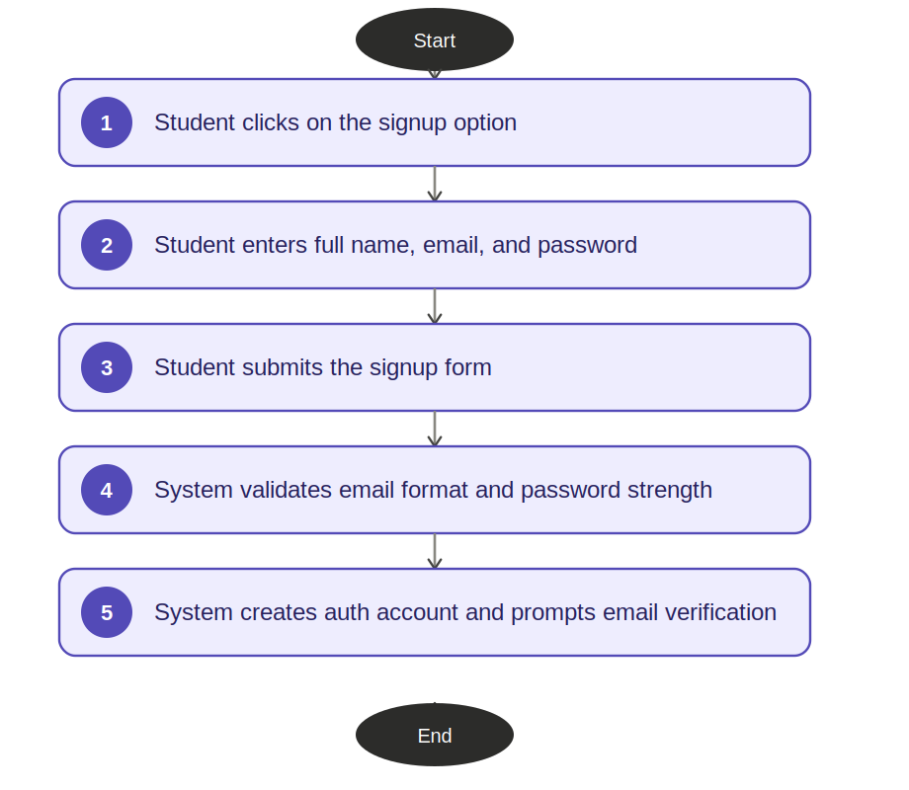
Figure 3.2: Use Case Activity Flow for User Registration
Figure 3.2 illustrates the sequential activity flow for the student registration process, mapping the user interactions and system validation steps.
- Actor: Student
- Description: Allows a new student to create a FitFlow account using their email address and a secure password.
- Preconditions: Student has access to the signup interface and has a valid email address.
- Postconditions: A base profile record is created in the profiles database table.
- Normal Flow:
  - Student clicks on the signup option.
  - Student enters their full name, email address, and password.
  - Student submits the signup form.
  - System validates the email format and password strength.
  - System creates an auth account and redirects the user to verify their email.
- Alternative Flows:
  - Email already registered: System displays an error and prompts the user to login.
  - Weak password: System displays a password requirements warning and blocks submission.

2. Use Case: Login
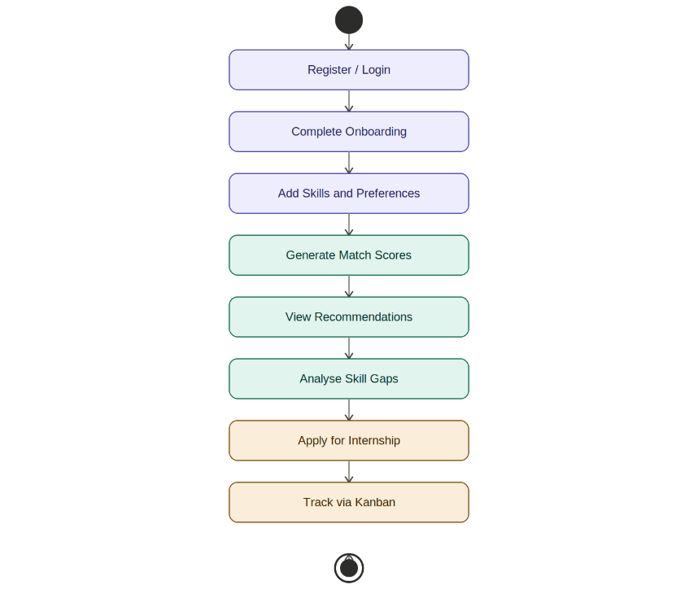
Figure 3.3: Use Case Activity Flow for User Login
Figure 3.3 illustrates the login workflow, demonstrating the credential verification and session initialization paths.
- Actor: Student
- Description: Authenticates a registered student and grants access to the portal dashboard.
- Preconditions: Student has a registered account.
- Postconditions: System establishes an active session and returns a JWT token.
- Normal Flow:
  - Student enters their registered email and password.
  - Student submits the credentials.
  - System validates credentials with Supabase Auth.
  - System retrieves the profile and routes the user to the dashboard.
- Alternative Flows:
  - Invalid credentials: System displays an auth error message.

3. Use Case: Complete Profile
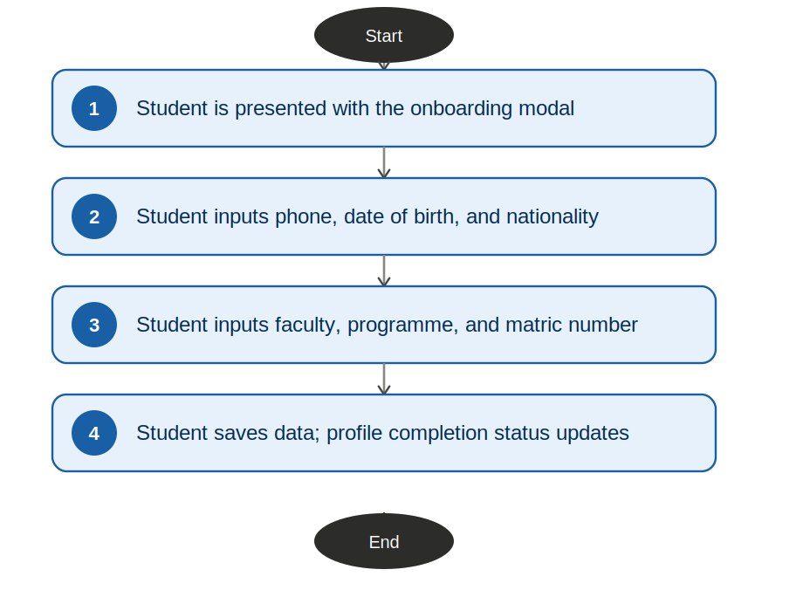
Figure 3.4: Use Case Activity Flow for Complete Profile
Figure 3.4 illustrates the guided onboarding sequence, showing the steps required to establish academic demographics and preferences.
- Actor: Student
- Description: Captures student demographic and academic program details during the onboarding workflow.
- Preconditions: Student is logged in for the first time.
- Postconditions: Deploys a new record in the student_profiles table.
- Normal Flow:
  - Student is presented with the onboarding modal.
  - Student inputs phone number, date of birth, and nationality.
  - Student inputs academic details (faculty, programme, matric number).
  - Student saves academic data, updating the profile completion status.
- Alternative Flows:
  - Invalid matric formatting: System displays a validation warning and blocks saving.

4. Use Case: Manage Skills

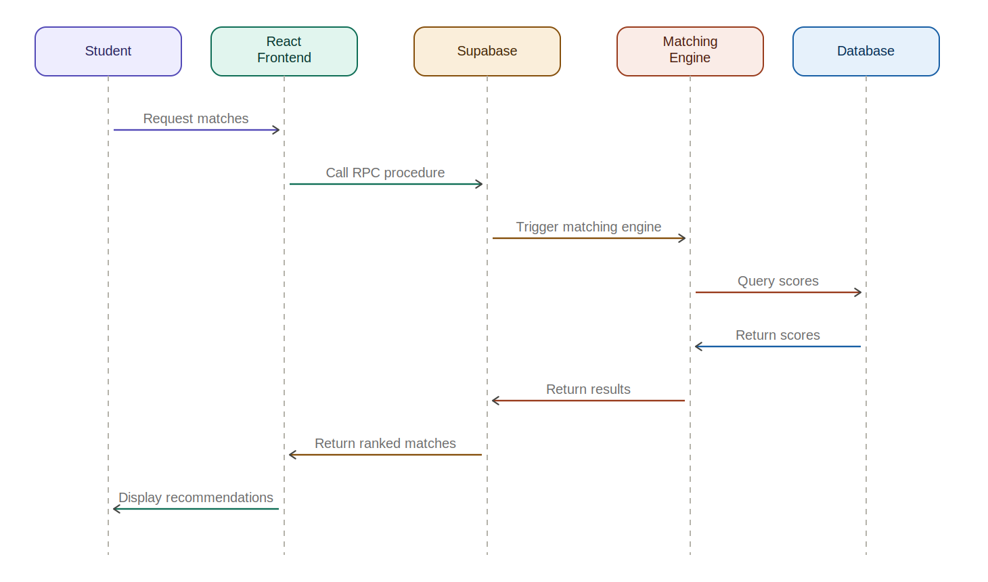
Figure 3.5: Use Case Activity Flow for Manage Skills
Figure 3.5 illustrates the workflow for updating student competencies, showing the mapping of technical skills to the user profile.
- Actor: Student
- Description: Allows students to update their technical skills inventory on their profile page.
- Preconditions: Student is authenticated and profile is active.
- Postconditions: Triggers skills mapping modifications in the user_skills table.
- Normal Flow:
  - Student navigates to the Skill Profile tab.
  - Student searches for a technical skill in the autocomplete search field.
  - Student selects and adds the skill.
  - System updates the skills chip array and triggers a matching score recalculation.
- Alternative Flows:
  - Skill already exists: System ignores duplicate addition.

5. Use Case: View Recommendations
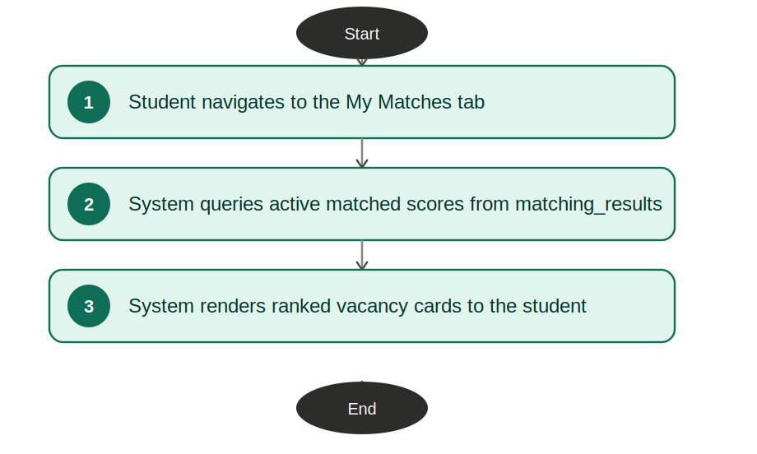
Figure 3.6: Use Case Activity Flow for View Recommendations
Figure 3.6 illustrates the recommendation retrieval activity flow, showing the system's database matching operations and recommendations feed render.
- Actor: Student
- Description: Displays ranked job vacancy listings sorted by their compatibility score.
- Preconditions: Student has configured their profile skills.
- Postconditions: Renders recommendations list on the client interface.
- Normal Flow:
  - Student navigates to the My Matches tab.
  - System queries active matched scores from matching_results.
  - System renders ranked vacancy cards to the user.
- Alternative Flows:
  - No skills configured: System prompts student to complete their profile setup.

6. Use Case: View Skill Gaps
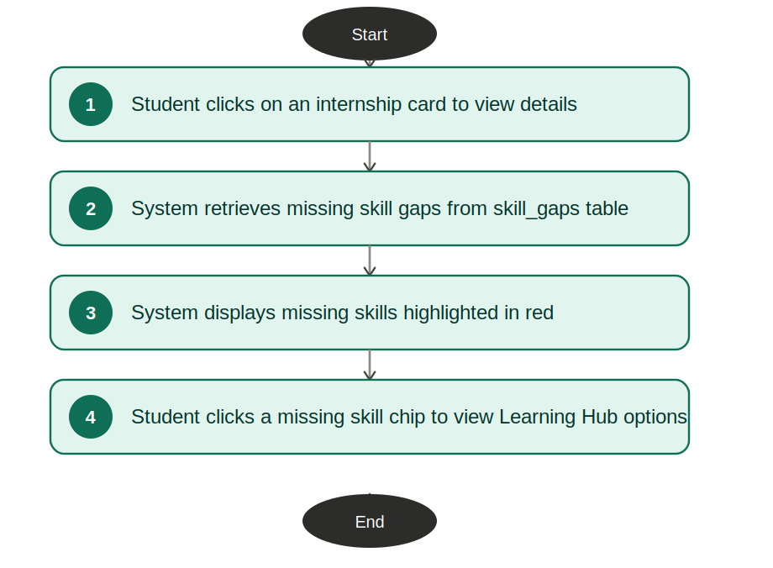
Figure 3.7: Use Case Activity Flow for View Skill Gaps
Figure 3.7 illustrates the skill gap analysis flow, demonstrating how the system identifies missing competencies relative to vacancy requirements.
- Actor: Student
- Description: Illustrates missing technical skills and maps them to educational search queries.
- Preconditions: Student selects a recommendation vacancy card.
- Postconditions: Opens detail view overlays.
- Normal Flow:
  - Student clicks on an internship card to view details.
  - System retrieves missing skill gaps from skill_gaps table.
  - System displays missing skills highlighted in red.
  - Student clicks on a missing skill chip to view Learning Hub search options.
- Alternative Flows:
  - Perfect skill match: System displays a congratulations message.

7. Use Case: Track Applications

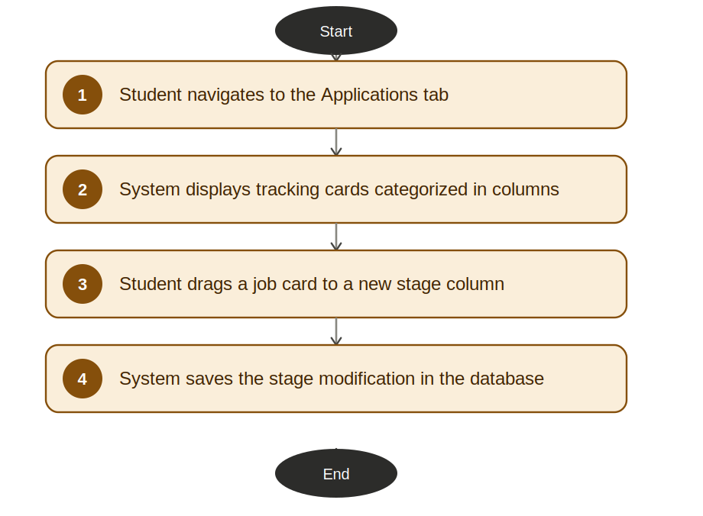
Figure 3.8: Use Case Activity Flow for Track Applications
Figure 3.8 illustrates the Kanban state transition flow, showing the drag-and-drop actions that update the application tracking status.
Actor: Student
- Description: Manages the tracking lifecycle of individual internship applications on a Kanban board.
- Preconditions: Student is authenticated and has vacancies in their saved pipeline.
- Postconditions: Updates stage values in the tracker_applications table.
- Normal Flow:
  - Student navigates to the Applications tab.
  - System displays tracking cards categorized in columns.
  - Student drags a job card to a new stage column.
  - System saves the stage modification in the database.
- Alternative Flows:
  - Manual card addition: Student inputs manual company details to track.

8. Use Case: Configure Setup
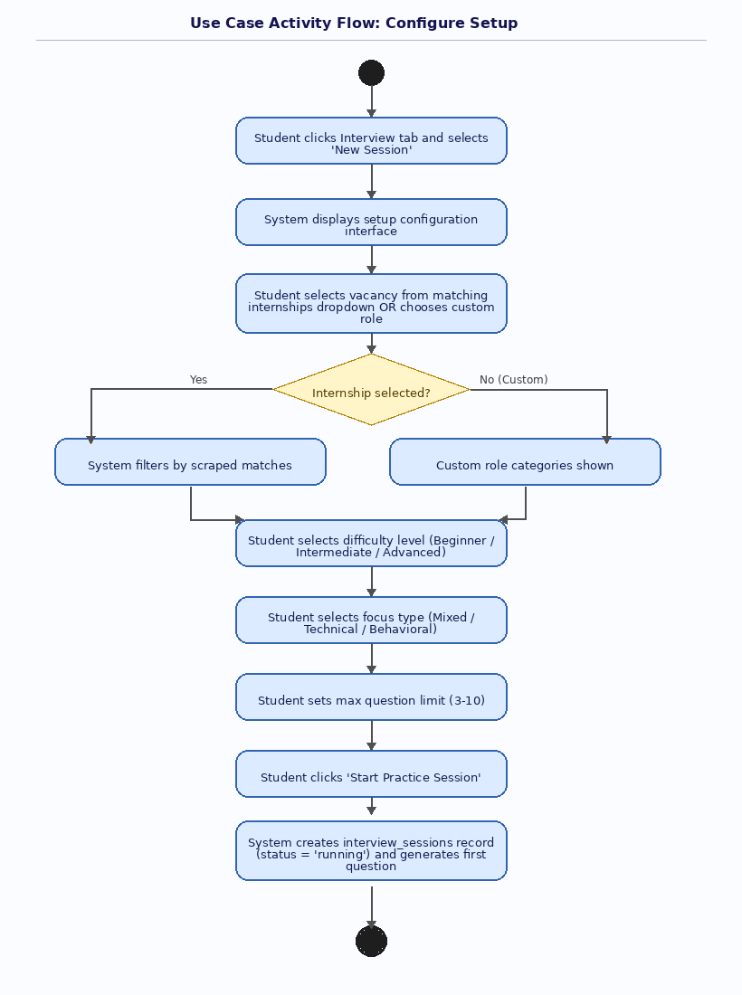
Figure 3.9: Use Case Activity Flow for Configure Setup
Figure 3.9 illustrates the sequential activity flow for the mock interview configuration process. The diagram models the decision path for selecting a target role, configuring session parameters, and initiating the AI-driven interview session. The system creates a new record in the interview_sessions table upon completion of the setup workflow.

Actor: Student
Description: Configures the mock interview parameters, including target role, focus area, difficulty, and question limit, to initialize a session.
Preconditions: Student is authenticated.
Postconditions: Creates a new record in interview_sessions table with status 'running'.
Normal Flow:
1. Student clicks the Interview tab and selects "New Session".
2. System displays the setup configuration interface.
3. Student selects a vacancy from the matching internships dropdown, or chooses a custom role (e.g. Software Developer, Data Analyst).
4. Student selects difficulty level (beginner, intermediate, advanced) and interview focus type (mixed, technical, behavioral).
5. Student sets the maximum question limit and clicks "Start Practice".
6. System creates a session record and generates the tailored introductory question.
Alternative Flows:
No internships matched: System displays custom role dropdown only.

9. Use Case: Conduct Voice Interview
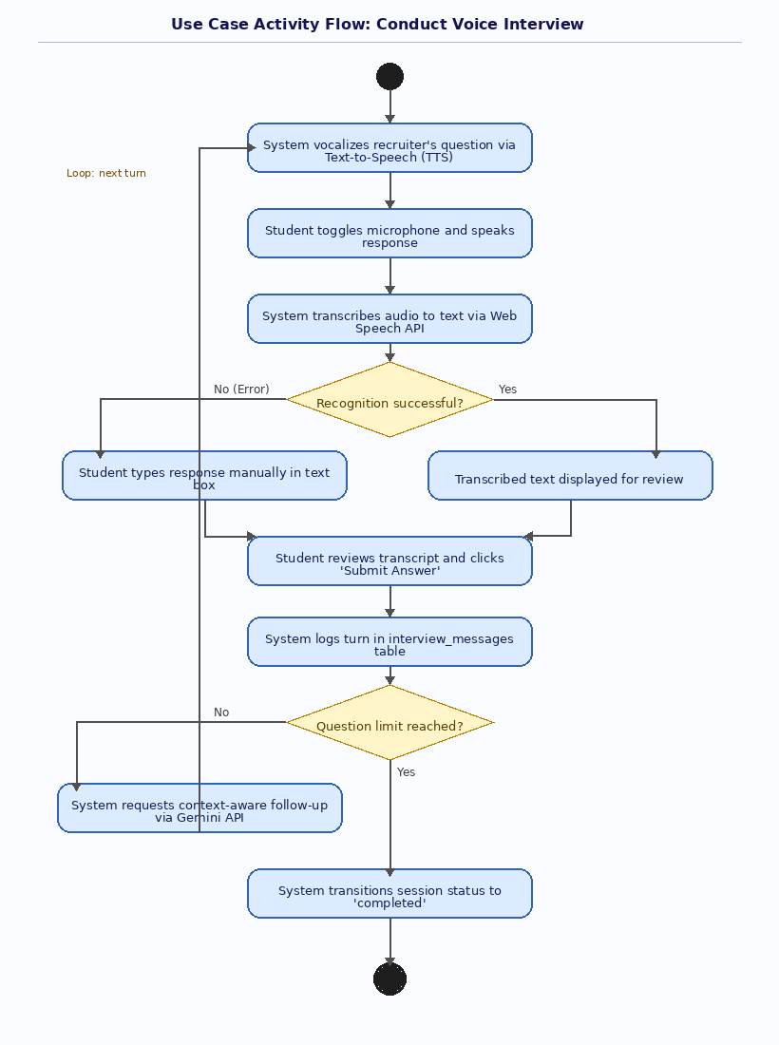
Figure 3.10: Use Case Activity Flow for Conduct Voice Interview
Figure 3.10 illustrates the real-time voice interview activity flow. The diagram models the turn-based question-answer loop, incorporating the Speech-to-Text transcription path and the manual text-input fallback for browser compatibility issues. A decision node checks whether the configured question limit has been reached; if not, the system invokes the Gemini API to generate a context-aware follow-up question and repeats the loop.

Actor: Student
Description: Participates in a real-time voice-driven mock interview, transcribing speech inputs and vocalizing follow-up questions.
Preconditions: Simulated session is initialized.
Postconditions: Logs dialogue turns in interview_messages table; completes the session.
Normal Flow:
1. System vocalizes the recruiter's question via browser Text-to-Speech (TTS).
2. Student toggles microphone recording and speaks their response.
3. System transcribes spoken audio to text in real-time via Web Speech Recognition.
4. Student reviews the transcribed text and clicks "Submit Answer".
5. System logs the turn in the database and evaluates progress.
6. If question limit is not reached, system requests a context-aware follow-up question from Gemini API and repeats.
Alternative Flows:
Speech recognition error: Student types response manually in text input box.
Mic access denied: System alerts student and defaults to manual text-based input.

10. Use Case: View Performance Report
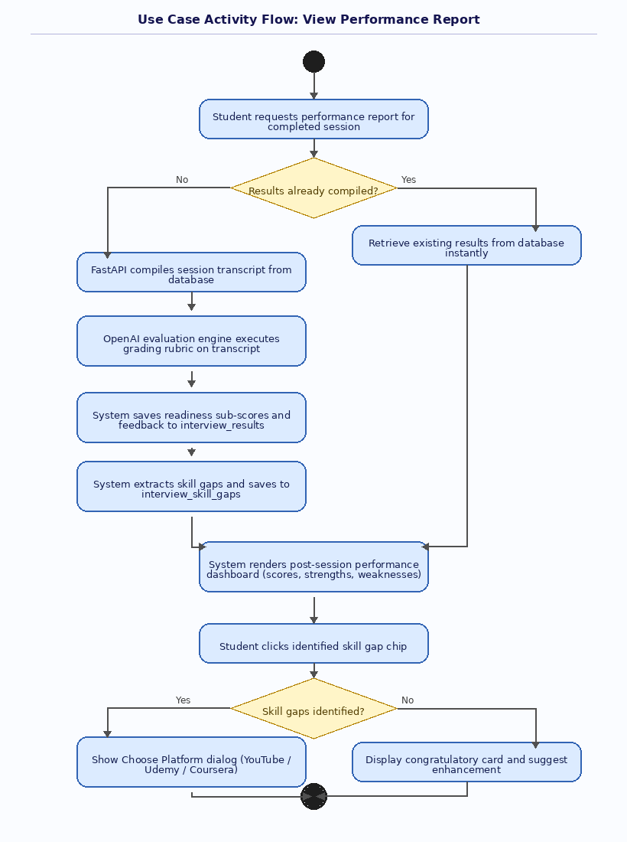
Figure 3.11: Use Case Activity Flow for View Performance Report
Figure 3.11 illustrates the post-session performance evaluation activity flow. The diagram models the conditional path for retrieving pre-compiled results versus triggering a fresh OpenAI evaluation. The evaluation engine scores the session across four rubric dimensions and persists the results and identified skill gaps to the database. The final dashboard renders readiness scores, qualitative feedback, and interactive skill gap chips that redirect to learning platforms.

Actor: Student
Description: Reviews the evaluated performance scores, dimension feedback, strengths/weaknesses, and maps identified skill gaps to learning resources.
Preconditions: Interview session is completed.
Postconditions: Stores scores and feedback in interview_results; stores identified gaps in interview_skill_gaps.
Normal Flow:
1. Student requests the performance report for a completed session.
2. System triggers the OpenAI evaluation engine, executing the grading rubric on the transcript.
3. System saves the calculated readiness sub-scores and textual feedback.
4. System extracts technical and behavioral skill gaps, mapping them to the database.
5. System displays the post-session performance dashboard.
6. Student clicks an identified skill gap and chooses a platform (YouTube, Udemy, Coursera) via the redirect dialog.
Alternative Flows:
Evaluation already compiled: System retrieves existing results from the database instantly.
No skill gaps identified: System displays a congratulatory card and suggests general career enhancement.

3.5 Chapter Summary
This chapter analyzed the system requirements, detailing the workflows, use case models, use case descriptions, and functional/non-functional requirements. The next chapter describes the system architecture, database design, and interface layouts.

CHAPTER 4
DESIGN

4.1 Introduction
This chapter describes the system architecture, activity and sequence diagrams, user interface design for all five core modules – the Internship Aggregation Module (Daily Scraper), Recommendation Engine, Learning Hub (with Skill Gap Analysis), Application Tracking Module (Kanban Board), and AI Interview Prep Module – conceptual ERD schemas, relational database summary tables, physical DDL, and Row-Level Security policies.

4.2 High-Level Design

4.2.1 System Architecture
FitFlow uses a three-tier system architecture to separate presentation, logic, and data storage.

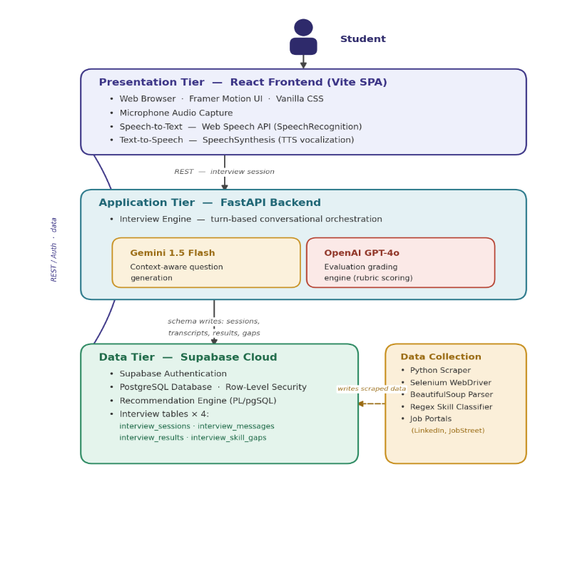
Figure 4.1: FitFlow Three-Tier System Architecture
Figure 4.1 illustrates the architectural organization of the FitFlow platform across three tiers. The Presentation Tier (React Frontend) runs on the client browser as a React single-page application, rendering interface layouts, managing user state, and serving as the voice interface layer for the AI Interview Prep module. This tier is responsible for managing audio capture via the browser microphone, performing dynamic Speech-to-Text (STT) transcription in real time through the Web Speech API’s SpeechRecognition engine, and triggering Text-to-Speech (TTS) question vocalization through the browser’s SpeechSynthesis interface. It communicates with the data storage and authentication endpoints hosted on Supabase Cloud via REST API calls, and with the Python FastAPI backend to handle AI processing. The Application Tier (FastAPI Backend) orchestrates the LLM conversational flow for the mock interview pipeline. It uses Google Gemini 1.5 Flash for turn-based context-aware question generation, producing dynamically tailored interviewer follow-up questions based on the student’s profile, selected role, and prior responses. It uses OpenAI GPT-4o as the evaluation grading engine, analyzing the completed session transcript against a strict multi-dimensional rubric to produce technical, behavioral, communication, and confidence scores alongside qualitative feedback. The Data Tier (Supabase Database) contains the PostgreSQL database, executing the recommendation matching procedures server-side and storing all student records. For the AI Interview Prep module, this tier performs schema writes for four dedicated tables: interview_sessions (tracking session metadata), interview_messages (storing full conversation transcripts), interview_results (persisting evaluated dimension scores and feedback), and interview_skill_gaps (recording identified competency gaps and remediation recommendations). The automated scraping daemon runs as a background process, extracting data and syncing vacancies with the Supabase database.

4.2.2 Activity Diagram
The activity diagram models the internship recommendation process workflow.

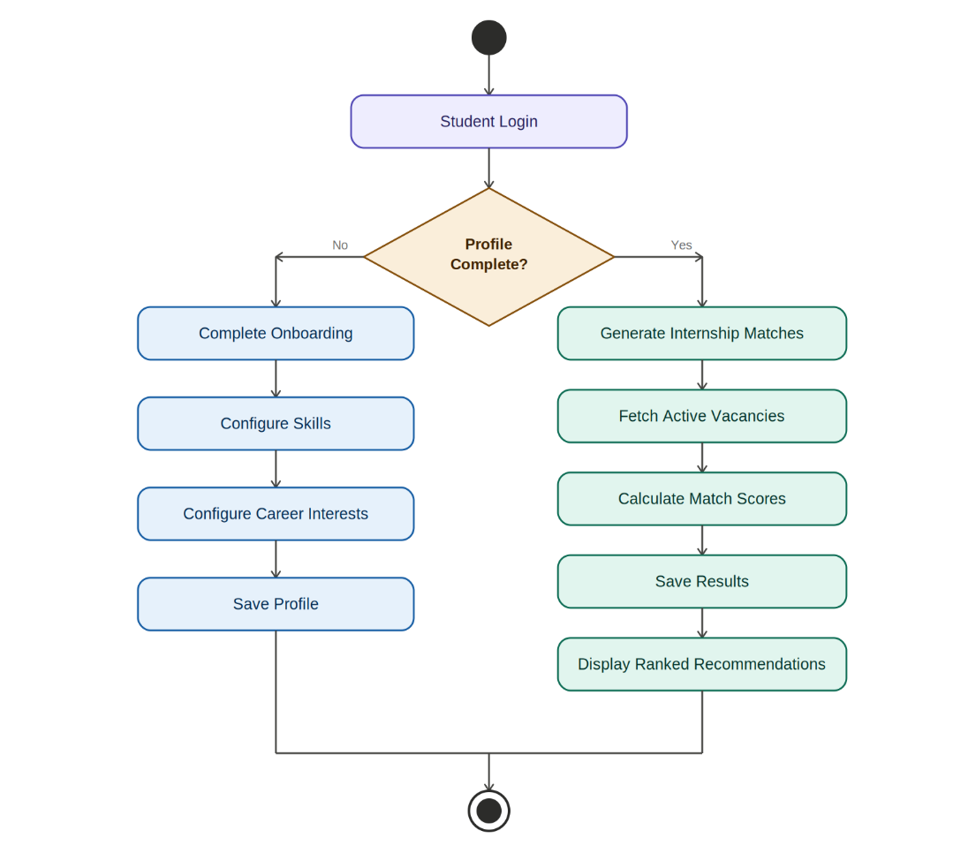
Figure 4.2a: Activity Diagram of the Internship Recommendation Process
Figure 4.2a illustrates the activity flow diagram for retrieving and calculating compatibility scores in the recommendation engine, modeling the full sequence from student profile retrieval through weighted matching score calculation to the ranked recommendations display.

4.2.3 Sequence Diagram
The sequence diagram models the object interactions and message flows governing the AI Mock Interview module.
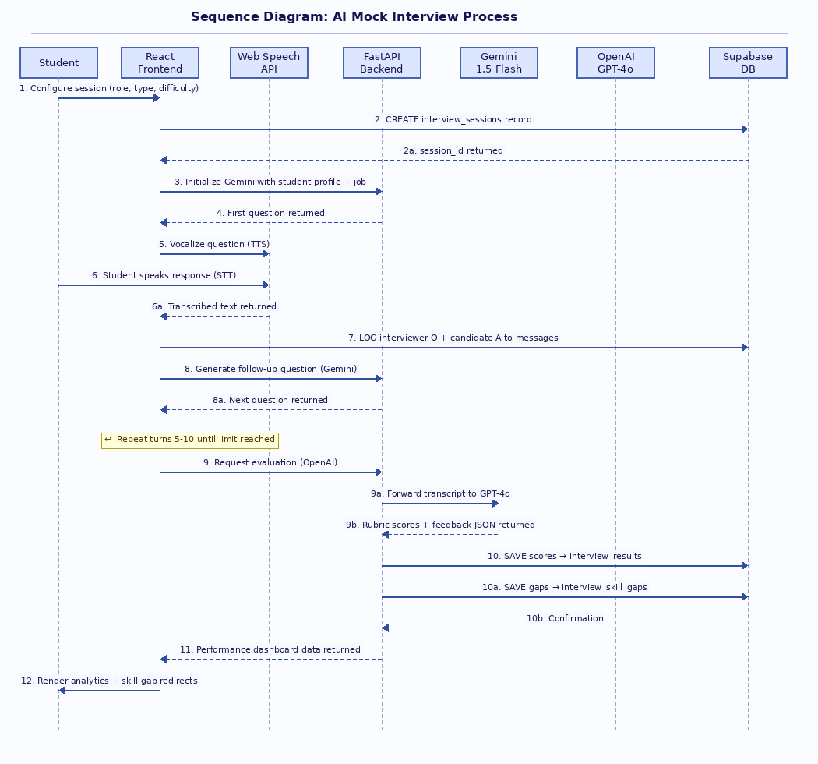
Figure 4.2b: Sequence Diagram of the AI Mock Interview Process
Figure 4.2b illustrates the sequence diagram of the AI Mock Interview process. The diagram models the object interactions and chronological message flows between the Student (actor), React Frontend, FastAPI Backend, Gemini 1.5 Flash API, OpenAI GPT-4o API, and the Supabase PostgreSQL database. It captures the full lifecycle from session configuration through the turn-based voice interview loop—including Web Speech API transcription, Gemini question generation, and database transcript logging—to the post-session OpenAI evaluation pipeline and the final rendering of the multi-dimensional performance analytics dashboard.

4.2.4 User Interface Design

(a) Navigation Design
The navigation structure coordinates user pathways through dashboard options.

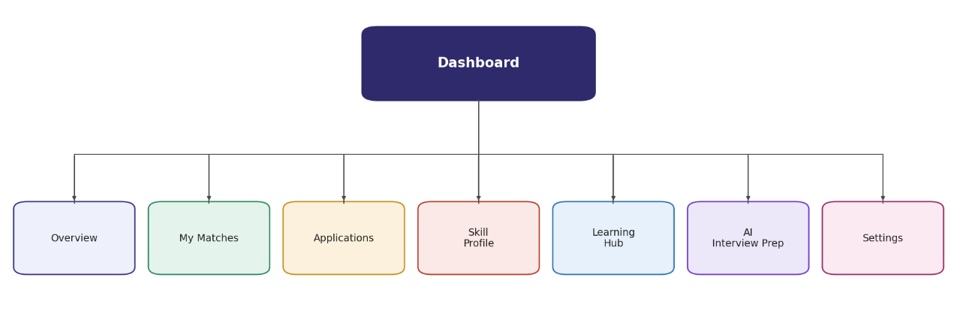
Figure 4.3: Sidebar Navigation Menu Structure
Figure 4.3 illustrates the navigation architecture and pages available to users within the student portal.

Figure 4.3 illustrates the sidebar navigation structure. The layout uses a fixed left sidebar on desktop screens and a collapsible drawer on mobile screens. The navigation options link to the dashboard panels (Overview, My Matches, Applications, Skill Profile, Learning Hub, AI Interview Prep, and Settings), allowing students to access internship recommendations, learning resources, application tracking, and AI-powered voice interview preparation directly through the sidebar navigation while maintaining active session state.

(b) Input Design
Registration and profile input forms validate inputs to maintain data quality.

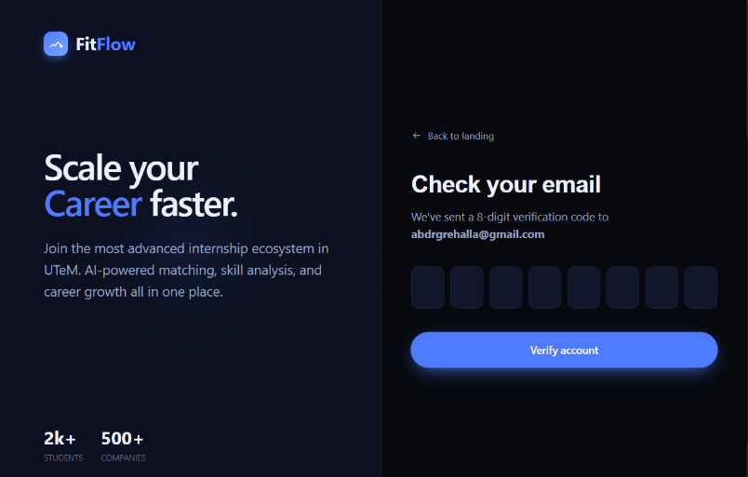
Figure 4.4: Secure User Authentication Portal
Figure 4.4 illustrates the secure login portal, containing input fields for user credentials and social authentication buttons.

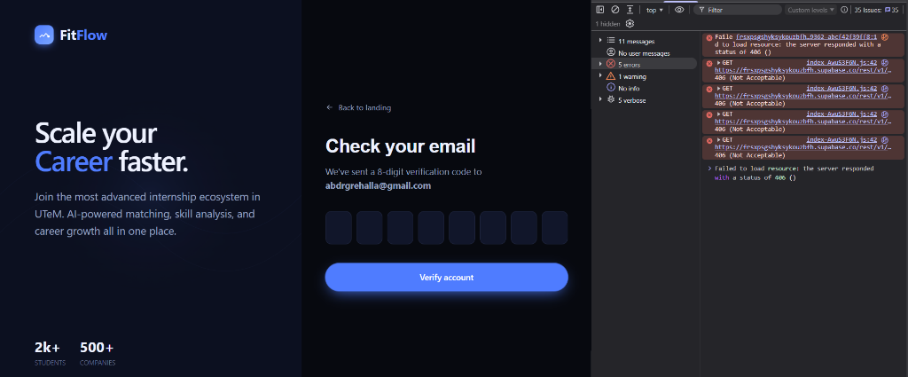
Figure 4.5: Student Registration Page
Figure 4.5 illustrates the registration form collected during user account creation, highlighting active password validation indicators.

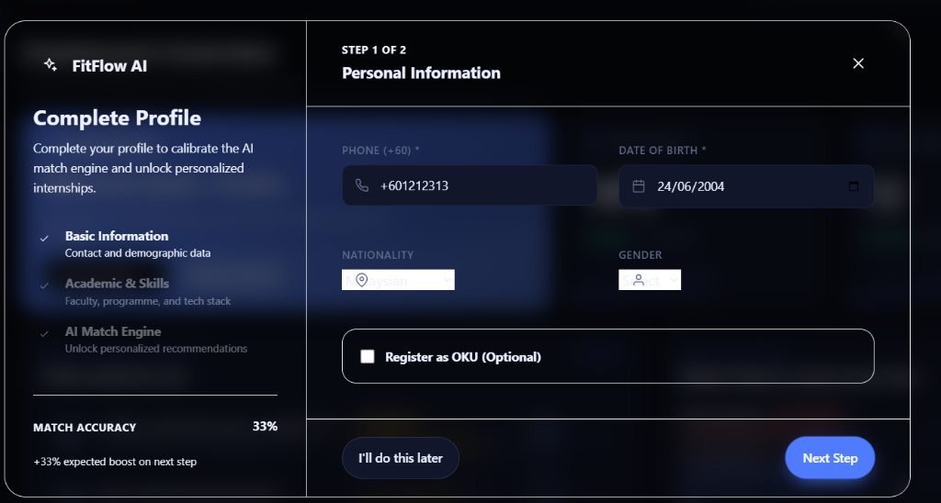
Figure 4.6: Onboarding Step 2 - Demographic Information
Figure 4.6 illustrates the demographic information onboarding step, which collects user contact details and nationality preferences.

Figure 4.7: Onboarding Step 3 - Academic Profile and Skills Selection
Figure 4.7 illustrates the academic profiling step, prompting the student to select their FTMK program specialization and key technical skills.

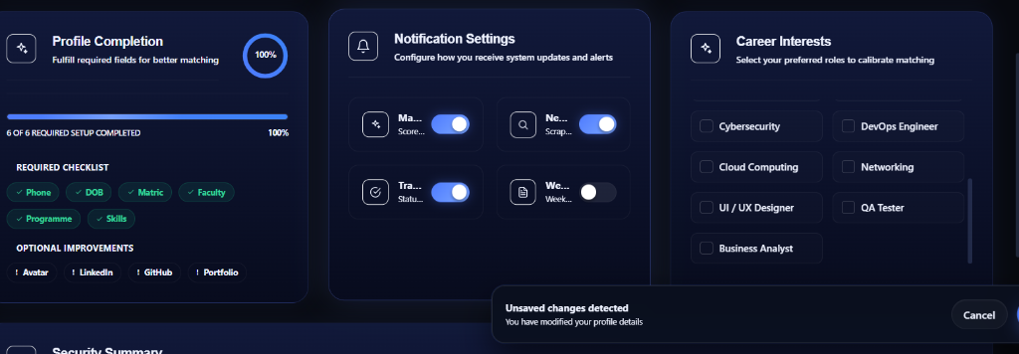
Figure 4.8: Onboarding Step 4 - Career Interests Selection
Figure 4.8 illustrates the career interests onboarding step, presenting a selectable list of standard industry roles for profile configuration.

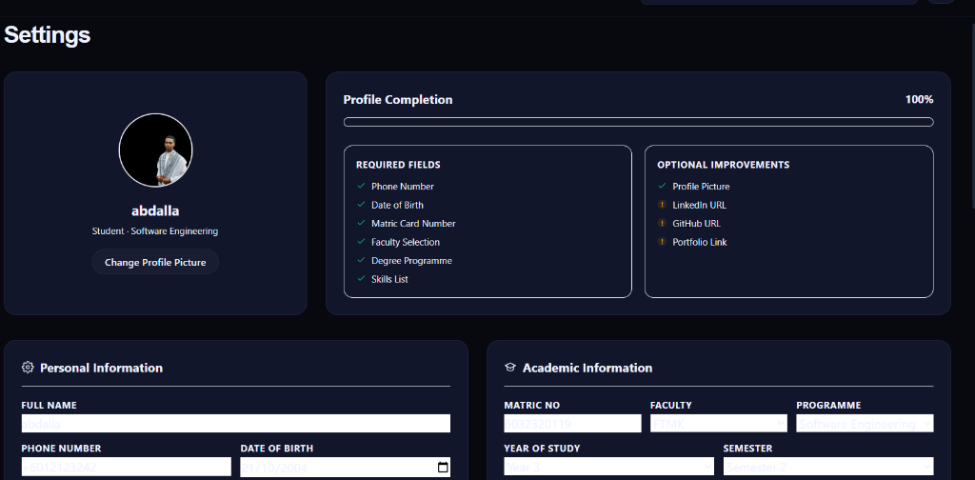
Figure 4.9: Profile Settings Form
Figure 4.9 illustrates the user profile settings tab, displaying editable forms for personal details, program specialization, and career targets.

The AI Interview Prep configuration interface allows students to define the parameters of their practice session before it is initialized. The configuration form presents the following input controls:
- Internship Role / Career Track: A dropdown selector that presents the student’s currently matched internship vacancies for targeted practice, or alternatively a set of standard career tracks including Software Developer, Data Analyst, UI/UX Designer, Cybersecurity, or General Practice for role-specific preparation.
- Focus Area (Interview Type): A set of selectable toggle options defining the nature of the interview questions to be generated. Options include Technical (domain-specific problem solving), Behavioral (situational judgment and soft skills), or Mixed (a combined session covering both dimensions).
- Difficulty Level: A selectable control that calibrates the complexity of the generated interview questions. Available levels are Beginner (foundational concepts), Intermediate (applied knowledge), or Advanced (industry-depth problem solving).
- Question Limit: A slider input control that allows the student to set the maximum number of interview questions for the session, ranging from 3 to 10 questions. This parameter manages session length and allows students to conduct focused short drills or extended full-length practice interviews.
Screenshots of the AI Interview Prep Configurator interface are compiled in Appendix B (Figure B.9).

(c) Output Design
System outputs present matches, tracking progress, and notifications.

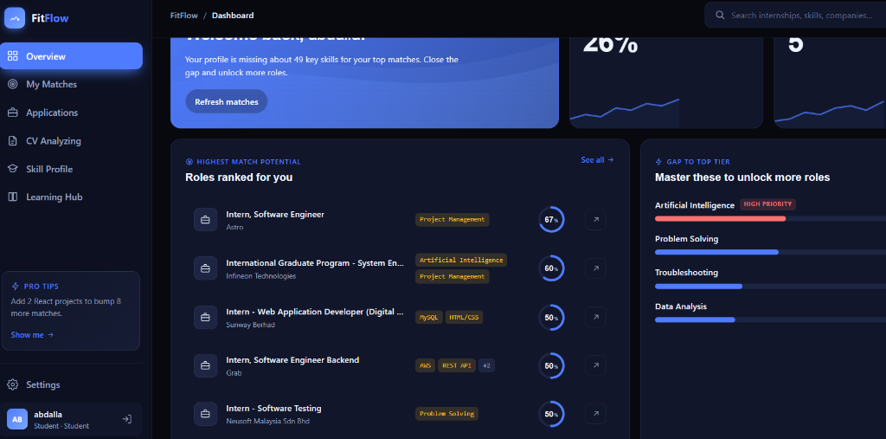
Figure 4.10: Dashboard Overview and KPI Metrics
Figure 4.10 illustrates the primary dashboard view, incorporating KPI widgets for application metrics and welcome notifications.

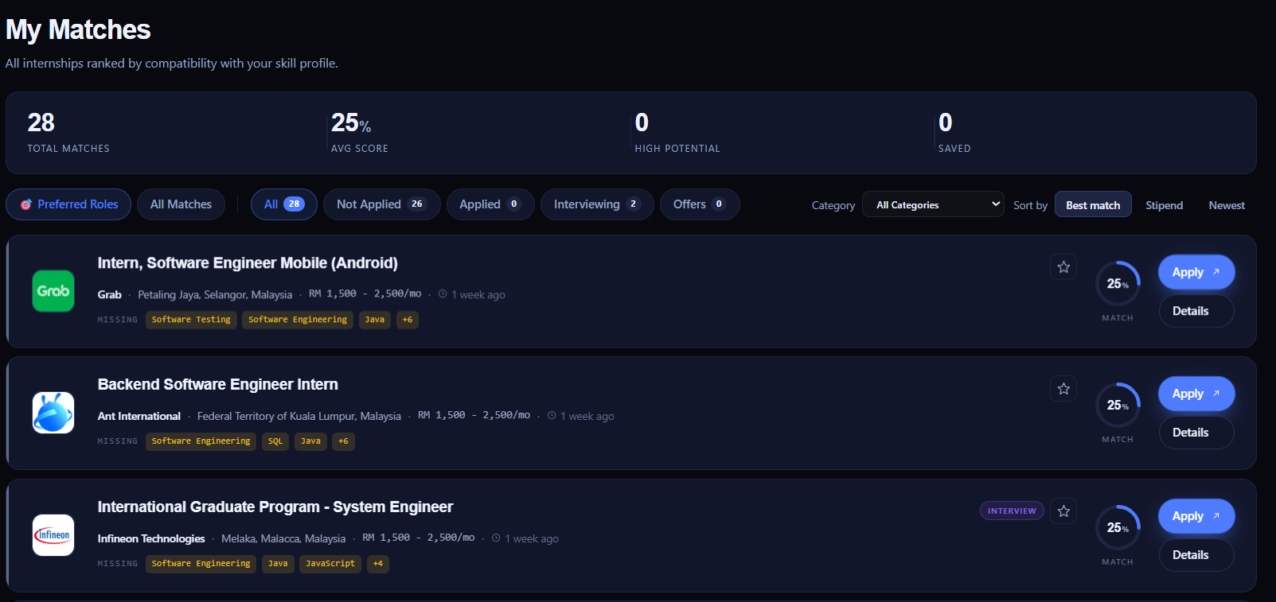
Figure 4.11: Ranked Internship Recommendations Feed
Figure 4.11 illustrates the ranked recommendations listing feed, displaying compatible vacancies sorted by match percentage scores.

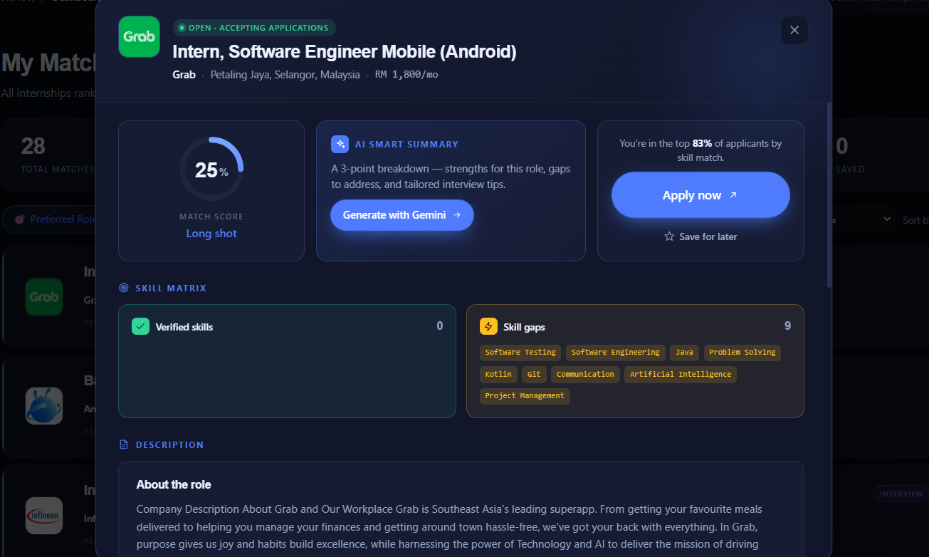
Figure 4.12: Internship Details Modal and Skill Overlaps
Figure 4.12 illustrates the detailed popup modal for a vacancy, displaying location info, stipend metadata, and a technical skill comparison grid.

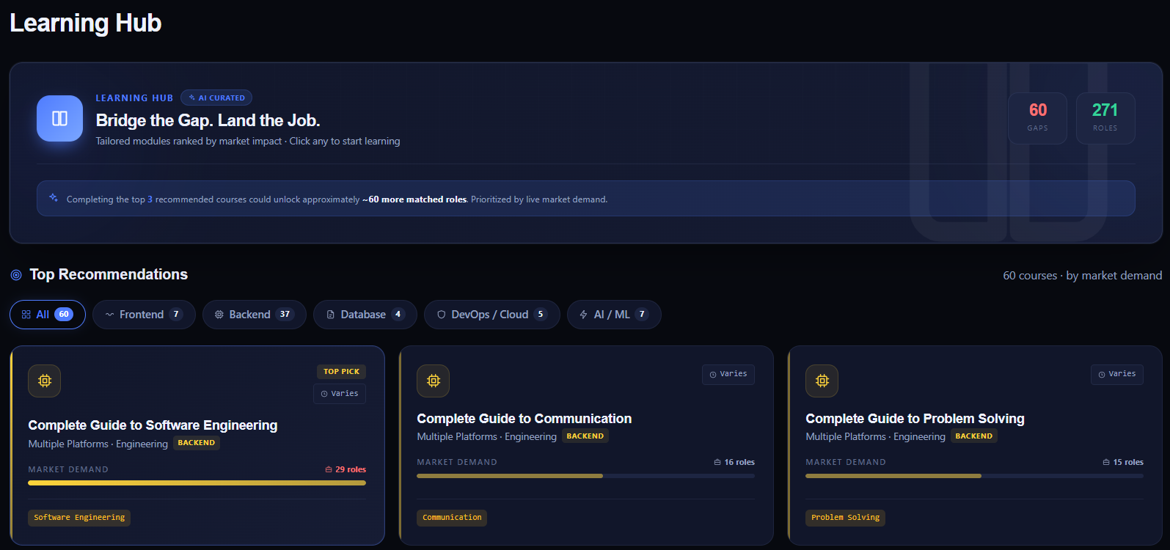
Figure 4.13: Learning Hub Resource Redirect Modal
Figure 4.13 illustrates the educational redirection modal, which parses missing skills and links students directly to external course libraries.

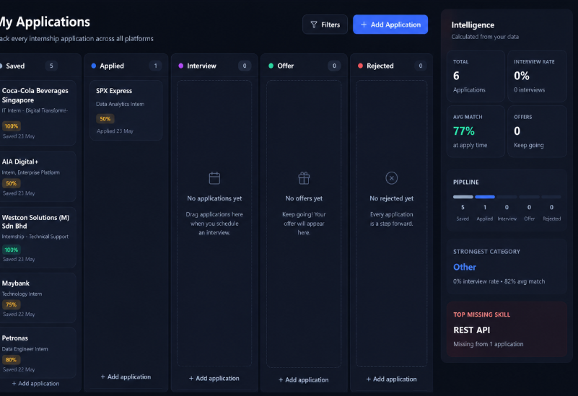
Figure 4.14: Kanban Application Tracking Board
Figure 4.14 illustrates the interactive Kanban board layout, supporting drag-and-drop actions to progress applications across various recruitment phases.
The AI Interview Prep module introduces two additional output interfaces that present real-time session interactions and post-session performance analytics to the student.
Live AI Interview Room: The real-time interview room interface is the primary output rendered during an active session. It displays the current question transcription in a chat-style dialogue panel so that the student can read the question while it is being vocalized. The interface provides real-time microphone recording controls (start/stop toggle) that activate the Web Speech API’s SpeechRecognition engine, capturing and transcribing the student’s spoken audio in real time. A live waveform visualization display reflects active audio input levels, providing visual confirmation that the microphone is receiving audio. A Text-to-Speech (TTS) vocalization trigger button allows the student to replay any question through the browser’s SpeechSynthesis engine. The session progress indicator tracks the current question number against the configured question limit. Screenshots of the Live AI Interview Room are compiled in Appendix B (Figure B.10).
AI Interview Evaluation Report: Upon session completion, the system renders a post-session analytics dashboard populated with the OpenAI GPT-4o evaluation results. The report output displays the following scored metrics, each expressed as a percentage on a scale of 0 to 100: an Overall Readiness Score representing the aggregate performance across all evaluated dimensions; a Technical Score reflecting domain knowledge and problem-solving accuracy; a Behavioral Score assessing situational judgment and professional conduct; a Communication Score evaluating clarity, coherence, and articulation; and a Confidence Score measuring delivery assurance and response assertiveness. Below the scored metrics, the report lists identified skill gaps, each tagged with a severity level and mapped to targeted learning platforms (YouTube, Udemy, or Coursera) via a Choose Platform redirect dialog. The report also presents qualitative feedback text with supporting evidence extracted from the transcript to justify each sub-score. Screenshots of the AI Interview Evaluation Report are compiled in Appendix B (Figures B.11 and B.12).

4.2.5 Database Design

4.2.5.1 Conceptual Database Design
The conceptual schema models the relationships between student profiles, skills, and internship listings.
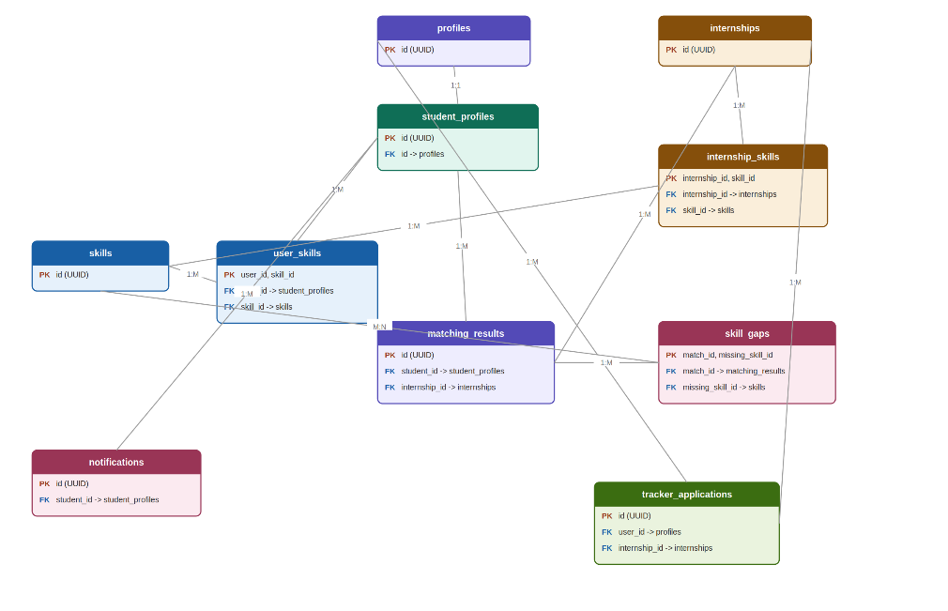
Figure 4.15: Relational Database Design Schema
Figure 4.15 illustrates the relational database design. The profiles table stores core credentials and relates to student_profiles to capture student demographics. The student_profiles table connects to the skills table through the many-to-many user_skills junction table. Internship listings in the internships table connect to skills through the internship_skills junction table. The matching_results table stores calculated compatibility scores for each student-internship pair, and the skill_gaps table maps missing skills for each match. To support mock interviews, the interview_sessions table connects student profiles to internships and tracks session status. It has a one-to-many relationship with the interview_messages table, which logs conversation histories, and a one-to-one relationship with the interview_results table, which holds multi-dimensional performance scores and feedback. Identified gaps are tracked in the interview_skill_gaps table, which maps competencies to sessions.

Relational Database Summary Table
The table below summarizes the purposes of the 16 system database tables:
Table 4.1: Relational Database Summary Table
Table Name | Primary Key | Foreign Keys | Purpose Description
profiles | id (UUID) | None | Stores user auth records and full names.
student_profiles | id (UUID) | id references profiles.id | Stores student demographics and academic programme codes.
skills | id (UUID) | None | Catalog of standardized technical skills.
user_skills | (user_id, skill_id) | user_id $→$ profiles, skill_id $→$ skills | Maps student profiles to their technical skills.
internships | id (UUID) | None | Stores scraped job listings and classification metrics.
internship_skills | (internship_id, skill_id) | internship_id $→$ internships, skill_id $→$ skills | Maps job listings to their required skills.
scrape_runs | id (UUID) | None | Tracks scraping execution history and success rates.
matching_results | id (UUID) | student_id $→$ profiles, internship_id $→$ internships | Stores calculated matching scores.
skill_gaps | (match_id, missing_skill_id) | match_id $→$ matching_results, missing_skill_id $→$ skills | Maps missing skills identified for each match.
notifications | id (UUID) | student_id $→$ profiles | Stores in-app alerts and notifications.
tracker_applications | id (UUID) | user_id $→$ profiles, internship_id $→$ internships | Stores Kanban application tracking cards.
applications | id (UUID) | student_id $→$ profiles, internship_id $→$ internships | Logs saved applications to support tracking.
interview_sessions | id (UUID) | user_id references profiles.id, internship_id references internships.id | Stores simulated interview sessions launched by students.
interview_messages | id (UUID) | session_id references interview_sessions.id | Stores conversation transcripts (interviewer questions and candidate responses).
interview_results | id (UUID) | session_id references interview_sessions.id | Records the OpenAI-evaluated performance scores and textual feedback.
interview_skill_gaps | id (UUID) | session_id references interview_sessions.id | Identifies technical and behavioral gaps revealed during the interview.

4.3 Detailed Design

4.3.1 Software Design
The software design uses modular React components to manage dashboard panels and user interactions.

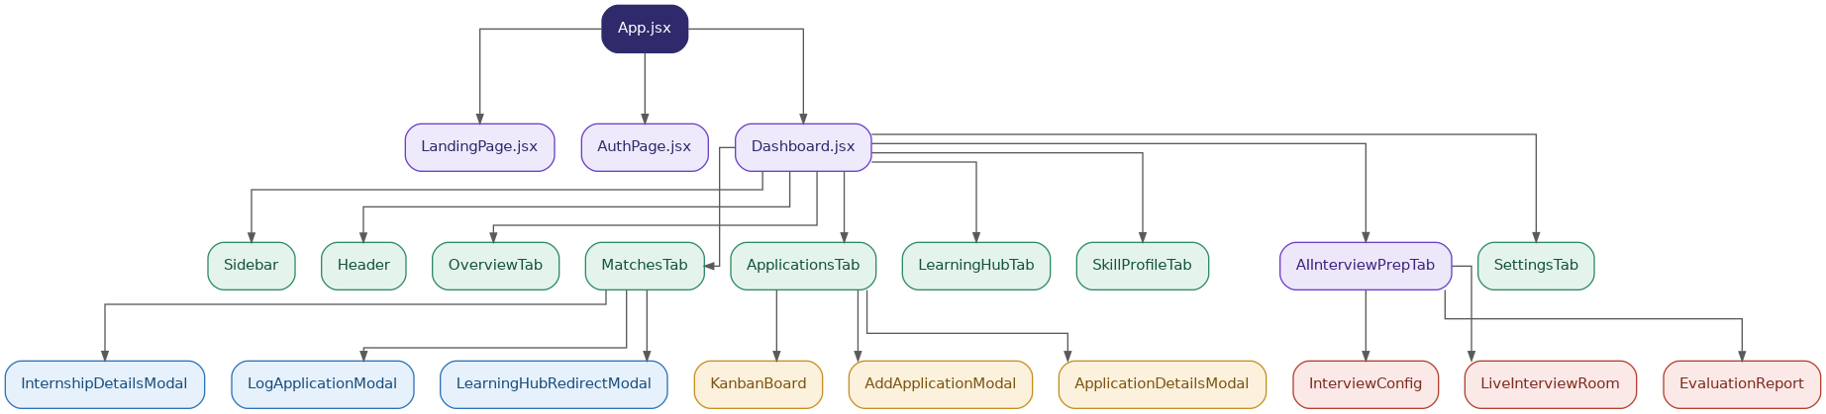
Figure 4.16: React Client Component Hierarchy
Figure 4.16 illustrates the component tree structure of the React frontend application, showing routing paths and sub-component dependencies.

4.3.2 Physical Database Design
The schema is deployed on PostgreSQL 15.1 on Supabase:
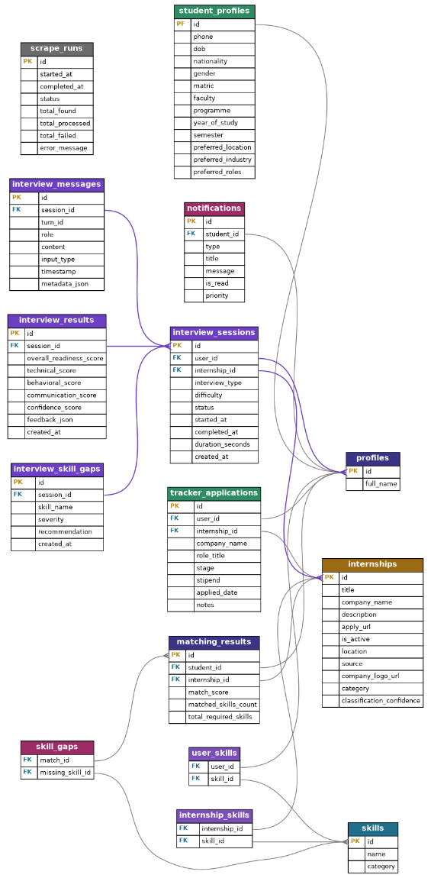
Figure 4.17: Physical Database Schema of the FitFlow System
Figure 4.17 illustrates the physical database design schema, showing all tables, columns, data types, and primary/foreign key relationships.

4.3.2.1 Database Data Dictionaries
The physical tables deployed on Supabase are described in detail below. These dictionaries outline column names, data types, nullability, keys, and operational purposes.
Table 4.2: Data Dictionary for internships Table
Column Name | Data Type | Nullable | Key / Constraints | Description
id | uuid | NO | PRIMARY KEY | Unique identifier for each scraped vacancy.
title | text | NO | None | The job title of the internship listing.
company_name | text | NO | None | Name of the employing company.
description | text | NO | CHECK (length >= 200) | Full job description text.
apply_url | text | NO | UNIQUE | URL redirect to the external job application page.
is_active | boolean | NO | DEFAULT true | Status flag indicating if the position is currently active.
created_by | uuid | YES | FOREIGN KEY $→$ profiles.id | Admin user who created the entry (nullable for scraper).
created_at | timestamptz | NO | DEFAULT now() | Timestamp when the internship record was created.
updated_at | timestamptz | NO | DEFAULT now() | Timestamp of the last record update.
location | text | YES | None | Physical work location (e.g. city, state, or Remote).
source | text | NO | CHECK (source IN (‘JobStreet’, ‘LinkedIn’)) | Job board source platform.
last_seen_at | timestamptz | NO | DEFAULT now() | Timestamp of the last scraper run where this listing was active.
last_verified_at | timestamptz | YES | None | Timestamp of the last reachability check of the apply URL.
company_logo_url | text | YES | None | URL path of the company’s brand logo image.
category | text | YES | None | Classified job domain (e.g., Software Engineer, DevOps).

Table 4.3: Data Dictionary for student_profiles Table
Column Name | Data Type | Nullable | Key / Constraints | Description
id | uuid | NO | PRIMARY KEY, FK $→$ profiles.id | Unique identifier matching the student’s auth account.
university | text | YES | None | Student’s higher education institution.
course | text | YES | None | Specific course name or curriculum path.
cv_url | text | YES | None | URL path to the student’s uploaded PDF resume.
phone | text | YES | None | Contact phone number.
nationality | text | YES | DEFAULT ‘Malaysian’ | Student’s nationality.
dob | date | YES | None | Date of birth.
gender | text | YES | CHECK (gender IN (‘Male’, ‘Female’)) | Student’s gender.
address | text | YES | None | Physical home or mailing address.
oku_status | text | YES | None | Disability status indicator (default: ‘None’).
matric | text | YES | UNIQUE | Student’s matric card registration number.
faculty | text | YES | CHECK (faculty IN (‘FTMK’, ‘FAIX’)) | UTeM faculty code.
programme | text | YES | None | Academic programme path code (e.g. BITS, BITD).
year_of_study | integer | YES | None | Current academic year (1, 2, 3, or 4).
semester | integer | YES | None | Current academic semester (1 or 2).
preferred_location | text | YES | None | Preferred internship location.
preferred_industry | text | YES | None | Preferred industry sector.
linkedin_url | text | YES | None | Link to personal LinkedIn professional profile.
github_url | text | YES | None | Link to personal GitHub code repository.
portfolio_url | text | YES | None | Link to personal web portfolio.
preferred_roles | text[] | YES | None | Array of selected tech career domains
Table 4.4: Data Dictionary for matching_results Table
Column Name | Data Type | Nullable | Key / Constraints | Description
id | uuid | NO | PRIMARY KEY | Unique identifier for the match record.
student_id | uuid | NO | FOREIGN KEY $→$ profiles.id | Associated student profile identifier.
internship_id | uuid | NO | FOREIGN KEY $→$ internships.id | Associated internship listing identifier.
match_score | numeric | NO | None | Computed weighted score percentage (0.0 to 100.0).
matched_skills_count | integer | NO | None | Count of overlapping skills.
total_required_skills | integer | NO | None | Total skills required by the internship listing.
created_at | timestamptz | NO | DEFAULT now() | Match record creation timestamp.
updated_at | timestamptz | NO | DEFAULT now() | Match record modification timestamp.

Table 4.5: Data Dictionary for tracker_applications Table
Column Name | Data Type | Nullable | Key / Constraints | Description
id | uuid | NO | PRIMARY KEY | Unique identifier for the tracking card.
user_id | uuid | NO | FOREIGN KEY $→$ profiles.id | Associated student user.
company_name | text | NO | None | Name of the company.
role_title | text | NO | None | Internship job title.
role_category | text | YES | None | Tech category classified for the tracked role.
job_source | text | YES | None | Origin source platform (e.g. JobStreet, LinkedIn).
source_url | text | YES | None | Job post URL redirect.
match_score | integer | YES | None | Match percentage at the time of saving.
matched_skills | text[] | YES | None | Array of skills matching the student’s profile when saved.
missing_skills | text[] | YES | None | Array of missing skills when saved.
stage | text | NO | CHECK stage stages, DEFAULT ‘saved’ | Current stage on the Kanban board.
saved_at | timestamptz | YES | DEFAULT now() | Timestamp when card was created/saved.
applied_at | timestamptz | YES | None | Timestamp when state transitioned to ‘applied’.
interview_scheduled_at | timestamptz | YES | None | Scheduled date and time for interviews.
offer_received_at | timestamptz | YES | None | Date when placement offer was received.
notes | text | YES | None | User’s personal application tracking notes.

Table 4.6: Data Dictionary for interview_sessions Table
Column Name | Data Type | Nullable | Key / Constraints | Description
id | uuid | NO | PRIMARY KEY | Unique identifier for each simulated session.
user_id | uuid | NO | FOREIGN KEY profiles.id | Associated student user.
internship_id | uuid | YES | FOREIGN KEY internships.id | Target internship selected for practice (nullable if custom role).
interview_type | text | NO | None | Focus area (e.g. 'mixed', 'technical', 'behavioral').
difficulty | text | NO | None | Difficulty level (e.g. 'beginner', 'intermediate', 'advanced').
status | text | NO | CHECK (status IN ('running', 'completed', 'failed')) | Current session status.
started_at | timestamptz | NO | DEFAULT now() | Timestamp when session began.
completed_at | timestamptz | YES | None | Timestamp when session was finished.
duration_seconds | integer | YES | None | Duration of the session in seconds.
created_at | timestamptz | NO | DEFAULT now() | Creation timestamp.

Table 4.7: Data Dictionary for interview_messages Table
Column Name | Data Type | Nullable | Key / Constraints | Description
id | uuid | NO | PRIMARY KEY | Unique identifier for each message turn.
session_id | uuid | NO | FOREIGN KEY interview_sessions.id | Parent interview session.
turn_id | integer | NO | None | Sequential turn number in conversation.
role | text | NO | CHECK (role IN ('interviewer', 'candidate')) | Speaker identity.
content | text | NO | None | The message content (question or answer).
input_type | text | NO | DEFAULT 'text' | Mode of input (e.g., 'text', 'voice').
timestamp | timestamptz | NO | DEFAULT now() | Message sending timestamp.
metadata_json | jsonb | YES | None | Metadata payload storing parameters like custom role or question limits.

Table 4.8: Data Dictionary for interview_results Table
Column Name | Data Type | Nullable | Key / Constraints | Description
id | uuid | NO | PRIMARY KEY | Unique identifier for the result record.
session_id | uuid | NO | FOREIGN KEY interview_sessions.id | Parent session.
overall_readiness_score | numeric | NO | CHECK (score >= 0 AND score <= 100) | Calculated average readiness score.
technical_score | numeric | NO | CHECK (score >= 0 AND score <= 100) | Technical competency score.
behavioral_score | numeric | NO | CHECK (score >= 0 AND score <= 100) | Behavioral competency score.
communication_score | numeric | NO | CHECK (score >= 0 AND score <= 100) | Communication competency score.
confidence_score | numeric | NO | CHECK (score >= 0 AND score <= 100) | Confidence and delivery score.
feedback_json | jsonb | NO | None | Detailed feedback object containing lists of strengths, weaknesses, suggestions, and sub-score reasonings/evidence.
created_at | timestamptz | NO | DEFAULT now() | Review creation timestamp.

Table 4.9: Data Dictionary for interview_skill_gaps Table
Column Name | Data Type | Nullable | Key / Constraints | Description
id | uuid | NO | PRIMARY KEY | Unique identifier for each gap record.
session_id | uuid | NO | FOREIGN KEY interview_sessions.id | Parent session.
skill_name | text | NO | None | Name of the missing technical or behavioral skill.
severity | text | NO | CHECK (severity IN ('critical', 'moderate', 'minor')) | Seriousness of the gap.
recommendation | text | YES | None | Actionable suggestions or study resources for this gap.
created_at | timestamptz | NO | DEFAULT now() | Creation timestamp.

4.3.2.2 Database Normalization
The FitFlow database schema has been designed in compliance with relational database normalization theory to eliminate data redundancy, ensure data integrity, and optimize query performance. The normalization process was applied across all sixteen tables in the schema, progressing through the First, Second, and Third Normal Forms as described below.

First Normal Form (1NF)
The First Normal Form (1NF) requires that all column values are atomic (indivisible) and that no repeating groups exist within a table. The FitFlow schema satisfies 1NF across all tables. Core identity and attribute tables such as profiles, student_profiles, skills, internships, notifications, and interview_sessions store only single-valued atomic attributes per column. For example, the student_profiles table stores individual atomic fields for phone, dob, nationality, gender, faculty, programme, and year_of_study, with no multi-valued columns in the normalized core structure. The preferred_roles column in student_profiles uses a PostgreSQL text array (text[]) as a deliberate denormalization for performance optimization of a low-cardinality student preference field; this is acceptable within the context of the Supabase PostgreSQL deployment. All tables use UUID primary keys to uniquely identify each record, satisfying the requirement for unique row identification.

Second Normal Form (2NF)
The Second Normal Form (2NF) builds on 1NF by requiring that all non-key attributes are fully functionally dependent on the entire primary key, thereby eliminating partial dependencies. Since all tables in the FitFlow schema use single-column UUID primary keys (with the exception of composite-key junction tables), there are no partial dependencies by definition in the single-key tables. The many-to-many relationships between students and skills, and between internships and skills, have been resolved through proper junction tables: user_skills (user_id, skill_id) and internship_skills (internship_id, skill_id). These junction tables use composite primary keys consisting of both foreign key columns, ensuring that the relationship records are fully dependent on the combination of both keys rather than either key alone. Similarly, the skill_gaps table uses a composite key (match_id, missing_skill_id) to record which skills are missing for a given match result, avoiding any partial dependency on a single key column.

Third Normal Form (3NF)
The Third Normal Form (3NF) extends 2NF by requiring that no non-key attribute is transitively dependent on the primary key through another non-key attribute. The FitFlow schema eliminates transitive dependencies through the separation of logically distinct entities into dedicated tables. For example, student authentication credentials and identity information are stored in the profiles table, while academic and demographic details are stored in the separate student_profiles table, related by a one-to-one foreign key (student_profiles.id → profiles.id). This separation removes the transitive dependency that would arise if academic fields such as faculty and programme were stored directly in the profiles table alongside authentication data. Similarly, internship skill requirements are not stored as text lists within the internships table; instead, they are normalized into the skills catalogue table and linked via the internship_skills junction table, removing the transitive dependency between an internship record and its required skill names. The AI Interview module follows the same principle: session metadata (interview_sessions), conversation transcripts (interview_messages), performance evaluations (interview_results), and identified competency gaps (interview_skill_gaps) are stored in four distinct tables rather than denormalized into a single session record. In conclusion, the FitFlow relational schema satisfies Third Normal Form (3NF) across all fourteen normalized tables, ensuring minimal data redundancy, referential integrity through foreign key constraints, and a maintainable database structure aligned with best practices in relational database design (Elmasri and Navathe, 2016).

4.3.3 Database Normalization
Database normalization is a systematic process of organizing relational database tables to eliminate data redundancy and ensure data integrity. The FitFlow database design has been evaluated against the first three normal forms (1NF, 2NF, and 3NF) to confirm its structural compliance. The following subsections describe how each normal form requirement is satisfied across all thirteen tables in the FitFlow schema.

4.3.3.1 First Normal Form (1NF)
A table satisfies First Normal Form (1NF) when every attribute contains only atomic (indivisible) values and no repeating groups exist within any row. The FitFlow database complies with 1NF across all tables. Every column stores a single scalar value: for example, the student_profiles table stores one faculty value and one programme value per student record rather than a comma-separated list. Skills associated with a student are not embedded as an array inside the student record; instead, they are decomposed into separate rows in the user_skills junction table, each holding a single skill identifier. Similarly, required skills per internship vacancy are stored as individual rows in internship_skills rather than as repeating columns. Interview conversation turns are stored as individual rows in interview_messages, each with an atomic content field. All tables define a UUID primary key that uniquely identifies every row, satisfying the requirement that no duplicate rows exist. Therefore, the FitFlow schema fully satisfies 1NF.

4.3.3.2 Second Normal Form (2NF)
A table satisfies Second Normal Form (2NF) when it is already in 1NF and every non-key attribute is fully functionally dependent on the entire primary key, with no partial dependency on a subset of the key. Because every table in FitFlow uses a single-column UUID primary key, the condition of partial dependency cannot arise by definition, and 2NF is therefore automatically satisfied. In junction tables such as user_skills and internship_skills, each row’s non-key columns depend exclusively on the surrogate UUID key rather than on only one of the foreign key columns. For instance, in matching_results, the match_score attribute depends on the combination of both student_id and internship_id, which is correctly captured through foreign key references rather than through a composite primary key, thereby avoiding any partial dependency. Accordingly, the FitFlow schema fully satisfies 2NF.

4.3.3.3 Third Normal Form (3NF)
A table satisfies Third Normal Form (3NF) when it is already in 2NF and no transitive dependency exists, meaning that no non-key attribute determines another non-key attribute. The FitFlow schema eliminates transitive dependencies by decomposing logically distinct entities into separate, dedicated tables. Skill information is isolated in the skills table and referenced by foreign key, so that the skill name and category are never duplicated across student or internship records. Internship vacancy details are stored exclusively in the internships table; the matching_results table holds only the computed score and a foreign key reference, not a copy of the company name or job title. Student profile data is separated from authentication credentials: the profiles table stores display name and avatar while student_profiles captures academic and career attributes, preventing transitive dependencies between unrelated profile attributes. Application tracking data is maintained in tracker_applications independently of internship vacancy data in internships. Interview module data is likewise distributed across four dedicated tables—interview_sessions, interview_messages, interview_results, and interview_skill_gaps—each serving a distinct concern so that no non-key attribute in one table indirectly determines an attribute stored in the same table through another non-key attribute.
Therefore, the FitFlow database design complies with 1NF, 2NF, and 3NF requirements. This normalization minimizes data redundancy, prevents update and deletion anomalies, and maintains referential integrity across all thirteen tables through the consistent use of UUID foreign keys and dedicated junction and detail tables for each logical entity.

4.3.4 Recommendation Algorithm Mathematical Explanation
The recommendation score evaluates compatibility based on technical skills, preferred roles, and program relevance. The primary matching calculation uses the weighted formula:
\text{Match Score} = \left( w_{\text{skill}} \times S_{\text{match}} \right) + \left( w_{\text{role}} \times R_{\text{match}} \right) + \left( w_{\text{prog}} \times P_{\text{match}} \right)
Where:
$S_{\text{match}}$ represents the skill match score, calculated as:

4.3.4.1 Fallback Formula
If a student has not configured preferred roles, the matching engine uses the fallback formula, distributing the remaining weight to the skill match score:

4.3.4.2 Stored Procedures Code
-- Function to check academic program relevance
CREATE OR REPLACE FUNCTION public.is_programme_relevant(p_programme TEXT, p_category TEXT)
RETURNS BOOLEAN AS $$
DECLARE
v_prog TEXT := lower(p_programme);
v_cat TEXT := lower(p_category);
BEGIN
IF p_programme IS NULL OR p_programme = '' THEN
RETURN TRUE;
END IF;
-- BITS / Software Engineering
IF v_prog LIKE '%bits%' OR v_prog LIKE '%software%engineering%' THEN
IF v_cat IN ('software engineer', 'full stack developer', 'backend developer', 'frontend developer', 'mobile app developer', 'qa tester', 'devops engineer', 'software engineering') THEN
RETURN TRUE;
END IF;
-- BITD / Networking
ELSIF v_prog LIKE '%bitd%' OR v_prog LIKE '%network%' OR v_prog LIKE '%cloud%' THEN
IF v_cat IN ('networking', 'cloud computing', 'devops engineer') THEN
RETURN TRUE;
END IF;
-- BITZ / Cybersecurity
ELSIF v_prog LIKE '%bitz%' OR v_prog LIKE '%security%' OR v_prog LIKE '%cyber%' THEN
IF v_cat IN ('cybersecurity', 'networking') THEN
RETURN TRUE;
END IF;
-- BITM / Interactive Media
ELSIF v_prog LIKE '%bitm%' OR v_prog LIKE '%media%' OR v_prog LIKE '%ui%' OR v_prog LIKE '%ux%' OR v_prog LIKE '%design%' THEN
IF v_cat IN ('ui / ux designer', 'frontend developer', 'mobile app developer') THEN
RETURN TRUE;
END IF;
-- BITA / AI & Data
ELSIF v_prog LIKE '%bita%' OR v_prog LIKE '%intelligent%' OR v_prog LIKE '%data%' OR v_prog LIKE '%ai%' OR v_prog LIKE '%ml%' THEN
IF v_cat IN ('data analyst', 'data scientist', 'ai / machine learning', 'business analyst') THEN
RETURN TRUE;
END IF;
ELSE
RETURN TRUE;
END IF;
RETURN FALSE;
END;
$$ LANGUAGE plpgsql IMMUTABLE SECURITY DEFINER;
Where $N_{\text{matched}}$ is the count of overlapping skills between the student's profile and the internship requirements, and $N_{\text{required}}$ is the total count of skills required by the internship.
$R_{\text{match}}$ represents the preferred role match score, which evaluates to $100\%$ if the internship category matches any of the student's preferred roles, and $0\%$ otherwise:
R_{\text{match}} = \begin{cases} 100, & \text{if } \text{category} \in \text{Preferred Roles} \\ 0, & \text{otherwise} \end{cases}
$P_{\text{match}}$ represents the program relevance score, evaluating to $100\%$ if the vacancy category maps to the student's FTMK academic program rules, and $0\%$ otherwise:
P_{\text{match}} = \begin{cases} 100, & \text{if } \text{category} \in \text{Program Relevant Categories} \\ 0, & \text{otherwise} \end{cases}
$w_{\text{skill}}$, $w_{\text{role}}$, and $w_{\text{prog}}$ represent the weights allocated to each match type:
w_{\text{skill}} = 0.75, \quad w_{\text{role}} = 0.15, \quad w_{\text{prog}} = 0.10
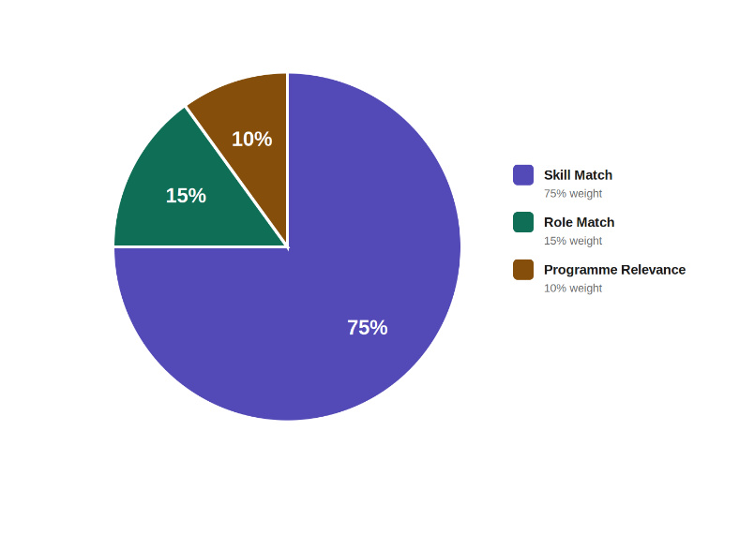
Figure 4.18: Match Score Weight Distribution
Figure 4.18 illustrates the percentage weight distribution utilized by the matching engine stored procedure, showing the relative significance of skill sets (75%), preferred roles (15%), and academic program alignment (10%).

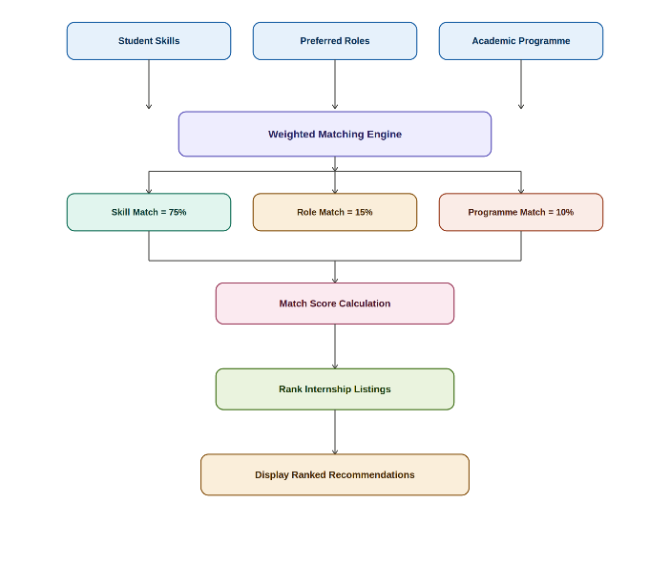

4.3.5 Row-Level Security Rules
Row-Level Security (RLS) policies restrict database read and write access to authenticated users.
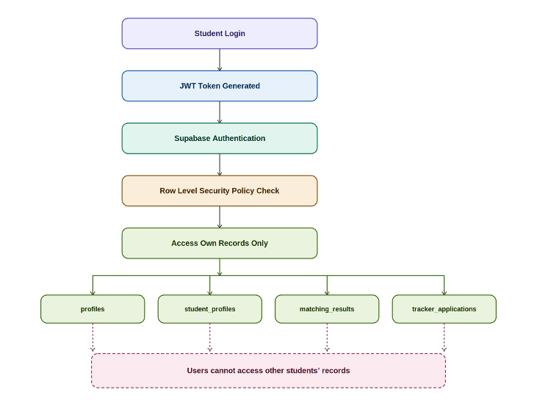
Figure 4.19: Supabase Row-Level Security Policies Interface
Figure 4.19 illustrates the RLS security policies interface deployed on the Supabase Cloud dashboard, showing the active select and update access control configurations.
-- Enable Row Level Security
ALTER TABLE public.profiles ENABLE ROW LEVEL SECURITY;
ALTER TABLE public.student_profiles ENABLE ROW LEVEL SECURITY;
ALTER TABLE public.user_skills ENABLE ROW LEVEL SECURITY;
ALTER TABLE public.tracker_applications ENABLE ROW LEVEL SECURITY;
ALTER TABLE public.matching_results ENABLE ROW LEVEL SECURITY;
ALTER TABLE public.skill_gaps ENABLE ROW LEVEL SECURITY;
ALTER TABLE public.interview_sessions ENABLE ROW LEVEL SECURITY;
ALTER TABLE public.interview_messages ENABLE ROW LEVEL SECURITY;
ALTER TABLE public.interview_results ENABLE ROW LEVEL SECURITY;
ALTER TABLE public.interview_skill_gaps ENABLE ROW LEVEL SECURITY;
-- Profiles Policies
CREATE POLICY "Users can view own profiles" ON public.profiles
FOR SELECT USING (auth.uid() = id);
CREATE POLICY "Users can update own profiles" ON public.profiles
FOR UPDATE USING (auth.uid() = id);
-- Student Profiles Policies
CREATE POLICY "Students can view own profiles" ON public.student_profiles
FOR SELECT USING (auth.uid() = id);
CREATE POLICY "Students can update own profiles" ON public.student_profiles
FOR UPDATE USING (auth.uid() = id);
-- Interview Sessions Policies
CREATE POLICY "Users can manage own interview sessions" ON public.interview_sessions
FOR ALL USING (auth.uid() = user_id);
-- Interview Messages Policies
CREATE POLICY "Users can manage own interview messages" ON public.interview_messages
FOR ALL USING (
EXISTS (
SELECT 1 FROM public.interview_sessions s
WHERE s.id = session_id AND s.user_id = auth.uid()
)
);
-- Interview Results Policies
CREATE POLICY "Users can view own interview results" ON public.interview_results
FOR SELECT USING (
EXISTS (
SELECT 1 FROM public.interview_sessions s
WHERE s.id = session_id AND s.user_id = auth.uid()
)
);
-- Interview Skill Gaps Policies
CREATE POLICY "Users can view own interview skill gaps" ON public.interview_skill_gaps
FOR SELECT USING (
EXISTS (
SELECT 1 FROM public.interview_sessions s
WHERE s.id = session_id AND s.user_id = auth.uid()
)
);

4.4 Chapter Summary
This chapter described the three-tier system architecture, activity and sequence diagrams, user interface design for the five core modules – the Internship Aggregation Module (Daily Scraper), Recommendation Engine, Learning Hub (with Skill Gap Analysis), Application Tracking Module (Kanban Board), and AI Interview Prep Module – database summaries including the four interview-related tables, physical DDL data dictionaries, recommendation formulas, and Row-Level Security access control policies, providing the complete design blueprint for system implementation.

REFERENCES
Abel, F., Celik, I., Houben, G.J. and Sieh, M. (2011). Social Semantic Web: Mining and Recommending in Career Networks. In: Proceedings of the International Conference on Web Engineering (ICWE). Springer. pp. 284-299.
Adomavicius, G. and Tuzhilin, A. (2005). Toward the next generation of recommender systems: A survey of the state-of-the-art and possible extensions. IEEE Transactions on Knowledge and Data Engineering. 17(6). pp. 734-749.
Al-Radaideh, M.J. and Al-Hawari, E.N. (2019). Mining Student Data to Predict Internship Performance. Springer Education and Information Technologies. 24(2). pp. 1215-1233.
Al-Saleem, A.S.M. (2019). A Review of Applicant Tracking Systems: Technology, Usability, and Future Trends. International Journal of Computer Applications. 182(45). pp. 12-19.
Anuar, M.K. (2019). Public Relations and Graduate Employability in Malaysia. Kuala Lumpur: University of Malaya Press.
Cockburn, A. (2006). Agile Software Development: The Cooperative Game. 2nd ed. Boston, MA: Addison-Wesley.
Cohn, M. (2010). Succeeding with Agile: Software Development Using Scrum. Boston, MA: Addison-Wesley.
Cruz, J.F.L. and Silva, M.C.G. (2021). The role of Applicant Tracking Systems in recruitment automation: A systematic literature review. ACM Computing Surveys (CSUR). 54(4). pp. 1-28.
Diaby, C., Radier, B. and Colella, S. (2013). Using taxonomic distance for job recommendation. In: Proceedings of the 2013 ACM Conference on Recommender Systems. pp. 411-414.
Elmasri, R. and Navathe, S.B. (2016). Fundamentals of Database Systems. 7th ed. Boston, MA: Pearson.
Gustavsson, H. (2019). Iterative development in student software projects: An empirical study of Agile Scrum vs. Waterfall. IEEE Transactions on Education. 62(2). pp. 115-122.
Kivimäki, J., Sarwar, M. and Hyvönen, A. (2015). Graph-based Method for Job Recommendation using Linked Data. In: Proceedings of the 2015 IEEE/WIC/ACM International Conference on Web Intelligence. pp. 441-448.
Landeiro, V., Silva, M. and Henriques, R. (2013). Information Extraction from Web Sites using Wrapper Induction. In: Proceedings of the ACM Symposium on Applied Computing. pp. 711-718.
Pazzani, M.J. and Billsus, D. (2007). Content-Based Recommendation Systems. In: Brusilovsky, P., Kobsa, A. and Nejdl, W. (Eds.) The Adaptive Web. LNCS 4321. Berlin: Springer. pp. 325-341.
PostgreSQL Global Development Group (2022a). PostgreSQL 15.1 Documentation: PL/pgSQL — SQL Procedural Language. [Online]. Accessed 2024 <https://www.postgresql.org/docs/15/plpgsql.html>.
PostgreSQL Global Development Group (2022b). PostgreSQL 15.1 Documentation: Row-Level Security Policies. [Online]. Accessed 2024 <https://www.postgresql.org/docs/15/ddl-rowsecurity.html>.
React Community (2024). React Documentation. [Online]. Accessed 2024 <https://react.dev/>.
Richardson, L. (2024). Beautiful Soup Documentation. [Online]. Accessed 2024 <https://www.crummy.com/software/BeautifulSoup/bs4/doc/>.
Schwaber, K. and Beedle, M. (2002). Agile Software Development with Scrum. Upper Saddle River, NJ: Prentice Hall.
Selenium Project (2024). Selenium WebDriver Documentation. [Online]. Accessed 2024 <https://www.selenium.dev/documentation/>.
Tan, S.L. and Chen, L.C. (2020). Rule-based Skill Extraction from Unstructured Job Advertisements. Expert Systems with Applications. 142. p. 112980.

BIBLIOGRAPHY
No additional non-cited background materials were used in the preparation of this report. All sources consulted during the research and development of the FitFlow system have been directly cited within the report text and are listed in the References section above.

APPENDIX A: PROJECT SUPPORTING DOCUMENTS
[INSERT SUPPORTING DOCUMENTS IF REQUIRED]
(This appendix is reserved for any additional project documents such as the Turnitin similarity report, signed project forms, or supervisor approval letters that may be required upon final submission.)

APPENDIX B: USER MANUAL AND INTERFACE SCREENSHOTS
This appendix presents the user interface screenshots of the FitFlow platform. The screenshots illustrate the user journey from landing page, registration, onboarding, main bento dashboard, matches feed, details overlay, learning redirects, settings panel, and background scraper monitoring.
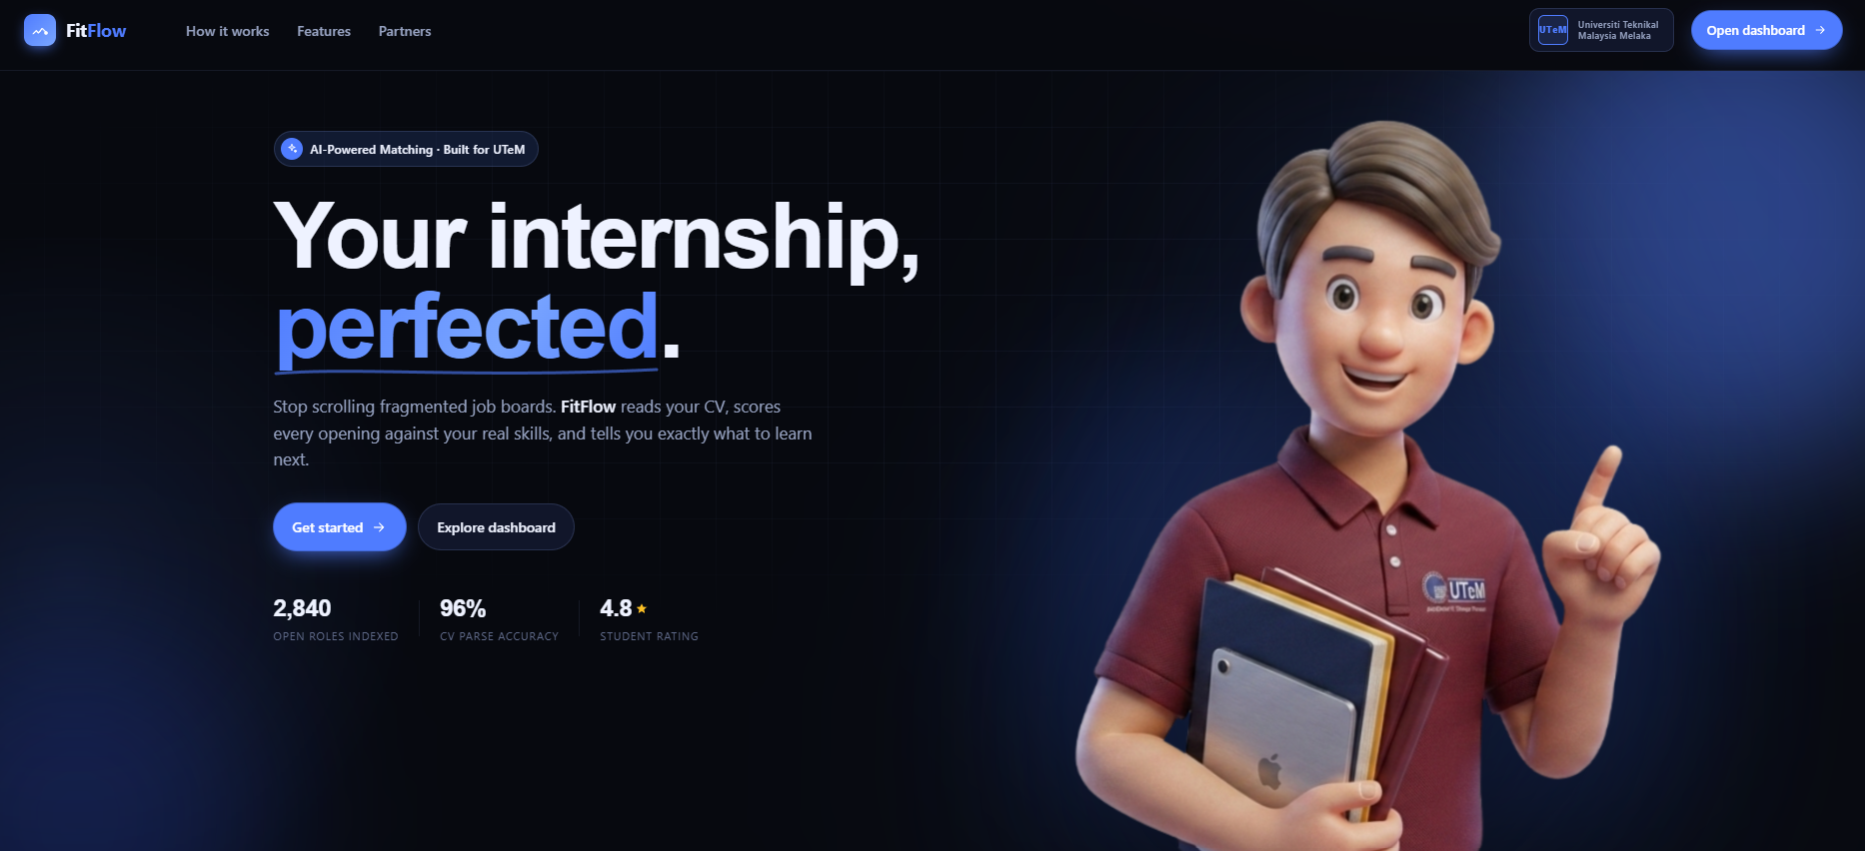
Figure B.1: FitFlow Landing Page
Figure B.1 illustrates the FitFlow landing page, introducing students to the system's core capabilities, including automated scraping, profile matching, and skill gap visualization.
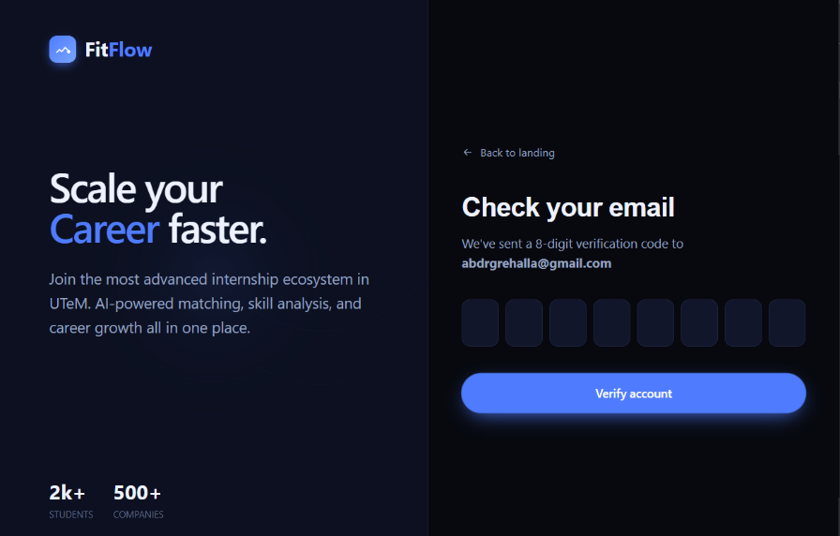
Figure B.2: Account Registration OTP Gateway
Figure B.2 shows the registration email verification screen. The system sends an 8-digit verification code to the student's registered email address to validate the account before allowing profile setup.
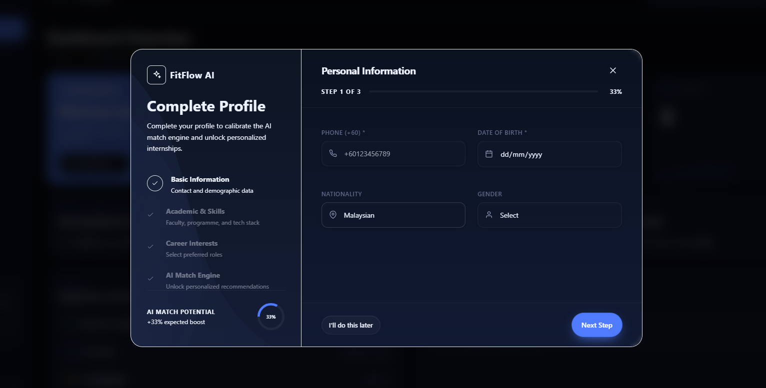
Figure B.3: Guided Student Onboarding Wizard (Step 1)
Figure B.3 shows the first step of the onboarding wizard, which captures student demographic details (phone, date of birth, nationality, gender) and guides them through account setup.
Figure B.4: Bento-Grid Dashboard Overview
Figure B.4 displays the unified student dashboard. The layout incorporates KPI cards showing average match score and saved roles, alongside a list of highest matching internships and top missing skills.
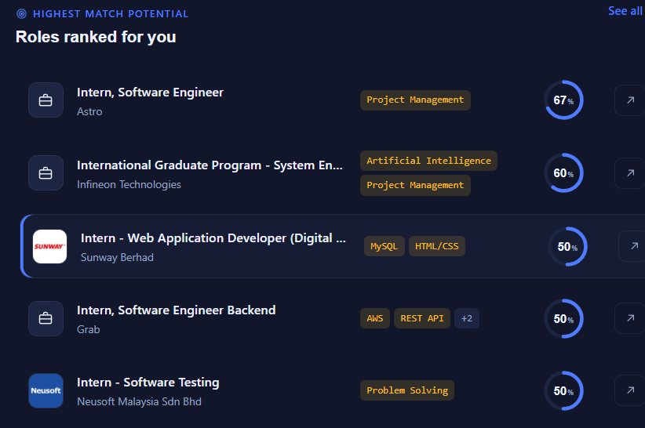
Figure B.5: Ranked Recommendations Feed
Figure B.5 shows the My Matches recommendation feed. Internships are ranked by compatibility percentages. Each listing displays required tech skills, location, and stipend values.
Figure B.6: Kanban Application Tracking Board
Figure B.6 presents the drag-and-drop Kanban application tracker. Applications are organized across Saved, Applied, Interviewing, Offers, and Rejected columns to simplify progress monitoring.
Figure B.7: Profile Settings and Preferences Configuration
Figure B.7 displays the settings configuration pane, showing the interactive profile completeness checklist, notification toggles, and the multi-select career interests checklist.
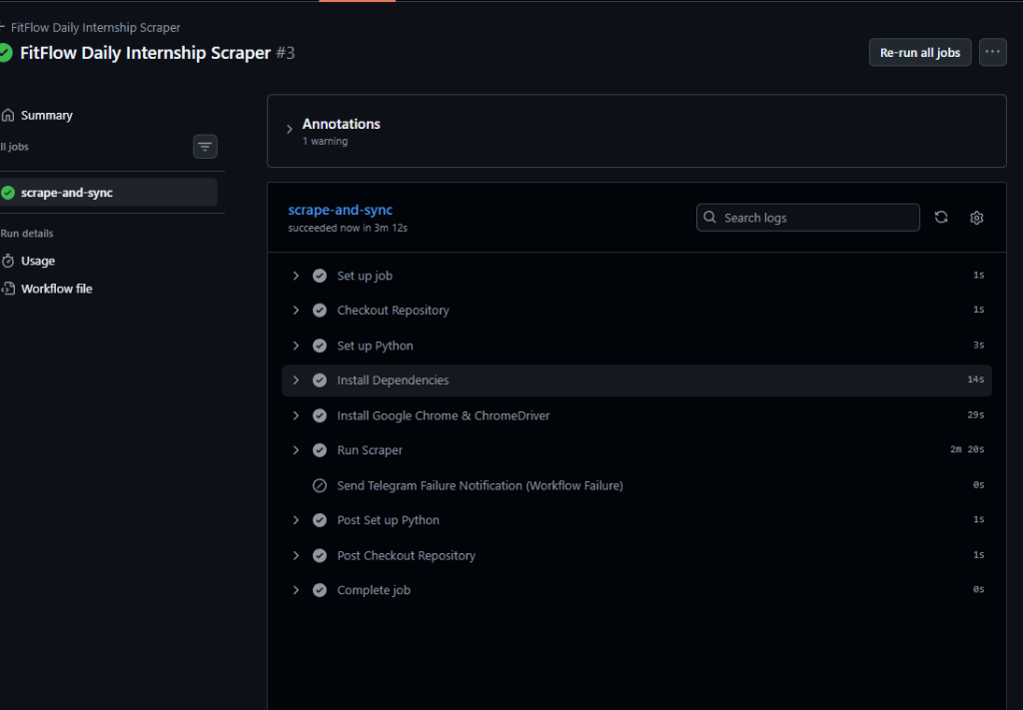
Figure B.8: Automated Daily Scraper Execution (GitHub Actions)
Figure B.8 displays the successful execution log of the background crawling service in GitHub Actions, illustrating regular automated database updates.

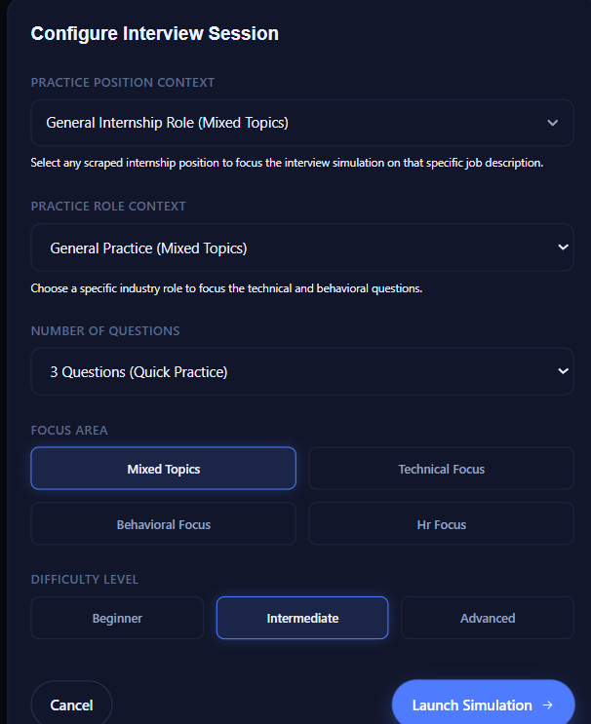
Figure B.9: AI Interview Prep Configurator
Figure B.9 illustrates the mock interview configuration setup. The interface
allows students to select specific web-scraped positions from their
recommended matches or choose standard career categories (Software
Developer, Data Analyst, UI/UX Designer, Cybersecurity, or General Practice).
Students configure session parameters including the focus area (mixed,
technical, or behavioral), difficulty level (beginner, intermediate, or advanced),
and maximum question count before starting the mock session.

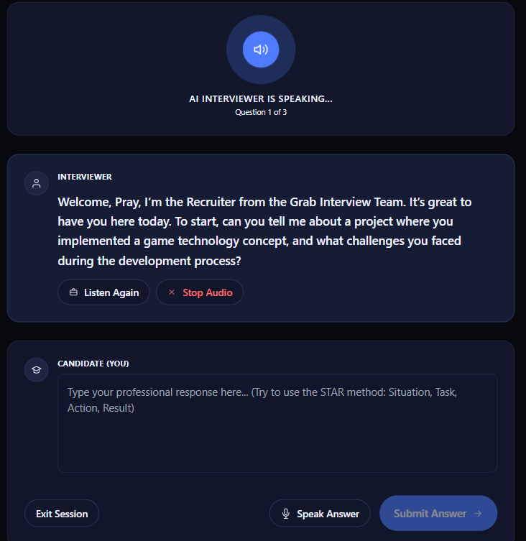

Figure B.10: Real-time Audio Interview Room
Figure B.10 illustrates the interactive voice interview environment. The user interface features a clean, glassmorphic card presenting the recruiter's active question. The system displays a live microphone audio waveform, speaker status indicators ("Recruiter is speaking...", "Listening..."), and controls to toggle recording, play/stop text-to-speech audio, or submit responses. Real-time transcription is rendered dynamically to let candidates review their spoken answers.

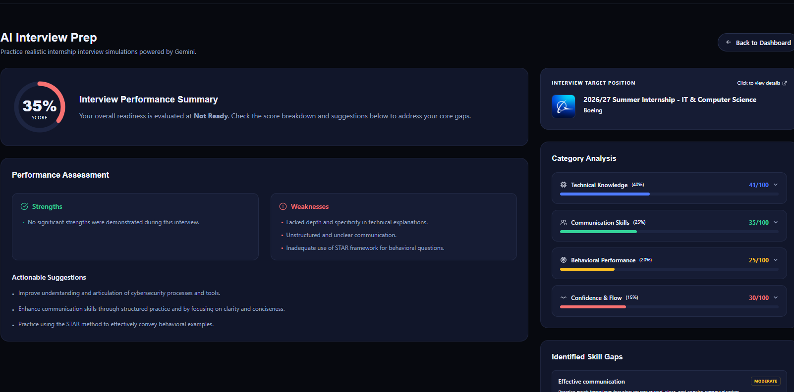

Figure B.11: Post-Session Performance Analytics Dashboard
Figure B.11 shows the multi-dimensional performance evaluation dashboard. The dashboard lists the overall readiness score alongside category scores (Technical, Communication, Behavioral, and Confidence) with expandable detail cards containing specific rubrics reasoning and quotes from the transcript as evidence. It also aggregates strengths, weaknesses, and concrete recommendations.

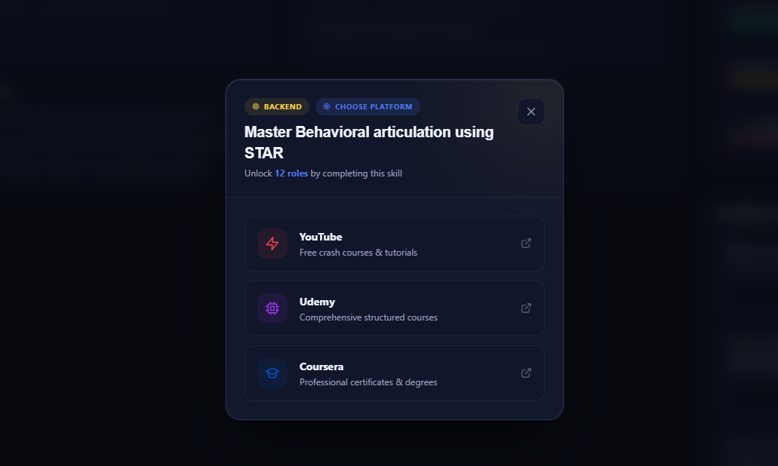
Figure B.12: Choose Platform Redirect Dialog
Figure B.12 illustrates the Choose Platform redirect dialog triggered when a student clicks on an identified skill gap. The popup presents direct learning pathways to YouTube (free crash courses), Udemy (comprehensive courses), or Coursera (professional certificates), automatically generating specific search queries so students can close skill gaps without leaving the application context.

