**Wild Island**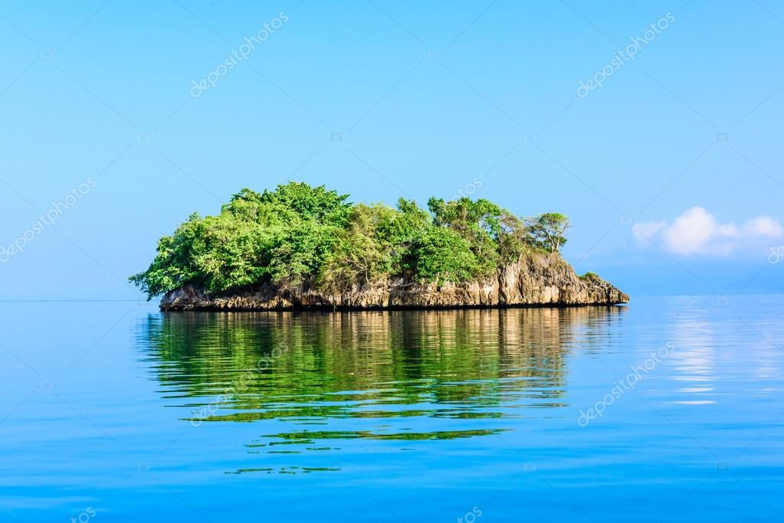

Story:

In the Caribbean Sea a ship crashes and you have been chosen to pick people who will sit in the small saving boat which will deliver them to the wild island. You have to chose 7 people and 6 to get out of the board

*В Карибском море корабль терпит крушение. В спасательную лодку могут попасть только 7 человек, 6 останутся за бортом. Спасательная лодка доставит людей на дикий остров, сколько им придется там находится - не известно*

|  |  |  |  |  |
| --- | --- | --- | --- | --- |
| ***Picture*** | ***Name*** | ***Profession*** | ***Description*** | ***Age*** |
| C:\Users\Alex\AppData\Local\Microsoft\Windows\INetCache\Content.Word\businessman.jpg | Tony | Comedian | Really fun guy | 33 |
| C:\Users\Alex\AppData\Local\Microsoft\Windows\INetCache\Content.Word\soldier2.jpg | John | Former soldier | Participated in the Iraq war. Served for over 15 years. Was retired with a scandal. | 38 |
| C:\Users\Alex\AppData\Local\Microsoft\Windows\INetCache\Content.Word\1.jpg | Ted | CrossFit coach | Won CrossFit championship in 2017. | 27 |
| C:\Users\Alex\AppData\Local\Microsoft\Windows\INetCache\Content.Word\doctor.jpg | Ellie | Medical student | 3rd year in but doesn’t have actual experience yet. | 23 |
| C:\Users\Alex\AppData\Local\Microsoft\Windows\INetCache\Content.Word\artworks-000203689035-36huow-t500x500.jpg | Rebecca | Hot yoga instructor | Has 8 thousand followers on Instagram | 22 |
| C:\Users\Alex\AppData\Local\Microsoft\Windows\INetCache\Content.Word\researcher.jpg | Herbert | Researcher | He was leading promising cancer treatment research. | 51 |
| C:\Users\Alex\AppData\Local\Microsoft\Windows\INetCache\Content.Word\chief.jpg | Maria | Waiter | She lost her parents in car accident and had to work all her life to make a living. Dreaming about becoming a chief. | 19 |
| **C:\Users\Alex\AppData\Local\Microsoft\Windows\INetCache\Content.Word\scarlet.jpg** | Scarlet | Child | She was to supposed to have a fun vacation and time without parents. Now she just doesn’t know what’s going on. | 14 |
| C:\Users\Alex\AppData\Local\Microsoft\Windows\INetCache\Content.Word\farmer.jpg | Collin | Farmer | Expert at farming but has visible arthritis. | 67 |
| C:\Users\Alex\Desktop\Island Project Images\after\constructor.png | Sanjay | Constructor | Hardworking and can be very useful, but has a criminal record. Speak English with accent. | 28 |
| C:\Users\Alex\AppData\Local\Microsoft\Windows\INetCache\Content.Word\1.jpg | Taylor | Mechanic | He was working on the ship and knows what happened | 42 |
| C:\Users\Alex\AppData\Local\Microsoft\Windows\INetCache\Content.Word\2.jpg | Liza | Linguist | Speak 4 languages: Spanish, Portuguese, Russian and Japanese | 28 |
| C:\Users\Alex\AppData\Local\Microsoft\Windows\INetCache\Content.Word\3.jpg | Miya | Artist | She has many different hobbies painting, singing and dancing | 24 |