Interaction Instructions
The content in brackets indicates that it was not presented in the interactive prototype diagram. Just for function description explanation
Start Page + Login Page:
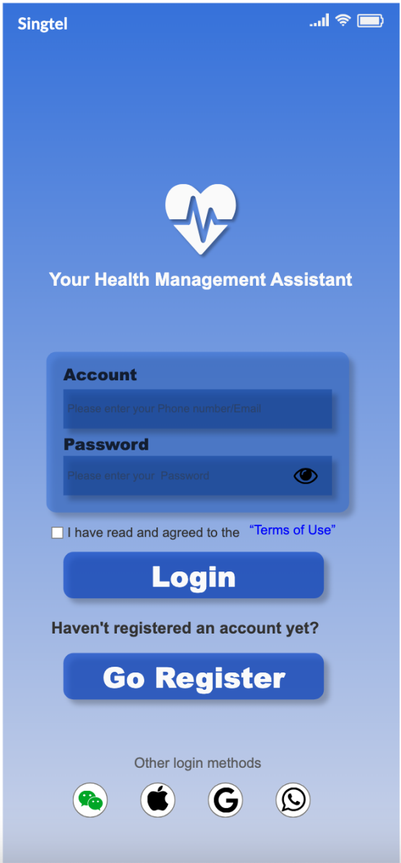
This page shows that the screen that appears when user use the APP for first time or after logging out.
- Upon entering the app, the current screen displays with an auto-playing splash animation.
- Tap the input field below “Account” to enter login details such as a phone number or email address.
- Tap the input field below “Password” to enter password.
- Tap the eye icon in the “Password” field to toggle text visibility
- Tap the checkbox left of “I have read and agreed to the ‘Terms of Use’” to accept. Tap again to deselect. (When deselected, the “Login” button should becomes inactive)
- (Tap “Terms of Use” to open the detailed information window regarding the terms of use)
- Tap the “Login” button to skip to the homepage. (This button is disabled if login information are incorrect or the checkbox for terms of use has not been selected.)
- Users without an account should Tap “Go Register” to skip to the registration page
- (Tap any of the four icons under “Other login methods” at the bottom of the screen skip to the corresponding third-party login page)

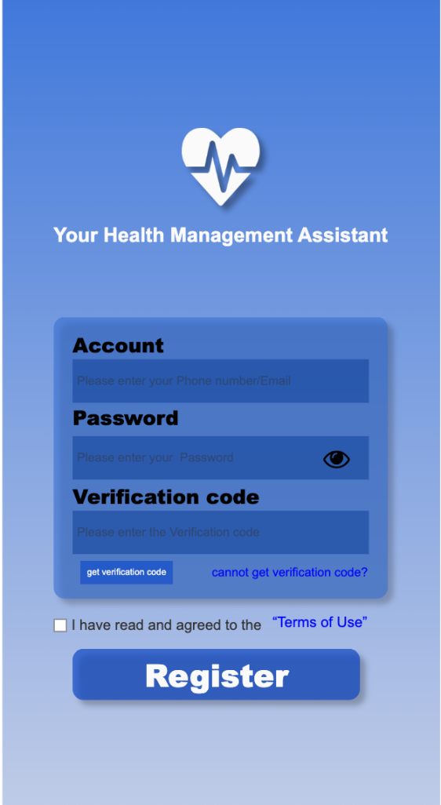
Registration:
- Tap the input field below “Account” to enter login details such as a phone number or email address.
- Tap the input field below “Password” to enter password.
- Tap the eye icon in the password field to toggle visibility of the entered text
- (User can tap the button “Get Verification Code” only after completing both fields to receive and enter the code. If user don't receive the code due to network issues or other reasons, Tap “Can't get verification code?” next to the button to resend it)
- Tap the checkbox to the left of “I have read and agreed to the ‘Terms of Use’” to accept the user agreement. Tap it again deselects it. (When deselected, the “Register” button should becomes inactive)
- (Tap “Terms of Use” to open the detailed information window regarding the terms of use)
- Tap the “Register” button skip to the profile picture and nickname interface. (This button is disabled if user information are format error or the checkbox for terms of use has not been selected.)
Start Page:
If the user is already logged in, the app automatically opens to this page. After the splash animation finishes, it automatically skip to the homepage. (Users can skip this page by Tap anywhere on the screen to go directly to the homepage.)

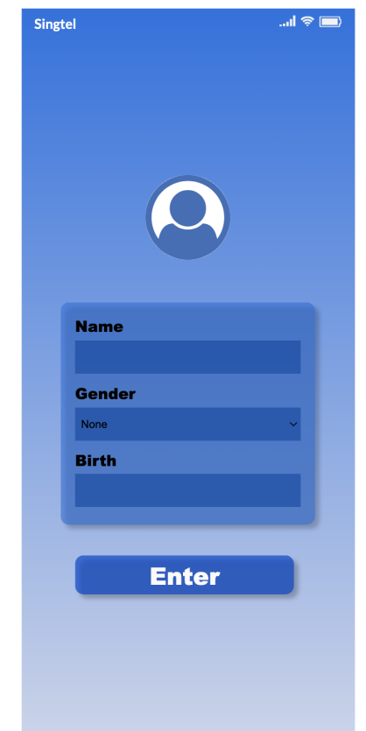
Profile Setup:
- Tap the circular profile picture area at the top to select an image from userr phone's gallery to use as user profile picture.
- Tap the input field below “Name” to enter user nickname
- Tap the input field below “Gender” to select user gender
- (Tap the input field below “Birth” to open the date/time picker)
- Tap the “Enter” button to skip to the home page

Home Page:
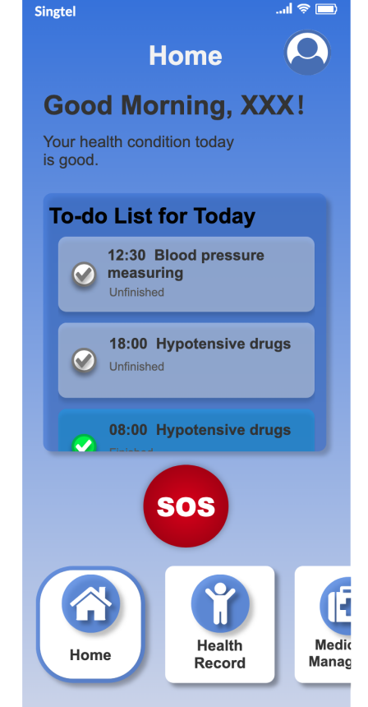
- (The text below the “Home” label dynamically updates based on user personal information, current time, and recorded health information.)
- Tap the profile icon to the right of “Home” to access user personal center.
- The checkbox on the left side of the middle panel can be taped to select/deselect. When selected, the small box and checkmark change color, and the “unfinished” label changes to “finished” to indicate completion. (It then moves to the end of the panel.)
- (Long-press the SOS button to initiate an emergency call, call the emergency contact and sending a text message.)
- The bottom row supports left/right swiping. When selected, icons change shape. Tap to skip to corresponding pages: Home (main page), Health Record , Medication Management , Contact Family, Personal Center.

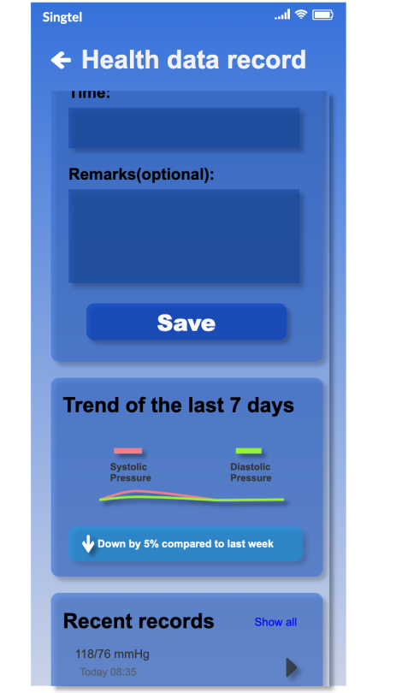
Health Record:
- Tap the arrow in the top-left corner to return to the home page
- This page can be scrolled vertically
- (Enter corresponding blood pressure data in the input field and tap “Save” to store it)
- (The curve and text in the “Trend of the last 7 days” box update based on the user's uploaded blood pressure data from the past seven days)
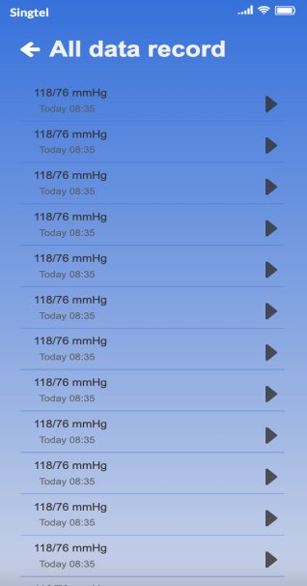
- The “Recent records” box displays blood pressure data recorded over the past three days. (Tap the right triangle arrow to view detailed data.) Tap “Show all” in the top-right corner of the box to skip to the full data records page
View Full Data Records:
- This page can be scrolled vertically
- Tap the arrow in the top-left corner to return to the Health Data Records page

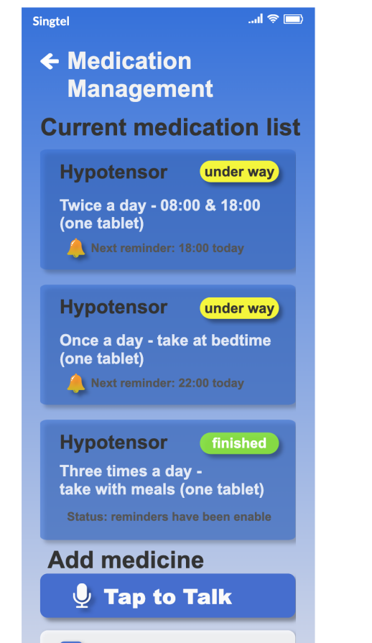
Medication Management:
- This page can be scrolled vertically
- Tap the arrow in the top-left corner to return to the Health Data Records page
-(The “current medication list” generated based on user-added medication information. When the user-set reminder time is reached, a notification is pushed. )Tap the oval button in the top-right corner of the small box to switch to completed mode, the “Under Way” text changes to “Finished,” the button color turns green, the text becomes white, the small bell below disappears, and the text next to the bell icon changes to “Status: reminder is completed.”
- Tap the “Tap to Talk” button to open the voice input medication page
- Tap the “Manually Add” button to open the manual input medication page
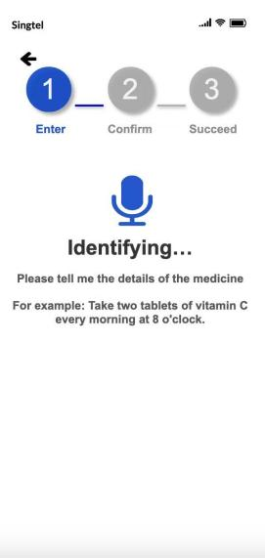
Voice Input Medication page Details:
- Tap the arrow in the top-left corner to return to the medication management page.
- Upon entering the page, a microphone icon appears with a zoom-in/zoom-out animation. The text below the microphone changes based on voice recognition status: “processing” when speech is detected, and “identifying” when speech stops.
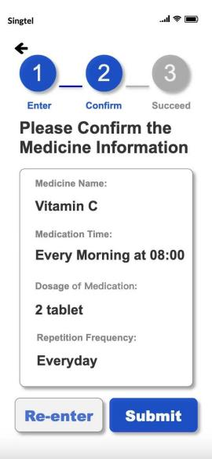
- After completing voice recognition, the microphone icon and related text disappear. The circular “2” icon indicating Step 2 and the ‘confirm’ text below turn blue, signifying input completion and progression to the next step. A medication information confirmation dialog appears, with “Re-Enter” and “Submit” buttons below.
- Tap “Re-Enter” returns to Step 1. The circular “2” icon indicating Step 2 and the “confirm” text below turn gray. A microphone icon appears with zoom-in/zoom-out animations. The text below the microphone changes based on speech recognition status: ‘processing’ when speech is detected, and “identifying” when speech stops.
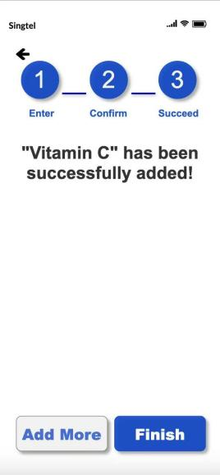
- Tap “Submit” turns the circular “3” icon indicating Step 3 and the text ‘Succeed’ below blue, signifying successful medication information entry. The “Add more” and “Finish” buttons appear below.
- Tap “Add more” returns to Step 1. The circular “2” icon indicating Step 2 and the text “confirm” below turn gray, as does the circular “3” icon for Step 3 and the text “Succeed” below. A microphone icon appears with zoom-in/zoom-out animation. The text below the microphone changes based on speech recognition status: ‘processing’ when speech is detected, and “identifying” when speech stops.
- Tap “Finish” returns to the medication management page.
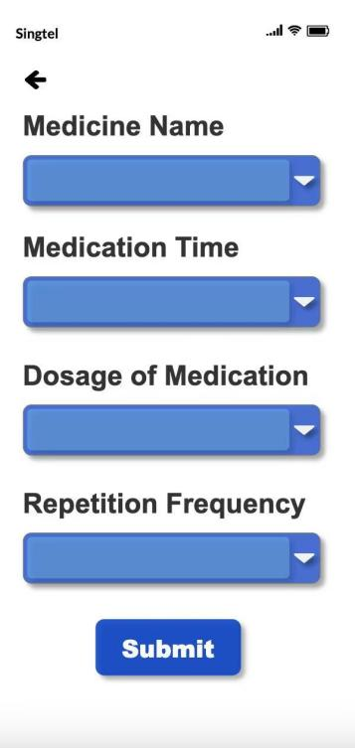
Manual Input Medication page Details:
- Tap the arrow in the upper-left corner to return to the medication management page
- Tap the input field to enter text
- Tap the inverted triangle icon to the right of the input field to display previously entered information for selection
- Tap Submit to return to the medication management page
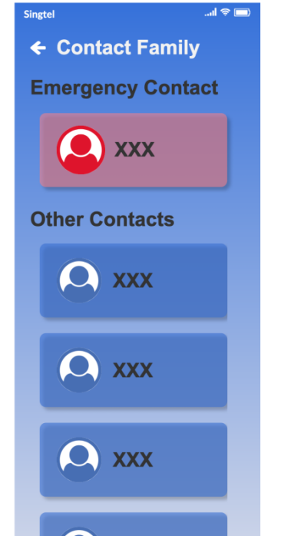

Contact Family:
- Tap the arrow in the top-left corner to return to the home page
- The page can be scrolled vertically
- (Tap the corresponding box to call the designated person)

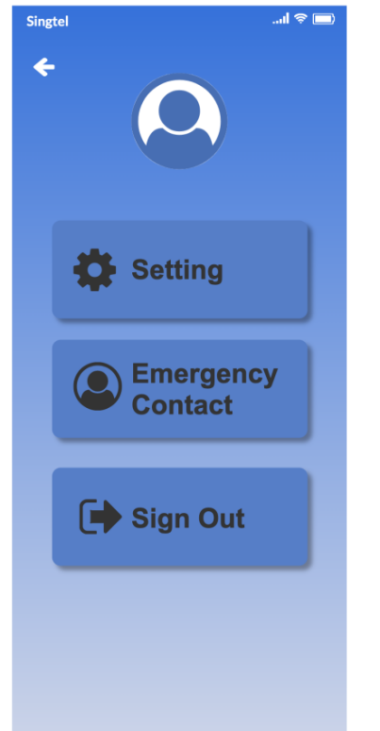
Personal Center:
- (Tap the profile icon to enter the personal information modification page)
- (Tap the Settings box to enter the settings page)
- (Tap the Emergency Contact box to enter the emergency contact modification page)
- Tap the Sign Out box to log out and skip to the login page

