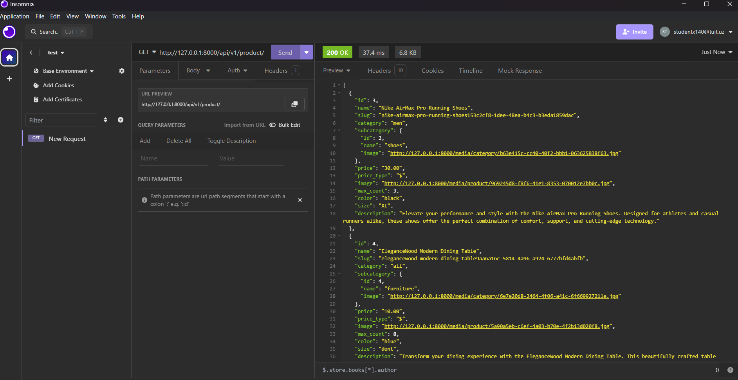

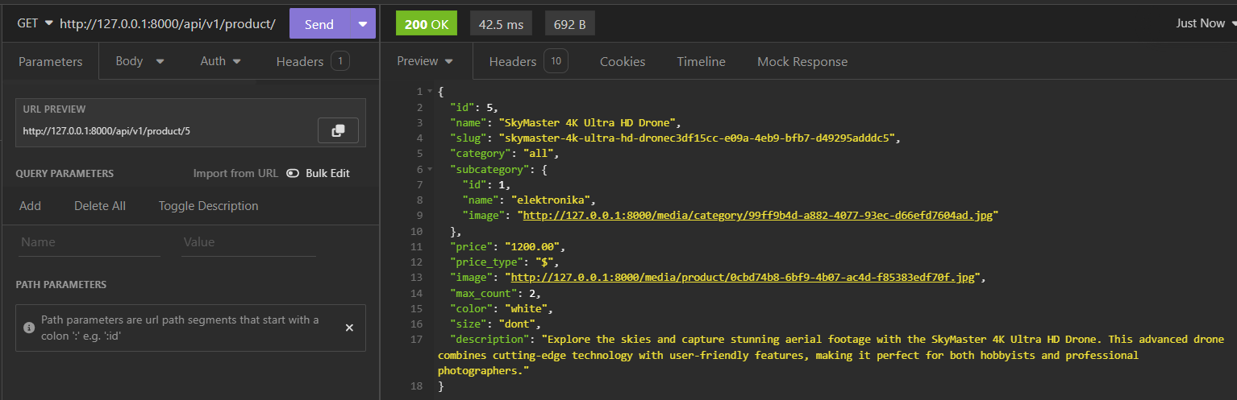

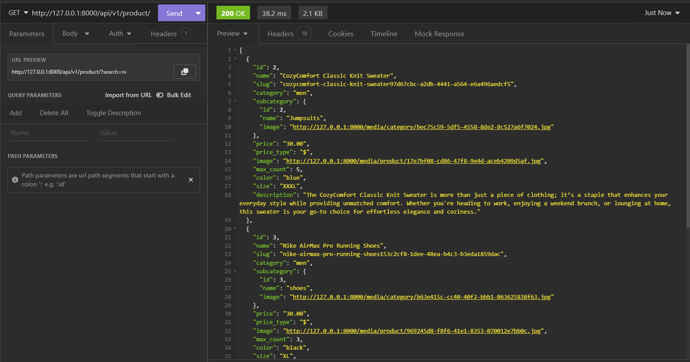

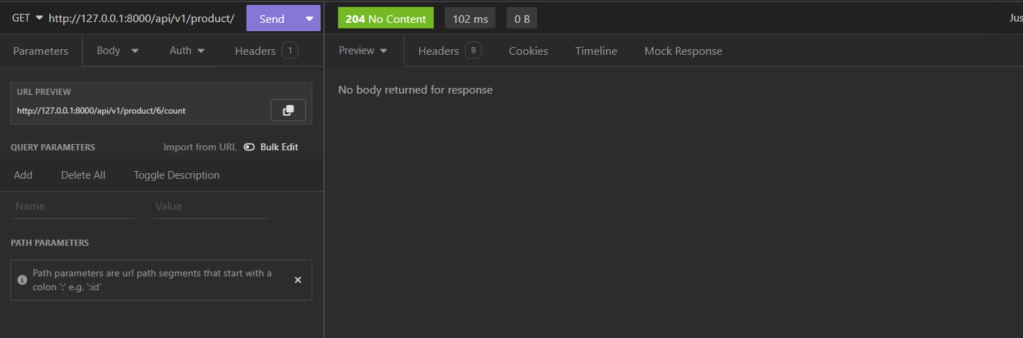

3 marta bosdim

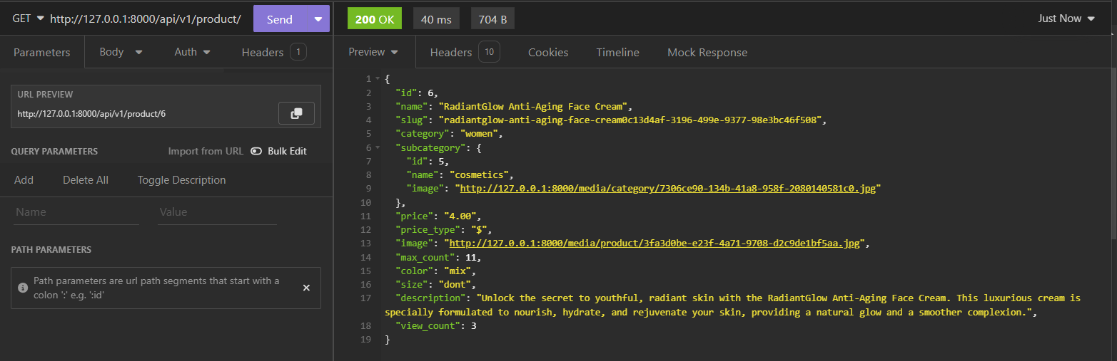

View_count 3ta boldi. Ishladi.

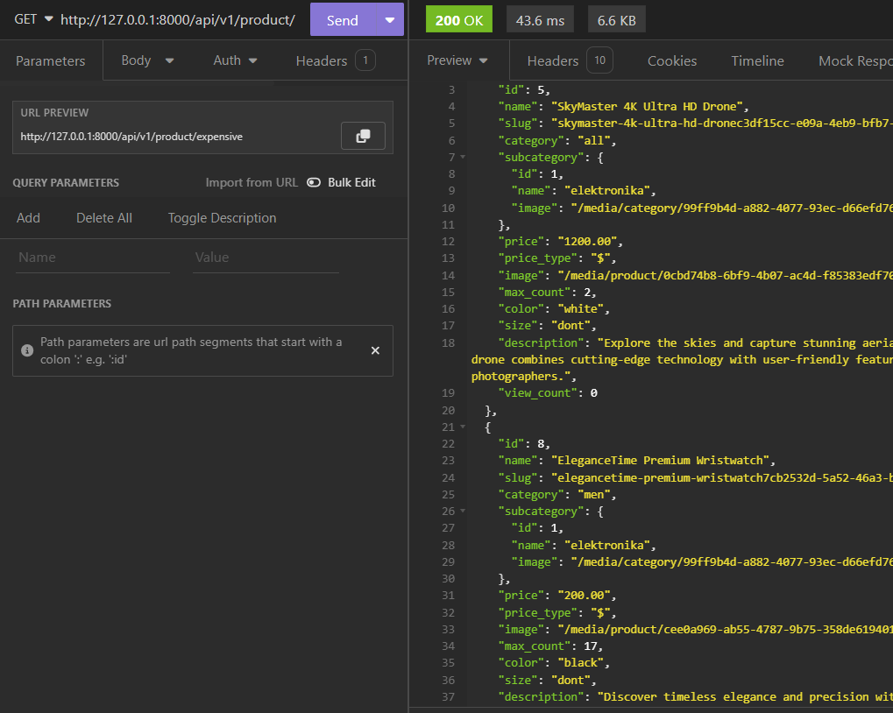

Expensive action. Bunda qimmat maxsulotlardan arzonga qarab tartiblaydi

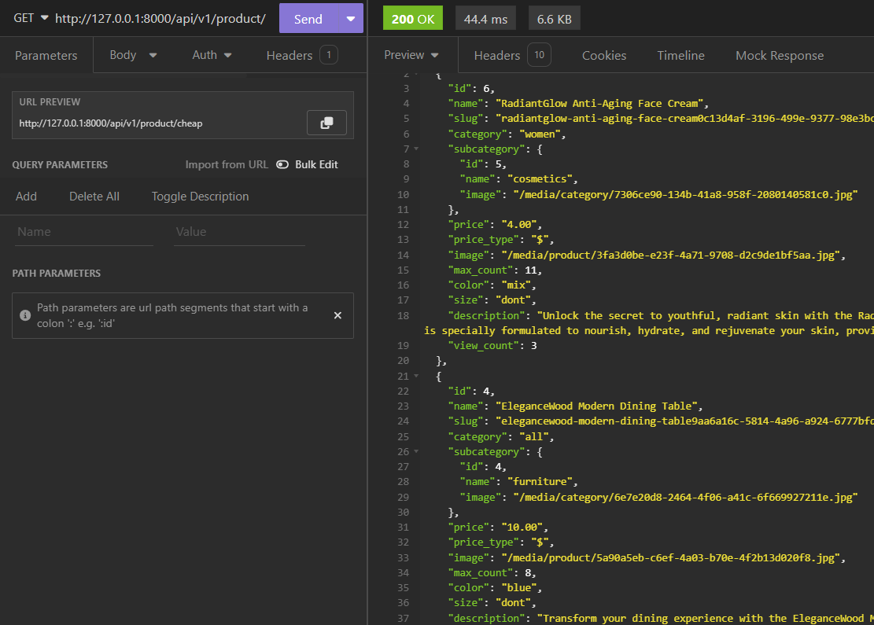

Cheap actioni narxini o’sib borish tartibida tartiblaydi

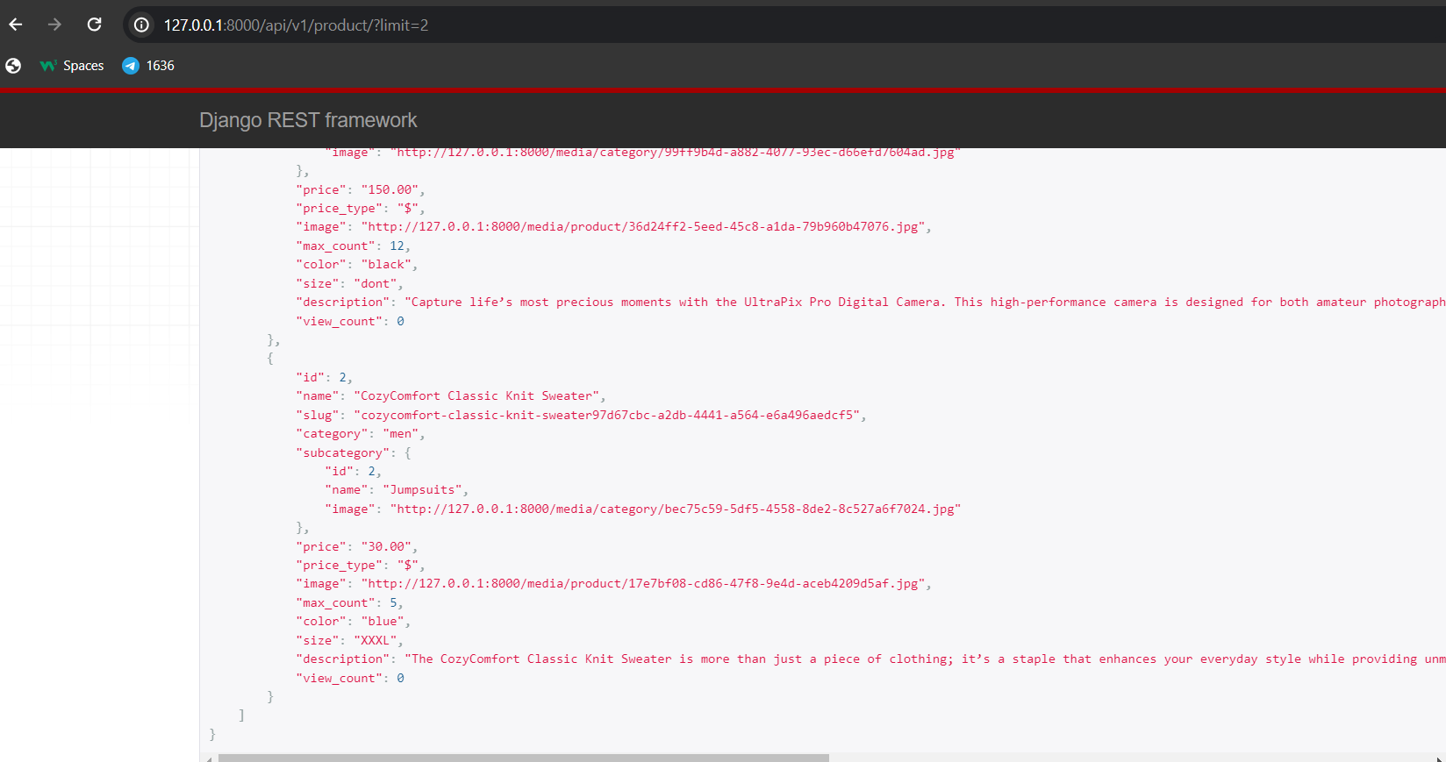

Limit

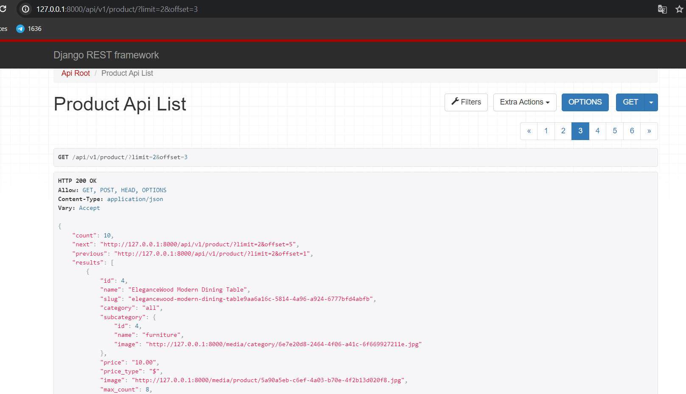

Limit and offset