WEB APPLICATION PROPOSAL
& SERVICE AGREEMENT
HK ENV. WEB-APP

PREPARED BY
Ausaf Ahmed
BIZMYZE
Toronto, Ontario, Canada
ausafahmed04@gmail.com
PREPARED FOR
HK Environmental Group
Chief Executive Officer
jarnail@hkenv.ca

1. Project Overview
BIZMYZE is pleased to present this proposal to HK Environmental Group for the design, development, and delivery of a custom web application — hereafter referred to as the “HK ENV. WEB-APP.” This document serves as both a project proposal and a binding service agreement upon execution by both parties.
The HK ENV. WEB-APP is a purpose-built digital operations platform designed to modernize and centralize the day-to-day management of haul operations, field personnel, load ticketing, dispatch, project tracking, and GPS route logging for HK Environmental Group.
The system will be accessible via web browser and will serve three levels of users — Owners, Admins, and Operators — each with distinct access permissions aligned to their operational role.

2. Scope of Work
The following modules represent the complete and exclusive scope of development covered under this Agreement. BIZMYZE will design and develop each of the modules listed below. No features or functionality outside of those explicitly described herein are included in the agreed project fee.

2.1 Authentication & User Management
- Email and password-based login system.
- Two-factor authentication (2FA) required on every login to the website, using a free authenticator app (such as Google Authenticator or Microsoft Authenticator) that generates time-based verification codes.
- Password reset functionality via secure email link.
- Three distinct user roles: Owner, Admin, and Operator.
- Owner and Admin can create, deactivate, and permanently delete user accounts.
- Fast, streamlined user creation through a single short form — new users can be added in seconds.
- Each user is automatically assigned a unique employee ID upon creation.
- Deactivated users lose login access while all historical data is preserved.
- Operator location is captured and timestamped at the moment of every login and every logout, giving Admins a clear record of when and where each operator began and ended their session.

2.2 Digital Load Ticketing (eTicketing)
The eTicketing module replaces HK’s current paper load ticket with a custom, fillable digital ticket. The operator enters all load information from the field through a structured form; the system then generates a clean, professionally formatted ticket and stores it permanently. The digital ticket template will replicate the layout and data fields of HK’s existing paper ticket, shown below for reference.
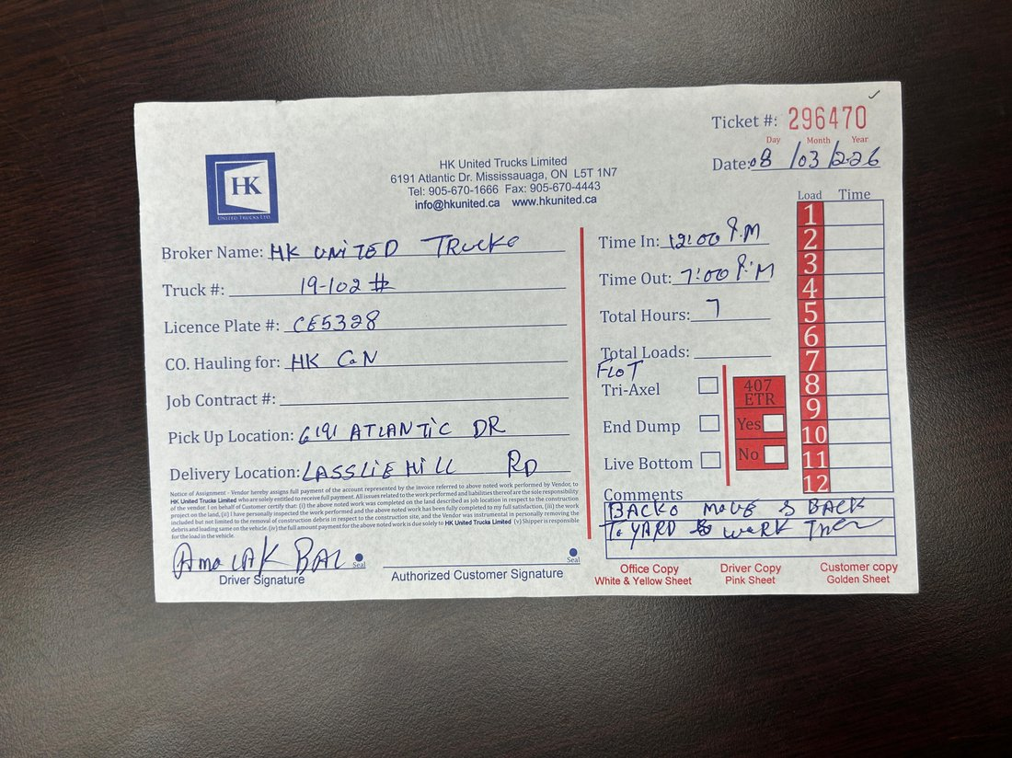
Reference: HK’s existing paper load ticket. The digital eTicket template will replicate this layout and capture the same data fields.
- Custom fillable ticket template modelled on HK’s existing paper ticket, capturing: ticket number, date, broker name, truck number, licence plate, company hauling for, job contract number, pick-up location, delivery location, equipment type (Tri-Axle, End Dump, Live Bottom, Float), 407 ETR usage, per-load count and times, and comments.
- Dedicated start time and end time fields on every ticket, with total hours calculated automatically.
- Auto-generated ticket number and auto-applied timestamp on every ticket.
- Operator electronic signature required prior to ticket submission.
- Structured ticket status workflow: Draft → Submitted → Approved / Flagged.
- Admin approval stamp with timestamp applied on every approved ticket.
- Each completed ticket is rendered as a clean, print-ready digital document.
- Tickets are permanently archived — never deleted.
- Full ticket searchability by date, operator, project, and truck.

2.3 Truck & Driver Management
- Truck profile management: license plate, type, capacity, colour/ID tag.
- Truck-to-operator assignment, reassignable per project or mid-job.
- Per-truck statistics: total loads hauled and active hours.
- Inactive and maintenance status flags — auto-removed from dispatch.
- Operator profiles: name, phone, employee ID, licence class, assigned truck, and photo.
- Load count tracking per operator: daily, weekly, and per project.

2.4 Project Dashboard & Budget Tracking
- Project creation with: name, client, address, start/end dates, material budget, load targets, and schedule.
- Live progress bar — loads completed vs. target.
- Operator and truck assignment per project.
- Master Admin dashboard showing all active projects: load counts and flagged issues.
- Per-project document vault with permanent storage.

2.5 GPS & Location History
- Operator location captured and timestamped at every login and logout (see Section 2.1).
- Operator-initiated trip tracking via browser GPS upon tapping ‘Start’ to begin a job.
- Configurable location snapshots (e.g., every 30 seconds or every 200 metres).
- Full route saved on trip completion: start point, end point, full path, and elapsed time.
- Trip count analytics: Site A to Site B frequency per shift or project.
- Admin/Owner map view with full route replay for any operator on any date.
- Months of searchable location history — filterable by operator, date range, project, and truck.
- GPS is active only while the browser session is open.

2.6 Multi-User Dispatch System
Dispatch assignments are prepared and sent to operators one day in advance, allowing each operator to review and confirm their work ahead of the next shift.
- Admin-created hauls assigned to a specific operator and truck, issued a day before the scheduled shift.
- Operator receives the dispatch and taps Accept to confirm, or Flag an Issue to raise a problem.
- Admin and Owner can see at a glance which operators have accepted their assignments — acceptance status is visible without requiring the operator’s location at that stage.
- When the operator is ready to begin the job, tapping Start launches the haul and begins GPS trip tracking.
- Real-time dispatch board with live haul status: Idle / En Route to Pickup / Loading / En Route to Dump / Completed.

2.7 End-of-Haul Ticket Submission & Arrival Alerts
- ‘Complete Load’ trigger initiates the structured digital ticket form, auto-populated with trip data.
- Arrival alert: when an operator reaches the assigned destination, a notification appears on the Admin dashboard with a live countdown timer showing how long the operator has been on-site without submitting a ticket — helping Admins follow up on outstanding tickets in real time.
- Operator enters: material type, load count, issues, and optional photos.
- Operator e-signs and submits — ticket is locked and permanently saved.
- Admin review queue: approve or flag each submitted ticket.
- Operator receives confirmation in their personal ticket history.
- All reports exportable as PDF or CSV.

2.8 Owner Exception Approvals
Certain situations fall outside standard operating rules and require Owner-level authorization. The system provides a dedicated exception-approval path so these items are escalated to and resolved by the Owner.
- Items flagged as exceptions — for example, tickets submitted outside the expected window, flagged tickets, or requested overrides — are routed to the Owner for review.
- The Owner can approve or decline each exception, with the decision and timestamp recorded.
- Exception history is retained and searchable for accountability.

3. Quality Assurance & Acceptance Demonstration
Prior to final delivery, BIZMYZE will complete a full round of internal quality-assurance testing across all modules described in Section 2 to identify and resolve errors and confirm the application performs as intended.
BIZMYZE will then conduct a working demonstration of the completed application with HK Environmental Group. This walkthrough allows HK to see the system in operation, confirm it meets operational expectations, and raise any concerns before the project is formally accepted. Final delivery and the review process described in Section 9 follow this demonstration.

4. Training & Onboarding
To support a smooth rollout, BIZMYZE will provide a library of step-by-step video tutorials covering each user role — Owner, Admin, and Operator. These tutorials are included in the project fee and allow HK staff to be onboarded at their own pace. In-person training is not included in this Agreement.

5. Database & IT Responsibilities
BIZMYZE will develop the application layer, user interface, and all client-side and server-side application logic described in Section 2 of this Agreement.
All database provisioning, configuration, infrastructure setup, hosting, server management, and ongoing database maintenance are the sole responsibility of HK Environmental Group’s internal IT team. BIZMYZE holds no liability for data loss, database performance, server downtime, or security breaches arising from infrastructure managed by HK Environmental Group or any third party they engage.
BIZMYZE will provide documentation and technical specifications required for HK Environmental Group’s IT team to configure the necessary database environment compatible with the application.

6. Project Timeline
BIZMYZE will make every reasonable effort to deliver the completed HK ENV. WEB-APP, including the quality-assurance testing and acceptance demonstration described in Section 3, within one (1) calendar month from the date the initial payment (50% deposit) is received and confirmed.
The timeline is provided as a good-faith estimate and may be subject to adjustment due to delays caused by HK Environmental Group’s IT team in providing required database access or configuration, scope clarifications, or other factors outside BIZMYZE’s direct control. Any such delays will be communicated promptly in writing.
No fixed delivery date is guaranteed unless separately agreed upon in writing by both parties.

7. Fees & Payment Terms

Payment Milestone | Amount (CAD)
50% Deposit — Due upon signing this Agreement | $8,250.00
50% Final Payment — Due within 3 days of project delivery | $8,250.00
Total Project Fee | $16,500.00
HST: All amounts stated above are exclusive of tax. Applicable Harmonized Sales Tax (HST) at the prevailing Ontario rate of 13% will be added to each invoice issued under this Agreement.
Payment may be made via Electronic Funds Transfer (EFT), cheque, or cash, as mutually agreed upon by both parties prior to each payment milestone.
Late Payment Penalty: Any payment not received by its due date will incur a late fee of $100.00 CAD per calendar day until the outstanding balance is paid in full. BIZMYZE reserves the right to suspend delivery of work and withhold access to project deliverables until all overdue amounts, including accrued late fees, are settled.

8. Scope Limitations & Additional Work
The features and modules described in Section 2 constitute the entire scope of development covered by the project fee stated in Section 7. This Agreement does not include, and BIZMYZE is under no obligation to develop, any functionality, feature, integration, screen, or modification not explicitly listed in Section 2.
Any request for work outside this defined scope will be treated as a separate engagement and will be subject to BIZMYZE’s applicable hourly rate at the time of the request. All additional work must be agreed upon in writing prior to commencement.

9. Revisions & Acceptance
Upon delivery of the completed application, HK Environmental Group is entitled to one (1) comprehensive review period. During this review, HK Environmental Group may request revisions, corrections, or improvements to features already delivered — including bug fixes and refinements to existing functionality.
The following are explicitly excluded from the revision period:
- Requests for new features not described in Section 2.
- Requests that alter the fundamental scope, architecture, or design direction of the application.
- Any item that constitutes a new development task rather than a correction or improvement of delivered work.
BIZMYZE’s determination of whether a request falls within the revision scope or constitutes new work shall be final and communicated in writing. Any such out-of-scope items will be quoted separately.

10. Intellectual Property
Upon receipt of full and final payment, all intellectual property rights in the HK ENV. WEB-APP — including but not limited to source code, design assets, and documentation developed specifically for this project — shall transfer to HK Environmental Group.
BIZMYZE retains the right to reference the project in its portfolio and use non-confidential aspects for promotional purposes, unless otherwise agreed upon in writing.

11. Confidentiality
Both parties agree to keep confidential all non-public information shared in the course of this engagement, including but not limited to business processes, operational data, technical specifications, and pricing. This obligation survives the termination or completion of this Agreement.

12. Governing Law
This Agreement shall be governed by and construed in accordance with the laws of the Province of Ontario and the federal laws of Canada applicable therein. Any disputes arising from this Agreement shall be subject to the exclusive jurisdiction of the courts of Ontario.

13. Entire Agreement
This document constitutes the entire agreement between BIZMYZE and HK Environmental Group with respect to the HK ENV. WEB-APP project. It supersedes all prior discussions, representations, or agreements, whether oral or written. Any modifications to this Agreement must be made in writing and signed by both parties.

14. Signatures
By signing below, both parties acknowledge that they have read, understood, and agree to all terms and conditions set out in this Agreement.
For BIZMYZE
Signature
Ausaf Ahmed
BIZMYZE — Toronto, Ontario
ausafahmed04@gmail.com
Date: ______________________
For HK Environmental Group
Signature
Jarnail — Chief Executive Officer
HK Environmental Group
jarnail@hkenv.ca
Date: ______________________
— End of Agreement —

