**Chapter 1**

**INTRODUCTION**

In almost every home there are horde of electrical products that practically remain in use throughout the day to provide us the comfort and easiness of life that we deserve. We are really grateful to these products which are necessity of every home. And if you are grateful to such products then you must care for them too. The breakdown of electrical domestic devices is inevitable as machines after long run tend to break down. At times they break down early due to misuse or over use. The electrical appliances like TV, Geysers, water heater, Washing Machine, Refrigerator, Iron, and Air Conditioner etc. are widely used in almost every house hold and Industries. The major manufacturers are Whirlpool, Godrej, Bajaj, Videocon, LG etc. These electrical appliances do need periodic servicing, maintenance and repair actively. Though there are a number of authorized repair & servicing centres, provided by the authorized dealers network but still there is wide spread need of the repair & servicing centres to cater the need of repair and servicing activity for these appliances specially in semi-urban and rural areas. The aim of the project is to help the customer for their betterment and obtain greater profit by having direct contact to service centre and customer to service communication. Online service maintenance system is very much essential for the maintenance of the electrical devices or product that we use in our regular life. Also it does notify the customer via SMS regarding current status of service or offer by our dealer. This easily accessible conducive and supportive project is developed using PHP and SQL. Modern direct selling includes sales made through the party plan, one-on-one demonstrations, and other personal contact arrangements as well as internet sales. Some sources have defined direct selling as: "The direct personal presentation, demonstration, and sale of products and services to consumers, usually in their homes or at their jobs.

Direct selling consists of two main business models: single-level marketing, in which a direct seller makes money by buying products from a parent organization and selling them directly to customers, and multi-level marketing in which the direct seller may earn money from both direct sales to customers and by sponsoring new direct sellers and potentially earning a commission from their efforts.

**1.2 OBJECTIVE**

**1.2.1 Design website for maintenance service**

Objective of this project is to design a website for maintenance services of electric products such as TV, Refrigerator, AC and Washing Machine etc. This maintain all the information about these products including make, date of purchase, serial number of machine, original cost of the machine etc.

**1.2.2 Enable customer online service**

This project will enable customer to complaint/request online from the website of company and also customer will get to know the information/policy of the company. The customer will find option of payment from the website.

**1.3 Purpose, Scope, Applicability**

**1.3.1 Purpose**

The aim of the project is to help the customer for their betterment and obtain greater profit by having direct contact to service centre and customer to service communication. Online service maintenance system is very much essential for the maintenance of the electrical devices or product that we use in our regular life.

**1.3.2 Scope**

This will be a service-oriented site to cater to the needs of the repair & servicing of Electrical Appliances. There is hardly any household which does not possess these items. In course of time, these items/ appliances need periodic servicing and repair requirement, therefore, there is a tremendous scope for the growth of these repair & servicing center, especially in semi urban and Rural Areas, which can be undertaken by the educated unemployed youths of the area with a little skill development without much capital requirement.

The project scope is the definition of what the project is supposed to accomplish and the budget of both time and money that has been created to achieve these objectives. A good project scope document defines specifically what tasks are to be performed or results delivered. It defines the specific date when the service has been provided and done completely.

**1.3.3 Scope of proposed system**

The scope of the proposed system will be based on the features and functionalities of the website proposed for company which is located in India, which manufacture and repair electronic products.

* + 1. **Core features of the proposed system:**

**1. Feedback services for customers:**

Customer feedback is the process or specific instance of providing information to businesses about products, services and customer service. Management, marketing and sales departments can all use customer feedback to streamline processes and improve profitability.

Performance feedback enables companies to assess the performance of employees there exist different forms of feedback. Companies can implement internal feedback measures or analyze the performance feedback. Companies can collect formal and informal feedback. Direct reports can also provide feedback on their managers to determine the managers' effectiveness and overall management skill level

**2. Online payment system**

Is the form of electronic commerce whereby customers directly complaint/request from the website of company over the internet, then he or she can find option of paying online depends on the cost of the service from the website, for this proposed project customers can pay online using his or her visa card or master card.

**3. Enhances features of the proposed system:**

* It means an e-commerce function where a company allows customers to request service for products or share feedback via their website.
* It will Captures request data from customers directly, stores the data in a central database and sends request information to the admin for managing complaint from the customers.
* Since the Internet is booming, having an online maintenance system can boost sales to some extent as it eases customers to place a request for the company's services. Customers can place request from their home as long as they have a computer/laptop with Internet connection.
* For company, customer can request online once he/she sign in if is the first time to use the service, and his or her information will be saved in the database, for the other time he or she will only use the same information to request from the company.

**1.4 Different Modules**

* **Customer:**

Customer has to register in our site by filling email id and login password. After this step customer must fill the one small form. That form contain the descriptive information regarding your problem, in that you have fill the detail address and submit the request.

Once supplier is registered he can log in to the portal by using his credentials. Supplier can post advertisement by specify the name of the crop he required, further this add is send to the respective farmers via SMS. If any farmer is ready to sell that particular crop supplier can see the details of it in his crop received section.

* **Technician:**

  Technician can view all the requested status posted by admin according to the profile of the technician. If Technician is ready to accept all the need and requirement given by customer, he can sell his product to supplier.

* **Admin:**

Admin is responsible to view all the complaints posted by customer and take necessary action.

**1.5 Advantage of Online Maintenance Service**

The major advantages of advertising are:

* expansion of the market
* increased sales
* fights competition
* enhances good-will
* elimination of middlemen
* better quality products
* supports the salesmanship
* more employment opportunities
* Higher standard of living!

**Chapter 2**

**PROJECT LANGUAGE PHP**

PHP for beginners and professionals provides deep knowledge of PHP scripting language. PHP stands for HyperTextPreprocessor.PHP is an interpreted language, i.e. there is no need for compilation.PHP is a server side scripting language.PHP is faster than other scripting language e.g. asp and jsp.

**2.1 Install PHP**

To install PHP, we have to install AMP (Apache, MySQL, PHP) software stack. It is available for all operating systems. There are many AMP options available in the market that are given below:

**WAMP** for Windows

**LAMP** for Linux

**MAMP** for Mac

**SAMP** for Solaris

**FAMP** for FreeBSD

**XAMPP** (Cross, Apache, MySQL, PHP, Perl) for Cross Platform: It includes some other components too such as FileZilla, OpenSSL, Webalizer, Mercury Mail etc.

# PHP Variables

A variable in PHP is a name of memory location that holds data. A variable is a temporary storage that is used to store data temporarily.In PHP, a variable is declared using $ sign followed by variable name.

**Syntax :** $variablename=value;

# PHP Constants

PHP constants are name or identifier that can't be changed during the execution of the script. PHP constants can be defined by 2 ways:

Using define() function

Using const keyword

## PHP constant: define()

**Syntax**: define(name, value, case-insensitive)

name: specifies the constant name

value: specifies the constant value

case-insensitive: Default value is false. It means it is case sensitive by default.

## PHP constant: const keyword

The const keyword defines constants at compile time. It is a language construct not a function.

It is bit faster than define().

It is always case sensitive.

**2.2 PHP Data Types**

PHP data types are used to hold different types of data or values. PHP supports 8 primitive data types that can be categorized further in 3 types:

Scalar Types

Compound Types

Special Types

## PHP Data Types: Scalar Types

* boolean
* integer
* float
* string

## PHP Data Types: Compound Types

* Array
* object

## PHP Data Types: Special Types

* resource
* NULL

# 2.3 PHP Operators

PHP Operator is a symbol i.e used to perform operations on operands. PHP Operators can be categorized in following forms:

Arithmetic Operators

Comparison Operators

Bitwise Operators

Logical Operators

String Operators

Incrementing/Decrementing Operators

Array Operators

Execution Operators

Error Control Operators

Assignment Operators

We can also categorize operators on behalf of operands. They can be categorized in 3 forms:

Unary Operators: works on single operands such as ++, -- etc.

Binary Operators: works on two operands such as binary +, -, *, / etc.

Ternary Operators: works on three operands such as "?:".

# 2.4 PHP Comments

PHP comments can be used to describe any line of code so that other developer can understand the code easily. It can also be used to hide any code.PHP supports single line and multi line comments. These comments are similar to C/C++ and Perl style (Unix shell style) comments.

## PHP Single Line Comments

// (C++ style single line comment)

# (Unix Shell style single line comment)

PHP Multi Line Comments

In PHP, we can comments multiple lines also. To do so, we need to enclose all lines within /* */.

**2.5 Control Statements**

**PHP If Else**

PHP if else statement is used to test condition. There are various ways to use if statement in PHP.

if

if-else

if-else-if

nested if

## PHP If Statement

PHP if statement is executed if condition is true.

**Syntax:**

**if**(condition){

//code to be executed

}

**Flowchart:**

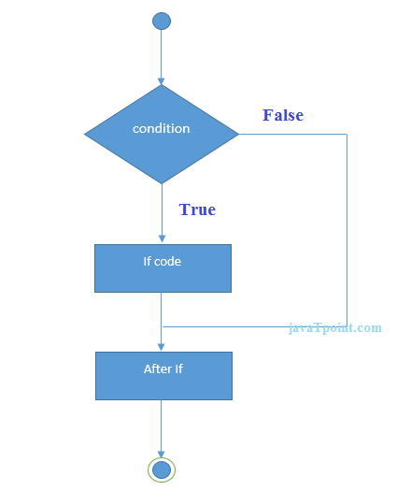

**Fig 2.1 Flowchart for If Statement**

## PHP If-else Statement

PHP if-else statement is executed whether condition is true or false.

**Syntax:**

**if**(condition){

//code to be executed if true

}**else**{

//code to be executed if false

}

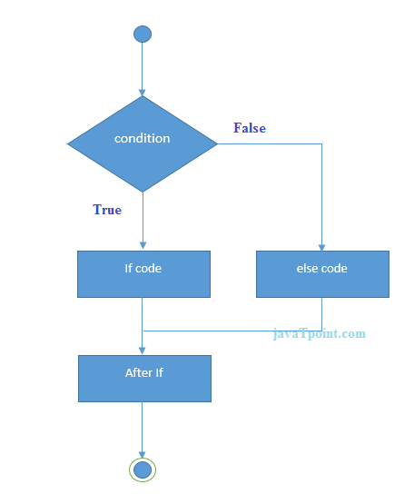**Flowchart:**

**Fig 2.2 Flowchart for If-else Statement**

**PHP Switch**

PHP switch statement is used to execute one statement from multiple conditions. It works like PHP if-else-if statement.

**Syntax:**

**switch**(expression){

**case** value1:

 //code to be executed

**break**;

**case** value2:

 //code to be executed

**break**;

......

**default**:

 code to be executed **if** all cases are not matched;

}

**Flowchart:**

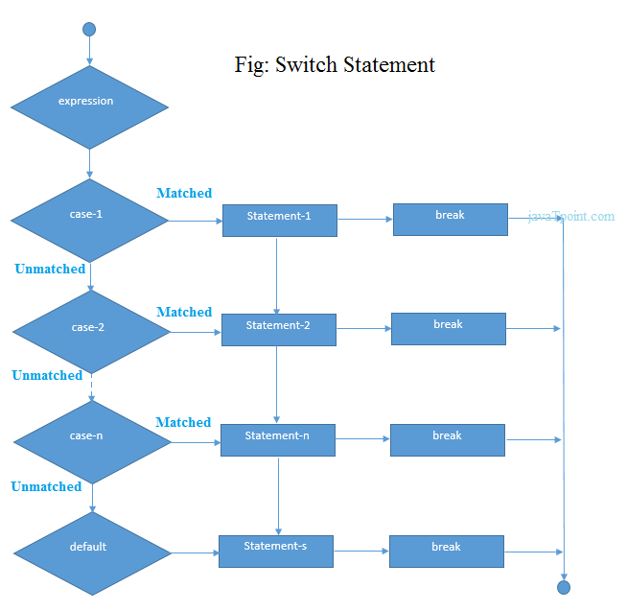

**Fig 2.3 Flowchart for Switch Statement**

**2.6 Conditional Loops**

# PHP For Loop

PHP for loop can be used to traverse set of code for the specified number of times.It should be used if number of iteration is known otherwise use while loop.

**Syntax:**

**for**(initialization; condition; increment/decrement){

//code to be executed

}

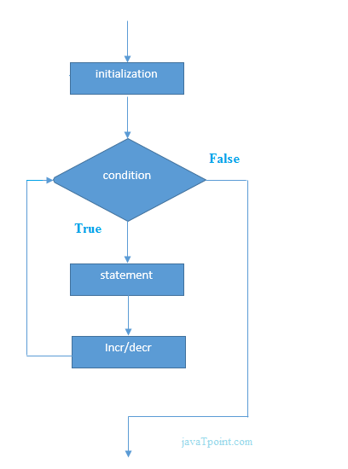**Flowchart:**

**Fig 2.4 Flowchart for For Loop**

## PHP Nested For Loop

We can use for loop inside for loop in PHP, it is known as nested for loop.In case of inner or nested for loop, nested for loop is executed fully for one outer for loop. If outer for loop is to be executed for 3 times and inner for loop for 3 times, inner for loop will be executed 9 times (3 times for 1st outer loop, 3 times for 2nd outer loop and 3 times for 3rd outer loop).

## PHP For Each Loop

PHP for each loop is used to traverse array elements.

**Syntax:**

**foreach**( $array **as** $var ){

 //code to be executed

}

?>

**PHP While Loop**

PHP while loop can be used to traverse set of code like for loop.It should be used if number of iteration is not known.

**Syntax:**

**while**(condition){

//code to be executed

}

**Flowchart:**

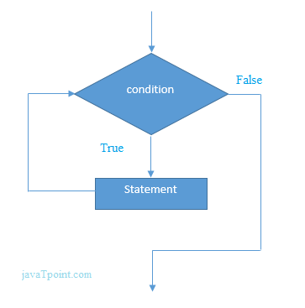

**Fig 2.5 Flowchart for While Loop**

## PHP Nested While Loop

We can use while loop inside another while loop in PHP, it is known as nested while loop. In case of inner or nested while loop, nested while loop is executed fully for one outer while loop. If outer while loop is to be executed for 3 times and nested while loop for 3 times, nested while loop will be executed 9 times (3 times for 1st outer loop, 3 times for 2nd outer loop and 3 times for 3rd outer loop).

**PHP do while loop**

PHP do while loop can be used to traverse set of code like php while loop. The PHP do-while loop is guaranteed to run at least once. It executes the code at least one time always because condition is checked after executing the code.

**Syntax:**

**do**{

//code to be executed

}

**while**(condition);

**Flowchart**

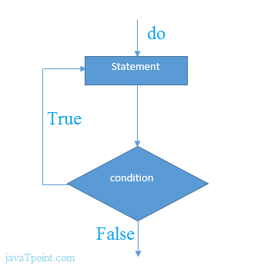

**Fig 2.6 Flowchart for Do Loop**

**PHP Break**

PHP break statement breaks the execution of current for, while, do-while, switch and for-each loop. If you use break inside inner loop, it breaks the execution of inner loop only.

**Syntax:** break;

**Flowchart:**

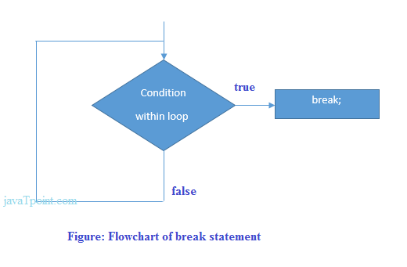

**Fig 2.7 Flowchart for Break**

# 2.7 PHP Functions

PHP function is a piece of code that can be reused many times. It can take input as argument list and return value. There are thousands of built-in functions in PHP.In PHP, we can define **Conditional function, Function within Function**and**Recursive function** also.

**PHP User-defined Functions**

We can declare and call user-defined functions easily.

## Syntax:

**function** functionname(){

//code to be executed

}

## PHP Function Arguments

## 1) PHP Call By Reference:

Value passed to the function doesn't modify the actual value by default (call by value). But we can do so by passing value as a reference.By default, value passed to the function is call by value. To pass value as a reference, you need to use ampersand (&) symbol before the argument name.

## 2) PHP Function: Default Argument Value:

We can specify a default argument value in function. While calling PHP function if you don't specify any argument, it will take the default argument.

# 3) PHP Call By Value:

PHP allows you to call function by value and reference both. In case of PHP call by value, actual value is not modified if it is modified inside the function.

# 4) PHP Call By Reference

In case of PHP call by reference, actual value is modified if it is modified inside the function. In such case, you need to use & (ampersand) symbol with formal arguments. The & represents reference of the variable.

# 5) PHP Recursive Function

PHP also supports recursive function call like C/C++. In such case, we call current function within function. It is also known as recursion.

# 2.8 PHP Arrays

* Indexed Array
* Associative Array
* Multidimensional Array

## PHP Indexed Array

PHP index is represented by number which starts from 0. We can store number, string and object in the PHP array. All PHP array elements are assigned to an index number by default.

**Syntax:**$season=array("summer","winter","spring","autumn");

## PHP Associative Array

We can associate name with each array elements in PHP using => symbol.

**Syntax:**$salary=**array**("Sonoo"=>"350000","John"=>"450000","Kartik"=>"200000");

# PHP Multidimensional Array

PHP multidimensional array is also known as array of arrays. It allows you to store tabular data in an array. PHP multidimensional array can be represented in the form of matrix which is represented by row * column.

# 2.9 PHP String Functions

PHP provides various string functions to access and manipulate strings. A list of important PHP string functions are given below.

## 1) PHP strtolower() function

The strtolower() function returns string in lowercase letter.

**Syntax:** string strtolower ( string $string )

## 2) PHP strtoupper() function

The strtoupper() function returns string in uppercase letter.

**Syntax:** string strtoupper ( string $string )

**3**) **PHP strrev()** function

The strrev() function returns reversed string.

**Syntax:** string strrev ( string $string )

**4) PHP strlen() function**

The strlen() function returns length of the string.

**Syntax:** int strlen ( string $string )

**2.10 PHP Math**

PHP provides many predefined math constants and functions that can be used to perform mathematical operations.

## 1) PHP Math: abs() function

The abs() function returns absolute value of given number. It returns an integer value but if you pass floating point value, it returns a float value.

**Syntax:**number abs ( mixed $number )

## 2) PHP Math: ceil() function

The ceil() function rounds fractions up.

**Syntax:**float ceil ( float $value )

## 3) PHP Math: floor() function

The floor() function rounds fractions down.

**Syntax:**float floor ( float $value )

**4) PHP Math: sqrt() function**

The sqrt() function returns square root of given argument.

**Syntax**: float sqrt ( float $arg )

**2.11 PHP File Handling PHP**

File System allows us to create file, read file line by line, read file character by character, write file, append file, delete file and close file.

1) **PHP Open File** - fopen()

The PHP fopen() function is used to open a file.

**Syntax:**resource fopen ( string $filename , string $mode [, bool $use_include_path = false [, resource $context ]] )

## 2) PHP Close File - fclose()

The PHP fclose() function is used to close an open file pointer.

**Syntax:**ool fclose ( resource $handle )

**3) PHP Read File - fread()**

The PHP fread() function is used to read the content of the file. It accepts two arguments: resource and file size.

**Syntax:** string fread ( resource $handle , int $length )

**4**)PHP Write File - fwrite()

The PHP fwrite() function is used to write content of the string into file.

**Syntax:**int fwrite ( resource $handle , string $string [, int $length ] )

## 5)PHP Delete File - unlink()

The PHP unlink() function is used to delete file.

**Syntax:**bool unlink ( string $filename [, resource $context ] )

# 2.12 PHP MySQL Connection

## 1) PHPmysqli_connect()

PHP **mysqli_connect() function** is used to connect with MySQL database. It returns resource if connection is established or null.

**Syntax:** resource mysqli _connect (server, username, password)

## 2) PHPmysqli_close()

PHP **mysqli_close() function** is used to disconnect with MySQL database. It returns true if connection is closed or false.

**Syntax:** bool mysqli_close(resource $resource_link)

**3) PHP MySQL Create Database**

Use one of the 2 alternatives to create database.

mysqli_query()

PDO::__query()

**4) PHP MySQL Create Table**

PHP mysql_query() function is used to create table. Since, **mysql_query()** function is *deprecated*, use one of the 2 alternatives.

mysqli_query()

PDO::__query()

**5) PHP MySQL Insert Record**

PHP mysql_query() function is used to insert record in a table. Since, mysql_query() function is *deprecated*, use one of the 2 alternatives.

mysqli_query()

PDO::__query()

**6) PHP MySQL Update Record**

PHP mysql_query() function is used to update record in a table. Since mysql_query() function is *deprecated*, use one of the 2 alternatives.

mysqli_query()

PDO::__query()

**7) PHP MySQL Delete Record**

PHP mysql_query() function is used to delete record in a table. Since  mysql_query() function is *deprecated*, use one of the 2 alternatives.

mysqli_query()

PDO::__query()

**Chapter 3**

**JAVASCRIPT**

**3.1 What is JavaScript**

JavaScript is a dynamic computer programming language. It is lightweight and most commonly used as a part of web pages, whose implementations allow client-side script to interact with the user and make dynamic pages. It is an interpreted programming language with object-oriented capabilities. JavaScript was first known as LiveScript, but Netscape changed its name to JavaScript, possibly because of the excitement being generated by Java. JavaScript made its first appearance in Netscape 2.0 in 1995 with the name LiveScript. The general-purpose core of the language has been embedded in Netscape, Internet Explorer, and other web browsers. This defined a standard version of the core JavaScript language.

**3.2 Features of JavaScript**

1. JavaScript is a lightweight, interpreted programming language.

2. Designed for creating network-centric applications.

3. Complementary to and integrated with Java.

4. Complementary to and integrated with HTML.

5. Open and cross-platform.

**3.3 Client-Side JavaScript**

Client-side JavaScript is the most common form of the language. The scriptshould be included in or referenced by an HTML document for the code to be interpreted by the browser. It means that a web page need not be a static HTML, but can include programs that interact with the user, control the browser, and dynamically create HTML content. The JavaScript client-side mechanism provides many advantages over traditional CGI server-side scripts. For example, you might use JavaScript to check if the user has entered a valid e-mail address in a form field. The JavaScript code is executed when the user submits the form, and only if all the entries are valid, they would be submitted to the Web Server. JavaScript can be used to trap user-initiated events such as button clicks, link navigation, and other actions that the user initiates explicitly or implicitly.

**3.4 Advantages of JavaScript**

The merits of using JavaScript are

1. Less server interaction: You can validate user input before sending the page off to the server. This saves server traffic, which means less load on your server.

2. Immediate feedback to the visitors: They don't have to wait for a page reload to see if they have forgotten to enter something.

3. Increased interactivity**:** You can create interfaces that react when the user hovers over them with a mouse or activates them via the keyboard.

4. Richer interfaces**:** You can use JavaScript to include such items as drag and drop components and sliders to give a Rich Interface to your site visitors.

**3.5 Limitations of JavaScript**

1. Client-side JavaScript does not allow the reading or writing of files. Thishas been kept for security reason.

2. JavaScript cannot be used for networking applications because there is no such support available.

3. JavaScript doesn't have any multithreading or multiprocessor capabilities.

JavaScript can be implemented using JavaScript statements that are placedwithin the <script>... </script>HTML tags in a web page.

You can place the <script>tags, containing your JavaScript, anywhere within you web page, but it is normally recommended that you should keep it within the **<**head**>**tags.

<script ...>

JavaScript code

</script>

**3.6 JavaScript Data types**

One of the most fundamental characteristics of a programming language is theset of data types it supports. These are the type of values that can be represented and manipulated in a programming language.

JavaScript allows you to work with three primitive data types:

1. Numbers, e.g., 123, 120.50 etc.

2. Strings of text, e.g. "This text string" etc.

3. Boolean, e.g. true or false.

JavaScript also defines two trivial data types, nulland undefined, each ofwhich defines only a single value. In addition to these primitive data types JavaScript supports a composite data type known as object.

**3.7 JavaScript Variable Scope**

The scope of a variable is the region of your program in which it is defined.

JavaScript variables have only two scopes.

**1. Global Variables:** A global variable has global scope which means it can be defined anywhere in your JavaScript code.

**2. Local Variables:** A local variable will be visible only within a function where it is defined. Function parameters are always local to that function.

**3.8 What is an Event?**

JavaScript's interaction with HTML is handled through events that occur whenthe user or the browser manipulates a page. When the page loads, it is called an event. When the user clicks a button, that click too is an event. Other examples include events like pressing any key, closing a window, resizing a window, etc. Developers can use these events to execute JavaScript coded responses, which cause buttons to close windows, messages to be displayed to users, data to be validated, and virtually any other type of response imaginable.

**1. onclick Event Type**

This is the most frequently used event type which occurs when a user clicks the left button of his mouse. You can put your validation, warning etc., against this event type.

<html>

<head>

<script type="text/javascript">

<!--

functionsayHello() {

document.write ("Hello World")

}

//-->

</script>

**2. onsubmit Event Type**

onsubmitis an event that occurs when you try to submit a form. You can putyour form validation against this event type.

The following example shows how to use onsubmit. Here we are callinga validate()function before submitting a form data to the webserver. If validate()function returns true, the form will be submitted, otherwise it will not submit the data.

<html>

<head>

<script type="text/javascript">

<!--

function validation() {

all validation goes here

.........

return either true or false

}

//-->

</script>

</head>

**3.9 Dialogue Box**

JavaScript supports three important types of dialog boxes. These dialog boxes can be used to raise and alert, or to get confirmation on any input or to have a kind of input from the users. Here we will discuss each dialog box one by one.

**1. Alert Dialog Box**

An alert dialog box is mostly used to give a warning message to the users. For example, if one input field requires to entersome text but the user does not provide any input, then as a part of validation, you can use an alert box to give a warning message. Nonetheless, an alert box can still be used for friendlier messages. Alert box gives only one button "OK" to select and proceed.

**2. Confirmation Dialog Box**

A confirmation dialog box is mostly used to take user's consent on any option. It displays a dialog box with two buttons: OKand Cancel.If the user clicks on the OK button, the window method confirm()will return true. If the user clicks on the Cancel button, then confirm()returns false.

**3. Prompt Dialog Box**

The prompt dialog box is very useful when you want to pop-up a text box to getuser input. Thus, it enables you to interact with the user. The user needs to fill in the field and then click OK.This dialog box is displayed using a method called prompt()which takes two parameters: (i) a label which you want to display in the text box and (ii) a default string to display in the text box.This dialog box has two buttons: OKand Cancel. If the user clicks the OKbutton, the window method prompt()will return the entered value from thetext box. Ifthe user clicks the Cancel button, the window method prompt()returns null.Voidis an important keyword in JavaScript which can be used as a unary operator that appears before its single operand, which may be of any type. This operator specifies an expression to be evaluated without returning a value.

<head>

<script type="text/javascript">

<!--

voidfunc()

javascript:voidfunc()

OR

void(func())

javascript:void(func())

//-->

</script>

</head>

**3.10 Form Validation**

Form validation normally used to occur at the server, after the client hadentered all the necessary data and then pressed the Submit button. If the data entered by a client was incorrect or was simply missing, the server would have to send all the data back to the client and request that the form be resubmitted with correct information. This was really a lengthy process which used to put a lot of burden on the server. JavaScript provides a way to validate form's data on the client's computer before sending it to the web server. Form validation generally performs two functions.

Basic Validation- First of all, the form must be checked to make sure allthe mandatory fields are filled in. It would require just a loop through each field in the form and check for data.

2.Data Format Validation- Secondly, the data that is entered must be checked for correct form and value. Your code must include appropriate logic to test correctness of data.

**Data Format Validation**

Anemail address must contain at least a ‘@’ sign and a dot (.). Also, the ‘@’ must not be the first character of the email address, and the last dot must at least be one character after the ‘@’ sign.

<script type="text/javascript">

<!--

functionvalidateEmail()

{

varemailID = document.myForm.EMail.value;

atpos = emailID.indexOf("@");

dotpos = emailID.lastIndexOf(".");

if (atpos< 1 || ( dotpos - atpos< 2 ))

{

alert("Please enter correct email ID")

document.myForm.EMail.focus() ;

return false;

}

return( true );

}

//-->

</script>

**3.11 Animation**

You can use JavaScript to create a complex animation having, but not limited to,the following elements:

1Fireworks

2 Fade Effect

3 Roll-in or Roll-out

4 Page-in or Page-out

5Object movem

JavaScript can be used to move a number of DOM elements (<img />, <div>, or any other HTML element) around the page according to some sort of pattern determined by a logical equation or function. JavaScript provides the following two functions to be frequently used in

animation programs.

 setTimeout (function, duration)- This function calls functionafterdurationmilliseconds from now.

2.setInterval (function, duration)- This function calls functionafter every durationmilliseconds.

3.clearTimeout (setTimeout_variable)- This function clears any timer set by the setTimeout() function.

JavaScript can also set a number of attributes of a DOM object including its position on the screen. You can set topand left attribute of an object to position it anywhere on the screen. Here is its syntax.

// Set distance from left edge of the screen.

object.style.left = distance in pixels or points;

or

// Set distance from top edge of the screen.

object.style.top = distance in pixels or points;

**Manual Animation**

So let's implement one simple animation using DOM object properties and JavaScript functions as follows. The following list contains different DOM methods.

1. We are using the JavaScript function getElementById()to get a DOM object and then assigning it to a global variable imgObj.

2. We have defined an initialization function init()to initialize imgObjwhere we have set its positionand leftattributes.

3. We are calling initialization function at the time of window load.

4. Finally, we are calling moveRight()function to increase the left distance by 10 pixels. You could also set it to a negative value to move it to the left side.

**Automated Animation**

Wecan automate this process by using the JavaScript function setTimeout() as follows.

Here we have added more methods. So let's see what is new here:

1. The moveRight()function is calling setTimeout() function to set the position of imgObj.

2. We have added a new function stop() to clear the timer set by setTimeout() function and to set the object at its initial position.

**Chapter 4**

**DESIGN AND IMPLEMENTATION**

**4.1 USE CASE DIAGRAM**

Use case diagrams describe what a system does from the standpoint of an external observer. The emphasis of use case diagrams is on what a system does rather than how. They are used to show the interactions between users of the system and the system. A use case represents the several users called actors and the different ways in which they interact with the system.

**ACTORS**

* Administrator - register to system, login to enter in the system, manage database, display result and upload song.
* User - register to system, login to enter in the system, play song and download song.

**USE CASES**

* Registration – user and admin add information for registration.
* Login – user and admin login for enter in system.
* Verification – user and admin login need verification.
* Upload song - admin upload songs to database and song details.
* Search query – user enter query for searching song.
* Search text – system process to find matching result related query.
* Download and Play - song user can download and play song.

They are used to show the interactions between users of the system and the system. A use case represents the several users called actors and the different ways in which they interact with the system. Use case diagrams describe what a system does from the standpoint of an external observer. The emphasis of use case diagrams is on what a system does rather than how.

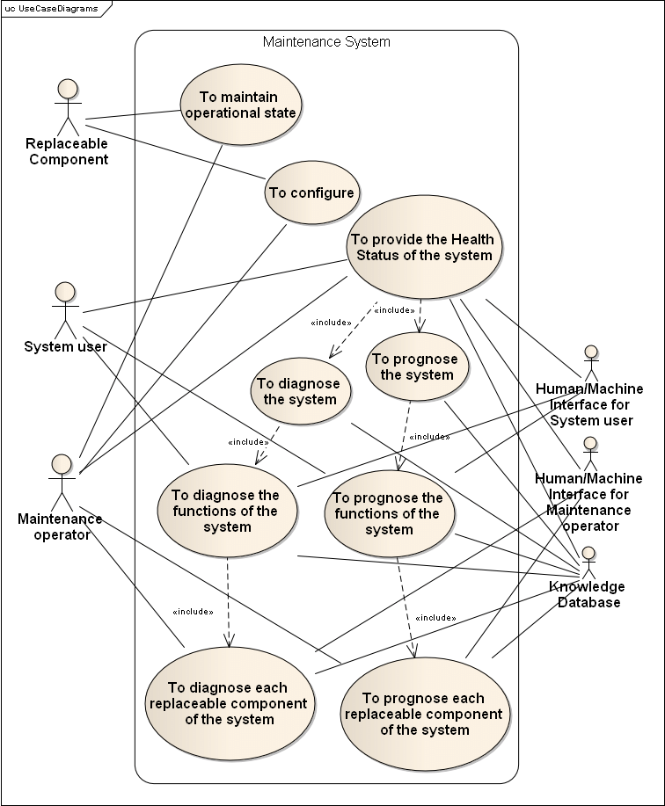

**Fig 4.1 Use Case Diagram**

**4.2 CLASS DIAGRAM**

A class diagram is an organization of related objects. It gives an overview of a system by showing its classes and the relationships among them. Class diagrams only display what interacts but not what happens during the interaction hence they are static diagrams.

The class diagram gives organization of related object included in system. The overview of the class diagram shows relationships between the classes.

Class diagram gives relation between the administrator class, system class, database class and user class. It gives static interaction between above class.

**CLASSES**

* Administrator – class includes name and password. Perform functions like login, upload and delete songs.
* User- class includes user id, name, email, password and choice. Perform functions like registration, login, enter query, play and download songs.
* System – class includes functions like process query, display results history and display result.
* Database – class includes functions like insert, update, delete.

A class diagram is an organization of related objects. It gives overviews of a system by showing its classes and the relationships among them. Class diagrams only display what interacts but not what happens during the interaction hence they are static diagrams.

* The class diagram gives organization of related object included in system. The overview of the class diagram shows relationships between the classes.
* Class diagram gives relation between the administrator class, system class, database class and user class. It gives static interaction between above class.

A class diagram is an organization of related objects. It gives an overview of a system by showing its classes and the relationships among them. Class diagrams only display what interacts but not what happens during the interaction hence they are static diagrams.

The class diagram gives organization of related object included in system. The overview of the class diagram shows relationships between the classes.

Class diagram gives relation between the administrator class, system class, database class and user class. It gives static interaction between above class.

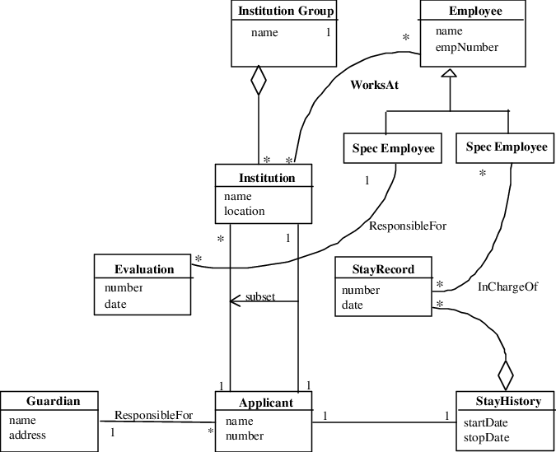

**Fig. 4.2 Class Diagram**

**4.3 State chart diagram**

State chart diagram is one of the five UML diagrams used to model the dynamic nature of a system. They define different states of an object during its lifetime and these states are changed by events. State chart diagrams are useful to model the reactive systems. Reactive systems can be defined as a system that responds to external or internal events.

State chart diagram describes the flow of control from one state to another state. States are defined as a condition in which an object exists and it changes when some event is triggered. The most important purpose of State chart diagram is to model lifetime of an object from creation to termination.

State chart diagrams are also used for forward and reverse engineering of a system. However, the main purpose is to model the reactive system. Purpose of state chart diagram:

* To model the dynamic aspect of a system.
* To model the life time of a reactive system.
* To describe different state of an object during its life time.
* Define a state machine to model the states of an object.

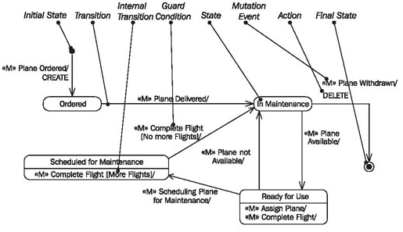

**Fig. 4.3 State Chart Diagram**

**4.4 Sequence diagram**

Sequence diagram describe interaction among classes in term of an exchange of messages over time. They’re also called event diagram. A sequence diagram is good way to visualize and validate various runtime scenarios. These can help to predict how a system will behave and to discover responsibilities a class may need to have in the process of modeling a new system.

**Sequence diagram notation**

* **Class Roles and Participants**

Class roles describes the way an object will behave in context. Use an UML object symbol to illustrate class roles, but don’t list object attributes.

Object symbol - Sequence diagram

**Fig. 4.4 Class Role and Participants**

* **Activation or Execution Occurrence**

Activation boxes represent the time an object needs to complete a task. When an object is busy executing a process or waiting for a reply message, use a thin gray rectangle placed vertically on its lifeline.

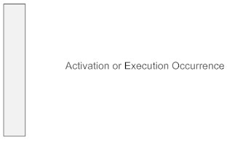

**Fig 4.5 Activation or Execution Occurrence**

* **Message**

Messages are arrows that represent communication between objects. Use half-arrowed line to represent asynchronous messges. Asynchronous message are sent from an object that will not wait for a response from the receiver before continuing its tasks.

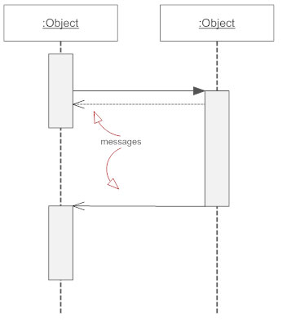

**Fig 4.6 Message**

* **Lifeline**

Lifelines are vertical dashed line that indicates the object’s presence over time.

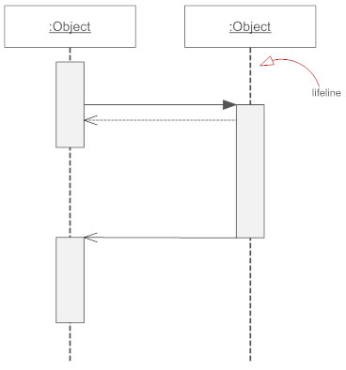

**Fig. 4.7 LifeLine**

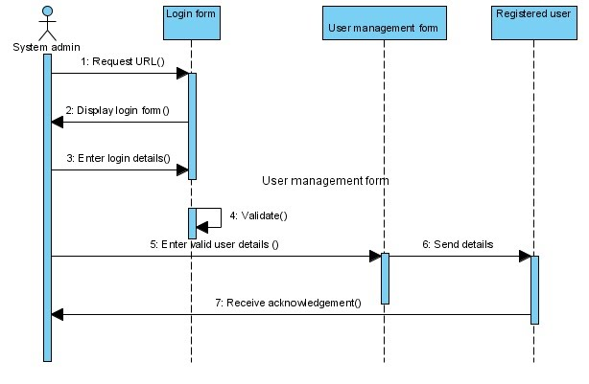

**Fig. 4.8 Sequence Diagram (Adding New user to system)**

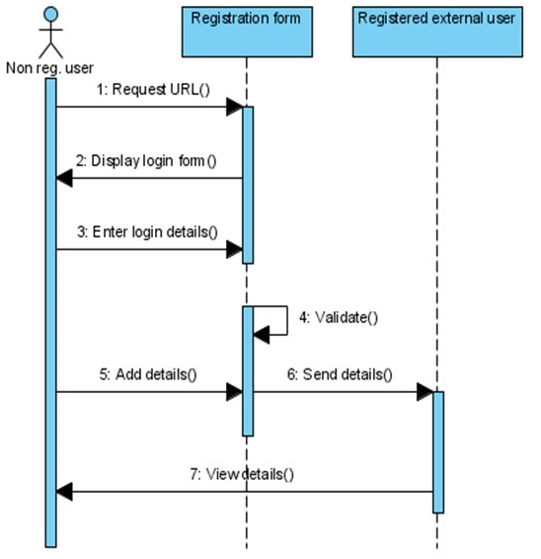

**Fig. 4.8 Sequence Diagram ( Non Register User)**

**Chapter 5**

**EXPERIMENTAL RESULTS**

The project displayed following experimental results:

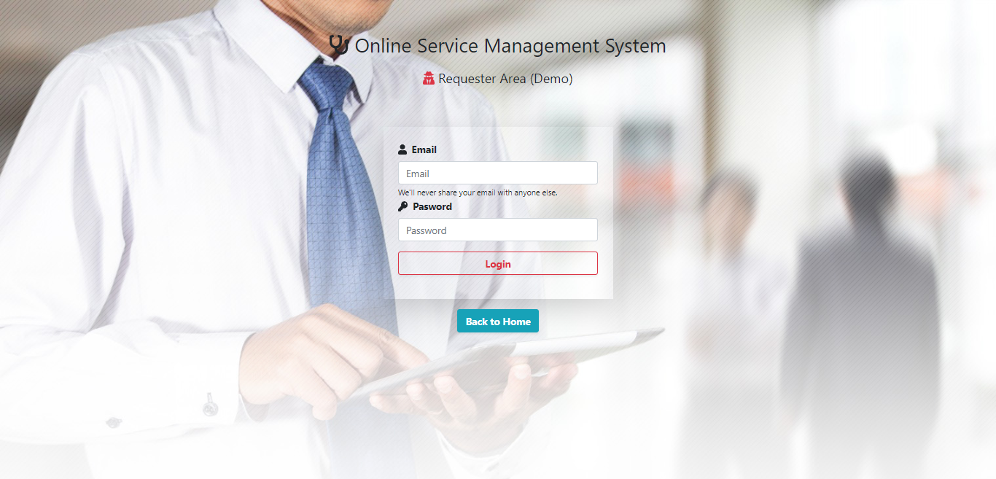

**Fig. 5.1 login page**

The above figure login page shows authentication purpose for valid user can go to our dashboard and see his/her personal information.

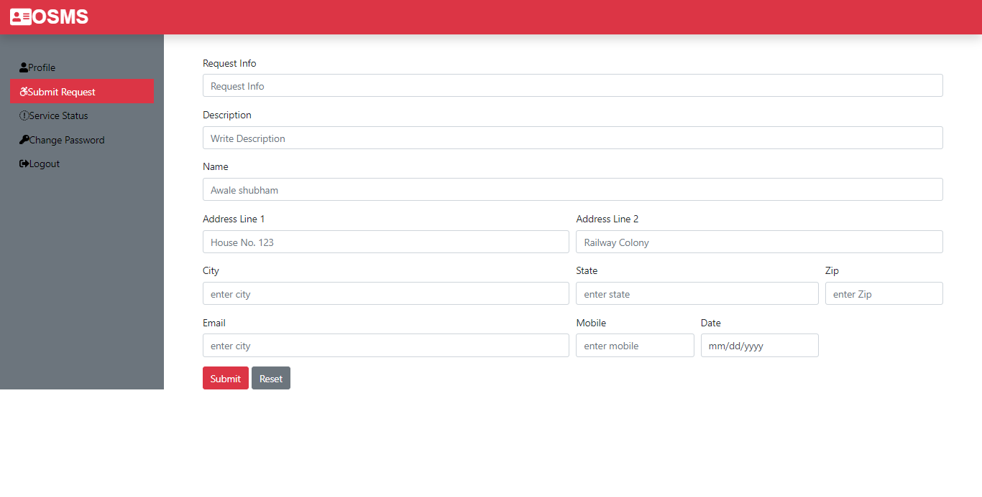

**Fig. 5.2 Submit Request**

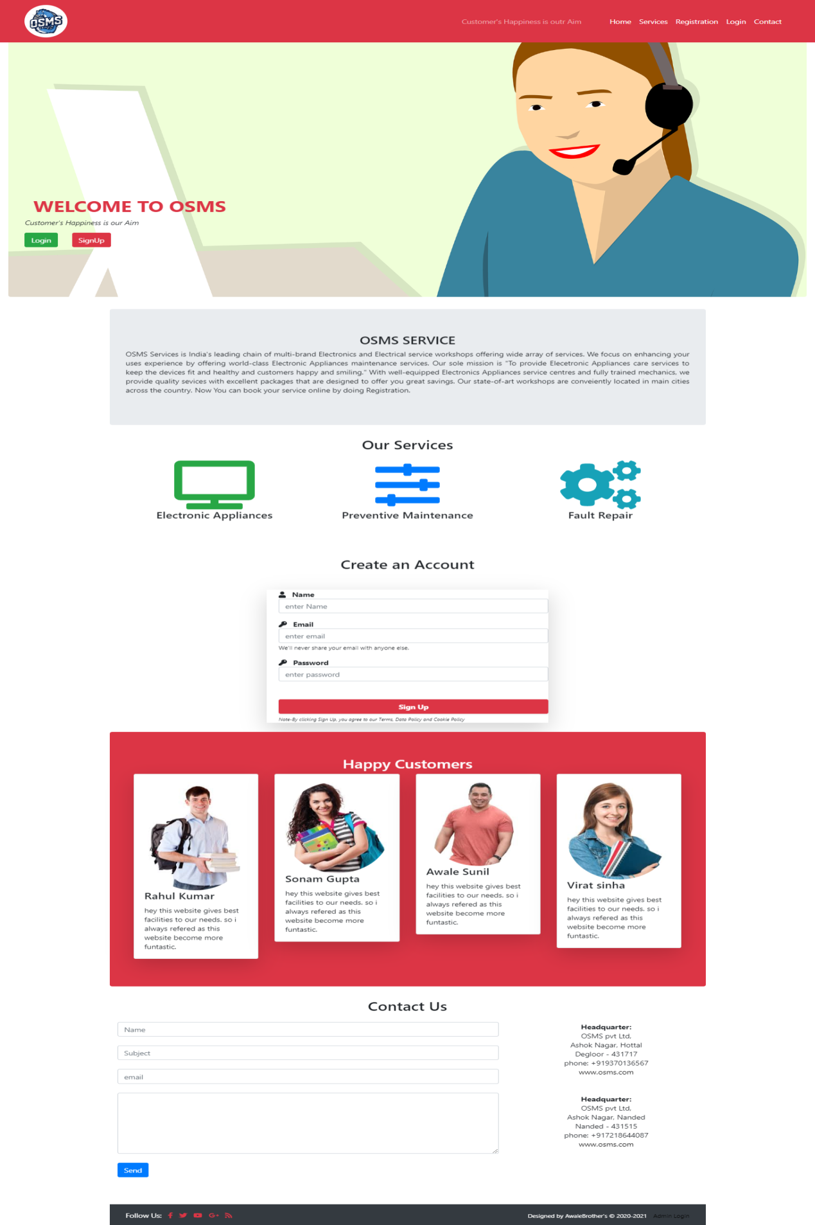

**Fig. 5.3 Main Page**

The above figure shows when go to website link at that time website seen like this.

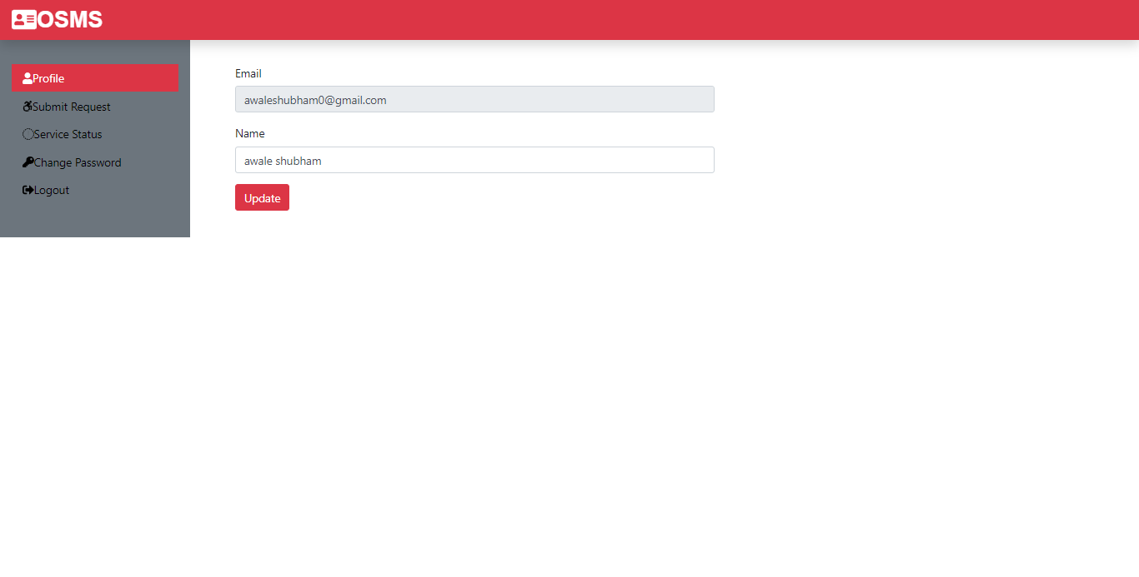

**Fig. 5.4 Profile**

The profile means that user email and name here displayed and also user can change their name but cannot change their email because some purpose. 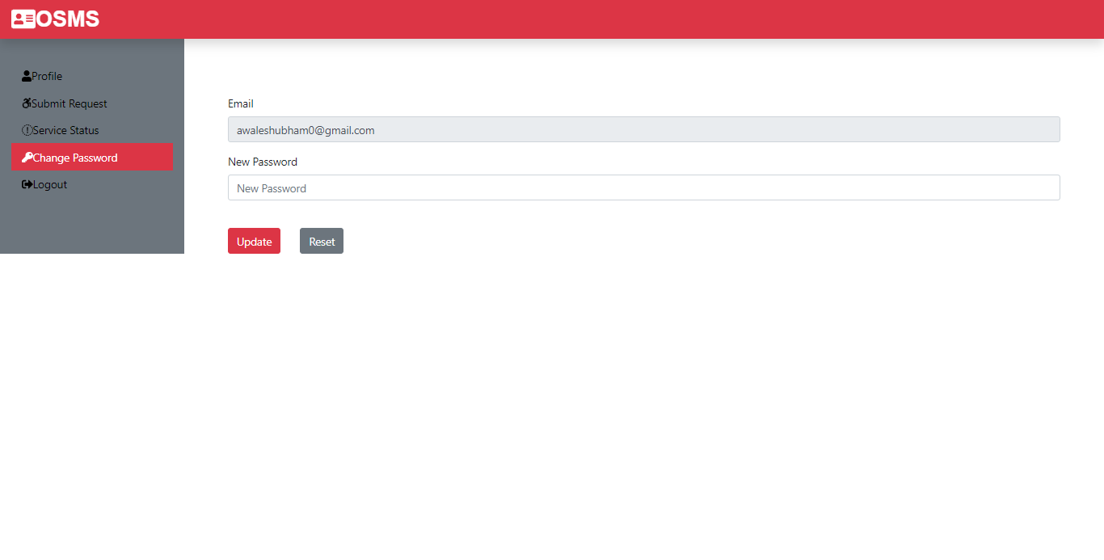

**Fig. 5.5 Change Password**

The figure change password shows information about when user wants to change their password for some security reasons or other purpose at that our website provides facility to customer not for only customer dashboard also available to admin dashboard.

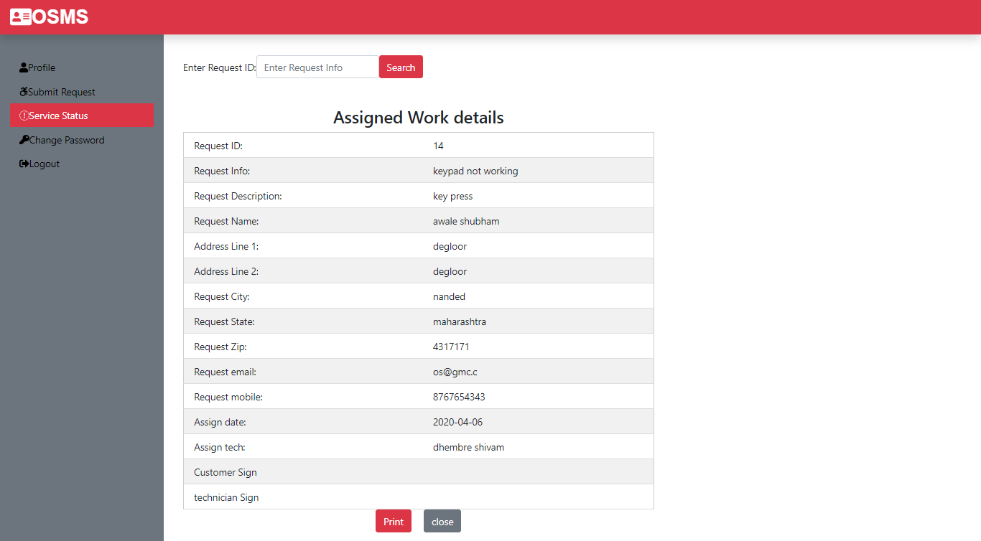

**Fig. 5.6 Service status**

When user applied or submit request for service of their electronic product. At that user knows their service status accepted or not from admin. At that time customer can fill request id and see their assigned work details.

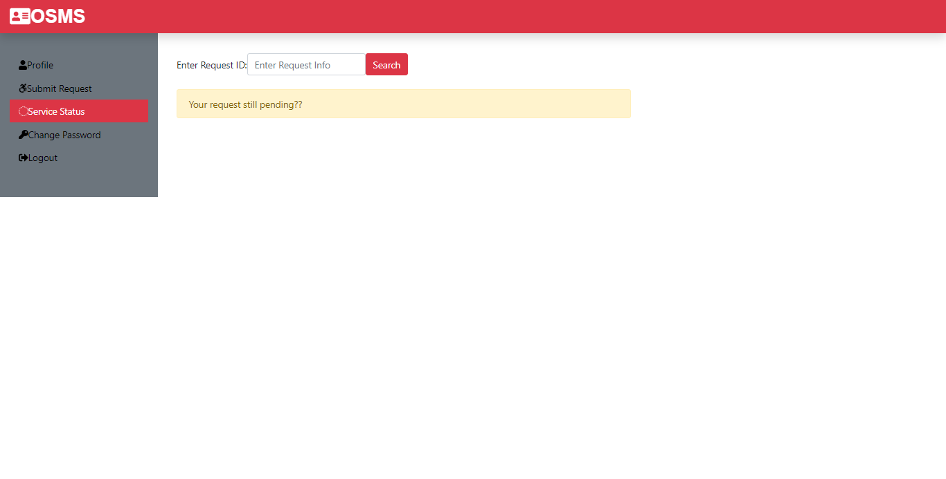

**Fig. 5.7 Service Pending**

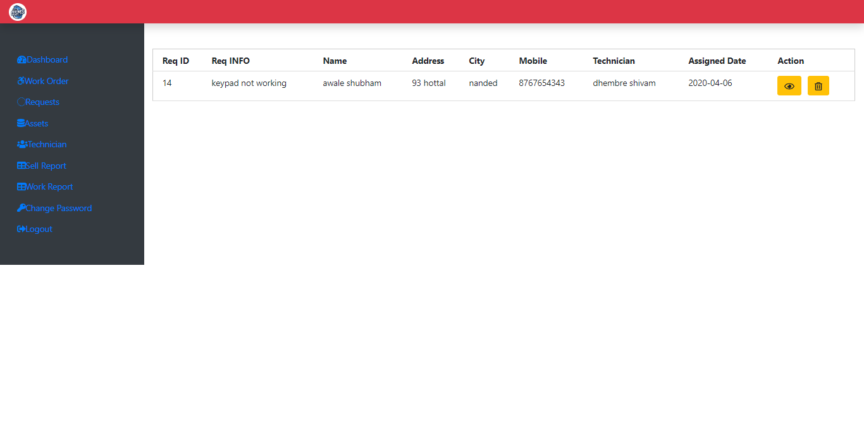

**Fig. 5.8 Request Action** 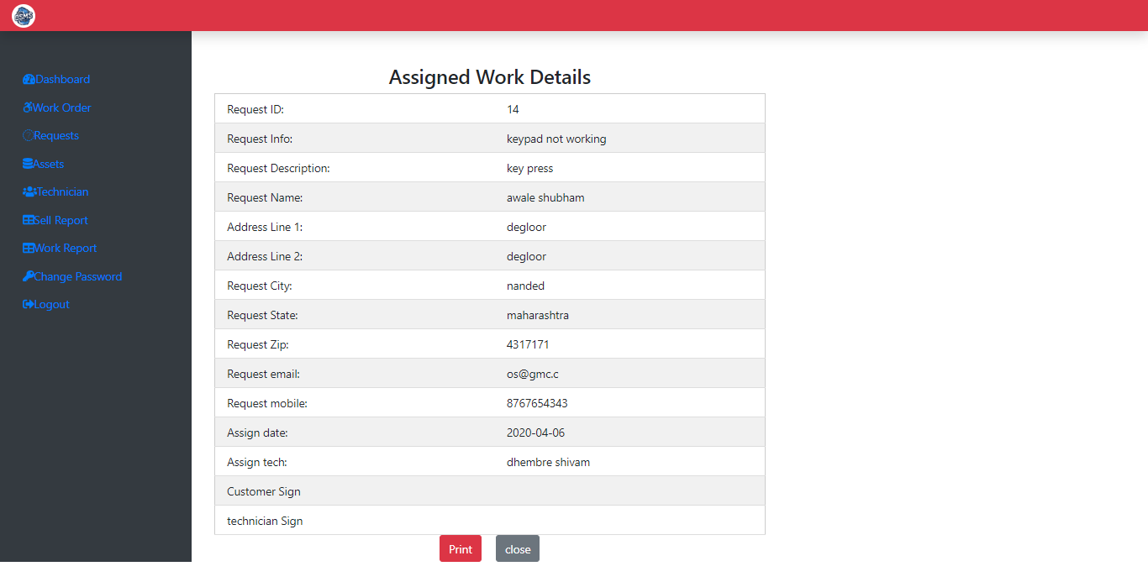

**Fig. 5.9 Status reprint**

The above two figure shows that status reprint and status action. Status action means he/she can see their assigned work details and next one is that about status reprint is most important part of our project when technician goes to customer home or their place he/she signed on that page.

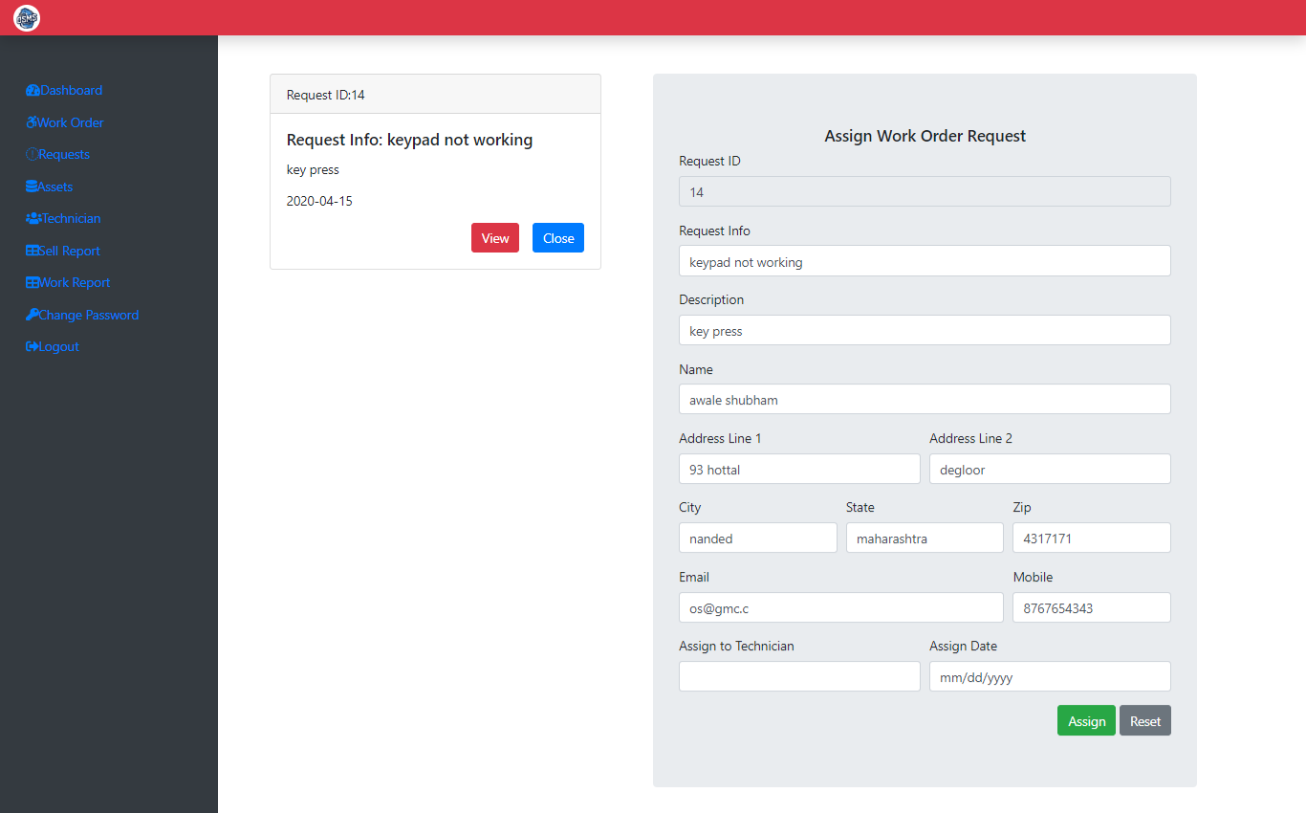

**Fig. 5.10 Requests**

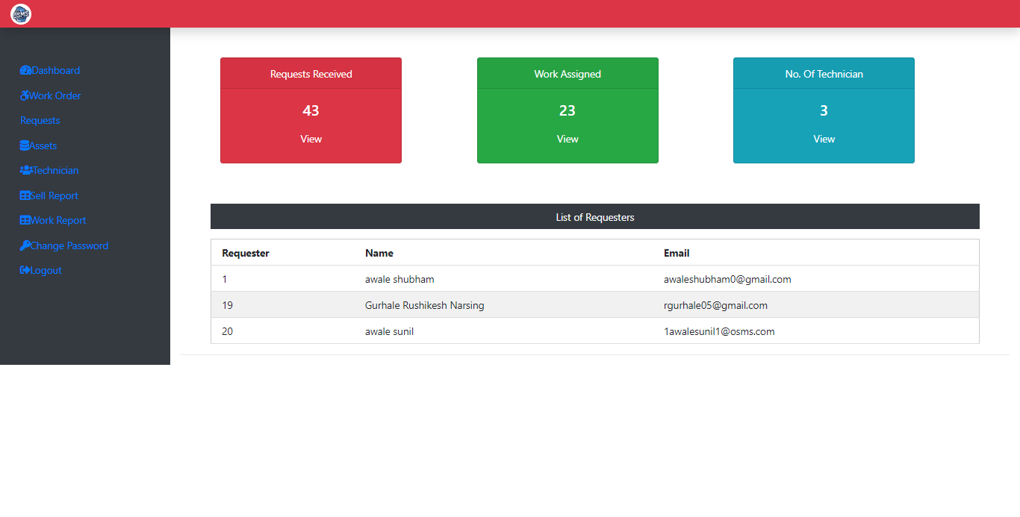

**Fig. 5.11 Admin Dashboard**

The above two figure shows that Admin dashboard and set of request. Those modules are part of admin dashboard means that set of request are coming from consumer portal then save into dashboard for authentication from administration when request is accepted at that time assign technician to for that consumer. Admin sees some false details he can delete their request or cancelled.

**CONCLUSION**

The project entitled “Online Maintenance Management” is developed using JavaScript as front end and Oracle database in back end to computerize the process of log requests for services for their household electronic items. This project covers only the basic features required. The main beneficiaries are both Customers as well as ADMIN who consume more time while dealing with complains. Administrator had to privilege to update the data. It saves time as it allows number of customers to apply for their complaints.

**REFERENCES**

[1] Luke Wellings, “PHP And MySQL Web Development”, Developer’s library, 3rd Edition, ISBN: 0-672-32525-X

[2] Jon Duckett, “HTML And CSS Design And Build Websites”, BPB publications, 2nd Edition, ISBN: 978-1-118-00818-8

[3] https://www.w3schools.com/html/

[4] https://www.w3schools.com/php/

[5] https://stackoverflow.com/