AI Game QA Tester — Demonstration Guide
FPS analysis prototype · about 10 minutes · 07 November 2026
A script for showing the prototype to the supervisor: what to run, what to say, and what will appear. The expected values below come from the Phase 6 test run on this computer.

Before the demo (5 minutes earlier)
- Open a terminal in the project folder: cd ~/Desktop/FYP
- Activate the environment: source backend/.venv/bin/activate
- Check it works: python main.py --help (shows the usage text)
- If a GUI is still running from before, stop it (Ctrl+C in its terminal) or use another port.
- Have these files ready: the real video in evaluation/videos/, evaluation/synthetic/phase6/inject_freeze.mp4 (known freeze), and any .txt file (to show the error message). The test videos are generated, not stored in git: if inject_freeze.mp4 is missing, start the GUI and run python backend/scripts/phase6_test.py once (about 3 minutes).
- Optional: run the tests once: cd backend && python -m pytest -q (takes about 75 s).

Step 1 · Introduce (1 minute)
Say: the prototype analyses a recorded gameplay video and measures frame pacing: how regularly new pictures appear. It finds freezes, FPS drops and stutter, with timestamps, and writes a Word report. It works from the terminal and from a local web page with no login. Important: it measures the recording, not the game's internal FPS. That would need a profiler log.

Step 2 · Command line on the real video (3 minutes)
python main.py analyze --video "evaluation/videos/YTDown.com_YouTube_Media_J8HB1-IQFxc_How-to-fix-Weapons-Hands-Clipping-Into-Walls-in-Unity-URP-SRP_001_1080p.mp4"

Takes about 26 s. Point out the progress bar, then the summary:
Video | 1920x1080, 199.25 s, 11,955 frames, nominal 60.0 FPS
Effective FPS | median 57.0, minimum 5.0 (target 60)
1 % low | 30.0 FPS
Measurable | 9 % (only the moving gameplay part)
Events | 1 freeze, 0 drops, 4 stutter periods
Verdict | Detected 1 freeze(s), 4 stutter period(s) in the 9% of the video that could be measured.

Then open the output folder printed at the end (Finder: open outputs/) and open FPS_ANALYSIS_REPORT.docx. Show the summary, the charts and the events table.
Explain the two questions it raises: only 9 % is measurable because the rest of the video is the static Unity editor, where a repeated frame is normal; the freeze at 00:18.367 is the held picture before an editing transition: a known false positive, shown honestly in the documentation.

Step 3 · The same analysis in the browser (3 minutes)
python main.py --gui

- The browser opens http://127.0.0.1:8765 by itself. Point out: no login, runs only on this computer.
- Drag the real video onto the page (or click and choose it), keep 60 FPS, click Analyze Video.
- While it runs: the bar shows the frame being analysed.
- Results: same numbers as the terminal (the CLI and GUI use one engine; a test checks they are identical). Scroll through the chart, the events table with timestamps, and click Download Word report.

Step 4 · Proof on a known defect (2 minutes)
Click Analyse another video and upload evaluation/synthetic/phase6/inject_freeze.mp4: the real gameplay with a 0.8-second freeze inserted at exactly 10.0 s (made by backend/scripts/phase6_test.py).
Expected: a Freeze event at 00:10.000–00:10.800 (0.80 s). Say: on synthetic tests generated after the thresholds were fixed, the engine found 11/11 stutters, 8/9 freezes and 7/7 FPS drops with no false alarms.
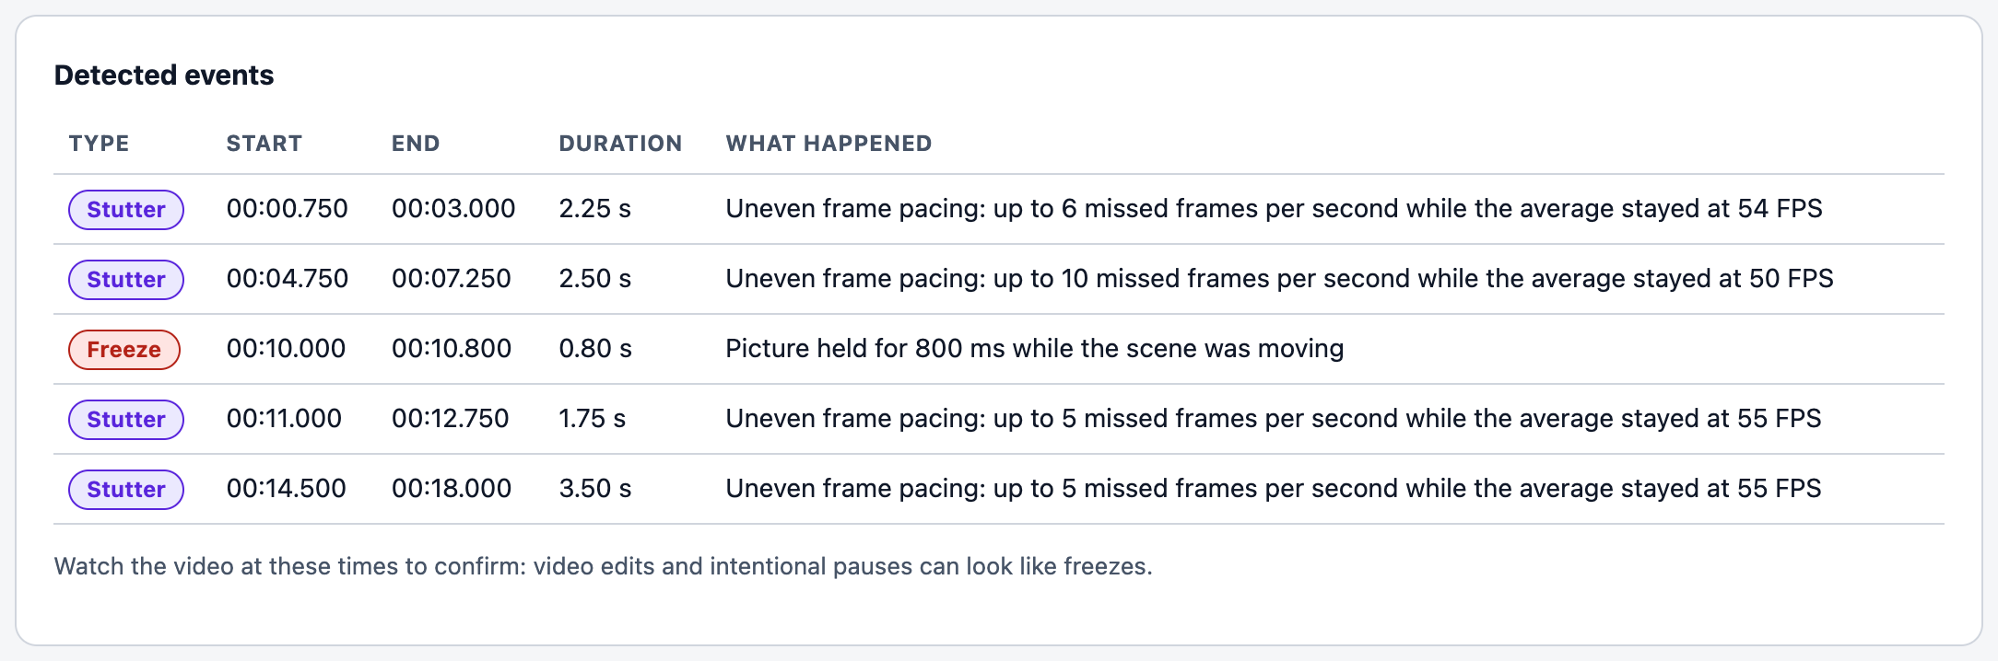
Figure 1. What the page shows for inject_freeze.mp4 (rehearsed through the real page).

Step 5 · Error handling (30 seconds)
Click Analyse another video and choose a .txt file: the page refuses it and names the accepted formats. In the terminal: python main.py analyze --video missing.mp4 prints a one-line error (exit code 2).

Step 6 · Limitations and next steps (1 minute)
- True game FPS cannot be read from a recording; the next step is footage with an FPS counter or a profiler log to measure the error.
- Still scenes cannot be measured; video edits can look like freezes.
- The other four detectors (NPC, texture, animation, clipping) are documented and partly built; they will be added one at a time after validation (PROJECT_DOCUMENTATION.docx, Sections 11–16).

Likely questions
Question | Answer
Is this the game's real FPS? | No. It is the rate of new pictures in the recording while the scene moves. The recording rate caps it (60 here).
How do you know it is correct? | Synthetic tests with defects injected at known times, tuned on one set and measured on a separate held-out set; plus the known-freeze video in Step 4. No profiler ground truth exists for the real video yet.
Why is so little of the video measurable? | When nothing moves, a repeated frame looks exactly like a normal one, so those parts are excluded instead of guessed.
Can it handle other formats? | .mp4, .mkv and .avi, constant or variable frame rate, 30 or 60 FPS: all tested in Phase 6.
Why no login? | It runs only on this computer (127.0.0.1); a login adds nothing for a local tool.

If something goes wrong
Symptom | Fix
'port 8765 is already in use' | A GUI is already running: open http://127.0.0.1:8765, or start with python main.py --gui --port 8766.
'Missing dependency (...)' (exit 3) | The environment is not active: source backend/.venv/bin/activate
Browser does not open | Open http://127.0.0.1:8765 by hand.
Report not opening | It is in the output folder printed by the CLI / shown under the GUI results.

