FPS Analysis Report
YTDown.com_YouTube_Media_J8HB1-IQFxc_How-to-fix-Weapons-Hands-Clipping-Into-Walls-in-Unity-URP-SRP_001_1080p.mp4
Analysed 2026-11-10 08:01 UTC · AI Game QA Tester 0.1.0 — FPS analysis service

1. Summary
Detected 1 freeze(s), 4 stutter period(s) in the 9% of the video that could be measured.
Target frame rate | 60 FPS (drop threshold 45 FPS)
Recording frame rate (nominal / average) | 60 / 60.0 FPS
Effective FPS while moving (median / mean / minimum) | 57.0 / 53.9 / 5.0
1 % low FPS (from 99th-percentile frame time) | 30.0 FPS
Part of the video that could be measured | 9%
Freezes / FPS drops / stutter periods | 1 / 0 / 4
Missed frames while moving | 130
Effective FPS is the number of new pictures per second in the recording, measured only while the picture is moving. It is not the game's internal rendering FPS (see Section 8).

2. Video
File | YTDown.com_YouTube_Media_J8HB1-IQFxc_How-to-fix-Weapons-Hands-Clipping-Into-Walls-in-Unity-URP-SRP_001_1080p.mp4
Size | 22.68 MB
Container / codec | mov,mp4,m4a,3gp,3g2,mj2 / h264
Resolution | 1920x1080
Duration | 199.25 s
Frames | 11,955
Nominal FPS (declared by the file) | 60.0
Average FPS (from timestamps) | 60.0
Variable frame rate | no (constant frame rate)
Audio | yes
Timestamp source | container timestamps (ffprobe), cross-checked with the OpenCV decoder

3. Analysis settings
Target FPS | 60
FPS drop | effective FPS < 75% of target in ≥ 2 consecutive 1 s windows
Freeze | one picture held ≥ 250 ms while the scene is moving
Stutter | ≥ 3 isolated missed frames in a 1 s window, above the drop threshold, ≥ 2 windows

4. Frame presentation timing
Expected interval (1 / nominal FPS) | 16.667 ms
Median interval | 16.667 ms
Minimum / maximum interval | 16.666 / 16.667 ms
99th percentile | 16.667 ms
Irregular intervals (> 25 % from the median) | 0
In a constant-frame-rate recording every interval is the same even when the game slowed down: the recorder repeats the last picture instead. Those repeats are analysed in Section 5.
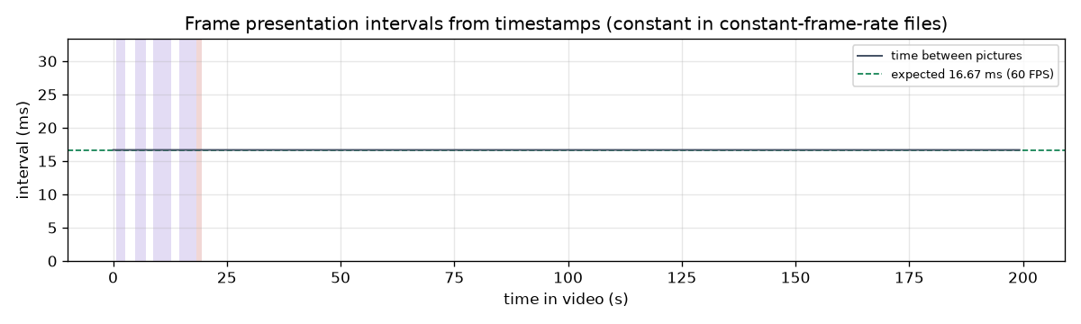

5. Effective frame rate and frame times
Effective FPS — median / mean | 57.0 / 53.9
Effective FPS — minimum / 5th percentile | 5.0 / 27.4
Frame time — median / 95th / 99th percentile | 16.67 / 17.5 / 33.33 ms
Longest frame time | 1050.0 ms
Frame times measured | 880
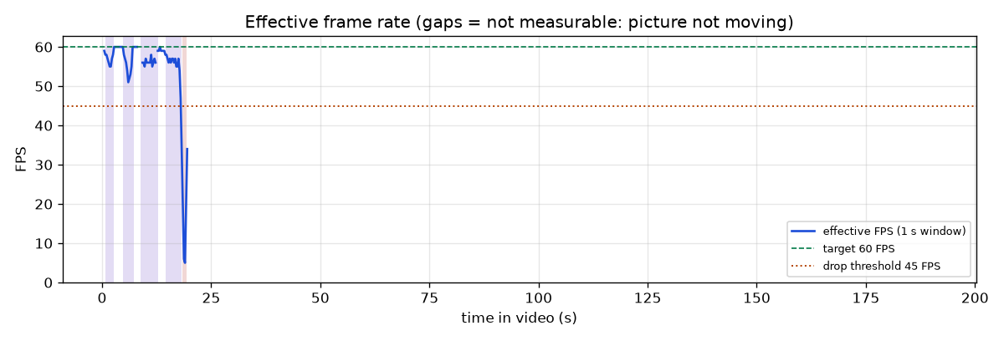
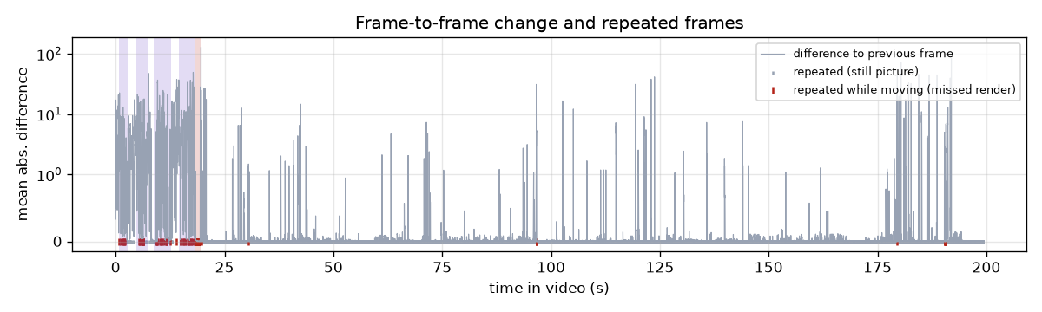
Shaded bands mark detected events: red = freeze, orange = FPS drop, purple = stutter.

6. Detected events
Type | Start | End | Duration | Description
Stutter | 00:00.750 | 00:02.750 | 2.00 s | Uneven frame pacing: up to 5 missed frames per second while the average stayed at 55 FPS
Stutter | 00:04.750 | 00:07.250 | 2.50 s | Uneven frame pacing: up to 9 missed frames per second while the average stayed at 51 FPS
Stutter | 00:08.750 | 00:12.750 | 4.00 s | Uneven frame pacing: up to 5 missed frames per second while the average stayed at 55 FPS
Stutter | 00:14.500 | 00:18.250 | 3.75 s | Uneven frame pacing: up to 6 missed frames per second while the average stayed at 54 FPS
Freeze | 00:18.367 | 00:19.417 | 1.05 s | Picture held for 1050 ms while the scene was moving
Each event should be confirmed by watching the video at that time: video-editing cuts and intentional pauses can look like freezes.

7. How this was measured
- Average FPS = (N − 1) / (t_last − t_first), from the frame presentation timestamps t of the N frames.
- Frame interval Δtᵢ = tᵢ − tᵢ₋₁; expected interval = 1 / nominal FPS.
- Repeated frame: mean absolute difference MADᵢ = mean|Gᵢ − Gᵢ₋₁| of 160×90 greyscale frames < 0.25 grey levels.
- Missed render: a repeated frame (or a longer interval in variable-frame-rate files) while the frames just before and after are clearly moving (MAD ≥ 1.0 for at least 3 nearby frames).
- Effective FPS = new pictures in a 1 s window ÷ 1 s, computed every 0.25 s over moving windows only.
- 1 % low FPS = 1 ÷ (99th percentile of the time each new picture stayed on screen).

8. Limitations
- The game's true rendering FPS cannot be recovered from an ordinary recording: the video only contains the pictures the recorder captured. Ground truth needs engine profiler logs or an on-screen FPS counter, which were not available.
- The recording frame rate caps what can be measured: a 60 FPS recording cannot show the game dropping from 144 to 90 FPS.
- FPS can only be measured while the picture is moving. In still stretches (menus, paused game, camera at rest) a repeated frame is indistinguishable from a normal one; these stretches are excluded and reported as 'not measurable'.
- Video-editing cuts and intentional game pauses (hit-stop, cut-scenes) can look like freezes.
- Repeated frames are detected on a 160x90 grey thumbnail with a small tolerance for compression noise; extremely small on-screen motion may be read as a repeat only when the surrounding frames are clearly moving.

9. Processing
Processing time | 23.36 s (8.53× real time)
Engine | gameqa.detectors.fps v1.0
Source file | /Users/amh/Desktop/FYP/evaluation/videos/YTDown.com_YouTube_Media_J8HB1-IQFxc_How-to-fix-Weapons-Hands-Clipping-Into-Walls-in-Unity-URP-SRP_001_1080p.mp4

