Department of Computer Science
Faculty of Computing and Information Technology (FCIT)
University of the Punjab, Lahore
AI Game QA Tester
Automated Game Bug Detection and Reporting Using Artificial Intelligence and Computer Vision
PROJECT DOCUMENTATION
Prototype 1: FPS Analysis Service (command line + local web GUI)

Group leader | Abdul Basit (BCSF23M526)
Group members | Furqan Khalid (BCSF23M534), Zayyam Waseem (BCSF23M549), Husnain Mughal (BCSF23M530)
Supervisor | Ma'am Tayyaba
Programme / session | BS Computer Science, session 2023–2027, FYP-1 (Fall 2026)
Document version | 1.0 — 10 November 2026
Generated from | real analysis run outputs/20261110-130113_YTDown.com_YouTube_Media_J8HB1-IQFxc_How-to-fix-Weapons-Hand/ by backend/scripts/build_project_docs.py

About this document
This document describes the first working prototype of the AI Game QA Tester: an FPS analysis service that measures frame pacing in a recorded gameplay video and reports freezes, FPS drops and stutter, usable from the terminal and from a simple local web page. It also documents the methodology planned for the other four defect categories of the project. Every result quoted here comes from programs that were actually run; nothing is simulated or typed in by hand. Each part of the system carries one of three status labels:
Table 1. Status labels used in this document
Label | Meaning
Implemented and Tested | Code exists, is used by the prototype and was tested; results are reported in Section 17.
In Development | Code exists in the repository (from earlier exploratory work) and was partly tested, but it is not validated well enough to be part of the prototype.
Proposed for Future Phases | Methodology only. No working code yet.

Contents
1. Project overview and objectives
2. Overall system architecture
3. Prototype scope and implemented functionality
4. Installation and environment setup
5. Using the command-line interface
6. Opening and using the GUI
7. The video-processing pipeline
8. FPS detection methodology
9. Mathematical equations and calculations
10. Technologies and libraries
11. NPC detection with YOLOv8
12. MediaPipe pose estimation
13. SSIM and autoencoder methodology (texture pop-in)
14. Farneback optical flow methodology (animation glitches)
15. Collision and geometry clipping methodology
16. Future integration plan
17. Testing methodology and actual results
18. Known limitations and technical challenges
19. Screenshots and actual outputs
20. Future development roadmap
Appendix A. Output files · Appendix B. Source files of the prototype

1. Project overview and objectives

1.1 Problem
Before a game is released, testers play it for many hours and write down what looks wrong. The process is slow, expensive and inconsistent, and short visual faults (a texture appearing late, a single stutter, a character stuck in a T-pose) are easy to miss after hours of play. Engine profilers measure performance but need access to the game and do not report what the player actually saw.

1.2 Aim of the final-year project
The AI Game QA Tester analyses a recorded gameplay video after it has been captured, with no access to the engine or the source code, and produces a bug report listing each defect with its timestamp, evidence and severity. The proposal and the SRS define five defect categories: NPC anomalies, texture pop-in, FPS drops, animation glitches, and collision / geometry clipping.

1.3 Objective of this prototype
For the first demonstration the scope was deliberately reduced to one module that works accurately rather than five incomplete ones: an FPS analysis service. Given a gameplay video it extracts the metadata, measures the timing of every frame, finds repeated (frozen) frames, freezes, FPS drops and stutter periods, and writes the results, charts and a Word report. It can be used from a terminal (python main.py analyze --video ...) or from a local web page started with python main.py --gui, which needs no login, password or account.
Table 2. Objectives and their status
Objective | Status
Accept a gameplay video and validate it (exists, .mp4 / .mkv / .avi, really a video) | Implemented and Tested
Extract metadata: resolution, nominal FPS, frame count, duration, frame timestamps | Implemented and Tested
Frame timing: intervals, irregular pacing, repeated / frozen frames, freezes, FPS drops, stutter | Implemented and Tested
Configurable targets and thresholds (30 / 60 / 120 / 144 FPS, drop ratio, freeze length, stutter) | Implemented and Tested
Command-line interface with progress and a concise summary | Implemented and Tested
Local web GUI without login: upload, progress, results, charts, events, report download | Implemented and Tested
Organised output folder and a Word report (FPS_ANALYSIS_REPORT.docx) per video | Implemented and Tested
NPC anomaly detection (YOLOv8 + MediaPipe) | In Development — not validated: no footage with characters
Texture pop-in detection (SSIM) | In Development — synthetic F1 0.76; false alarms on real UI footage
Animation glitch detection (Farneback optical flow) | In Development — synthetic F1 0.92; no real glitches
Collision / geometry clipping detection | In Development — experimental, failed validation
Convolutional-autoencoder texture check; floating-NPC check | Proposed for Future Phases
Unified pipeline for all five modules with severity and one combined report | Proposed for Future Phases

1.4 Relationship to earlier work in the repository
The repository also contains an earlier, larger exploratory build (git commit 9a192cf): a dashboard with login, a PostgreSQL database, the four other detectors and PDF reports. That build is kept unchanged but is not part of this prototype, and the prototype does not need it. The prototype reuses two of its components that had already been validated: the common video-reading code (gameqa/video) and the FPS detector (gameqa/detectors/fps.py). The other detectors are the starting point for the future modules and are labelled In Development in this document.

2. Overall system architecture
STATUS: IMPLEMENTED AND TESTED — for the prototype components; future modules are proposed

The prototype is a small modular Python application that runs on one computer and stores its results as files. There is no database, no authentication, no cloud service and no job queue. Figure 1 shows the components and how data flows between them.
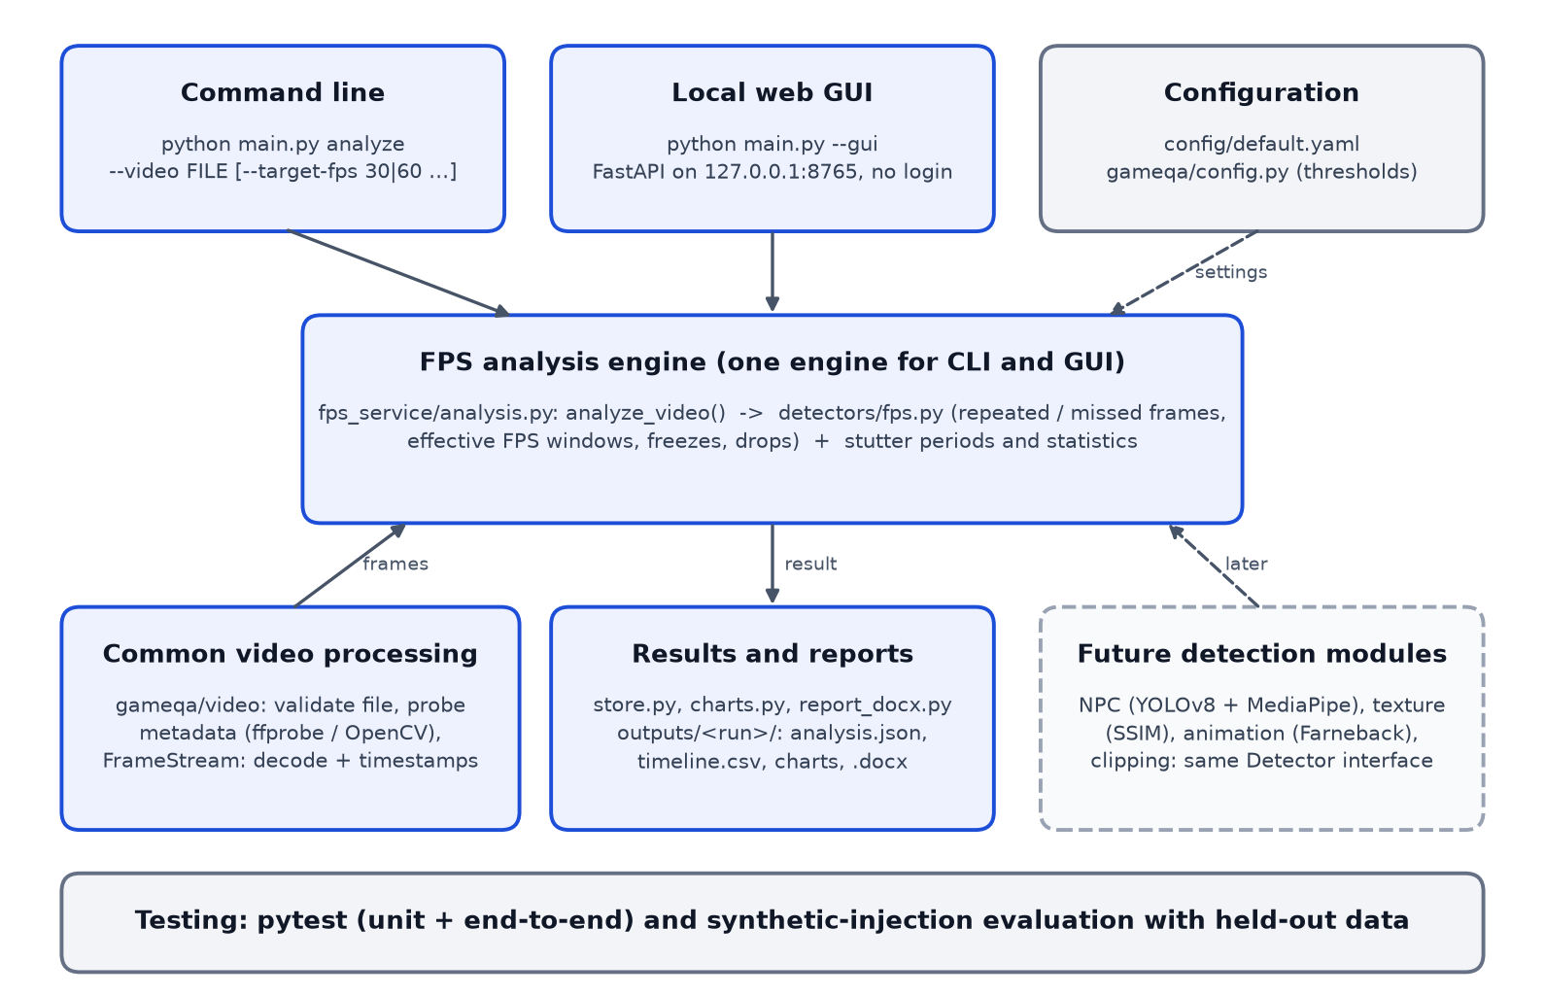
Figure 1. Architecture of the prototype. Solid boxes are implemented; the dashed box is future work.
Table 3. Components of the prototype
Component | Location | Responsibility
Common video processing | backend/src/gameqa/video/ | Validates the file, reads metadata with ffprobe (OpenCV fallback) and decodes frames with their presentation timestamps (FrameStream).
FPS analysis engine | gameqa/fps_service/analysis.py, gameqa/detectors/fps.py | analyze_video(): the single analysis function used by both interfaces. Classifies frames, computes windows, events and statistics.
Command-line interface | main.py (project root) | Argument parsing, progress bar, terminal summary, exit codes.
Local web GUI | gameqa/webgui/app.py, webgui/static/ | FastAPI server on 127.0.0.1 with one HTML page; upload, background analysis, progress polling, results and downloads.
Report generation | fps_service/store.py, charts.py, report_docx.py | analysis.json, timeline.csv, windows.json, three PNG charts and FPS_ANALYSIS_REPORT.docx.
Configuration | config/default.yaml, gameqa/config.py | Default target FPS and thresholds, output folder, GUI address; every value can be overridden per run.
Testing | backend/tests/, backend/scripts/eval_prototype_fps.py | Unit and end-to-end tests; synthetic evaluation with tuning and held-out sets.

2.1 Key design decisions
- One engine. The CLI and the GUI both call fps_service.analyze_video() and save_results(); an automated test checks that both give identical results for the same video.
- Local files instead of a database. Each analysis writes one folder outputs/<date-time>_<video>/. This is enough for a single user and easy to inspect.
- No login, local only. The GUI listens on 127.0.0.1 so only the same computer can open it; starting it on another address prints a warning.
- FastAPI + plain HTML/CSS/JavaScript. FastAPI was already used in the repository, starts in about a second, and handles file uploads; the page needs no build step or external scripts.
- Pluggable detectors. Every detector implements the same start / process / finish interface (gameqa/core/detector.py), so later modules can be added next to the FPS engine without changing it (Section 16).

2.2 Folder structure (prototype-relevant parts)
FYP/
├── main.py CLI entry point: analyze --video ... | --gui
├── config/default.yaml default thresholds (fps_service section)
├── backend/
│ ├── pyproject.toml package 'gameqa' and its dependencies
│ ├── src/gameqa/
│ │ ├── video/ validate, probe (ffprobe / OpenCV), FrameStream
│ │ ├── detectors/fps.py repeated / missed frames, windows, freezes, drops
│ │ ├── fps_service/ analysis.py, charts.py, store.py, report_docx.py
│ │ └── webgui/ app.py + static/ (index.html, style.css, app.js)
│ ├── tests/ test_fps_service.py, test_main_cli.py, test_webgui.py, ...
│ └── scripts/ eval_prototype_fps.py, capture_gui_screenshots.py,
│ build_project_docs.py
├── evaluation/ real videos (videos/) and evaluation results (results/)
├── outputs/ one folder per analysis (git-ignored)
└── docs/ PROJECT_DOCUMENTATION.docx, FPS_ANALYSIS_REPORT.docx, screenshots/

3. Prototype scope and implemented functionality
STATUS: IMPLEMENTED AND TESTED

Table 4. Implemented functionality
Input formats | .mp4, .mkv, .avi; other extensions are rejected with a message naming the accepted formats; files whose content is not a video are rejected even with a valid extension.
Metadata | Resolution, codec, container, nominal FPS, average FPS from timestamps, frame count, duration, constant or variable frame rate, file size, audio present.
Frame timing | Interval between every pair of consecutive frames (expected, median, min, max, 99th percentile, number of irregular intervals).
Repeated frames | Frames showing the same picture as the previous one; repeats while the scene moves are counted as missed renders.
Effective FPS | New pictures per second in 1-second windows (every 0.25 s), while the picture moves; mean, median, minimum, 5th percentile; share of the video that could be measured.
Frame times | Time between new pictures while moving: p50, p95, p99, maximum, '1 % low' FPS.
Events | Freeze (picture held ≥ 250 ms while moving), FPS drop (effective FPS below 0.75 × target), stutter (≥ 3 missed frames per second while the average stays above the drop threshold); each with start / end time, frames, duration and description.
Outputs | Terminal summary, analysis.json, timeline.csv, windows.json, three charts, FPS_ANALYSIS_REPORT.docx; in the GUI the same results on screen with downloads.
Interfaces | python main.py analyze --video FILE [options]; python main.py --gui

Out of scope for this prototype, by decision: login, registration or user management; databases; cloud deployment; a complex dashboard; the four other detectors; severity classification. These remain part of the full project (Sections 11–16 and 20).

4. Installation and environment setup
STATUS: IMPLEMENTED AND TESTED — tested on the machine listed in Table 5; not yet tested on Windows or Linux

Table 5. Environment on which the prototype was built and tested (read at build time)
Machine | Apple M1, 8 GB RAM
Operating system | macOS 26.5.1 (macOS-26.5.1)
Python | 3.13.12
OpenCV | 4.14.0.94
NumPy | 2.5.4
FFmpeg / ffprobe | 9.0.1
matplotlib | 3.11.2
python-docx | 1.2.0
FastAPI | 0.162.0
uvicorn | 0.54.0
pydantic | 2.14.3
pytest | 9.2.0
Google Chrome (screenshots only) | 156

4.1 Steps
The commands below are for macOS / Linux. On Windows, the activation command is backend\.venv\Scripts\activate instead of source backend/.venv/bin/activate (not yet tested).
# 1. get the project and open a terminal in it
cd ~/Desktop/FYP
# 2. create a Python 3.10+ virtual environment (3.13 was used)
python3 -m venv backend/.venv
source backend/.venv/bin/activate
# 3. install the package with the web GUI and test dependencies
pip install -e "backend[api,dev]"
# 4. optional but recommended: FFmpeg (ffprobe gives exact metadata)
brew install ffmpeg # macOS (Homebrew)
# 5. check that it works
python main.py --help
cd backend && python -m pytest -q

Without FFmpeg the prototype still works: metadata is then read with OpenCV only and the report contains a warning that the frame count may be an estimate. Running python main.py with a Python that lacks the packages prints the activation instructions instead of a traceback (exit code 3).

5. Using the command-line interface
STATUS: IMPLEMENTED AND TESTED

Activate the environment first (source backend/.venv/bin/activate), then run the commands from the project folder.
Table 6. CLI commands
Command | What it does
python main.py analyze --video "path/to/gameplay.mp4" | Analyse with the defaults (target 60 FPS).
python main.py analyze --video game.mp4 --target-fps 30 | Judge against a 30 FPS target.
python main.py analyze --video game.mp4 --drop-ratio 0.8 --freeze-ms 200 --stutter-min-missed 4 | Custom thresholds.
python main.py analyze --video game.mp4 --output results/run1 | Choose the output folder.
python main.py analyze --video game.mp4 --no-report | Skip the Word report (faster).
python main.py analyze --video game.mp4 --quiet | No progress output (for scripts).
python main.py --gui | Start the local web GUI (Section 6).

5.1 Options (actual --help output)
usage: main.py analyze [-h] --video VIDEO [--target-fps TARGET_FPS]
[--drop-ratio DROP_RATIO] [--freeze-ms FREEZE_MS]
[--stutter-min-missed STUTTER_MIN_MISSED]
[--output OUTPUT] [--no-report]
[--max-events MAX_EVENTS] [--quiet]
options:
-h, --help show this help message and exit
--video VIDEO path to an .mp4, .mkv or .avi file
--target-fps TARGET_FPS
frame rate the game should hold (e.g. 30 or 60)
--drop-ratio DROP_RATIO
drop if effective FPS < ratio x target (default 0.75)
--freeze-ms FREEZE_MS
freeze if a picture is held this long (default 250)
--stutter-min-missed STUTTER_MIN_MISSED
missed frames per second for a stutter (default 3)
--output OUTPUT output folder (default: outputs/<date-time>_<video>)
--no-report skip the Word report
--max-events MAX_EVENTS
events to list in the terminal
--quiet no progress output

5.2 A real run
Output of python main.py analyze --video on the real gameplay recording, captured exactly as printed (output redirected to a file, so progress appears as lines instead of the one-line bar shown in a terminal):
AI Game QA Tester — FPS analysis
video : evaluation/videos/YTDown.com_YouTube_Media_J8HB1-IQFxc_How-to-fix-Weapons-Hands-Clipping-Into-Walls-in-Unity-URP-SRP_001_1080p.mp4
target: 60 FPS (drop < 45 FPS, freeze >= 250 ms, stutter >= 3 missed/s)
0% checking file
10% analysing frame 720 of ~11,955
20% analysing frame 2,160 of ~11,955
31% analysing frame 3,600 of ~11,955
41% analysing frame 5,040 of ~11,955
51% analysing frame 6,480 of ~11,955
61% analysing frame 7,920 of ~11,955
72% analysing frame 9,360 of ~11,955
82% analysing frame 10,800 of ~11,955
92% computing statistics
100% done
writing results and Word report ...
VIDEO
1920x1080, 199.25 s, 11,955 frames, h264
nominal 60 FPS | average 60.0 FPS | constant frame rate
FRAME RATE (while the picture moves)
effective FPS median 57.0 | mean 53.9 | min 5.0
frame time p50 16.67 ms | p99 33.33 ms | 1% low 30.0 FPS
measurable 9% of the video
EVENTS freezes 1 | drops 0 | stutters 4 | missed frames while moving 130
STUTTER 00:00.750 - 00:02.750 Uneven frame pacing: up to 5 missed frames per second while the average stayed at 55 FPS
STUTTER 00:04.750 - 00:07.250 Uneven frame pacing: up to 9 missed frames per second while the average stayed at 51 FPS
STUTTER 00:08.750 - 00:12.750 Uneven frame pacing: up to 5 missed frames per second while the average stayed at 55 FPS
STUTTER 00:14.500 - 00:18.250 Uneven frame pacing: up to 6 missed frames per second while the average stayed at 54 FPS
FREEZE 00:18.367 - 00:19.417 Picture held for 1050 ms while the scene was moving
RESULT Detected 1 freeze(s), 4 stutter period(s) in the 9% of the video that could be measured.
output folder: /Users/amh/Desktop/FYP/outputs/20261107-223236_YTDown.com_YouTube_Media_J8HB1-IQFxc_How-to-fix-Weapons-Hand
Word report : /Users/amh/Desktop/FYP/outputs/20261107-223236_YTDown.com_YouTube_Media_J8HB1-IQFxc_How-to-fix-Weapons-Hand/FPS_ANALYSIS_REPORT.docx
note: effective FPS is measured from the recording; it is not the game's internal FPS.
exit=0

Table 7. Exit codes
Exit code | Meaning
0 | analysis finished; results written
2 | invalid input: missing file, unsupported format, not a video, damaged video, invalid option value
3 | wrong Python environment (packages missing): prints how to activate backend/.venv

Error messages are one line and name the problem, for example:
AI Game QA Tester — FPS analysis
video : missing_video.mp4
target: 60 FPS (drop < 45 FPS, freeze >= 250 ms, stutter >= 3 missed/s)
0% checking file
ERROR: 'missing_video.mp4' does not exist or is not a file
exit=2
AI Game QA Tester — FPS analysis
video : notes.mov
target: 60 FPS (drop < 45 FPS, freeze >= 250 ms, stutter >= 3 missed/s)
0% checking file
ERROR: 'notes.mov': format .mov is not supported. Accepted formats: .avi, .mkv, .mp4
exit=2

6. Opening and using the GUI
STATUS: IMPLEMENTED AND TESTED

source backend/.venv/bin/activate
python main.py --gui # opens http://127.0.0.1:8765 in the default browser
python main.py --gui --port 8800 # another port
python main.py --gui --no-browser # start the server only, open the address yourself
# stop: Ctrl+C in the terminal

No login, password or account is needed. The page runs only on this computer. If the port is already in use (for example the GUI is already running), the command says so and suggests the next port.
- Drop a video on the dashed area or click it to choose a file (.mp4, .mkv or .avi).
- Choose the target frame rate (60, 30, 120 or 144 FPS). Advanced thresholds are optional.
- Click Analyze Video. The bar shows the upload and then the frame being analysed.
- Read the results: verdict, key numbers, effective FPS chart, events with timestamps, more charts, video details and limitations.
- Click Download Word report for FPS_ANALYSIS_REPORT_<video>.docx (or JSON for the raw data).
- Click Analyse another video to start again. The address #job=<id> reopens a result while the GUI runs.
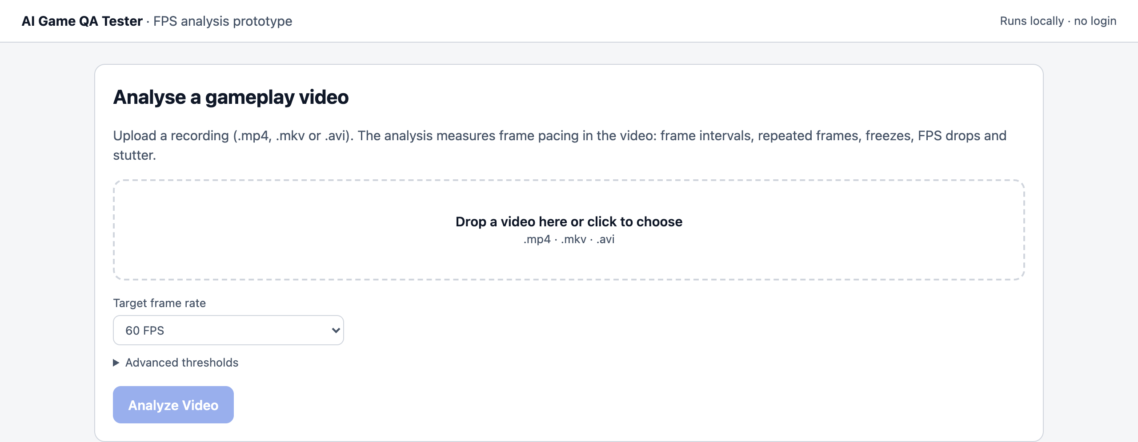
Figure 2. Start page (real screenshot, light mode).
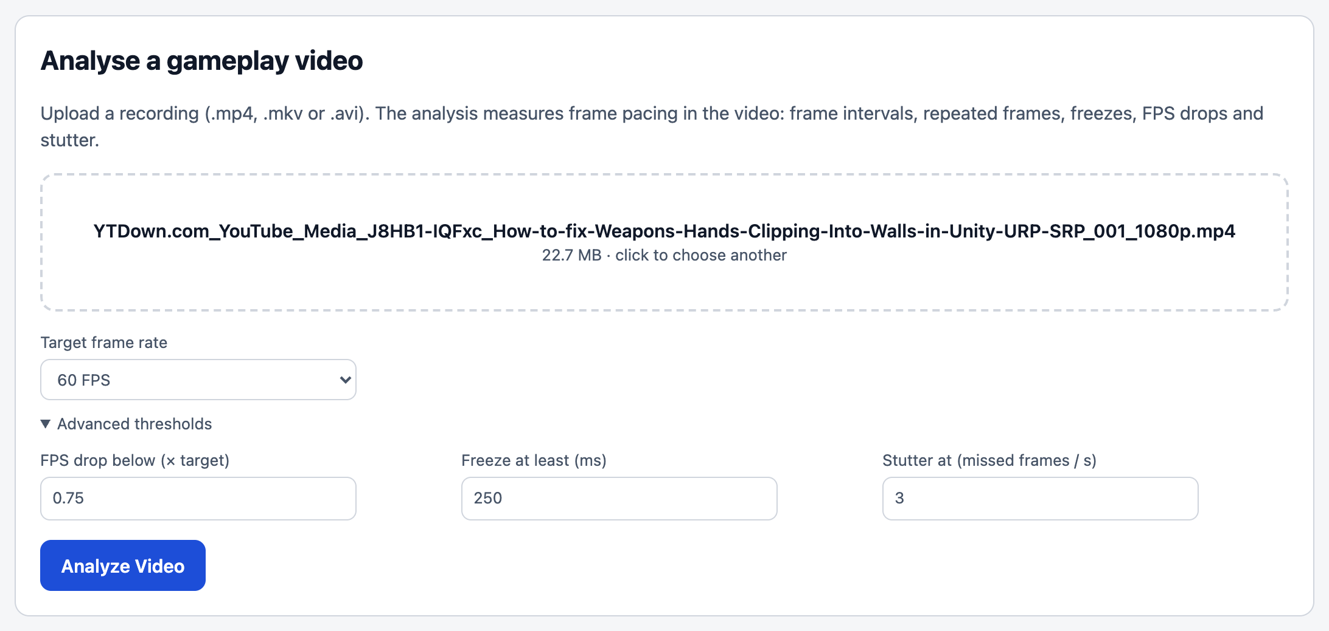
Figure 3. The real gameplay video selected, advanced thresholds open.
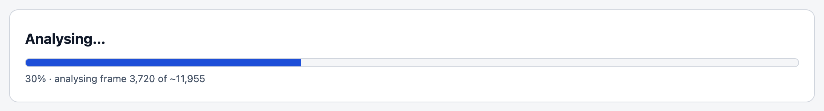
Figure 4. Progress while the real video is analysed.
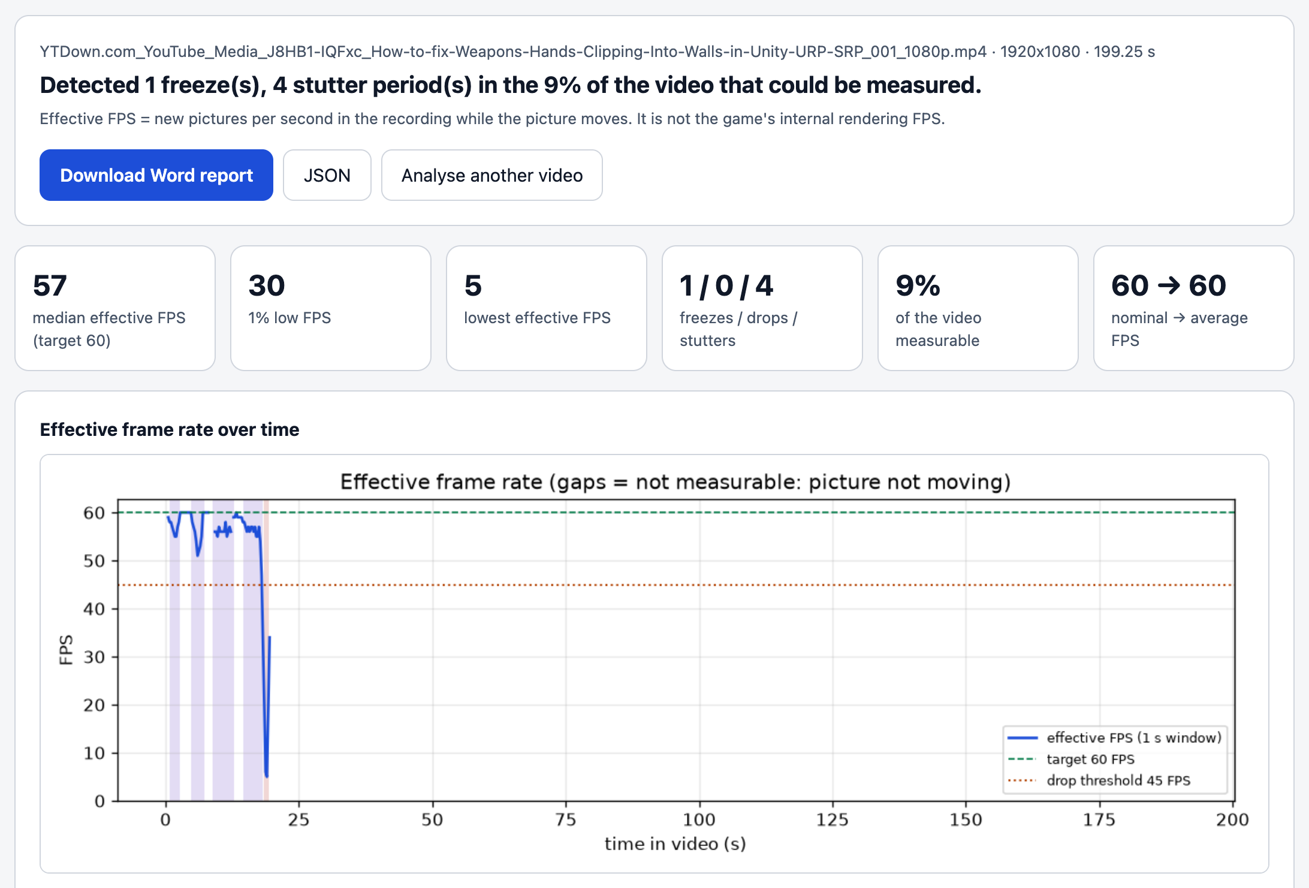
Figure 5. Results for the real video: verdict, key numbers, effective FPS chart.
A step-by-step script for demonstrating the prototype (commands, expected results, likely questions) is delivered separately as docs/DEMO_GUIDE.docx.

7. The video-processing pipeline
STATUS: IMPLEMENTED AND TESTED

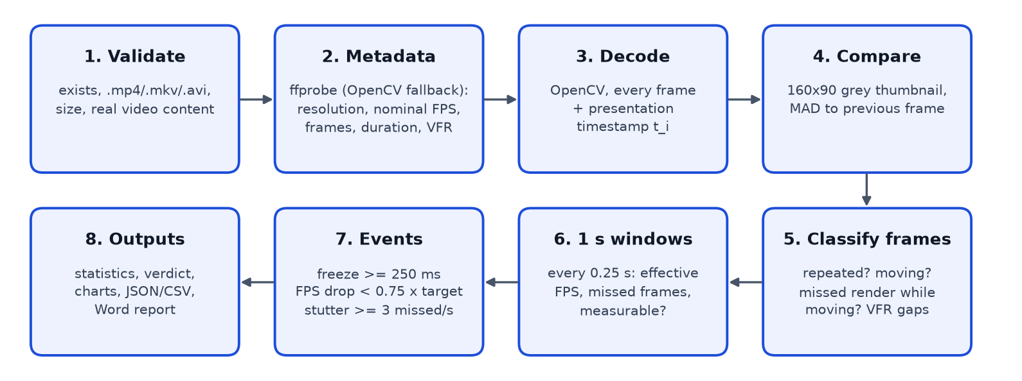
Figure 6. Processing steps from the video file to the report.
Table 8. Pipeline steps
Step | What happens
1. Validate | The path must exist and be a file; the extension must be .mp4, .mkv or .avi; the size must be under the limit (2 GB); the first bytes must match a video container, so a text file renamed to .mp4 is rejected before decoding.
2. Metadata | ffprobe reads codec, container, resolution, nominal frame rate (r_frame_rate), average frame rate, frame count, duration and whether the frame rate is variable. Without ffprobe, OpenCV's properties are used.
3. Decode | OpenCV decodes every frame (full rate: frame timing needs all frames). Each frame carries its presentation timestamp t_i from the container, cross-checked with the decoder.
4. Compare | Each frame is reduced to a 160 × 90 greyscale thumbnail and compared with the previous one (mean absolute difference, Eq. 5). Small thumbnails make the comparison fast and robust to compression noise.
5. Classify | Repeated picture? Scene moving? A repeated picture inside motion is a missed render; in variable-frame-rate files a long interval hides missing frames (Section 8).
6. Windows | A 1-second window slides in 0.25 s steps; in each moving window the new pictures are counted (effective FPS) and missed frames are summed.
7. Events | Freezes, FPS drops and stutter periods are found with persistence rules (Section 8.4).
8. Outputs | Statistics, verdict, three charts, analysis.json, timeline.csv, windows.json and the Word report are written to outputs/<date-time>_<video>/.

8. FPS detection methodology
STATUS: IMPLEMENTED AND TESTED

8.1 What a video can and cannot tell
A recording does not contain the game's frame times. It contains the pictures the recorder captured. Four different quantities are easily confused, so the prototype keeps them apart:
Table 9. Nominal FPS vs timestamps vs repeated frames vs true engine FPS
Quantity | Definition | What it reveals | Measurable from the video?
Nominal FPS | The rate written in the file header (e.g. 60). | The recorder's setting, not the game. | Yes (metadata)
Presentation timestamps | The time at which each frame should be shown. | Gaps in variable-frame-rate recordings where the game delivered no frame. | Yes, when the container has timestamps
Repeated frames | Consecutive frames with the same picture. | In constant-frame-rate recordings a skipped render appears as a repeated picture. | Yes, while the scene moves
True engine FPS | How many frames the game rendered per second. | Ground truth. | No. Needs a profiler log or an on-screen FPS counter

The prototype therefore reports an effective FPS: the number of new pictures per second visible in the recording while the scene moves. It is capped by the recording rate (a 60 FPS recording cannot show a drop from 144 to 90 FPS) and is not the game's internal FPS; the reports say this explicitly.

8.2 Repeated and missed frames
Two consecutive frames show the same picture when their thumbnail difference is below 0.25 grey levels (Eq. 6). Repeated frames are not bit-identical after lossy compression: differences of 0.02–0.14 were measured at CRF 18, and the threshold was calibrated on the tuning set. A repeated picture says nothing on its own: in a menu, a paused game or when the player stands still every frame repeats. A repeat is therefore counted as a missed render only when the scene is clearly moving on both sides: the frame before and the frame after the hold must both differ by at least 1.0 grey level (abrupt edges), and the median motion of three changing frames within 0.25 s on each side must also be at least 1.0 (sustained motion). A player slowing to a stop decelerates gradually and fails this test; a stalled renderer stops and restarts within one frame and passes it. This rule came from the real footage, where 91 % of the editor segment consists of identical frames.
Variable-frame-rate recordings store the same information differently: instead of repeating a picture, the recorder leaves a longer interval. An interval of k normal intervals hides k − 1 frames (Eq. 9). These hidden frames are treated exactly like k − 1 repeated frames of a constant-frame-rate file, placed at their own times inside the gap: missed renders only if the same abrupt-edge and sustained-motion test passes, otherwise a still stretch. (Phase 6 found that an earlier version counted every gap as missing pictures; see Section 17.6.)
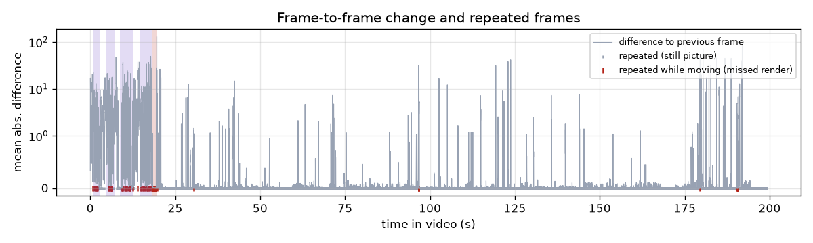
Figure 7. Frame-to-frame change in the real video; red marks are repeated frames during motion (missed renders).

8.3 Effective FPS windows
A 1-second window moves through the video in 0.25 s steps. A window is measurable when it holds at least two frames and at least half of its frames are moving. In a measurable window, effective FPS is the number of frames that are not missed renders (Eq. 10). Windows that are not measurable are shown as gaps in the charts and reported as the 'measurable' share of the video.

8.4 Events and default thresholds
Table 10. Detected events and their thresholds
Event | Rule | Default (config/default.yaml) | CLI option
Freeze | One picture held for ≥ 250 ms while the scene moves on both sides (also: a timestamp gap ≥ 250 ms between two moving pictures in VFR files). | freeze_ms = 250 | --freeze-ms
FPS drop | Effective FPS below drop ratio × target in at least two consecutive windows (≥ 0.5 s). | drop_ratio = 0.75, target_fps = 60 (→ 45 FPS) | --drop-ratio, --target-fps
Stutter | At least K missed frames in a window while effective FPS stays ≥ the drop threshold, in at least two consecutive windows, not overlapping a freeze or a drop (uneven pacing, not a low average). | stutter_min_missed K = 3 | --stutter-min-missed

Internal constants (not exposed as options): thumbnail 160 × 90; repeat threshold 0.25; motion threshold 1.0; window 1 s, step 0.25 s; moving share ≥ 0.5; motion context 3 frames within 0.25 s. They were fixed on the tuning set before the held-out evaluation (Section 17).

9. Mathematical equations and calculations
STATUS: IMPLEMENTED AND TESTED

Notation: N frames with presentation timestamps t_1 < t_2 < … < t_N (seconds); G_i is frame i reduced to a 160 × 90 greyscale image.
FPS_nominal = r_frame_rate of the stream (e.g. 60/1) (1)
read from the container header by ffprobe
Δt_i = t_(i+1) − t_i , i = 1 … N−1 (2)
frame (presentation) interval
FPS_avg = (N − 1) / (t_N − t_1) (3)
average FPS from timestamps
Δt_expected = 1000 / FPS_nominal ms; irregular ⇔ |Δt_i − median(Δt)| > 0.25 · median(Δt) (4)
expected interval and irregular-interval count
MAD_i = (1 / (W·H)) · Σ_x Σ_y | G_i(x, y) − G_(i−1)(x, y) | , W = 160, H = 90 (5)
mean absolute difference between consecutive thumbnails (grey levels 0–255)
repeated_i ⇔ MAD_i < τ_rep , τ_rep = 0.25 (6)
frame i shows the same picture as frame i−1
missed(a…b) ⇔ MAD_(a−1) ≥ τ_mov ∧ MAD_(b+1) ≥ τ_mov ∧ M_before ≥ τ_mov ∧ M_after ≥ τ_mov (7)
frames a…b repeat frame a−1; M = median MAD of 3 changing frames within 0.25 s on that side; τ_mov = 1.0
hold = t_(b+1) − t_(a−1) ; freeze ⇔ missed(a…b) ∧ hold ≥ 0.250 s (8)
length of a held picture
k_i = round(Δt_i / median(Δt)) − 1 , hidden frames at t_i + m · median(Δt), m = 1 … k_i (9)
frames hidden inside a VFR interval; treated like repeated frames (missed only if Eq. 7's test passes)
FPS_eff(w) = #{ i : t_i ∈ [w, w + 1 s), not missed_i } / 1 s (10)
effective FPS of a measurable window, w = t_1, t_1 + 0.25 s, …
drop ⇔ FPS_eff(w) < r · FPS_target for ≥ 2 consecutive windows , r = 0.75 (11)
at a 60 FPS target the drop threshold is 0.75 × 60 = 45 FPS
stutter ⇔ missed(w) ≥ K ∧ FPS_eff(w) ≥ r · FPS_target for ≥ 2 consecutive windows , K = 3 (12)
missed(w) = missed renders + VFR missing frames in the window; the event is widened by 0.5 s on each side
FT_j = t(next new picture) − t(new picture j) , 1 % low FPS = 1 / P99(FT) (13)
frame times while moving; P99 = 99th percentile
measurable share = measurable windows / all windows (14)
P = TP / (TP + FP) , R = TP / (TP + FN) , F1 = 2·P·R / (P + R) (15)
evaluation metrics (Section 17); an event matches a ground-truth event of the same type that it overlaps

9.1 Worked example: the real video
Table 11. Equations applied to the real recording (values from analysis.json)
Frames, first and last timestamp | N = 11,955; duration 199.25 s
Average FPS (Eq. 3) | (11,955 − 1) / (199.25 s) ≈ 60.0 FPS (nominal 60.0)
Intervals (Eq. 2, 4) | expected 16.667 ms; median 16.667 ms; min 16.666 / max 16.667 ms; irregular intervals: 0 → constant frame rate
Drop threshold (Eq. 11) | 0.75 × 60 = 45 FPS
Effective FPS (Eq. 10) | median 57.0, mean 53.9, min 5.0, 5th percentile 27.4 FPS over the 9 % measurable part
1 % low (Eq. 13) | P99 frame time 33.33 ms → 1 / 0.0333 s = 30.0 FPS
Repeated / missed | 10,684 repeated frames in total, of which 130 during motion (missed renders)

10. Technologies and libraries
Table 12. Technologies (versions read from the installed environment)
Technology | Version | Used for | Used by the prototype?
Python | 3.13.12 | Language of the whole system. | Yes
OpenCV | 4.14.0.94 | Video decoding (VideoCapture), image resizing and colour conversion. The contrib-headless build avoids the GUI dependencies and the clash between the OpenCV wheels of ultralytics and mediapipe. | Yes
NumPy | 2.5.4 | Array maths: differences, percentiles, windows. | Yes
FFmpeg / ffprobe | 9.0.1 | Exact metadata and timestamps; optional (OpenCV fallback). | Yes (optional)
pydantic / pydantic-settings | 2.14.3 / 2.16.2 | Typed, validated configuration and result objects (invalid thresholds are rejected). | Yes
PyYAML | 6.0.3 | Reads config/default.yaml. | Yes
matplotlib | 3.11.2 | The three charts (PNG) and the diagrams in this document. | Yes
python-docx | 1.2.0 | FPS_ANALYSIS_REPORT.docx and this document. | Yes
FastAPI + uvicorn | 0.162.0 / 0.54.0 | Local web server of the GUI; chosen because it is light, already used in the repository, and supports file upload with python-multipart (0.0.33). | Yes
HTML, CSS, JavaScript | — | The GUI page; no framework, no build step, no external scripts. | Yes
pytest + httpx | 9.2.0 / 0.28.1 | Automated tests, including the GUI API. | Yes
scikit-image | 0.26.0 | SSIM for the texture pop-in detector. | No (future module)
Ultralytics YOLOv8 | 8.4.204 | Person detection for the NPC detector. | No (future module)
MediaPipe | 1.2.2 | Pose landmarks for the NPC detector. | No (future module)

11. NPC detection with YOLOv8
STATUS: IN DEVELOPMENT — code in gameqa/detectors/npc.py; unit-tested; not validated — no footage with characters

YOLOv8 is a one-stage convolutional object detector. A backbone network extracts features at three scales; a detection head predicts, for every location of each feature map, a bounding box (centre, width, height) and a score for each class, in a single forward pass. Overlapping predictions of the same object are merged by non-maximum suppression. The model used (YOLOv8n, COCO weights) knows the class 'person', which is how human-like game characters are found.
- Locating characters: frames sampled at 12 FPS; boxes of class person with confidence ≥ 0.4 are kept and normalised to the frame size.
- Tracking: a box is linked to the existing track with the highest overlap (IoU ≥ 0.3, Eq. 16) seen in the last 0.5 s, so each character gets an identity over time.
- Filtering: tracks that touch the bottom screen edge in ≥ 80 % of observations and stay fixed on screen are the player's own first-person hands and are ignored (on the real video all 48 YOLO 'person' hits were the player's gloved hand, confidence 0.42–0.49; the detector reported 0 NPC anomalies, which is correct for a video without characters).
- Output: each track's box crops the frame for pose estimation (Section 12).
IoU(A, B) = area(A ∩ B) / area(A ∪ B) (16)
overlap of two boxes (also used in Section 15)
Tested so far: the model pipeline on a real photograph (person found with confidence > 0.5, pose found) and the rules on synthetic keypoints. Not tested: real game characters. Limitations: COCO and MediaPipe were trained on real people, so stylised, non-human, very small or heavily occluded characters are missed.

12. MediaPipe pose estimation
STATUS: IN DEVELOPMENT — T-pose, frozen NPC and ragdoll rules implemented; floating NPC is proposed only

MediaPipe PoseLandmarker estimates 33 body landmarks (nose, shoulders, elbows, wrists, hips, knees, ankles, …), each with x, y, a relative depth z and a visibility score. It handles one person per image, so it runs on each YOLO crop. Joint angles are computed from three landmarks:
θ_b = arccos( ((a − b) · (c − b)) / (‖a − b‖ · ‖c − b‖) ) (17)
angle at joint b, e.g. elbow (a = shoulder, b = elbow, c = wrist)
Table 13. NPC anomaly rules
Anomaly | Rule (temporal tracking over the track's history) | Status
T-pose | Both elbows ≥ 150° (straight arms), upper arms 70–110° from the torso, wrist-to-wrist span ≥ 2.2 × shoulder width, held ≥ 1 s. | In Development
Frozen NPC | Landmarks in box-relative coordinates barely change (std ≤ 0.012) over 2 s while the box moves ≥ 0.5 box heights in the world (camera motion removed): sliding without walking. A character standing still is not reported. | In Development
Ragdoll anomaly | Mean landmark jump ≥ 0.35 box heights per analysed frame for ≥ 0.25 s (limbs teleporting); a heuristic, not a physics check. | In Development
Floating character | Needs a ground reference: a single 2-D view has no depth, so contact cannot be measured. Possible approaches: feet-to-shadow contact, monocular depth estimation, or a learned classifier on labelled examples. | Proposed for Future Phases

13. SSIM and autoencoder methodology (texture pop-in)
STATUS: IN DEVELOPMENT — SSIM detector in gameqa/detectors/texture.py; autoencoder proposed

Texture pop-in is a surface suddenly changing its level of detail (blurry → sharp) between two frames. The Structural Similarity Index compares two image patches x and y by luminance, contrast and structure:
SSIM(x, y) = ((2μ_x μ_y + C1)(2σ_xy + C2)) / ((μ_x² + μ_y² + C1)(σ_x² + σ_y² + C2)) (18)
μ means, σ² variances, σ_xy covariance of the patches; C1, C2 small constants; 1 = identical
- Comparing consecutive frames: every frame, 480 × 270 greyscale; the previous frame is first aligned to the current one (phase correlation, ORB + RANSAC fallback).
- Finding sudden changes: the SSIM map is averaged per grid cell; cells far above the frame's own typical dissimilarity (median + k·MAD) are candidates.
- Camera movement: removed by the alignment; frames that cannot be aligned are skipped.
- Lighting changes: a pop-in keeps the colour layout (low-pass difference small) but changes high-frequency detail by a large factor; a lighting change does the opposite.
- Scene transitions: frames whose typical dissimilarity is high everywhere (cuts, fades, fast motion) are skipped; a pop-in must be local and stay quiet afterwards.
Recorded results (DEVELOPMENT_PROGRESS.md, Phase 4): held-out synthetic set precision 0.833, recall 0.703, F1 0.763; on the real video 9 detections, all false positives caused by editor interface elements. Real recall is unknown because no real pop-in footage is available.

13.1 Convolutional autoencoder (proposed)
STATUS: PROPOSED FOR FUTURE PHASES

An autoencoder is trained only on clean frames (or patches) of a game. The encoder E compresses the input to a small code and the decoder D reconstructs it. Patterns seen in training reconstruct well; unusual ones (missing or low-resolution textures, magenta placeholder materials) reconstruct badly:
e(x) = (1 / n) · ‖x − D(E(x))‖² ; anomaly ⇔ e(x) > P99 of e on clean validation frames (19)
reconstruction error and threshold
Requirements before it can be built: clean footage of the target game for training, labelled defects for validation, and a GPU for training in reasonable time.

14. Farneback optical flow methodology (animation glitches)
STATUS: IN DEVELOPMENT — gameqa/detectors/animation.py; validated on synthetic data only

Dense optical flow estimates a motion vector for every pixel between two consecutive frames. Farneback's method approximates each neighbourhood of an image by a quadratic polynomial f(x) ≈ xᵀAx + bᵀx + c. If the neighbourhood moves by d, the polynomial's coefficients change, and d can be solved from them:
d = −½ · A⁻¹ · (b₂ − b₁) (20)
displacement from the polynomial coefficients of frames 1 and 2 (solved iteratively over an image pyramid)
- Camera motion: the global translation is estimated and removed, leaving the motion of objects.
- Jitter: flow (or camera motion) that reverses direction frame after frame with magnitude ≥ 1.5 px, with at least 5 direction reversals in the recent window; normal movement keeps its direction.
- Flicker: a region's brightness alternating up and down by ≥ 20 grey levels in ≥ 4 of 7 frame pairs.
- Unnatural transition: a one-frame spike in image change ≥ 3 × both neighbours (camera snap, missing keyframe).
- Temporal consistency: events must persist over several frames; duplicates are merged.
Recorded results (Phase 5): held-out synthetic precision 0.940, recall 0.904, F1 0.922. On the real video: one video-edit cut (indistinguishable from a teleport by definition) and one false jitter during a fast camera pitch. Limitations: when the whole scene or the camera moves quickly, alignment fails and intended effects (screen shake, strobe lights, hit flashes) look like glitches.

15. Collision and geometry clipping methodology
STATUS: IN DEVELOPMENT — experimental code in gameqa/detectors/clipping.py; FAILED validation; not usable yet

The SRS proposes detecting dynamic objects and characters with YOLOv8 and checking their bounding boxes for overlap (IoU, Eq. 16) with environmental objects; overlap that persists over time would indicate clipping.
Why box overlap alone cannot prove clipping:
- In a single 2-D view an object behind a wall (correct occlusion) and an object inside the wall (clipping) produce the same overlap; there is no depth.
- COCO-trained YOLO has no classes for walls, floors or terrain, so there is no geometry box to compare with.
- Boxes are coarse: a weapon tip entering a wall changes a few pixels, far below box precision.
What was tried: learning the first-person weapon ('viewmodel') appearance and reporting when its tip stops matching while the body still matches. On real footage with 9 hand-labelled clipping events, the frame-level check on held-out data gave precision 0.43 at recall 0.87, against 0.39 for always saying 'clipping': essentially chance. It is therefore labelled failed validation.
Approaches that could work better: semantic segmentation of walls / floors; monocular depth estimation to compare object and surface depth; engine collision logs as ground truth; a classifier trained on labelled clipping clips; temporal reasoning (an object should be visible before it disappears into a surface).

16. Future integration plan
STATUS: PROPOSED FOR FUTURE PHASES

All detectors implement the same interface (gameqa/core/detector.py): start(video) → process(frame) for each frame → finish() returning detections with category, subtype, start / end time and frame, confidence and evidence. The FPS engine already uses this interface through FpsDropDetector, so new modules plug in next to it without changes:
- One decoder pass feeds all detectors: full-rate modules (FPS, texture, animation) receive every frame, sampled modules (NPC, clipping) every fifth frame (12 FPS for a 60 FPS video).
- The CLI gains a --modules option (e.g. --modules fps,texture); the GUI shows a checkbox per module. Modules that are not validated stay off by default.
- Each module adds its own section and charts to the Word report; analysis.json gains one list per module.
- A rule-based severity (Low / Medium / High) from affected area, duration and recurrence is applied to all detections, as specified in the SRS.
Table 14. Integration order and gates
Module | Needed before integration | Validation gate
Texture pop-in | Suppress UI regions (static screen areas); real footage with pop-ins for testing | Real-footage precision ≥ 0.8 on labelled clips
Animation glitches | Real footage with jitter / flicker; handling of video-edit cuts | Held-out real F1 measured and documented
NPC anomalies | Footage with characters (and deliberately broken animations) | T-pose and frozen-NPC precision / recall on labelled clips
Clipping | New method (segmentation or depth) — current method failed | Better than the 'always clipping' baseline on held-out data
Unified report + severity | All above; severity calibrated against human ratings | Agreement with tester ratings

17. Testing methodology and actual results
STATUS: IMPLEMENTED AND TESTED

17.1 Methodology
- Automated tests (pytest): unit tests of every rule, end-to-end runs of the CLI and the GUI API on real decoding, invalid-input tests.
- Synthetic injection with ground truth: freezes, FPS drops and stutter are injected into clean generated videos at known times; detections are matched to them by type and overlap. Thresholds were tuned on seed 0 only; seeds 1–3 were generated afterwards and re-encoded at CRF 23 (held out, never used for tuning).
- Real footage: the analysis of a real gameplay recording was reviewed frame by frame at the reported times. There is no profiler ground truth for this video, so it is reviewed, not scored.
- Manual interface tests: the CLI in a real terminal and the GUI in a browser, including error cases.

17.2 Automated tests
Table 15. Automated tests
Test file | Tests | What is checked
tests/test_fps_service.py | 14 | Missing / unsupported / text-as-video / damaged files, constant-frame-rate statistics, VFR gap → freeze, stutter vs drop, configurable thresholds, OpenCV fallback, saved files, too-short video.
tests/test_main_cli.py | 8 | Report contents, command-line thresholds, five invalid inputs (exit 2 + message), running exactly as python main.py analyze.
tests/test_webgui.py | 8 | Page without login, upload → results flow, GUI and CLI give identical results, unsupported format, fake video, invalid setting, browser opening, port in use.
Whole repository | — | Full suite result: 209 passed, 3 xfailed, 2 warnings in 73.80s (0:01:13). The expected failures are the experimental clipping detector (Section 15).

17.3 Synthetic evaluation
Table 16. Synthetic evaluation (from evaluation/results/prototype_fps/report_seeds_*.md)
Event | Set | TP | FP | FN | Precision | Recall | F1
Stutter | Tuning (seed 0 + 2 clean videos) | 5 | 0 | 0 | 1.000 | 1.000 | 1.000
Stutter | Held-out (seeds 1–3, CRF 23) | 11 | 0 | 0 | 1.000 | 1.000 | 1.000
Freeze | Tuning (seed 0 + 2 clean videos) | 2 | 0 | 0 | 1.000 | 1.000 | 1.000
Freeze | Held-out (seeds 1–3, CRF 23) | 8 | 0 | 1 | 1.000 | 0.889 | 0.941
FPS drop | Tuning (seed 0 + 2 clean videos) | 2 | 0 | 0 | 1.000 | 1.000 | 1.000
FPS drop | Held-out (seeds 1–3, CRF 23) | 7 | 0 | 0 | 1.000 | 1.000 | 1.000

The one missed held-out freeze: after CRF 23 compression its first repeated frame differed by 0.68 grey levels from the previous one (above the 0.25 repeat threshold), so the hold seemed to start one frame later after a 'slowing' frame and the abrupt-edge rule rejected it. The threshold was not changed on the held-out data; this is recorded as a limitation.

17.4 Real gameplay recording
Table 17. Real-video results (analysis.json of the run named on the title page)
Video | YTDown.com_YouTube_Media_J8HB1-IQFxc_How-to-fix-Weapons-Hands-Clipping-Into-Walls-in-Unity-URP-SRP_001_1080p.mp4
Format | 1920x1080, h264, 199.25 s, 11,955 frames, 22.68 MB, constant frame rate
Content | A Unity tutorial: about 19 s of first-person gameplay followed by editor footage.
Nominal / average FPS | 60.0 / 60.0
Effective FPS | median 57.0, mean 53.9, min 5.0 (target 60)
Frame times | p50 16.67 ms, p99 33.33 ms → 1 % low 30.0 FPS
Measurable | 9 % of the video (the moving part)
Events | 1 freeze, 0 FPS drops, 4 stutter periods; 130 missed frames while moving
Processing | 23.36 s (8.53× real time) on the machine in Table 5

Table 18. Events detected in the real video
Event | Start | End | Duration | Description
Stutter | 00:00.750 | 00:02.750 | 2.00 s | Uneven frame pacing: up to 5 missed frames per second while the average stayed at 55 FPS
Stutter | 00:04.750 | 00:07.250 | 2.50 s | Uneven frame pacing: up to 9 missed frames per second while the average stayed at 51 FPS
Stutter | 00:08.750 | 00:12.750 | 4.00 s | Uneven frame pacing: up to 5 missed frames per second while the average stayed at 55 FPS
Stutter | 00:14.500 | 00:18.250 | 3.75 s | Uneven frame pacing: up to 6 missed frames per second while the average stayed at 54 FPS
Freeze | 00:18.367 | 00:19.417 | 1.05 s | Picture held for 1050 ms while the scene was moving

Review: the four stutter periods cover the gameplay part, where isolated exact repeats appear during smooth motion: real uneven pacing in the recording, but whether the game, the recorder or the tutorial's editing caused it cannot be decided from the video. The freeze at 18.37 s is a known false positive: it is the held picture just before an editing transition. No FPS drop was reported, consistent with the median of 57.0 FPS.

17.5 Interface tests
Table 19. CLI and GUI tests
Case | Expected | Actual | Status
CLI, real video | Results + Word report, exit 0 | As Section 5.2; identical on re-run | Implemented and Tested
CLI, missing file / .mov / text renamed .mp4 / --drop-ratio 1.5 / --target-fps 0 | One-line message, exit 2 | As expected (Section 5) | Implemented and Tested
CLI with a Python lacking the packages | Activation instructions, exit 3 | As expected | Implemented and Tested
GUI, real video upload | Progress, results equal to CLI, downloads | Identical results; report and JSON downloaded | Implemented and Tested
GUI, notes.txt | Rejected before upload | Message shown, button disabled | Implemented and Tested
GUI, text file renamed .mp4 | Analysis failed with reason, nothing left on disk | As expected | Implemented and Tested
Second python main.py --gui while running | Port-in-use message, exit 2 | As expected | Implemented and Tested
GUI at phone width (375 px) and in dark mode | Readable, no sideways scrolling | Fixed during testing (long file names), then passed | Implemented and Tested

17.6 Phase 6: CLI and GUI on a test set of videos
Only one real gameplay recording is available, so the Phase 6 test set was derived from it (backend/scripts/phase6_test.py): other containers and codecs, 30 FPS, variable frame rate, a static segment, damaged and tiny files, a non-ASCII file name, and two copies with a freeze or an FPS drop injected at a known time. Each video was analysed with the real CLI and uploaded to the running GUI; invalid inputs were tried in both.
Table 20. Phase 6 test set (from evaluation/results/phase6/results.json)
File | Variant | CLI | GUI | Result / message
real_full_1080p60.mp4 | real recording (original) | exit 0 | same result | 9 % measurable; median 57.0 FPS; 1 / 0 / 4 freeze / drop / stutter
real_gameplay_20s.mp4 | real, first 20 s (gameplay), stream copy | exit 0 | same result | 94 % measurable; median 57.0 FPS; 1 / 0 / 4 freeze / drop / stutter
real_gameplay_20s.mkv | real, MKV container (stream copy) | exit 0 | same result | 94 % measurable; median 57.0 FPS; 1 / 0 / 4 freeze / drop / stutter
real_gameplay_720p.avi | real, AVI container, MPEG-4 Part 2, 720p | exit 0 | same result | 83 % measurable; median 58.0 FPS; 0 / 0 / 5 freeze / drop / stutter
real_gameplay_30fps.mp4 | real, resampled to 30 FPS (target 30) | exit 0 | same result | 95 % measurable; median 30.0 FPS; 1 / 0 / 1 freeze / drop / stutter
real_gameplay_vfr.mp4 | real, repeated frames removed -> variable frame rate | exit 0 | same result | 87 % measurable; median 57.0 FPS; 1 / 0 / 4 freeze / drop / stutter
real_editor_static_30s.mp4 | real, 30 s of the (mostly static) Unity editor | exit 0 | same result | 0 % measurable; nothing moves, so no FPS is reported; 0 / 0 / 0 freeze / drop / stutter
real_gameplay_truncated.mp4 | real 20 s file cut to half its bytes (damaged) | exit 2 | failed | cannot read video 'real_gameplay_truncated.mp4': the file is damaged or incomplete (Invalid data found when processing input)
tiny_2_frames.mp4 | real, only 2 frames | exit 2 | failed | video too short to analyse (fewer than 3 frames)
gameplay clip ü (copy).mp4 | real 20 s, file name with spaces / non-ASCII | exit 0 | same result | 94 % measurable; median 57.0 FPS; 1 / 0 / 4 freeze / drop / stutter
inject_freeze.mp4 | real gameplay 0–18 s, 720p, freeze injected (10.0, 10.8) | exit 0 | same result | 93 % measurable; median 57.0 FPS; 1 / 0 / 4 freeze / drop / stutter. FOUND freeze 10.00–10.80 s (injected 10.0–10.8 s)
inject_drop.mp4 | real gameplay 0–18 s, 720p, 20 FPS drop injected (4.0, 6.5) | exit 0 | same result | 93 % measurable; median 56.5 FPS; 0 / 1 / 3 freeze / drop / stutter. FOUND fps_drop 3.50–6.75 s (injected 4.0–6.5 s)
does_not_exist.mp4 | missing path | exit 2 | not uploadable (not a file) | '/Users/amh/Desktop/FYP/evaluation/synthetic/phase6/invalid/does_not_exist.mp4' does not exist or is not a file
notes.txt | unsupported extension .txt | exit 2 | rejected (415) | 'notes.txt': format .txt is not supported. Accepted formats: .avi, .mkv, .mp4
clip.mov | unsupported extension .mov | exit 2 | rejected (415) | 'clip.mov': format .mov is not supported. Accepted formats: .avi, .mkv, .mp4
text_renamed.mp4 | text file renamed .mp4 | exit 2 | failed | 'text_renamed.mp4' is not a video file (content does not match any accepted container). Accepted formats: .avi, .mkv, .mp4
empty.mp4 | 0-byte .mp4 | exit 2 | failed | 'empty.mp4' is empty
a_folder.mp4 | folder named .mp4 | exit 2 | not uploadable (not a file) | '/Users/amh/Desktop/FYP/evaluation/synthetic/phase6/invalid/a_folder.mp4' does not exist or is not a file

Findings: CLI and GUI gave identical results for every video; both injected defects were found at the injected times; every invalid input produced a one-line reason (exit code 2, or HTTP 415 / a failed job in the GUI) and left no files behind. One bug was found and fixed: in the variable-frame-rate copy a 0.7 s moment where the player stood still (repeated frames removed by the encoder) was reported as an FPS drop, while the same moment in the original file was correctly 'not measurable'. Timestamp gaps now follow the same rule as repeated frames (Section 8.2); a regression test covers it, and the Phase 3 and prototype evaluations were re-run with unchanged scores. The damaged-file message was also made clearer. One finding is recorded, not tuned: in the AVI (MPEG-4 Part 2) re-encode the first frame of the held picture at 18.37 s differs by 0.33 grey levels (threshold 0.25), so that freeze is not reported: the same compression limitation as the one missed held-out freeze.

18. Known limitations and technical challenges
Table 21. Limitations
Limitation | Details
True game FPS | Cannot be recovered from an ordinary recording. Only the pictures the recorder captured are available; ground truth needs profiler logs (e.g. PresentMon, engine profiler) or an on-screen FPS counter.
Recording rate cap | A 60 FPS recording cannot show the game falling from 144 to 90 FPS.
Still scenes | When the picture does not move a repeated frame is indistinguishable from a normal one; such parts are excluded and reported as not measurable (91 % of the real video).
Video editing and intended pauses | Cuts, transitions, hit-stop effects and cut-scene pauses can look like freezes (the real-video freeze is such a case).
Compression noise | Heavy compression can hide the first frame of a freeze (1 of 9 held-out freezes missed; the 18.37 s hold in the AVI re-encode of Phase 6).
Little real footage | Only one real recording, without ground truth, has been analysed; the Phase 6 test videos are derived from it. Recordings from other games, with an FPS counter, and real variable-frame-rate captures are needed to measure error against truth.
Prototype GUI | One analysis at a time; results kept in memory (old result links stop working after a restart, files remain in outputs/); uploaded videos are kept in outputs/<run>/input/; no login, so it must stay on 127.0.0.1.
Platforms | Built and tested on macOS (Apple M1, 8 GB). Windows and Linux are expected to work but were not tested.
Other modules | NPC, texture, animation and clipping detectors are not validated on real defects (Sections 11–15).

Main technical challenges met during development: separating a skipped render from a player standing still (solved with the abrupt-edge and sustained-motion rule); compression noise on repeated frames (calibrated repeat threshold); conflicting OpenCV wheels from ultralytics and mediapipe (single contrib-headless build); Word tables showing without borders in some viewers (explicit borders in the generated documents).

19. Screenshots and actual outputs
STATUS: IMPLEMENTED AND TESTED — all screenshots taken from real runs on the real video

The GUI screenshots were captured automatically from a real upload of the real video by backend/scripts/capture_gui_screenshots.py (headless Chrome driving the page; nothing on the page was edited). Figures 2–5 in Section 6 show the start page, file selection, progress and results.
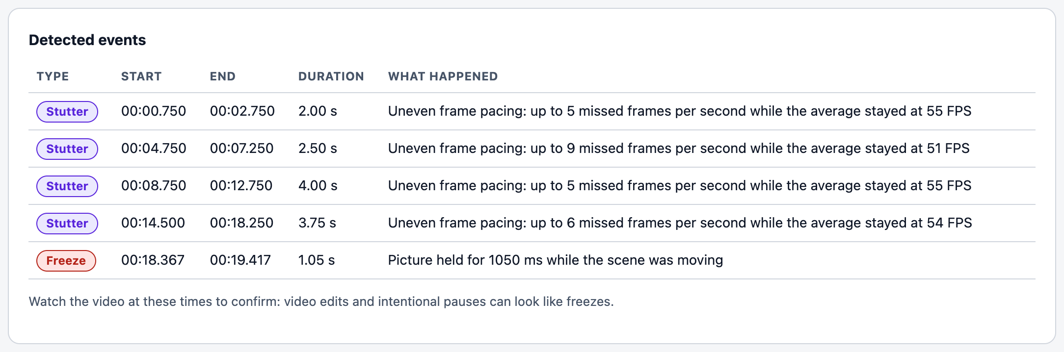
Figure 8. Detected events with timestamps (GUI).
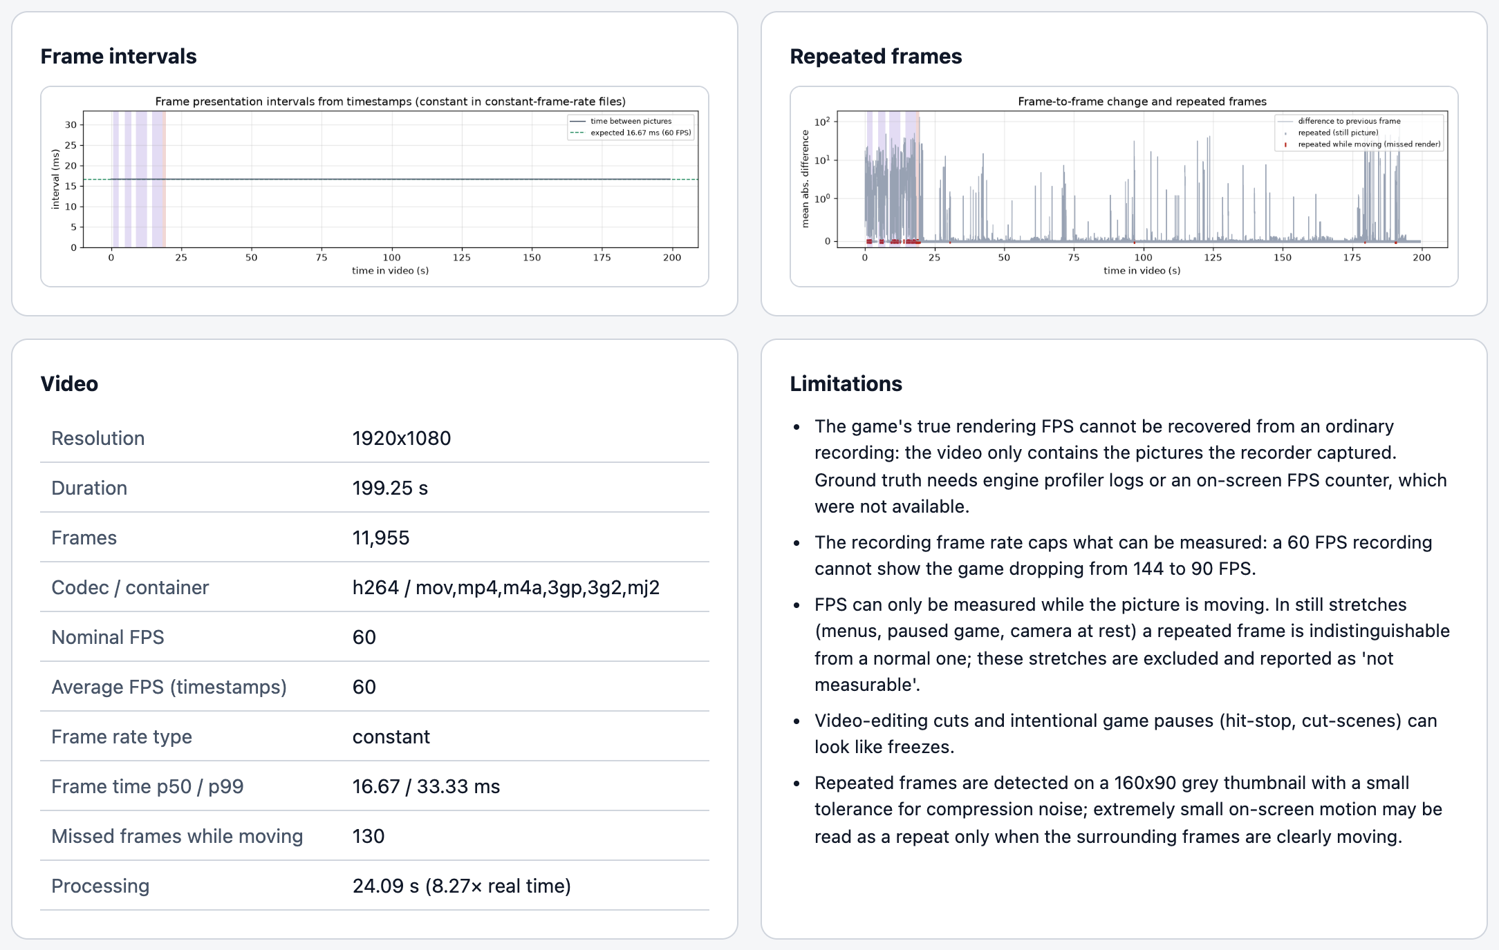
Figure 9. Frame-interval and repeated-frame charts, video metadata and limitations (GUI).
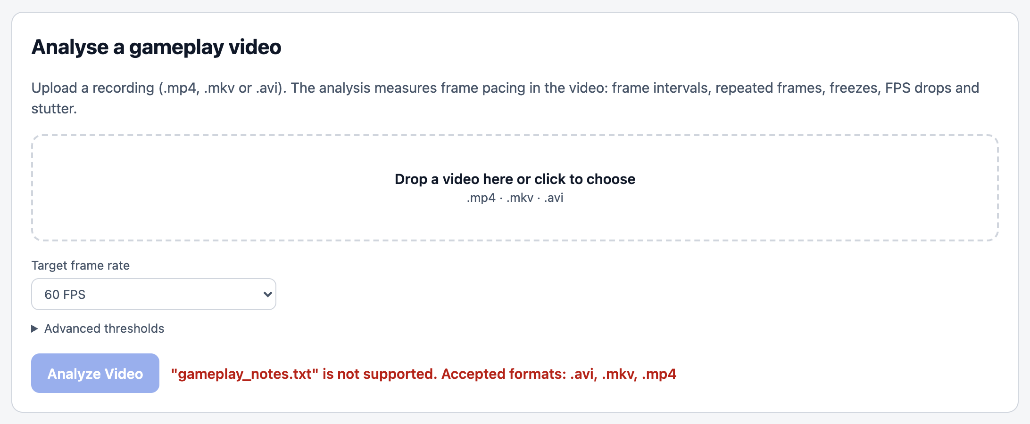
Figure 10. Unsupported file rejected before upload (GUI).
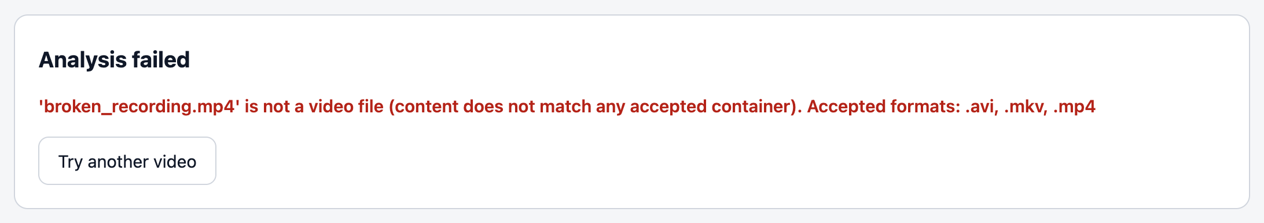
Figure 11. A text file renamed to .mp4: the analysis fails with a clear reason (GUI).
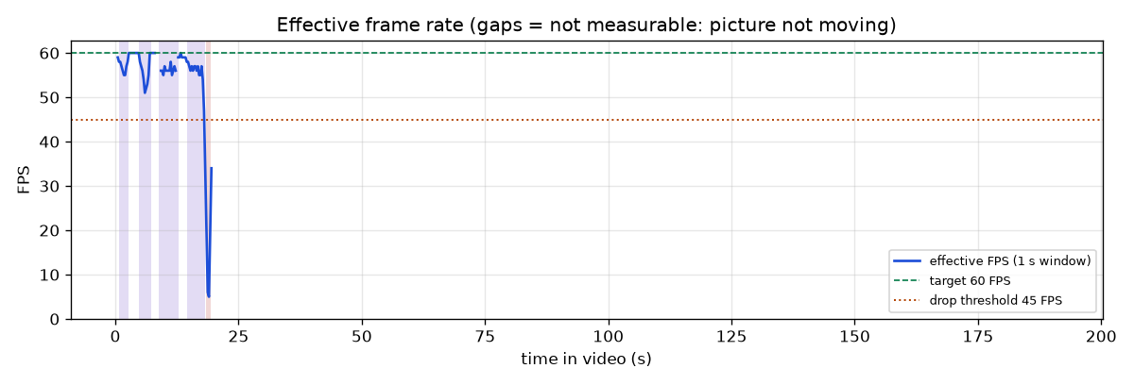
Figure 12. Chart from the output folder: effective FPS over time with target and drop threshold; shaded spans are events.
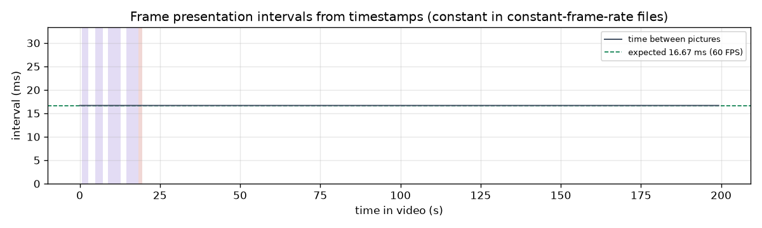
Figure 13. Chart from the output folder: presentation intervals from timestamps (constant, as expected for a CFR file).
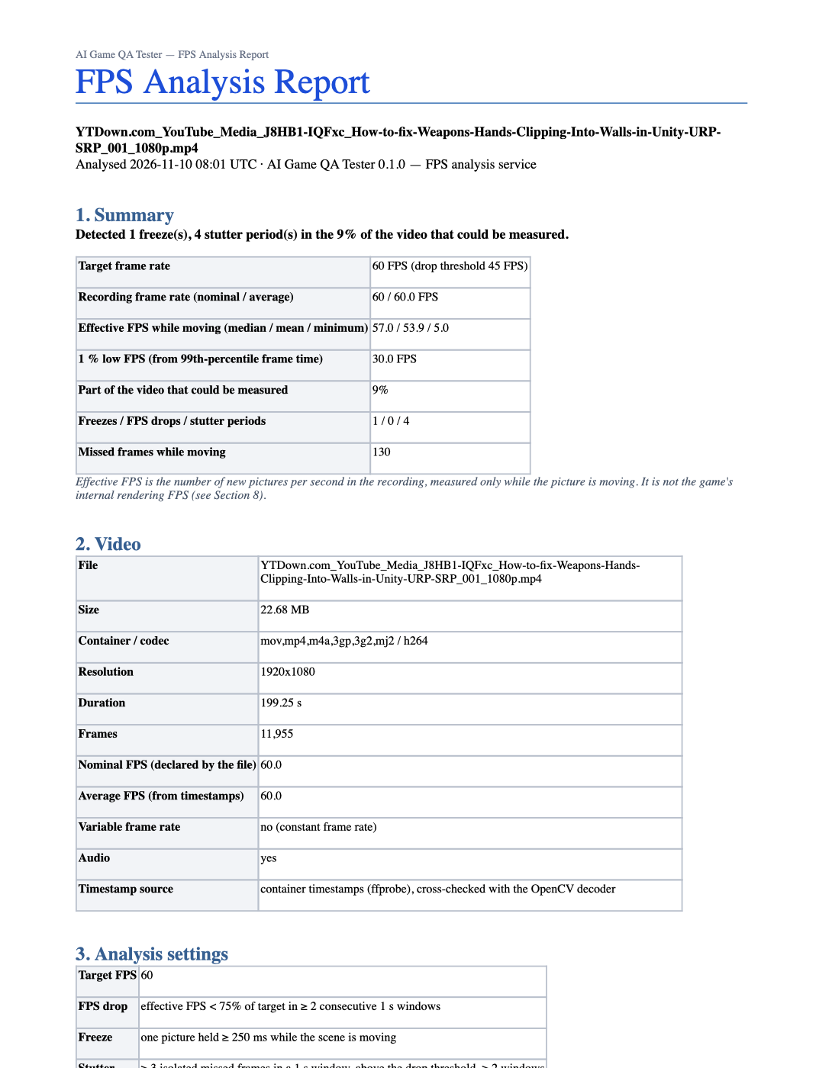
Figure 14. First page of the generated FPS_ANALYSIS_REPORT.docx for the real video (rendered by macOS Quick Look).
The full Word report for the real video is delivered next to this document as FPS_ANALYSIS_REPORT.docx.

20. Future development roadmap
Table 22. Roadmap
Phase | Work | Status
P1–P6 | Foundation, FPS engine, CLI, local GUI, documentation, prototype testing and demo guide | Implemented and Tested
Next | Collect real footage with an on-screen FPS counter / profiler log; measure the error of the FPS estimates (mean absolute error, as required by the SRS) | Proposed for Future Phases
Module 2 | Texture pop-in: UI suppression, real pop-in footage, validation | Proposed for Future Phases
Module 3 | Animation glitches: real footage, cut handling, validation | Proposed for Future Phases
Module 4 | NPC anomalies: footage with characters, validation; floating-NPC research | Proposed for Future Phases
Module 5 | Clipping: new method (segmentation / depth), validation | Proposed for Future Phases
Integration | Unified pipeline (--modules), severity classification, combined Word / JSON report | Proposed for Future Phases
FYP-2 | Usability test with testers; performance on the target GPU machine; final evaluation | Proposed for Future Phases

Appendix A. Output files of one analysis
Table 23. Files in outputs/<date-time>_<video>/
File | Contents
analysis.json | All results: settings, metadata, intervals, effective FPS, frame times, counts, events, verdict, limitations, processing time.
timeline.csv | One row per analysis window: time, measurable, effective FPS, missed frames.
windows.json | The same windows in JSON for programs.
charts/effective_fps.png | Effective FPS over time with target and drop threshold.
charts/frame_intervals.png | Presentation intervals from timestamps.
charts/frame_changes.png | Frame-to-frame change with repeated and missed frames marked.
FPS_ANALYSIS_REPORT.docx | Word report: summary, video, settings, timing, effective FPS, events, method, limitations, processing.
input/<video> (GUI only) | Copy of the uploaded video.

Appendix B. Source files of the prototype
Table 24. Source files
File | Purpose
main.py | CLI and --gui entry point
backend/src/gameqa/fps_service/analysis.py | analyze_video(), statistics, stutter, verdict
backend/src/gameqa/detectors/fps.py | repeated / missed frames, windows, freezes, FPS drops
backend/src/gameqa/fps_service/charts.py, store.py, report_docx.py | charts, saved files, Word report
backend/src/gameqa/webgui/app.py, static/ | local web GUI
backend/src/gameqa/video/ | validation, metadata, decoding
config/default.yaml, backend/src/gameqa/config.py | configuration
backend/tests/test_fps_service.py, test_main_cli.py, test_webgui.py | prototype tests
backend/scripts/eval_prototype_fps.py | synthetic evaluation
backend/scripts/capture_gui_screenshots.py, build_project_docs.py | screenshots and this document

