Table of Contents
1. Project Title 1
2. Executive Summary/Abstract 1
3. Requirements Analysis 2
3.1 User Classes and Characteristics 2
3.2 Requirement Identifying Techniques 3
4. Functional Requirements 3
4.1 Gameplay Video Upload and Job Queueing 4
4.2 Video Preprocessing and Frame Extraction 4
4.3 Multi-Category Glitch Detection 5
4.4 Timestamp Localisation and Evidence Extraction 5
4.5 Severity Classification and Persistence 6
4.6 Detection Review Dashboard and Report Export 7
5. Non-Functional Requirements 7
5.1 Reliability 7
5.2 Usability 8
5.3 Performance 8
5.3.1 The ingestion of video and preprocessing 8
5.3.2 Detection Pipeline 8
5.3.3 Dashboard queries and report export 8
5.4 Security 9
6. Hardware and Software Requirements 9
6.1 Hardware 9
6.2 Software 10
6.2.1 Operating System 10
6.2.2 Front End 10
6.2.3 Back End 10
6.2.4 Libraries, Models, and Frameworks 10
6.2.5 Automation and Integration Tools 11
6.3 Server-side Requirements 11
6.4 Others 11
7. Use Case Analysis 11
7.1 Use Case 1: Submit a Gameplay Video for Analysis 12
7.2 Use Case 2: Detect Glitches and Classify Their Severity 13
7.3 Use Case 3: Review the Detections and Export the Bug Report 15
8. Storyboards 17
8.1 Logging in and accessing the Project Dashboard 17
8.2 Gameplay Video Upload and Job Queue 18
8.3 Review of detections and inspection of the evidence 19
8.4 Summary of the Bug Report and Export 20
9. References 21
SRS Submission Checklist 22

1. Project Title
AI Game QA Tester: Automated Game Bug Detection and Reporting Using Artificial Intelligence and Computer Vision

2. Executive Summary/Abstract
Before any game build is released, the staff members of the studio play it through and record any issues that appear wrong. Although this method does work, it is slow, costly, and inconsistent. Because games have become considerably larger and more visually detailed in the past few years, the amount of footage that has to be watched has increased as a result, and after several hours of playing it is easy to overlook minor faults such as a texture loading late or a single stutter. Moreover, two testers usually describe the same problem in different terms, which makes it difficult for developers to deal with the reports produced.
The AI Game QA Tester is a system which looks at videos of gameplay and produces a report listing the defects that are commonly found in them. It operates after the video has been recorded rather than while the game is running, and therefore does not require access to the game engine, the source code or profiler logs. The user uploads the video via a web dashboard, after which it is queued by the backend system and the analysis is carried out independently. The result is a bug report consisting of each defect together with the timestamp at which it occurs, a screenshot, a short clip showing evidence of the defect and a severity level.
The system includes five categories of defect; NPC anomalies such as T-poses and frozen characters are detected by means of YOLOv8 object detection and MediaPipe pose estimation. Texture pop-in is detected by means of the Structural Similarity Index calculated between consecutive frames, while convolutional autoencoders are suggested as an alternative method. Drops in FPS are caused by frame timing being measured against the 30 and 60 FPS targets. Animation glitches are detected using Farneback dense optical flow, and collision or geometry clipping is detected by checking for bounding-box overlap between dynamic objects and static geometry. A rule-based classifier assigns each detection a severity level of Low, Medium or High, the level being determined by the size of the affected area, the duration of the problem and how frequently it recurs.
The people intended to use it are QA testers, who provide the footage; game developers, who deal with the defects that have been reported; and QA leads, who decide which defects are to be repaired first. The dashboard is developed using React.js and has a backend based on either Flask or FastAPI, with the detections and evidence being stored in MongoDB or PostgreSQL. Reports can be exported in JSON format for use by other tools or as a PDF for distribution among team members.
The result of this project is expected to be an operational offline analysis pipeline accompanied by a dashboard and reporting module for it. Detection performance will be assessed by using precision, recall and the F1 score for each type of defect, mAP@0.5 for those defects which occupy a region of the frame, the mean absolute error for the FPS estimates compared with the profiler's ground truth, and processing throughput in frames per second. The document does not include any performance figures since the system has not yet been implemented.

3. Requirements Analysis
Given a recorded gameplay video the system produces a list of the defects it has detected in that video. All of this takes place after the video has been captured, so the process includes video ingestion, frame-by-frame analysis, assigning a severity score, extracting evidence and preparing a report. The system does not carry out real-time analysis within a game engine and it does not produce the footage itself.
Three groups of people interact with the system and have different requirements regarding it. The QA tester wants to hand over the footage and obtain the results without having to carry out any complicated configuration. The developer needs sufficient detail in order to reproduce a defect, specifically a timestamp and something to examine rather than a written description. The QA lead needs to know how many problems there are and how serious they are, so that the work can be prioritised within a build. These three requirements determined most of the functional requirements in Section 4.
A limitation came up over and over again during the work we were doing. Since the system has no way of seeing the engine's state, all judgments must be based only on the rendered frames. This means that we can't compare what is on screen with what the engine expected, which is the reason why each of the five defect categories has its own detector instead of using a single model. It also implies that the system can only pick up on things that are visible in the footage and so any defect that never appears on screen during the recording will go undetected.
The scope that has been agreed upon for this phase consists of the five defect categories listed in the approved proposal: NPC anomalies, texture pop-in, FPS drops, animation glitches, and collision or geometry clipping. Audio problems, network issues and localisation errors are not included within the scope, and the system makes no attempt to correct anything it detects. All it does is to produce a report, and it is up to the team to decide what action to take in each case.

3.1 User Classes and Characteristics
Four types of users were identified. The first three are taken directly from the stakeholders mentioned in the approved proposal; the fourth refers to the person who puts the system into use and looks after it.
Table 1. User Classes and Their Characteristics
User Class | User Characteristics
QA Tester / QA Analyst | Records or collects gameplay footage from builds under test and submits it for analysis. Uses the system daily during a test cycle. Familiar with game testing workflows but not necessarily a programmer. Uploads videos, watches job progress, and reviews detections to confirm or dismiss them.
Game Developer | Receives the reported defects and fixes them in the build. A programmer, comfortable with engines and debugging. Filters detections by category and severity, opens screenshots and evidence clips, and exports reports as JSON or PDF.
QA Lead / Project Manager | Responsible for tracking how many defects a build has and deciding what is fixed first. Mixed technical background, focused on triage rather than implementation. Reviews summary statistics, filters by severity and exports reports for the team.
System Administrator / Maintainer | Deploys the backend and dashboard, manages the database and the GPU machine that runs inference, and applies updates. Technical user with server access. Does not review detections as part of the normal workflow.

3.2 Requirement Identifying Techniques
The requirements were identified in four different ways. The first of these was a review of the way game QA is currently carried out, based on published work concerning automated game testing as well as on the limitations mentioned in that literature. It was from this review that the five defect categories emerged: each of them represents a problem that existing tools either fail to detect or are unable to report in a format that a developer can use.
The second technique involved carrying out a use-case analysis. We considered exactly what each of the three main groups of users does with the system from beginning to end and converted each action into a requirement. The three use cases in Section 7 were obtained as a result of this analysis, and the functional requirements in Section 4 can be traced back to them.
Third, we looked at the current manual QA process — recording the footage, watching it, writing up a ticket, and reproducing the defect — and determined which steps could be automated and which had to remain the responsibility of a person. That is the reason why the system stops at reporting and does not try to classify the intent or fix anything.
In the end, we decided to use storyboarding. The act of drawing the dashboard screens described in Section 8 caused a number of requirements to come to light that were not clearly apparent in the original proposal, such as the need to display job status, the ability to filter by category and severity, and the requirement for an evidence clip together with the screenshot. These requirements were discussed with our project supervisor before being confirmed in this document.

4. Functional Requirements
The following requirements include the six main modules of the system; each of them has been written in such a way that it can be tested against the running system and is linked to a use case in Section 7.

4.1 Gameplay Video Upload and Job Queueing
Table 2. Functional Requirement FR-1
Identifier | FR-1
Title | Gameplay Video Upload and Job Queueing
Requirements | The system shall allow a user to upload a gameplay video in .mp4, .avi or .mkv format through the dashboard. Files in any other format shall be rejected with a message naming the accepted formats, and no job shall be created.  The backend shall accept an uploaded video, create an analysis job and place it in a processing queue so that analysis runs asynchronously and the upload does not block.  The dashboard shall show the status of every submitted video as queued, processing, complete or failed.
Source | Video Ingestion module; QA Tester; UC-VID-01
Rationale | Footage is the only input the system has. Uploading must work without engine access or any change to the game build, and a full-length video takes long enough to analyse that the user cannot be left waiting on the request.
Dependencies | FR-2 (preprocessing consumes the queued job); Flask/FastAPI REST API; MongoDB/PostgreSQL for job records; file storage for uploaded videos
Priority | High

4.2 Video Preprocessing and Frame Extraction
Table 3. Functional Requirement FR-2
Identifier | FR-2
Title | Video Preprocessing and Frame Extraction
Requirements | The system shall decode a queued video into individual frames using OpenCV.  The system shall normalise frame resolution and colour space so that footage recorded at different settings produces comparable input for the detectors.  The system shall read timestamp information from the video metadata and associate a timestamp with every extracted frame.  The system shall retain the full-rate frame presentation intervals required by FPS analysis, while sub-sampling frames to 10–15 FPS for the detectors that do not need every frame.
Source | Preprocessing module; UC-VID-01
Rationale | The detectors compare frames against one another, so inconsistent resolution or colour space would produce false detections. Sub-sampling keeps GPU load within what the project hardware can handle without losing the timing data the FPS analyser needs.
Dependencies | FR-1 (supplies the queued video); OpenCV 4.x; Python 3.10+
Priority | High

4.3 Multi-Category Glitch Detection
Table 4. Functional Requirement FR-3
Identifier | FR-3
Title | Multi-Category Glitch Detection
Requirements | The system shall analyse the preprocessed frames and detect the following five categories of defect in a single pass:  (a) NPC anomalies, including T-poses, frozen characters, floating meshes and ragdoll physics failures, using YOLOv8 object detection with MediaPipe pose estimation;  (b) texture pop-in, including sudden texture changes, unrendered textures and mesh resolution changes between frames, using the Structural Similarity Index and, as a proposed alternative, convolutional autoencoder reconstruction error;  (c) FPS drops below the 30 or 60 FPS target and frozen frames, using frame timing analysis;  (d) animation glitches, including unnatural movement transitions, missing keyframes, flickering and directional jitter, using Farneback dense optical flow;  (e) collision and geometry clipping between dynamic objects and static geometry, using bounding-box overlap analysis.  A candidate detection shall be reported only if it persists across consecutive frames or frame pairs, so that single-frame noise is suppressed.
Source | Detection Engine module; UC-DET-01; approved project proposal
Rationale | These five categories are the defects the project set out to find, and each has a different visual signature, so each needs a method matched to it. Running them over the same footage in one pass is what makes the tool usable in place of several separate systems.
Dependencies | FR-2 (supplies normalised frames); YOLOv8 (Ultralytics) with COCO pre-trained weights; MediaPipe pose estimation; OpenCV; CUDA-capable GPU
Priority | High

4.4 Timestamp Localisation and Evidence Extraction
Table 5. Functional Requirement FR-4
Identifier | FR-4
Title | Timestamp Localisation and Evidence Extraction
Requirements | The system shall record the timestamp at which each detected defect occurs, together with its end timestamp where the defect has a duration.  The system shall extract a high-resolution screenshot at the detection timestamp for every detection.  The system shall extract a video clip of 5–10 seconds covering the interval around every detection.  Every detection shall remain traceable to the screenshot and clip taken from the original footage.
Source | Media Extraction module; UC-DET-01; Game Developer
Rationale | A detection on its own is only a claim. A developer needs a time, a picture and a short clip in order to reproduce the defect, and the clip covers the lead-up, which often matters more for reproduction than the defect frame itself.
Dependencies | FR-3 (supplies detections); OpenCV; file storage for evidence artefacts
Priority | High

4.5 Severity Classification and Persistence
Table 6. Functional Requirement FR-5
Identifier | FR-5
Title | Severity Classification and Persistence
Requirements | The system shall assign each detection a severity level of Low, Medium or High using rules based on the proportion of the visual area affected, the duration of the anomaly in seconds, and how often it recurs across the video.  Low shall denote a visual-only defect that does not affect gameplay, Medium a defect that affects gameplay without blocking it, and High a collision problem or a severe performance issue.  The system shall store detections, timestamps, severity levels and links to the evidence artefacts in the database so that they can be retrieved after the job completes.
Source | Severity Classification module; UC-DET-01; QA Lead
Rationale | A report listing every finding without ranking is of little use during triage. Rules were chosen over a learned model because the inputs are measurable and the three bands are defined by what the defect means for a player.
Dependencies | FR-3 and FR-4 (supply detections and evidence); MongoDB/PostgreSQL. Numeric thresholds for the three bands are to be calibrated on the labelled dataset during implementation.
Priority | High

4.6 Detection Review Dashboard and Report Export
Table 7. Functional Requirement FR-6
Identifier | FR-6
Title | Detection Review Dashboard and Report Export
Requirements | The dashboard shall display all detections for a processed video together with their category, timestamp, severity level, screenshot and evidence clip.  The dashboard shall allow detections to be filtered by defect category and by severity level, individually or in combination.  The system shall export a bug report in JSON format containing the detection records, timestamps, severity levels and references to the evidence artefacts.  The system shall generate a PDF bug report containing the detections, their screenshots and summary statistics by category and severity.
Source | Reporting and Dashboard module; UC-RPT-01; Game Developer; QA Lead
Rationale | This is the part of the workflow that existing research tools leave out. The output has to fit into how a team already triages defects, which means a filterable list on screen and a report that can be read outside the system.
Dependencies | FR-5 (supplies stored, scored detections); React.js dashboard; Flask/FastAPI REST API; ReportLab or WeasyPrint for PDF generation
Priority | High

5. Non-Functional Requirements
The targets below are the values the project is working towards. Where a target depends on hardware the group has not finalised, the measurement method is given instead of a number, and the value will be fixed after baseline profiling.

5.1 Reliability
The system runs as a single-instance web application for a small QA team rather than a public service, so the availability target is 99% during working hours, which allows for about one hour of unplanned downtime in a five-day week. Scheduled maintenance is excluded from that figure.
A failure inside one detector must not lose the whole job. If a detector fails on a frame, the pipeline shall log it, carry on with the remaining detectors and mark the job as completed with warnings. A job that fails outright shall be re-runnable from the dashboard without the video being uploaded again.
The detection database shall be backed up daily, with videos and evidence stored on disk separately from it, and recovery from a backup shall take no more than one hour. Because analysis can be repeated from the original footage, the worst case for a lost job is that it is queued and run again.

5.2 Usability
A QA tester must be able to upload a video in three steps at the most: select the project, pick the file, and then confirm the upload. To open a detection and play the evidence clip, a user should be able to do it in no more than two clicks from the detection list, and exporting a report should involve only one action. A person who is already engaged in game QA should require no more than 15 minutes of introductory training before being able to use the system without assistance.
The dashboard must be usable by people who have no knowledge of computer vision, and in this case the names of the detectors and the confidence scores should be displayed as supplementary information rather than as the primary label. The colours of the text and of the interface must have a contrast ratio of at least 4.5:1, and the severity should be indicated both by a colour and by a written label. To check usability, we will ask people who are not part of the group to upload a video, identify the detection of highest severity and export a PDF report, keeping a record of the number of steps they take and noting the points at which they hesitate.

5.3 Performance
Batch analysis runs in the background while it waits for dashboard requests, which is why the two are listed separately below.

5.3.1 The ingestion of video and preprocessing
The decoding, normalisation and timestamp extraction must be carried out at a speed equal to or greater than real time when processing 1080p footage at 30 or 60 frames per second, so that a 15-minute video is preprocessed in a period of 15 minutes on the project machine. The system should accept an upload of up to 2 GB, and the job had better appear in the queue within 5 seconds of the upload finishing. It is assumed that at any one time only one job is being processed with a maximum of five jobs queued behind it.

5.3.2 Detection Pipeline
The throughput must be given in frames per second and should be measured end to end, this including the severity classification and the extraction of evidence. When the analysis rate is 12 FPS a 15-minute video corresponds to approximately 10,800 analysed frames, and the aim is for it to be completed within 45 minutes. However, this target is only provisional and will be verified after the first end-to-end test, as it depends on the GPU available to the group.

5.3.3 Dashboard queries and report export
The detection list must load within two seconds when there are up to 500 detections, and a category or severity filter must update it within one second. A screenshot has to open within one second and an evidence clip must begin playing within three seconds. The JSON export must be completed within five seconds, and a PDF report containing up to 100 detections together with the screenshots must be generated within thirty seconds, on the assumption that there are up to five concurrent users.

5.4 Security
To access the system, a user must provide an email address and a password which shall be at least eight characters long, the password to be stored only in the form of a salted bcrypt hash. Sessions must make use of signed tokens that expire after twelve hours of inactivity. Access control based on role shall be in accordance with the user types as shown in Table 1: testers and developers are allowed to upload footage and to view or export the results for their own projects, QA leads in addition have the ability to see the cross-project statistics, and administrators can manage the accounts and the deployment settings. A user must not be able to access any materials that belong to a project to which they have not been added.
Traffic between the browser and the backend must use HTTPS with TLS 1.2 or a later version. The uploaded videos and the extracted evidence must be stored outside the web root and be served only via authenticated endpoints, thus preventing a direct URL from being used to access another team's footage. The uploaded files must be checked regarding their content type and size before they are processed, and access to the database must make use of parameterised queries.
Since footage from an unreleased build is commercially sensitive, the system must maintain a timestamped audit log which records for each job which user uploaded, viewed, exported or deleted it. When a job is deleted, its video, screenshots and clips must also be removed from the disk and its database records must be deleted as well.

6. Hardware and Software Requirements
Since video decoding and model inference are the most demanding aspects of the pipeline, a GPU that has CUDA support is required if the analysis is to run at a useable speed. As for the dashboard, all it needs is a modern web browser.

6.1 Hardware
Item | Minimum Specification
Processor | Multi-core CPU (Intel Core i5 or equivalent) for video decoding, frame extraction and pipeline orchestration
GPU | CUDA-capable GPU for YOLOv8, MediaPipe and autoencoder inference [INFORMATION REQUIRED: exact model available to the group]
RAM | 16 GB recommended for holding decoded frame batches during analysis [INFORMATION REQUIRED: minimum to be confirmed after profiling]
Storage | 256 GB SSD or larger — approximately 20 GB for the gameplay dataset, plus space for uploaded videos, screenshots and evidence clips
Display / Other | 1920×1080 display for reviewing screenshots and evidence clips at the resolution they were captured
Client machine | Any system able to run a modern web browser; no GPU required for dashboard use

6.2 Software

6.2.1 Operating System
• Development and analysis: Ubuntu 22.04 LTS or Windows 11 with CUDA drivers installed
• Deployment: Ubuntu 22.04 LTS server
• Dashboard users: any operating system with a supported browser — Windows, macOS or Linux

6.2.2 Front End
• React.js — developer dashboard for reviewing, filtering and exporting detections
• HTML5 video element — playback of the extracted evidence clips
• JavaScript (ES2020+) and CSS — interface logic and layout

6.2.3 Back End
• Python 3.10+ — detection modules, computer vision code and backend logic
• Flask or FastAPI — REST API for upload, job status, detection retrieval and report export
• MongoDB or PostgreSQL — storage for jobs, detections, severity levels, evidence paths and user data [final choice to be confirmed during implementation]
• File storage on the server for uploaded videos, screenshots and evidence clips

6.2.4 Libraries, Models, and Frameworks
Library / Model / Tool | Purpose
OpenCV 4.x (Python) | Video decoding, frame extraction, colour-space conversion, SSIM computation and Farneback dense optical flow
YOLOv8 (Ultralytics) | Object detection for in-game characters and assets, producing the bounding boxes used by NPC anomaly and clipping detection
MediaPipe | Pose estimation over 33 skeletal key points, used to identify T-poses and frozen characters
Microsoft COCO (pre-trained weights) | Starting point for YOLOv8 person and object detection before fine-tuning on gameplay footage
Convolutional autoencoder | Proposed alternative to SSIM for texture pop-in detection, flagging frames with high reconstruction error
ReportLab or WeasyPrint | Generation of the PDF bug report with detections, screenshots and summary statistics
CVAT | Annotation of the custom gameplay bug dataset used for evaluation

6.2.5 Automation and Integration Tools
• GitHub — version control, one branch per module, with merges reviewed by the group leader before integration
• JIRA or Trello — project board holding the design documents and diagrams produced during FYP Phase I, as required by the department [INFORMATION REQUIRED: board URL]
• Asynchronous job queue inside the Flask/FastAPI backend so that analysis runs independently of the upload request

6.3 Server-side Requirements
The system is deployed as a single backend instance with an attached GPU. It is not designed for large-scale concurrent use; the expected load is one QA team working on one or two builds at a time.
Item | Specification
Compute | 4 vCPU plus one CUDA-capable GPU for inference [INFORMATION REQUIRED: exact GPU model]
Memory | 16 GB RAM
Storage | 250 GB SSD — uploaded videos, extracted screenshots and clips, and the detection database
Expected load | Up to 5 concurrent dashboard users; one analysis job processing at a time with up to 5 queued
Runtime | Python 3.10+ with CUDA drivers; Node.js for building the React dashboard

6.4 Others
Web browsers: Google Chrome 120+, Mozilla Firefox 120+, Microsoft Edge 120+
Mobile and other devices: are not supported at this stage. The dashboard is intended for use on desktops, as the primary activity involves reviewing screenshots and evidence clips at the resolution at which they were captured.
The demonstration setup consists of the project's GPU machine running the backend locally, with the dashboard being accessed from a laptop browser on the same network.

7. Use Case Analysis
The system's main capabilities are illustrated through three use cases: inserting the footage into the system, analysing the footage, and obtaining a report from it afterwards. Each of these is presented in the form of a UML use-case diagram and is also specified in the table that comes after it.

7.1 Use Case 1: Submit a Gameplay Video for Analysis
A QA tester has a recording of a build that is being tested and would like it to be analysed. He or she uploads the video via the dashboard, whereafter the system checks the format, sets up the analysis job and places it in the queue. Since it takes a long time to process a full-length video, the job runs asynchronously and the tester is then able to check the status of the job at any time rather than having to wait for the upload request to complete.
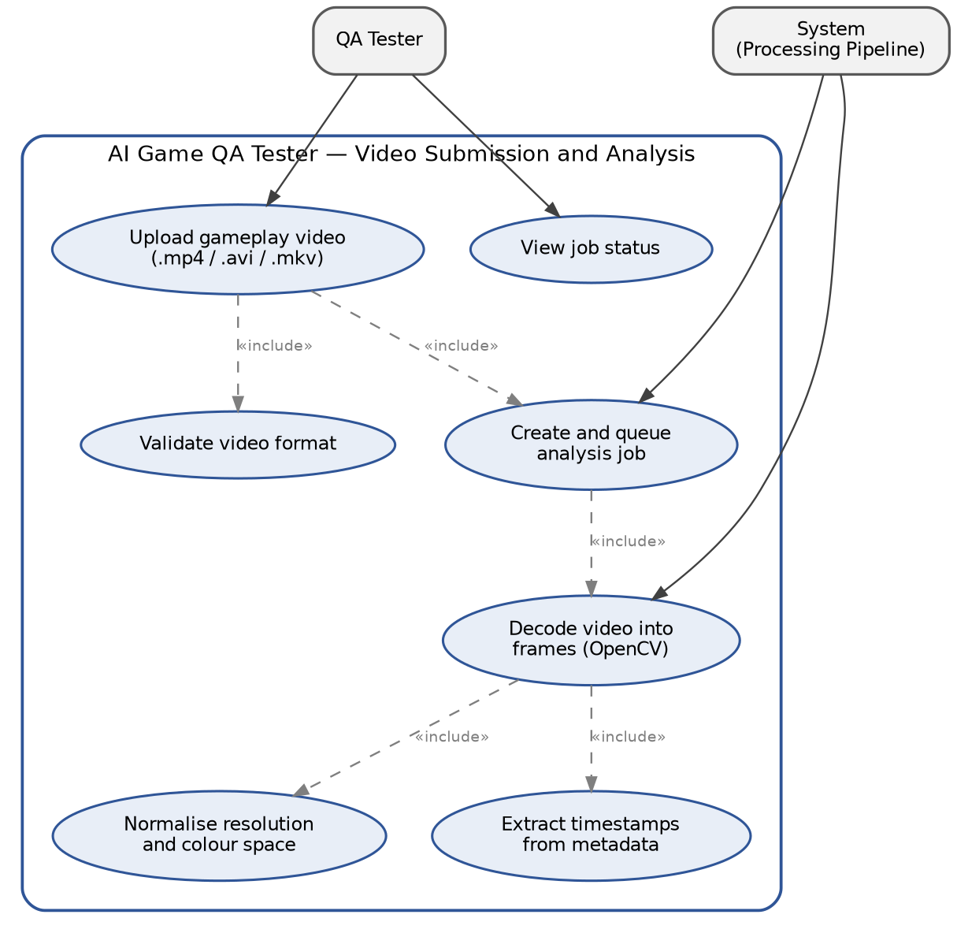
Figure 1: Submit Gameplay Video for Analysis
Table 8: UC-VID-01
UC Identifier | UC-VID-01
Requirement Traceability | FR-1, FR-2
Purpose | Accept a recorded gameplay video, queue it for analysis, and preprocess it into normalised frames with timestamps.
Priority | High
Preconditions | 1. The user is authenticated and belongs to the project the video is being added to.  2. A gameplay recording in .mp4, .avi or .mkv format is available on the user's machine.  3. The backend and its job queue are running.
Postconditions | The video is stored on the server, an analysis job exists with status queued or processing, and a normalised frame stream with associated timestamps is available to the detection engine. The user can see the job in the dashboard.
Actors | QA Tester (primary), System / Processing Pipeline (secondary)
Main Success Scenario | 1. The QA tester opens the upload page and selects the project.  2. The tester selects a gameplay video file and confirms the upload.  3. The system validates that the file format is supported.  4. The system stores the video, creates an analysis job and adds it to the queue.  5. The system returns the job identifier and shows the job as queued.  6. The processing pipeline picks up the job and decodes the video into frames using OpenCV.  7. The system normalises frame resolution and colour space and extracts timestamps from the video metadata.  8. The job status changes to processing and the normalised frames are passed to the detection engine.  9. The tester views the current job status on the dashboard.

7.2 Use Case 2: Detect Glitches and Classify Their Severity
After the job has been preprocessed, the system then examines the frames without requiring any additional input from the user. Five detectors are applied to the same frame stream, each one searching for a particular type of defect. Each detection that passes the persistence check is assigned a timestamp, given a severity level, and is stored together with a screenshot and a short evidence clip.
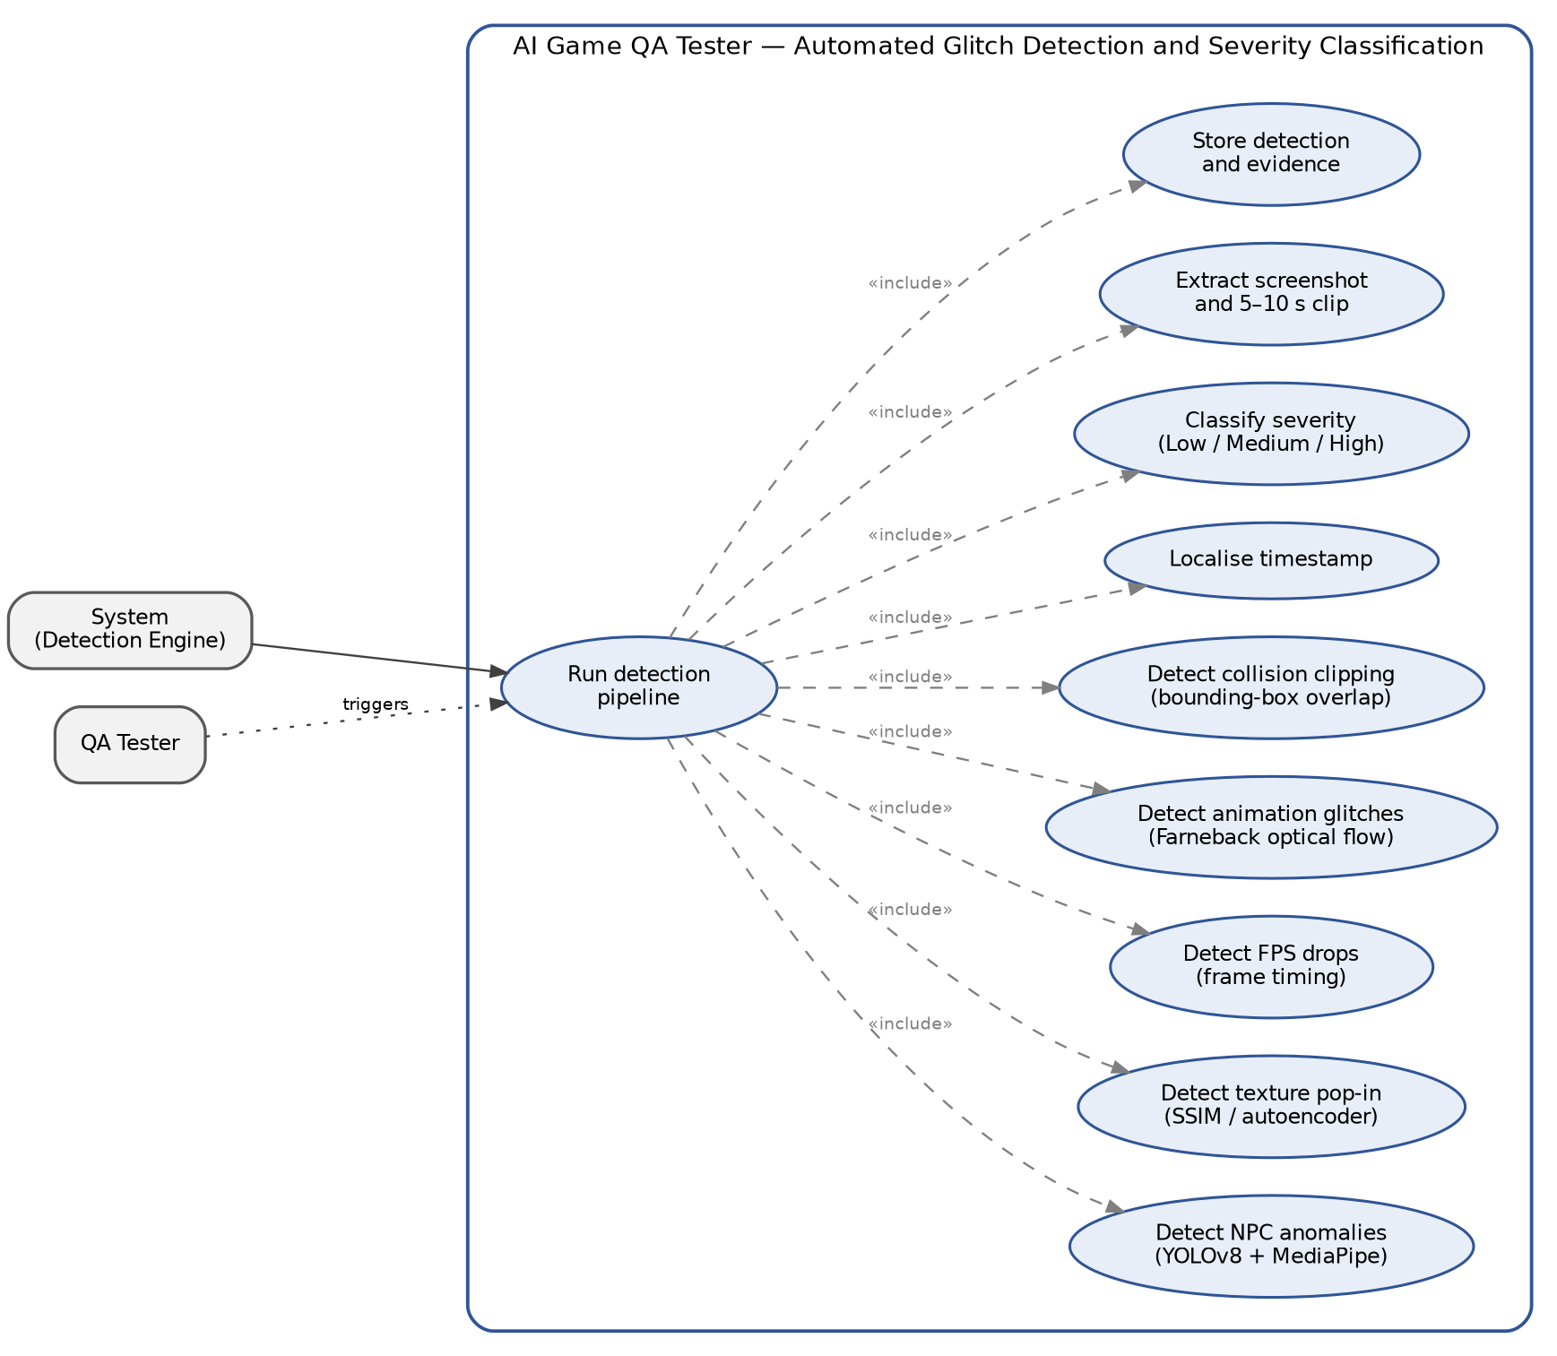
Figure 2: Detect Glitches and Classify Severity
Table 9: UC-DET-01
UC Identifier | UC-DET-01
Requirement Traceability | FR-3, FR-4, FR-5
Purpose | Detect the five categories of defect in the preprocessed frames, score each detection for severity, and store it with evidence.
Priority | High
Preconditions | 1. A job has been preprocessed and a normalised frame stream with timestamps is available (UC-VID-01 completed).  2. The detection models and their weights are loaded.  3. A CUDA-capable GPU is available to the backend.
Postconditions | Every detected defect is stored with its category, start and end timestamps, affected region, confidence and severity level, together with a screenshot and a 5–10 second evidence clip. The job status is set to complete.
Actors | System / Detection Engine (primary), QA Tester (triggers the job)
Main Success Scenario | 1. The detection engine receives the normalised frame stream for the job.  2. The NPC glitch detector runs YOLOv8 to locate characters and MediaPipe to estimate 33 pose key points, and flags T-poses and frozen characters.  3. The texture pop-in detector computes region-wise SSIM between consecutive frames and flags sharp similarity drops that do not match the global camera motion.  4. The FPS drop analyser compares frame presentation intervals against the 30 or 60 FPS target and flags drops and frozen frames.  5. The animation anomaly detector computes Farneback dense optical flow and flags motion that falls outside the surrounding distribution.  6. The collision clipping detector compares bounding boxes of dynamic objects against static geometry and flags sustained overlap.  7. Candidate detections that do not persist across consecutive frames are discarded.  8. Each surviving detection is localised to a timestamp and assigned Low, Medium or High severity from its affected area, duration and recurrence.  9. The system extracts a screenshot at the detection timestamp and a 5–10 second clip around it.  10. The detections and evidence are written to the database and the job is marked complete.

7.3 Use Case 3: Review the Detections and Export the Bug Report
When a job has been completed, the developer or QA lead opens it in order to look at the findings. The list of defects can be restricted by defect category and by severity, and each item in the list can be opened to display the screenshot and the evidence clip that back it up. After the list has been examined, the report can be exported in JSON format for use by another tool or as a PDF to be shared with the team.
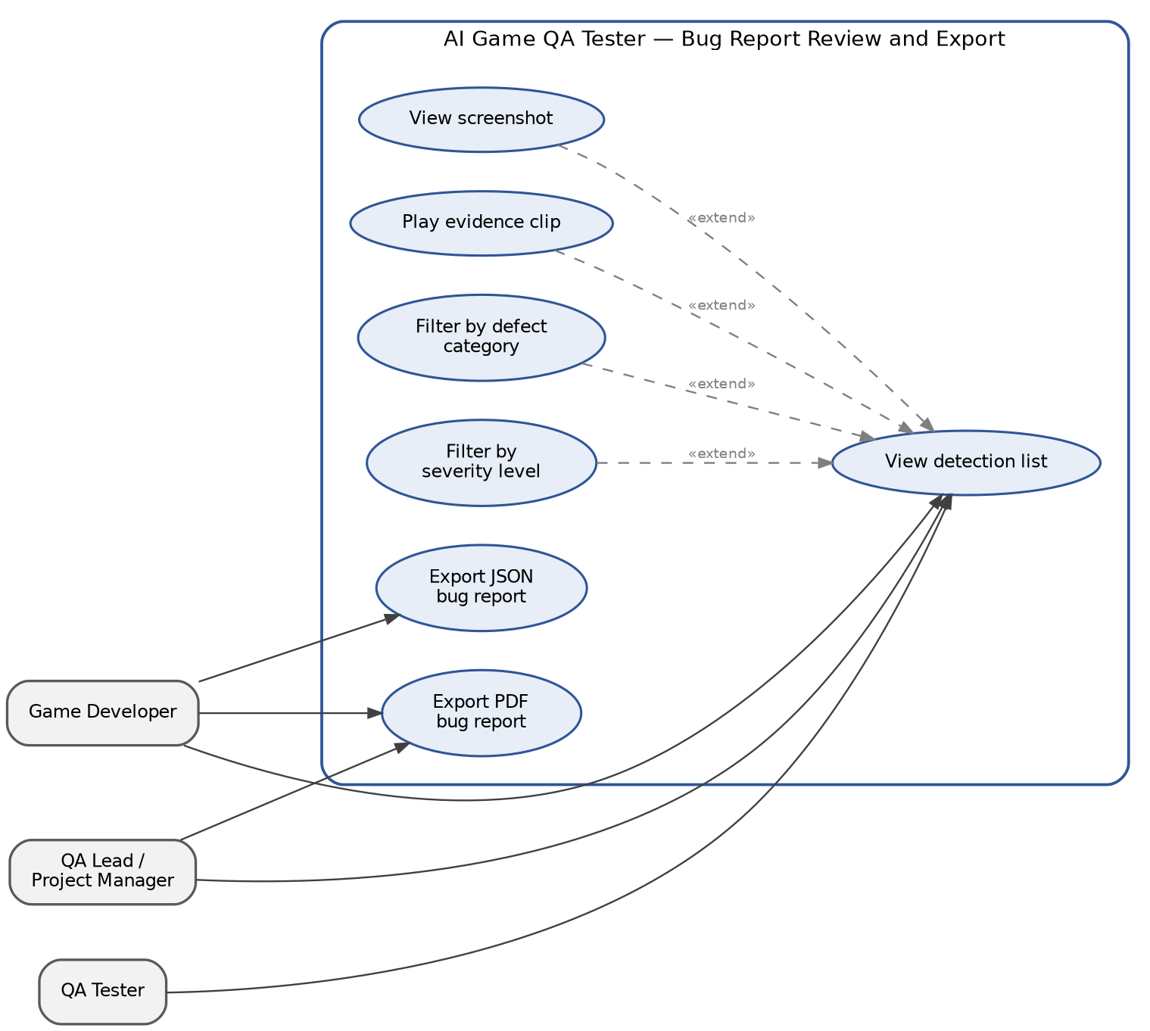
Figure 3: Review Detections and Export Bug Report
Table 10: UC-RPT-01
UC Identifier | UC-RPT-01
Requirement Traceability | FR-6
Purpose | Let a developer or QA lead review the detections found in a job, filter them, inspect the supporting evidence, and export a bug report.
Priority | High
Preconditions | 1. The user is authenticated and belongs to the project.  2. An analysis job has completed and its detections and evidence are stored (UC-DET-01 completed).
Postconditions | The user has reviewed the detections for the job, and a JSON or PDF bug report has been generated and downloaded where requested. Stored detections are unchanged by viewing or filtering.
Actors | Game Developer (primary), QA Lead / Project Manager, QA Tester (secondary)
Main Success Scenario | 1. The user opens a completed job from the dashboard.  2. The system displays the detection list with category, timestamp, duration and severity for each entry.  3. The user filters the list by defect category, by severity level, or by both.  4. The user selects a detection.  5. The system shows the screenshot taken at the detection timestamp, together with the detector used, the confidence and the frame range.  6. The user plays the 5–10 second evidence clip for that detection.  7. The user requests an export in JSON or PDF format.  8. The system generates the report, including the detection records, screenshots and summary statistics by category and severity.  9. The report is downloaded to the user's machine.

8. Storyboards
The four screens that a user goes through — are those shown in the storyboards: logging in and selecting a project, submitting a video, reviewing the results, and exporting the report. These are wireframes of the proposed React.js dashboard and not screenshots of an actual implemented interface, as the system has not yet been put into place. The data included in them is for illustrative purposes.

8.1 Logging in and accessing the Project Dashboard
It is the starting point; the user logs in using their email address and password and is then taken to a list of the projects they are associated with. In this list, each row displays the game build, the number of videos that have been analysed, the number of detections which are still open, and when the last analysis took place. The recent activity panel lists the most recent jobs along with information on whether they have completed or not, and the severity summary provides a QA lead with a quick overview of how many serious defects remain. Once here, the user can begin a new upload or open a project in order to look at its detections.
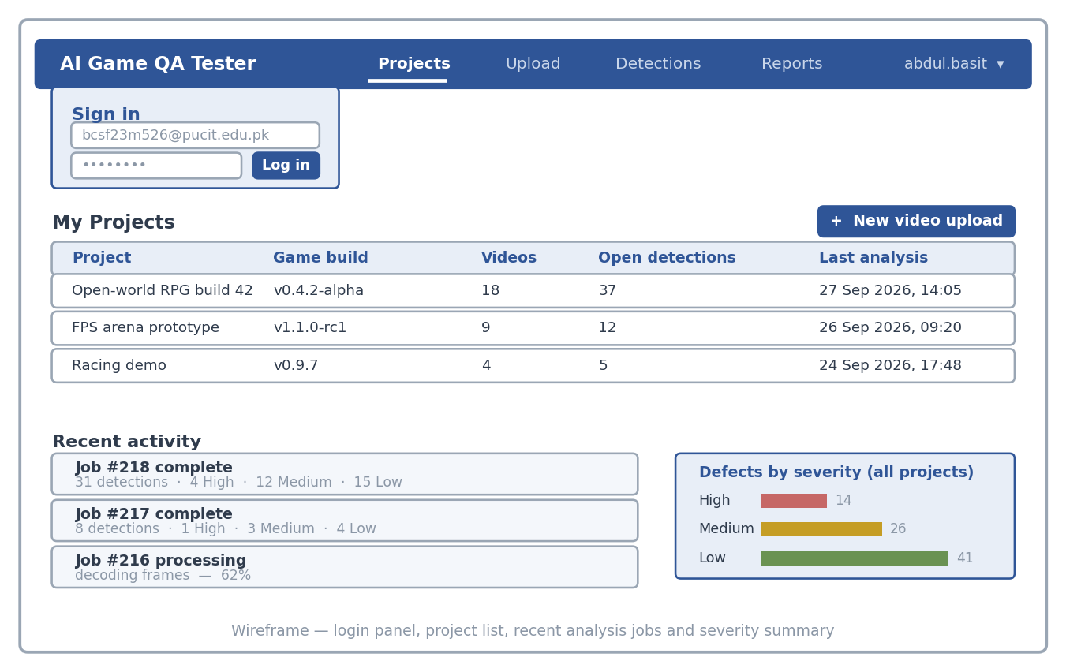
Figure 4: Login and Project Dashboard

8.2 Gameplay Video Upload and Job Queue
The user can either drag the gameplay recording into the drop zone or select the file using the browser dialog. The settings panel on the right then shows which project the video is associated with, the target frame rate that the FPS analyser should use, the sampling rate for the vision detectors, and which detectors are enabled. After the upload has finished, the job appears in the queue below with its status and a progress bar. Since the analysis takes place asynchronously, the user is free to leave the screen and return to it later.
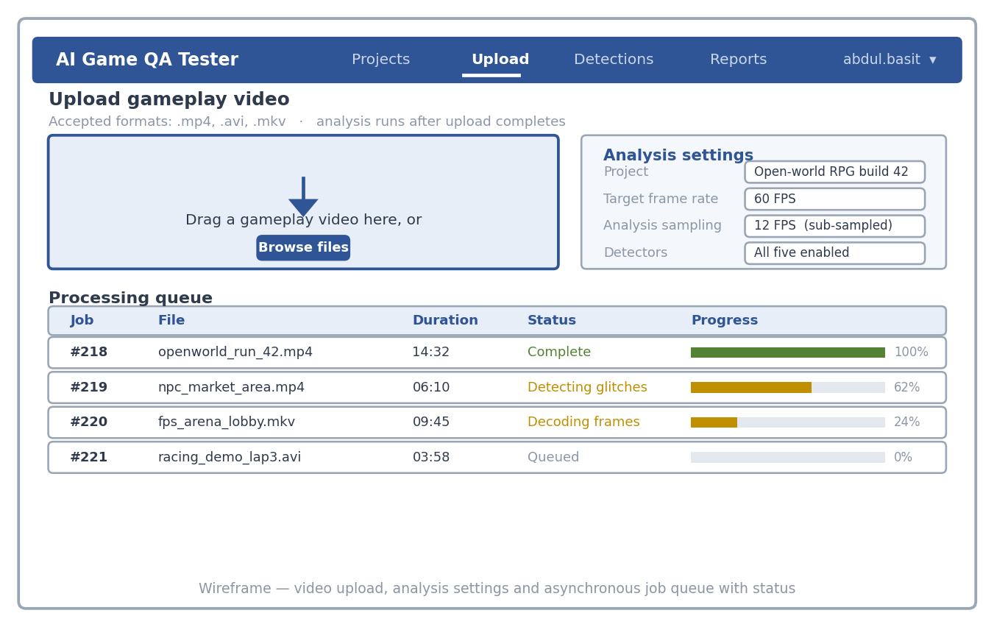
Figure 5: Gameplay Video Upload and Job Queue

8.3 Review of detections and inspection of the evidence
It is here that the main amount of the work takes place. On the left-hand side there is a list of all the detections in the job, together with their category, timestamp, duration and severity, and the filter row situated above it limits this list by category of defect and by severity level. When a detection is selected the panel on the right hand side opens and displays the screenshot taken at the timestamp of the detection, with the area that was affected outlined, the 5 to 10 second evidence clip, and the supporting details consisting of the severity and the reason for it being assigned, which detector made the detection, its confidence level and the frame range.
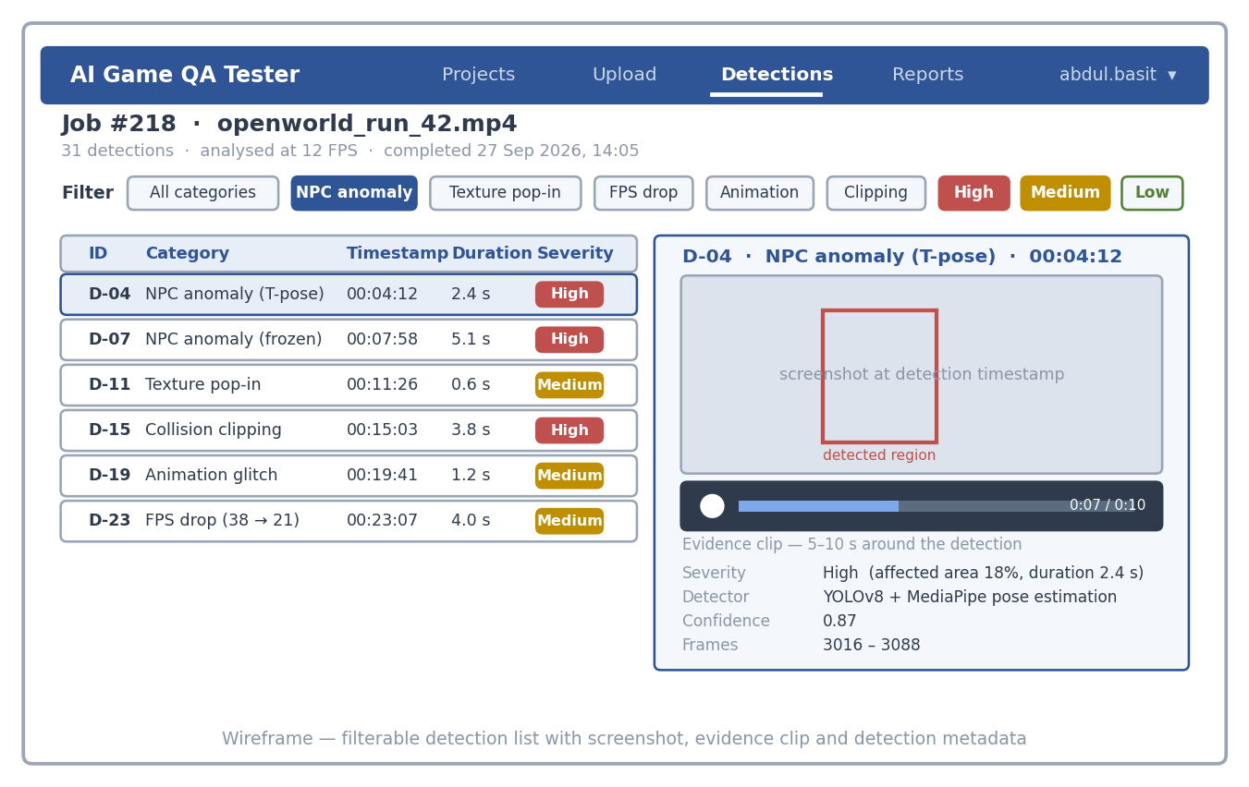
Figure 6: Detection Review and Evidence Inspection

8.4 Summary of the Bug Report and Export
The job is summarised on the report screen rather than being listed in full. The figures at the top show the total number of detections together with their distribution among the three severity levels, while the bar chart underneath divides those detections by defect category. In the preview panel you can see how each entry will look in the exported report, including its screenshot, timestamp and severity. There are two buttons in the top right corner: one for exporting the data in JSON format for use by another tool and another for producing a PDF version for use within the team.
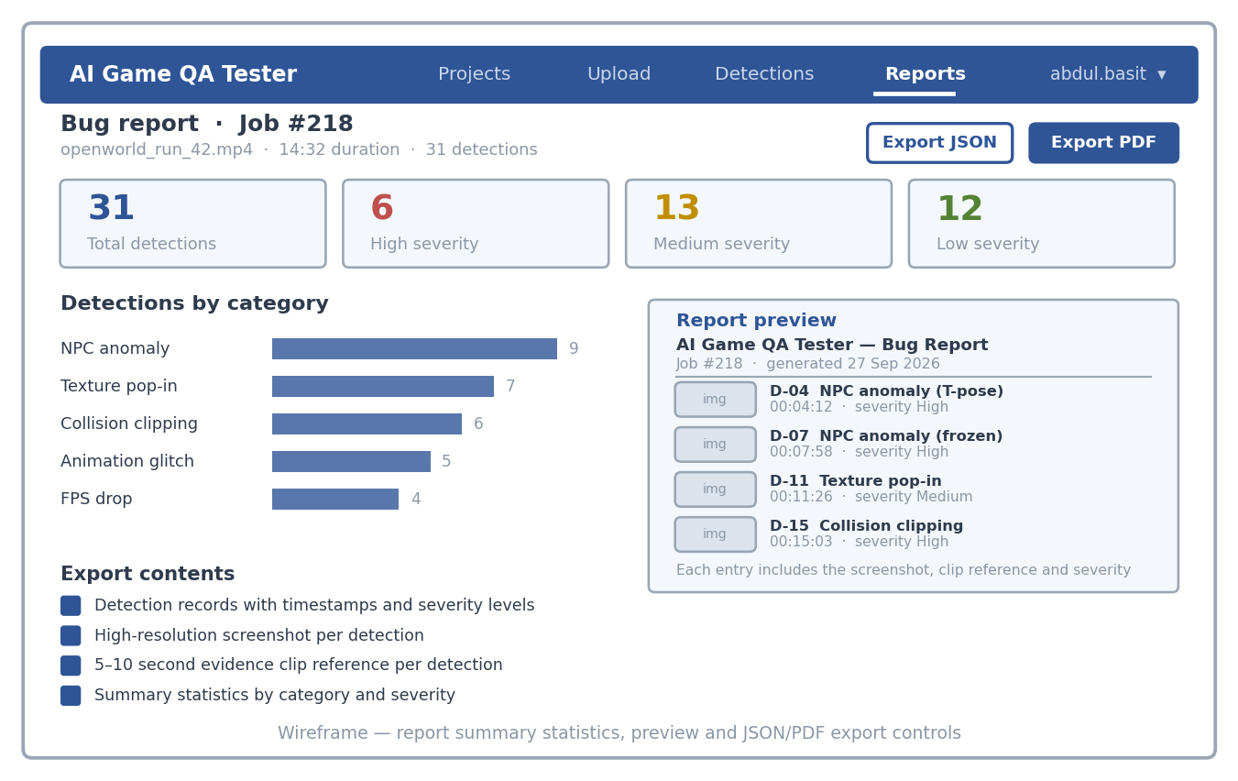
Figure 7: Bug Report Summary and Export

9. References
[1] G. Jocher, A. Chaurasia, and J. Qiu, “Ultralytics YOLOv8,” Ultralytics Real-Time Object Detection Framework, 2023. [Online]. Available: https://github.com/ultralytics/ultralytics
[2] C. Lugaresi et al., “MediaPipe: A framework for building perception pipelines,” arXiv preprint arXiv:1906.08172, 2019. [Online]. Available: https://arxiv.org/abs/1906.08172
[3] G. Farnebäck, “Two-frame motion estimation based on polynomial expansion,” in Proc. Scandinavian Conference on Image Analysis (SCIA), Springer, 2003, pp. 363–370.
[4] Z. Wang, A. C. Bovik, H. R. Sheikh, and E. P. Simoncelli, “Image quality assessment: from error visibility to structural similarity,” IEEE Transactions on Image Processing, vol. 13, no. 4, pp. 600–612, 2004.
[5] T.-Y. Lin et al., “Microsoft COCO: Common objects in context,” in Proc. European Conference on Computer Vision (ECCV), Springer, 2014, pp. 740–755.
[6] G. Bradski, “The OpenCV Library,” Dr. Dobb's Journal of Software Tools, 2000. [Online]. Available: https://opencv.org
[7] Zheng et al., “Automated verification of in-game state and positioning using YOLO and homography,” 2021. [CITATION INCOMPLETE — full author list, title, venue and page numbers required]
[8] Azizi and Zaman, “AstroBug: Perceptual glitch detection using LSTM networks,” 2023. [CITATION INCOMPLETE — full author list, title, venue and page numbers required]
[9] Taesiri et al., “GlitchBench: Evaluating large vision-language models on game glitch identification,” 2024. [CITATION INCOMPLETE — full author list, title, venue and page numbers required]

