# Admin in a day

# Module 2: Reporting and Telemetry

# Hands on lab

# Lab Scenario

In this Hands-on Lab, you are an administrator for Contoso helping adopt the Power Platform.

An important part of keeping the Power Platform running successfully is monitoring the ongoing usage. In this hands on lab you will be using the platform tools to enable logging of activity and perform usage monitoring.

# Lab Requirements

## Lab Test Environment

This hands on lab is designed to be completed in an environment setup for multiple students to complete the Admin in a day series of hands on labs.

You need to use the assigned user and environment information to complete this lab. You must have completed the prior labs to successfully complete this lab.

# Exercise 1: Using a PowerApp to monitor activity

## Scenario

Both PowerApps and Microsoft Flow have administrative connectors that you can use to build apps to help tailor your monitoring experience.

In this exercise, you will be importing an example PowerApp and see how the admin connectors can be used to monitor activity

### Task 1: Import the PowerApp

1. Navigate to **https://make.powerapps.com**
2. Select **Central Apps Test** environment.
3. Download app from here **https://aka.ms/powerappsadminapp** and save it.
4. Select **Apps** and click **Import Package**.

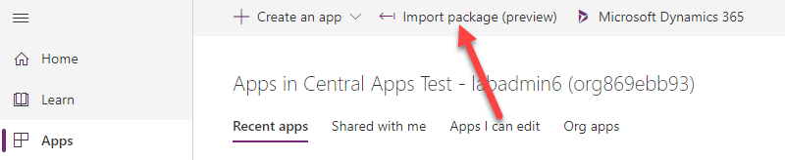

Import app package

1. Click **Upload**.
2. Select the app you downloaded and click Open.
3. Click **Configure**.

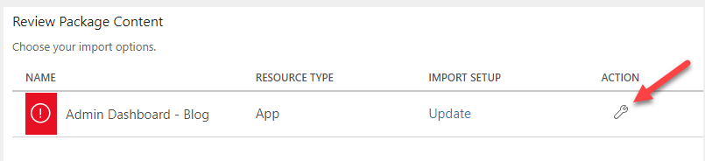

Configure

1. Select **Create as New** and click Save.

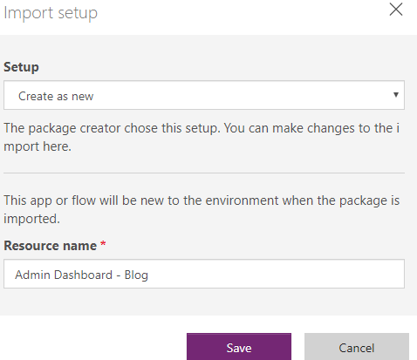

Create as new application

1. Click **Import** and wait for the import to complete.
2. Select **Apps** again and open the new application.

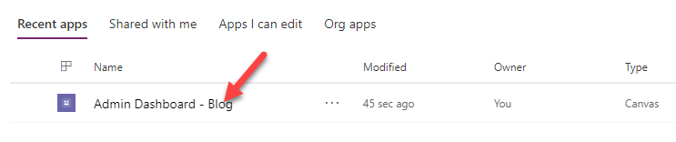

Run the application

1. Browse around the app and get familiar with what data is available.

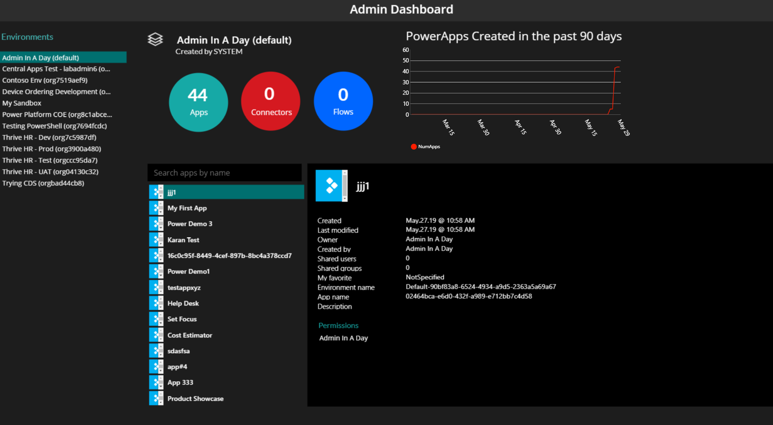

Admin dashboard app

1. If you have time and are curious open the app in the designer and review how it was built.

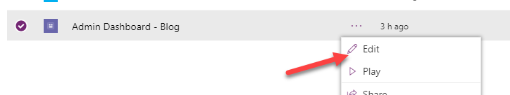

Admin dashboard app

# Exercise 2: Review tenant audit logs

## Scenario

All other auditing of PowerApps and Microsoft Flow (other than CDS data modification) are viewed through the Office 365 Security and Compliance site.

Prior to use, this must be enabled by a global tenant administrator using [these](https://docs.microsoft.com/en-us/office365/securitycompliance/turn-audit-log-search-on-or-off) instructions. In the tenant you are using we have already completed that for you as well as granting you permission to view the audit log data for the tenant. That was done using the PowerShell command Add-RoleGroupMember “Compliance Management” -Member your user.

In this exercise, you will be using the log search and alert tools to work with the audit data.

### Task 1: Enable audit logging in the environment

1. Navigate to **https://Protection.office.com**.
2. Expand **Search**.
3. Select **Audit log search**.

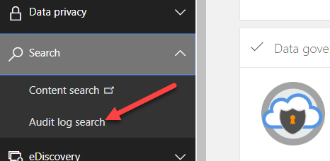

select audit log search

1. Click **Search** using the default search criteria.

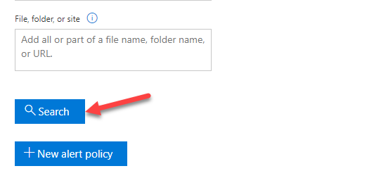

click search

1. Review the items displayed; drill into a few of them to see the type of data available.
2. Click **Export Results**. You can download the data if you like. Using export you can open the data in other tools for analysis.

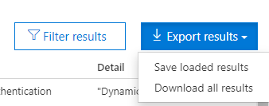

Available downloads

1. Click on the **Activities** dropdown.

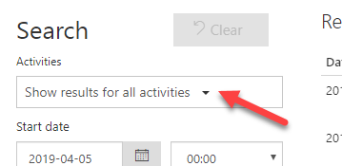

Activities dropdown

1. Select all **Power Apps, Microsoft Flow and Dynamics 365** activities. Click on the section names to select all.
2. Click **Search** again.
3. Review the results.
4. Look for an activity of Edited Flow, click on the item to open up the detail. Click on the More info, and review what data is provided
5. A common task is to look at all activity for a particular user. Copy the user from this Edited flow activity and go back to the search criteria.
6. Paste the user you copied into the Users filter and click search again. Now you are looking at all the activity for a single user.
7. You can also click on the filter results in the upper right corner. This will expose filters just below the headers in the table.
8. Try clicking on an item to view detail. Copy the Item field and then go back to the list and click the filter results. Paste the item info you just copied into the filed. The results list will now only show activities related to that item. For example, you could use this to show all activities for a specific flow.

# Exercise 3: Enable CDS Auditing

## Scenario

The Common Data Service (CDS) has the ability to perform application login tracking, as well as read and modification auditing on data stored. To activate this auditing, settings changes must be made at the entity and field level as well as the environment features settings.

Prior to deploying the Device Ordering app, you worked with the team building it to enable auditing on the Device Order entity and key fields within that entity. You can read more about configuring entities and attributes for auditing here https://docs.microsoft.com/en-us/powerapps/developer/common-data-service/configure-entities-attributes-auditing

In this exercise, you will modify the environment settings to enable login tracking as well as entity tracking in the deployed environment.

### Task 1: Enable audit logging in the environment

1. Navigate to **https://admin.powerplatform.microsoft.com**.
2. Select **Environments** in left navigation
3. Select the **Central Apps Test** environment.
4. Select **Settings**.
5. Select **Features**.

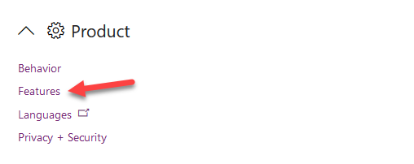

Select features

1. Enable **Auditing Entities**, User Access, Read Access. Note: While we are enabling read access to demonstrate it, in real projects this should only be enabled for entities where that level of auditing is required.

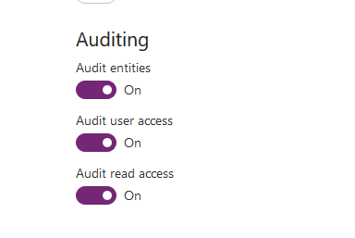

Enable auditing

1. Click **Save**.

**Note:** You will test the logging in a later module after you deploy the Device Ordering app.

# Exercise 4: Get notification of new apps, flows and connectors

## Scenario

In this exercise, you will be using one of the pre-built Microsoft Flow templates that runs on a schedule and looks for newly created canvas apps, flows and connectors and sends you an email.

### Task 1: Create the flow from the template

1. Navigate to **https://flow.microsoft.com**.
2. Make sure **Central Apps Test** environment is selected
3. Paste the URL and press enter. https://us.flow.microsoft.com/en-us/galleries/public/templates/0b2ffb0174724ad6b4681728c0f53062/get-list-of-new-powerapps-flows-and-connectors/

paste url

paste url

1. Click **Sign in**.

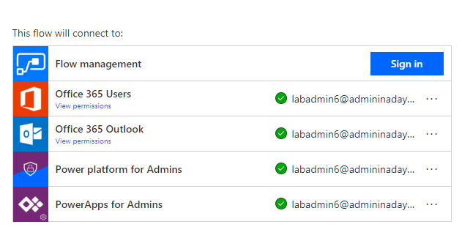

sign in

1. Select the user you are signed in as.
2. Click **Accept**.

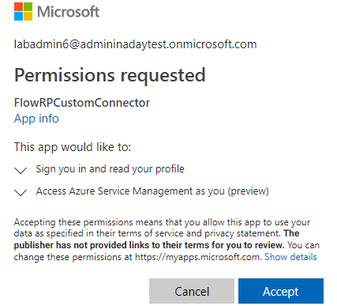

accept permissions

1. Click **Continue**.

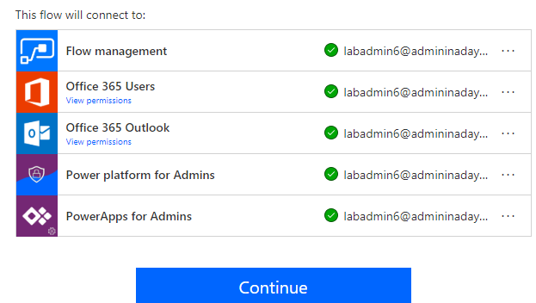

continue

1. Examine the flow steps and then click **Flow Checker**.

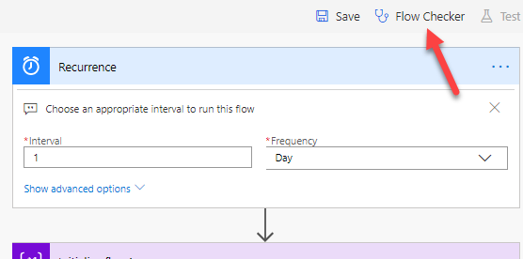

check flow

1. There should be no errors.
2. Click **Save**.
3. Click on the back arrow.

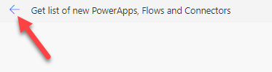

back to flow

1. The flow should have one run in progress.

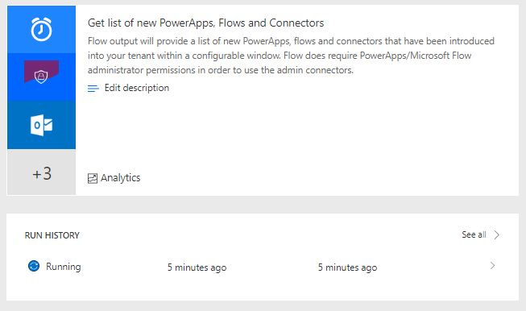

run in progress

1. Wait for the flow to complete and then click to open the run.

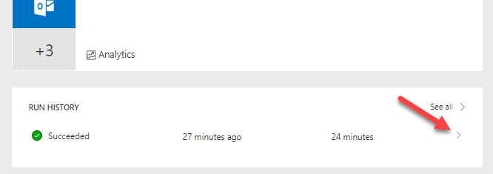

open the run

1. Examine the flow run.

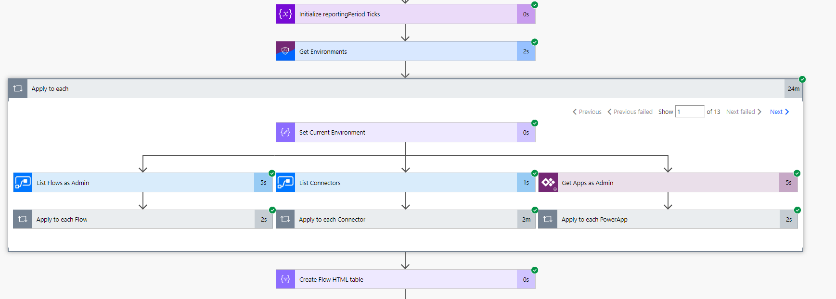

examine run

1. Navigate to https://outlook.office.com/
2. You should get an email from the flow. Open the email.

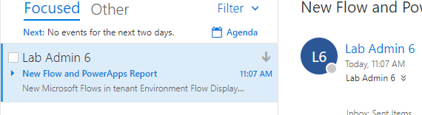

email

1. The report should list flows, power apps, connectors in tables.

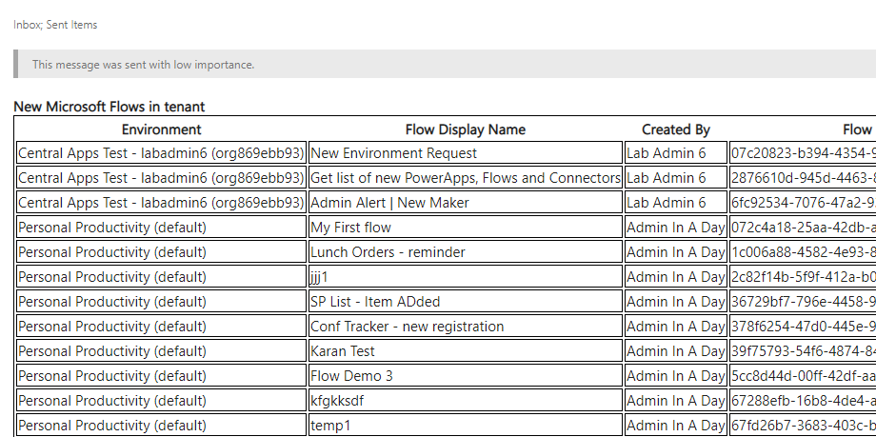

report

# Terms of Use

© 2019 Microsoft Corporation. All rights reserved.

By using this demo/lab, you agree to the following terms: The technology/functionality described in this demo/lab is provided by Microsoft Corporation for purposes of obtaining your feedback and to provide you with a learning experience. You may only use the demo/lab to evaluate such technology features and functionality and provide feedback to Microsoft. You may not use it for any other purpose. You may not modify, copy, distribute, transmit, display, perform, reproduce, publish, license, create derivative works from, transfer, or sell this demo/lab or any portion thereof. COPYING OR REPRODUCTION OF THE DEMO/LAB (OR ANY PORTION OF IT) TO ANY OTHER SERVER OR LOCATION FOR FURTHER REPRODUCTION OR REDISTRIBUTION IS EXPRESSLY PROHIBITED. THIS DEMO/LAB PROVIDES CERTAIN SOFTWARE TECHNOLOGY/PRODUCT FEATURES AND FUNCTIONALITY, INCLUDING POTENTIAL NEW FEATURES AND CONCEPTS, IN A SIMULATED ENVIRONMENT WITHOUT COMPLEX SET-UP OR INSTALLATION FOR THE PURPOSE DESCRIBED ABOVE. THE TECHNOLOGY/CONCEPTS REPRESENTED IN THIS DEMO/LAB MAY NOT REPRESENT FULL FEATURE FUNCTIONALITY AND MAY NOT WORK THE WAY A FINAL VERSION MAY WORK. WE ALSO MAY NOT RELEASE A FINAL VERSION OF SUCH FEATURES OR CONCEPTS. YOUR EXPERIENCE WITH USING SUCH FEATURES AND FUNCTIONALITY IN A PHYSICAL ENVIRONMENT MAY ALSO BE DIFFERENT.

## FEEDBACK

If you give feedback about the technology features, functionality and/or concepts described in this demo/lab to Microsoft, you give to Microsoft, without charge, the right to use, share and commercialize your feedback in any way and for any purpose. You also give to third parties, without charge, any patent rights needed for their products, technologies and services to use or interface with any specific parts of a Microsoft software or service that includes the feedback. You will not give feedback that is subject to a license that requires Microsoft to license its software or documentation to third parties because we include your feedback in them. These rights survive this agreement. MICROSOFT CORPORATION HEREBY DISCLAIMS ALL WARRANTIES AND CONDITIONS WITH REGARD TO THE DEMO/LAB, INCLUDING ALL WARRANTIES AND CONDITIONS OF MERCHANTABILITY, WHETHER EXPRESS, IMPLIED OR STATUTORY, FITNESS FOR A PARTICULAR PURPOSE, TITLE AND NON-INFRINGEMENT. MICROSOFT DOES NOT MAKE ANY ASSURANCES OR REPRESENTATIONS WITH REGARD TO THE ACCURACY OF THE RESULTS, OUTPUT THAT DERIVES FROM USE OF DEMO/ LAB, OR SUITABILITY OF THE INFORMATION CONTAINED IN THE DEMO/LAB FOR ANY PURPOSE.

## DISCLAIMER

This demo/lab contains only a portion of new features and enhancements in Microsoft PowerApps. Some of the features might change in future releases of the product. In this demo/lab, you will learn about some, but not all, new features.