# Admin in a day

# Module 3: Action through Automation

# Hands on lab

# Lab Scenario

In this hands-on lab, you are an administrator for Contoso, helping them to adopt the Power Platform.

Contoso has decided to control creation of Power Platform environments by disabling creation unless you are a global or service admin. Contoso doesn’t want to discourage use of the Power Platform so they would like you to put an automated process in place to allow users to request an environment and a Common Data Service database.

In this lab, you will be building a Microsoft Form to allow users to submit their environment requests. Using the Power Platform administrative connectors and the built-in approval capabilities of Microsoft Flow you will automate the processing of the requests.

The following is an outline of the process you will be implementing:

* A user submits request via the form including justification for the environment
* Form submission triggers flow to run
* Flow uses the approval connector to ask admin team for approval
* If approved, the environment and CDS database are created
* User is notified of the outcome; approved or rejected.

This process could easily be expanded to request approval from the users manager as well as the request information along with the environment information could be stored for resource usage charge back.

Additionally, you will be installing a pre-created flow that checks for new people building apps and adds them to an Office 365 group and sends them a welcome e-mail.

# Lab Requirements

## Lab Test Environment

This hands-on lab is designed to be completed in an environment setup for multiple students to complete the Admin in a day series of hands-on labs.

You will be assigned one or more users to use to complete the hands on tasks. Because this is a shared environment, some tasks that require a tenant Global Administrator or a Service Administrator will already be performed.

This lab does not require you have completed any of the prior labs.

# Exercise 1: Create Environment Request Form

## Scenario

In this exercise, you will be creating an environment request form using Microsoft Forms. This form could collect additional information allowing it to be tailored to your individual organization requirements.

### Task 1: Create Microsoft Form

1. While logged in as the lab admin user navigate to **https://forms.office.com** and click New Form.

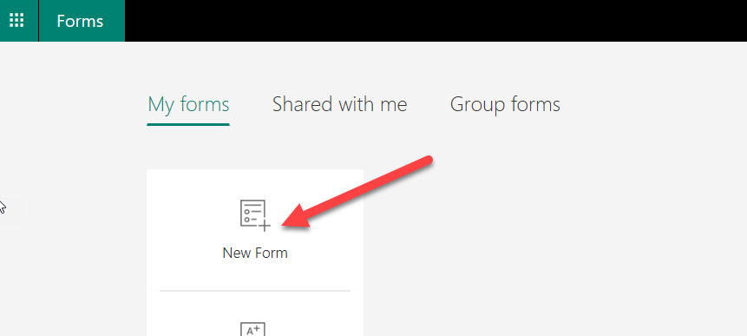

New form

1. Enter **New Environment Approval Request** for title, enter **New environment request** for description, and click **Add new**.

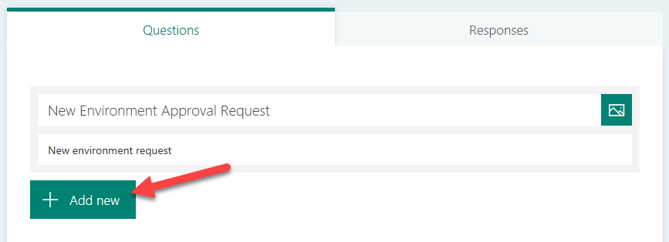

Add new

1. Enter **Environment Name**, make the question Required, and click Add New.

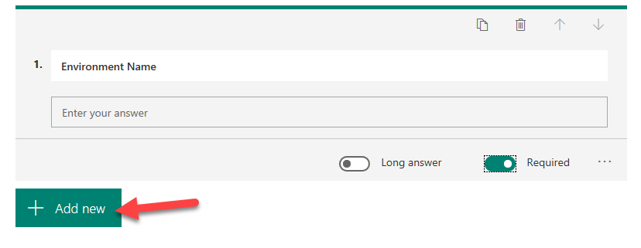

Add new question

1. Select **Text** again.
2. Enter **Business Justification**, select Long Answer, and make it Required.

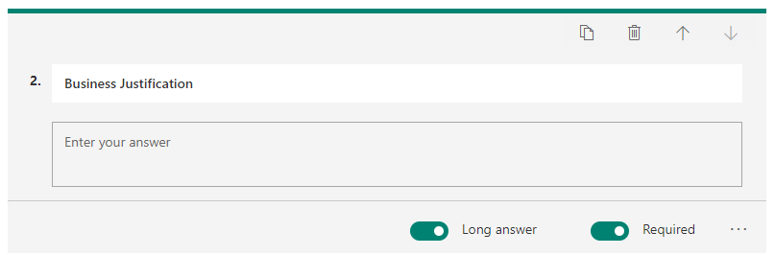

Select long answer and make it required

1. The form will be saved automatically.
2. Click **Preview**.

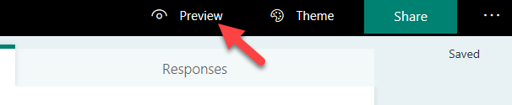

Preview form

1. Your form should look like the image below.

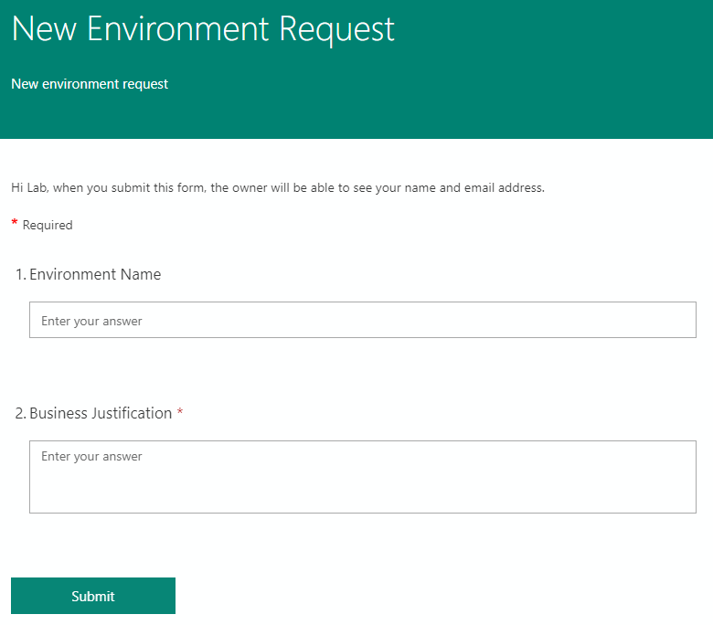

Completed form

# Exercise 2: Create Flow

## Scenario

In this exercise, you will be building the automated flow to process new form submissions.

Note: for the purposes of this exercise we have hard-coded the language, currency and environment template. The Power Platform Administration connector has actions allowing you to dynamically retrieve these and make the process more flexible. In fact, you could allow the user to specify the values, or infer them from the user’s Office 365 profile information using the Office 365 connector.

### Task 1: Create New Environment Approval Flow

1. Logged in with your **Lab Admin** user, navigate to **https://flow.microsoft.com/**. Confirm that your environment is set to Central Apps Test
2. Select **My flows**.
3. Click + New **Automated from Blank**.
4. Type **New Environment Approval** in the Flow name field.
5. In the **Choose your flow’s trigger** section, search for Microsoft Forms, select When a new response is submitted, and click **Create**.

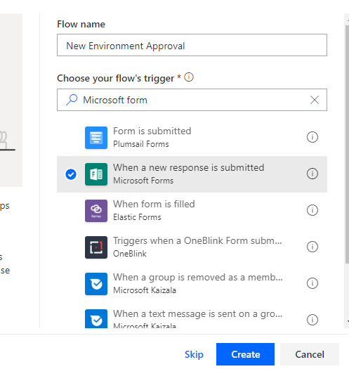

Select when a new response is submitted

1. Select **the New Environment Approval Request** form you created and click **+ New Step**.

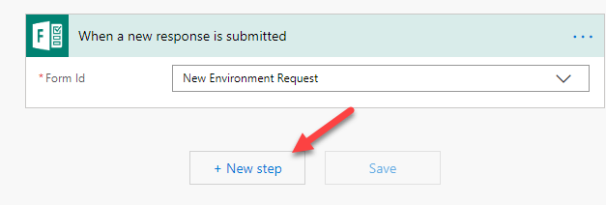

Add new step

1. Search for **Microsoft Forms** and select **Get Response Details**.

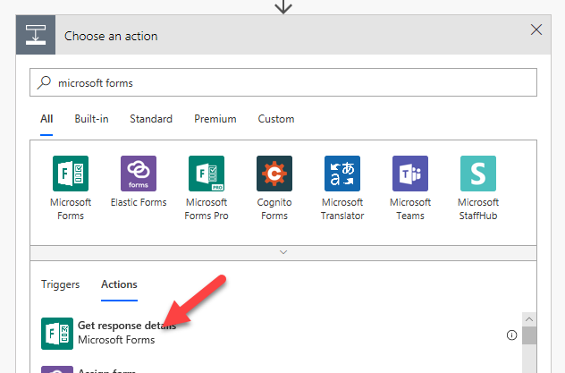

Select get response details

1. Select New Environment Request for Form Id and click on the Response Id field.

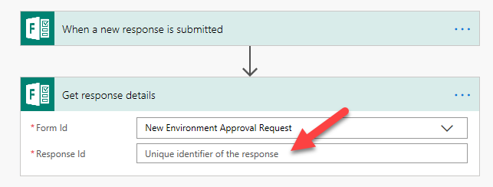

Select form id

1. Select **List of Response Notifications Response Id** from the Dynamic content pane.

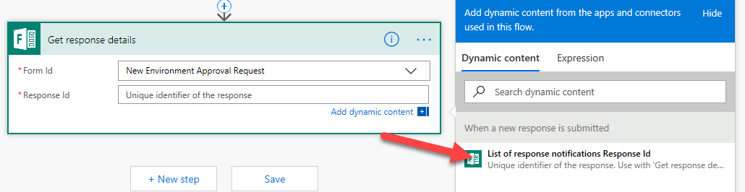

Select response id

1. Apply to each will be added for you. In the Apply for each scope, Click Add an action.

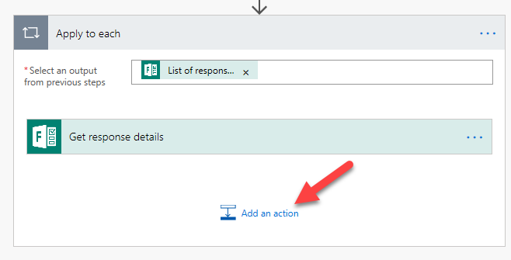

Add action

1. Search for **Approvals** and select **Start and Wait for an Approval (V2)**.

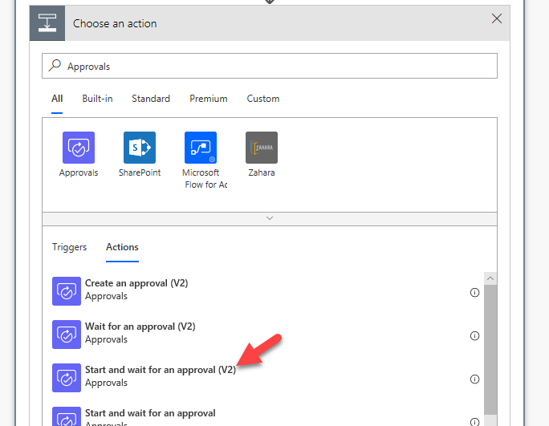

Start approval

1. Select **First to Respond** for **Approval Type**.

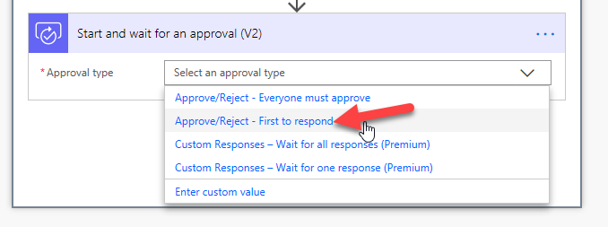

Select first to respond

1. Enter **Environment Approval Requested** for Title
2. Select the user you are logged in as for Assigned to
3. Type New Environment was requested by: in the Details field.

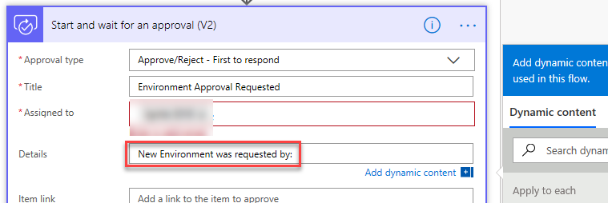

Provide approval details

1. Select **Responders’ Email** from the Dynamic content pane.

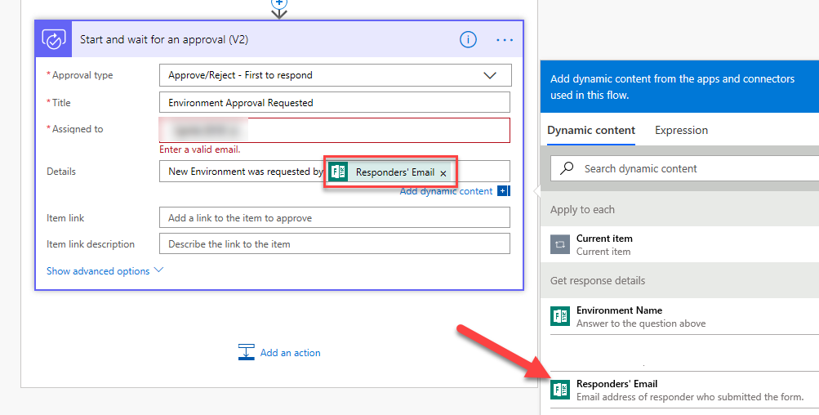

Select responder

1. Hit the enter key and type **Environment Name:** and select Environment Name from the Dynamic content pane.

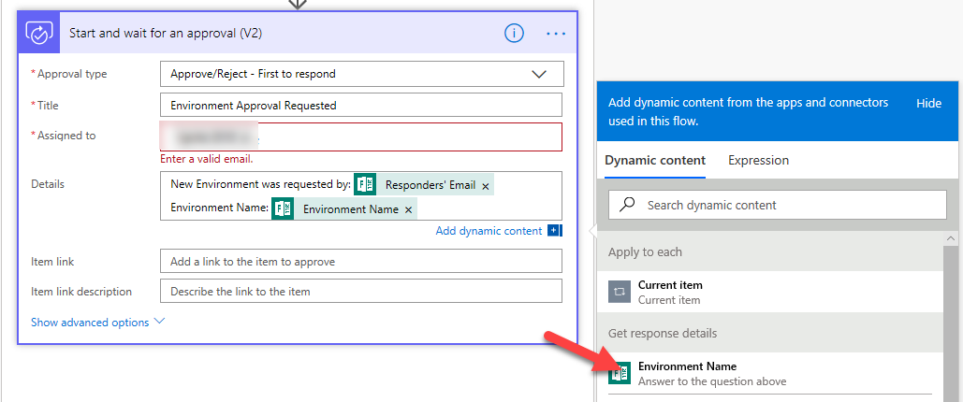

Select name

1. Hit the enter key again and type **Business Justification:** and select Business Justification from the Dynamic content pane.

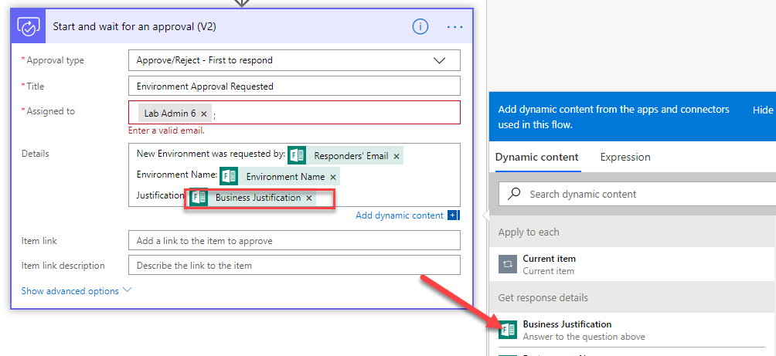

select justification

1. Click **Add an Action**.
2. Select **Condition** Control.

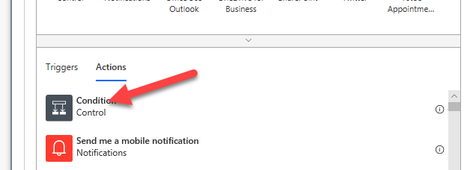

Add condition control

1. Click on the Choose a value field and select **Outcome**

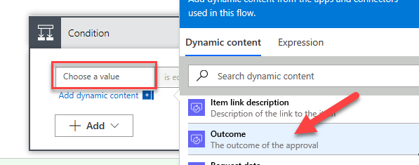

Select outcome

1. Complete condition as shown below and click **Add an action** in the **Yes** branch.

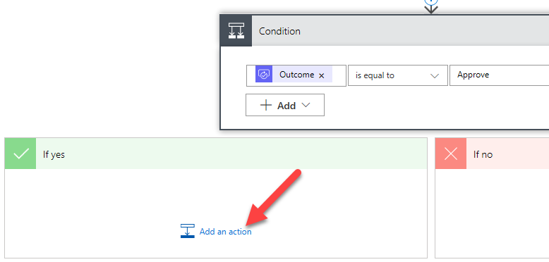

Add new action

1. Search Create Environment and select it.

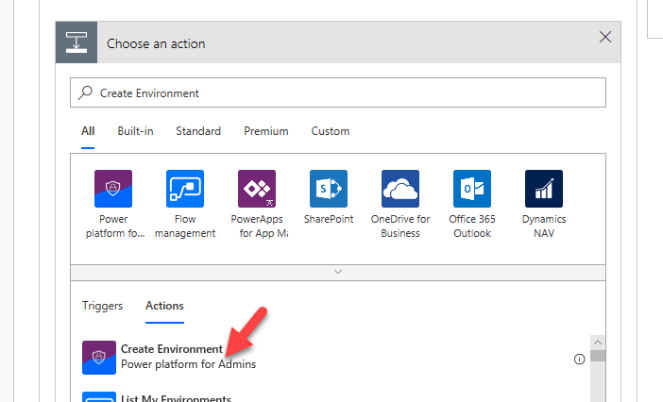

Select create environment action

1. Provide your **location** and click on the **Display Name** field.
2. Select **Environment Name** from the Dynamic content pane.

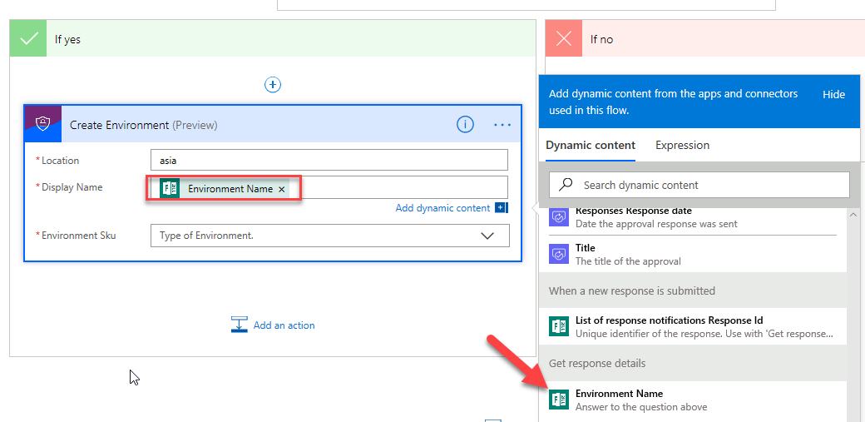

select environment name

1. Select **Trial** for **Environment Sku**.
2. Click Save. Do not navigate away from this page.

### Task 2: Create Database and Notify User

1. Click Add Action.

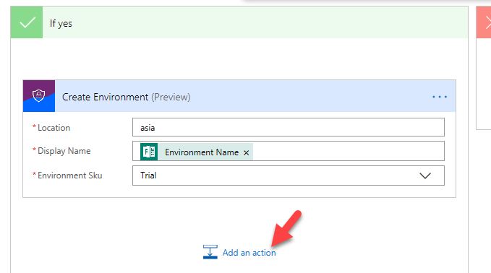

Add another action

1. Search for **Create CDS Database** and select it.

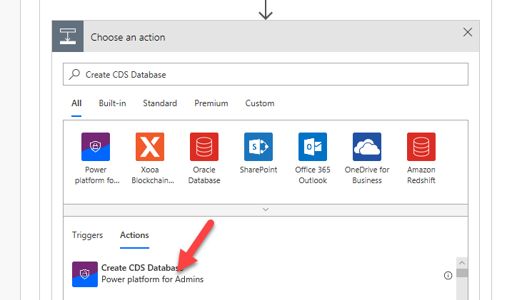

Select create cds

1. Click on the **Environment Name** dropdown and select **Enter Custom Value**.

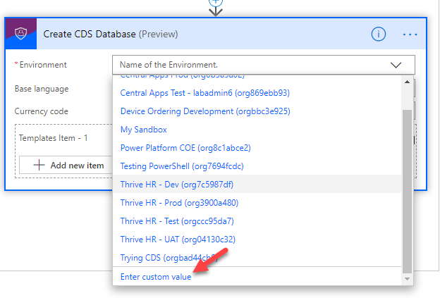

Select custom value

1. Select Name from the Dynamic content pane.

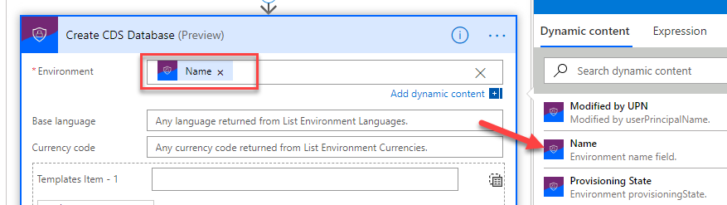

select name

1. Enter **1033** for Base Language and enter USD for Currency Code.
2. Enter **D365_CDSSampleApp** for Template Item.
3. Click Add an Action.
4. Search for Send Email and select **Send an email Office 365 Outlook**.

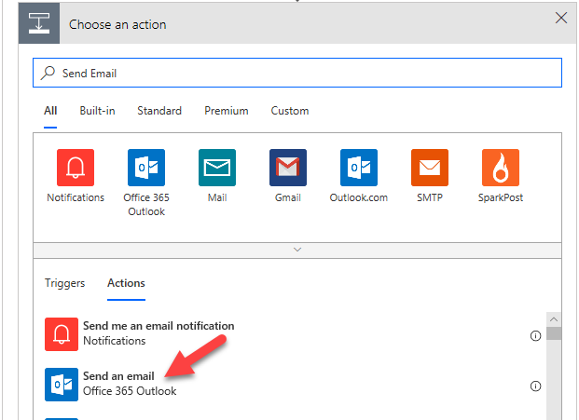

Select send email

1. Provide the information below for the email.

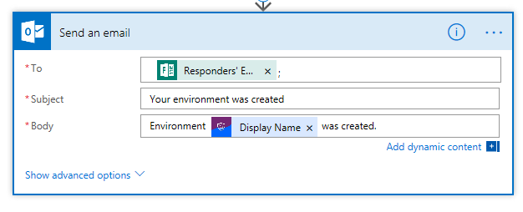

Email information

1. Go to the **No** branch and click Add an Action.
2. Search for Send email and select **Send an email Office 365 Outlook**.
3. Provide the information below for the email.

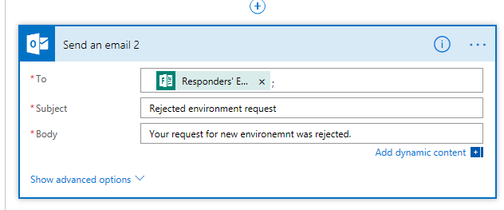

Email information

1. Name the flow **New Environment Request** and click Save.

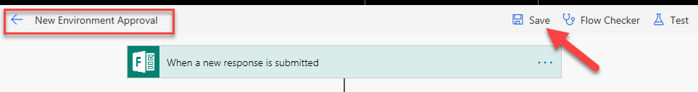

Rename the flow

1. Click Flow Checker and make sure there are no errors.

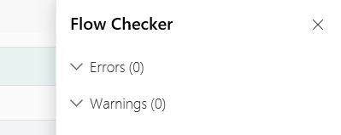

Check the Flow

1. Close the Flow Checker pane.
2. Click on the Back button.

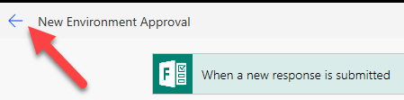

Go back to the Flow

### Task 3: Test the Flow

1. Navigate to https://forms.office.com and click to open the form you created.

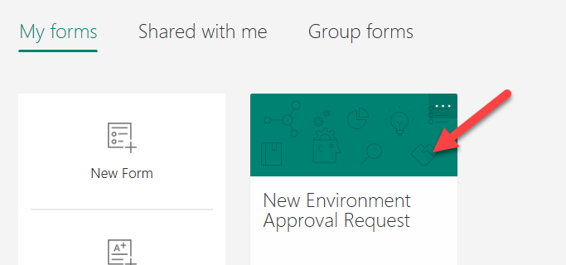

Open the form

1. Click Share and copy the link.

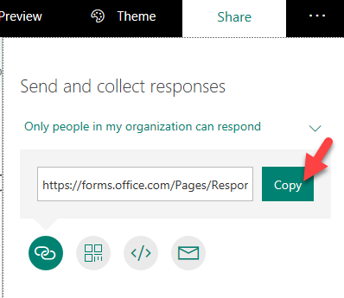

Copy the form url

1. Paste the link in the browser and navigate to it.
2. The form will load. Provide an Environment Name and Business Justification.
3. Click Submit.

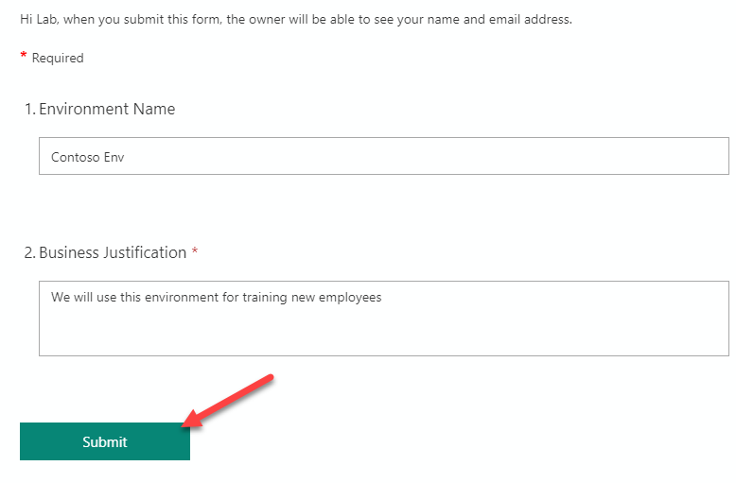

Submit the form

1. Go back to My flows list and open the flow you created.

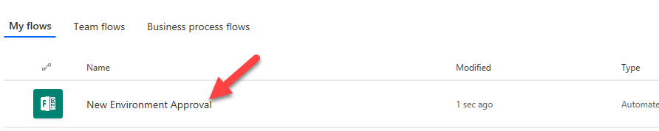

Open the Flow

1. You should see the flow running. Click to open it.

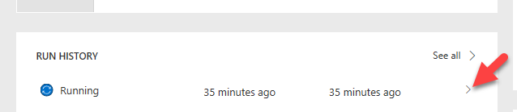

Open the run

1. The flow is waiting for the approval.

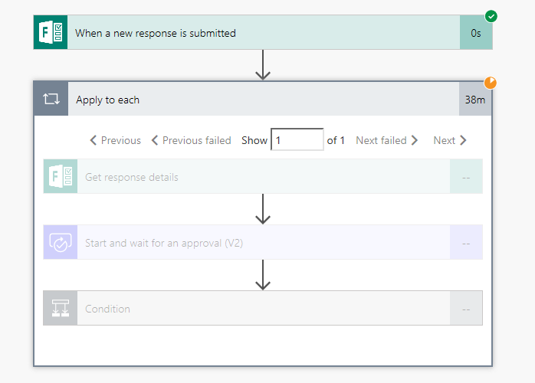

Flow is waiting

1. Start a new browser tab and navigate to https://outlook.office365.com
2. You should have approval request email, click to open it.

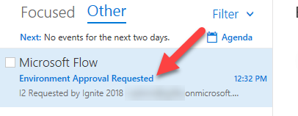

Open the email

1. Click Approve.

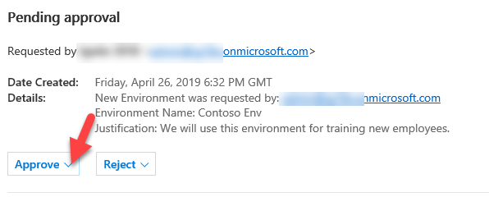

Approve

1. Click Submit.

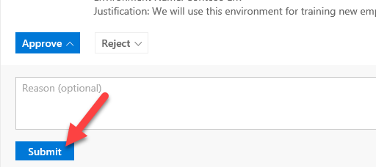

Submit

1. Go back to the flow browser tab.
2. The flow should succeed.

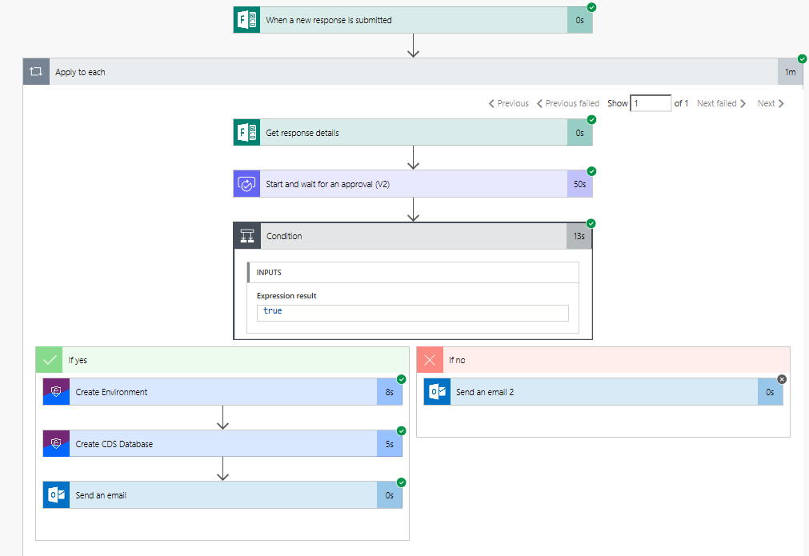

Flow should succeed

1. Navigate to https://admin.powerplatform.microsoft.com/ and select Environments. The new environment should be listed here.

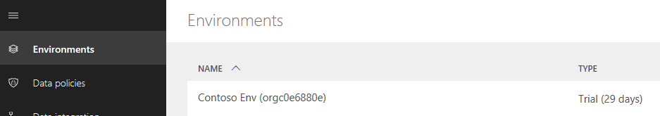

New environment should be listed here

1. You should also get an email.

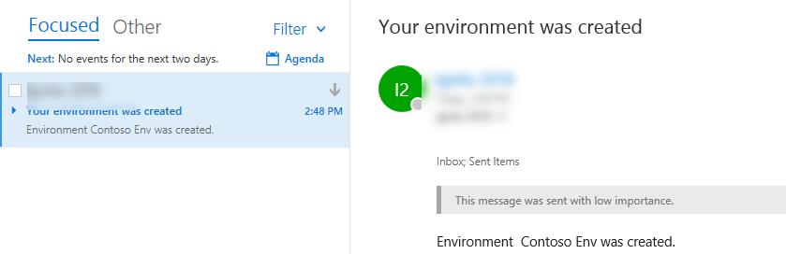

You should get email notification

1. You may test for request rejection if you like.

# Exercise 3: Welcome New Makers

## Scenario

In this exercise, you will be importing a pre-built flow that is designed to identify new app makers and welcome them by sending them an e-mail with some information for new makers. Additionally, the flow will add the user to an Office 365 group so you have an easy way to communicate with all the makers in the company.

### Task 1: Create Office 365 Group

1. Navigate to https://portal.azure.com
2. Select **Azure Active Directory**.

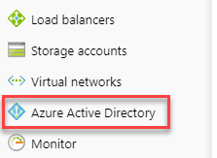

select azure active directory

1. Select **Groups**.

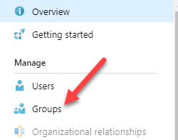

select groups

1. Click **+ New Group**

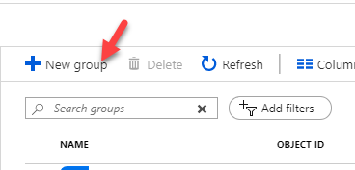

new group

1. Select **Office 365** for Group Type, enter **Lab Admin Your# Makers** for Group Name, select **Assigned** for Membership Type and click **Create**.

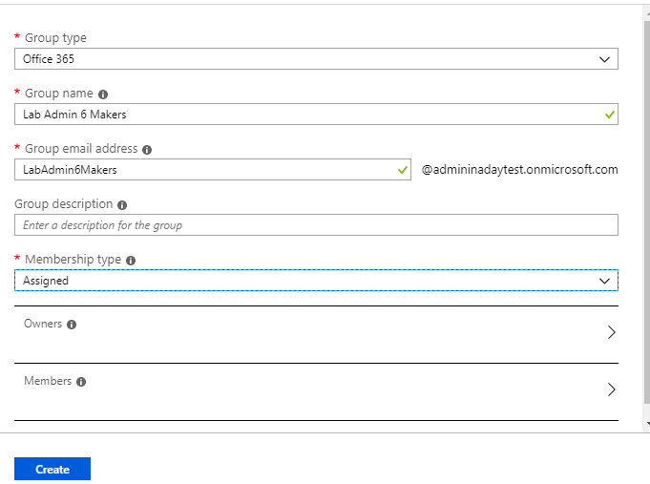

create group

1. Open the group after it gets created.

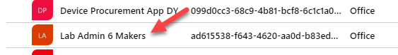

open group

1. Select **Properties** and copy the **Object ID**.

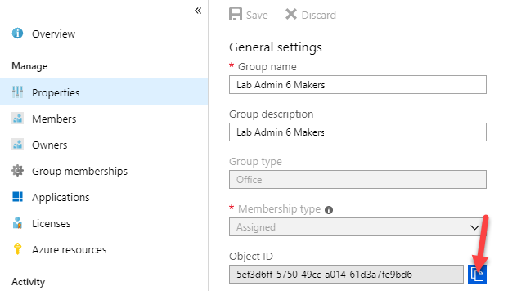

copy object id

1. Paste the object ID to a notepad, you will needed in future step.

### Task 2: Import Flow

1. Navigate to https://flow.microsoft.com and make sure you have the Central Apps Test environment selected.
2. Select My **Flows** and click **Import**.

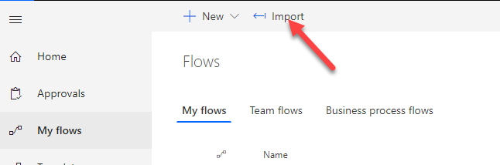

import flow

1. Click **Upload**.
2. Select the Send Welcome Email zip file and click **Open**.

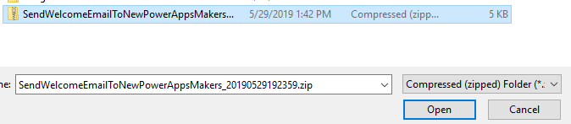

select flow

1. Click Action for **Power Platform for Admin Connection**.

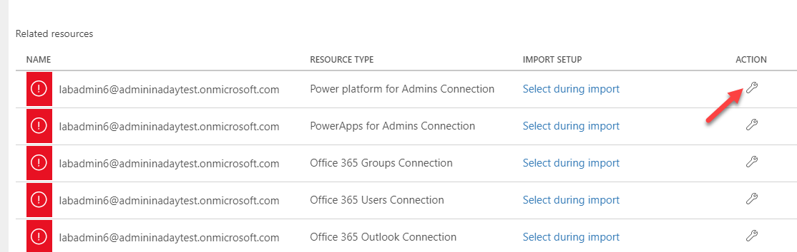

action for power platform admin

1. Select the available connection and click **Save**.

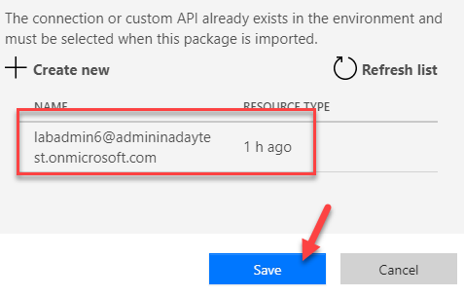

save connection

1. Click Action for **Power Apps for Admin Connection**.
2. Select the available connection and click **Save**.
3. Click Action for **Office 365 Outlook Connection**.
4. Select the available connection and click **Save**.
5. Click Action for **Office 365 Users Connection**.
6. Select the available connection and click **Save**.
7. Click Action for **Office 365 Groups Connection**.
8. Click **Create New**.

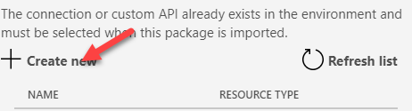

create new

1. Click **New Connection**.

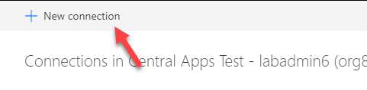

new connection

1. Search for **Office 365 Groups** and select it.
2. Click **Create**.
3. Select the signed user.

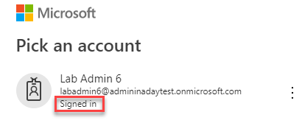

select user

1. Close the Connections browser tab
2. Select the available connection and click **Save**.

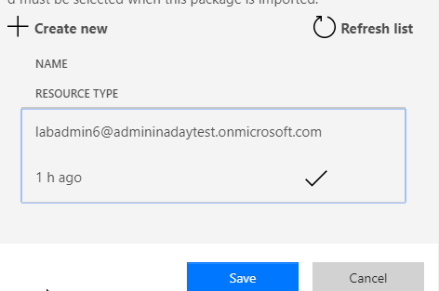

save connection

1. Click **Action** for the Flow.

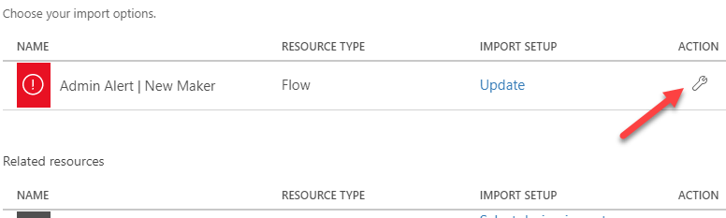

configure flow

1. Select **Create as New** for Setup and click **Save**.

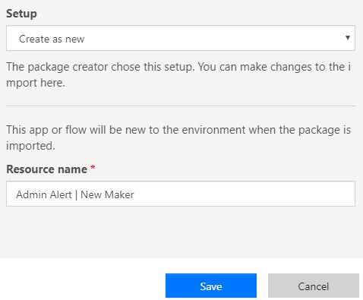

create as new

1. Click **Import** and wait the it to complete.

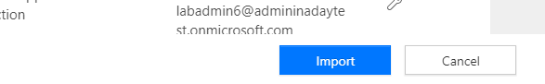

import flow

1. The flow should import successfully.

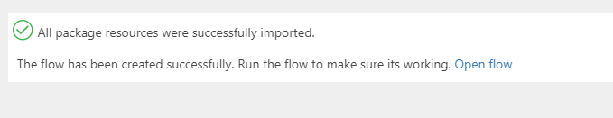

import completed

### Task 3: Edit and Test Flow

1. Navigate to https://flow.microsoft.com and make sure you have the Central Apps Test environment selected.
2. Select My **Flows**.
3. Locate the Flow you created and click **Edit**.

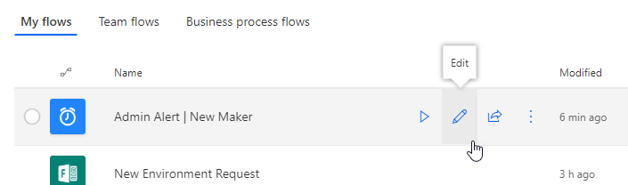

edit flow

1. Expand the Recurrence and make sure the flow is set to run once a day.

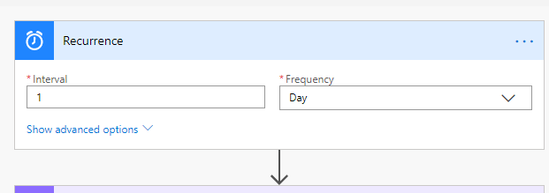

recurrence

1. Expand the Office Group ID step.
2. Clear the current Group ID.
3. Copy the **Group ID** from your notepad and paste it here.

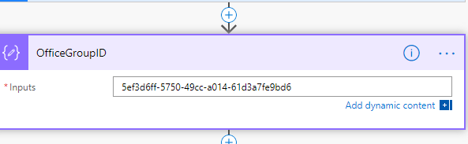

paste group id

1. You may examine the steps of the flow.
2. Click **Save**.
3. Click on the back button.

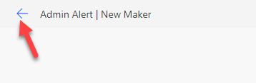

go back to flow

1. Click **More** and select **Run**.

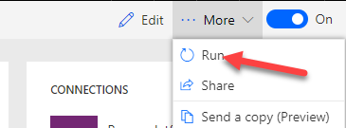

run flow

1. Click **Run Flow**.
2. Click **Done**.



click done

1. Refresh the browser tab.
2. Your flow run should succeed.

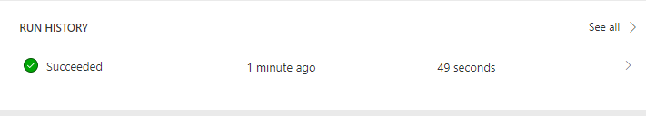

success run

1. Go back to https://portal.azure.com
2. Select **Azure Active Directory**.
3. Select **Groups** and open the group you created.

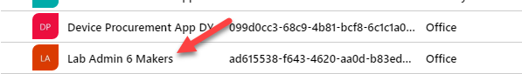

open group

1. Select **Members**. You should have at least one member.

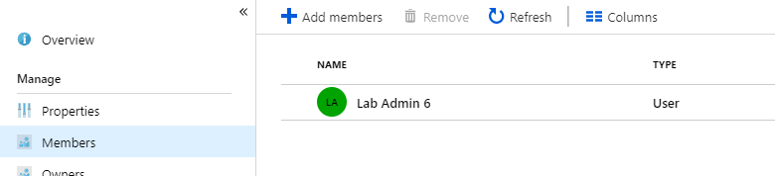

created members

1. Navigate to https://outlook.office.com/
2. You should get a welcome email. Open the email

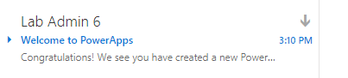

welcome email

# Terms of Use

© 2019 Microsoft Corporation. All rights reserved.

By using this demo/lab, you agree to the following terms: The technology/functionality described in this demo/lab is provided by Microsoft Corporation for purposes of obtaining your feedback and to provide you with a learning experience. You may only use the demo/lab to evaluate such technology features and functionality and provide feedback to Microsoft. You may not use it for any other purpose. You may not modify, copy, distribute, transmit, display, perform, reproduce, publish, license, create derivative works from, transfer, or sell this demo/lab or any portion thereof. COPYING OR REPRODUCTION OF THE DEMO/LAB (OR ANY PORTION OF IT) TO ANY OTHER SERVER OR LOCATION FOR FURTHER REPRODUCTION OR REDISTRIBUTION IS EXPRESSLY PROHIBITED. THIS DEMO/LAB PROVIDES CERTAIN SOFTWARE TECHNOLOGY/PRODUCT FEATURES AND FUNCTIONALITY, INCLUDING POTENTIAL NEW FEATURES AND CONCEPTS, IN A SIMULATED ENVIRONMENT WITHOUT COMPLEX SET-UP OR INSTALLATION FOR THE PURPOSE DESCRIBED ABOVE. THE TECHNOLOGY/CONCEPTS REPRESENTED IN THIS DEMO/LAB MAY NOT REPRESENT FULL FEATURE FUNCTIONALITY AND MAY NOT WORK THE WAY A FINAL VERSION MAY WORK. WE ALSO MAY NOT RELEASE A FINAL VERSION OF SUCH FEATURES OR CONCEPTS. YOUR EXPERIENCE WITH USING SUCH FEATURES AND FUNCTIONALITY IN A PHYSICAL ENVIRONMENT MAY ALSO BE DIFFERENT.

## FEEDBACK

If you give feedback about the technology features, functionality and/or concepts described in this demo/lab to Microsoft, you give to Microsoft, without charge, the right to use, share and commercialize your feedback in any way and for any purpose. You also give to third parties, without charge, any patent rights needed for their products, technologies and services to use or interface with any specific parts of a Microsoft software or service that includes the feedback. You will not give feedback that is subject to a license that requires Microsoft to license its software or documentation to third parties because we include your feedback in them. These rights survive this agreement. MICROSOFT CORPORATION HEREBY DISCLAIMS ALL WARRANTIES AND CONDITIONS WITH REGARD TO THE DEMO/LAB, INCLUDING ALL WARRANTIES AND CONDITIONS OF MERCHANTABILITY, WHETHER EXPRESS, IMPLIED OR STATUTORY, FITNESS FOR A PARTICULAR PURPOSE, TITLE AND NON-INFRINGEMENT. MICROSOFT DOES NOT MAKE ANY ASSURANCES OR REPRESENTATIONS WITH REGARD TO THE ACCURACY OF THE RESULTS, OUTPUT THAT DERIVES FROM USE OF DEMO/ LAB, OR SUITABILITY OF THE INFORMATION CONTAINED IN THE DEMO/LAB FOR ANY PURPOSE.

## DISCLAIMER

This demo/lab contains only a portion of new features and enhancements in Microsoft PowerApps. Some of the features might change in future releases of the product. In this demo/lab, you will learn about some, but not all, new features.