# Admin in a day

# Module 4: Deploying Apps

# Hands on lab

# Lab Scenario

In this Hands-on Lab, you are an administrator for Contoso, helping them to adopt the Power Platform.

The team building the Device Order Management app is now ready for you to transport their solution from their development environment to the test environment for testing.

In this lab, you will be deploying their app to the Central Apps Test environment so it can be tested prior to deployment to the production environment.

Because this is the first deployment to test, you will have to do some setup to configure security for users to be able to access the app.

# Lab Requirements

## Lab Test Environment

This hands-on lab is designed to be completed in an environment setup for multiple students to complete the Admin in a day series of hands-on labs.

You will be assigned one or more users to use to complete the hands on tasks. Because this is a shared environment, some tasks that require a tenant Global Administrator or a Service Administrator will already be performed.

This lab assumes you have completed M01_SecuringYourEnvironment prior to starting this lab.

# Exercise 1: Exporting Solutions from development environment

## Scenario

The Device Order Management team has indicated they would like to deploy a copy of the app to test before moving it into production.

In this exercise, you will be exporting both a managed and unmanaged copy of the Device Ordering solution. While you will only be deploying the managed solution, it is important that you have a matching copy of the unmanaged solution. If you ever have to re-create the development environment, the unmanaged solution is required.

### Task 1: Export the unmanaged solution

1. While logged in with your Lab Admin account. Navigate to https://make.powerapps.com and select the **Device Ordering Development** environment.
2. Select the **Solutions** tab and click to open the **Contoso Device Order Management** solution.
3. Click Export.

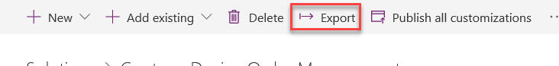

Export button

1. Click **Publish** to ensure that all changes have been published. Click Next.
2. Select **Unmanaged** and click click **Export**.

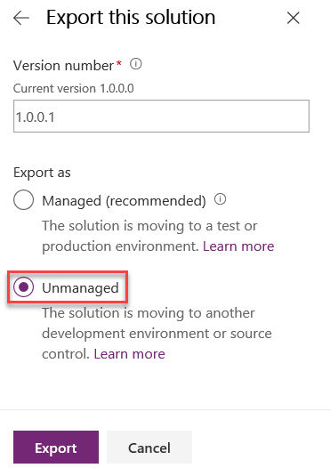

Unmanaged option selected

1. Wait for the export to complete and save the exported solution on your machine.

### Task 2: Export the managed solution

1. Go back to the solution and click **Export** again.
2. Click Next.
3. Select **Managed** and click **Export**.

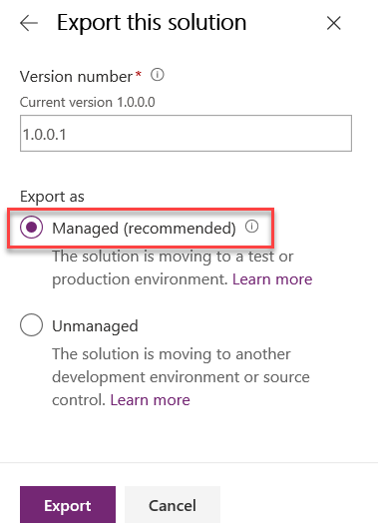

Export button

1. Wait for the export to complete and save the exported solution.

# Exercise 2: Import the managed solution into test environment

## Scenario

In this exercise, you will be importing the managed Device Ordering solution into the test environment.

### Task 1: Import the managed solution

1. Navigate to https:/make.powerapps.com and change the selected environment to **Central Apps Test** environment. It’s important that any time you start working in the portals you ensure you are in the correct environment to avoid making mistakes.
2. Select Solutions.
3. Click Import.

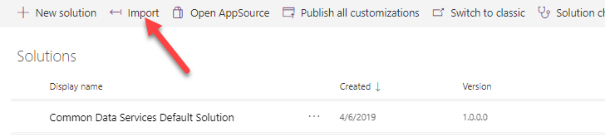

Import button

1. Click Browse.
2. Select the managed solution you exported and click Open. The solution file will have a name like ContosoDeviceOrderManagement_1_0_0_1_managed.zip
3. Click Next.
4. Here you can click View solution package details if you like to see what you are importing. Click Next again.
5. Click Import. Note: The Enable Any SDK message processing steps allows any included developer logic to be active, if you disable that you would have to know how to manually activate each individual step after import, generally it is best left enabled during import.
6. Wait for the import to complete, ensure it says it completed successfully and then click Close. If the import failed, you would be prompted to download an Excel log file that contains detailed information about the problems encountered.

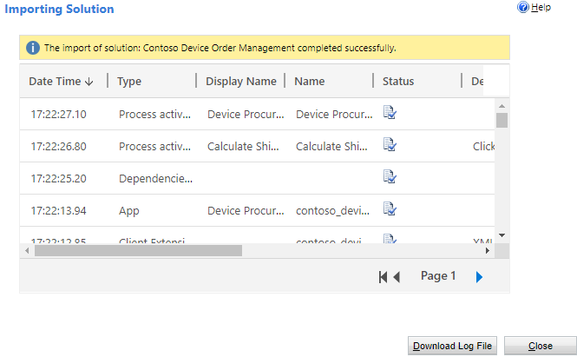

Completed import

# Exercise 3: Share the apps with the users

## Scenario

In this exercise, you will be sharing the Device Ordering canvas app with all users of the Device Ordering App Azure AD security group. When you do the share, you will pick the Device Ordering App security role for the CDS permissions. Behind the scenes this will cause the system to create a CDS team that is associated with the Azure AD group and associate that team with the security role. The end result of this is making it possible to give users access to the app and CDS data all in the same sharing action.

### Task 1: Share the device ordering app

1. Navigate to https://make.preview.powerapps.com and make sure you are in the correct environment (Central Apps Test).
2. Select Apps.
3. Click on the … More Commands button on the Device Ordering App and select Share.

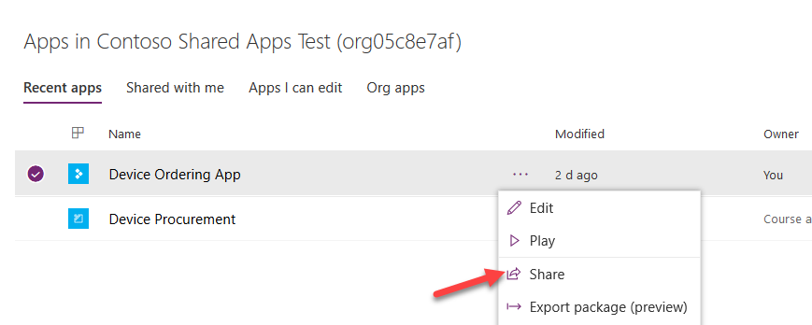

Share application

1. Search for **Device** and select the **Device Ordering App** group.

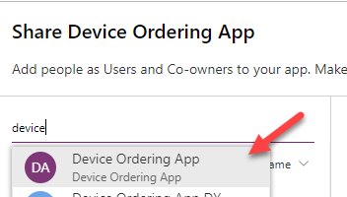

group selection

1. On the right side of the share panel next to the CDS Connector click on the Assign a security role dropdown and select the **Contoso Device Order App** security role. The system will create a CDS Team and assign this security role to the team. Any member of the Azure AD Group will then get those privileges.

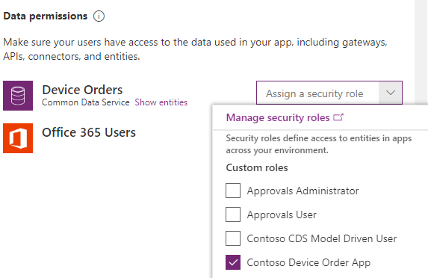

select selection

1. Un-check the Send Notification checkbox and Click on the Share button.

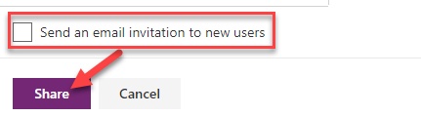

share

1. Don’t Close the share pane we are going to use it in the next task.

### Task 2: Share the device procurement model-driven app

While you can click on the Share link of a model-driven app it will simply list the manual steps you need to take. These steps are the following * Make sure the model-driven app has a security role assigned to it, and users that need to run it has that role * Make sure the users that need to access the app have a security role giving them appropriate CDS permissions to the data.

In the future, the model-driven share experience will be updated to be more like the canvas experience above. Until that happens, we can leverage the canvas share to do the connection of an Azure AD group to a CDS Team. In our example, we want the back office group to also have access to our canvas app, but if we didn’t after using the share to hookup the team and the security role to the Azure AD group we could remove the share to this group and it would leave the team and connection to Azure AD in place.

1. While still on the share pane from the prior task, search for the **Device Procurement App** group and select it.

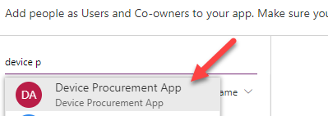

device procurement app group

1. In the Assign security role drop down select the **Contoso CDS Model Driven User** and **Contoso Device Procurement App** security roles.

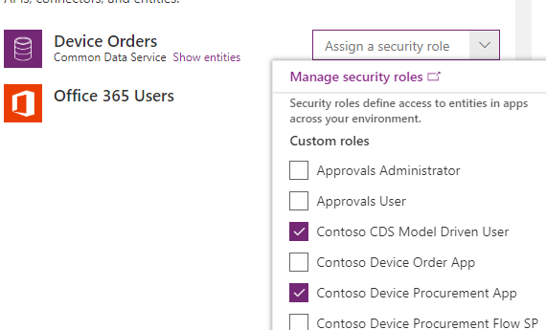

select security roles

1. Un-check send an email and click **Share**. Since our model-driven app uses the Contoso Device Procurement App role, our back office users will now have access to the model-driven app.
2. Close the share pane.

# Exercise 4 (Optional): Test the application

## Scenario

In this exercise, you will login with the users and test the application.

### Task 1: Test the Device Ordering app

1. Navigate to make.powerapps.com and make sure you are in the Central Apps Test environment
2. Select on **Apps**.
3. Click on … next to the **Device Ordering App** and select **Details**.

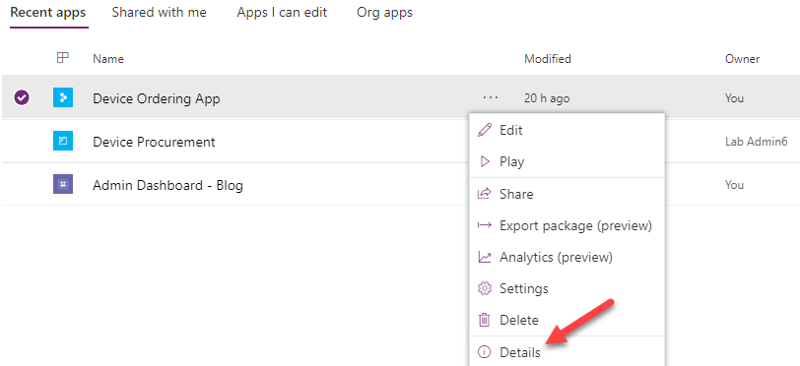

app details

1. On the details page copy the URL in the Web link section.

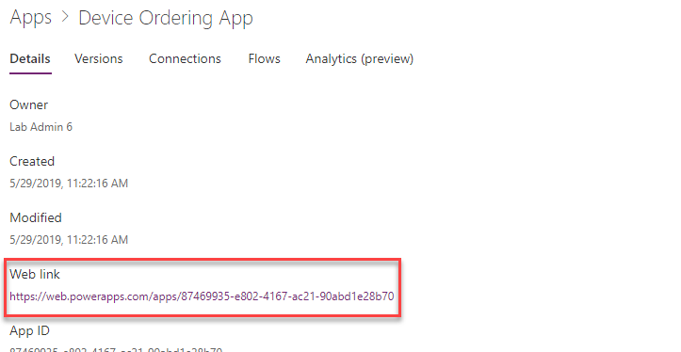

copy link

1. In another in-private browser window, paste the copied URL into the browsers address bar to launch the app
2. Log in with your Lab Employee account.
3. Make sure the selected connections are correct and click Allow.

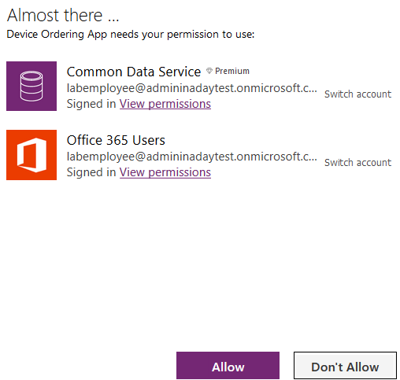

check connections

1. Select Manufacturer.
2. Select Few devices and click Compare.

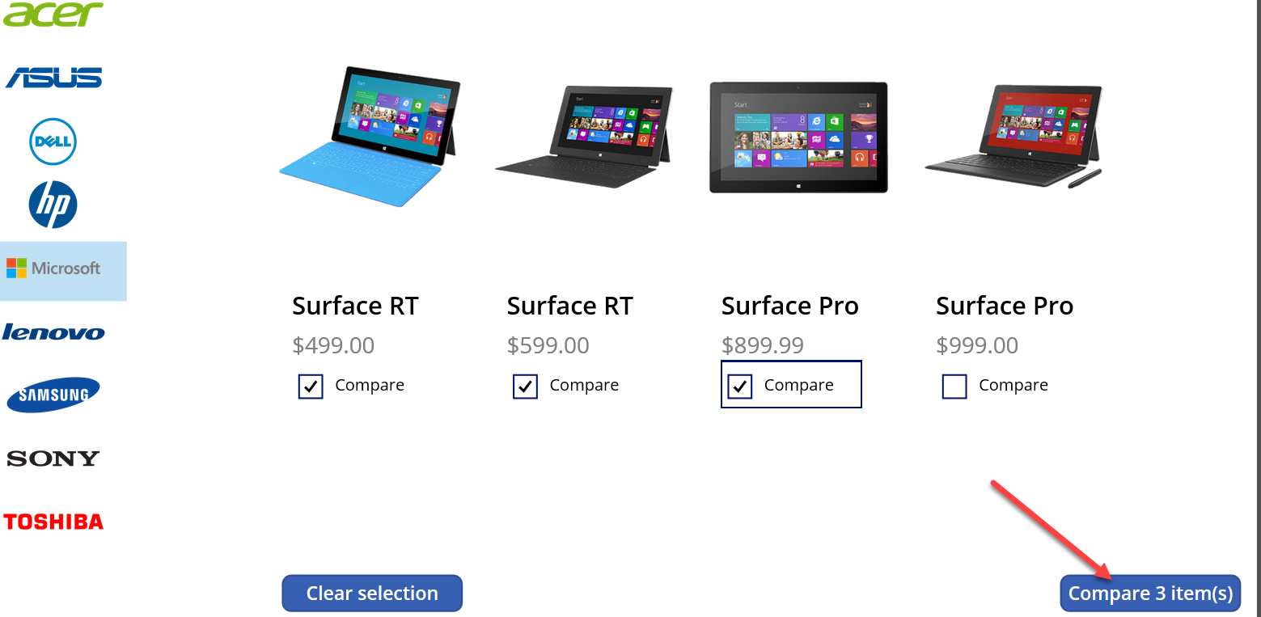

Compare devices

1. Select one of the devices
2. Change the approver to your lab admin account
3. Provide a comment and click **Submit Device Request**.

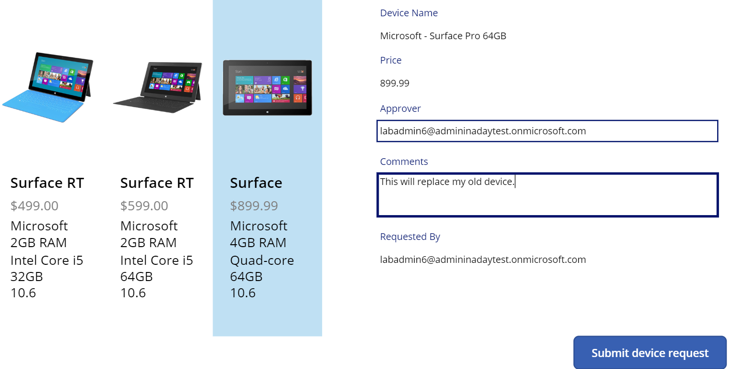

submit request

1. Click OK.

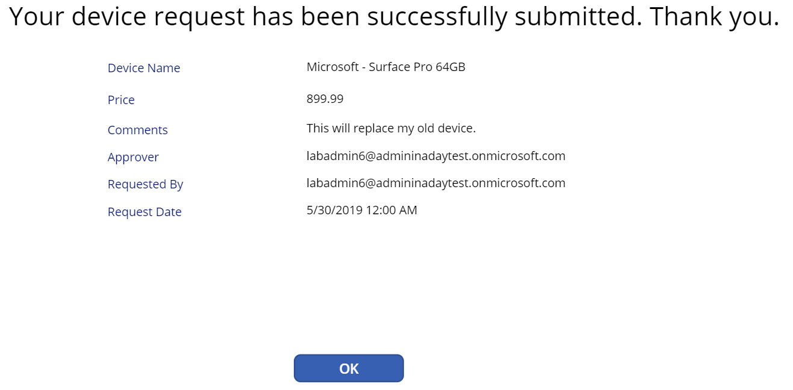

confirmation

### Task 2: Test the Device Procurement app

1. In the browser window logged in with Lab Admin, navigate to make.powerapps.com and make sure you are in the correct environment.
2. Select Apps and click on the … next to the **Device Procurement App** and select Share
3. Copy the URL from Step 4.

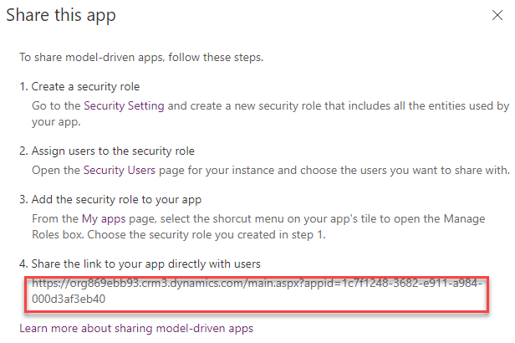

copy url

1. In a private browser window paste the url for the app into the address bar and login with your Lab Back Office account. If the you can’t login, give few minutes and try again.
2. Select Device Orders and you should see at least one device order.

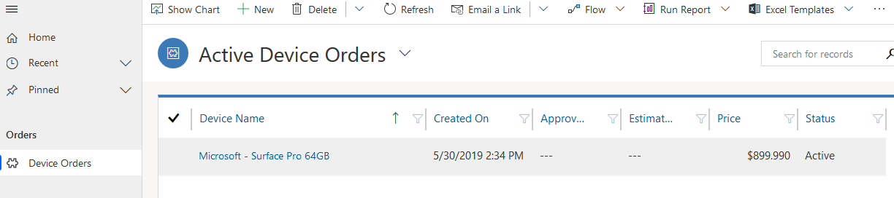

Check approval status

### Task 3: Test the application and log some data

1. Navigate to **make.powerapps.com** and select the Central Apps Test environment.
2. Select **Apps** and open the Device Procurement App.

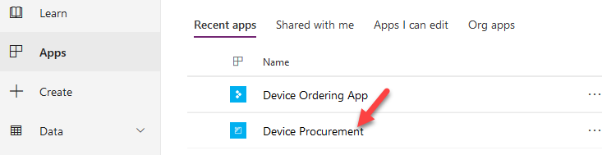

Open application

1. Open one of the existing records, If you don’t have any records on the list, run the Device Ordering application and order a device.

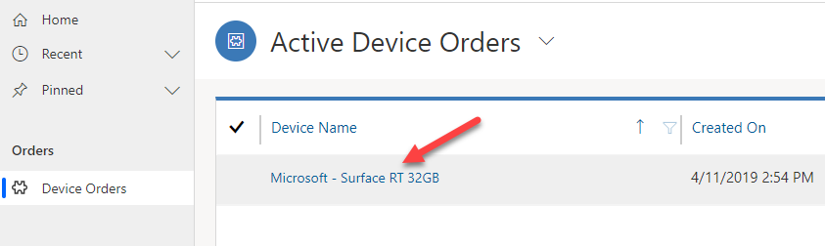

Open record

1. Edit the **Name** and click Save.

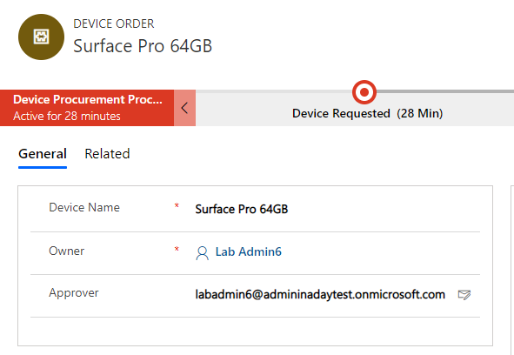

edit and save record

1. Review the **Related -> Audit History**.

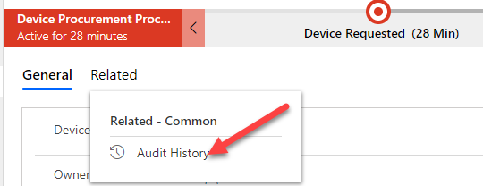

audit history

1. Audit history should look like the image below.

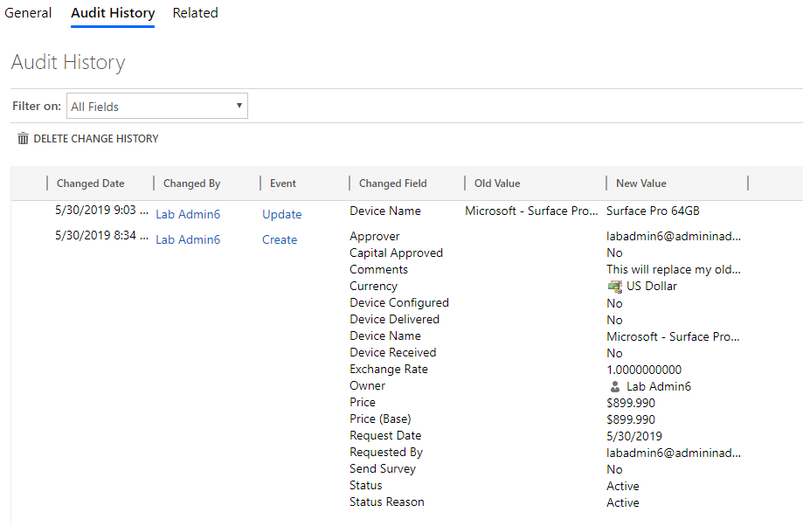

audit history

# Exercise 5 (Optional): Setup the Flow to use a service principal

## Scenario

In this exercise, you will be setting up the Microsoft Flow to use a service principal and shared service accounts.

The goal of this setup is to ensure the flow runs in a non-system admin account with least privileges required.

To accomplish that the following accounts will be used * For Common Data Service trigger and actions we will use a service principal that has just the permissions required for the flow actions * For the Approval and Office 365 e-mail send we will use a Service Account that only has permission to send e-mail and has no other permissions at this time.

The most important thing is to make sure we don’t use our admin account that generally has very broad access to resources in the tenant.

### Task 1: Setup the service principal

1. Navigate to https://portal.azure.com/
2. Select Azure Active Directory.
3. Select App Registration (not the one that says (Legacy)) and click New Registration.

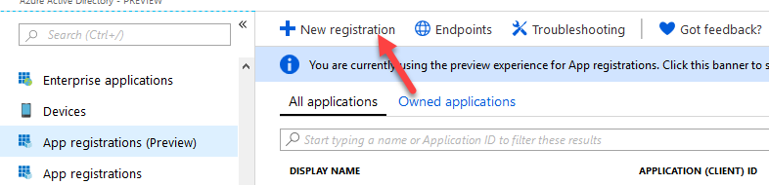

New registration

1. Enter Device Procurement App (Your Initials) for Name, select Accounts in this Organizational Directory Only, and click Register.

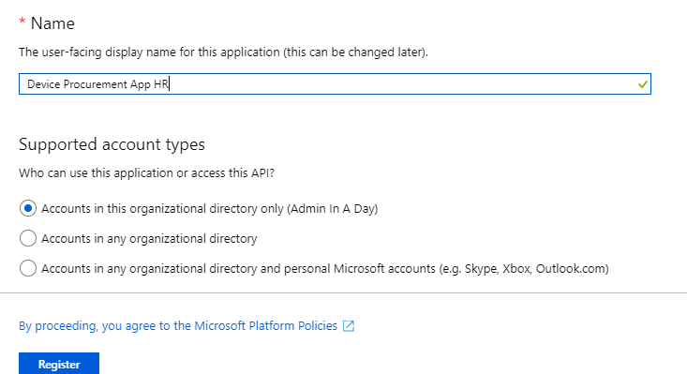

Register button

1. Copy the Application(client) ID and Directory Tenant I. Save them in a notepad.

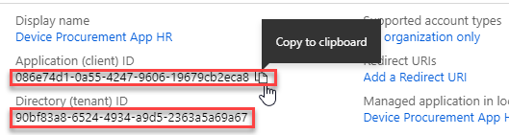

copy id

1. Select Certificates & Secrets and click + New Client Secret.

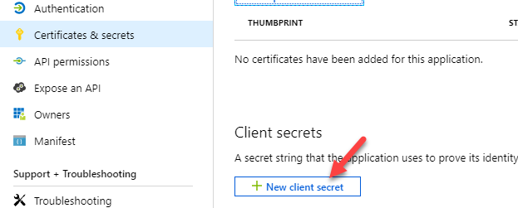

New client secret

1. Enter Description and click Add. For the Expires duration, we are choosing 1 year, in a real deployment you need to make sure if you choose 1 or 2 years you have a plan to rotate the keys prior to expiration or anything using the key will fail upon expiration.

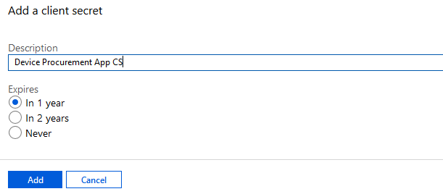

Add client secret

1. Copy the Value and keep in a notepad. This value is not available again once you leave this area of the portal.

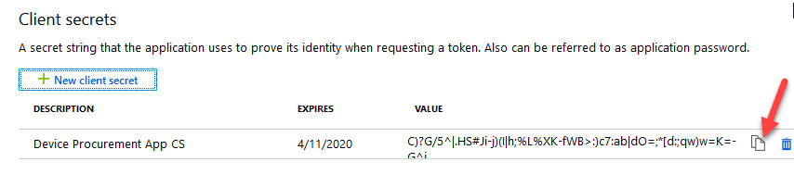

copy the value

1. Go back to https:/make.powerapps.com click Settings and select Advanced Customizations.

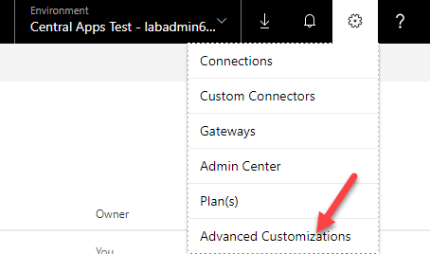

advanced customizations

1. Select Users.
2. Select Advanced Settings

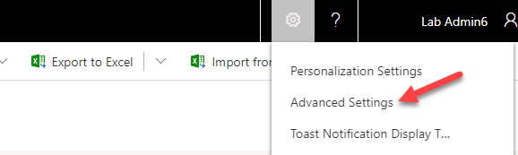

Advanced settings

1. Navigate to Settings | Security.

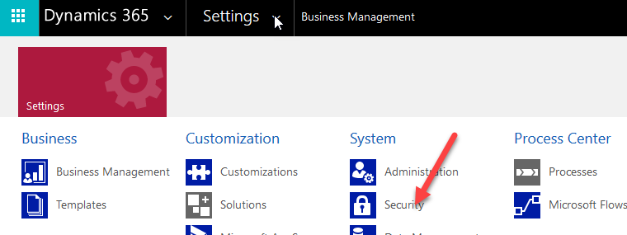

Navigate to security

1. Click Users.
2. Change the view to Application Users.

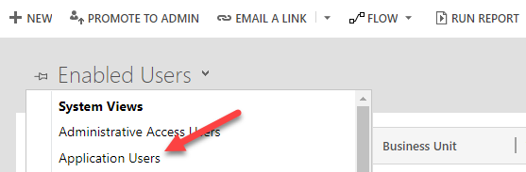

change view

1. Click New.
2. Change the form to Application User.

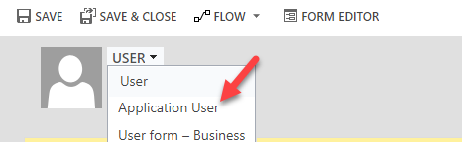

change form

1. Enter Contoso App User for Name.
2. Paste the Application ID you copied from the Azure Portal.
3. In the Full Name field, provide First and Last Name and then click Done.
4. Provide an email address and click Save.

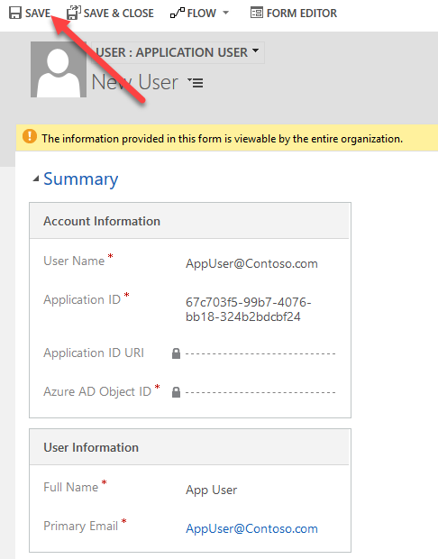

Save app user

1. The Application ID URL and Azure AD Object ID should populate.

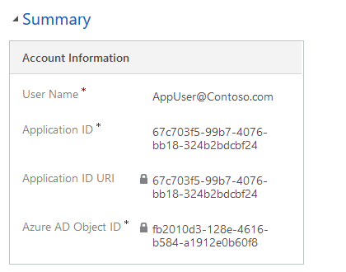

populated fields

1. Click Manage Roles,
2. Select the Contoso Device Procurement Flow SP security role and click OK.

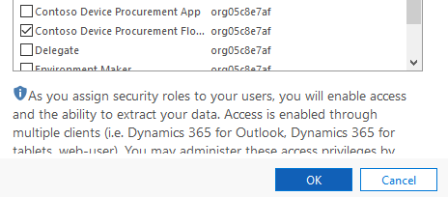

Security role selection

### Task 2: Edit the flow to fix up the connections

1. Navigate to https://make.powerapps.com
2. Select Solutions and open Contoso Device Order Management.
3. Locate Device Approval Request and click to open.

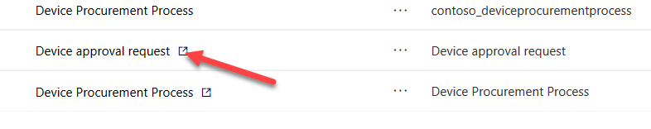

Open Flow

1. Click Edit.

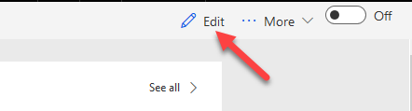

Edit Flow

1. Click on the trigger step to expand.

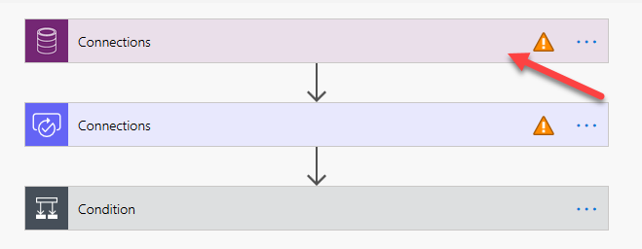

Expand Flow stage

1. Click Add New.
2. Click Connect with Service Principal.

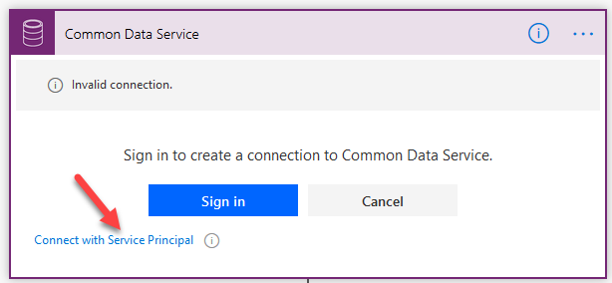

Connect with service principle

1. Provide a name Contoso App User.
2. Paste the Application (Client) ID.
3. Paste the secret from the notepad in the Client Secret field.
4. Paste the Tenant ID from the notepad in the Tenant field.
5. Click Create.

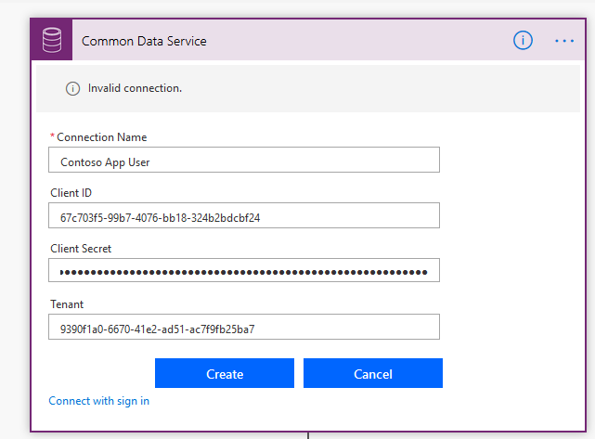

Create

1. Click on the Approval step.
2. Select Approvals.

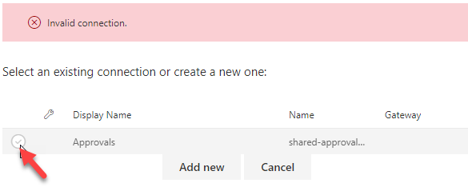

Approval connection

1. Expand the Condition stage.
2. Select Contoso App User.

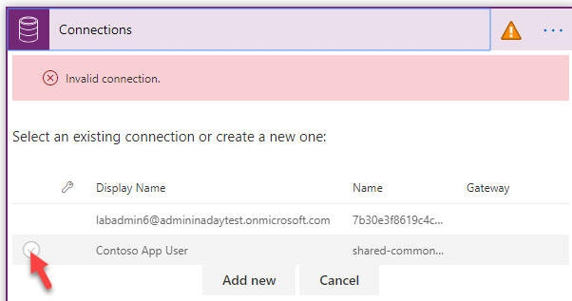

Application user

1. Expand the Email action.
2. Click Add New Connection.
3. Click on the … button and select Add New Connection
4. Login with the Service Account credentials you were provided.
5. In the If No branch, click on the CDS connector and select the Contoso App User service principal.
6. In the If No branch, click on the Email action and select the Service Account connection.
7. Click on the Flow Checker button.
8. Make sure you don’t have errors and close the Flow Checker pane.
9. Save the Flow.
10. Click on the Back arrow next to the Flow Name
11. Confirm the flow is now turned on (upper right corner) and turn on the Flow if it is still turned off.

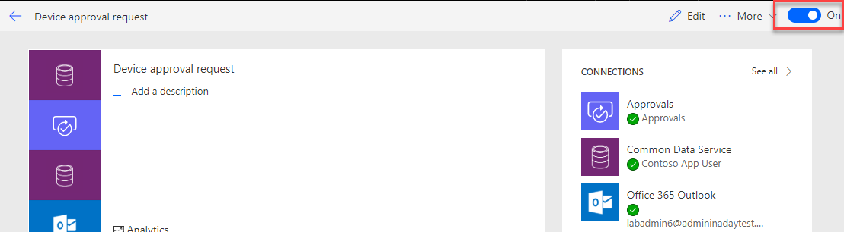

confirm the flow is on

# Terms of Use

© 2019 Microsoft Corporation. All rights reserved.

By using this demo/lab, you agree to the following terms: The technology/functionality described in this demo/lab is provided by Microsoft Corporation for purposes of obtaining your feedback and to provide you with a learning experience. You may only use the demo/lab to evaluate such technology features and functionality and provide feedback to Microsoft. You may not use it for any other purpose. You may not modify, copy, distribute, transmit, display, perform, reproduce, publish, license, create derivative works from, transfer, or sell this demo/lab or any portion thereof. COPYING OR REPRODUCTION OF THE DEMO/LAB (OR ANY PORTION OF IT) TO ANY OTHER SERVER OR LOCATION FOR FURTHER REPRODUCTION OR REDISTRIBUTION IS EXPRESSLY PROHIBITED. THIS DEMO/LAB PROVIDES CERTAIN SOFTWARE TECHNOLOGY/PRODUCT FEATURES AND FUNCTIONALITY, INCLUDING POTENTIAL NEW FEATURES AND CONCEPTS, IN A SIMULATED ENVIRONMENT WITHOUT COMPLEX SET-UP OR INSTALLATION FOR THE PURPOSE DESCRIBED ABOVE. THE TECHNOLOGY/CONCEPTS REPRESENTED IN THIS DEMO/LAB MAY NOT REPRESENT FULL FEATURE FUNCTIONALITY AND MAY NOT WORK THE WAY A FINAL VERSION MAY WORK. WE ALSO MAY NOT RELEASE A FINAL VERSION OF SUCH FEATURES OR CONCEPTS. YOUR EXPERIENCE WITH USING SUCH FEATURES AND FUNCTIONALITY IN A PHYSICAL ENVIRONMENT MAY ALSO BE DIFFERENT.

## FEEDBACK

If you give feedback about the technology features, functionality and/or concepts described in this demo/lab to Microsoft, you give to Microsoft, without charge, the right to use, share and commercialize your feedback in any way and for any purpose. You also give to third parties, without charge, any patent rights needed for their products, technologies and services to use or interface with any specific parts of a Microsoft software or service that includes the feedback. You will not give feedback that is subject to a license that requires Microsoft to license its software or documentation to third parties because we include your feedback in them. These rights survive this agreement. MICROSOFT CORPORATION HEREBY DISCLAIMS ALL WARRANTIES AND CONDITIONS WITH REGARD TO THE DEMO/LAB, INCLUDING ALL WARRANTIES AND CONDITIONS OF MERCHANTABILITY, WHETHER EXPRESS, IMPLIED OR STATUTORY, FITNESS FOR A PARTICULAR PURPOSE, TITLE AND NON-INFRINGEMENT. MICROSOFT DOES NOT MAKE ANY ASSURANCES OR REPRESENTATIONS WITH REGARD TO THE ACCURACY OF THE RESULTS, OUTPUT THAT DERIVES FROM USE OF DEMO/ LAB, OR SUITABILITY OF THE INFORMATION CONTAINED IN THE DEMO/LAB FOR ANY PURPOSE.

## DISCLAIMER

This demo/lab contains only a portion of new features and enhancements in Microsoft PowerApps. Some of the features might change in future releases of the product. In this demo/lab, you will learn about some, but not all, new features.