**Purpose of this Document**

This is a document describing the use of AVRGait which is a sensor-based wearable focused on reducing overstride by analysing the sensor data collected from the device and reporting it to the runners if overstriding is observed. The system is currently aimed at use by runners, athletes and others performing fitness training activities which involves jogging or running.

**Introduction to AVRGait (what is the system?)**

This system on a whole is focused to reduce overstriding. It consists of electronic sensor-based hardware which is used to sense and store the accelerometer and gyroscope data which is generated while jogging or running.

After performing workout, this data is then sent via Bluetooth to the software installed in user’s windows machine for analysis to find out if overstriding is noticed.

**Graphical Representation of the System**

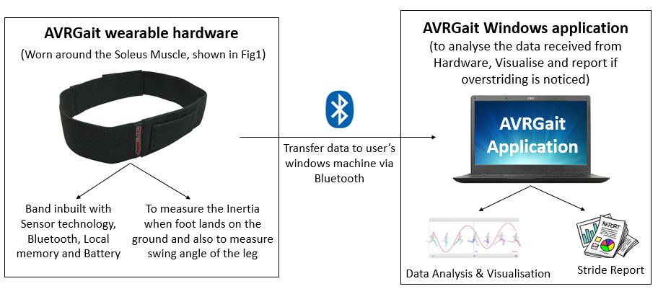

**Figure1 – image of this band was taken from Internet for reference**

**Who will be interacting with AVRGait (the System)** The following are the Primary characters who will be interacting with the system in the story. No technician is required for setting up the system for the primary user and also, no assistance is required for them while using it.

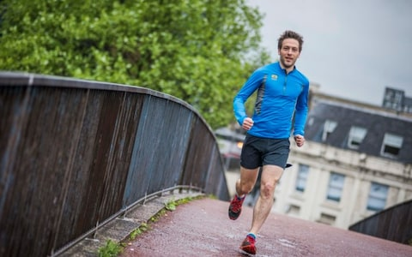

Figure 2 Praveen - 26 years old

**Praveen** will be the primary user of AVRGait and its Software. He is a 26-year-old physically active young man. He recently read an article online about overstriding. He says that, overstriding has been shown to increase stress on the body. Some people have enough strength to absorb the increased stress but many do not. Even with enough strength, it is not efficient to run accepting more mechanical load (stress) than is necessary to produce forward momentum. He also found out that overstriding causes the body to spend too much time on the ground, pulling itself first into a mid-stance phase, and then propelling itself forward. Increased time on the ground means increased time for injury to occur.

After reading through articles and also after browsing and knowing about the issues caused due to overstriding, he is very much interested to know about his strides while **jogging at various speeds in the treadmill** and also wants to know about his strides while **running in the running track**.

**When Praveen wants to use AVRGait, he needs**

**The AVRGait Wearable Hardware**

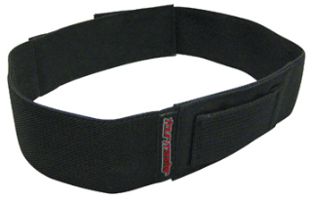

**Figure 3 – image of this band was taken from Internet for reference**

This band is worn on around the Soleus Muscle as shown in figure 6.

**Charger for the Hardware**

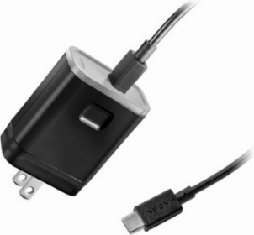

Figure 4 Charger

Praveen has to charge the AVRGait Wearable after every workout session. A common Smartphone Power adapter can be used here

**Windows Application of AVRGait**



**Figure5 AVRGait windows application**

This windows application is an important part of AVRGait. It is used to analyse the data received from Hardware, Visualise and report it to user if overstriding is noticed

**Real-time usage instruction of the System**

**Charge the AVRGait Wearable** by using a regular smartphone adapter with micro USB type pin

**Install the AVRGait Windows application** in Praveen’s laptop by following the standard procedure usually involved for installing other software.

**Turn on the Wearable** by using the slide switch provided near the Red LED

**Check the Status of the LED indicator:** once it is turned on, then the Green LED will start to glow, from which Praveen can figure out that battery is fully charged, there is no fault in the wearable sensor and its ready for usage.

**Wearing AVRGait:** Praveen should wear the device exactly in the mentioned position and should fasten it for accurate readings

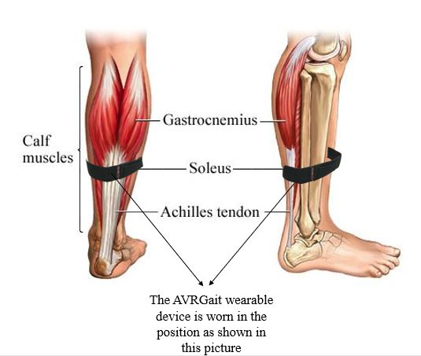

**Figure 6 Illustrating position to wear the device**

**Performing the regular workout:** After wearing and fasteningthe hardware, Praveen will go for jogging in the running track.AVRGait is not Shock resistant so Praveen should handle it with care by not dropping it. If he drops it, there are chances of damaging it.

**Connecting AVRGait with Windows:** After completing the workout, remove the device and the SD card from it and connect it to the windows Machine with AVRGait application installed

**Data transferring from AVRGait Wearable to Windows application:** Now, Copy the .csv file from the SD card into the local folder where the AVRGait application is installed.

**Using the AVRGait Windows application:**

**Step1:** whenPraveenLaunches the application, itopens the Homepage of the AVRGait Windows UI.

As shown in Figure 7, It contains brief description of functionalities of the buttons available in the User Interface of AVRGait.

**Step2:** Depending on the parameter which Praveen wishes to know, he presses the corresponding buttons from the AVRGait UI.

For Example, when Step Mean button from UI is pressed it display Mean time between all steps as shown in *Figure 12.* Similarly, when the Cadence button is pressed, it displays Number of steps per minuteas shown in *Figure11.*

Likewise, when Step Counter button is pressed it detects and count the number of steps taken by Praveen during the workout as shown in *Figure9.* When the Activity Level button is pressed a graph is plotted which displays the Calculated physical activity levels as shown in *Figure8.*

**Step3:** After viewing the desired parameters. Praveen, closes the AVRGait Windows application, removes the SD Card from the Machine and inserts it back into the wearable.

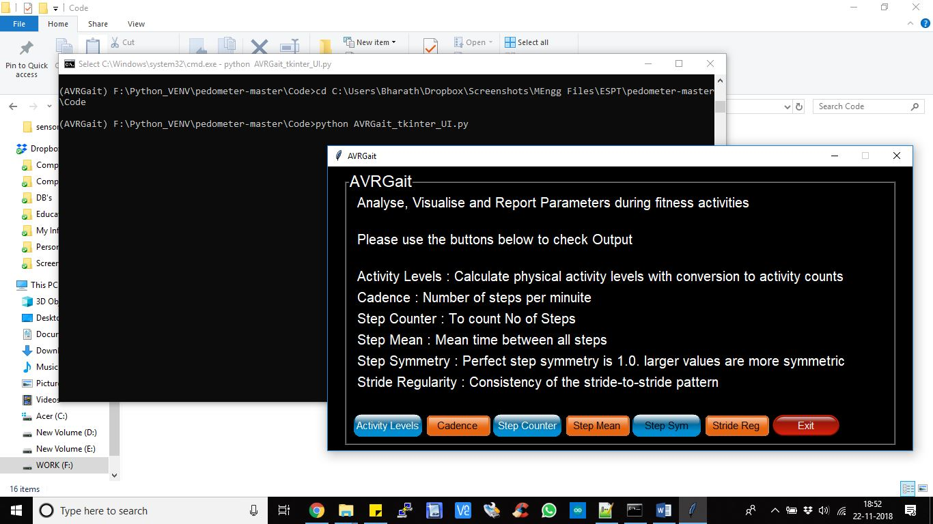

**Figure 7 Homepage of the AVRGait Windows UI containing brief description of functionalities of the buttons in the bottom.**

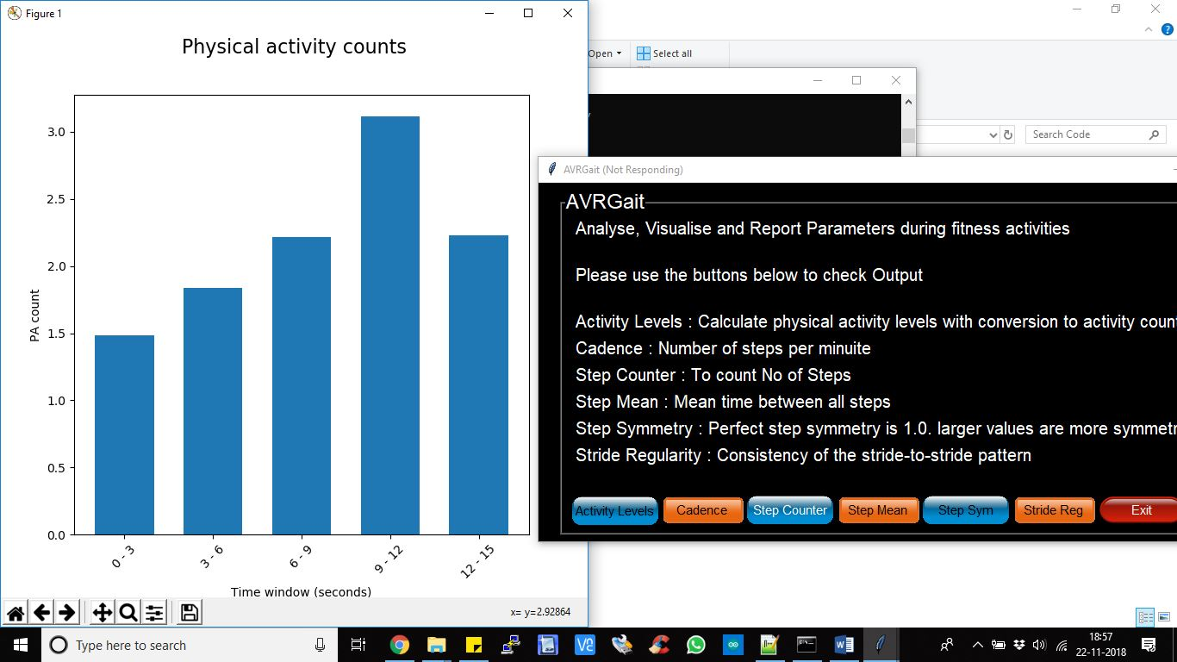

**Figure 8 When Activity Levels Button is clicked, a graph is plotted which displays the Calculated physical activity levels**

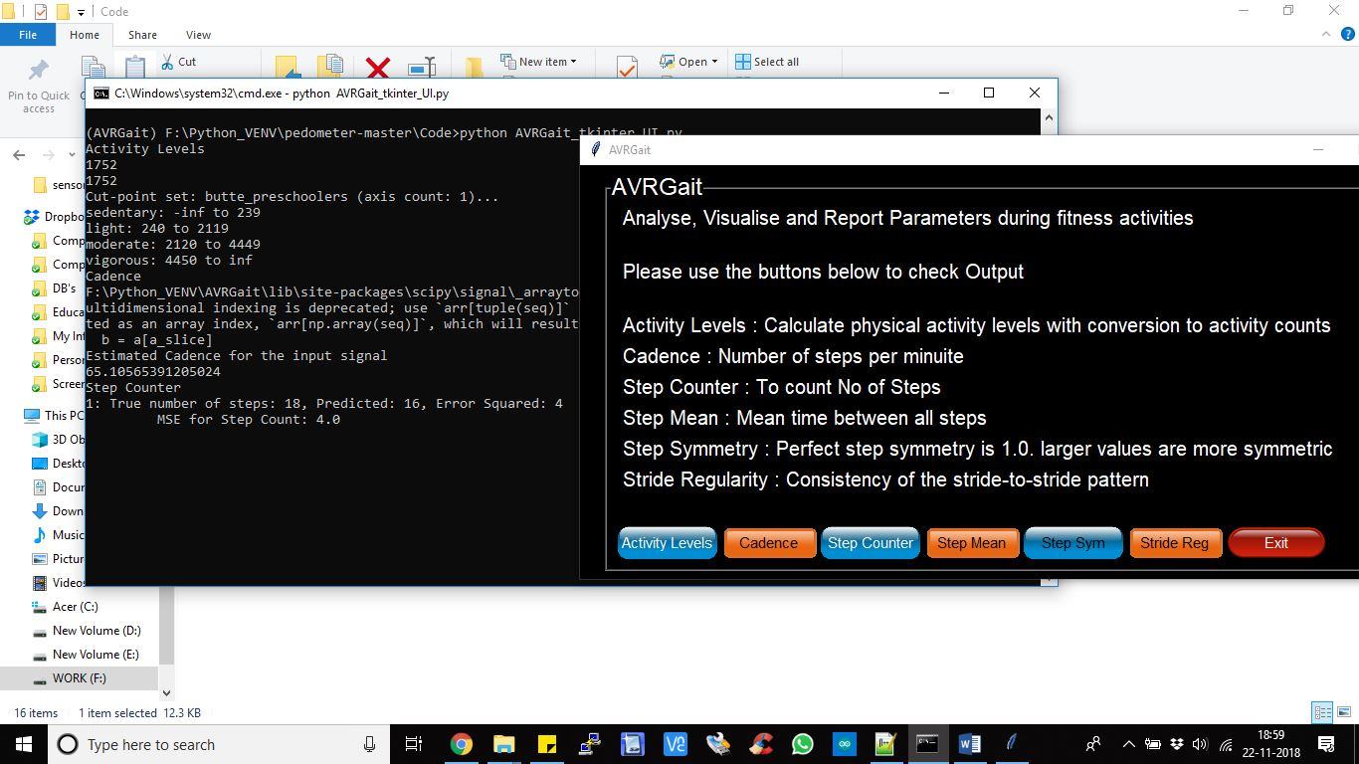

**Figure 9 The Number of counted steps is displayed in the Terminal window**

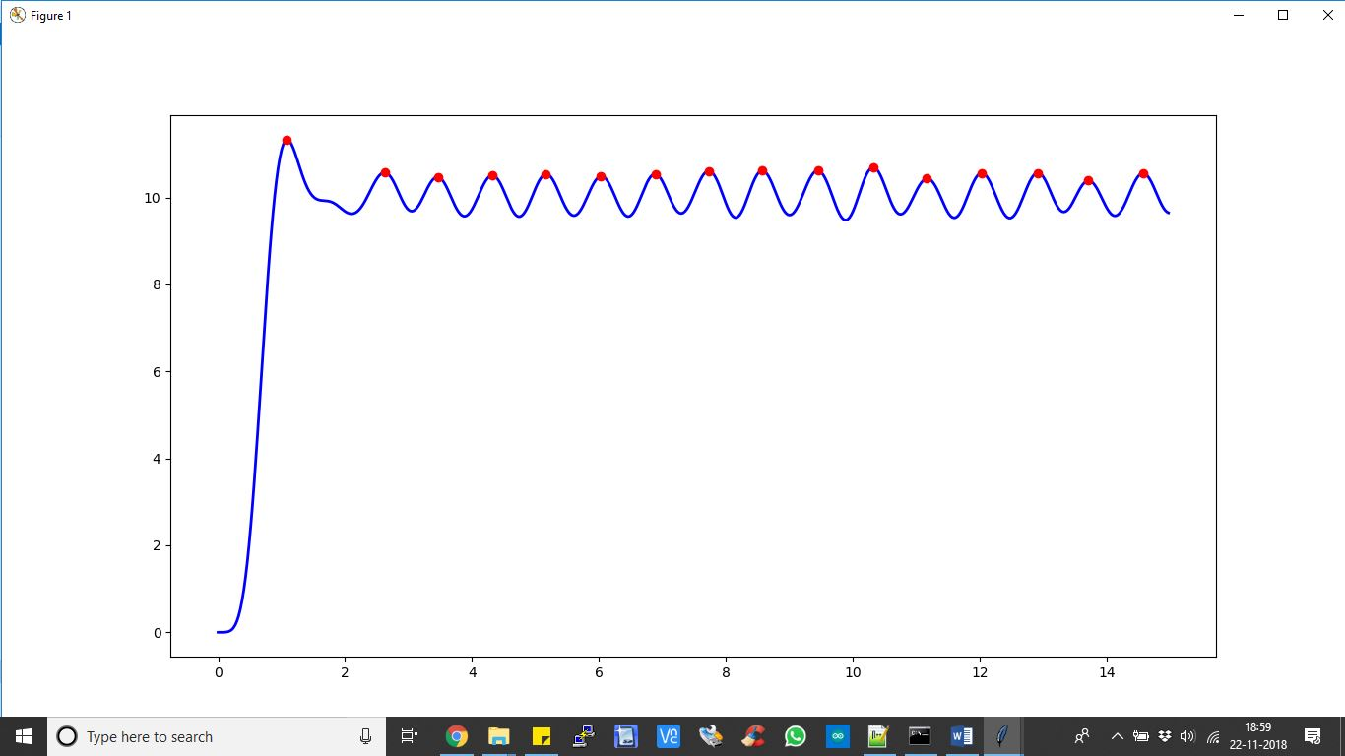

**Figure 10 Detecting the number of peaks from the signal to find step count**

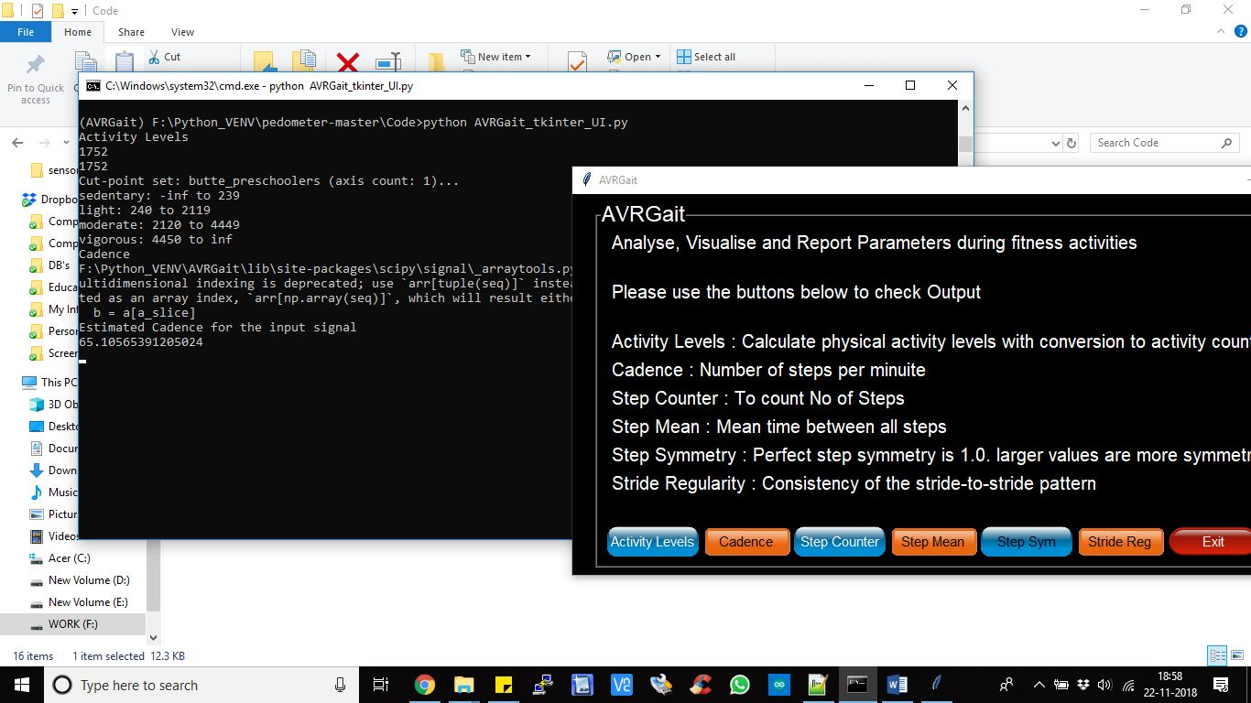

**Figure 11 When Cadence Button is pressed, it displays the Estimated Cadence Level of the input signal is calculated and displayed in the terminal as shown**

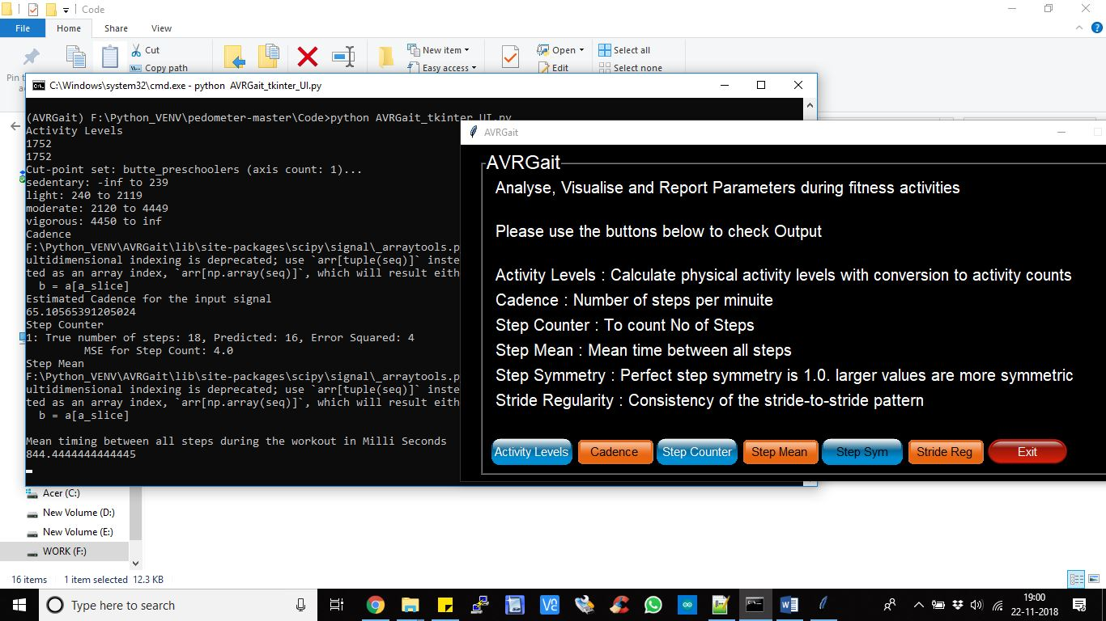

**Figure 12 When the Step Mean button is pressed from UI. The mean timing between all the steps during the workout is calculated and displayed in the terminal**