**Lab 6: Creating network topologies using Packet Tracer**

**Theory**

Network topology describes how network devices are arranged and how they communicate. It outlines the physical or logical structure of a network, which is essential for both design and troubleshooting. Different topologies, such as star, mesh, and ring, offer various advantages and challenges. Understanding these topologies helps in creating efficient and reliable network systems.

**Different types of Network Topologies:**

**1.Bus Topology**

2.Ring Topology

3.Star Topology

4.Mesh Topology

5.Tree Topology

**6.Hybrid Topology**

**Ring Topology**

In a ring topology, network devices are connected in a circular layout, forming a closed loop. Each device is linked to exactly two other devices, creating a continuous pathway for data transmission. This configuration ensures that data travels in one direction, reducing the chances of collisions and ensuring efficient communication.

**Component Used**

**Hardware:** Switches (4), Ethernet cables, End devices(4).

**Software:** Cisco Packet Tracer

**Network Diagram**

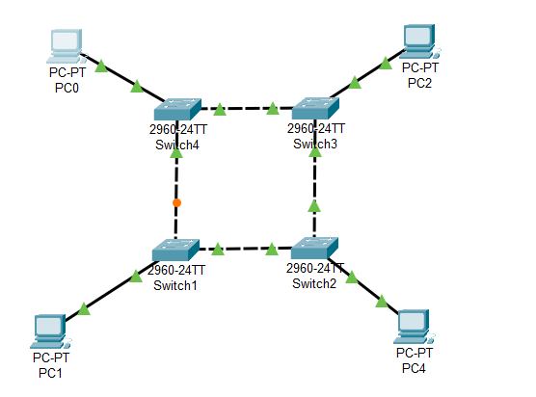

*Fig: Network map for Ring Topology*

**Procedure**

Here is the procedure for creating the Ring Topology shown in the image using Cisco Packet Tracer:

**Step 1: Launch Cisco Packet Tracer**

*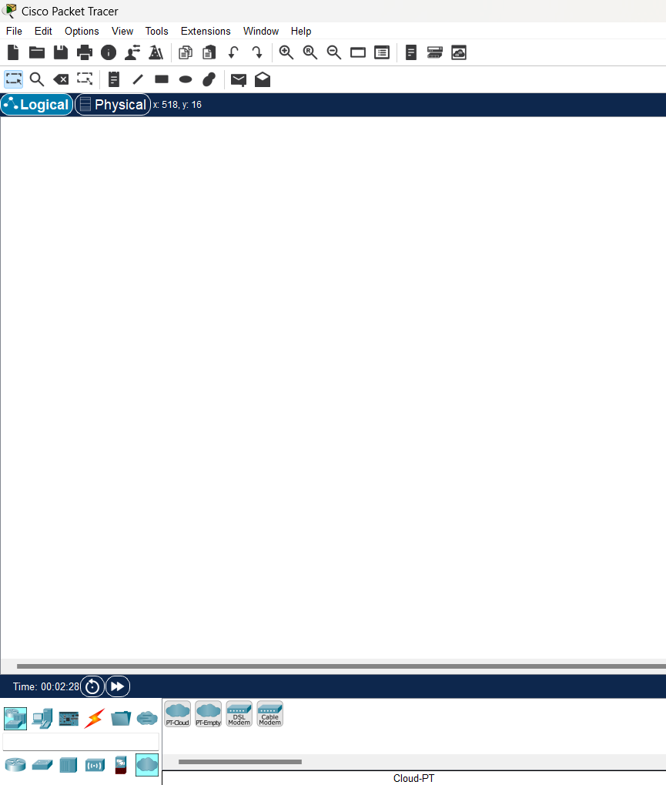Fig: Workspace for network design*

**Step 2: Add the network devices to the workspace**

2.1 From the Device-Type Selection box, choose the following devices and add them to the workspace:

2.2 Four 2960-24TT Switch

2.3 Four PCs (labeled PC0, PC1, PC2, and PC3)

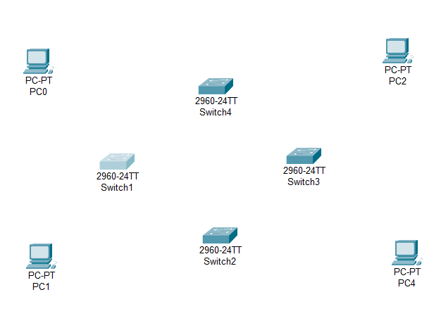*Fig:Switches and PC's for Ring Topology*

**Step 3: Connect the devices**

3.1 Use a copper straight-through cable to connect each PC to an available port on the switch. Connect adjacent switches using a copper cross-over cable. This setup ensures proper network connectivity.

3.2 Make sure each connection is secure and properly established.

3.3 Also renamed the PC’s as PC0(10.0.0.1), PC1(10.0.0.2), PC2(10.0.0.4), and PC3(10.0.0.3)

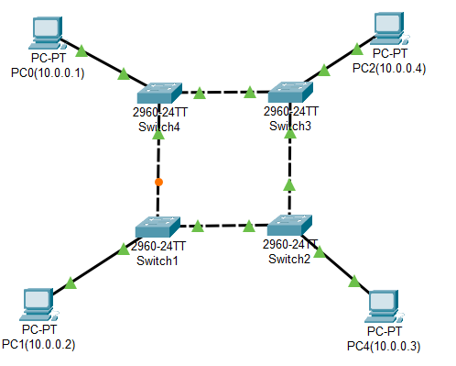

*Fig:Connection between Switch and PC’s*

**Step 4: Configure IP addresses**

4.1 Right-click on each PC and select "IP Configuration."

4.2 In the IP Configuration window, enter the IP address as (10.0.0.1 to 10.0.0.4), subnet mask, and default gateway for each PC .

*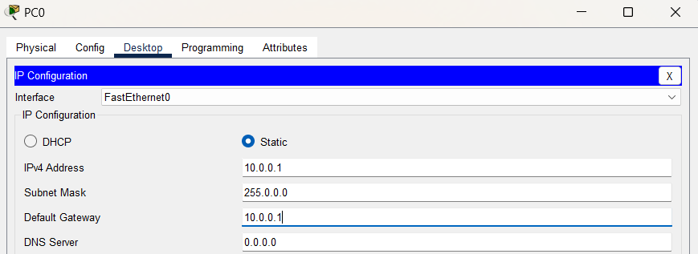Fig:IP configuration*

**Step 5: Verify connectivity:**

5.1 To test whether the network is working, you can ping other devices on the network from each PC.

5.2 Now ping PC1(10.0.0.2) from PC2(10.0.0.4) and vice-versa.

5.3 If the ping is successful, you should see replies from the other device.

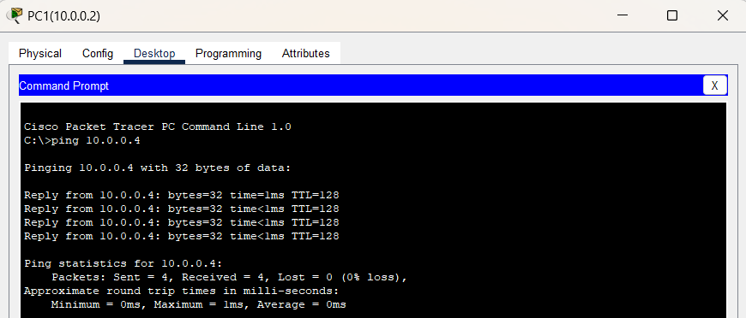

*Fig: Connectivity test from PC1(10.0.0.2) to PC2(10.0.0.4)*

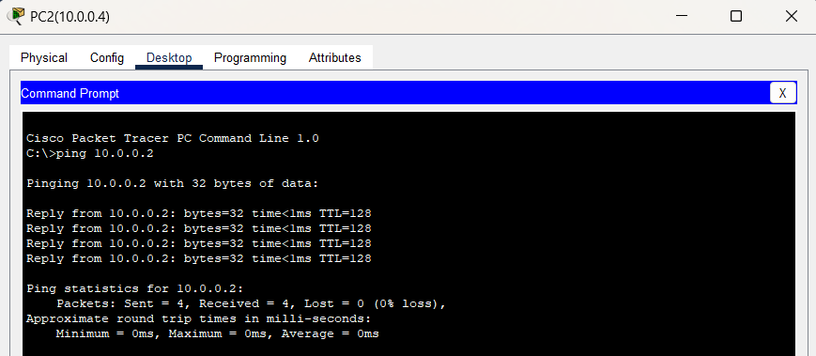

*Fig:Connectivity test from PC2(10.0.0.4) to PC1(10.0.0.2)*

**Star Topology**

Star topology is a network configuration where all devices are connected to a central hub or switch.This central device acts as a communication hub for all connected devices.

**Component Used**

**Hardware:** Switches (1), Ethernet cables, End devices(5).

**Software:** Cisco Packet Tracer

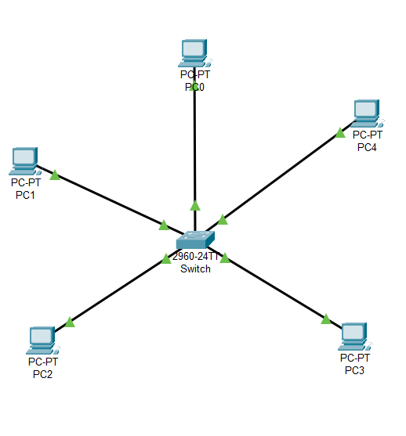**Network Diagram**

*Fig:Network Map for Star Topology*

**Procedure**

Here is the procedure for creating the Star Topology shown in the image using Cisco Packet Tracer:

**Step 1: Launch Cisco Packet Tracer**

*Fig:Workspace for network design*

**Step 2: Add the network devices to the workspace**

2.1 From the Device-Type Selection box, choose the following devices and add them to the workspace:

2.2 One 2960-24TT Switch

2.3 Five PCs (labeled PC0, PC1, PC2, PC3and PC4)

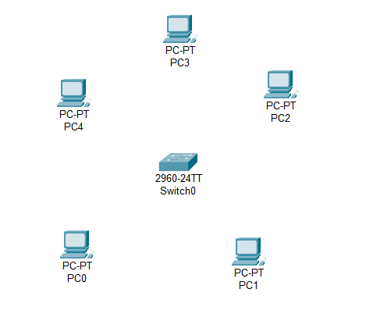*Fig:Switches and PC's for Star Topology*

**Step 3: Connect the devices**

3.1 Use the copper straight-through cable to connect each PC to one of the available ports on the switch.

3.2 Ensure that each connection is made properly.

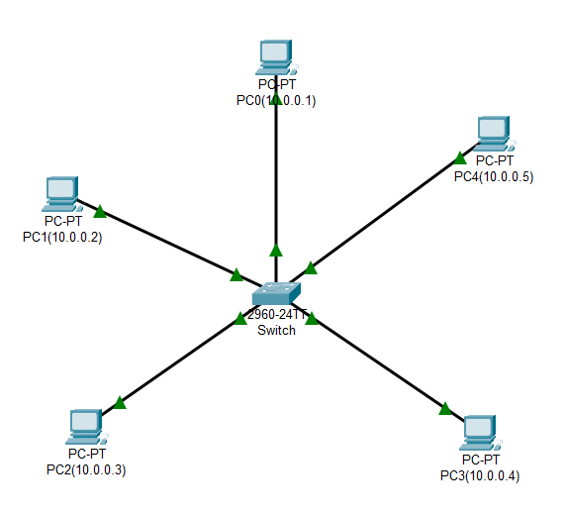3.3 Also renamed the PC’s as PC0(10.0.0.1), PC1(10.0.0.2), PC2(10.0.0.3), PC3(10.0.0.4) and PC4(10.0.0.5).

*Fig:Connection between Switch and PC’s*

**Step 4: Configure IP addresses**

4.1 Right-click on each PC and select "IP Configuration."

4.2 In the IP Configuration window, enter the IP address as (10.0.0.1 to 10.0.0.5), subnet mask, and default gateway for each PC .

**

*Fig:IP configuration*

**Step 5: Verify connectivity:**

5.1 To test whether the network is working, you can ping other devices on the network from each PC.

5.2 Now ping PC0(10.0.0.1) from PC2(10.0.0.3) and vice-versa.

5.3 If the ping is successful, you should see replies from the other device.

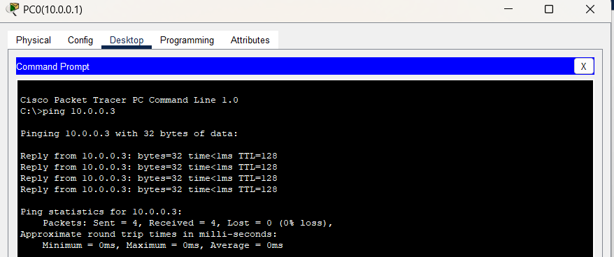

*Fig:Connectivity test from PC0(10.0.0.1) to PC2(10.0.0.3)*

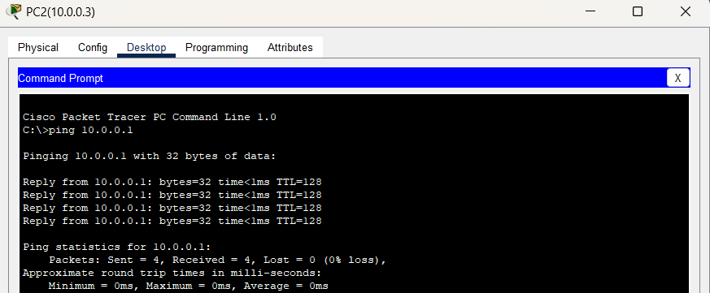

*Fig: Connectivity test from PC2(10.0.0.3) to PC0(10.0.0.1)*

**Mesh Topology**

In a mesh topology, every device is directly connected to all other devices in the network. This highly interconnected setup provides multiple paths for data transmission, enhancing network reliability and redundancy.

**Component Used**

**Hardware:** Switches (4), Ethernet cables, End devices(4).

**Software:** Cisco Packet Tracer

**Network Diagram**

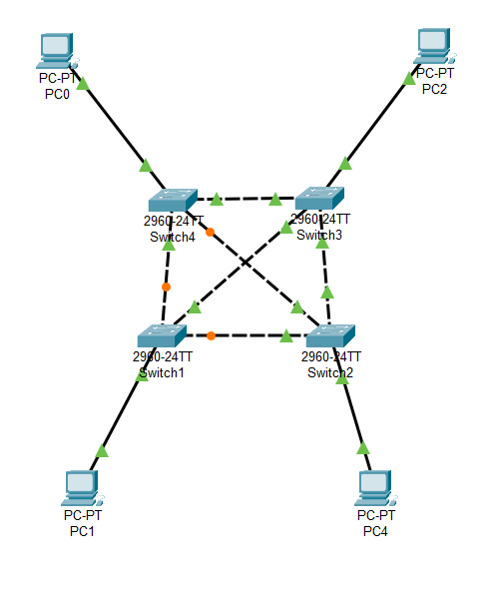

*Fig:Network Map for Mesh Topology*

**Procedure**

Here is the procedure for creating the Mesh Topology shown in the image using Cisco Packet Tracer:

**Step 1: Launch Cisco Packet Tracer**

*Fig:Workspace for network design*

**Step 2: Add the network devices to the workspace**

2.1 From the Device-Type Selection box, choose the following devices and add them to the workspace:

2.2 Four 2960-24TT Switch

2.3 Four PCs (labeled PC0, PC1, PC2, and PC4)

*Fig:Switches and PC's for Mesh Topology*

**Step 3: Connect the devices**

3.1 Use the copper straight-through cable to connect each PC to one of the available ports on the each switch and copper cross-over cable to connect between each adjacent and diagonal switches.

3.2 Ensure that each connection is made properly.

3.3 Also renamed the PC’s as PC0(10.0.0.1), PC1(10.0.0.2), PC2(10.0.0.3), PC4(10.0.0.4).

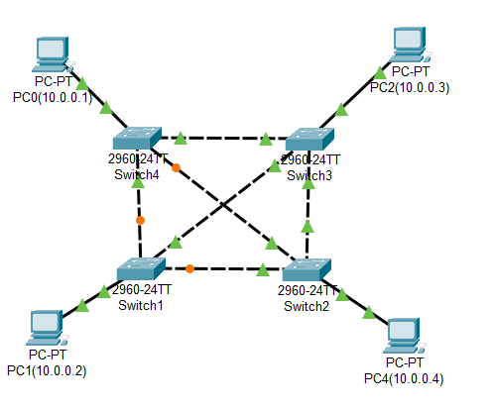

*Fig:Connection between Switch and PC’s*

**Step 4: Configure IP addresses**

4.1 Right-click on each PC and select "IP Configuration."

4.2 In the IP Configuration window, enter the IP address as (10.0.0.1 to 10.0.0.4), subnet mask, and default gateway for each PC .

*Fig:IP configuration*

**Step 5: Verify connectivity:**

5.1 To test whether the network is working, you can ping other devices on the network from each PC.

5.2 Now ping PC0(10.0.0.1) from PC2(10.0.0.3) and vice-versa.

5.3 If the ping is successful, you should see replies from the other device.



*Fig:Connectivity test from PC0(10.0.0.1) to PC2(10.0.0.3)*



*Fig:Connectivity test from PC2(10.0.0.3) to PC0(10.0.0.1)*

**Conclusion**

In this lab, we conclude that creating different topologies in Cisco Packet Tracer provides hands-on experience in network design and configuration. By simulating the placement and connection of components like switches and end devices, we can test connectivity to ensure smooth data flow and proper network setup. This powerful tool offers a flexible approach to network simulation, allowing users to accurately model and analyze various topologies. The hands-on experience enhances understanding and prepares users for real-world networking tasks. Overall, Packet Tracer is an invaluable resource for both learning and professional development in networking.