**Lab 1: Understanding the Network Equipment, wiring in details.**

**Network Hardware:**

**1. To understand the networking equipment and the major components of Network:**

**Repeater:**

**Function:** To amplify the incoming signals

Repeaters are defined as a networking device that is used to amplify and generate the incoming signal. Repeaters work at the physical layer of the OSI model. The main aim of using a repeater is to increase the networking distance by increasing the strength and quality of signals.

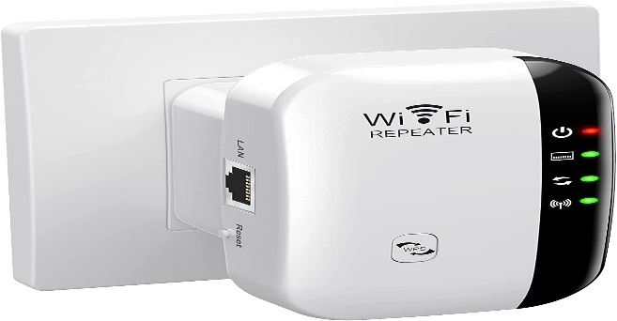

Figure Repeater

**Hub:**

A hub is a device that links multiple computers and devices together. Hubs can also be referred to as repeaters or concentrators, and they serve as the center of a local area network (LAN). In a hub, each connected device is on the same subnet and receives all data sent to the hub. The hub then forwards that data out to all other connected devices, creating an efficient system for sharing data between users.

**Function:** Network data distribution

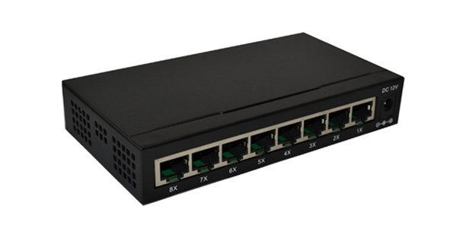

Figure Hub

**Bridge:**

A bridge is a [network device](https://www.shiksha.com/online-courses/articles/network-devices-in-computer-networks-and-its-types/) that connects multiple subnetworks to create a single network. It provides interconnection with other computer networks that use the same protocol. Through a bridge, multiple LANs can be connected to form a larger and extended [LAN](https://www.shiksha.com/online-courses/articles/lan-local-area-network/).

**Function:** To connect multiple LANs to a larger LAN

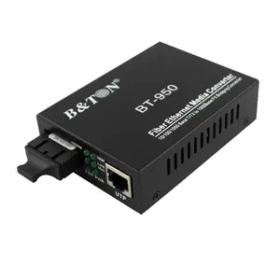

Figure Bridge

**Router:**

A router is a device that connects two or more packet-switched networks or subnetworks. It serves two primary functions: managing traffic between these networks by forwarding [data packets](https://www.cloudflare.com/learning/network-layer/what-is-a-packet/) to their intended [IP addresses](https://www.cloudflare.com/learning/dns/glossary/what-is-my-ip-address/), and allowing multiple devices to use the same Internet connection . inspects a given data packet’s destination IP address and calculates the best way for it to reach its destination and then forwards it accordingly.

**Function:** Network Routing

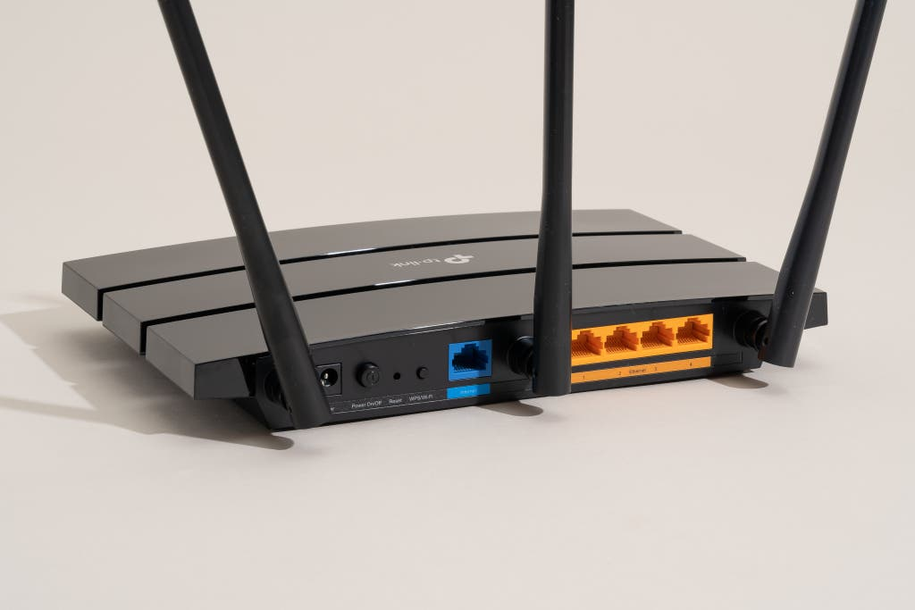

Figure Router

**Switch:**

Switches are networking devices operating at layer 2 or a [**data link layer**](https://www.tutorialspoint.com/data_communication_computer_network/data_link_layer_introduction.htm) of the [**OSI model**](https://www.tutorialspoint.com/The-OSI-Reference-Model). They connect devices in a network and use packet switching to send, receive or forward data packets or data frames over the network.

**Function:** Packet Switching

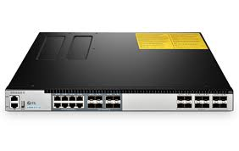

Figure Switch

**Modem**:

A modem is a device that modulates and demodulates signals to encode and decode digital information for transmission and reception over communication channels such as telephone lines, cable systems or satellite links. They are crucial devices for enabling digital communication over various types of analog and digital transmission media. There are different types of modems such as dial-up, cable, fiber optic and satellite modems.

**Function:** To modulate and demodulates the signals

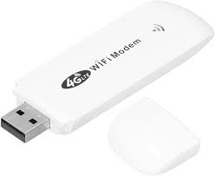

Figure Modem

**Wireless Access Point (WAP):**

A wireless access point (wireless AP) is a network device that transmits and receives data [over a wireless local area network (WLAN)](https://www.techtarget.com/searchnetworking/answer/Wireless-vs-Wi-Fi-What-is-the-difference-between-Wi-Fi-and-WLAN), serving as the interconnection point between the WLAN and a fixed wire network. Conceptually, an AP is like an Ethernet hub, but instead of relaying LAN frames only to other [802.3](https://www.techtarget.com/searchnetworking/definition/8023) stations, an AP relays [802.11](https://www.techtarget.com/searchmobilecomputing/definition/80211) frames to all other 802.11 or 802.3 stations in the same subnet.

**Function:** Wireless connection

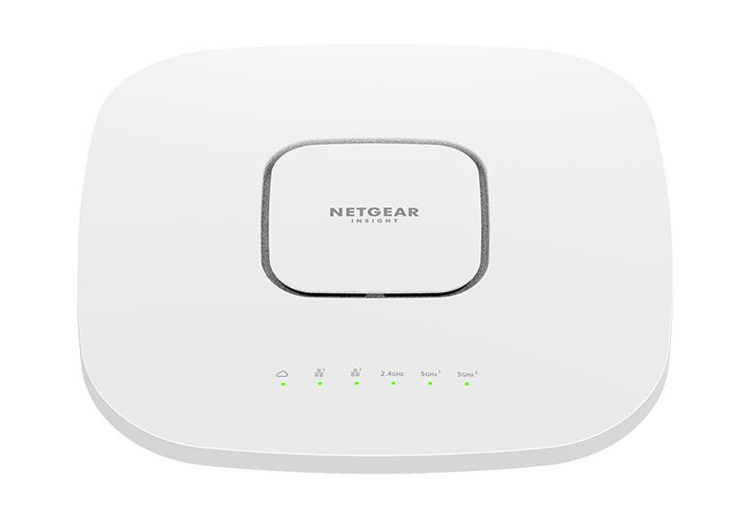

Figure Wap

**2) To understand the color coding of UTP Cable:**

**Description:**

The color coding of UTP cables follows specific standards to ensure proper wiring and connectivity. These standards are defined by the TIA/EIA (Telecommunications Industry Association/ Electric Industries Alliance) and are commonly known as T568A and T568B. Each standard specifies the order of wire pairs and their corresponding colors for RJ45 connectors. It ensures consistency and helps technicians and network engineer to correctly identifies and match the wire during termination.

**Pictorial Representation of Straight-Through UTP cable:**

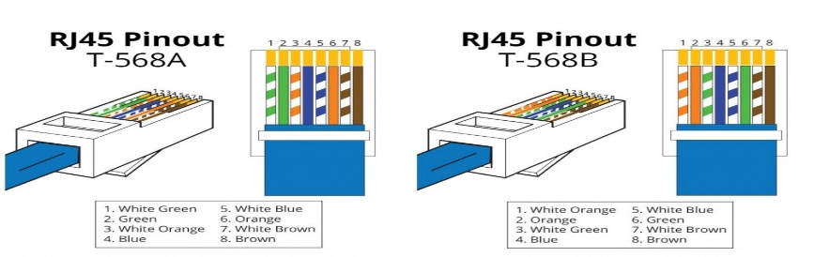

Figure UTP

**3)** **To understand the concept of Straight-Through and Crossover UTP LAN** **Cabling structure:**

**Straight-Through UTP cable:**

**Description:**

A straight-through UTP (unshielded Twisted Pair) cable is a type of Ethernet cable commonly used to connect different network devices, such as computer to a network switch, router or hub. It can be used as an alternative to wireless connections where one or more computers access a router through a wireless signal. In this cable, same wire pairs are connected to the same pins on each end of the cable. Since they don’t have additional shielding layer which make them more flexible and easier to install. They provide reliable and straightforward connections between various devices.

**Pictorial Representation of Straight-Through UTP cable:**

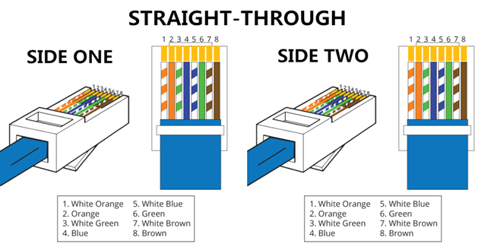

Figure straight through UTP cable

**Crossover UTP Cable:**

**Description:**

A Crossover cable is an Ethernet cable that allows two systems to directly connect to each other back to back. Basically it connects two similar devices in a network such as connecting two computers or two switches without the need for a hub or switch. It is enabled by reversing the transmission and receiving pins at both ends, so that the output from one computer becomes input to the other and vice versa. They are essential for specific networking scenarios where direct device-to-device communication is required.

**Pictorial Representation of Crossover UTP cable:**

**4)To understand the purpose of different equipment used in LAN cabling:**

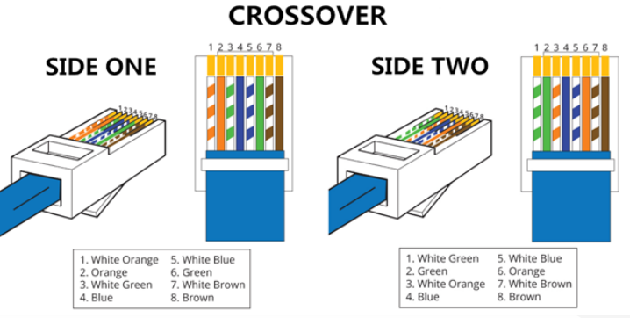In LAN cabling, various equipment and tools are essential to establish and maintain proper network connectivity. Here’s an overview of the different equipment used in LAN cabling:

**RJ45 Connectors:**

The main purpose of RJ45 connectors is to establish and maintain network connections by ensuring the proper data transmission. They are used to terminate the ends of Ethernet cables.

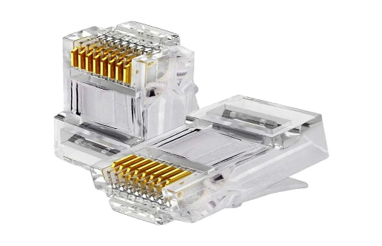

Figure RJ45 Connectors

**Cable Tester:**

The main purpose is to test the strength and connectivity of a particular type of cable or other wired assemblies. It is used to verify the integrity and performances of various type of network cables and also test the communication strength between the source and destination.

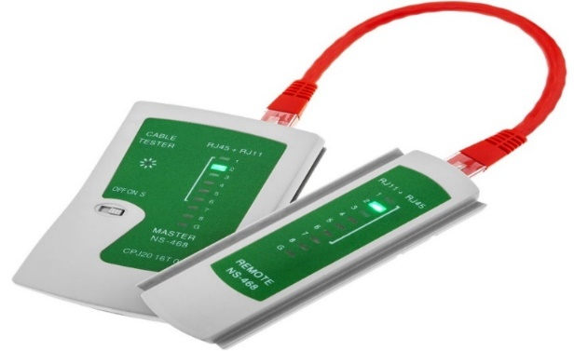

Figure Cable Tester

**Crimping tool:**

It is an handheld tool which is used to attach connectors (such as RJ45 connectors) to the ends of Ethernet cables. It provides secure and reliable Connection which is crucial for network connectivity and data transmission.

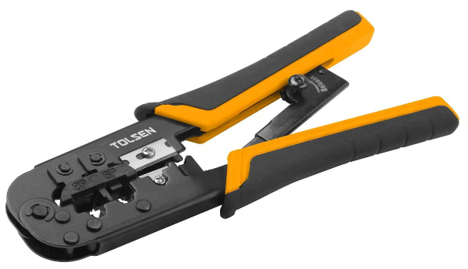

Figure Crimping Tool

**Wire Stripper:**

It is an hand tool designed to remove insulation or outer jacket from electrical wires and cables without hampering the inner wire. It also helps in untwisting and straightening the pairs of wires inside the cable.

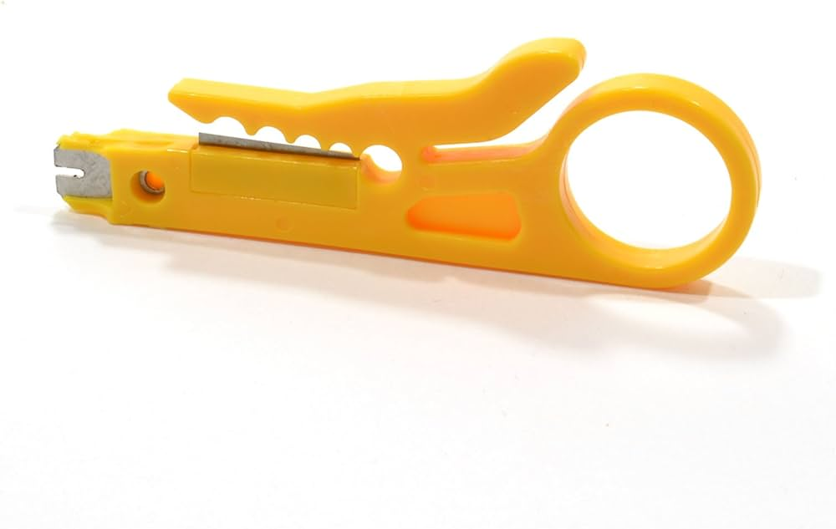

Figure wire stripper

**Punch Down Tool:**

It is used for terminating and connecting wires into punch down blocks, patch panels and other terminal blocks. It provide secure and reliable electrical communications.

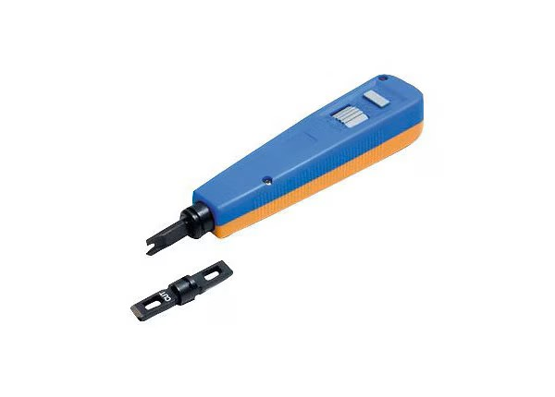

Figure Punch Down tool

**UTP Cable:**

UTP cable are used in telecommunications and computer network and the medium through which the data is transmitted in a LAN. Some example of UTP cables are Cat 5, Cat 5e, Cat 6 and many others which support the data transfer rate up to 10 Gbps.

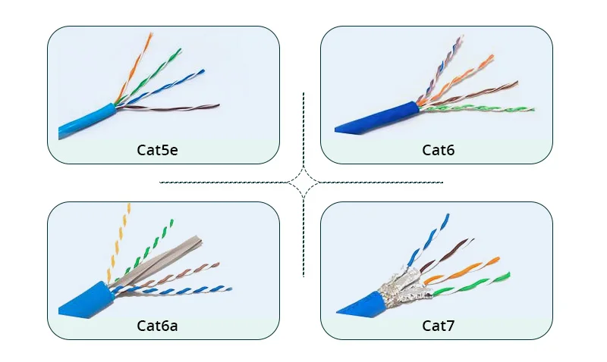

Figure UTP Cable

**Keystone Jacks:**

Keystone jacks are modular connectors used extensively in networking and telecommunications for terminating twisted pair cable such as Cat 5e or Cat 6 cables. They are essential components in structured cabling systems which offers versatility, ease of installation and reliability.

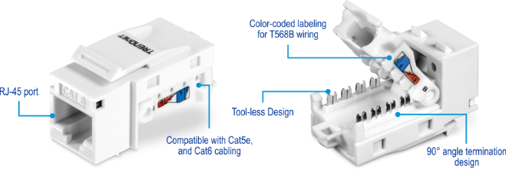

Figure keystone jacks

**5) To build a Straight-Through and Cross Over UTP LAN cabling:**

**Apparatus:** UTP CAT6 cable, Crimper, LAN tester, RJ45 connector,Cable stripper

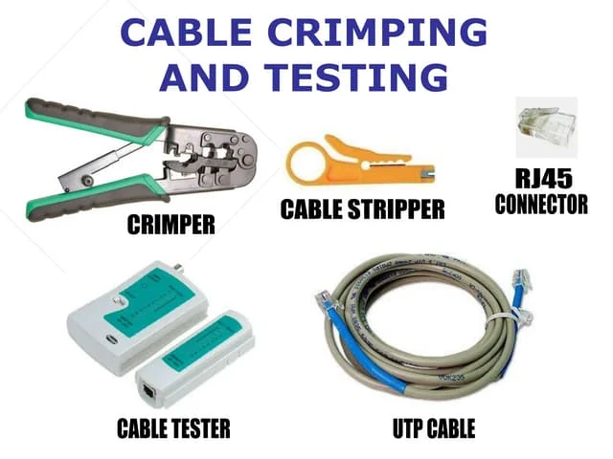

Figure cable crimping

Above are the apparatus which are required to construct both **Straight-Through** and **Crossover** wiring. Basically these equipment are suitable for connecting different types of network devices in a standard networking setup. These tools helps us to ensure the proper termination and functionality.

**Algorithm for Straight-Through Wiring:**

1. Cut the cable to the desired length using the wire cutter.
2. Strip off about 2 inch (5 cm) of the outer jacket from each end of the cable using wire stripper. (Note: Be careful not to cut internal wire.)
3. Inside the cable there are four twisted pairs cable so separate these pairs and untwist them. After that arrange the wires in the order of T568B standard.
4. Once the wires are in correct order then trim them to a uniform length of about ½ inch (1.3 cm) from the end of the jacket.
5. Insert the wires carefully into the RJ45 connector and make sure that the each wire is fully inserted.
6. Place the RJ45 connector into the crimping tool and squeeze the tool firmly to crimp the connector onto the cable. (Note: We can hear the sound when it is firmly crimped.)
7. Repeat the same steps for the other end of the cable and make sure that the wires follows the same T568B standard.
8. Finally use a cable tester to check the continuity and proper wiring of the cable.

**Algorithm for Crossover Wiring:**

1. Cut the cable to the desired length using the wire cutter.
2. Strip off about 2 inch (5 cm) of the outer jacket from each end of the cable using wire stripper. (Note: Be careful not to cut internal wire.)
3. Inside the cable there are four twisted pairs cable so separate these pairs and untwist them. After that, arrange the wires in the order of T568B standard in either of the two end and T568A in other end.
4. Once the wires are in correct order then trim them to a uniform length of about ½ inch (1.3 cm) from the end of the jacket.
5. Insert the wires carefully into the RJ45 connector and make sure that the each wire is fully inserted.
6. Place the RJ45 connector into the crimping tool and squeeze the tool firmly to crimp the connector onto the cable. (Note: We can hear the sound when it is firmly crimped.)
7. Repeat the same steps for the other end of the cable and make sure that the wires follows the same T568B standard.
8. Finally use a cable tester to check the continuity and proper wiring of the cable.

**Conclusion:**

In this lab, we gained practical skills in creating straight-through and crossover UTP cables, crucial for networking different types of devices. We learned about color codes, wiring order, standards like T568A and T568B, and the use of tools such as crimping tools, wire strippers, and cable testers.