**Lab-3: Static IP Setting on Windows Machine**

**Theory:**

The objective of this lab is to learn how to configure a static IP address on both Linux and Windows machines. This skill is essential for setting up network devices in environments where a fixed IP address is required for consistent network communication.

**Default Gateway:**

The default gateway in a computer network is the device that routes traffic from a local network to devices on another network, typically the internet. When computer tries to communicate with a device that isn’t on the same local network, it sends the data to the default gateway, which then forwards it to the appropriate destination. It is crucial for enabling communication between local networks and external networks acting as the intermediary that routes data between them. Without a default gateway, devices on a local network wouldn’t be able to access external networks such as internet.

Example: Default Gateway: 192.168.0.1 (often used by Netgear and D-link routers)

**Subnet Mask:**

A subnet mask is a crucial component of IP addressing in networking that helps to determine which portion of an IP address identifies the network and which part identifies the host (specific device) on that network. A subnet mask defines the range of IP addresses that a subnet can use where a subnet is a smaller network within a larger network. It enables efficient IP address management, routing and network segmentation. It allows larger networks to be divided into smaller sub-networks which can improve network efficiency and security.

Example: Subnet Mask: 255.255.0.0 (used in class B networks)

**DNS Server (Domain Name System Server):**

The Domain Name System (DNS) is the phonebook of the internet. It is a critical component of the internet infrastructure that translates human-friendly domain names into IP address that computers use to identify each other on a network. By managing this complex and distributed system, DNS server make the internet accessible and navigable for everyone. It allows you to interact with devices on the internet without having to remember long strings of numbers. It is a piece of software that keeps track of domain names and IP addresses.

Example: 1.1.1.1 (Cloudfare DNS)

**IP Address:**

An IP address represents a unique address that distinguish any device on the internet or any network from another. In another words, it is the unique identifying number assigned to every device connected to the internet. It is a numeric label assigned to devices that use the internet to communicate. It serves two primary purposes i.e identifying the host or network interface and providing the location of the host in the network, enabling the routing of traffic across the internet or within a local network.

There are two types of IP address:

i) IPv4 (Internet Protocol version 4):

Example: 192.168.1.1

ii) IPv6 (Internet Protocol version 6):

Example: 2001:0db8:85a3:0000:0000:8a2e:0370:7334

**Static IP:**

A static IP address is a permanent, fixed IP address that is manually assigned to a device on a network. Unlike dynamic IP addresses which are automatically assigned by a DHCP (Dynamic Host Configuration Protocol) server and can change over time whereas a static IP address remains constant and does not change unless it is manually reconfigured. It is commonly used for devices that require a stable and predictable connection such as servers, printers, and devices that need remote access.

**Benefits of Static IP:**

1. Ensures reliable connections, particularly for servers and other critical network devices

2. Easier to set up services like web hosting, remote access and email because the IP address does not change

3. Simplifies network management, as administrators know the exact IP address of each device

**Network Information:**

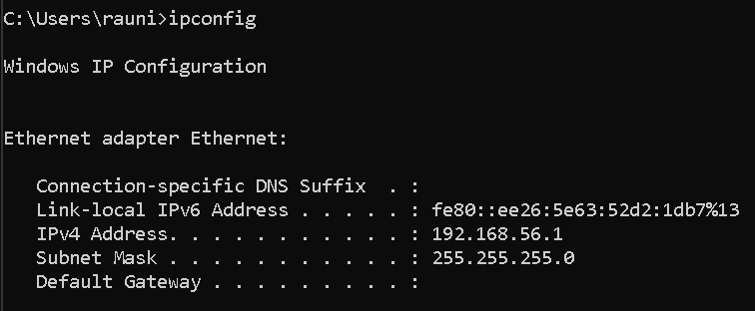

Fig: Default network information

Checking network connectivity on default network connection using ‘ping’ command to test connectivity with the gateway and external sites.

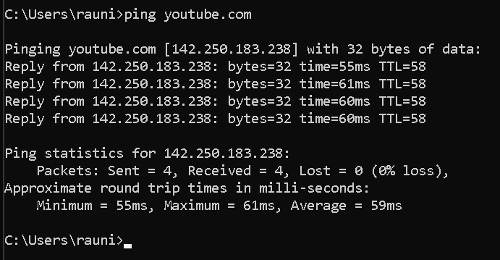

Fig: Network connectivity of Youtube server

**Materials and Equipment:**

* **Hardware:**
* A computer with Windows installed
* **Software:**
* Windows operating system
* **Network Information:**
* IP address: 192.168.1.100
* Subnet Mask: 255.255.255.0
* Default Gateway: 192.168.1.1
* DNS Server: 8.8.8.8

**Static IP Configuration on a Windows Machine:**

**Step 1**: **Open the Network and Sharing Center**

1.1 At first, open the Control Panel.

1.2 After that, click on the Network and Internet and then click on Networkand

Sharing Center.

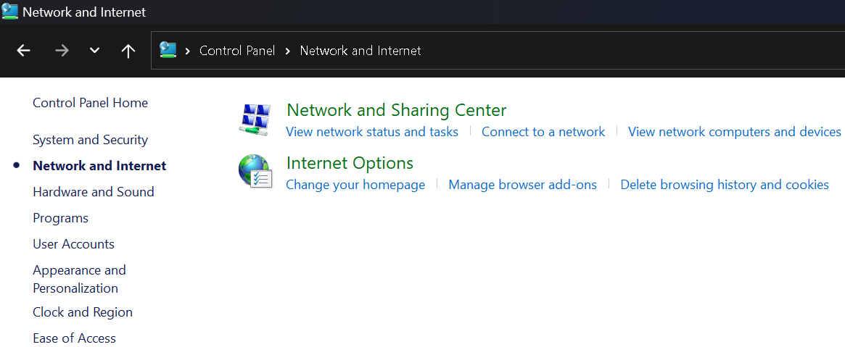

Fig: Network and sharing center in control panel

**Step 2: Access Adapter Settings**

2.1 Click on Change adapter settings from the left panel.

2.2 Right click on the desired network connection.

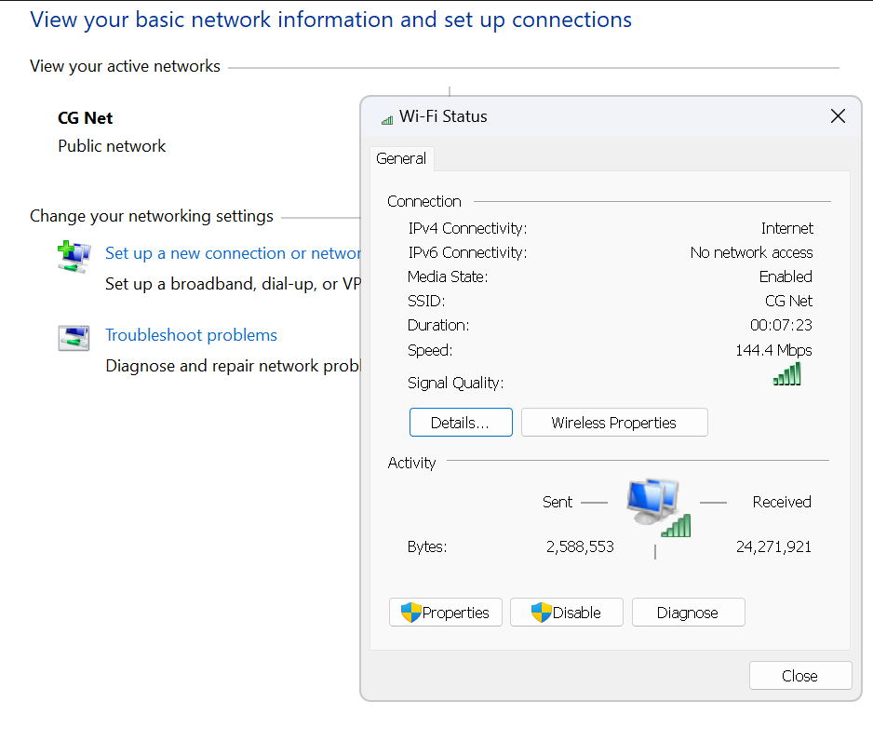

Fig: Network selection on Adapter settings

**Step 3: Configure IPv4 Settings**

3.1 Select Internet Protocol Version 4 (TCP/IPv4) and click Properties.

3.2 Select on Use the following IP address and input the following details:

IP address: 192.168.1.100

Subnet Mask: 255.255.255.0

Default Gateway: 192.168.1.1

3.3 Enter the DNS server address:

Preferred DNS server: 8.8.8.8

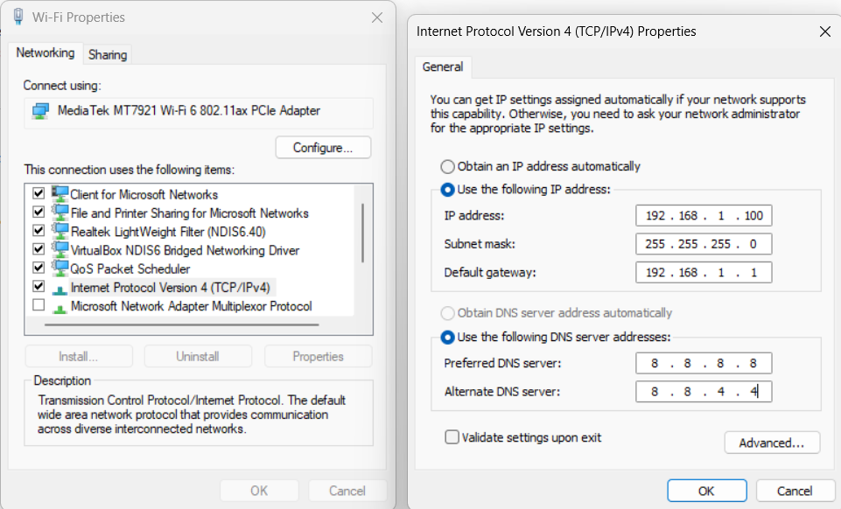

Fig: configuring IPv4 Properties

**Step 4: Save and Verify**

4.1 Click on OK button and save the settings

4.2 Execute ‘ipconfig’ command to verify that the static IP address is configured

correctly.

**Network Information after Static configuration:**

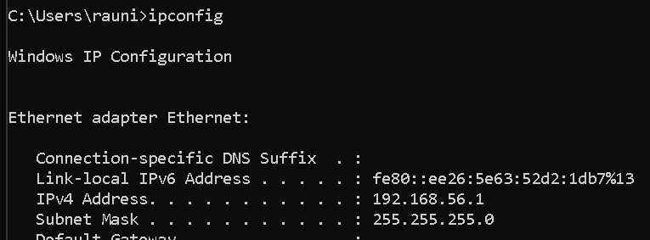

Fig: Network information after Static IP *configuration*

Checking network connectivity after Static IP configuration using ‘ping’ command to test connectivity with the gateway and external sites.



Fig: Network connectivity of Youtube server

**Conclusion:**

In this lab, we explored the process of configuring a static IP address on both Linux and Windows machine. We covered key networking concepts such as default gateways, subnet masks, DNS servers and IP address. We also highlight their importance in maintaining efficient and reliable network communication. By practicing these steps, we gained a valuable experience in managing network settings that is crucial for troubleshooting and optimizing network performance in real-world scenarios. This lab not only reinforced theoretical concepts but also provided practical experience in network configuration and verification.