**Lab 11: DNS and Web Server Configuration using Packet Tracer**

**Theory**

**Domain Name System (DNS)**: DNS translates human-readable domain names (like google.com) into numeric IP addresses (such as 192.168.1.1) that computers use to communicate. This conversion simplifies internet navigation by eliminating the need to remember complex numeric addresses. When a user types a domain name into their browser, DNS works in the background to find the corresponding IP address, enabling quick and easy access to the requested web page

**Web Server**: A web server is a computer system that hosts websites and delivers web pages to users upon request. When a user enters a URL or clicks a link, the web server processes the request, retrieves the appropriate files (such as HTML, images, or scripts), and sends them to the user’s browser. Web servers manage these requests through HTTP or HTTPS protocols. They handle both static content (like basic web pages) and dynamic content generated by server-side applications. In essence, web servers ensure that web content is available and delivered efficiently to users.

**Network Diagram**

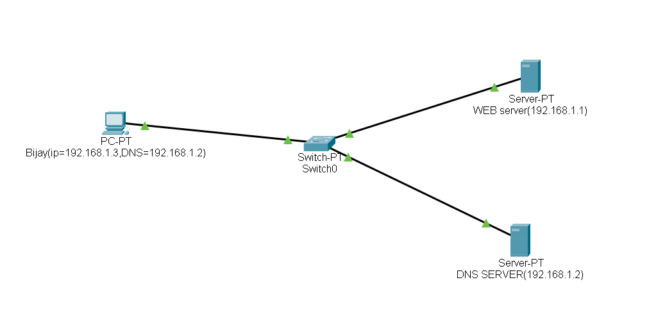 *Fig: Network Diagram*

**1.Configuring DNS Server and Web Server**

**DNS Server Configuration:**

**Step 1: Access the DNS Server** and navigate to the Desktop tab.

**Step 2:** Set the IP Address to 192.168.1.2 and the Subnet Mask to 255.255.255.0.

*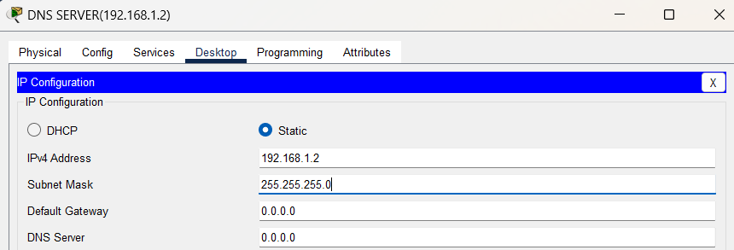Fig: Configuring DNS server*

**Step 3:** Click on the Services tab, then navigate to HTTP and turn it ON.

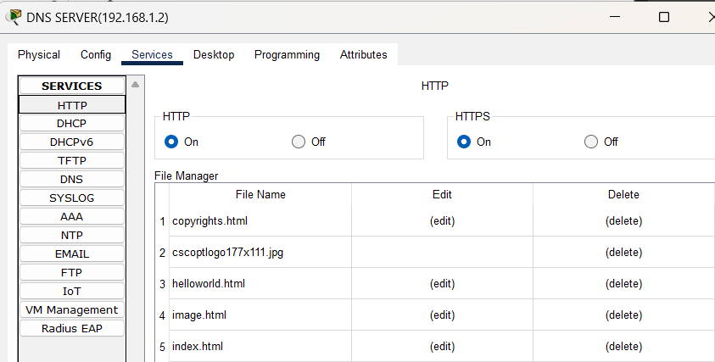

*Fig: Turning ON HTTP*

**Step 4: Open index.html**, click **Edit**, make the necessary changes to the file, and click **Save**.

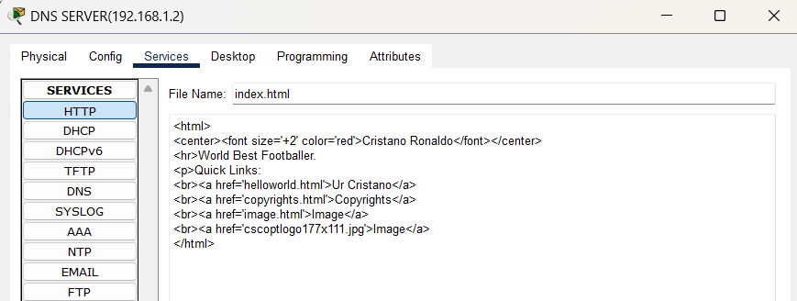

*Fig: Configuring index.html file*

**Web Server Configuration:**

**Step 1: Select the Web Server**, then navigate to the **Config tab**.

**Step 2:** Set the DNS Server to 192.168.1.2.

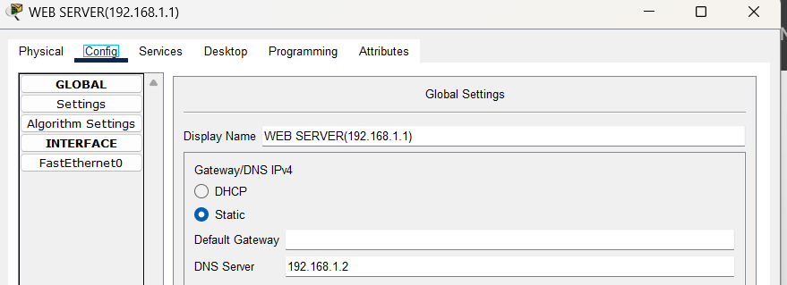*Fig: Configuring DNS on WEB server*

**Step 3: Navigate to the Desktop tab** and set the **IP Address** to **192.168.1.1**, the **Subnet Mask** to **255.255.255.0**, and the **DNS Server** to **192.168.1.2**

*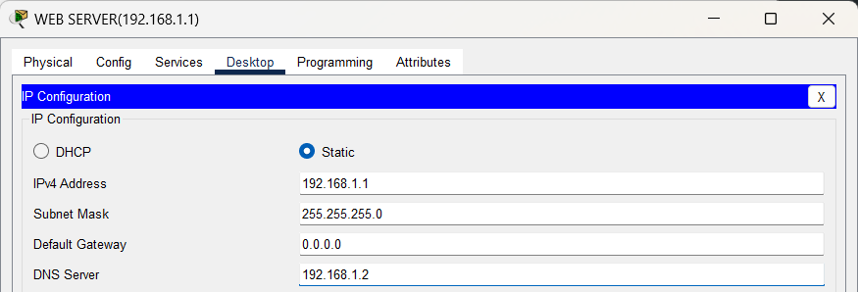Fig: Configuring WEB server*

**PC Configuration:**

**Step 1:** Go to the PC, then navigate to the Desktop tab.

**Step 2:** Set the IP Address to 192.168.1.3, the Subnet Mask to 255.255.255.0, and the DNS Server to 192.168.1.2.

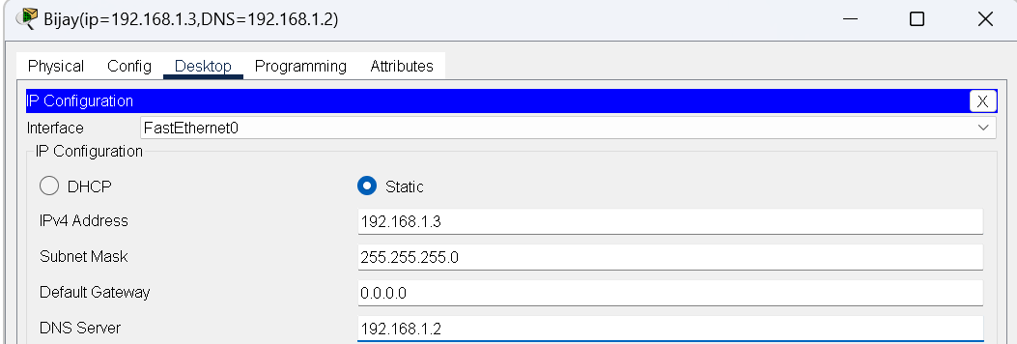

*Fig:IP configuration on PC*

**Testing Web Server on PC**

**Step 1:** Go to the Desktop, click on Web Browser, and in the URL tab, enter the IP address of the Web Server, i.e., 192.168.1.1.

*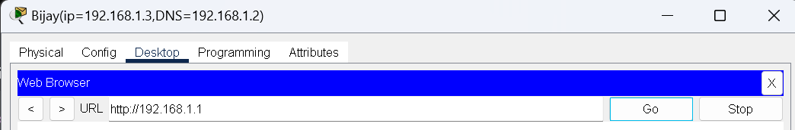Fig: Checking WEB server on PC*

**Web Server in DNS Server Configuration**

**Step 1:** Go to the DNS Server then click on Services, then select DNS.

**Step 2:** In the Name field, type google.com and enter the IP address of the Web Server in Address field, , i.e., 192.168.1.1 then click add and then save.

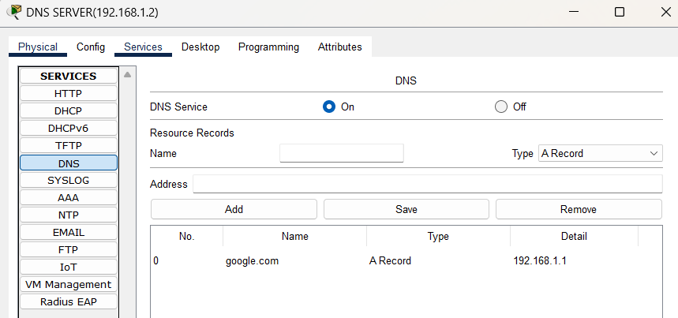

*Fig: Adding WEB server on DNS server*

**Testing Web Server on PC after configuring in DNS**

**Step 1: Navigate to the Desktop tab**, click on **Web Browser**, and in the **URL field**, type **google.com** to access the web page served by the Web Server.

*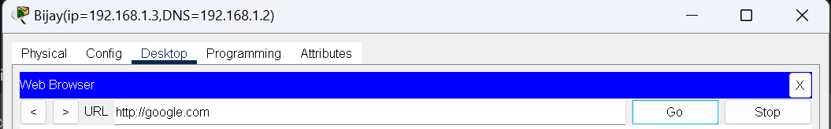Fig: Checking Web Server after configuration in DNS*

From the above image, we can confirm that entering either the domain name or the IP address will direct us to the same web page.

**Conclusion**

In this lab, we conclude how DNS simplifies the process of accessing web services by resolving human-readable domain names into machine-friendly IP addresses. The configuration in Packet Tracer illustrates how DNS and web servers can be set up and function together within a network, making it easier for users to access web resources using familiar domain names.