**Lab 4: Introduction to Packet Tracer**

**Theory**

Cisco Packet Tracer, developed by Cisco Systems, is a powerful network simulation tool. It enables users to configure and test complex networks in a virtual environment. This software is especially beneficial for educational purposes, offering students a platform to experiment with network designs and configurations without needing physical hardware.

**Key Concepts of Cisco Packet Tracer**

Packet Tracer provides various features for network design, configuration, and simulation, including:

* **Network Simulation**: Simulate real-world network scenarios with diverse devices and protocols.
* **Real-Time and Simulation Modes**: Observe network behavior in real-time or simulate packet propagation step by step.
* **Activity Wizard**: Create guided learning activities within the software.

**Interface of Cisco Packet Tracer**

The interface of Cisco Packet Tracer is designed to be user-friendly, featuring various panels and tools. These elements make network design and simulation straightforward and efficient.

**Work Space Details**  
The workspace in Cisco Packet Tracer is the main area for designing and visualizing your network topology. You can easily drag and drop devices like routers, switches, and end devices onto the workspace, connecting them with various types of cables. Grid lines are provided for precise alignment and organization, ensuring a clear and structured network diagram. This setup helps in creating an efficient and visually organized network layout.

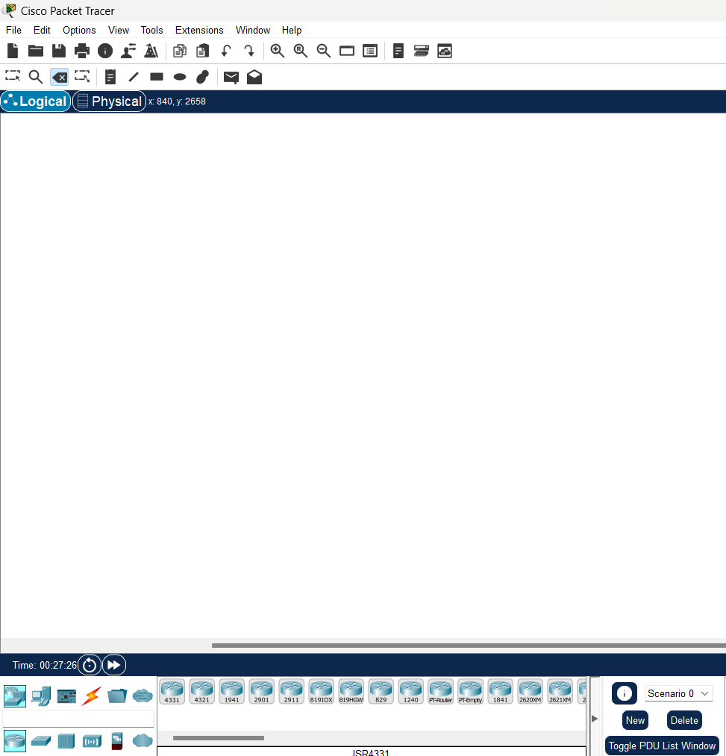*Fig:Cisco Packet Tracer Workspace*

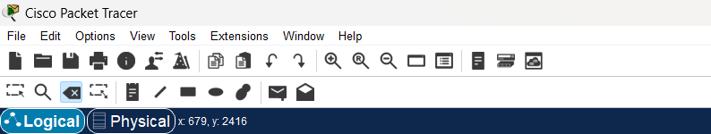**Toolbar**  
The toolbar provides quick access to essential functions like saving and opening files, zooming in and out, and controlling the simulation process. It also allows you to switch between physical and logical views of your network. By offering direct access to frequently used tools and settings, the toolbar streamlines your workflow and enhances efficiency.

*Fig:Toolbar in Cisco packet tracer*

**Device-Type Selection Panel**  
The left panel displays all available network devices, categorized into routers, switches, and end devices. You can quickly choose a device and drag it onto the workspace to incorporate it into your network design. This layout streamlines the process of locating and adding devices for your network topology.

*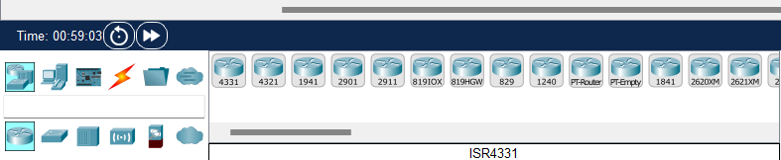Fig: Device selection panel*

**Device Configurations**  
After placing a device on the workspace, you can configure its settings through a configuration window. This includes assigning IP addresses, setting up routing protocols, and enabling features like DHCP or NAT. Configuration can be done using both a graphical interface and a command-line interface (CLI), offering flexibility for both beginners and advanced users. This dual approach ensures that users of all skill levels can effectively manage their network configurations.

.

*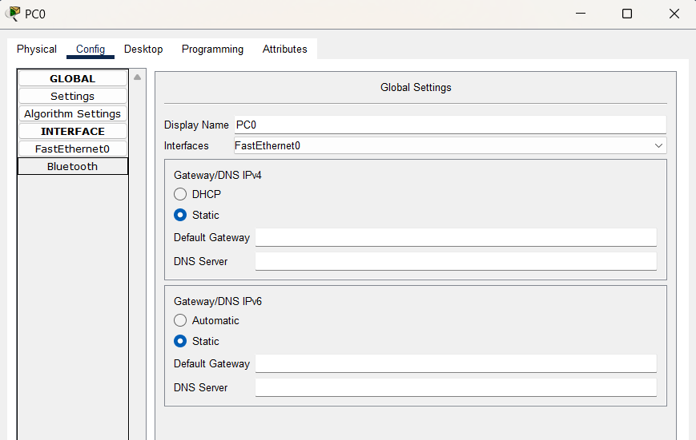Fig: Device configuration settings*

**Real-Time and Simulation Mode**  
Packet Tracer operates in two modes: Real-Time Mode, where network actions occur instantly as they would in a real network, and Simulation Mode, which lets you pause and step through network operations. Simulation Mode is especially useful for analyzing packet flow, understanding protocol behavior, and troubleshooting network issues by observing data movement across the network. This dual-mode functionality enhances both learning and practical application.

*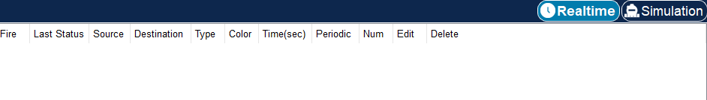Fig: Different modes in Cisco packet tracer*

**Network Component Icons and Labels**  
Devices and connections in the workspace are represented by specific icons, making it easy to identify different network components. You can add labels to these icons to provide additional details, such as device names, IP addresses, or VLAN information. These labels help organize the network diagram and improve clarity, making it easier to understand and manage complex network designs. This setup enhances both the visual organization and functionality of your network layout.

*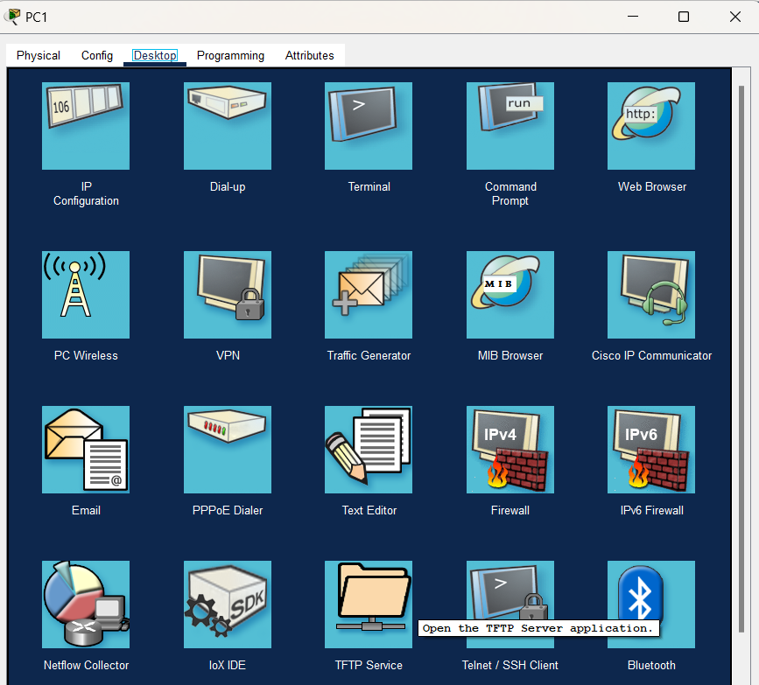Fig: Network component icons and labels*

**Options and Preferences**  
The Options and Preferences menu in Packet Tracer allows for extensive customization of your environment. You can change visual settings like background color and font size, set default values for device configurations, and control simulation speeds. This flexibility lets you tailor the software to your personal preferences and working style, enhancing your overall user experience.

*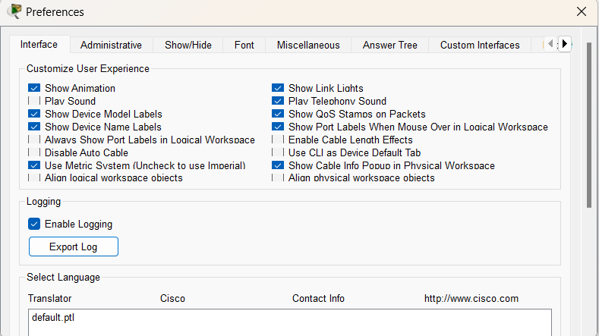Fig: Option and preferences menu*

**Activity Wizard**  
The Activity Wizard in Packet Tracer is designed for creating interactive learning activities. Instructors can use it to design tasks, provide step-by-step instructions, and set up assessments within the software. This tool is particularly useful for educational purposes, allowing students to practice and test their networking skills in a guided and structured environment. It enhances the learning experience by offering a hands-on approach to understanding network concepts.

*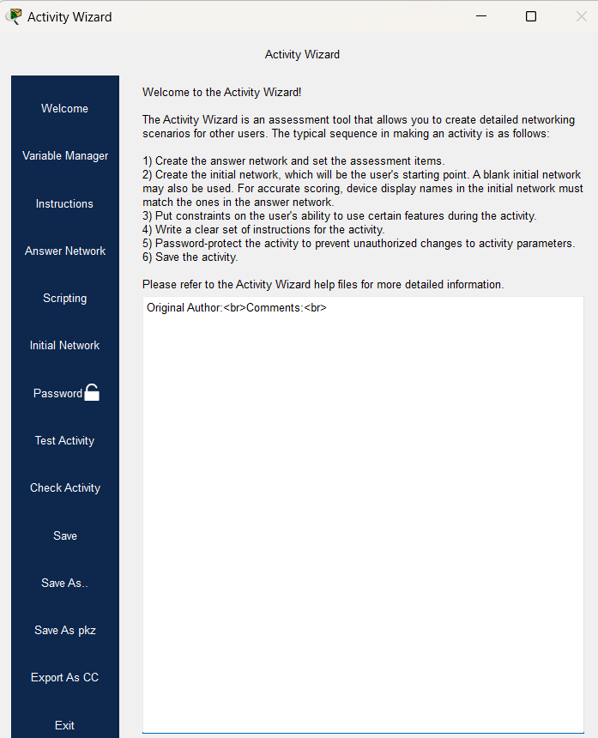Fig: Activity wizard feature*

**Conclusion**

In this lab we conclude that the Activity Wizard in Packet Tracer is designed for creating interactive learning activities. Instructors can use it to design tasks, provide step-by-step instructions, and set up assessments within the software. This tool is particularly useful for educational purposes, allowing students to practice and test their networking skills in a guided and structured environment. It enhances the learning experience by offering a hands-on approach to understanding network concepts, making learning more engaging and effective.