Lab 8: Basic router configuration and static routing in Packet Tracer

# Theory:

A **router** is a networking device that directs data between different networks. It determines the best path for data packets to travel, typically between a local network (like your home network) and an external network (like the internet). Routers connect multiple devices to the internet, manage traffic, and ensure data is sent efficiently by selecting optimal routes. They also provide security features, such as firewalls, to protect the network from external threats.

# Network Diagram:

# 

*Fig: Network diagram*

# Basic Router Configuration

## Configuring Global Parameters

The initial configuration of the router involves setting global parameters such as hostname, passwords, and interface descriptions.

## Steps:

1. Access Privileged EXEC mode by entering the appropriate command.
2. Set a custom hostname for the device using the hostname command.
3. Configure passwords for both Privileged EXEC mode and console access to enhance security.
4. Optionally, configure banners to display custom messages if needed.
5. Repeat these steps for the other router.

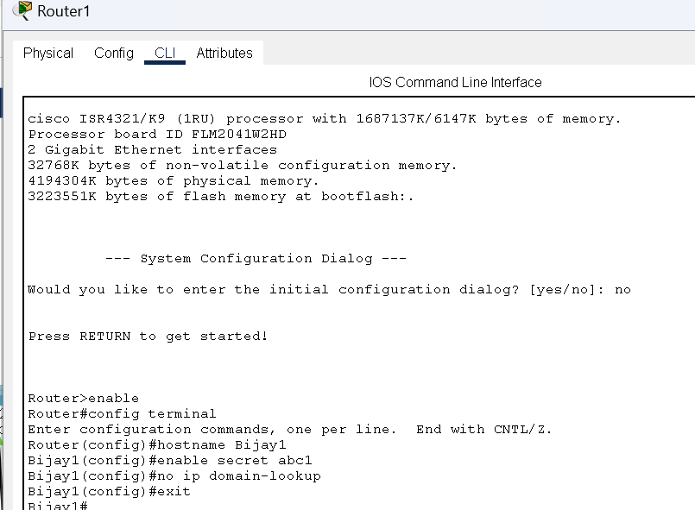

*Fig: Router configuration*

## Configuring Gigabit Ethernet

After setting global parameters, configure the Gigabit Ethernet interfaces to enable communication between networks.

**Steps:**

1. Enter interface configuration mode with the interface gig0/0 command.
2. Assign an IP address and subnet mask to the interface.
3. Activate the interface using the no shutdown command.
4. Repeat these steps for the other router.

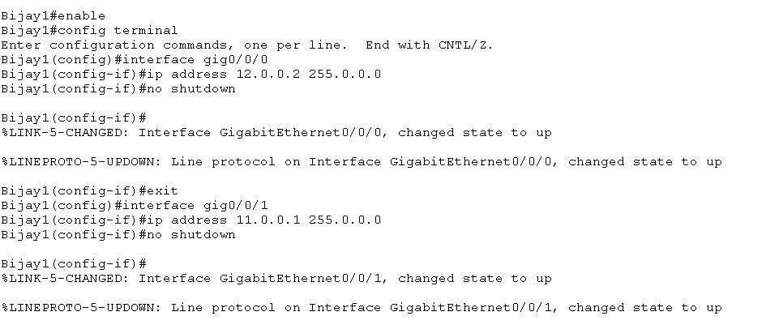

*Fig: Gigabit Ethernet configuration*

**Connection Testing Before Static Routing Configuration**

**Steps:**

1. Pinging PC (Bijay(11.0.0.2)) from PC(Bijay1(10.0.0.2)) to verify connection if exists. .

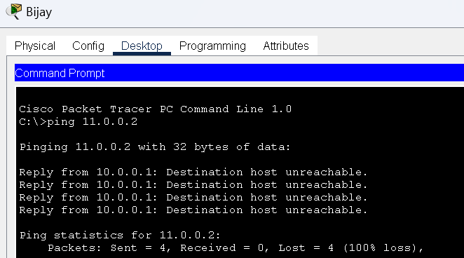

*Fig: Connectivity test from PC(sangit1(10.0.0.2)) to PC(sangit2(11.0.0.2))*

Here we can see there is not any connection in the network. So to establish connection in the network ,we need to statically configure the router through CLI.

# Static Routing Configuration

## Configuring Network (PCs and Routers)

Set up static routes to allow the routers to communicate with networks beyond their directly connected networks.

## Steps:

1) Configure the IP addresses of PCs connected to the each network.

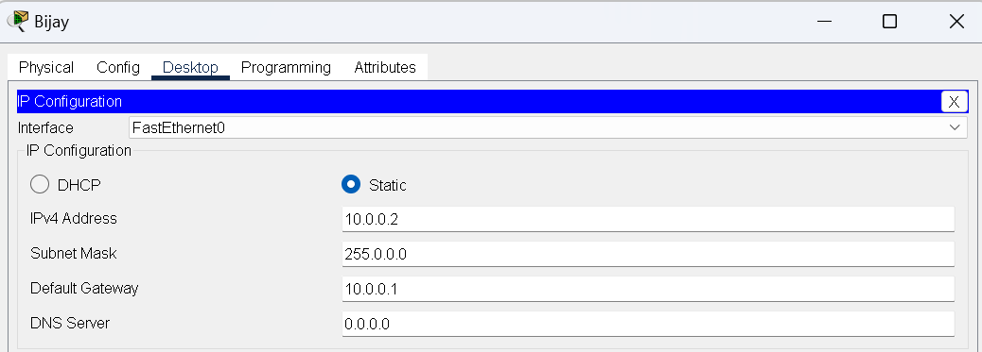

*fig: IP configuration PC(sangit1(10.0.0.2))*

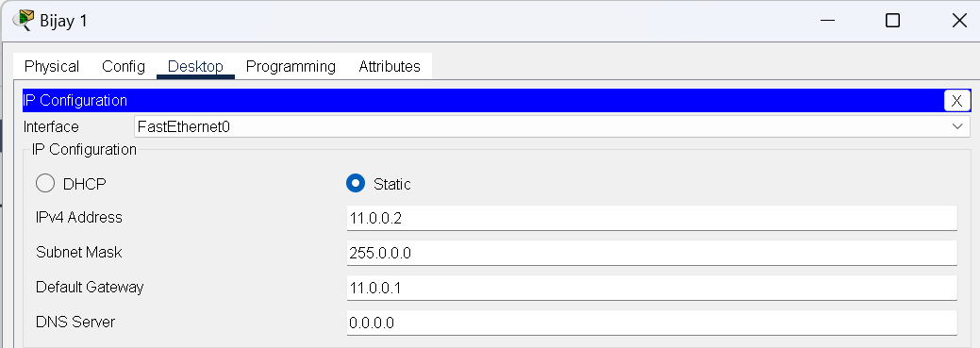

*fig: IP configuration PC(sangit2(11.0.0.2))*

2) On each router, configure static routes using the ip route command to manually specify the next hop for network traffic.

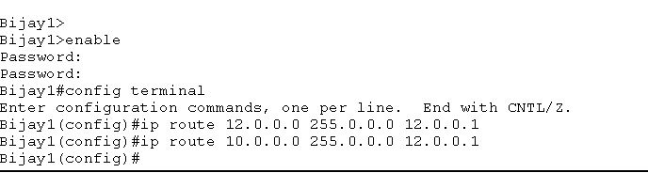

*fig: static configuring routing*

## Testing and Validation

To test whether the network is working, you can ping other devices on the network from each PC.

## Steps:

1) Ping PC (Bijay1 (11.0.0.2)) from PC (Bijay(10.0.0.2)) .

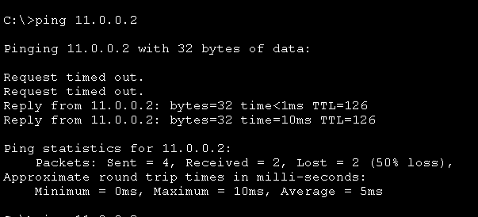2) If the ping is successful, you should see replies from the other device.

*Fig : Connectivity test from PC(sangit2(11.0.0.2)) from PC(sangit1(10.0.0.2))*

# Conclusion

In conclusion, this lab enabled us to effectively configure basic router settings and implement static routing using Cisco Packet Tracer. Through hands-on practice, we successfully set up global parameters, configured Ethernet interfaces, and established static routes between routers. By manually directing network traffic with static routes, we ensured seamless communication between different network segments, thereby enhancing our understanding of network routing and management.