ITWS-CASE STUDY-DOCUMENTATION BSIT-2B

Mark Lennard Torres Mark Jacob Capague

In this project, we developed two interconnected personal webpages as part of our coursework in Introduction to Web Systems (ITWS). The goal was to create visually appealing and functional platforms that showcased our individual profiles, skills, and interests. Our webpage showcases both of our unique journeys and interests. Our webpage provides an in-depth look into our individual journeys and shared interests. Both sections highlight our academic paths in BSIT, showcasing the projects we have worked on, the skills we have developed, and the hobbies that inspire us. Each page also reflects our professional aspirations and creative endeavors, giving a well-rounded view of who we are and what we aim to achieve.

The design of our personal webpage is structured to provide a seamless user experience while presenting relevant information in a visually engaging manner. The website features a minimalist and simple design that prioritizes user-friendliness, for Player1/Player2 we used sidebar using hamburger menu. Clear navigation, clean layouts, and a cohesive color palette ensure an intuitive and enjoyable browsing experience. The webpage consists of the following sections:

* About Us: This section introduces our webpage, highlighting the course we are studying and the support of our teachers. It also shares a brief overview of our shared interests and goals as creators.
* Player Profiles: Each profile features a personal introduction, skills, interests, and key projects that define our individual journeys. These sections provide a glimpse into who we are and what we aim to achieve.
* Resume: This section outlines our educational background, showcasing our academic achievements and milestones. It reflects the foundation of our skills and future aspirations.
* Contact: A simple contact form allows visitors to reach us easily by providing their name, email, subject, and message. We also share our contact details for direct communication.
* Address: Our location is displayed on an interactive map, making it convenient for collaborators or visitors to find us.

Designing the personal webpage presented several problems and challenges that tested our technical skills and collaboration. One significant hurdle was working on two separate laptops, which made it difficult to combine files seamlessly. Coordinating updates and ensuring consistency required extra effort and meticulous organization. Additionally, we faced issues with color schemes, where some combinations did not achieve the desired aesthetic or contrast, leading to multiple revisions. Despite these obstacles, the process enhanced our problem-solving abilities and improved our understanding of design principles, ultimately resulting in a cohesive and visually engaging webpage.

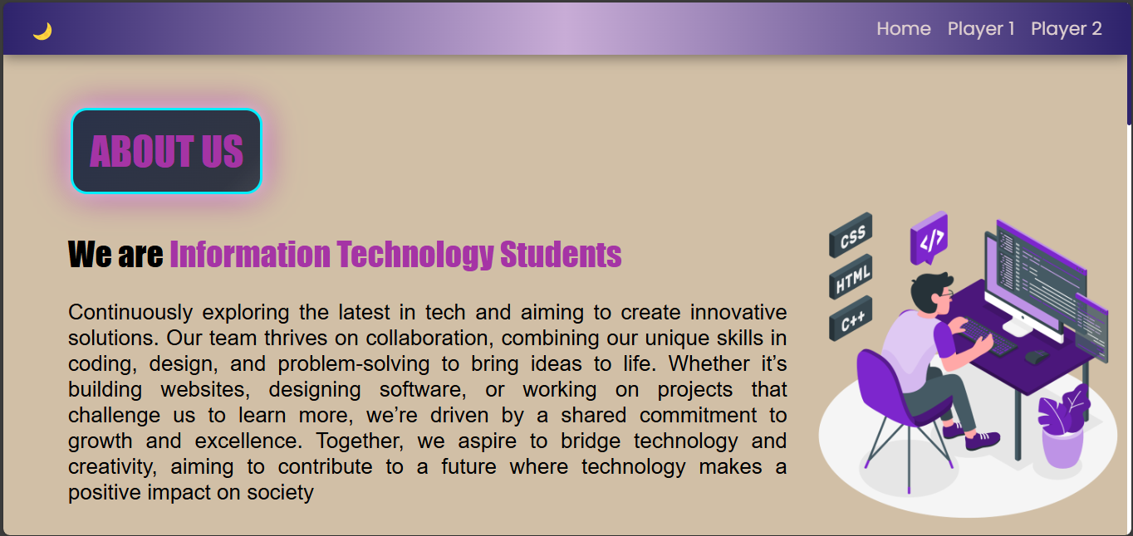

Completing this project was a rewarding experience, as it allowed us to apply theoretical knowledge to a practical task while learning new web development techniques along the way. We are proud of the collaborative effort that brought our vision to life and the way our webpages highlight our unique identities while maintaining a cohesive design.