**CD Site Social Club Guideline Handbook**

2011 Rev.0

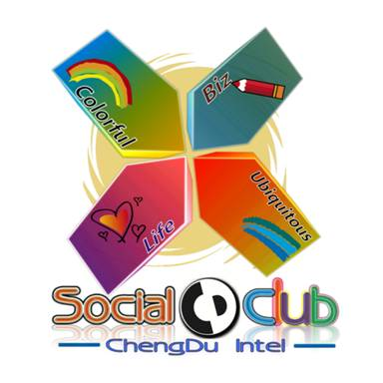

CD site Social Club

Intel Chengdu Labor Union

Preface

Forward from Labor union

Forward from Social Club

-------------------------------------------------------------------------

Objective

Employee Eligibility & Enrollment

CD Social Club Org Chart

Role and Responsibility

Labor union committee

Social club Chair

Finance controller

Social club leader

Club member

Budget & Expense

Funding philosophy

Ground rule

Budget Allocation and forecast

Field and Transportation

Spending & Reimbursement

Performance review & Recognition

New Club application

Social Club website

Appendix

**Preface**

**Forward from Labor union**

CD Site Social Club has turned on a new leaf when it was officially included into Union management structure in end of the year 2007 with the intention to further uphold and advocate one of Intel’s strongest values-Great Place to Work. During these passing years when it grew rapidly with CD site, it has successfully gained enormous attention and popularity from employees who have passion and personal interest.

Social Club has always proved itself to be one of Union’s favorite kids that makes union feel so proud of by the responsibility it proactively shoulders to emotionally bond CD site employees, the contribution it makes to polish the soft environment of CD site, as well as the vitality it infuses into the “CD Can Do” culture.

It has undoubtedly engaged itself to be the bridge that connects employees across the whole site creating so much joy and fun for all CD employees. No matter what departments they are in, no matter how different their characteristics are, they all can find a specific one or even more clubs where they can learn, share, enjoy and have fun together. Meanwhile, those fans have witnessed the mutual growth and development they experience with this club.

Social club, apart from her role as a ‘hobby leader’, is very active and dedicated in taking on promoting and strengthening CD site team spirit by organizing and implementing a great number of quality site level events. In this way, it helps demonstrate to the world that Intel Chengdu is so much more than just great minds but also with strong body and positive lifestyle.

However, this ambitious and innovative child never stops on the success. With our talented people and creative volunteers, it is keen on exploring new fun and adventures all the time, with the purpose to continuously inspire and motivate our employees.

All of these cannot be done without the dedication and diligence provided by all social club chairs, sub leaders and all players. Union, as a thankful parent, would like to extend our sincere gratitude to all social club practitioners and best wishes on an even brighter future of this club.

**Intel Chengdu Union Committee**

**Forward from Social Club----Happy at work, happy in life**

Life is beautiful, isn’t it? Just need to change the angle…

You might have experienced the challenges of balancing the needs of your work and life. Both work and life are becoming more complex so creating optimal work performance in combination with a balanced life seems increasingly difficult.



Look, in the magic of starting, our employees dedicatedly created the logo above and made the point that it is your days that define your life. Here, I want to challenge the common perception that it is only possible to enjoy your leisure time.

**1. Appreciate Beauty.** Each day we come across beauty in a number of shapes and forms. When joining the new social club, e.g., Photo Club. I suggest looking again at your colleagues, plants, gadgets, and buildings around you and taking a moment to appreciate what makes them so special. Don’t you believe so?

**2. Connect With Nature.** Nature is an amazing healer for the stresses and strains of modern life. Travel Club says YES to you!! Eating lunch in the park, attending to a vegetable garden in your backyard, or watching the sunset are just a few simple ideas for how you can enjoy the outdoors on a daily basis. You can enjoy more with the increasing of your footprints.

**3. Have Simple Pleasures with connected hearts.** Sports can help you find out your inner self. You will definitely let your body refresh and ‘communicate’ with the nature. It will sweat, breathe, or even hurt, but you will finally enjoy the whole unforgettable time spent with your team mates and the spirit of persistence. Basketball, soccer, badminton, Taichi, Tennis, Swimming, just dream and go for it. In this way, it is our relationships with people that give us the most happiness in life. Perhaps, then, the best way to enjoy your work more is not to get a raise or a promotion, but rather to build rewarding relationships with your co-workers.

**4. Rethink Your Mornings and Evenings in Musical Way.** Are the mornings a mad rush for you to get out the door? Do you switch off the TV at night and go straight to bed? How about music? Does music inspire you? In Dancing and Music Club, you play the musical instrument for your muscle, you sing yourself out of you heart and you dance with the craziest music. You will find the Sound of Music everywhere.

**5. Celebrate Your Successes.** With Toastmaster, this is what I want you to achieve. During a normal day we are sure to have some minor successes. Perhaps you have successfully dealt with troubleshooting, reported a DRM, or received a promotion letter from your boss. Wherever you are, Social Club is always together with you. Once you feel you cannot have a better work & life without social club, social club has already been staying in your heart.

Just join and enjoy, Chengdu Can DO!!

SC Chair: Tang, Reed & Chi, Wangqing

**Objective**

Intel CD Site Social Club aims to promote GPTW across the site by providing a platform to CD employees through sport and interest activities to enjoy the work and life balance. All the blue badge employees are eligible to attend social club activities. This handbook is an overview of CD social club guidelines for CD employees, especially social club members. Employees joining social club activities should strictly follow the guidelines.

Back to top

**Employee Eligibility & Enrollment**

* All Intel CD Blue Badge employees are eligible to join Intel CD site social club activity.
* Direct relatives* can join social club activities on voluntary and self-funded base and need to meet specific requirement from each social club.
* Direct relatives are eligible to use site facility with following CD site direct family member sports facility usage guideline in appendix A.
* For Enrollment, please directly contact sub club chair or through [social club website](http://cdsite.cd.intel.com/siteportal/SocialClub-new/homepage.htm). Mandatory register information included area: WWID, Name, Gender, Department and Factory.

**\*:** direct relatives- spouse, parents, parents in law, children and siblings.

* **Safety & Security**
  + Safety is on the first priority of all social club activities. All the employees should follow Intel and social clubs’ safety guidelines.
  + All employees must sign waiver form in appendix B upon registering for any social club activities or programs.
  + All employees should take full responsibility of his or her private properties. Intel doesn’t take any responsibility of any lost during social club activities.

Back to top

**Intel CD Social Club Org Chart: 2011**

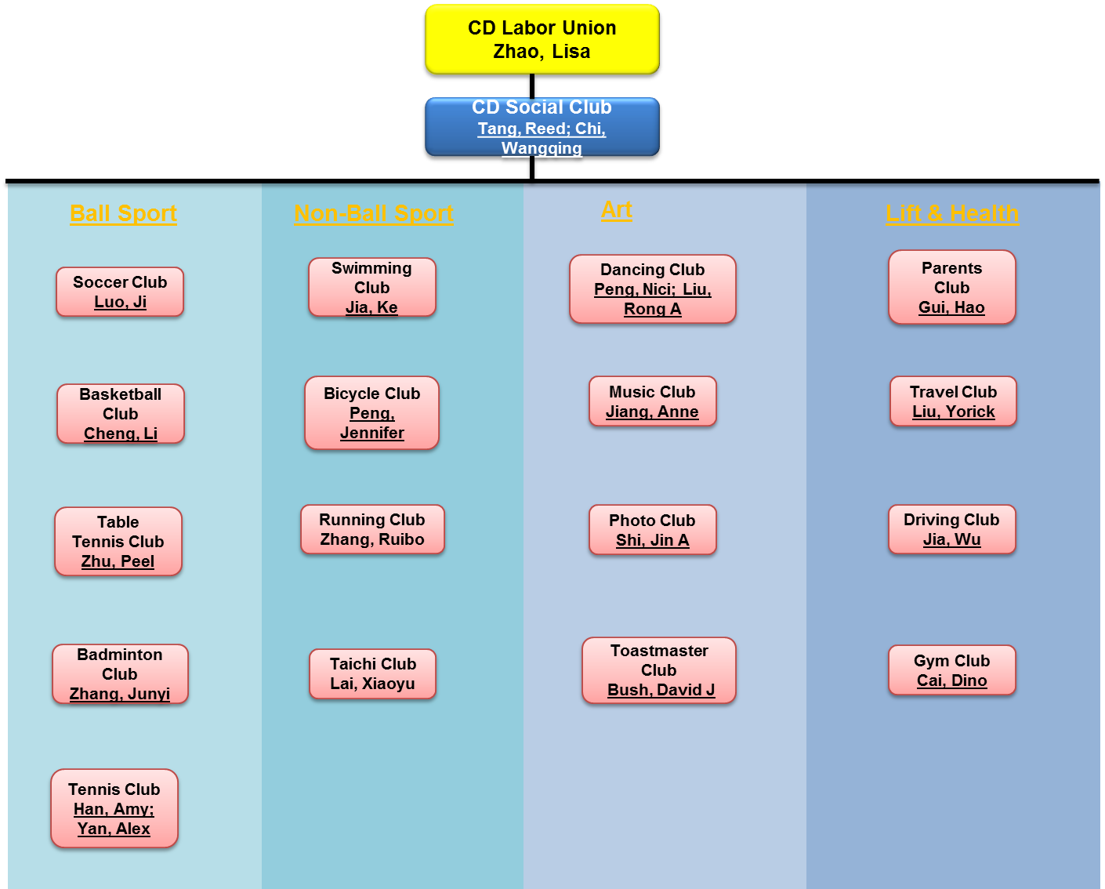

* There are total 17 clubs including 5 ball sport clubs, 4 non-ball sport clubs, 4 art clubs and 4 life & health. 2 supporting teams are under construction: one focusing on shift coordinate and the other focusing on technique support like IT, finance…
* For detail contacts for office and shift, please go to [social club website](http://cdsite.cd.intel.com/siteportal/SocialClub-new/homepage.htm) for latest information.

Back to top

**Role and Responsibility**

Intel CD Site social club has 6 key stakeholders: Labor union committee, Social club chair, Social Club finance controller, Sub club chair, Sub club leader, and Social club member.

**Labor union committee** is the sponsor for all social club organization and funding. Its responsibility follows in:

* Define the overall social club strategy to support site GPTW.
* Plan and allocate budget for social club.
* Review and ratify guidelines for social club activities. Review and buy off social club budget plan and has authority to audit club’s activity for Intel COC compliance.
* Own the final authority of explanation of all social club activities.
* Monitor and review social club’s performance.
* Recruit and assign social club chair.

**Social Club Finance controller** is the finance expert to make sure all social club budget and spending following Intel and CD site requirements. His or her responsibility follows in:

* Manage social club budget in backend.
* Review and control social club spending within budget and make sure reimbursement follows Intel policy.
* Review social club budget and spending status in quarterly base and advise cost efficiency proposal to social club.
* Being consultant for any finance related question or policy.

**Site Social club chair** is the chairperson of CD social club. He or she reports to labor union committee and leads sub club chairs to plan and execute social club events and activities. His or her responsibility follows in:

* Set Social Club guidelines
* Communication channel for pass-down and feedback between labor union and sub club chair.
* Drive site social club operational excellence and cost effectiveness through closely teamwork with sub club chair.
* Promote GPTW concept through social club activities and market the achievement.
* Provide support to sub club chairs to promote club activities to site employees.
* Manage social club budget and spending.

**Sub club chair** is the chairperson of specific function club. He or she reports to social club chair and leads club leaders to plan and execute each club’s events and activities. His or her responsibility follows in:

* Drive sub club’s operational excellence through planning, executing and problem solving.
* Co-work with social club chair to promote GPTW concept through social club activity.
* Forecast and allocate club’s budget quarterly base, and make sure club’s whole spending follow site expense guideline.
* Comply with Intel safety and COC requirement and strictly follow Intel CD Social club guidelines.
* Timely monitor club’s activity and quarterly report club’s performance to social club chair

**Sub club leader** is the leader reporting to sub club chair. He or she leads club’s regular activities for office, CD1 Shift, CD6 shift and IW shift respectively. His or her responsibility follows in:

* Schedule club’s regular activities or events in office or shift.
* Support sub club chair on club to drive club operation improvement.
* Promoting club activity to all the EE under his or her scope.
* Comply with Intel safety and COC requirement and strictly follow Intel CD Social club guidelines.
* Collect and respond EE’s feedback on specific club activities

**Club Member:** is the employee attending social club activity. His or her responsibility follows in:

* Comply with Intel safety and COC requirement and strictly follow Intel CD Social club guidelines.
* Comply with sub club’s specific requirements.
* Be accountable for personal safety and security during the club activities. Sign Waiver form (Appendix B) before joining any social club sponsored activities.
* Behave in public to maintain Intel image.

Back to top

Budget & Expense

* Funding philosophy
  + Labor union (LU) allocates budget to social club on annual base by taking into consideration of a few key items of labor union priorities, total number of social clubs, social club historical average spending, equality and fairness.
* Ground rule
  + It’s not Intel CD site LU’s responsibility to fully cover all club activities. LU sponsors reasonable funding to provide a platform for employees and employees are subjected to pay for part of spending based on specific activities’ needs.
  + LU doesn’t sponsor personal spending like clothes (external competition on behalf of Intel is an exception and only for core team members), personal sports facilities like badminton bat; tennis bat etc, and other personal spending like food. Reasonable drink and snack is allowable.
  + Total social club budget is split into two potions: social club regular budget and ad-hoc budget (including site level activity both external and internal, new club seed fund, recognition, and balance etc.). Regular budget is allocated on yearly base to each sub club, considering club’s history allocation, actual spending, attendee number and club performance. Ad-hoc budget is applied ahead by each club.
  + Sub club chair should submit quarterly budget with standard forecast template (appendix C) before quarter start to social club chair, and control spending within yearly allocation.
  + Sub club chair should submit quarterly spending summary with highlits and lowlits to social club chair to call out help needed and cost effectiveness proposal. The latter will have overall quarterly review with labor union committee.
  + For promotion and internal reward, each sub club should control the cost within 5% of total sub club’s yearly budget with cap @ 1500 RMB. (Note: the reward is to recognize those who make significant contribution to club’s daily activity.)
  + Intel Chengdu site qualified vendors were highly recommended for purchasing club related consumables (like ball, net, etc.) and services (coach, shuttle, travel agency, etc.). For those items without qualified vendors, it’s chair’s responsibility and accountability to strictly follow Intel COC policy. Reference vendor list in appendix D
* Field and Transportation

* + Site facilities or fields (appendix E) are the first priority for the social club activity. Each sub club chair and leader has the responsibility to maximize the utilization of site available resource.
  + Social club’s group activities will be put 1st priority to use site facility VS individual employee or family, when there is interest conflict between social club group activity and individual or family. Different clubs with sharing field should align the utilization schedule first and follow the agreement to avoid the conflict.
  + For site level external match, both field and transportation fee should be covered by forecast if needed.
  + For regular club activity, if field rental fee were charged, no transportation fee will be supported to individual employee for joining the activity; if no field rental fee, transportation fee can be claimed based on below policy:
    - Group activity: Soccer, Basketball, Dancing : 15RMB /person and minimum 10 people
    - Non Group activity: Tennis, Table Tennis, Gym, Badminton, Taichi: 15RMB /person and minimum 4 people
* Spending & Reimbursement
  + Chairs and/or leaders have to pay the cost first, then reimburse through finance.
  + Reimbursement procedure:

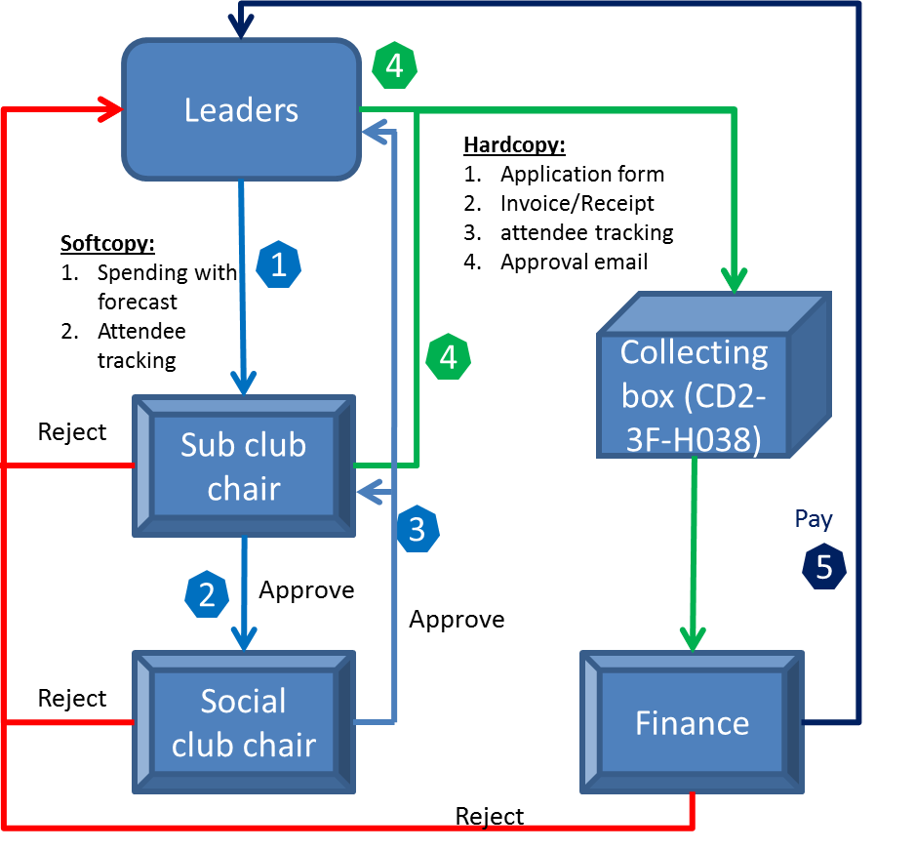

* + Forms: forecast template (appendix C), Attendee tracking (appendix F ) and Application form (appendix G)
  + Finance will open collecting box @ Monday of 3rd week on monthly base. Missing submission will be processed in next month. Payment TPT is within two weeks.
    - If cost is more than 5000 RMB, reimbursement can be submitted at any time.
  + If invoice or receipt was missing, approval is needed from LU committee by submitting Justification Form (appendix H). Substitute for missing invoice or receipt is NOT allowed based on Intel Policy.
  + Note:
    - For social club overall spending, follow the same practice and need LU chair’s approval.
    - Finance contact: Yu, Jiang F, CD2-3F-H038

Back to top

Performance review & Recognition

* The objective of performance review is to create a positive competing environment among sub clubs to drive each club to maximize the contribution to site’s GPTW.
* Each club’s performance is measured quarterly by indicators including attendee rate, cost effectiveness, increase and diversity. Safety and COC are prerequisite for the top performer. Club with Safety or COC issue will be removed from top performer even its rating is on top. Detail rating and weights are in below table:



* Score will be granted to each category to club from 1~10 point based on “Focal” practices. Each club’s performance is based on the total score. Top 3 performance clubs will be recognized and granted with priority for budget increase. Bottom 3 performance clubs will be target for sunset or budget decrease.
* Register and attendee tracking template in appendix F.
* Recognition please see detail in below table:

|  |  |  |  |  |  |
| --- | --- | --- | --- | --- | --- |
| **Items** | **Recognition** | | **Frequency** | **Criteria** | **Comments** |
| Best club | EC communication | 1st: 800 RMB 2nd: 500RMB 3rd:300RMB | Quarterly | Diversity, Attend Rate and # event | Leader to define club related award to either whole club or key contributors |
| Top increase social club | EC communication | 1st: 500RMB 2nd: 300RMB 3rd: 200RMB | Quarterly | >10% and total # |
| Social club reporter | EC communication | 100RMB Coupon | Quarterly | top # of reports |  |
| Site Award | EC communication | Follow Site strategy | Quarterly | Special contribution to Site GPTW |  |
| EOY | EC communication | Follow Site policy | Yearly | LU Co-nominate with Leader's manager | Yearly high performance Leader with big contribution to site GPTW |

Back to top

**New club application**

New club application will be open in Q1 each year by social club communication. All blue badge employees are eligible to apply for the new social club. Selecting criteria and procedure please see below for details.

* Criteria
  + Promote GPTW value in CD site with popularity across different groups or departments, and demonstrate work & life balance. Those targeting help on employees’ health with fun will be put as priority.
  + Easy to organize and maximize the utilization of site’s resources & facilities with reasonable sustaining cost.
  + No limitation on the structure/form of each club

* Procedure



* + New Club Application form in Appendix I

Back to top

Social Club website

* <http://cdsite.cd.intel.com/siteportal/SocialClub-new/homepage.htm>

Back to top

**Appendix**

**Appendix A:**

**Intel CD site direct family member sports facility usage guideline**



Back

**Appendix B**

**INTEL Chengdu Social Club/GPTW Turbo Employee/Team Liability Waiver Form**



Back

**Appendix C**

**Budget forecast template**



Back

**Appendix D**

**Vendor list**



Back

**Appendix E**

**Intel CD site facility**

* Intel CD site provides 8 kinds of on-site facilities including:
* 1 Soccer field
* 3 Basketball field- two outside and one in-house
* 2 Tennis yard-two outside
* 1 Gym
* 3 Badminton field-(share in-house basketball field)
* 3 table tennis field-two in CD2 and one in IW; (new field in BUM room under construction.
* 1 Taichi field- (share outside basketball field)
* 1 Dancing filed

Back

**Appendix F**

**Attendee Tracking**



Back

**Appendix G**

**Reimbursement Application form**



Back

**Appendix H**

**Missing Invoice/Receipt Reimbursement Justification Form**



Back

**Appendix I**

**New Club application form**



Back

Back to top