物理模型

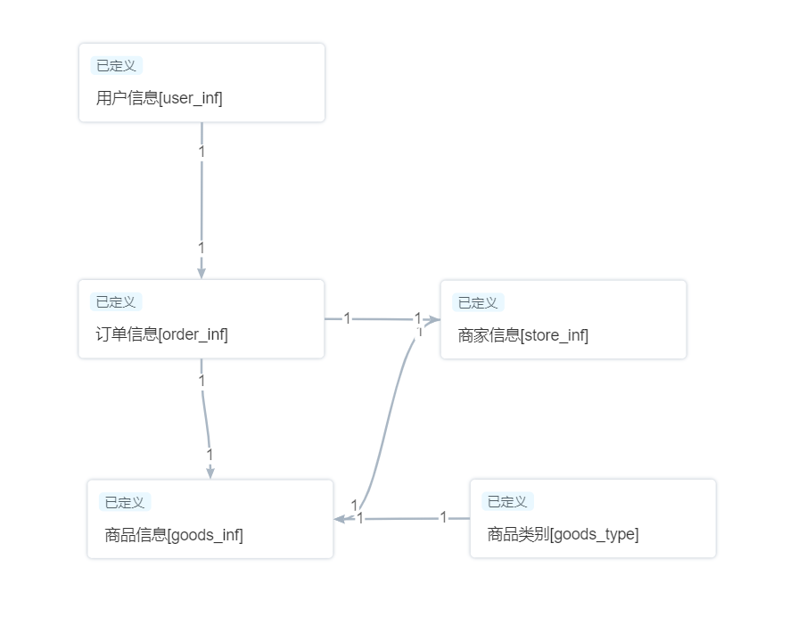

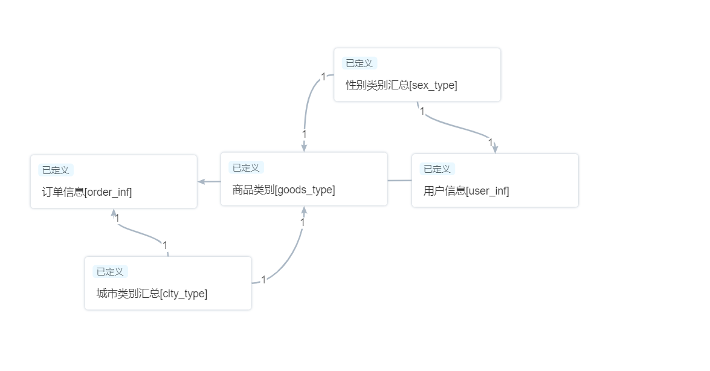

按月查看总体销售额：

select sum(price)

from data_yys.order_inf

where to_char(ord_time,'mm')=to_char(current_date,'mm')

按月查看新增注册人数：

select count(*)

from data_yys.user_inf

where to_char(user_time,'mm')=to_char(current_date,'mm')

按月查看城市的销售额（收货城市）：

select ord_address,sum(price)

from data_yys.order_inf

where to_char(ord_time,'mm')=to_char(current_date,'mm')

group by ord_address

按月查看城市、商品类别的销售额：

select ord_address,type_id,sum(price)

from data_yys.city_type

where to_char(month,'mm')=to_char(current_date,'mm')

group by ord_address,type_id

按月查看性别、商品类别的销售额：

select sex,type_id,sum(price)

from data_yys.sex_type

where to_char(month,'mm')=to_char(current_date,'mm')

group by sex,type_id

数据质量任务：

