Acceptance Criteria
There’s a ton of functionality and UI to review here, so i’m breaking AC/testing up into categories. When testing, we’ll approve functionality by category and may, depending on the success/failure rate, break testing out into separate stories.
UI Layout (to be reviewed by TJ)
- The User details section is laid out and labeled per the design spec
- required fields are marked per the design spec
- the +Another user line is accurate per the design spec
- multiple inputs/user are laid out per the design spec
- when multiple users are present, hovering over a user row produces the row highlight, per the design spec=>Not Working
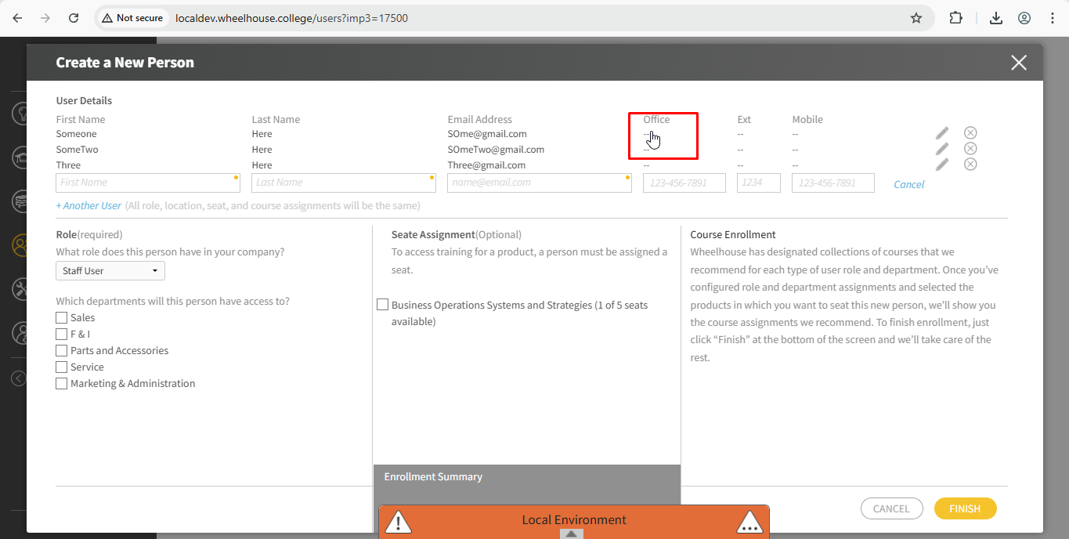
- when multiple users are present, the pencil icon is displayed per the spec, hovering presents the “Edit” tooltip=> Courser is pointer Not working
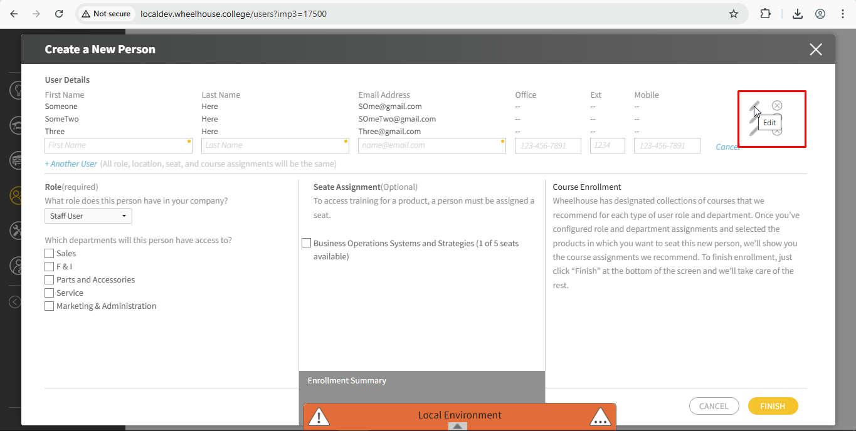
- when multiple users are present, the X icon is displayed per the spec, hovering presents the “Delete” tooltip=>Not Working
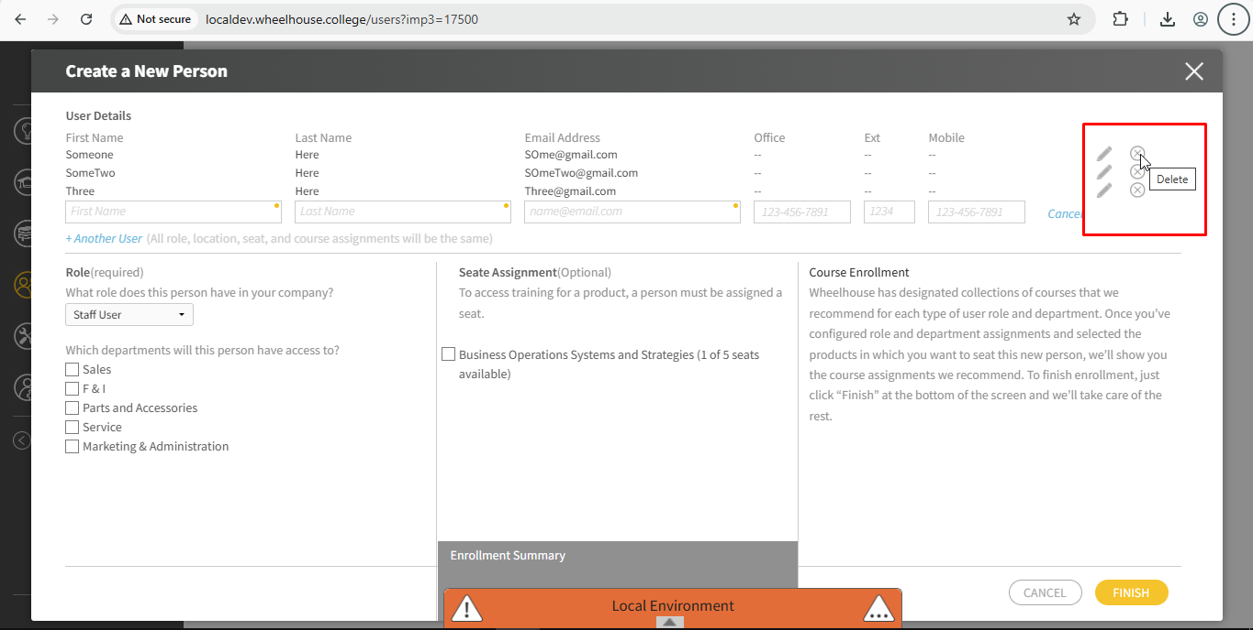

role section
- the Role section is laid out per the design spec
- “Staff User” is selected by default
- the department checkboxes checked and unchecked are styled per the design spec/system patterns
- when “Admin” is selected, the title options are displayed as radio selects

locations section
- the Locations section is laid out per the design spec
- “All Locations” is selected by default
- the location checkboxes checked and unchecked are styled per the design spec/system patterns

seat assignment section
- the Seat Assignment section is laid out per the design spec=>Not Working
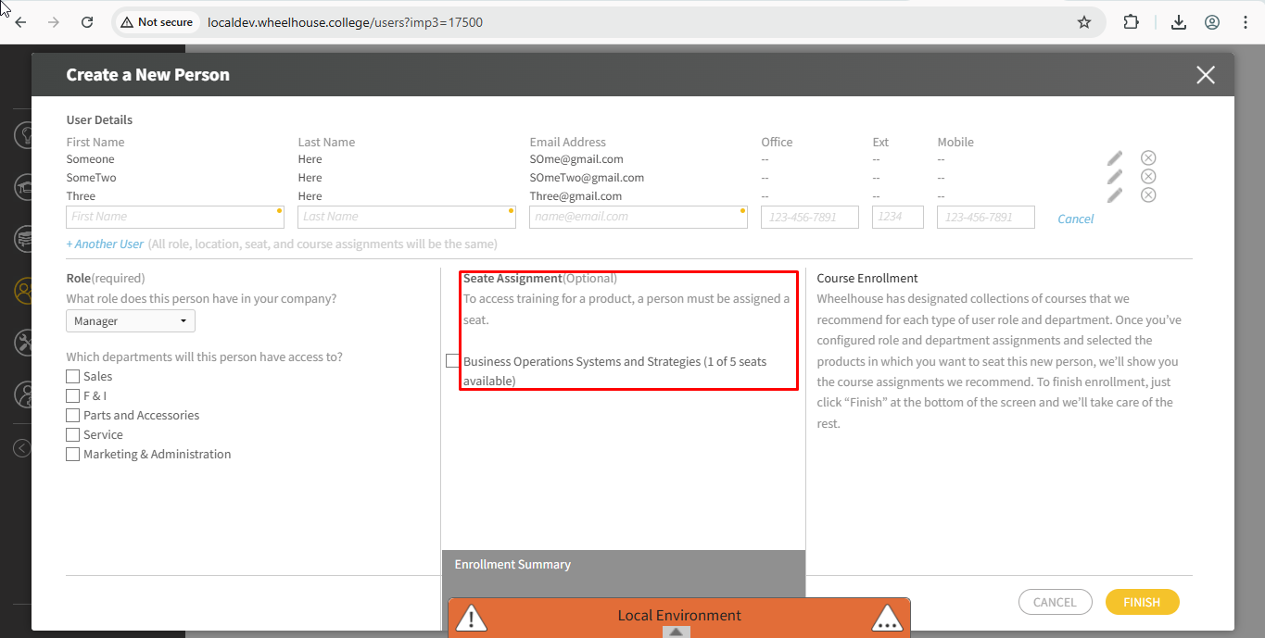
- for multiple product accounts, if seated in a product and courses have been selected, the border block around the product is green
- for multiple product accounts, if seated in a product and NO courses have been selected, the border block around the product is gray
- for multiple product accounts, a product can be “focused” (show details in the enrollment panel) by clicking anywhere in the product block
- when a product with courses selected is “focused” the background is transparent green
- when a product with NO courses selected is “focused” the background is transparent gray
- the seat checkboxes checked and unchecked are styled per the design spec/system patterns
the Course Enrollment section in read only state is laid out per the design spec=>The Course Enrollment massage should be in italic
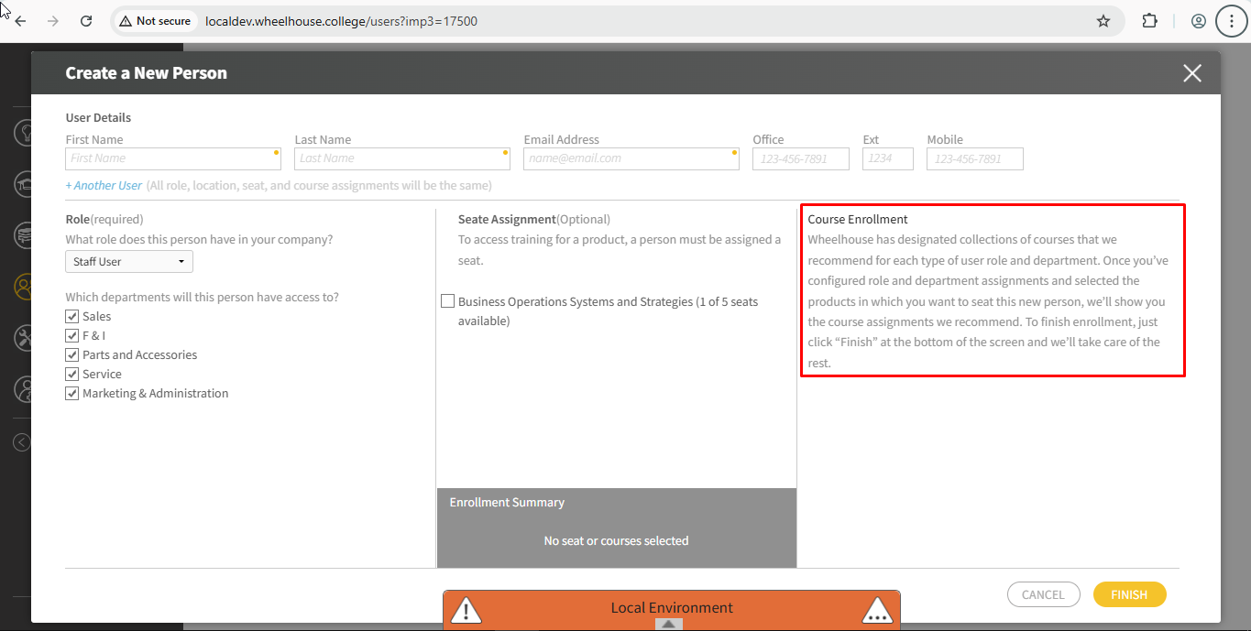
- show selected
- show all
- the Course Enrollment section in custom selection state is laid out per the design spec=>Not working Courses are getting lost
step 01
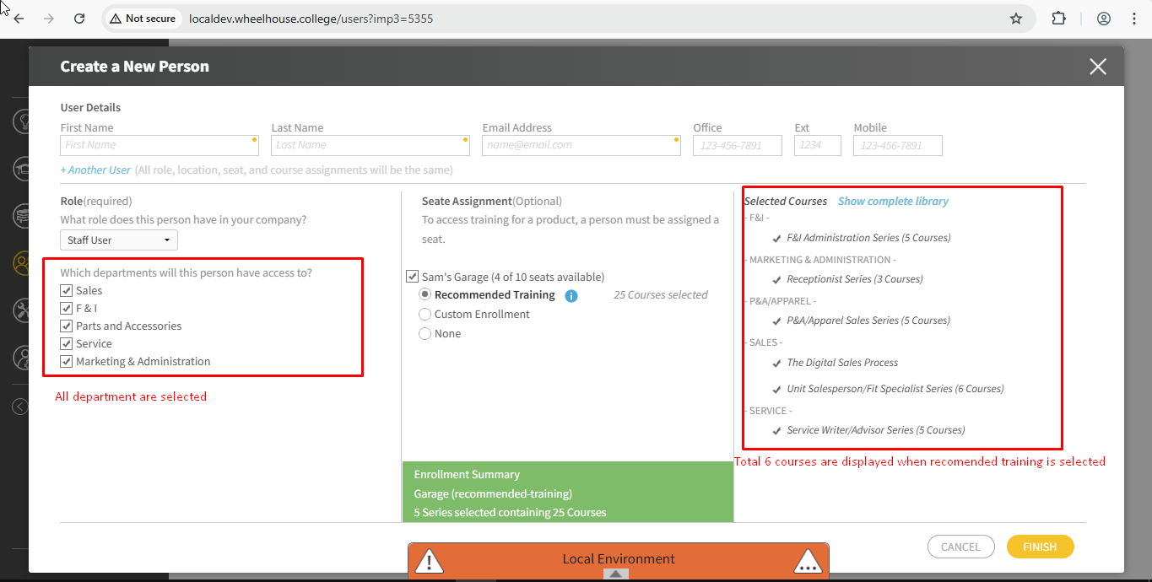
step 02:-Now Toggle the show complete library twice and deselect all the department excluding sales but show selected will display all the courses
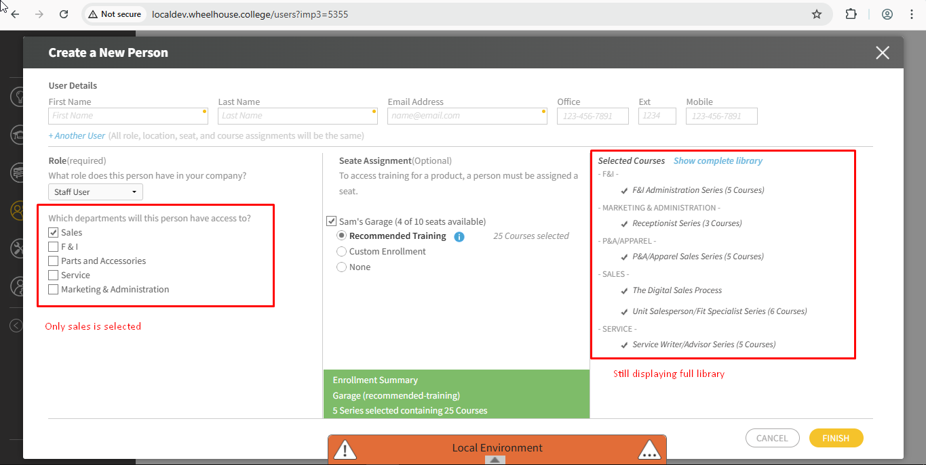
- the course selection checkboxes checked and unchecked are styled per the design spec/system patterns
- the product selection control is laid out per the design spec=>Not Working
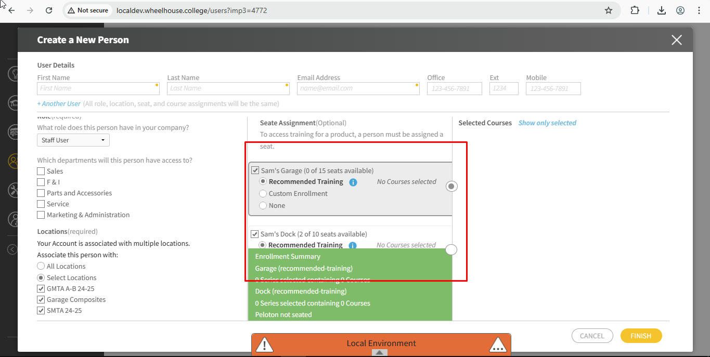
Display logic
- clicking “+Another User” loads another set of user detail inputs and the row above becomes text-only
- when multiple users are added, the edit and delete icons are displayed on each row excluding the last
- when multiple users are added, the last row has a “cancel” blue action link rather than edit/delete action icons
- clicking the “edit” icon triggers the display of inputs for the associated row and action icons are replaced by “cancel” action link
- clicking the “delete” removes the associated new user row
- clicking “cancel” on the last row removes that row and the proceeding row should then be in the edit state=>Not Working
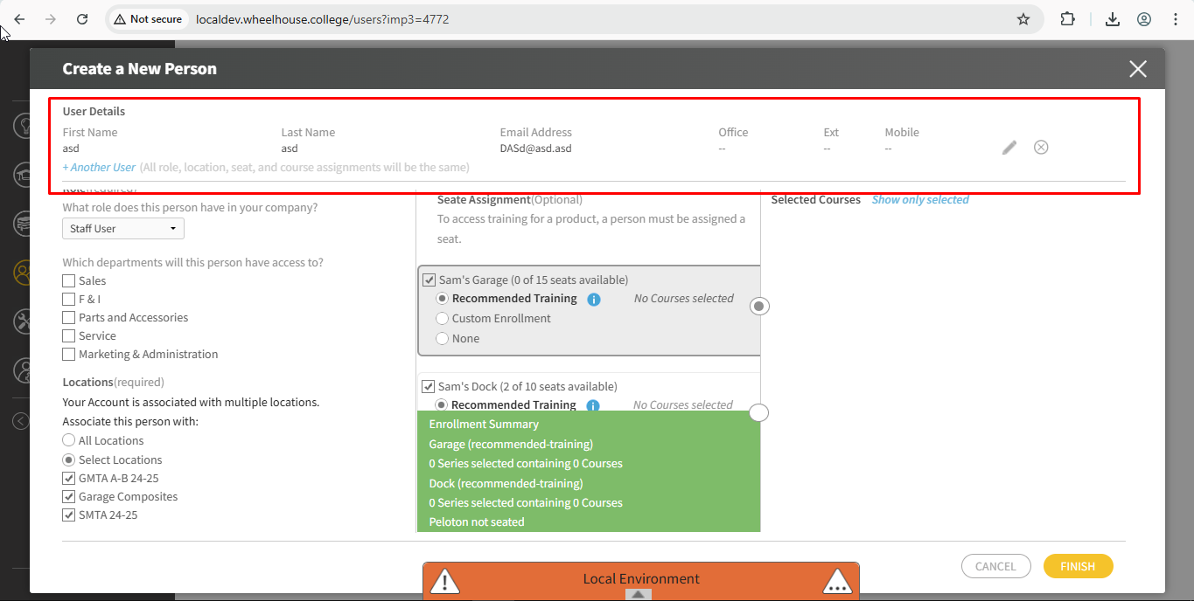
- the user details section flexes up to 2/5 modal height, after which scrolling is implemented=>Not working
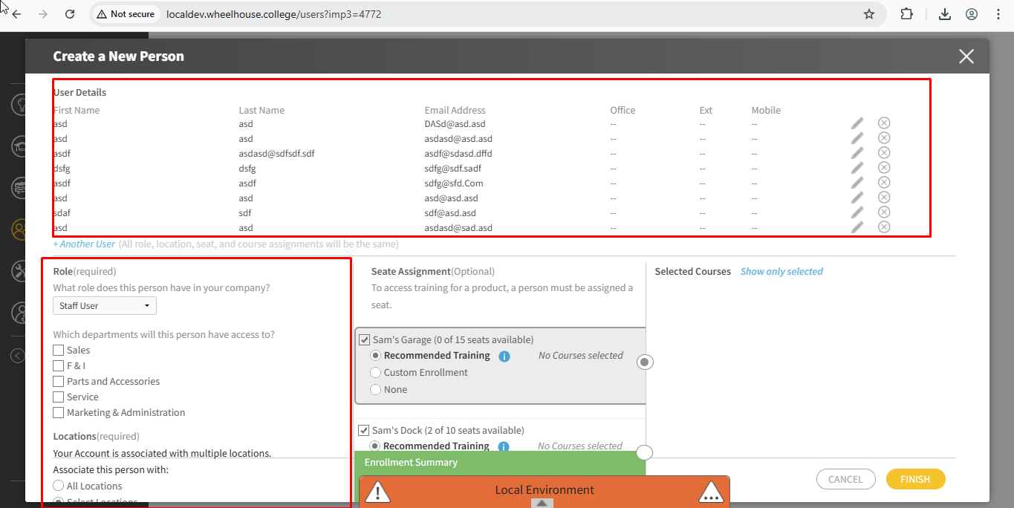
role section
- in the Role section, when Admin is selected the title options are displayed rather than departments
locations section
- the Locations section is only displayed if the Account has multiple locations
- the list of locations is not displayed by default
- when “Select Locations” is checked, the list of locations is displayed
- on vertical overflow, the Role + Locations sections scroll together as expected
seats section
- when a seat is selected, the default enrollment option is “recommended training”
- product styling/active-state reflects available seats for a single user (disabled if no seats are available)
- product styling/active-state reflects available seats for a multiple user when the user count exceeds the available seats
- when “recommended enrollment” is selected, the course enrollment section is read only
- when “custom enrollment” is selected, the course enrollment section courses can be selected via checkbox
- if a product does not have recommended enrollments (BOSS), the “Recommended Training” radio option is replaced with the hint text “No recommended enrollment available”=>Not Working
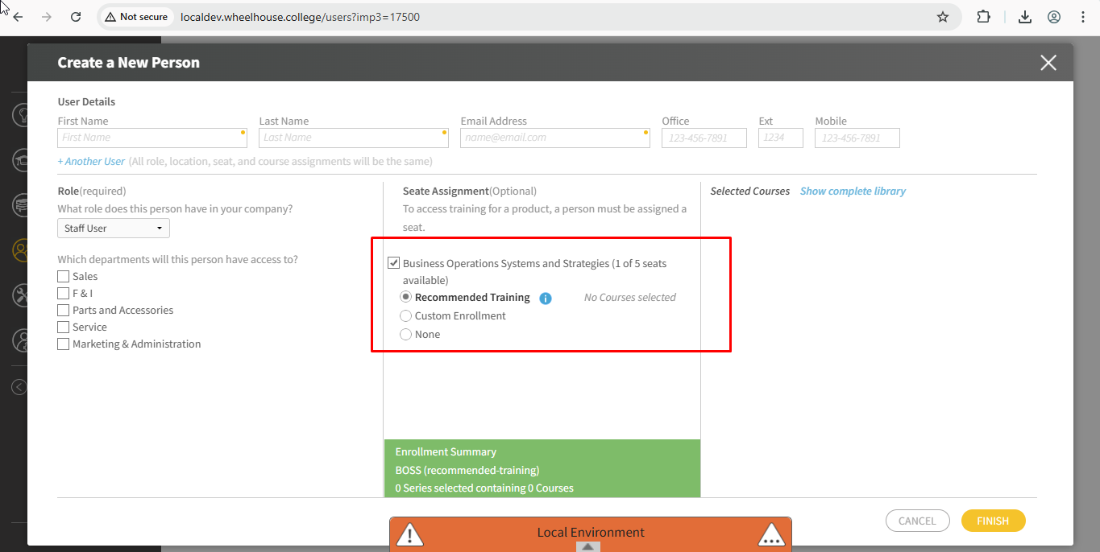
- if a product does not have recommended enrollments (BOSS), custom enrollment is selected by default
Course Enrollment
- when no seat is assigned, the empty state message is displayed
- when a seat is selected, course data is displayed
- clicking on the “show selected/show all courses” toggles the display of the course list in the recommended state
- clicking on the “show selected/show all courses” toggles the display of the course list in the custom state
- the product select control includes the product icon for all products to which the account is actively subscribed
- in the product select, a product in which the new user is not seated is disabled
- hovering over a disabled product button triggers the display of a tooltip, “Not seated in {Product Name}”
- when in custom mode, the course within a series are referred to by “Level #” and not the entire course name
Data logic/calculations
- the list of locations for a multi-location account is accurate
- the list of available products is accurate for single and multi-subscription accounts
- the available seats are calculated correctly for each product in an account
- product series and course content is accurate
- course level availability reflects pre-req. requirements
- if the user unchecks any course in a series, all courses after that course should be both unchecked and disabled
- when a subset of courses has been unchecked, the first in the series should always be enabled and everything that follows is disabled, allowing the user to progressively select the next course in the series as the necessary pre-requisites are checked
- Series 3-state checkbox functions as expected
- check when all courses are selected
- dash when a subset of courses are selected
- empty when no courses are selected
- toggling the Series check box selects/deselects all courses in the series
Validation
- the primary action button (Finish) is in the “test” state and display as long as required fields in the form remain unfilled=>Not Working(Color)
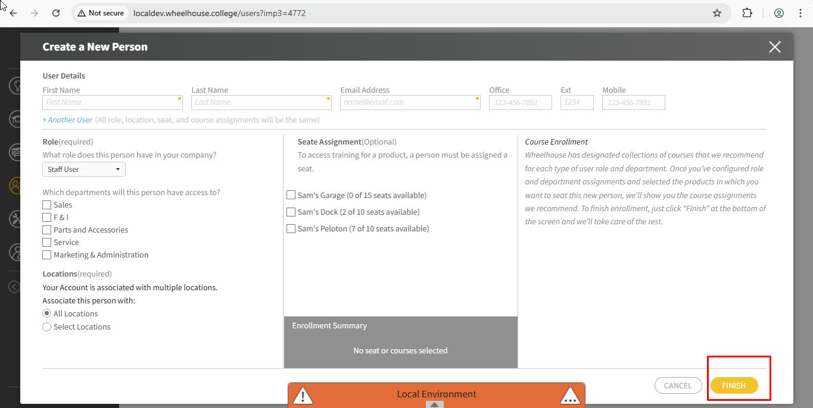
- clicking the primary action button while in the test state highlights ALL required fields that remain unfilled
- if multiple fields are outlined on validation test, each input remains outlined until the user touches that field
- the generic “please address all required fields” is displayed per the design spec=>Alignment issue
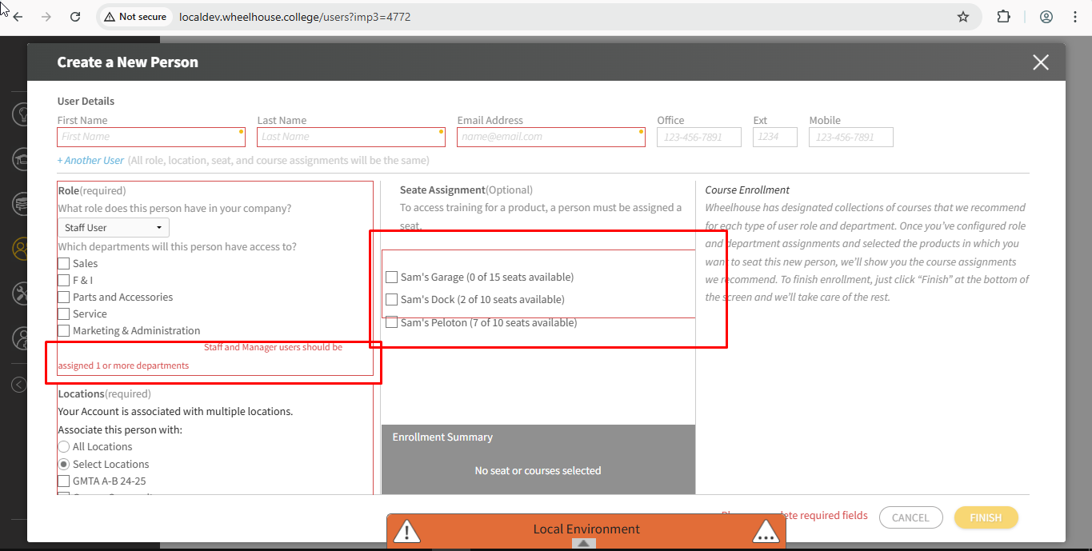
- role section validation is triggered when a staff/manager user does not have a selected department
- role section validation and validation message are displayed per the design spec
- location section validation is triggered no selection is checked for a multi-location account when the “select locations” option is check by no location is checked
- location section validation and validation message are displayed per the design spec
- incomplete email address validation functions per the design spec
- existing email address validation functions per the design spec
- email address validation mask is present when email validation is triggered
- the email input is on top of the validation mask
- in the incomplete email validation message, clicking “Please try again” removes the mask and focuses the email input
- in the incomplete email validation message, keying esc on the keyboard removes the mask and focuses the email input
- in the existing email validation message, clicking “Please use a different email address” removes the mask and focuses the email input
- in the existing email validation message, keying esc on the keyboard removes removes the mask and focuses the email input
Success modal
- the single person success message is accurate and without error
- the multi-person success message is accurate and without error
- the multi-person success modal lists up to 3 people, comma separated and employing the oxford comma
- when more than 3 users are created the multi-person success message is laid out like so: name, name, name, and 3 others=>Not working-Showing 4 People has been enrolled and it is getting discarded automatically
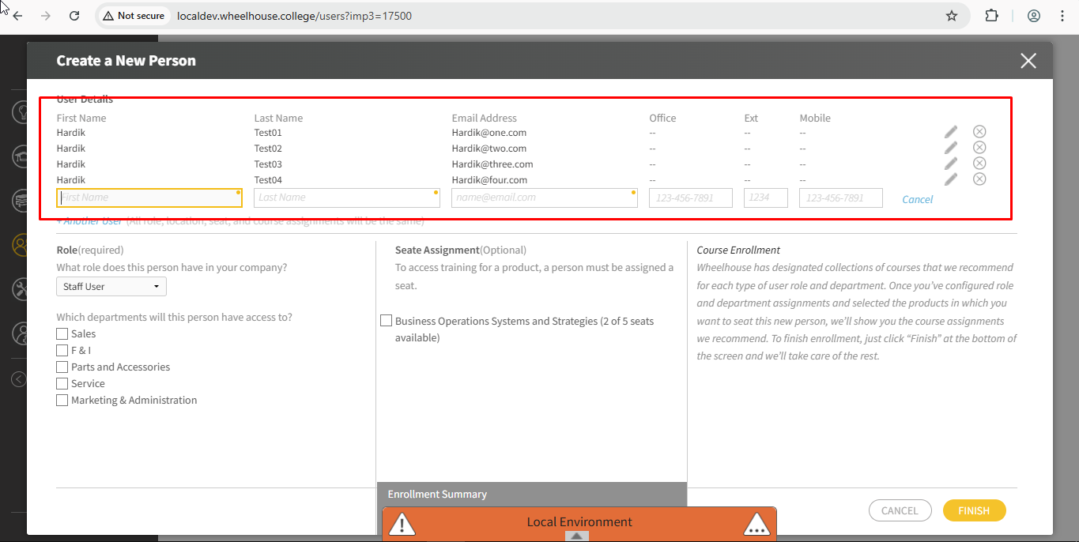
User creation and enrollment
- on completion of the process the new user(s) is created in the system
- on completion of the process the new user(s) is enrolled in all of the selected courses
- on clicking finish, invite emails are sent to the provided email addresses
- on clicking finish, Sendgrid Template “Enrolled in Courses” Template ID: d-d6055ad299f8498498bb74c21639d1a is triggered and displays the courses the user was just enrolled into.
- the signup email directs the user to the correct url@

