**NIYOMWUNGERI Emmanuel 29257**

**Individual assignment**

**1.**

Business Context: "Classic cars" Classic cars-store company

Data Challenge: We need to analyze sales patterns across regions, identify top-performing products, segment customers by value, and track monthly performance trends to optimize inventory and marketing.

Expected Outcome: Data-driven decisions for regional product allocation, customer loyalty programs, and inventory planning.

**2.Success Criteria**

I used 5 goals provided:

1. Top 5 products per region/quarter→ RANK()
2. Running monthly sales total→ SUM() OVER()
3. Month-over-month growth→ LAG() LEAD()
4. Customer quartile→ NTILE(4)
5. 3-month moving averages→ AVG() OVER()
6. **Database Schema**

Let assume that database name =

Create database classic_db;

**Customers table**

CREATE TABLE customers (

customer_id int PRIMARY KEY,

name VARCHAR2(100),

region VARCHAR2(50),

signup_date DATE);

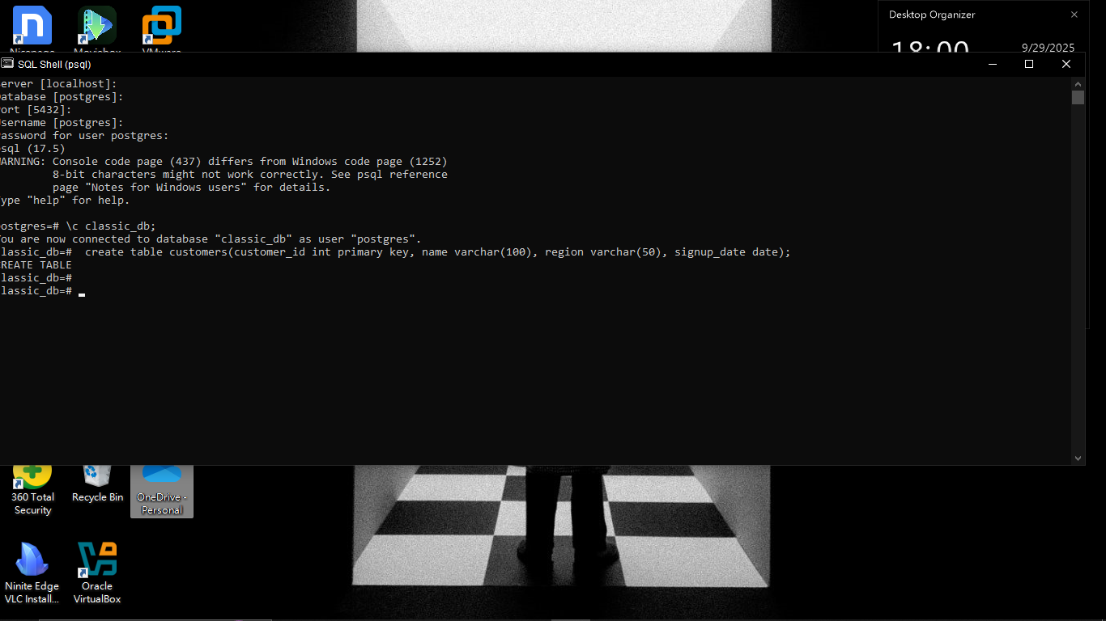

**Products table**

CREATE TABLE products (

product_id int PRIMARY KEY,

name VARCHAR2(100),

category VARCHAR2(50),

price int);

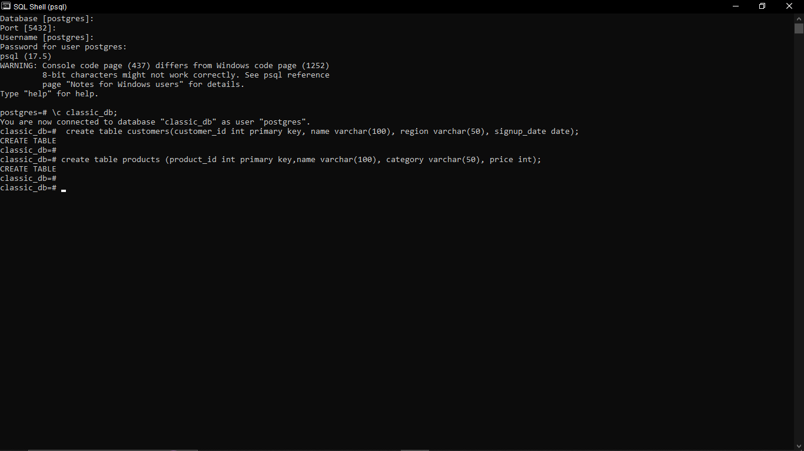

**Transactions table**

CREATE TABLE transactions (

transaction_id int PRIMARY KEY,

customer_id int REFERENCES customers(customer_id),

product_id int REFERENCES products(product_id),

sale_date DATE,

quantity int,

amount int);

