# Real Estate Recommendation Machine Learning Algorithm

The Home Finder Application allows users to input their preferences into the system, fitting and filtering those attributes against all existing listings on the market and their comparable attributes.

The algorithm for determining preferences has been resolved down to two options / implementation methods and may require a hybrid implementation of both.

1. High Dimensional Clustering:

* Using the scikit-learn python package, HDBSCAN can be used to create a weighted graph with axis dimensions representing the quantifiable attributes of a listing that can be matched with preferences after filtering.
* An example simplified to 2 dimensions is as follows.

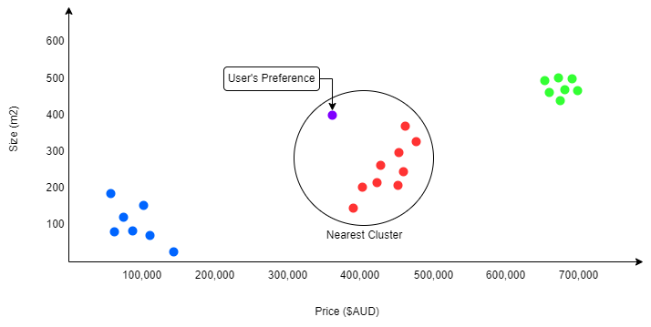

1. Nearest Neighbours:

* By implementing a nearest neighbouring node algorithm in python, we are able to select the listings that most accurately apply to the preferences of the user.
* This may be essential if clustering in the amount of dimensions required to match preferences does not produce accurate results. One way of implementing this is through the aggregation of nearest neighbour searches amongst many different dimensional comparisons, which would reduce complexity in the mathematical modelling of distance in 10+ dimensions.
* An example simplified to 2 dimensions is as follows.

