# Version 1 Mock-up

**Aim: to develop a realistic design of the initial solution in Adobe XD to allow for changes and recommendations of design and functionality to be made**

About the Adobe XD mock-up:

* Includes UI and UX design for the proposed system as well as the first iteration of graphics and logos for the site.
* Contains the functionality proposed by the team including region recommendations and a preferences search section for more specific listings information.
* <https://xd.adobe.com/view/38d792f6-eab1-4ec9-8a08-ddcbf03df6e5-6d84/?fullscreen&hints=off>

Sections:

* Top of Home Screen
  + Menu Bar
    - Settings, help and notifications
    - Search bar
  + Highest recommended suburbs at the top and their changes over time.
  + High level overview section including
    - Affordability
      * Region average property prices over time
      * Mortgage interest rates over time
    - Region Map to have an overview of areas and their proximity
    - Prompt to move to the personalised recommendation section
* Middle of Home Screen
  + Preferences section
    - Many user inputs to define preferences.
    - Randomiser preset to check properties close to but not exactly the same as your preferences.
    - Completely random preferences for insights into the market.
  + Results section
    - List of listings that are recommended to you
    - Region breakdown of what areas suit you
    - Average price across your regions over time.
* Bottom of Home Screen
  + Navigation items
  + The site branding

## Top of Home Screen

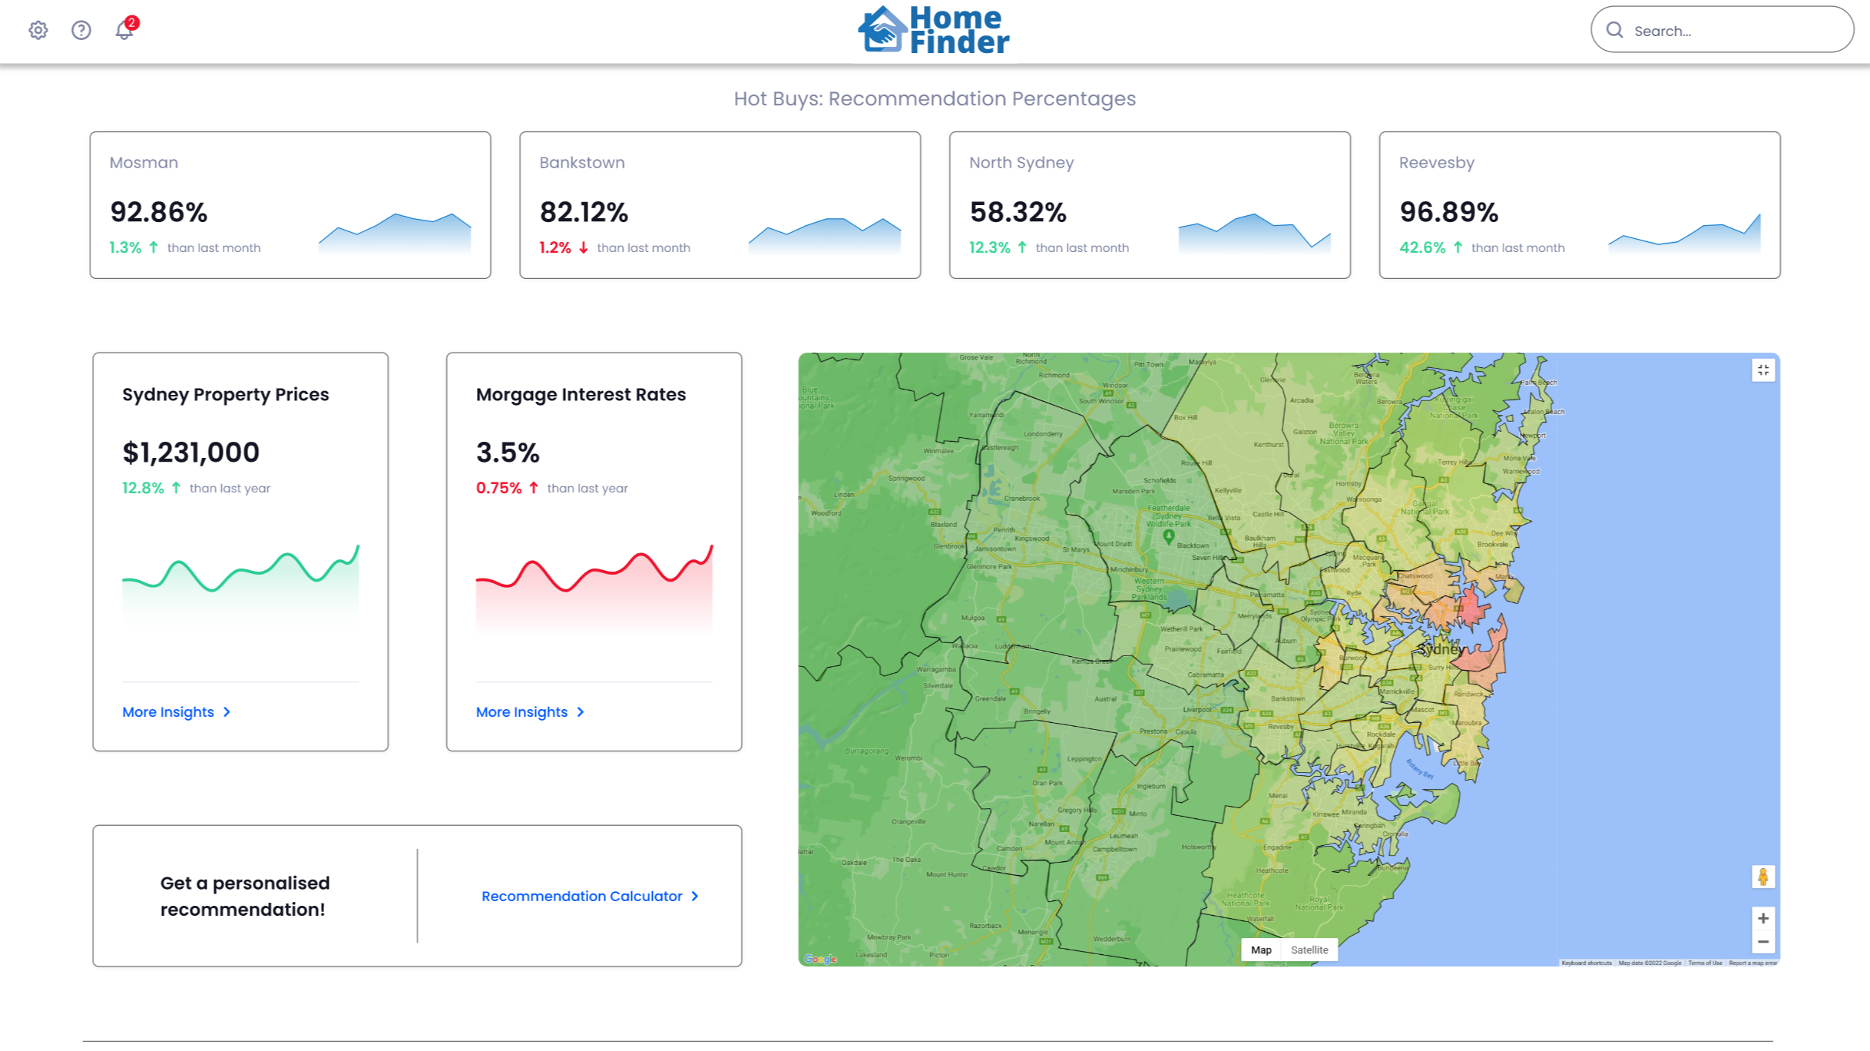

## Middle of Home Screen

## Bottom of Home Screen

