Write Up for Easy 1

!! Warning !!

Here be spoilers, this is your final warning

Note

The intention of these write ups is to provide an insight into the intended strategy for solving the challenge. If you used a differing method to solve the challenge, feel free to message @1cysw0rdk0 or @Simon on slack. Write ups may not be provided or complete for all challenges, and may or may not include scripts used to create or solve the challenge.

Easy 1

The flag for Easy 1 is stored in the image metadata, in a form other than the standard RC3{flag-go-here}.

Step 1:

Inspecting the image using the properties window from windows explorer, or Exiftools on linux shows the metadata for the image. Notice the equals sign after the Copyright and Rights fields, indicating padding on an encoded string.

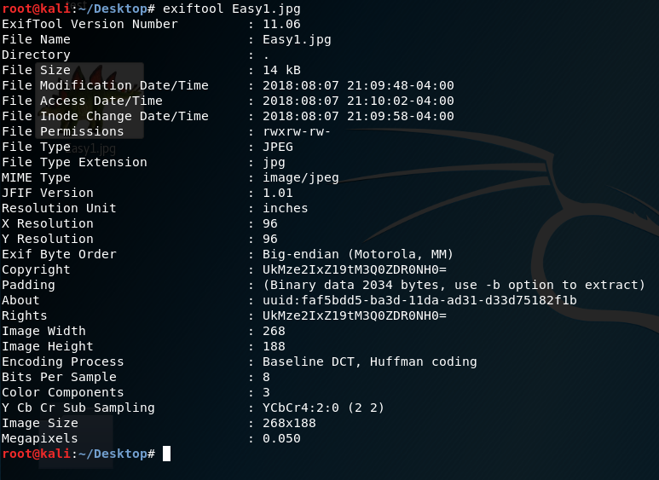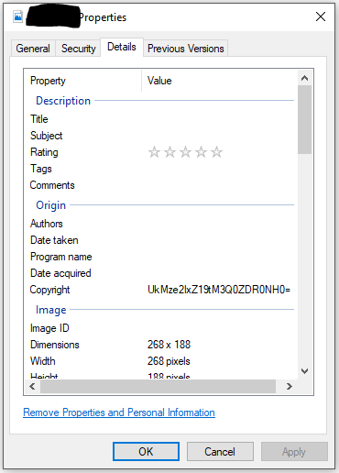

Step 2:

Decoding the string using a base64 decoder yields the flag.

