TRAFFIC SIGN RECOGNITION: A COMPARATIVE ANALYSIS OF MACHINE LEARNING AND DEEP LEARNING MODELS

A Project Report Submitted in Partial Fulfilment of the Requirements for the Course, AIE514 – Advanced Machine Learning

By:
Chahyaandida Ishaya
(253307014)

Programme:
MSc Artificial Intelligence Engineering (With Thesis)

Institution:
Istanbul Okan University

Supervisor:
Prof. Hakan Ocal

Submission Date:
April, 2026

Contents
1. Introduction 4
1.1 Background of the Study 4
1.2 Problem Statement 4
1.3 Aim and Objectives 4
2.1 Dataset Overview 4
2.2 Dataset Characteristics 5
2.3 Data Preprocessing 5
3. Methodology 6
3.1 Data Preparation 6
3.2 Feature Representation 6
3.3 Model Selection 6
4. Experiments 6
4.1 Experimental Setup 6
4.2 Machine Learning Experiments 6
4.3 Deep Learning Experiments 7
5. Results 8
5.1 Performance Evaluation Metrics 8
5.2 Model Performance Comparison 8
5.3 Confusion Matrix Analysis 8
5.4 Training Performance 9
6. Discussion 10
6.1 Comparative Analysis 10
6.2 Key Findings 10
6.3 Implications 10
7. Conclusion 10
7.1 Summary of Findings 10
7.2 Recommendation 11
8. Future Work 11
8.1 Improvements 11
8.2 Extensions 11
REFERENCES 12

TRAFFIC SIGN RECOGNITION: COMPARATIVE ANALYSIS OF MACHINE LEARNING AND DEEP LEARNING MODELS

1. Introduction

1.1 Background of the Study
Traffic sign recognition plays a fundamental role in the development of intelligent transportation systems and autonomous driving technologies. Accurate identification of road signs enhances driver assistance systems, improves road safety, and contributes to efficient traffic management. However, recognizing traffic signs in real-world scenarios is a complex task due to varying environmental conditions such as poor lighting, motion blur, occlusions, and physical damage to signs. These challenges necessitate robust and efficient computational models capable of extracting meaningful features from image data.

1.2 Problem Statement
Despite advancements in machine learning and deep learning, there remains a need to systematically evaluate and compare their effectiveness in traffic sign recognition tasks. Traditional machine learning models rely heavily on manual feature extraction and may fail to capture spatial dependencies in images, while deep learning models automatically learn features but require more computational resources. Therefore, determining the most suitable approach for accurate and efficient classification remains a key challenge.

1.3 Aim and Objectives
The aim of this project is to compare the performance of machine learning and deep learning models for traffic sign recognition. The specific objectives are to implement and evaluate Random Forest and Support Vector Machine models, develop deep learning models including CNN and LSTM, compare their performance using standard evaluation metrics, and identify the most effective model for real-world applications.
2. Dataset Description

2.1 Dataset Overview
The dataset used in this project is the German Traffic Sign Recognition Benchmark (GTSRB), which is widely used for image classification research. It contains over 50,000 images across 43 different traffic sign classes. For this study, a subset of 39,209 images was utilized for training and validation.
Each sample in the dataset includes image attributes such as width, height, region of interest (ROI), and class labels. The images vary in size and quality, making the dataset suitable for evaluating model robustness.

2.2 Dataset Characteristics
The dataset presents several real-world challenges, including variations in lighting conditions, motion blur, occlusions, and differences in scale and orientation. Additionally, the dataset exhibits class imbalance, where some classes have significantly more samples than others, potentially influencing model performance.

2.3 Data Preprocessing
Before training the models, preprocessing steps were applied to standardize the dataset. All images were resized to 32×32 pixels to ensure uniformity across inputs. Pixel values were normalized to a range between 0 and 1 to facilitate efficient model training. The dataset was then split into training and validation sets using an 80:20 ratio, resulting in 31,367 training samples and 7,842 validation samples.
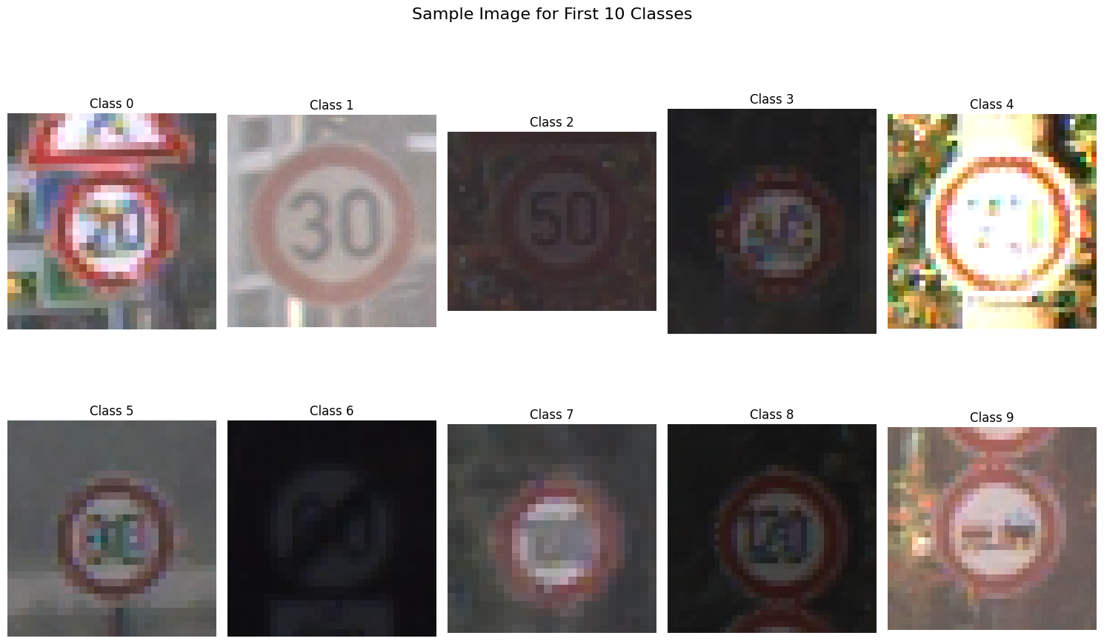
Figure 1: Sample Images from Dataset
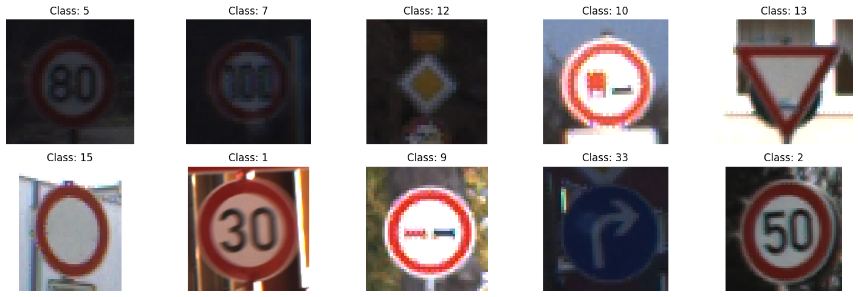
Insert Figure 2: Class Distribution Plot

3. Methodology

3.1 Data Preparation
The preprocessing pipeline involved loading images from file paths, resizing them to a fixed dimension, and normalizing pixel values. For machine learning models, image data was flattened into one-dimensional vectors, while deep learning models retained the original three-dimensional structure of the images.

3.2 Feature Representation
Machine learning models require structured input; therefore, each image was converted into a vector of 3072 features (32 × 32 × 3). In contrast, deep learning models were fed raw image tensors, allowing them to automatically learn spatial features.

3.3 Model Selection
3.3.1 Machine Learning Models
The machine learning models implemented include Random Forest and Linear Support Vector Machine (SVM). Random Forest is an ensemble learning method that improves classification performance by combining multiple decision trees, while SVM is a powerful classifier that seeks to find an optimal hyperplane for separating classes.
3.3.2 Deep Learning Models
The deep learning models implemented include Convolutional Neural Networks (CNN) and Long Short-Term Memory (LSTM) networks. CNNs are specifically designed for image data and can capture spatial hierarchies, while LSTMs are typically used for sequential data but were adapted in this study to process images as sequences.

4. Experiments

4.1 Experimental Setup
All models were trained and evaluated using the same dataset split to ensure fairness. Deep learning models were trained for 15 epochs with a batch size of 64 using the Adam optimizer and sparse categorical cross-entropy loss function.

4.2 Machine Learning Experiments
4.2.1 Random Forest
The Random Forest model was trained using 100 decision trees. It was applied to flattened image vectors and evaluated on the validation dataset.
4.2.2 Support Vector Machine (SVM)
A Linear SVM model was implemented due to its efficiency on large datasets. The model was trained on flattened image data and evaluated similarly.

4.3 Deep Learning Experiments
4.3.1 Convolutional Neural Network (CNN)
The CNN architecture consists of multiple convolutional layers followed by pooling layers and fully connected layers. This structure allows the model to extract spatial features effectively from image data.
4.3.2 Long Short-Term Memory (LSTM)
The LSTM model reshaped each image into a sequence format and processed it using recurrent layers. Although unconventional for image data, this approach was used to compare sequential learning performance.
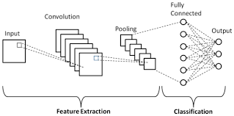
Figure 3: CNN Architecture Diagram
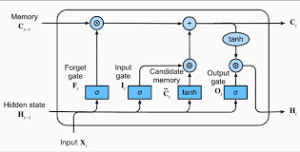
Figure 4: LSTM Architecture Diagram

5. Results

5.1 Performance Evaluation Metrics
Model performance was evaluated using accuracy, precision, recall, and F1-score. Confusion matrices were also used to visualize classification errors.

5.2 Model Performance Comparison
The Random Forest model achieved an accuracy of 98.16%, demonstrating strong performance. The Linear SVM achieved an accuracy of 93.64%, indicating relatively lower performance. The CNN model achieved near-perfect accuracy of approximately 99–100%, while the LSTM model achieved accuracy in the range of 98–99%.
Table 1: Model Performance Comparison
 | Model Type | Model Name | Validation Accuracy
2 | Deep Learning | CNN (Convolutional) | 99.50%
0 | Machine Learning | Random Forest | 98.16%
3 | Deep Learning | LSTM (Recurrent) | 96.74%
1 | Machine Learning | Linear SVM | 93.64%

5.3 Confusion Matrix Analysis
Confusion matrices revealed that the CNN model had minimal misclassifications, while the Random Forest model showed slight confusion among similar classes. The SVM model exhibited more misclassifications, especially in complex categories.
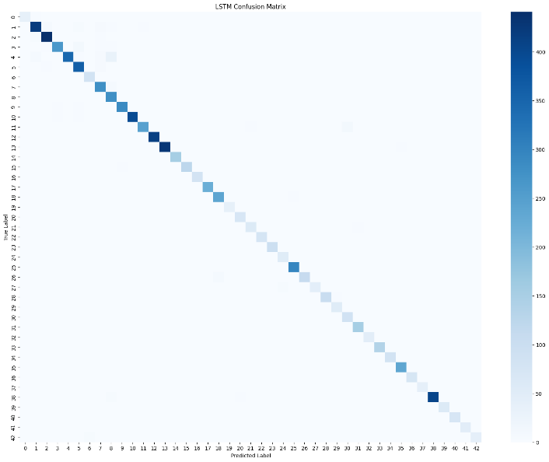
Figure 5: Confusion Matrix for Random Forest
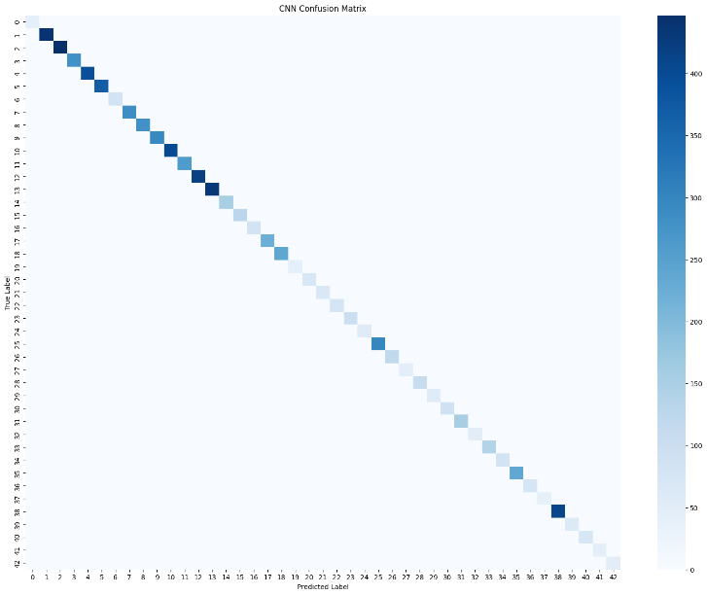
Figure 6: Confusion Matrix for CNN

5.4 Training Performance
Training and validation curves indicate that the CNN model converged quickly with minimal overfitting. The LSTM model showed gradual improvement over epochs but required more time to stabilize.
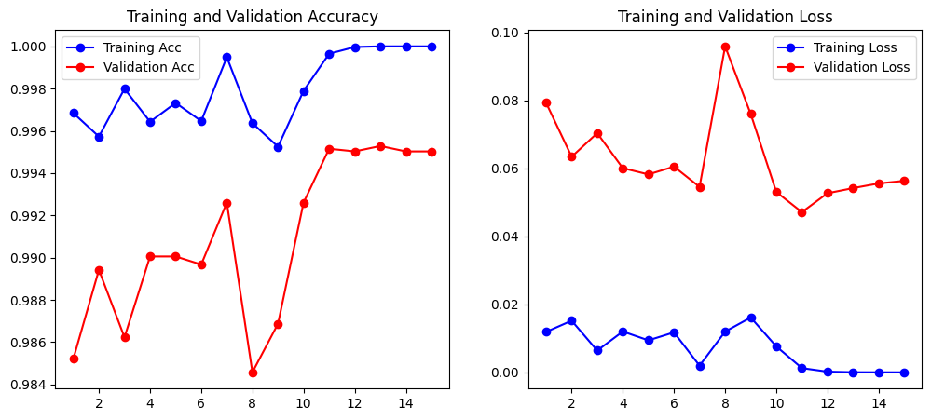
Figure 7: Training and Validation Accuracy Curves
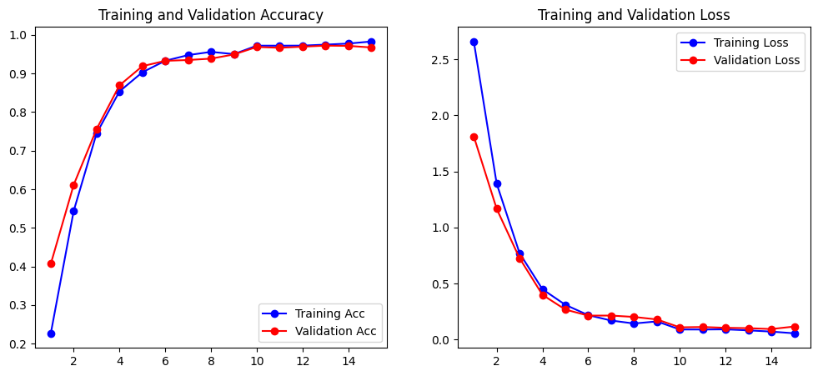
Figure 8: Training and Validation Loss Curves

6. Discussion

6.1 Comparative Analysis
The results demonstrate that deep learning models outperform traditional machine learning models in traffic sign recognition tasks. CNNs, in particular, excel due to their ability to learn spatial hierarchies directly from image data.

6.2 Key Findings
Random Forest performed well despite its limitations, indicating the strength of ensemble methods. However, SVM struggled with high-dimensional image data. The LSTM model, while effective for sequential data, was less suitable for spatial image processing compared to CNN.

6.3 Implications
The findings suggest that the nature of the data should guide model selection. For image-based problems, deep learning models are more appropriate due to their ability to capture complex spatial patterns.

7. Conclusion

7.1 Summary of Findings
This study successfully compared machine learning and deep learning approaches for traffic sign recognition. The CNN model achieved the highest performance, followed by LSTM and Random Forest, while SVM showed the lowest accuracy.

7.2 Recommendation
Based on the results, CNN is recommended for real-world deployment in traffic sign recognition systems due to its superior accuracy and robustness.

8. Future Work

8.1 Improvements
Future work may include applying data augmentation techniques, optimizing hyperparameters, and experimenting with more advanced deep learning architectures such as ResNet and EfficientNet.

8.2 Extensions
Further research can explore real-time deployment, integration into autonomous systems, and hybrid approaches combining machine learning and deep learning methods.

REFERENCES,
J. Stallkamp, M. Schlipsing, J. Salmen, C. Igel, Man vs. computer: Benchmarking machine learning algorithms for traffic sign recognition, Neural Networks, Available online 20 February 2012, ISSN 0893-6080, 10.1016/j.neunet.2012.02.016. (http://www.sciencedirect.com/science/article/pii/S0893608012000457) Keywords: Traffic sign recognition; Machine learning; Convolutional neural networks; Benchmarking

