***Docs 0.2 Server***

**ToBuy**

* 1 bc Disk for 1 tb -- 100e (one bc disk for server) ONE
* 400wat pc cost is approx. 12-15e / Month 150e Year

**Domain name:**

* <https://cart.godaddy.com/go/checkout?isc=cjcfos3#/basket>:
* AnalystCrypto.com 100e 5Y domain

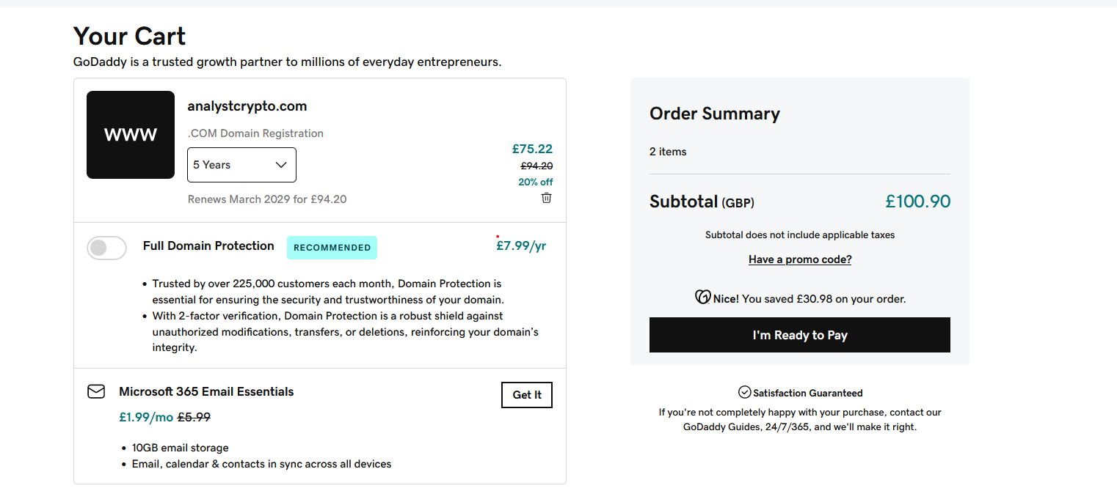

Additional Charge = Energy Consumption (kWh) * Additional Charge per kWh = 29 kWh * €0.013936/kWh ≈ €0.404344

Total Monthly Cost (Winter) = (29 kWh * €0.120236/kWh) + (29 kWh * €0.04964/kWh) = €3.489644 + €1.43956 ≈ €4.9292

**-----#####-----**

[**https://docs.blocknative.com/**](https://docs.blocknative.com/)

**darihilureho@jollyfree.com**

**2*v}V3#6+_jB56Q**

**-----#####-----**

Server Specs: 400 Kwh Power Supply

<https://discourse.ubuntu.com/t/jammy-jellyfish-release-notes/24668>

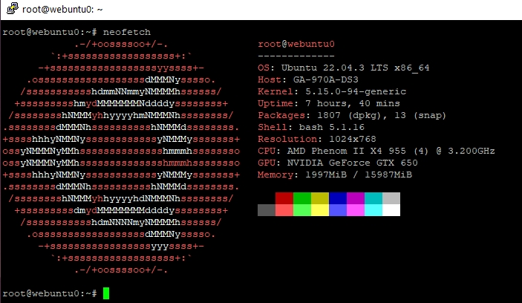

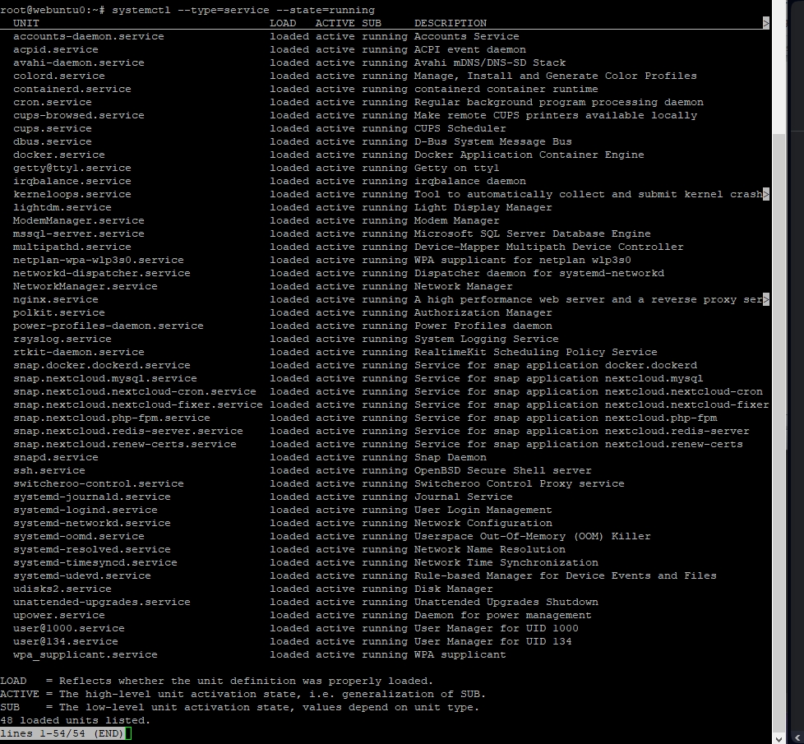

|  |  |  |  |
| --- | --- | --- | --- |
|  |  |  |  |
|  |  |  |  |
|  |  |  |  |
|  |  |  |  |
|  |  |  |  |
|  |  |  |  |
|  |  |  |  |

---------------------- ---------------- ----------------- ------------------------------ **api –get>**

[**https://explorer.blocknative.com/?v=1.36.15&0=ethereum&1=main&s=%7B%22name%22%3A%22Dai%22%2C%22address%22%3A%220x6b175474e89094c44da98b954eedeac495271d0f%22%7D**](https://explorer.blocknative.com/?v=1.36.15&0=ethereum&1=main&s=%7B%22name%22%3A%22Dai%22%2C%22address%22%3A%220x6b175474e89094c44da98b954eedeac495271d0f%22%7D)

[**https://docs.blocknative.com/mempool-tools/webhook-api**](https://docs.blocknative.com/mempool-tools/webhook-api)

[**https://docs.blocknative.com/**](https://docs.blocknative.com/)

[**https://mempool.space/docs/faq#looking-up-transactions**](https://mempool.space/docs/faq#looking-up-transactions)

[**https://explorer.blocknative.com/?v=1.36.15&0=ethereum&1=main&s=%7B%22name%22%3A%22Dai%22%2C%22address%22%3A%220x6b175474e89094c44da98b954eedeac495271d0f%22%7D**](https://explorer.blocknative.com/?v=1.36.15&0=ethereum&1=main&s=%7B%22name%22%3A%22Dai%22%2C%22address%22%3A%220x6b175474e89094c44da98b954eedeac495271d0f%22%7D)

[**https://pulsechain.publicnode.com/?testnet**](https://pulsechain.publicnode.com/?testnet)

[**https://ethereum-testnet.publicnode.com/**](https://ethereum-testnet.publicnode.com/)

[**https://etherscan.io/tx/0x3482869613a2b0f1a518914251a24423e3aad2df97346d926a29976bcc3af815**](https://etherscan.io/tx/0x3482869613a2b0f1a518914251a24423e3aad2df97346d926a29976bcc3af815)

**Error: Transaction or receipt is null for hash: 0xd7687e34f52f69a9761f20dbb000ef1cc0a3b47586d1c696465fec63153e7bf3**

**| 0x51160948331d7012e9c565d6c3a3c23929a53b9c5dbe07cd75b7dbc8615d01c5 | 0xd24400ae8bfebb | 0x5f65f7b6096784 | 0 | 0.000000100 | 398636 | 434990 | Pending |**

**Error: Transaction or receipt is null for hash: 0x582f201857d6a37f6bbb5410167155f047475a02cee0b903718a150640dd3ecd**

**| 0xf4656ac19a6794138941286da4056afd1970e0e72af9b9ed303f2f6f95d98903 | 0x1ab4973a48dc89 | 0x572e8913530f2a | 0.216781 | 0.000000104 | 100000 | 180614 | Pending |**

**Error: Transaction or receipt is null for hash: 0x5e248e7e4abd731462c5fb6b8dbd01a0b40b2e2c8de9088e5a298523be9d7455**

<https://docs.alchemy.com/reference/alchemy-pendingtransactions>

<https://docs.infura.io/tutorials/ethereum/subscribe-to-pending-transactions>

<https://docs.alchemy.com/reference/alchemy-pendingtransactions>

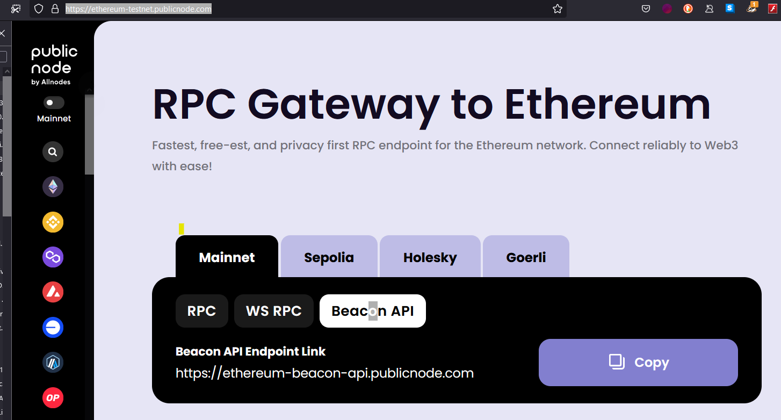

<https://ethereum-testnet.publicnode.com/>

The URL wss://ethereum-rpc.publicnode.com appears to be a WebSocket Secure (WSS) endpoint for connecting to an Ethereum node. WebSocket is a communication protocol that provides full-duplex communication channels over a single TCP connection. It's commonly used in real-time web applications for its efficiency and low-latency communication capabilities. In the context of Ethereum, this URL likely represents a publicly accessible Ethereum node that provides WebSocket support. Ethereum nodes are computers running software that participates in the Ethereum network, maintaining a copy of the blockchain and facilitating transactions and smart contract executions. Using this URL with a library like Nethereum.Web3 in C# allows you to connect to this Ethereum node over a secure WebSocket connection and interact with the Ethereum network, such as querying blockchain data, sending transactions, and executing smart contracts.

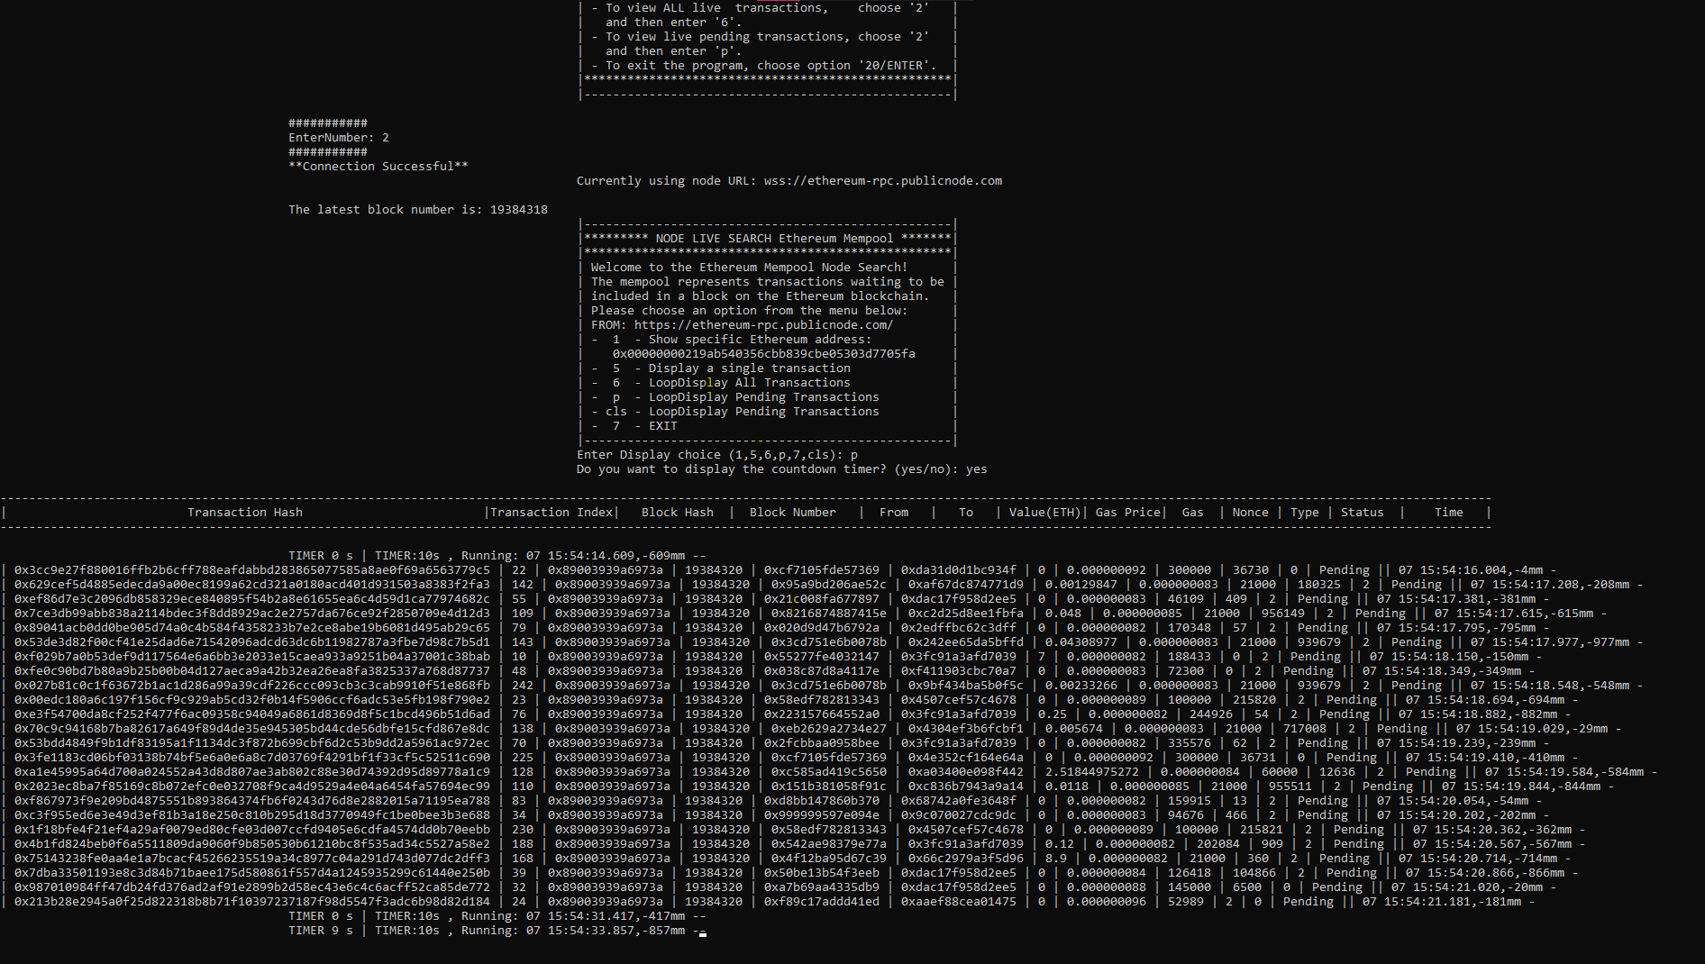

**GH Repo**

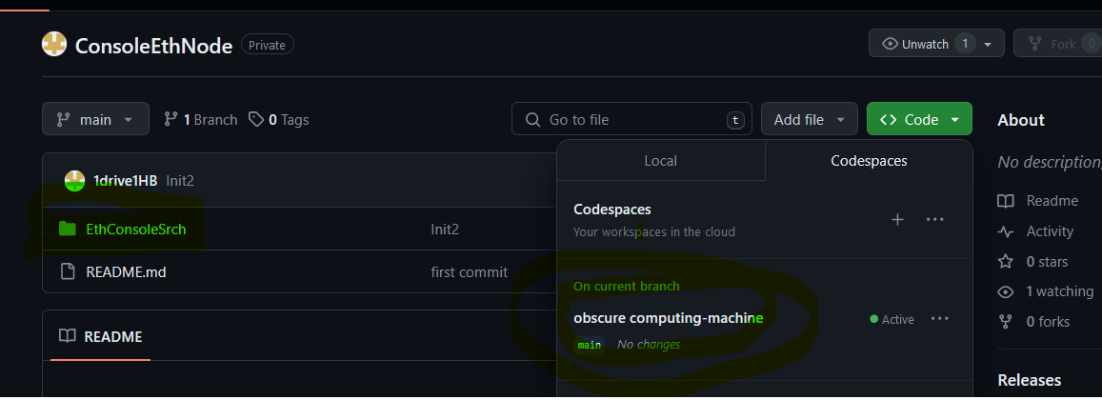

[**https://github.com/1drive1HB/ConsoleEthNode/tree/main**](https://github.com/1drive1HB/ConsoleEthNode/tree/main)

**NewTerminal -> Commnads Into Terminal:**

**sudo apt update**

**sudo apt install -y dotnet-sdk-6.0**

**sudo apt update**

**sudo apt install -y aspnetcore-runtime-6.0**

**dotnet --list-sdks**

**dotnet --list-runtimes**

dotnet --list-sdks: List installed .NET SDKs. ||dotnet --list-runtimes: List installed .NET runtimes.

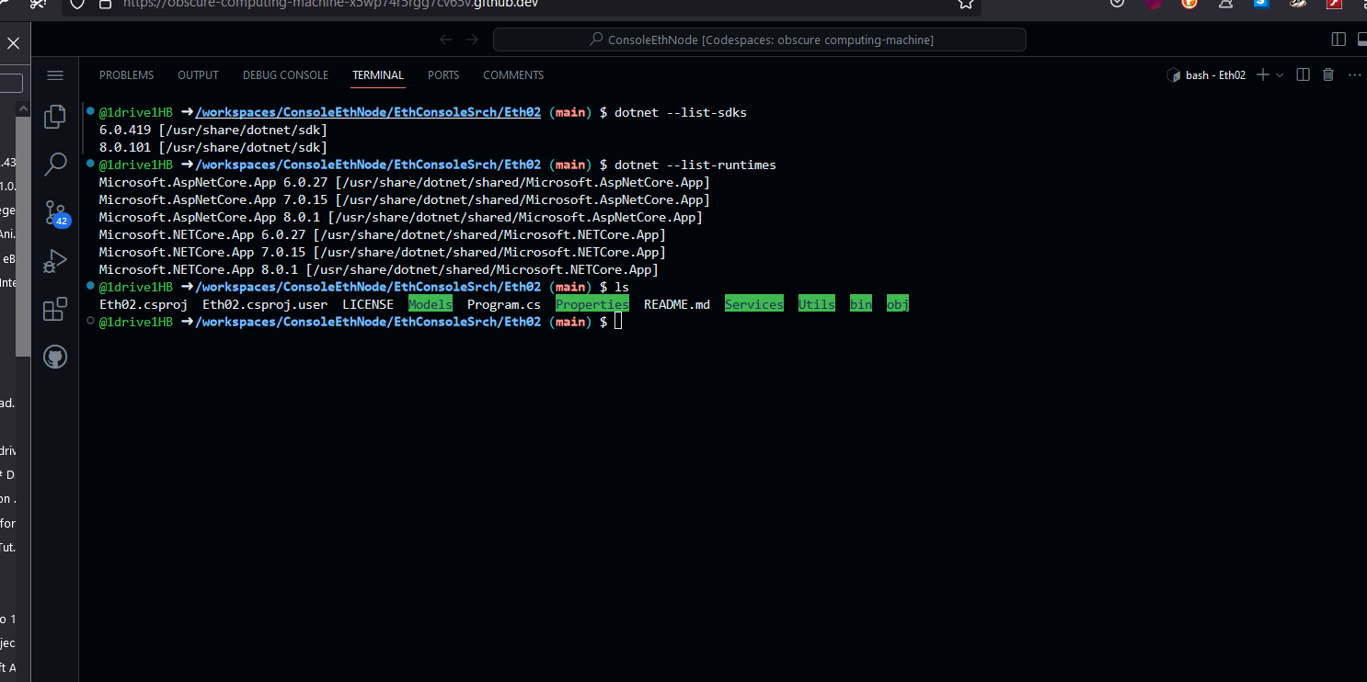

**Execute program For Pending**

**Cd Into Dir**

* **clear**
* **cd** workspaces/ConsoleEthNode/EthConsoleSrch/Eth02 (main) $
* **dotnet build**
* **dotnet run**

**Commands:**

**‘2’ – for** wss://ethereum-rpc.publicnode.com

**‘cls’** – for Clear Console

**‘p’** – for LoopDisplay Pending Transactionsyes

Yes and No options

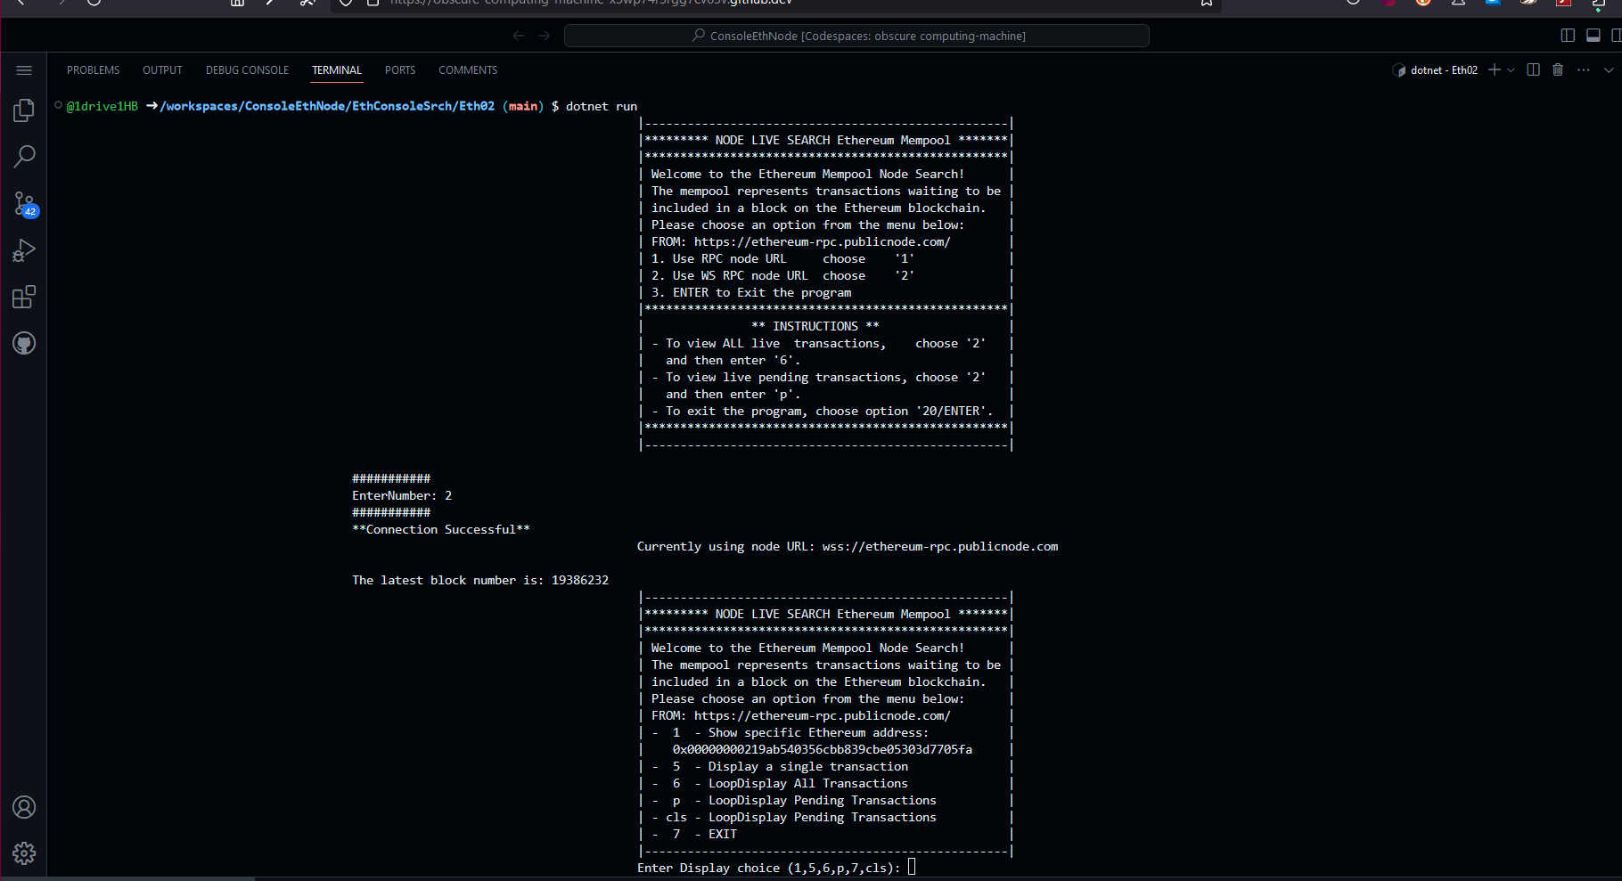

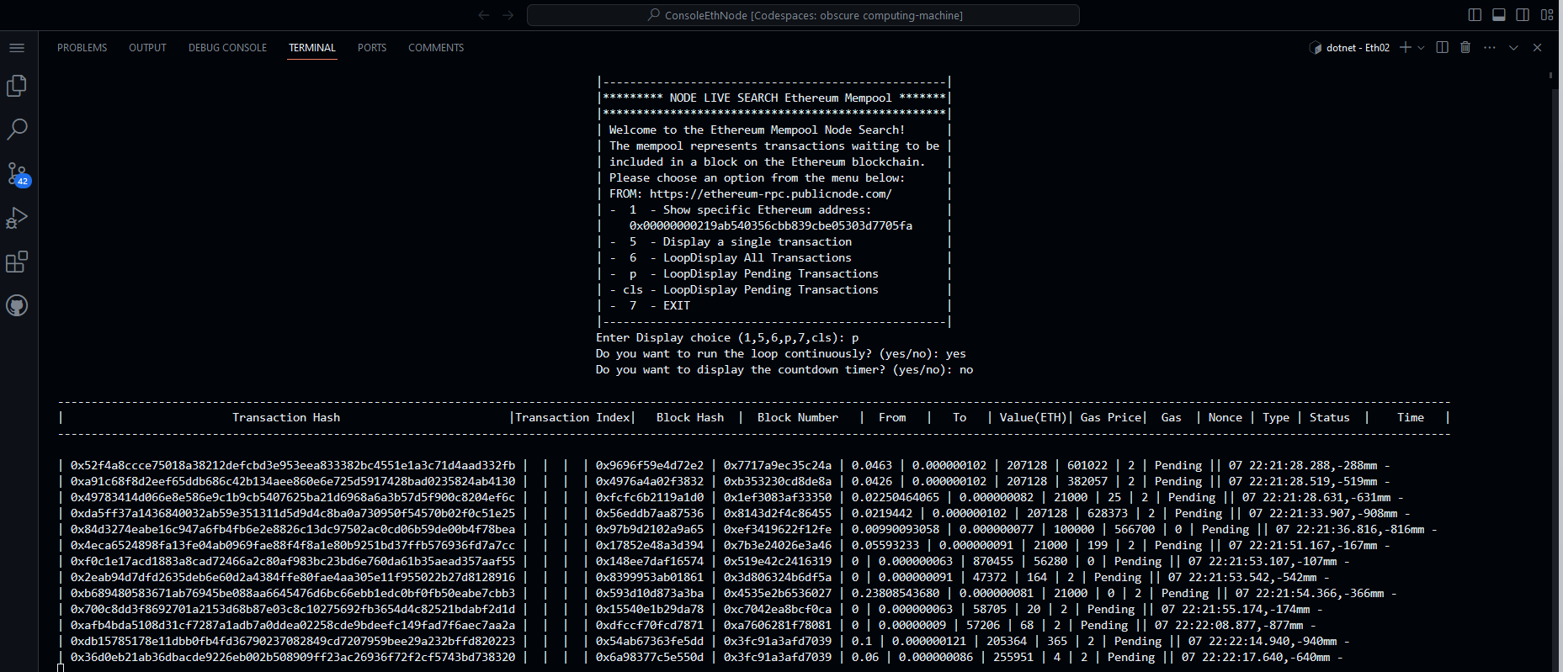

* **to do , Run Inside DOkcer Container for liisening in 8080:80 , or 8081:443 ,**
* **version: v1.1**