RapidMiner1_Spirit
總流程 :
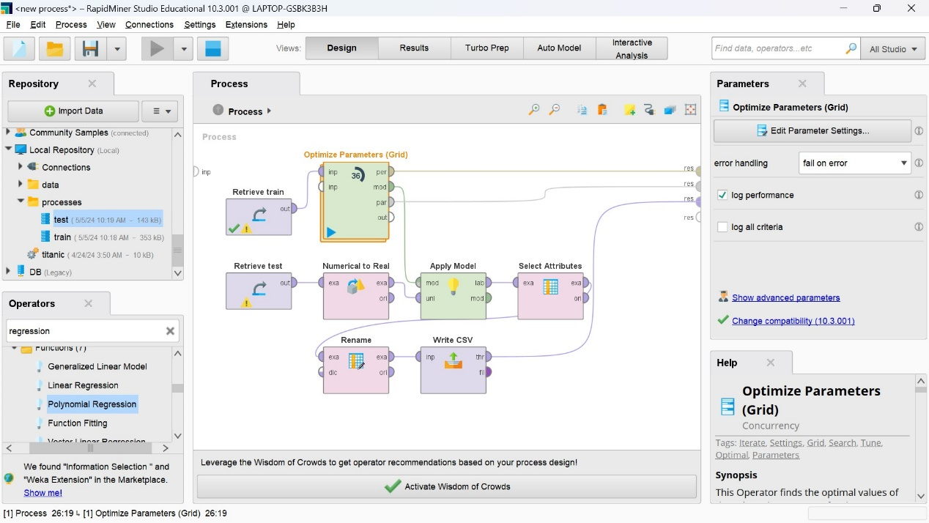

Cross Validation架構(alpha值取0.01):
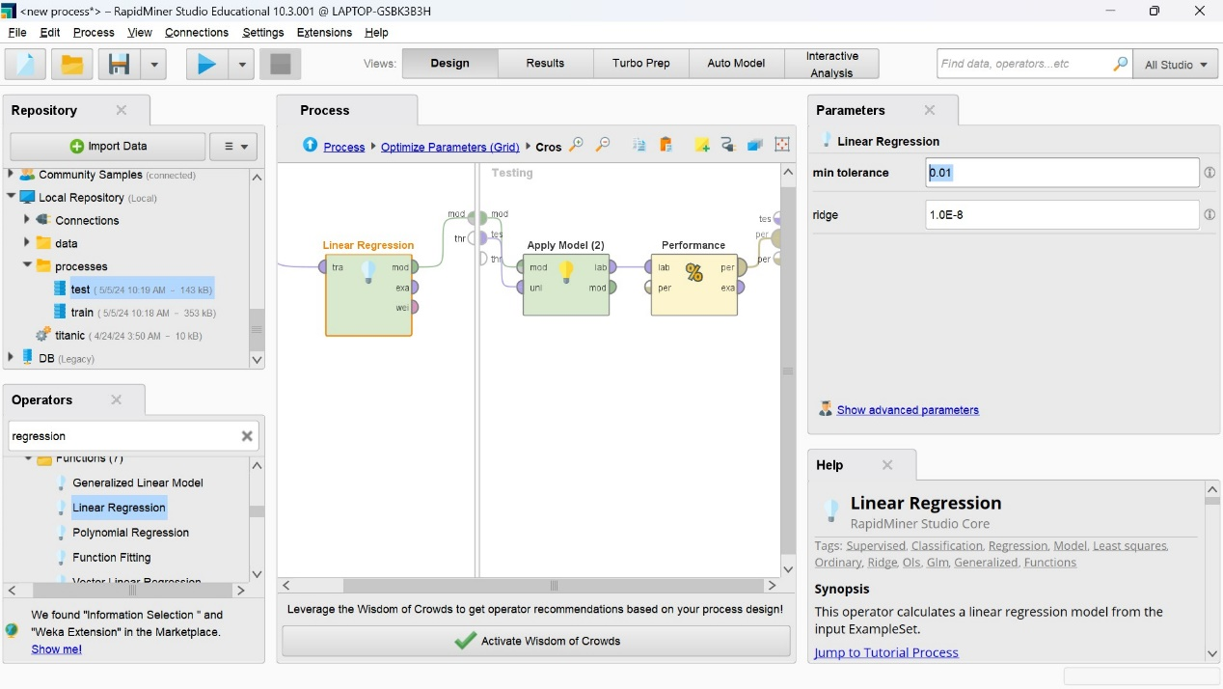

Optimize Parameters(Grid):
