## Exercise SQL03-EX-01:

SQL Komut1.1:

ALTER TABLE employees

ADD MAX_SALARY DECIMAL(10, 2);

SQL Çıktı:

SQL Komut1.2:

UPDATE employees

SET MAX_SALARY = (SELECT MAX(SALARY)

FROM employees

);

SQL Çıktı:

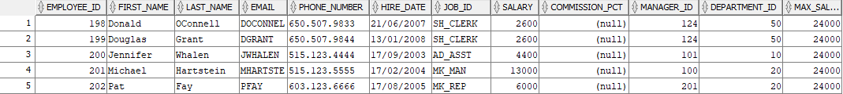

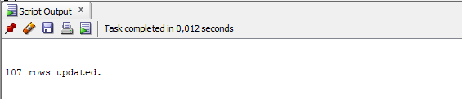

SQL Komut1.3:

DELETE FROM employees

WHERE salary = (

SELECT MIN(salary)

FROM employees

);

SQL Çıktı:

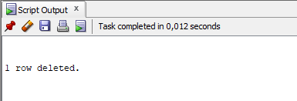

## Exercise SQL03-EX-02:

SQL Komut2.1:

CREATE INDEX DPR_NAME_IDX

ON DEPARTMENTS (DEPARTMENT_NAME);

SQL Çıktı:

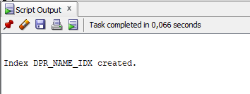

SQL Komut2.2:

ALTER TABLE employees

ADD CONSTRAINT CNSTR_SALARY CHECK (salary >= 1000 AND salary <= 100000);

SQL Çıktı:

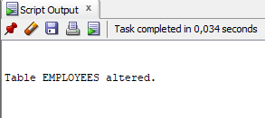 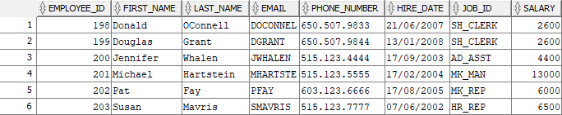

SQL Komut2.3:

DROP INDEX DPR_NAME_IDX;

SQL Çıktı:

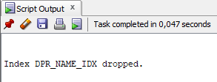

SQL Komut2.4:

ENABLE: ALTER TABLE employees ENABLE CONSTRAINT CNSTR_SALARY;

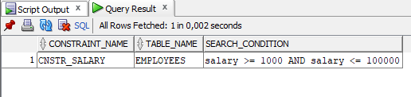

DISABLE: ALTER TABLE employees DISABLE CONSTRAINT CNSTR_SALARY;

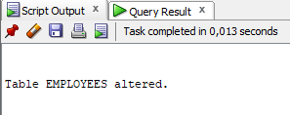

DROP: ALTER TABLE employees DROP CONSTRAINT CNSTR_SALARY;

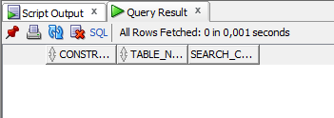

## Exercise SQL03-EX-03:

SQL Komut3.1:

CREATE TABLE NEW_DEPARTMENTS AS

SELECT DISTINCT e.department_id, d.department_name

FROM EMPLOYEES e

INNER JOIN DEPARTMENTS d ON e.department_id = d.department_id;

SQL Çıktı:

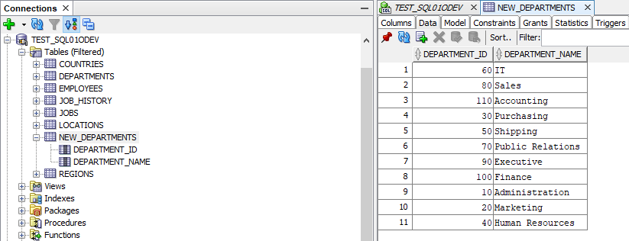

SQL Komut3.2:

MERGE INTO NEW_DEPARTMENTS dd

USING DEPARTMENTS d

ON (dd.department_id = d.department_id)

WHEN MATCHED THEN

UPDATE SET dd.department_name = d.department_name

WHEN NOT MATCHED THEN

INSERT (department_id, department_name)

VALUES (d.department_id, d.department_name);

SQL Çıktı:

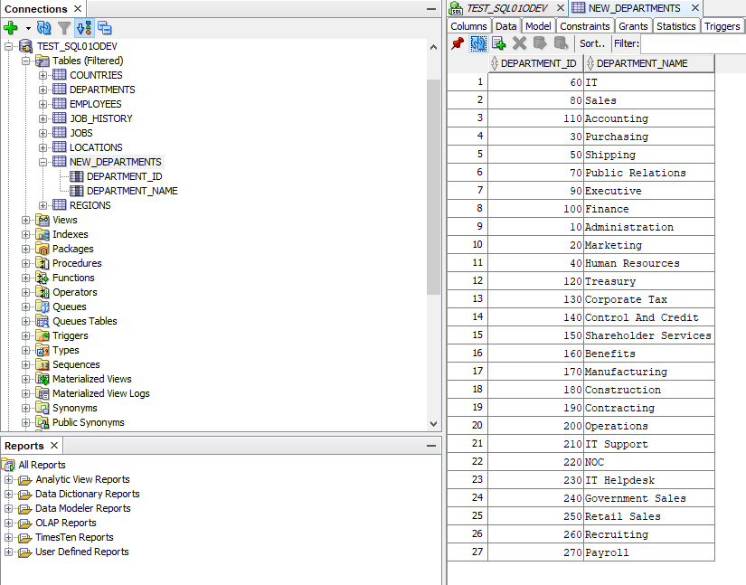

## Exercise SQL03-EX-04:

SQL Komut:

with employees_with_s AS (

SELECT first_name, last_name, job_id, department_id, salary

FROM employees

WHERE job_id LIKE 'S%'

) SELECT

e.first_name,

e.last_name,

e.job_id,

j.job_title,

d.department_name,

e.first_name || ' ' || e.last_name AS full_name,

e.salary

FROM employees_with_s e

JOIN jobs j ON e.job_id = j.job_id

JOIN

departments d ON e.department_id = d.department_id;

SQL Çıktı:

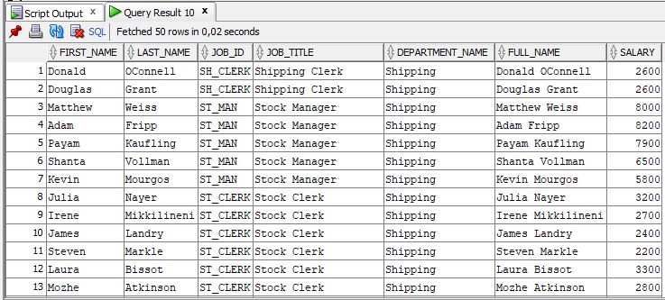

## Exercise SQL03-EX-05:

/*-

COMMIT; This is the command that notifies Oracle that an operation has ended and requests that the changes you have made be made permanent.

ROLEBACK; ROLLBACK (Geri Dönüş): If one of the operations such as Insert, Update, Delete fails in the database, the entire process is rolled back with the ROLLBACK command.

-*/