- background
As ICS business scenarios increase, ICS's disk space requirements are getting higher and higher. Even large servers face the problem of full disk space. This article analyzes the use of ICS disk space and provides disk expansion methods based on this, for reference by services and customers, as well as for research and development.
- ICS disk usage instructions
- ICS services that use more disks mainly include the following:
  - Non-contact interrogation warning face image and scene image, storage directory: /home/ics/file
  - Intelligent disposal evidence files, storage directory: /home/ics/evidence_store
  - MMS attachments, storage directory: /home/ics/im
  - Audio and video playback files, storage directory: /home/ics/mrs , can be deleted directly
- Check disk usage
  - Command View
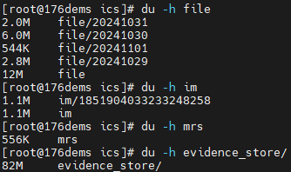
  - ICS background management disk monitoring interface
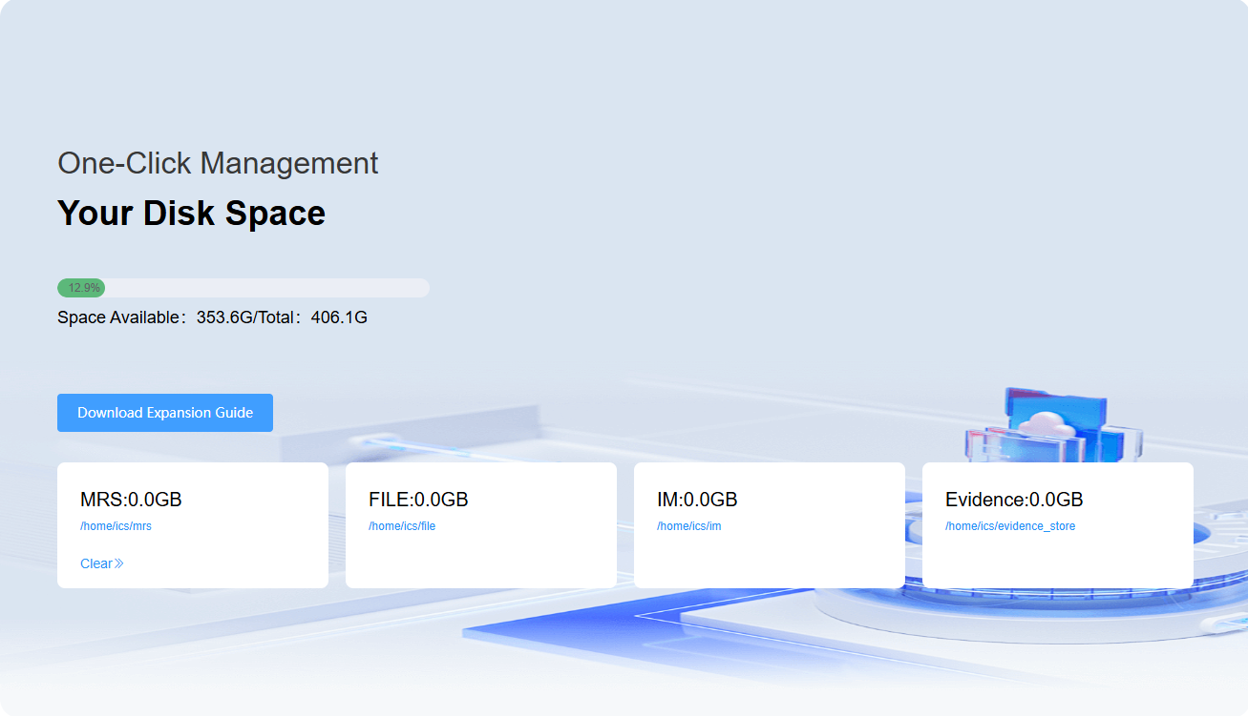
- Disk expansion
- Expansion method
By using NFS, the Network File System (NFS) distributed file system protocol, you can remotely mount directories of different network file servers to the local computer to achieve capacity expansion.
- Planning Directory
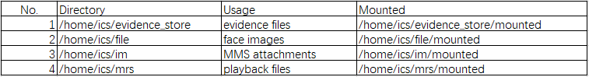
- Implementation of expansion
- Network file server (nfs server, Euler system comes with nfs, just start the corresponding service)
  - Create a shared directory mkdir -p /path/to/shared_directory
  - Change the shared directory permissions chmod -R 755 /path/to/shared_directory
  - Start NFS services (rpcbind and nfs)
  - Edit the nfs configuration file /etc/exports and add a new line
/path/to/shared_directory client_ip_or_netmask(rw,sync,no_root_squash,no_subtree_check)
  - Apply configuration exportfs -a
  - Example
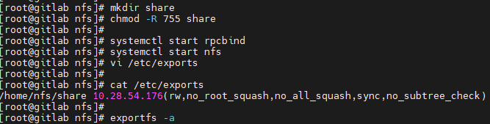
- ICS server (nfs client, Euler system comes with nfs client tool, just start the corresponding service)
- Create a mapping directory mkdir path_to_mounted_directory
- Start the service (remote-fs.target) and set it to start automatically at boot
- mount -t nfs nfs_server_ip:path_to_shared_directory path_to_mounted_directory
- Test whether the mount is successful
Client:
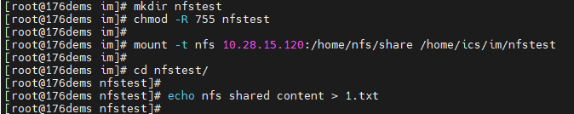
Server:
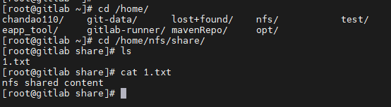
- Modify the ICS microservice configuration file
1) Upload the file clangcmd -persist-new.yaml to the server / opt/ics/yaml directory.
Use the kubectl apply -f cloudcmd-persist-new.yaml command to create pvc and pv.
2 ) Configure the relationship between the microservice and the new pvc and pv.
kubectl edit deployment -n ics cloudcmd-iap-server
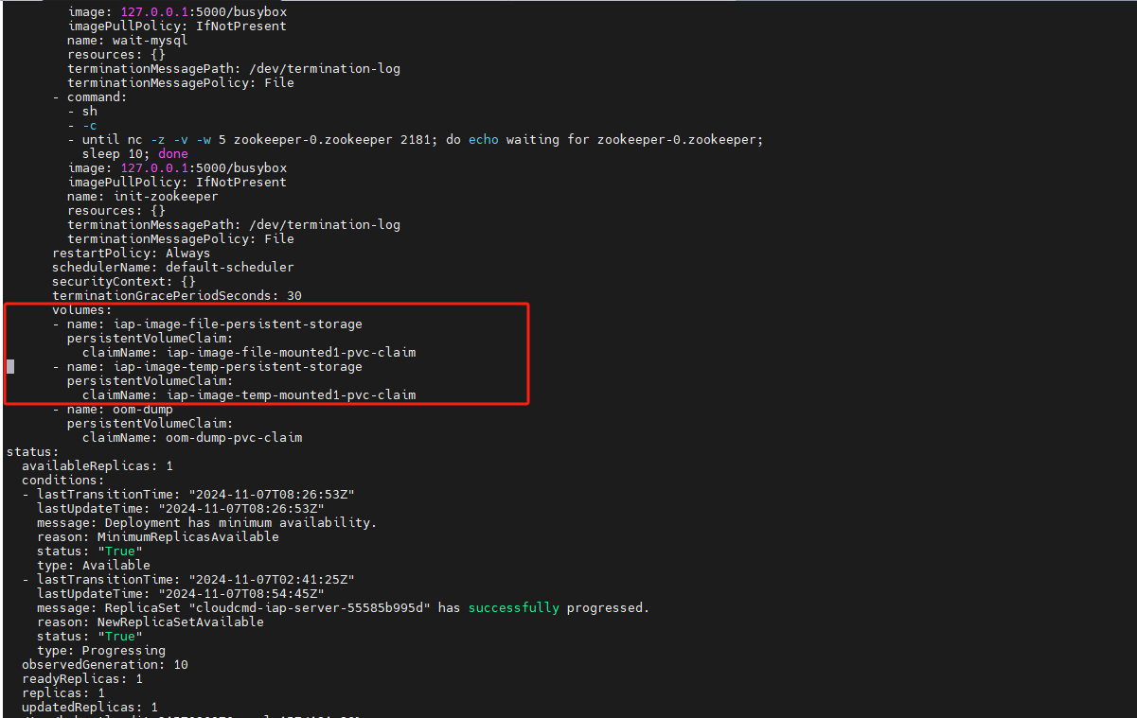
kubectl edit deployment -n ics cloudcmd-iap-recorder-gateway
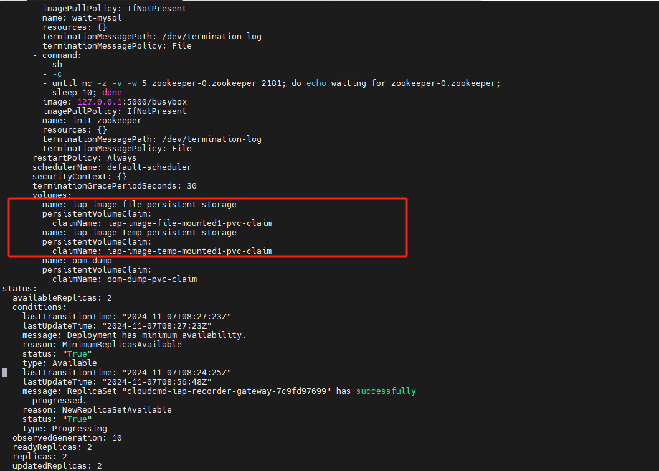
kubectl edit deployment -n ics cloudcmd-evidence-service
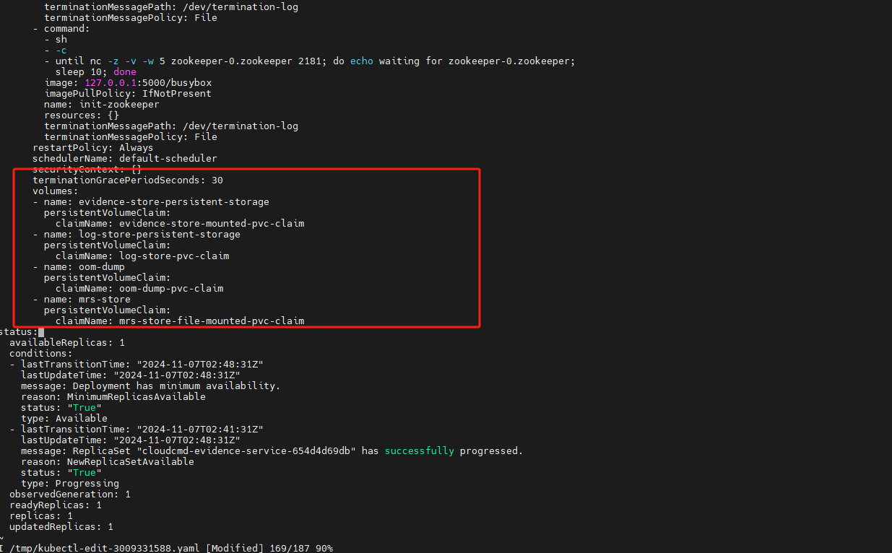
kubectl edit deployment -n ics cloudcmd-im-record-service
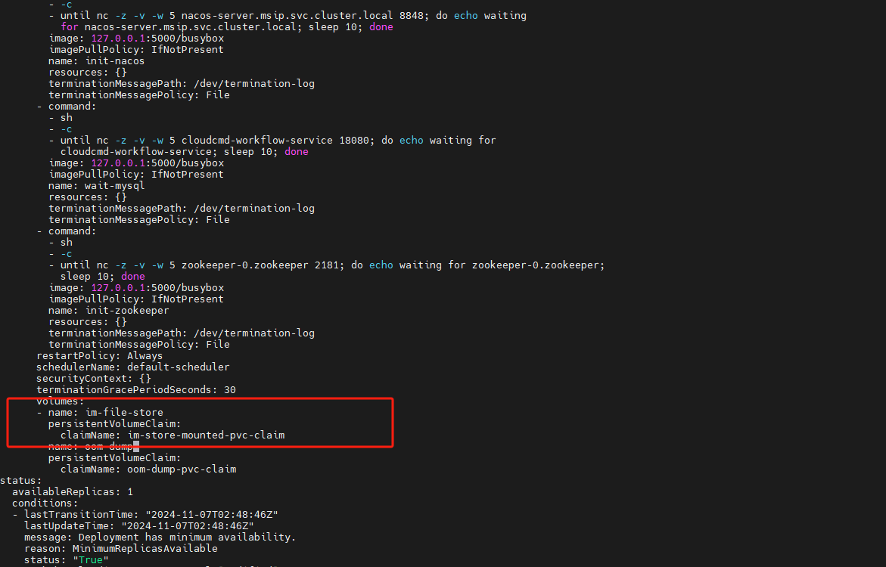
If you need to configure crossnet-bus for cross-network,
run kubectl edit deployment -n ics cloudcmd-crossnet-bus
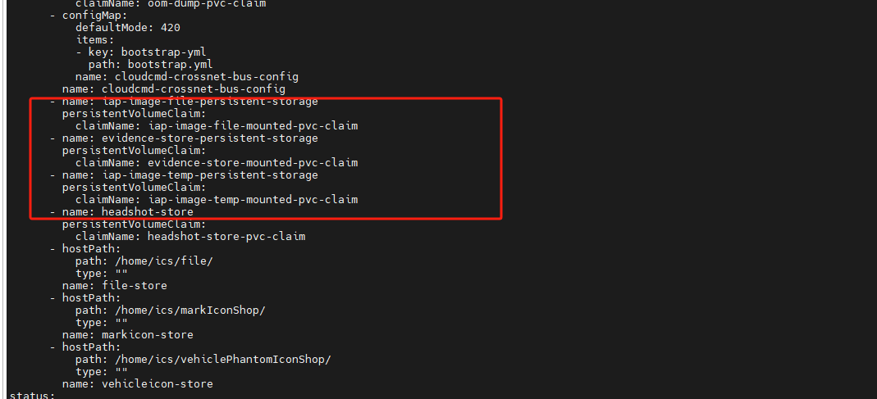
（3）Handling old alarm data
Example: Migration of alarm images to a new expanded directory
cd /home/ics/file
ls
mv /home/ics/file/20241211 /home/ics/file/mounted
mv /home/ics/file/20241212 /home/ics/file/mounted
mv /home/ics/file/20241213 /home/ics/file/mounted
(4) Move old evidence, audio and video recordings, etc. to the new expanded directory using the alarm data migration method

