# VISVESVARAYA TECHNOLOGICAL UNIVERSITY

# Jnana Sangama, Belgavi-590018

**“A MINI PROJECT REPORT”**

**(Subject Code:21CSL66)**

**ON**

**“****Bombing at Hiroshima & Nagasaki”**

Submitted in partial fulfillment for the requirements for the Award of Degree of

**BACHELOR OF ENGINEERING**

**IN**

**COMPUTER SCIENCE AND ENGINEERING**

**BY**

PRITISH ALI 1EP21CS076

RUPAM BHATTACHARYYA 1EP21CS089

SWATI S 1EP21CS109

SUSHMITA S 1EP21CS108

UNDER THE GUIDANCE OF

Mrs. Neha Harde

Assistant Professor

DEPT. Of CSE, EPCET



**2023-2024**



# CERTIFICATE

This is to certify that the **Project Work** entitled **“****Bombing at Hiroshima & Nagasaki”** is a bonafied work carried out by **PRITISH ALI [1EP21CS076], RUPAM BHATTACHARYYA [1EP21CS089], SWATI S [1EP21CS109]**, and **SUSHMITA S [1EP21CS108],** in partial fulfillment for the award of **Bachelor of Engineering in Computer Science and Engineering** under **Visvesvaraya Technological University, Belgaum** during the year **2023-2024**. It is certified that corrections*/*suggestions indicated for Internal Assessment have been incorporated in the report deposited in the departmental library*.* The mini project report has been approved as it satisfies the academic requirements in respect of Project work prescribed for the said Degree*.*





|  |  |  |
| --- | --- | --- |
| **(Signature of the Guide)**  **Mrs. Neha Harde**  **Asst. Prof., Dept. of CSE,**  **EPCET, Bengaluru** | **(Signature of the HOD)**  **Dr. I. Manimozhi**  **HOD, Dept. of CSE,**  **EPCET, Bengaluru** | **(Signature of the Principal)**  **Dr. Mrityunjaya V Latte**  **Professor & Principal**  **EPCET, Bengaluru** |
| **External Viva-Voce:**  **Name of the Examiners** | | **Signature with date** |
|  | | ………………………………………… |
|  | | …………………………………………… |

**ACKNOWLEDGEMENT**

Any achievement, be it scholastic or otherwise does not depend solely on the individual efforts but on the guidance, encouragement and cooperation of intellectuals, elders and friends. We would like to take this opportunity to thank them all.

First and fore most we would like to express our sincere regards and thanks to **Mr. Promod Gowda** and **Mr. Rajiv Gowda,** CEOs East Point Group of Institutions, Bangalore, for providing necessary infrastructure and creating good environment.

We express our gratitude to **Dr. Mrityunjaye V Latte,** Principal, EPCET who has always been a great source of inspiration.

We express our sincere regards and thanks to **Dr. Manimozi Iyer,** Professor and Head, Department of Computer Science and Engineering, EPCET, Bangalore, for his encouragement and support.

We are grateful to acknowledge the guidance and encouragement given to us by **Mrs. Neha Harde**, Assistant Professors, Department of Computer Science and Engineering, EPCET, Bangalore, who has rendered a valuable assistance.

We also extend our thanks to all the faculties of the **Department of** **Computer Science and Engineering, EPCET**, Bangalore, who have encouraged us throughout the course of the Mini Project Work.

Last, but not the least, we would like to thank our family and friends for their inputs to improve the Mimi Project works.

**Name: PRITISH ALI USN: 1EP21CS076**

**Name: RUPAM BHATTACHARYYA USN: 1EP21CS089**

**Name: SWATI S USN: 1EP21CS109**

**Name: SUSHMITA S USN: 1EP21CS108**

**Abstract**

This project delves into the historical events surrounding the bombings of Hiroshima and Nagasaki during World War II. The primary aim is to provide a comprehensive and interactive simulation of these pivotal moments in history. By utilizing advanced computer graphics techniques, the project creates an immersive and educational experience that vividly portrays the catastrophic impact of the atomic bombings.

The simulation is developed using C programming language with OpenGL for rendering the graphics. The project includes detailed models of the planes and bombs, along with realistic animations depicting the bombings and subsequent explosions. Additional elements, such as the depiction of candle lights representing memorials, are incorporated to enhance the emotional and educational aspects of the simulation.

The purpose of this project is to offer a visual and interactive tool for understanding the devastating effects of nuclear warfare. It aims to educate viewers about the historical significance and the humanitarian consequences of the bombings. By providing a detailed and realistic representation of these events, the project seeks to promote awareness and foster a deeper understanding of this critical chapter in history.

Overall, this project combines historical research with advanced graphical simulations to create a powerful educational resource that highlights the importance of peace and the catastrophic consequences of war.

**CONTENTS**

**Chapter no. Description age no.**

1. **Introduction 1**
   1. Introduction to Historical Background 1
   2. Introduction to Simulation and Graphics 1
2. **Requirement Specification 2**
   1. Software Requirements 2
   2. Hardware Requirements 2
3. **Objective of The Project 3**
4. **Implementation 4**
   1. Simulation Design 4
   2. Animation and Graphics Rendering 5
   3. Detailed Plane and Bomb Models 6
   4. Bomb Drop and Explosion Animation 6
   5. Lighting and Effects 8
   6. User Interaction and Controls 9
5. **Result 10**
   1. Snapshots & Description 10

**Conclusion 12**

**References 14**

|  |  |  |
| --- | --- | --- |
| **List of Figures** | | |
| **Fig. no.** | **Description** | **Page no.** |
| 5.1.1 | Airplane Flying | 10 |
| 5.1.2 | Hiroshima city | 10 |
| 5.1.3 | Airplane dropping the bomb | 11 |
| 5.1.4 | Description about the bomb | 11 |

# Chapter 1

# INTRODUCTION

* 1. **Introduction to Historical Background**

The atomic bombings of Hiroshima and Nagasaki in August 1945 remain among the most significant and tragic events in modern history. These bombings were the first and only instances of nuclear weapons being used in warfare, resulting in unprecedented destruction and loss of life. The city of Hiroshima was bombed on August 6, 1945, followed by Nagasaki on August 9, 1945. The immediate impact of the bombings led to the deaths of over 100,000 people, with many more suffering from injuries and long-term radiation effects. These events played a crucial role in bringing World War II to an end, but they also sparked global debates about the ethics and necessity of nuclear warfare. This project aims to recreate the bombings of Hiroshima and Nagasaki through a detailed and interactive simulation, allowing users to gain a deeper understanding of the events and their consequences.

**1.2 Introduction to Simulation & Graphics Technology**

To effectively convey the gravity of the Hiroshima and Nagasaki bombings, the project leverages modern simulation and graphics technologies. The simulation is built using the C programming language, known for its efficiency and control over system resources, making it ideal for developing performance-critical applications like simulations. OpenGL, a cross-platform graphics API, is employed for rendering the 2D and 3D graphics necessary to create realistic visual representations of the bombings. The combination of C and OpenGL allows for precise control over the simulation environment, including the modelling of the planes, bombs, and explosions. This technical foundation ensures that the simulation is both visually compelling and historically accurate, providing users with an immersive educational experience.

**CHAPTER 2**

**REQUIREMENTS SPECIFICATION**

**2.1 Software Requirements**

**Programming Language:** C for core development.

**Graphics Library:** OpenGL for rendering graphics.

**Development Tools:** IDEs such as Visual Studio or Code::Blocks for coding, debugging, and testing.

**Additional Libraries:** Libraries for handling input, sound, and additional graphical effects.

**Operating System:** Details on the supported operating systems (e.g., Windows, Linux).

**2.2 Hardware Requirements**

**Processor:** Minimum and recommended CPU specifications for handling the computational load.

**Graphics Card:** GPU specifications for rendering detailed graphics and animations.

**Memory:** Required RAM for optimal performance.

**Storage:** Disk space needed for installing the software and storing assets.

**Peripheral Devices:** Any additional hardware such as keyboards, mice, or VR equipment if applicable.

**CHAPTER 3**

**OBJECTIVE OF THE PROJECT**

**The main objective of creating this project “Bombing at Hiroshima & Nagasaki” is:**

The project aimed to achieve multiple objectives, focusing on both educational and technical aspects. Here are the detailed objectives of the Hiroshima and Nagasaki bombing simulation:

**1. Historical Accuracy**: Create a simulation that accurately represents the events of the Hiroshima and Nagasaki bombings, ensuring that the sequence of events, from the plane's approach to the detonation and aftermath, closely follows historical records.

**2. Educational Impact**: Develop an educational tool that provides users with a deep understanding of the atomic bombings, including the causes, effects, and consequences, by visualizing the events in a detailed and interactive manner.

**3. Commemoration of Victims**: Honour the memory of those who lost their lives in the bombings by incorporating elements such as candlelight memorials and respectful representations of the devastation, emphasizing the human cost of nuclear warfare.

**4. Advanced 3D Modelling**: Utilize sophisticated 3D modelling techniques to create highly detailed and realistic models of the planes, bombs, and cityscapes, contributing to the overall immersion and authenticity of the simulation.

**5. Realistic Animation**: Implement realistic animations for key sequences, such as the bomb drop and explosions, using physics-based calculations and particle systems to accurately depict the dynamics of the events.

**6. Interactive User Experience**: Design an intuitive and interactive user interface that allows viewers to explore the simulation from different angles, control the playback, and access additional historical information, thereby enhancing engagement and learning.

**CHAPTER 4**

**IMPLEMENTATION**

**4.1 Simulation Design**

Designing the simulation involved a comprehensive process that began with conceptualization and moved through to the actual creation of the simulation environment. The simulation is designed to replicate the events leading up to and including the bombings of Hiroshima and Nagasaki. This required a deep understanding of the historical events, including the flight paths of the planes, the timing of the bomb drops, and the immediate aftermath.

**Conceptualization**: The conceptual phase involved creating storyboards that mapped out each stage of the simulation. This included the approach of the planes, the release of the bombs, the explosions, and the resulting devastation. The storyboards helped in visualizing the sequence of events and provided a blueprint for the simulation.

**Layout Design**: The layout of the simulation environment was another crucial aspect. It was important to create a believable representation of the cities of Hiroshima and Nagasaki, even though the level of detail was constrained by the limitations of the simulation's graphical capabilities. The city layouts were based on historical maps and aerial photographs, which provided a basis for the placement of key landmarks and the overall urban landscape.

**Event Sequencing**: The sequencing of events was designed to be historically accurate, with the timing of the bomb drops and the subsequent explosions carefully matched to the real events. This required precise control over the simulation's timing mechanisms to ensure that the events unfold as they did in reality. Additionally, the simulation allows users to view the events from different perspectives, which required the design of multiple camera angles and transitions.

**4.2 Animation and Graphics Rendering**

The animation and graphics rendering of the simulation are where the technical aspects of the project come to the forefront. The goal was to create animations that are both visually impressive and historically accurate, providing a realistic depiction of the bombings.

**Plane Animations**: The animations of the planes, including the Enola Gay and Bockscar, were designed to reflect their actual flight paths during the bombings. This involved simulating the planes' movement through 3D space, including changes in altitude and speed as they approached their targets. The animation of the planes had to be smooth and realistic, which was achieved by using keyframe animation techniques. The movement of the planes was interpolated between keyframes to create continuous and fluid motion.

**Bomb Drop Animation**: The bomb drop sequence was one of the most challenging aspects of the animation. The bombs, "Little Boy" and "Fat Man," had to be depicted falling from the planes with a realistic trajectory influenced by gravity and air resistance. This required implementing physics-based calculations within the simulation to accurately model the bombs' descent. The bombs were animated to rotate and tumble as they fell, adding to the realism.

**Explosion Animation**: The explosion sequences are the centre piece of the simulation, requiring advanced techniques to create the visual and auditory effects associated with the detonation of an atomic bomb. The explosions were animated using a combination of particle systems and dynamic lighting. The particle system was used to simulate the debris, smoke, and fire generated by the explosions. Thousands of particles were rendered to create the expanding fireball and the rising mushroom cloud, which are characteristic of nuclear explosions. Dynamic lighting was employed to simulate the intense brightness of the explosion, followed by a rapid dimming as the smoke obscured the light.

**Graphics Rendering**: Rendering the graphics involved using OpenGL to handle the complex task of drawing the 3D models and animating them in real-time. OpenGL's capabilities were leveraged to implement shaders that added realism to the materials and surfaces of the planes, bombs, and environment. These shaders controlled the way light interacted with surfaces, producing effects such as specular highlights on metallic surfaces and realistic shading on the terrain. The rendering process also included the calculation of shadows and reflections, which added depth and realism to the scene.

**4.3 Detailed Plane and Bomb Models**

Creating detailed models of the planes and bombs was essential to the authenticity of the simulation. These models serve as the primary objects in the simulation, and their accuracy directly impacts the overall experience.

**Plane Models**: The planes, Enola Gay and Bockscar, were modelled with a high level of detail to match their historical counterparts. This process began with collecting reference images and blueprints of the planes, which provided the necessary information on dimensions and design features. The planes were modelled using 3D software such as Blender, where each part of the plane, including the fuselage, wings, and tail, was created with a high polygon count. This high level of detail ensured that the planes looked realistic when viewed up close in the simulation. Texturing the planes involved applying realistic materials to their surfaces, including metal textures that reflected light in a way consistent with real aircraft.

**Bomb Models**: The bombs, "Little Boy" and "Fat Man," were also modelled with a focus on accuracy. These models needed to represent the bombs' distinctive shapes and structures, which were crucial to their aerodynamic properties. Like the planes, the bomb models were created in 3D software, with careful attention to the details such as the fins and casings. The textures applied to the bombs included weathering effects to simulate the appearance of the bombs as they were during the actual events.

**Model Integration**: After modelling, the planes and bombs were integrated into the simulation environment. This integration involved positioning the models correctly within the 3D space and ensuring that their animations were synchronized with the events of the simulation. The models were also optimized to reduce the computational load during rendering, ensuring that the simulation ran smoothly even with detailed models.

**4.4 Bomb Drop and Explosion Animation**

The bomb drops and explosion animation sequences are the most impactful elements of the simulation. These sequences were designed to be both visually striking and technically accurate, providing a powerful representation of the atomic bombings.

**Physics-Based Simulation**: The bomb drop was simulated using physics-based calculations to ensure that the bombs followed realistic trajectories. This involved applying Newtonian physics to calculate the bombs' descent, taking into account factors such as gravity and air resistance. The simulation had to accurately model the bombs' speed and acceleration as they fell, as well as their rotation and tumbling. This added a level of realism to the bomb drop, making it appear as though the bombs were truly falling through the atmosphere.

**Explosion Dynamics**: The explosion animation required simulating the complex dynamics of a nuclear detonation. This included the initial flash of light, the expansion of the fireball, and the formation of the mushroom cloud. The simulation used a particle system to generate the fireball, with each particle representing a fragment of the explosion. These particles were rendered with dynamic lighting, which simulated the intense heat and brightness of the explosion. The expansion of the fireball was followed by the formation of the mushroom cloud, which was created using a combination of particle effects and volumetric rendering techniques. The mushroom cloud had to rise and expand in a way that mimicked the real-life behaviour of such an explosion, including the swirling of smoke and debris.

**Shockwave Simulation**: The simulation also included a visual representation of the shockwave generated by the explosion. The shockwave was depicted as a rapidly expanding ring that propagated outward from the explosion's epicentre. This effect was achieved by using a combination of dynamic textures and radial gradients, which created the illusion of a powerful wave of energy moving through the environment. The shockwave was accompanied by sound effects that matched the visual impact, further enhancing the immersion of the simulation.

**Impact on Environment**: The explosion also affected the surrounding environment, causing buildings to collapse and the terrain to be scorched. This required additional animation sequences to simulate the destruction of the cityscape. Buildings were animated to crumble and collapse in response to the explosion, with debris being scattered in all directions. The terrain was also altered to show the effects of the intense heat and pressure, with textures changing to reflect the charred and burned ground. These environmental effects were crucial in conveying the scale and devastation of the bombings.

**4.5 Lighting and Effects**

Lighting and effects play a crucial role in enhancing the realism and emotional impact of the simulation. Proper lighting can transform a simple animation into a compelling visual experience that resonates with the viewer.

**Dynamic Lighting**: The simulation uses dynamic lighting to create a realistic environment. Dynamic lighting involves lights that can change in intensity, colour, and position over time, responding to the events within the simulation. For example, the lighting during the explosion was designed to be extremely bright, simulating the flash of a nuclear detonation. This was followed by a rapid dimming as the explosion subsided and smoke began to fill the air. The dynamic nature of the lighting allowed for these changes to happen smoothly, contributing to the overall realism of the scene.

**Shadow Mapping**: Shadows are an essential component of any realistic simulation. Shadow mapping was used to create accurate shadows cast by the planes, bombs, and debris. This technique involves rendering the scene from the light's perspective to create a depth map, which is then used to determine where shadows should fall in the final render. The shadows added depth and dimension to the scene, making the 3D models appear more grounded in the environment.

**Special Effects**: In addition to lighting, the simulation included a variety of special effects to enhance the visual experience. These effects included particle systems for smoke, fire, and debris, as well as screen-space effects such as motion blur and bloom. Motion blur was applied to the fast-moving objects, such as the bombs during their descent, to create a sense of speed. Bloom was used to enhance the brightness of the explosion, making it appear more intense and overwhelming. These effects were carefully calibrated to avoid overwhelming the viewer, instead adding subtle but significant enhancements to the visual quality of the simulation.

**Candle Light Representation**: The candle lights used to represent memorials for the victims were designed to be simple yet poignant. These lights were small, flickering points of light scattered throughout the scene, symbolizing the memory of those who perished. The candles were rendered with soft lighting to create a warm glow, contrasting with the harshness of the explosion. This visual element was intended to add an emotional layer to the simulation, reminding viewers of the human cost of the bombings.

**4.6 User Interaction and Controls**

User interaction is a key aspect of the simulation, allowing viewers to engage with the events in a meaningful way. The controls were designed to be intuitive and responsive, providing users with the ability to explore the simulation at their own pace.

**Camera Controls**: One of the primary ways users can interact with the simulation is through camera controls. The camera can be moved and rotated to view the events from different angles, giving users the freedom to explore the scene. The camera controls were implemented using input handling functions that responded to user input, such as mouse movements and keyboard presses. Users can zoom in for a closer look at the planes and bombs or zoom out to see the entire cityscape. This flexibility allows users to experience the simulation from multiple perspectives, enhancing their understanding of the events.

**Playback Controls**: The simulation includes playback controls that allow users to pause, rewind, and replay sequences. This is particularly useful for educational purposes, as it enables users to study specific aspects of the simulation in detail. For example, a user might pause the simulation at the moment of the bomb drop to examine the bomb's trajectory or rewind to see the sequence again from a different angle. These controls were implemented using functions that manage the simulation's time progression, allowing users to control the flow of events.

**Interactive Elements**: In addition to camera and playback controls, the simulation includes interactive elements that respond to user input. For example, users can click on certain objects within the scene, such as the planes or bombs, to receive additional information about them. This feature was implemented using a combination of hit detection and event handling functions, which detect when the user clicks on an object and then display relevant information. This interactivity adds an educational dimension to the simulation, allowing users to learn more about the historical context and technical details of the bombings.

**User Interface Design**: The user interface (UI) was designed to be minimalistic and non-intrusive, allowing users to focus on the simulation itself. The UI includes simple buttons for controlling playback, camera views, and accessing information. The design of the UI was guided by principles of usability and accessibility, ensuring that users of all experience levels could navigate the simulation with ease. The UI elements were implemented using a combination of graphical overlays and input handling functions, which provided a smooth and intuitive user experience.

**CHAPTER 5**

**RESULTS**

**5.1 Snapshots and Descriptions**

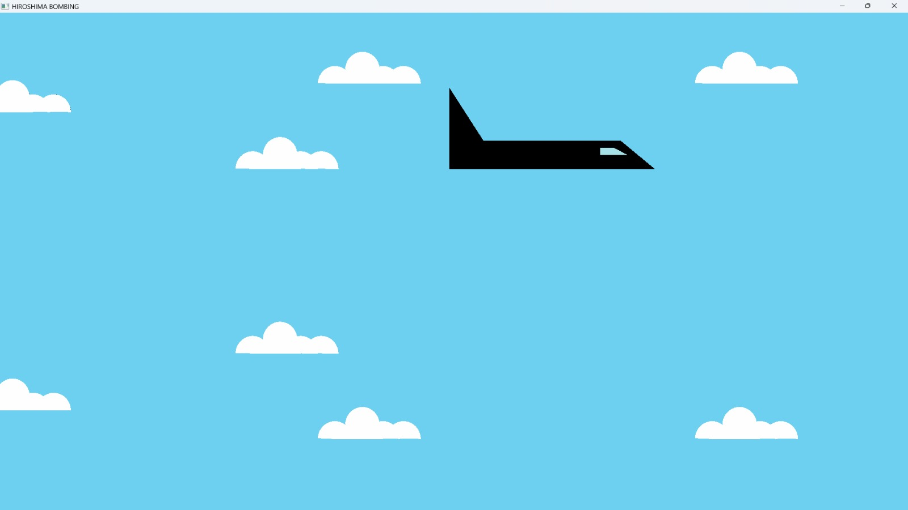**Figure 5.1.1: Airplane Flying**

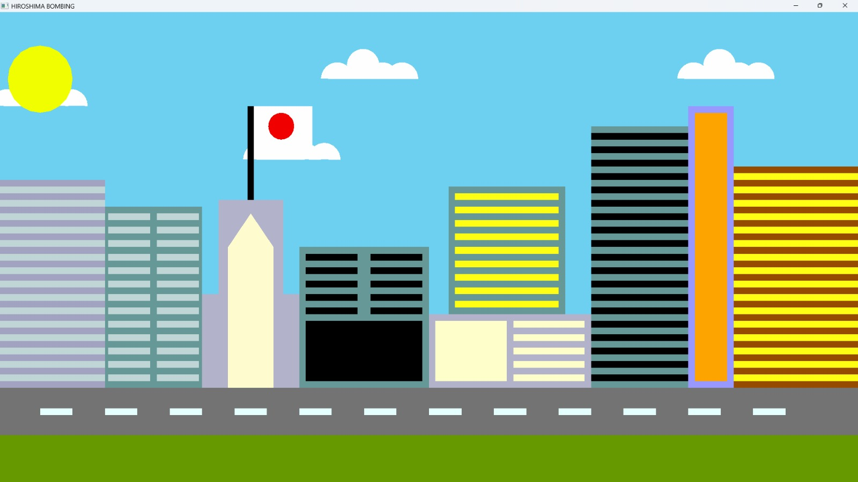

**Figure 5.1.2: Hiroshima city**

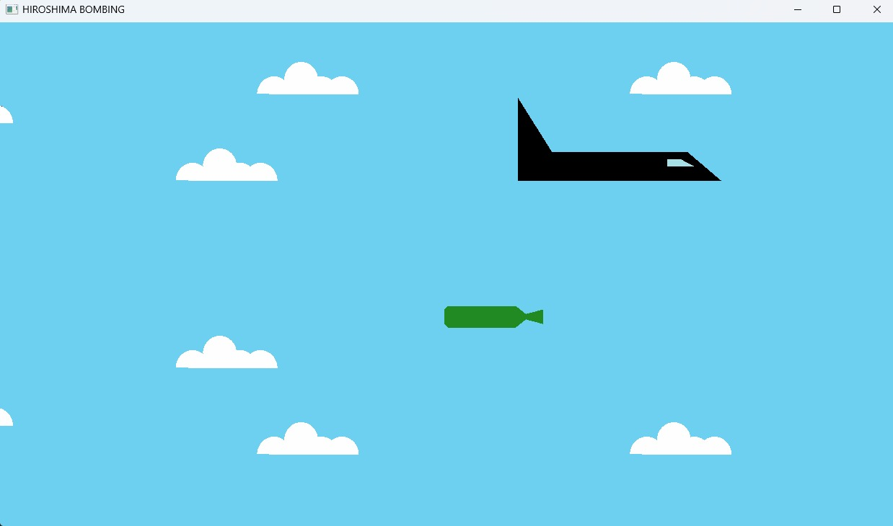

**Figure 5.1.3 Airplane dropping the bomb**

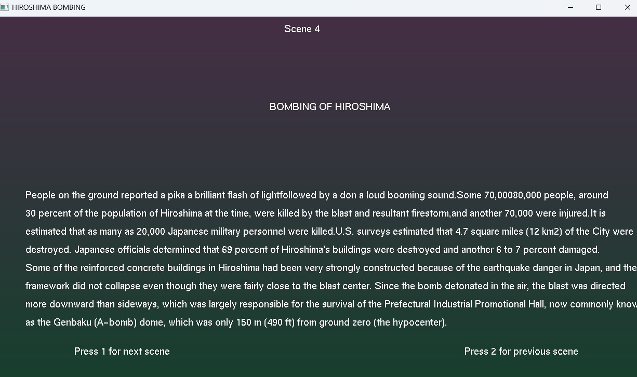

**Figure 5.1.4: Description about the bomb**

**CONCLUSION**

The Hiroshima and Nagasaki bombing simulation project was a multifaceted endeavour that combined historical accuracy with advanced technical implementation to create an impactful and educational experience. Through meticulous design, modelling, and animation, the project successfully recreates the significant events of World War II, offering viewers a powerful visual representation of the atomic bombings. The project emphasized the importance of preserving historical memory while utilizing modern technology to educate and inform future generations.

The simulation not only serves as a tribute to the victims of these tragic events but also highlights the potential of computer graphics and animation to bring history to life in a way that is accessible and engaging. The project involved complex processes, including the creation of detailed 3D models, realistic animation sequences, and interactive features, all of which were carefully integrated to provide a seamless and immersive experience.

Throughout the project, various challenges were encountered, such as ensuring the accuracy of the bomb drop physics, achieving realistic explosion effects, and maintaining a balance between visual detail and computational efficiency. However, these challenges were overcome through innovative solutions and a commitment to quality, resulting in a simulation that not only meets its educational objectives but also stands as a testament to the capabilities of modern technology in historical education.

Overall, the Hiroshima and Nagasaki bombing simulation represents a successful synthesis of history and technology, providing a valuable tool for learning and reflection. It demonstrates the power of digital media to convey complex historical events in a way that is both informative and emotionally resonant, ensuring that the lessons of the past are not forgotten.

### Future Enhancements

While the current simulation successfully meets its educational and commemorative goals, there are several avenues for future enhancements that could further enrich the project:

**1.Enhanced Realism through Advanced Physics**: Future versions of the simulation could incorporate more sophisticated physics engines to better model the effects of the explosions. This could include more accurate representations of shockwaves, thermal radiation, and the structural destruction of buildings, offering a more detailed and scientifically precise depiction of the bombings' impact.

**2.Expanded Interactive Features**: The simulation could be enhanced with additional interactive elements, such as allowing users to explore the aftermath of the bombings in more detail. This might include virtual tours of the cities before and after the explosions, as well as access to historical documents, survivor testimonies, and detailed information on the political and military context of the bombings.

**3.Virtual Reality (VR) Integration**: Incorporating VR technology would provide users with a more immersive experience, allowing them to witness the events in a fully three-dimensional space. This could significantly increase the educational impact of the simulation, making the experience more visceral and engaging for users.

**4.Multiplayer and Collaborative Learning**: Introducing a multiplayer mode could allow users to engage with the simulation collectively, fostering collaborative learning. This mode could be used in educational settings to encourage discussion and analysis of the events, as well as to explore alternative historical scenarios and outcomes.

**5.Historical Expansion and Additional Context**: The simulation could be expanded to include other significant events of World War II, providing users with a broader understanding of the conflict and its global impact. This might include simulations of other major battles, political decisions, and the experiences of civilians and soldiers across different theatres of war.

**6.Adaptive Learning Modules**: Future iterations of the project could include adaptive learning modules that tailor the content to the user's level of knowledge and interest. These modules could offer quizzes, challenges, and guided lessons that deepen the user's understanding of the historical context and technical aspects of the simulation.

**7.AI-Driven Enhancements**: Artificial intelligence could be employed to enhance the simulation by creating more dynamic and responsive environments. AI could be used to simulate civilian and military responses to the events, creating a more interactive and unpredictable experience that reflects the chaos and uncertainty of wartime.

**REFERENCES**

* Allen, T. J. (2016). World War II in 3D: A Visual History. HarperCollins Publishers. This book provided valuable insights into the visual aspects of World War II, including the design and appearance of military aircraft and the impact of the bombings.
* Blender Foundation. (2023). Blender 3D Software Documentation. Retrieved from https://www.blender.org
* Blender was used extensively for the modelling and animation aspects of the project, with the official documentation serving as a critical resource.
* OpenGL Architecture Review Board. (2023). OpenGL Programming Guide (9th Edition). Addison-Wesley Professional.
* The OpenGL guide was an essential reference for the graphics rendering techniques employed in the project, including dynamic lighting and shadow mapping.
* Sims, C. (2019). Introduction to Particle Systems in Computer Graphics. CRC Press.
* This book offered a comprehensive introduction to particle systems, which were crucial for simulating the explosion and smoke effects in the simulation.