INTERNSHIP REPORT
ON
HASTA-KALA SHOP
MICRO-SALES ANALYTICS & BILLING APP FOR ARTISANS
By
DEIVA M
1EP22EC030

Department of Electronics & Communication Engineering
Visvesvaraya Technological University, Belagavi
2025 - 26

Department of Electronics & Communication Engineering
CERTIFICATE
This is to certify that the INDUSTRY INTERNSHIP (BINT883A) entitled "HASTA-KALA SHOP - MICRO-SALES ANALYTICS & BILLING APP FOR ARTISANS" is a bona fide work carried out by DEIVA M [1EP22EC030], in partial fulfillment of the requirements of BACHELOR OF ENGINEERING in DEPARTMENT OF ELECTRONICS & COMMUNICATION ENGINEERING in VISVESVARAYA TECHNOLOGICAL UNIVERSITY, Belagavi, during the year 2025-2026. It is certified that corrections/suggestions recommended have been incorporated in the Internship report.

Internal Guide | Signature of HOD | Signature of Principal
Dr. Sivakumar V | Dr. Yogesh G S | Dr. Pradip Kumar Dixit
Associate Professor, Dept. of ECE | HOD, Dept. of ECE, EPCET, Bangalore | Principal, EPCET, Bangalore
Reviewers:
Reviewer 1 | Reviewer 2
Name: | Name:
Signature with date: | Signature with date:
Examiners:
Examiner 1 | Examiner 2
Name: | Name:
Signature with date: | Signature with date:

ACKNOWLEDGEMENT
First and foremost I would like to express my sincere regards and thanks to Management of East Point Group of Institutions, Bengaluru for providing me an opportunity to study in the esteemed organization.
I would like to express my humble and sincere thanks to Dr. Pradip Kumar Dixit, Principal, East Point College of Engineering and Technology for his suggestions that motivated me for the successful completion of my Internship.
I would like to express my heartfelt thanks to Dr. Yogesh G S, Vice Principal and Head of Department of Electronics & Communication Engineering, EPCET for his valuable advice and suggestions to do my best in this Internship.
I am obliged to my guide Dr. Sivakumar V, Associate Professor, Department of Electronics & Communication Engineering and Department Internship Coordinators Dr. V. Navya and Mrs. Jaanki S M, Dept. of Electronics & Communication Engineering, who have rendered valuable assistance and guidance for the Internship.
I would like to thank Mr. Tirumal Mutalikdesai, Mind Matrix.io (CL Infotech Pvt. Ltd.), Bengaluru for providing technical support and knowledge during the internship.
I would like to thank my parents and friends for their support and encouragement during the course of my Internship. Finally, I offer my regards to all the faculty members of the Electronics & Communication Engineering Department and all those who supported me in any respect during the Internship.
DEIVA M [1EP22EC030]

Appendix - I
Consent of Internship Mentor / Supervisor
I, Dr. Sivakumar V, having designation Associate Professor, nominated as mentor/supervisor in East Point College of Engineering and Technology, hereby extend my consent to allow the student Mr./Ms. DEIVA M of semester VIII bearing USN 1EP22EC030 of Electronics & Communication Engineering Department to do the internship in Mind Matrix.io (CL Infotech Pvt. Ltd.), Bengaluru during the academic year 2025-26.
Mr. Tirumal Mutalikdesai will act as the Internship Mentor from the organization.

Signature of Internal Guide
Name: Dr. Sivakumar V
Designation: Associate Professor
Address: Dept. of ECE, EPCET, Bengaluru
Email: [Enter Email]

Appendix - II
Internship Completion Certificate
It is certified that Mr./Ms. DEIVA M of Department of Electronics & Communication Engineering carried out his/her internship from [Enter Start Date] to [Enter End Date] in Mind Matrix.io (CL Infotech Pvt. Ltd.), Bengaluru. On the basis of his/her regularity, punctuality, interest shown towards learning skills, team participation and work awarded, the internship work is found satisfactory.

Date: ____________
Signature of Mentor
Name of Mentor (External Guide): Mr. Tirumal Mutalikdesai
Designation: [Enter Designation]
Address: Mind Matrix.io, Bengaluru
Email: [Enter Email]
Seal of the Organization

Student Certificate
CERTIFICATE
This Internship report is an original report of work done by me under the guidance of Internship Mentor/Supervisor Dr. Sivakumar V and under the supervision of Internship Supervisor (Industry) Mr. Tirumal Mutalikdesai, submitted as a part of the Internship Course of Undergraduate Programme of Visvesvaraya Technological University, Jnana Sangama, Machhe, Belagavi.

Date: ____________
Signature of the Student

TABLE OF CONTENTS
1. Introduction
2. About the Company / Training Institute
3. Aim / Objectives / Future Implications of the Internship
4. Literature Survey
5. Internship Timeline
6. Technical Skills Gained
7. Tools / Framework / Technology Stack / Database Used
8. Hardware and Software Requirements
9. Flow Diagram / Block Diagram / Use Case Diagram
10. Internship Implementation
11. Testing and Result Analysis
12. Learning Outcome
13. Challenges Faced
14. Conclusion and Future Enhancement
15. References
16. Appendix - Screenshots

1. Introduction
Hasta-Kala Shop is a micro-sales analytics and billing Android application designed for rural and small-scale artisans. The application gives artisan micro-entrepreneurs data analytics power similar to larger retailers by identifying sales performance, tracking income, maintaining product inventory and supporting billing in a simple mobile interface.
App Name | Hasta-Kala Shop
Platform | Android (Kotlin)
Subject Code | BINT883A
Student | Deiva M | 1EP22EC030 | VIII Sem B.E (ECE)
Training Institute | Mind Matrix.io (CL Infotech Pvt. Ltd.), Bengaluru
Guides | Internal: Dr. Sivakumar V | External: Mr. Tirumal Mutalikdesai
Target Users | Artisans making small crafts, banana fiber bags, pottery, textiles, keychains and jewelry
Domain | Self-Employment / Micro-Sales Analytics for rural artisans

2. About the Company / Training Institute
Mind Matrix.io (CL Infotech Pvt. Ltd.) is a Bengaluru-based training and technology organization founded in 2018. The training institute focuses on industry-aligned Android development, Generative AI integration, real-world project labs, mentorship and placement-oriented learning. The organization bridges academic learning and industry practice through hands-on projects and skill assessment.

3. Aim / Objectives / Future Implications of the Internship

Aim
To build an offline-first Android application that gives artisan micro-entrepreneurs sales analytics and billing support, enabling smarter production and stock decisions without depending on complex software.

Objectives
- Master Android development with Kotlin and Jetpack Compose.
- Build quick billing with customer name, quantity control, GST and total calculation.
- Display weekly and monthly income summaries using charts.
- Maintain products, categories, prices and stock quantity.
- Identify best-selling products and low-stock items.
- Create a clean, culturally relevant UI using terracotta, cream, deep brown and gold.
- Generate a production-ready prototype that can be enhanced for real artisan users.

Future Implications
- Export monthly reports to PDF/CSV.
- Kannada/Hindi language support for artisans.
- Cloud backup using Firebase or GCP.
- Gemini AI suggestions such as demand prediction and production advice.
- WhatsApp bill sharing and printable invoice generation.

4. Literature Survey
Author / Source | Title / Area | Year | Merits | Demerits
Mukherjee et al. | Mobile POS and Sales Tracking for Small Retailers | 2021 | Offline support and simple billing | Limited AI insights
Android Developers | Jetpack Compose UI Toolkit | 2024 | Modern declarative UI, reusable components | Requires learning Compose architecture
Material Design | Material Design 3 Guidelines | 2024 | Accessible components and consistent visual system | Needs customization for local craft identity
Google Gemini AI | Generative AI for mobile assistance | 2024 | Can provide natural language suggestions | Requires careful validation before production use

5. Internship Timeline
Week | Activity
Week 1 | Requirement analysis, problem identification and study of artisan sales workflow
Week 2 | UI/UX design, color system, screen planning and app navigation design
Week 3 | Implementation of dashboard, products module and billing module
Week 4 | Order history, Kala AI module, testing, APK generation and documentation

6. Technical Skills Gained
- Kotlin programming for Android.
- Jetpack Compose UI development.
- Material Design 3 component usage.
- State management using Compose remember and mutableStateListOf.
- Local data persistence using SharedPreferences and JSON.
- Chart drawing using Canvas in Compose.
- Debug APK generation using Gradle.
- Report writing and project documentation.

7. Tools / Framework / Technology Stack / Database Used
Category | Technology
Language | Kotlin
IDE | Android Studio
UI Framework | Jetpack Compose
Design System | Material Design 3
Storage | SharedPreferences with JSON
Build Tool | Gradle Kotlin DSL
Testing | Manual functional testing and debug build verification

8. Hardware and Software Requirements
Requirement | Specification
Hardware | Laptop/Desktop with Android Studio support
Mobile Device | Android phone or emulator
Operating System | Windows / Android
JDK | Android Studio bundled JDK
Android SDK | Configured using local.properties
Minimum SDK | As configured in Gradle project

9. Flow Diagram / Block Diagram / Use Case Diagram
The system flow begins with the splash screen, followed by the Home dashboard. The user can navigate using the bottom navigation bar to Products, Billing, Khata/History and Kala AI. Product data and order data are stored locally. When a bill is generated, order history is updated and dashboard analytics are recalculated.
User Action | System Response
Open app | Splash screen appears and navigates to dashboard
Add product | Product is saved in local inventory
Generate bill | Subtotal, GST and total are calculated; order is stored
Open dashboard | Sales, orders, weekly and monthly charts are calculated
Ask Kala AI | Assistant returns weekly sales, best seller or restock alert

10. Internship Implementation
The application was implemented as a single-activity Kotlin Android app. MainActivity hosts the full Compose UI. The major composable screens are SplashScreen, HomeDashboard, ProductsScreen, BillingScreen, OrderHistoryScreen and KalaAiScreen. CraftStore manages the local product and order data.

Modules Implemented
- Splash Screen: Displays Kala Marketplace branding with terracotta background and mandala pattern.
- Dashboard: Shows greeting, sales, orders, customers, weekly sales chart and monthly revenue chart.
- Products: Provides product search, inventory cards and add product dialog.
- Billing: Provides customer entry, quantity controls, GST calculation and bill generation.
- Khata / Order History: Maintains generated bills with amount and status.
- Kala AI: Provides chat-style business insights through quick suggestion chips.

11. Testing and Result Analysis
Test Case | Expected Result | Status
Open application | Splash screen and dashboard appear | Passed
Add product | New product appears in product list | Passed
Generate bill | Order is created and stock is reduced | Passed
Dashboard sales | Sales and order count update after bill generation | Passed
Weekly chart | Graph updates from current week order totals | Passed
Monthly chart | Revenue line changes based on stored orders | Passed
Kala AI | Responds with weekly sales, best seller and restock alert | Passed
The debug APK was generated successfully from Android Studio/Gradle. The latest APK path is app/build/outputs/apk/debug/app-debug.apk.

12. Learning Outcome
- Understood end-to-end Android app development workflow.
- Learned how to translate a problem statement into UI screens and working modules.
- Gained experience with Compose layouts, cards, charts and bottom navigation.
- Implemented business logic for billing and analytics.
- Improved project documentation and internship report preparation skills.

13. Challenges Faced
- Designing a simple interface suitable for non-technical artisan users.
- Making the dashboard charts dynamic instead of fixed demo values.
- Managing local product and order state consistently.
- Balancing traditional craft-inspired visuals with modern Material Design components.
- Preparing the report according to the exact internship template.

14. Conclusion and Future Enhancement
Hasta-Kala Shop successfully demonstrates a Kotlin Android solution for artisan micro-sales analytics and billing. The application helps users manage products, generate bills, view order history and understand business performance through charts and AI-style suggestions. The project aligns with the internship objective of applying Android and AI-oriented concepts to a practical real-world problem.
Future enhancements include Room database integration, PDF bill export, WhatsApp sharing, cloud backup, regional language support, barcode scanning, product image upload and advanced AI recommendations.

15. References
- Android Developers Documentation - Kotlin and Jetpack Compose.
- Material Design 3 Guidelines.
- Mind Matrix.io training material and internship guidance.
- Hasta-Kala Shop project PPT: Hasta_Kala_12SlidesDEIVA-3 (1).pdf.
- Internship Report 25-26 Format PDF provided by the department.

16. Appendix - Screenshots

Screenshot 1
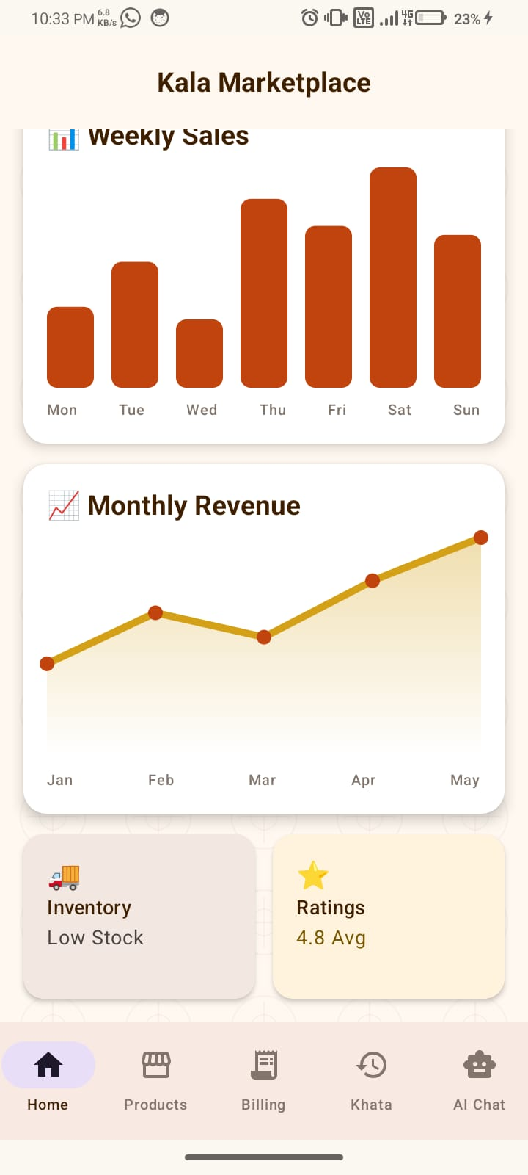
Home dashboard with sales, product and order summary

Screenshot 2
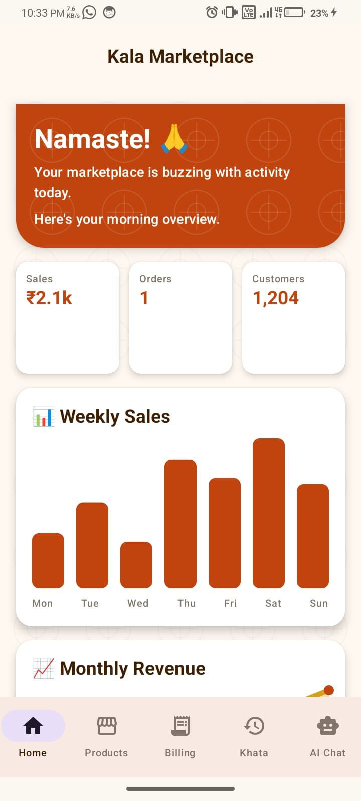
Lookbook feed showing artisan products

Screenshot 3
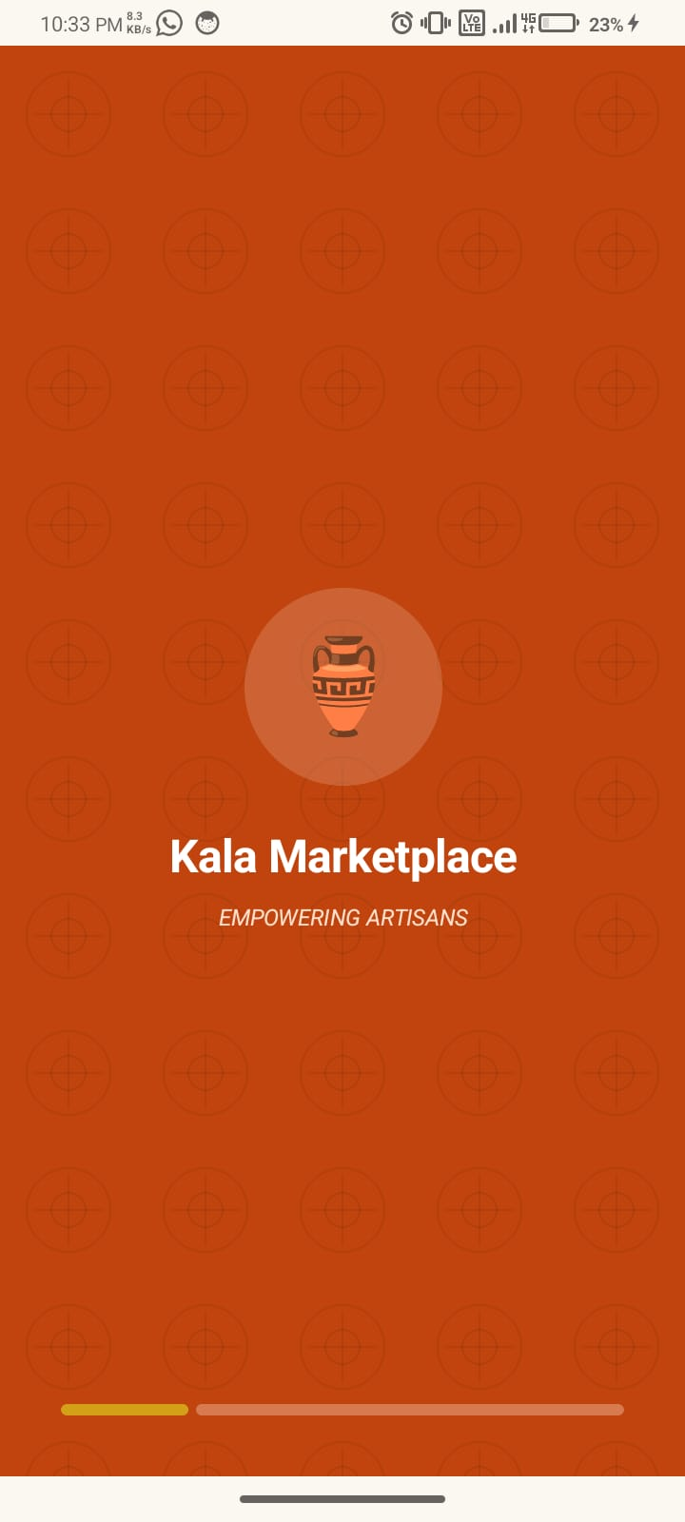
Products screen with search and inventory list

Screenshot 4
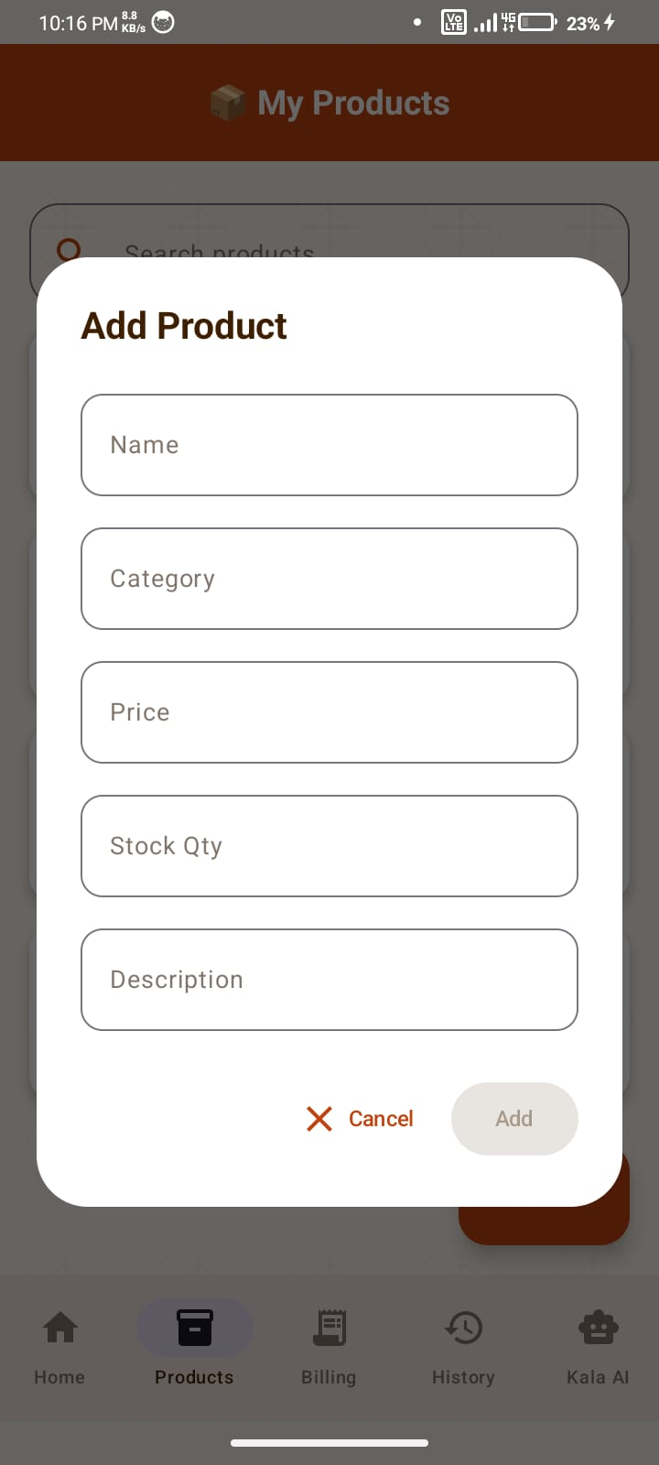
Billing screen with GST and Generate Bill option

Screenshot 5
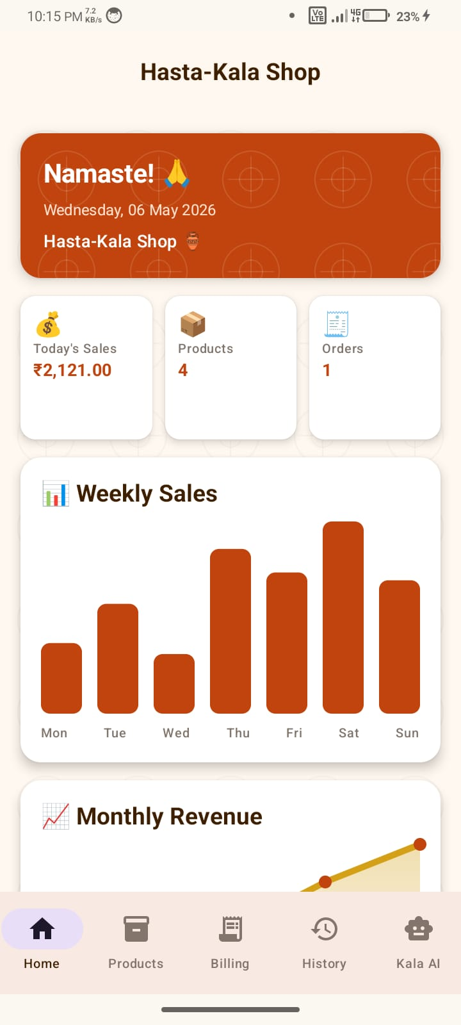
Kala AI screen with business insight suggestions

Screenshot 6
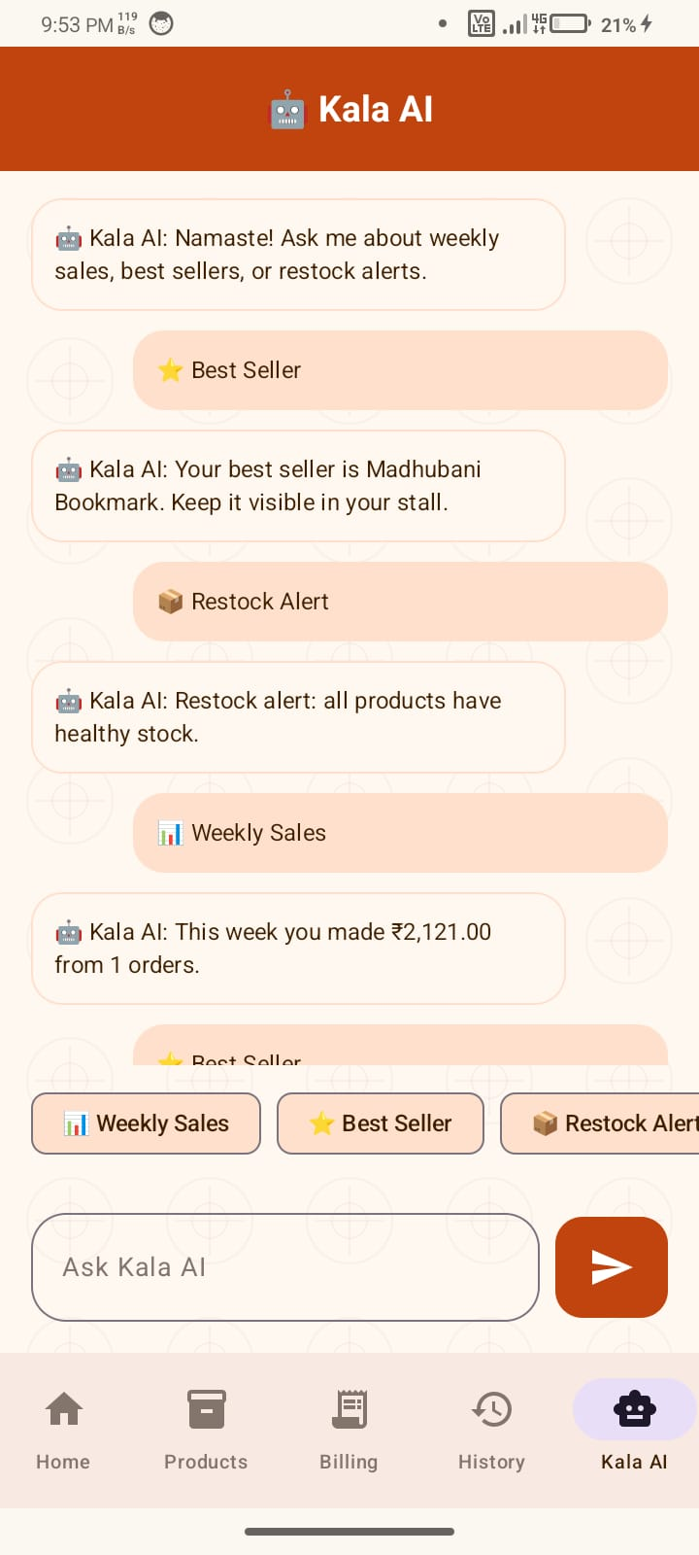
Dashboard after bill generation with updated sales

Screenshot 7
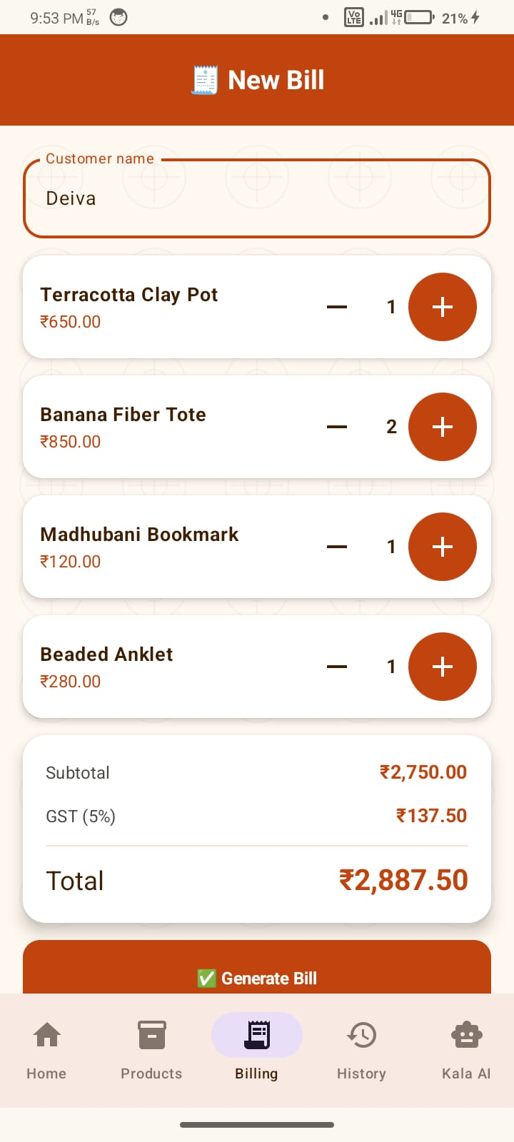
Add Product dialog

Screenshot 8
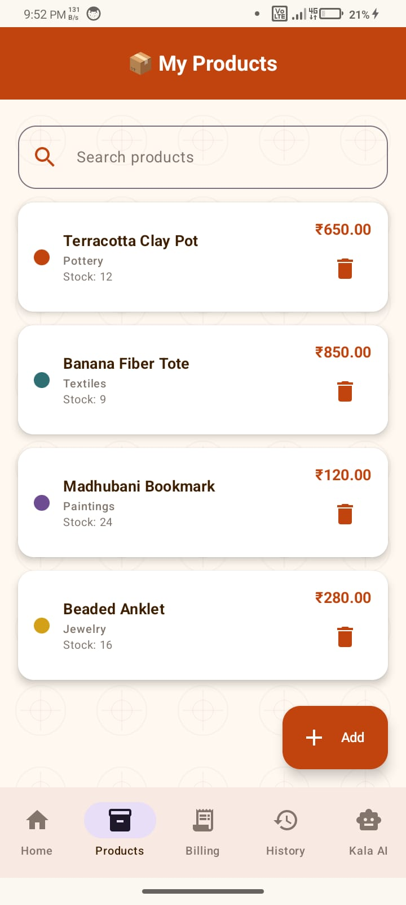
Splash screen with Kala Marketplace branding

Screenshot 9
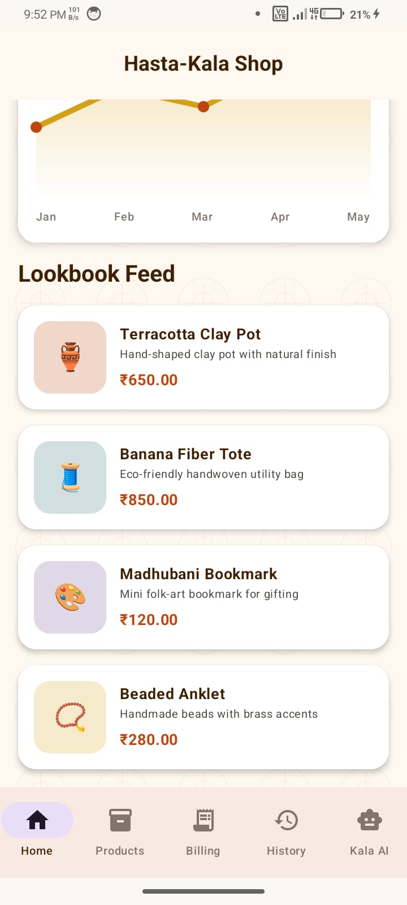
Updated dashboard overview

Screenshot 10
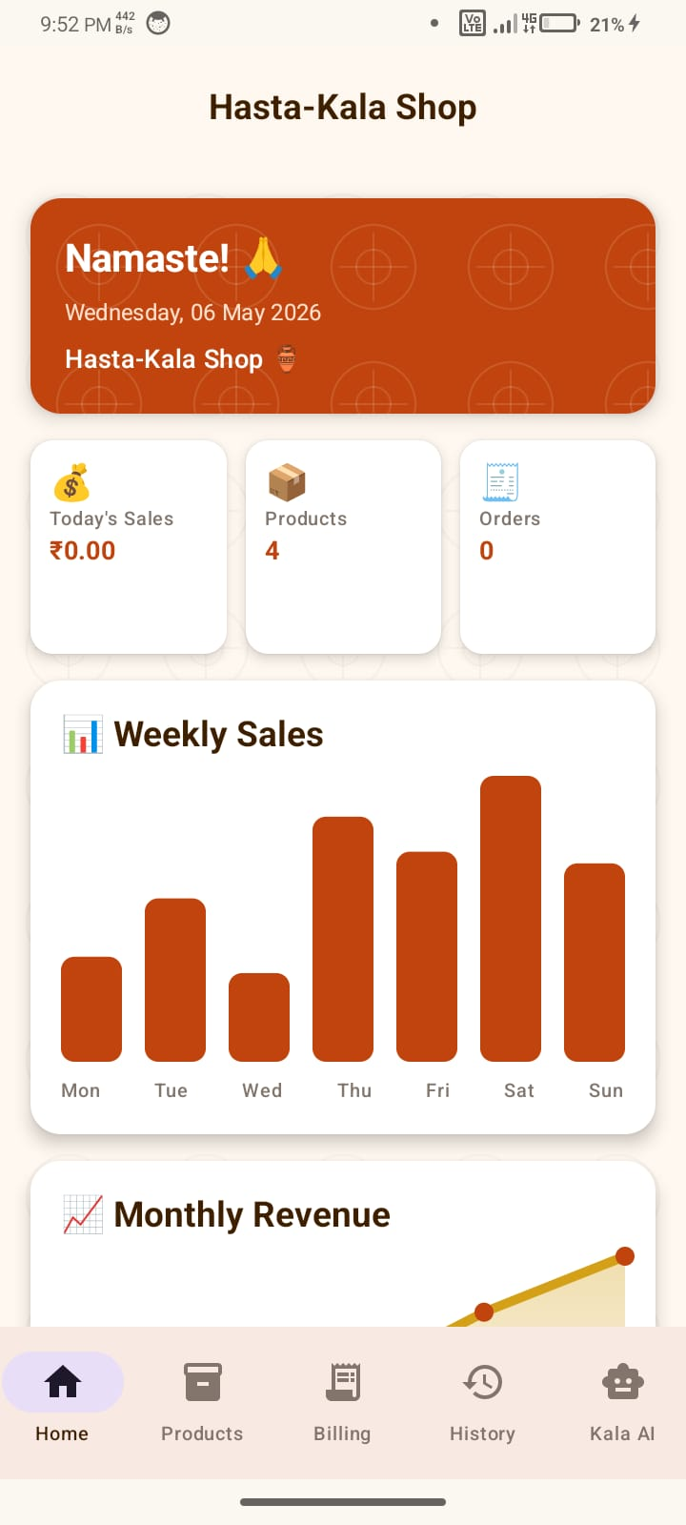
Analytics section with weekly and monthly charts

