Вариант 6

1) select bludo_id,bludo_type,weight_bludo

from bludo

where weight_bludo >= 500;

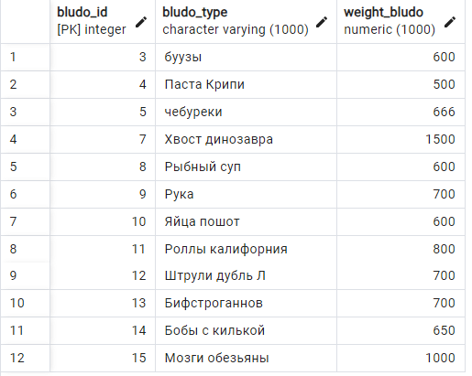

2) select product_id,product_name

from product

where product_name like '%ка%';

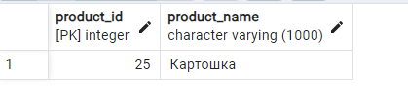

3) select dp.product_volume, p.product_name, dp.bludo_id

from needs dp

join product p on dp.product_id = p.product_id

where dp.bludo_id between 3 and 12;

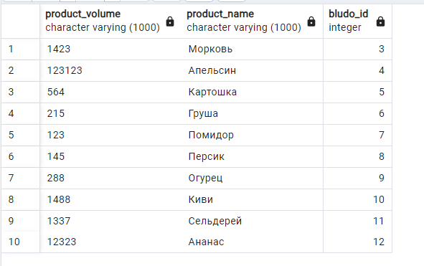

4) select recipe, bludo_type, bludo_id, carbs_capacity

from bludo

where carbs_capacity >= 10;

