EE444 Homework 1

# Question 1)

Figure Packet Visualization in FCFS

Figure # of Packets in the System vs Time FCFS

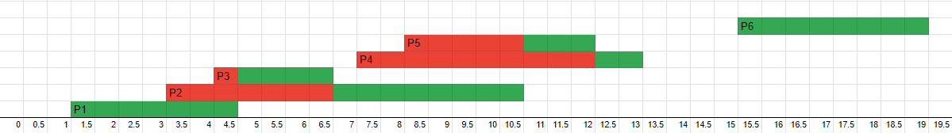

Figure Packet Visualization in LCFS

Figure # of Packets in the System vs Time LCFS

In time range between t = 0 and t = 19, FCFS has 3 seconds and LCFS has 3 seconds, which are equal. It is because there is no loss of packets. So even though the service time values are different, all the packets are sent in the same time frame.

$$E{\left[IA\right]}_{FCFS}=\frac{\left(4+2+6+2+14\right)}{5}*0.5=2.8=\frac{1}{λ_{FCFS}}→λ_{FCFS}≅0.36 \frac{packet}{sec} \\ E{\left[T_{s}\right]}_{FCFS}=\frac{\left(7+11+13+9+10+8\right)}{6}*0.5≅4.84 \frac{sec}{packet} \\ E{\left[N_{s}\right]}_{FCFS}=λ_{FCFS}*E{\left[T_{s}\right]}_{FCFS}≅1.74 \left(From Little^{'}s Law\right)$$

$$E{\left[IA\right]}_{LCFS}=E{\left[IA\right]}_{FCFS}=2.8=\frac{1}{λ_{LCFS}}→λ_{LCFS}≅0.36 \frac{packet}{sec} \\ E{\left[T_{s}\right]}_{LCFS}=\frac{\left(7+15+5+12+8+8\right)}{6}*0.5≅4.59 \frac{sec}{packet} \\ E{\left[N_{s}\right]}_{LCFS}=λ_{LCFS}*E{\left[T_{s}\right]}_{LCFS}≅1.65 \left(From Little^{'}s Law\right)$$

On average, FCFS had fewer packets in the system, and spent more time waiting in the queue before being served. The rate of packet arrivals per second is the same for both methods because same arrival times are used. From Little’s Law, while rate of packet arrivals per second is constant, as expected time a packet spends in the system decreases, expected time of packets in the system decreases.