# CHAPTER FIVE

# REQUIREMENTS ANALYSIS, SYSTEM DESIGN AND PROJECT IMPLEMENTATION

# Introduction

## 5.0 System Implementation

This is an interface that gives the user access to the system. When the application loads, it will prompt the login interface which requires the user to enter the username and password and then click the login button. The login page for users is shown in Fig. bellow.

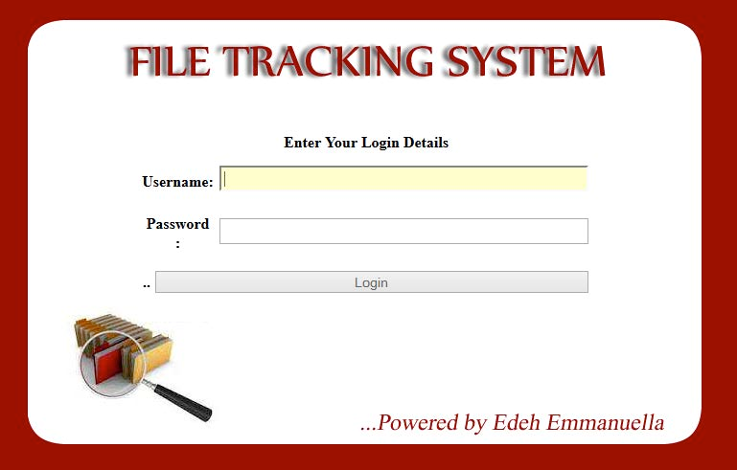

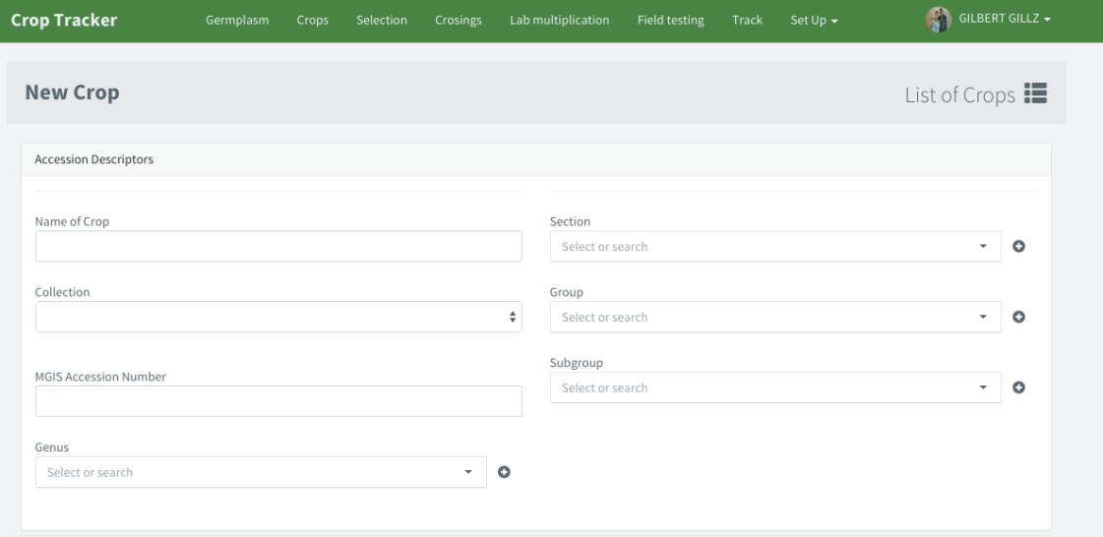

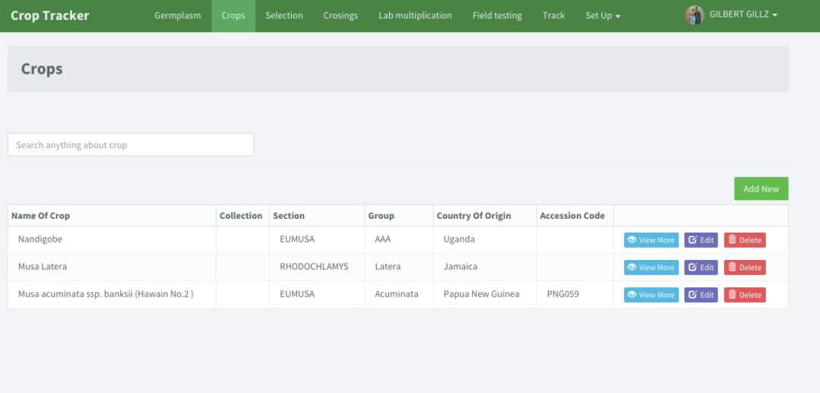

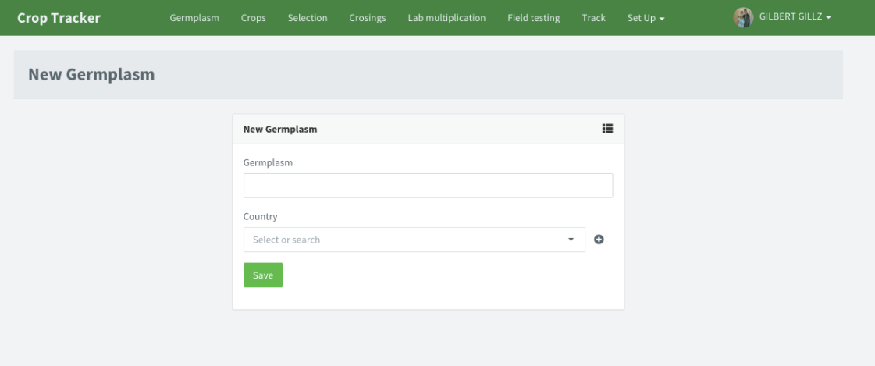

This interface allows scientists to capture and store information. This allows all news crops and old crops.

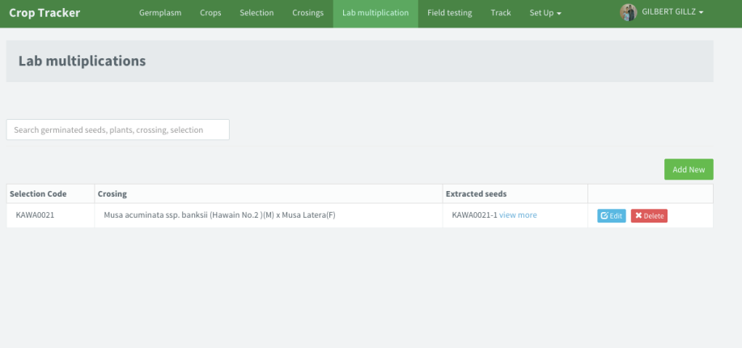

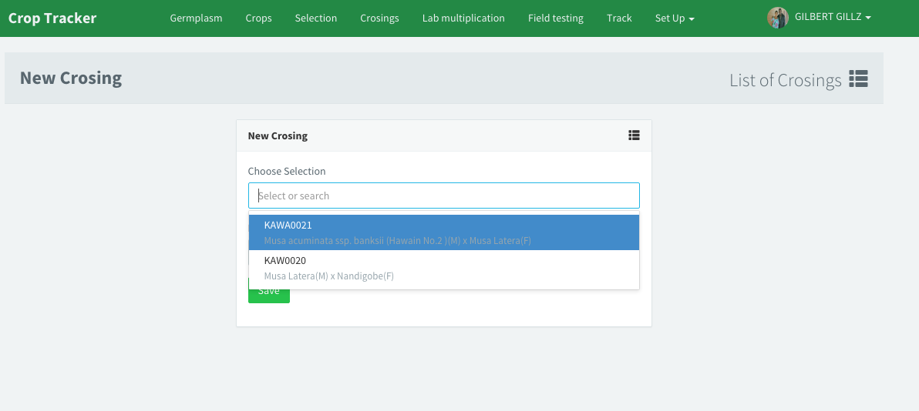

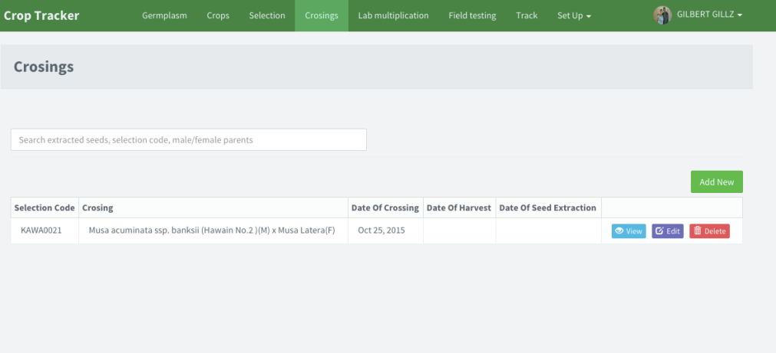

When the breeder selects the breeding lines in the germplasm collection, they are crossed to each other for the purposes of getting a new improved crop. when selecting the breeding lines, you are targeting high yield and resistance to diseases and pests, that is the improved lines generating by crossing between two lines should be having the attributes started above.

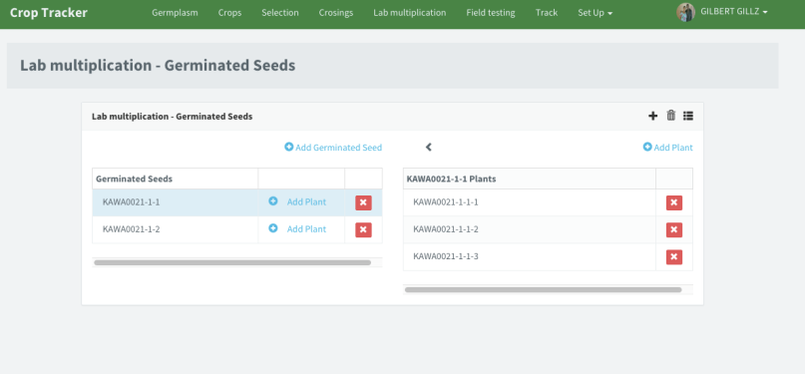

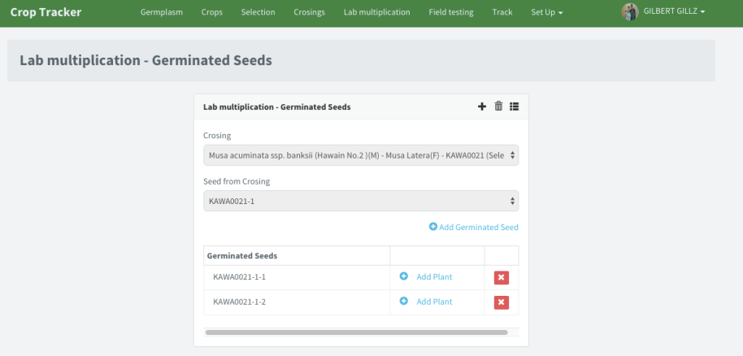

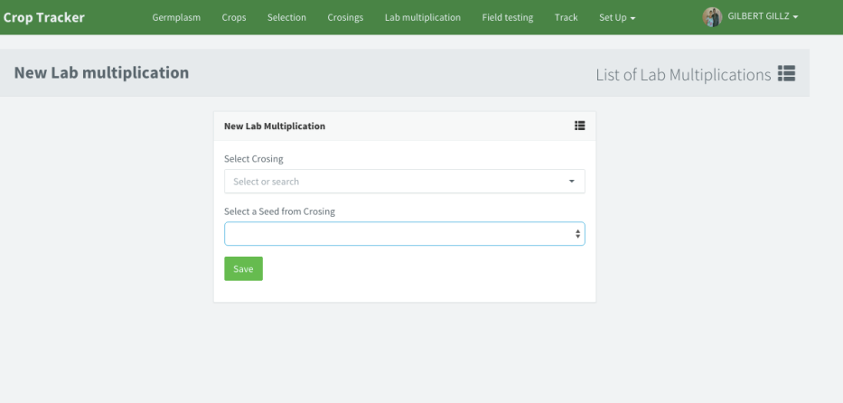

This interface show the multiplication of the crossed plant in the laboratory, when the crops are crosses,(female and male) the generated plant is multiplies faster in the laboratory, because it would take longer when multiplied in the field.as the multiplication takes place in the laboratory the following are recorded, the serial number of the seeds brought in the laboratory, the serial number of the multiplied plant, each plant generated is considered different from the other.

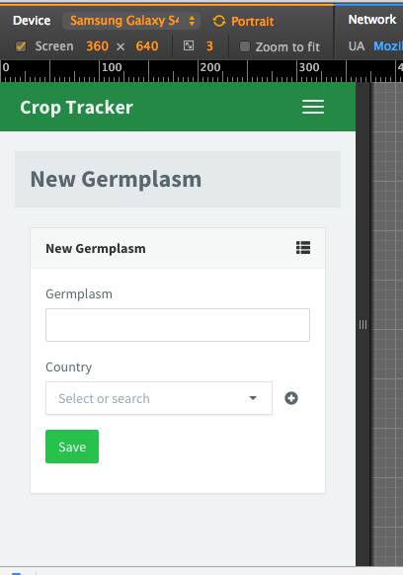 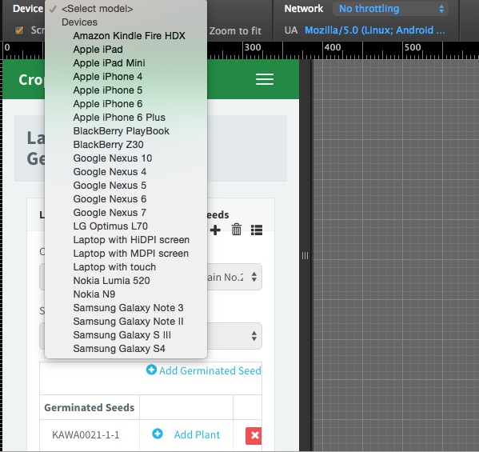

**Compertibilty**

The system is designed in such way that it can be compertible to diffirence platform ranging from the smartphone,ipas and laptops and computers, this helps the researchers to be able to collect data using his phone at any point.

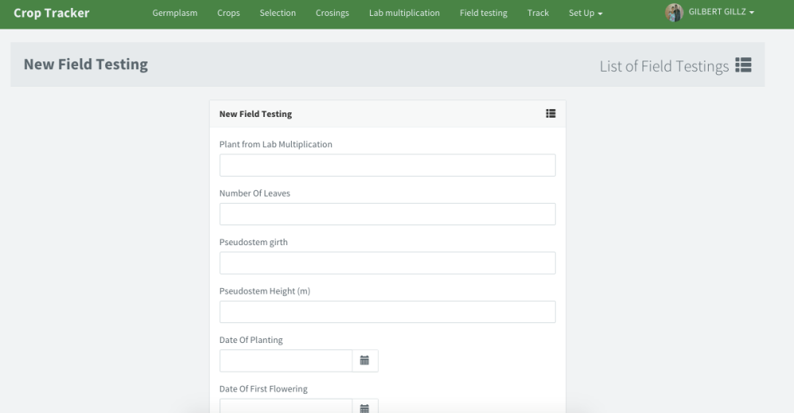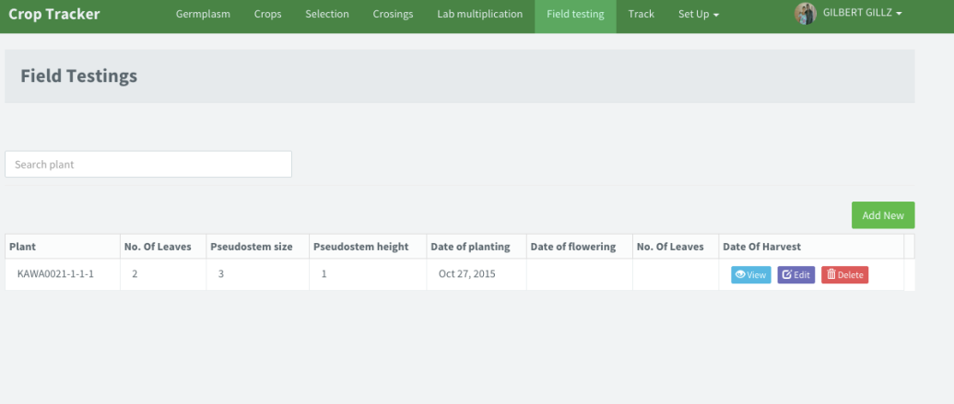

This interface allows the scientist collect and records information about the new crop bred, this information will either confirms the presence of good trait in the new crop, and this would be the basis for the further improvement.