**CG Boost – Youtube**

[**https://youtu.be/tQfFlzHJJ88**](https://youtu.be/tQfFlzHJJ88)

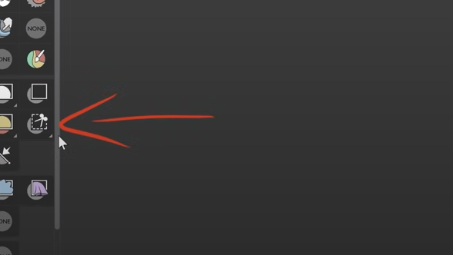

Lasso trim tool

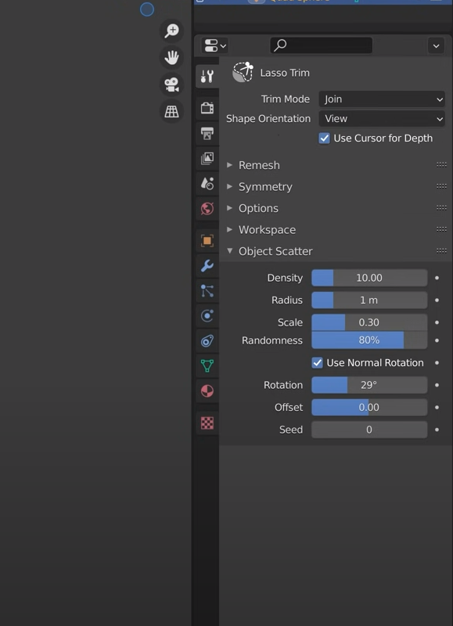

Shift H – for deleting the geometry  
Control L - copy modify

C – Select

Auto retopo

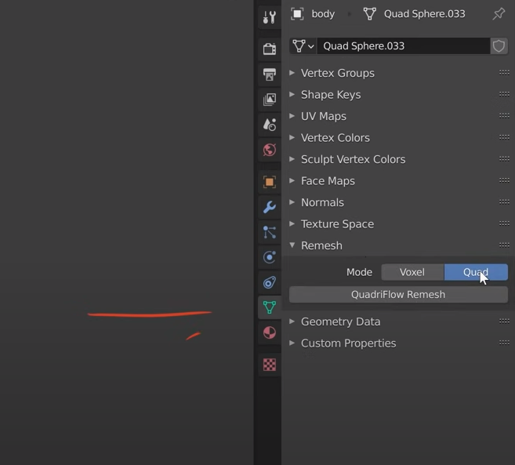  
  
Shift R – check resolution

