

Java Full Stack Internship

CYBER CRIME REPORTING SYSTEM
A Desktop-Based Application
Project Report
Developed Using Java Swing & MongoDB
Submitted by:
Chandana B
ETH/SJBIT/OOO532

ABSTRACT
The Cyber Crime Reporting System is a desktop-based application designed to provide a simple platform for users to report cyber crimes digitally. The system allows users to register, log in, file complaints related to cyber crimes, and track the status of their complaints using a unique complaint ID.

The application is developed using Java Swing for the graphical user interface and MongoDB for database management. The system stores user details and complaint information securely in the database. Once a complaint is submitted, a unique complaint ID is generated which helps users track their complaints easily.

The main objective of the project is to simplify the process of reporting cyber crimes and provide an organized system for managing complaints digitally.

CHAPTER 1 – INTRODUCTION

Cyber crime has become a major concern in today's digital world. With the increasing use of the internet and online platforms, cyber crimes such as online fraud, identity theft, phishing attacks, and social media hacking have increased significantly.

Traditionally, reporting cyber crimes involves visiting police stations or contacting authorities manually. This process can be time-consuming and inconvenient for many users.

The Cyber Crime Reporting System provides a digital platform where users can easily register, log in, submit cyber crime complaints, and track their complaint status. The system ensures proper storage and management of complaint data using a database.

OVERVIEW
The Cyber Crime Reporting System is a desktop-based application that manages the entire complaint reporting process digitally.

Users can create an account, log in to the system, file cyber crime complaints, and receive a unique complaint ID. This complaint ID can later be used to track the status of the complaint.

The application stores all user and complaint information in a MongoDB database. This ensures that data is securely stored and can be retrieved whenever required. The system provides a simple and user-friendly interface for users to interact with the application.

NEED FOR THE PROJECT
In many situations, victims of cyber crimes face difficulties in reporting incidents quickly. Traditional complaint systems may require physical visits to authorities, which can delay the reporting process.

The Cyber Crime Reporting System provides a convenient digital platform where users can report cyber crimes instantly. This helps in maintaining digital records of complaints and ensures efficient management of cyber crime data.

The system reduces manual work and improves accessibility for users who need to report cyber crimes.

SCOPE OF THE PROJECT
The scope of the Cyber Crime Reporting System includes developing a desktop application that allows users to register, log in, file complaints, and track complaint status.

The system stores complaint information in a database and generates a unique complaint ID for each complaint submitted. In the future, the system can be expanded by adding features such as admin monitoring, evidence file uploads, email notifications, and integration with official cyber crime portals.

EXISTING SYSTEM
In the existing system, cyber crime complaints are often reported through physical visits to police stations or through limited online platforms. Manual processes may lead to delays in complaint registration and difficulties in tracking complaint status. Users may not always receive immediate updates regarding their complaints.

This makes the complaint reporting process inefficient and less accessible for many individuals.

PROBLEM STATEMENT
Cyber crime victims often face challenges when trying to report incidents quickly and efficiently. Traditional systems for reporting complaints may involve manual procedures, lack of proper record management, and limited tracking capabilities.

There is a need for a digital system that allows users to easily report cyber crimes, store complaint information securely, and track complaint status through a simple user interface.

LITERATURE REVIEW
With the growth of digital technology, many systems have been developed to simplify the process of reporting crimes and managing information digitally. Online complaint systems allow users to submit complaints, store records in databases, and track the status of their requests. These systems improve efficiency, reduce manual work, and ensure proper management of data.

The Cyber Crime Reporting System follows similar principles by providing a digital platform for users to report and track cyber crime incidents.

CHAPTER 2 – PROJECT OBJECTIVES

1. To Develop a Cyber Crime Reporting System
The primary objective of the project is to create a platform where users can report cyber crimes easily.

2. To Provide a Simple User Interface
The system uses Java Swing to provide a graphical interface that allows users to interact with the system easily.

3. To Allow Complaint Submission
Users can file cyber crime complaints through the application.

4. To Generate a Unique Complaint ID
Each complaint generates a unique ID that helps users track the status of their complaint.

5. To Store Complaint Data in a Database
The system uses MongoDB to store user information and complaint records securely.

6. To Provide Complaint Tracking
Users can track the progress of their complaints using the generated complaint ID.

MOTIVATION FOR THE PROJECT
The motivation behind developing the Cyber Crime Reporting System is to provide an easy and accessible way for users to report cyber crimes. Many people hesitate to report cyber crimes due to complicated procedures. By creating a simple digital platform, users can easily submit complaints and track their status.
CHAPTER 3 – METHODOLOGIES AND TECHNIQUES

Software Development Methodology
The system follows a modular development approach where each module is developed and tested individually before integrating them into the complete system.

Frontend Development Techniques
The graphical user interface is developed using Java Swing. Components such as buttons, text fields, labels, tables, and panels are used to create an interactive interface.

Backend Development Techniques
Java programming is used to implement the backend logic of the system. The application handles user authentication, complaint submission, and complaint tracking operations.

Database Management
MongoDB is used as the database for storing user details and complaint information. The application communicates with the database to insert, retrieve, and update data.

CHAPTER 4 – IMPLEMENTATION AND ANALYSIS

The Cyber Crime Reporting System is implemented using Java Swing for the user interface and MongoDB for data storage. The system consists of several modules including user registration, login authentication, complaint submission, complaint details display, and complaint tracking.

Users can register and log in to the application. After logging in, users can submit cyber crime complaints by entering details such as crime type and description. Once a complaint is submitted, the system generates a unique complaint ID and stores the complaint information in the database. Users can later use this complaint ID to track the status of their complaint.

Testing is conducted to ensure that all modules function correctly and that data is stored and retrieved properly from the database.

SYSTEM ARCHITECTURE
The system architecture below illustrates the three-tier structure of the Cyber Crime Reporting System, consisting of the User Interface Layer (Java Swing GUI), the Application Logic Layer, and the Database Layer (MongoDB).

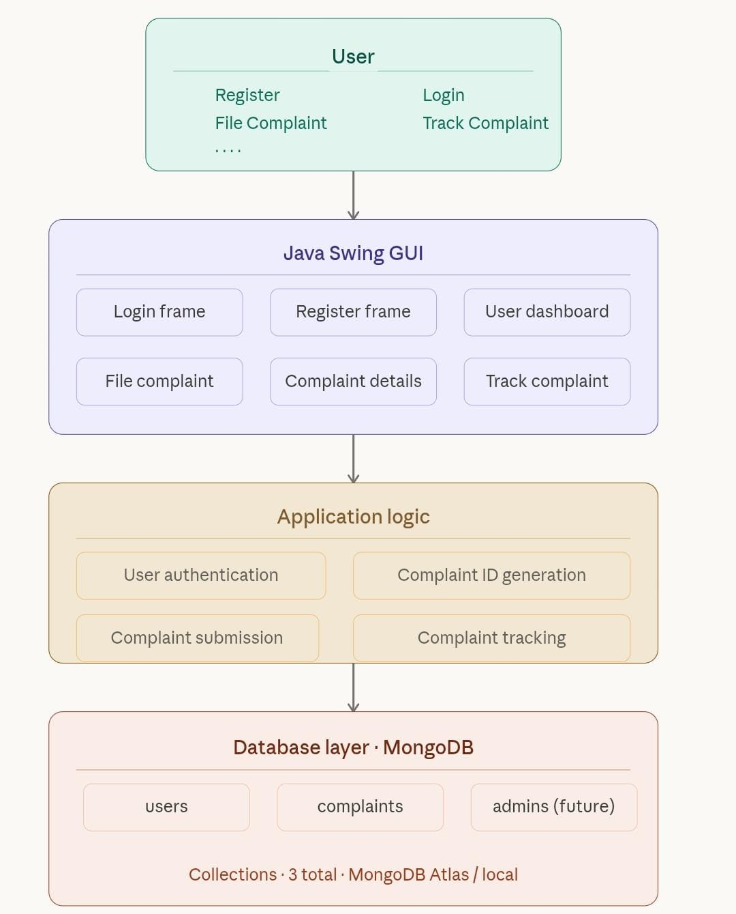
Figure 1: System Architecture Diagram – Cyber Crime Reporting System

ANALYSIS
The system improves efficiency by automating the complaint reporting process. Users can register, log in, and submit complaints without visiting any physical office. The use of MongoDB ensures proper and scalable storage of complaint records.The graphical interface provides a simple and user-friendly experience for users. The modular structure of the application makes it easy to extend and maintain.
CHAPTER 5 – RESULTS AND DISCUSSION

The Cyber Crime Reporting System was successfully developed using Java Swing and MongoDB. The application allows users to register accounts, log in, file cyber crime complaints, and track complaint status using a unique complaint ID.

The system simplifies the process of reporting cyber crimes and ensures proper storage and management of complaint information. The graphical interface provides a user-friendly environment that allows users to interact with the system easily.

All modules were tested and verified to be functioning correctly. Data insertion, retrieval, and update operations on the MongoDB database performed as expected.

CHAPTER 6 – CONCLUSIONS AND RECOMMENDATIONS

The Cyber Crime Reporting System provides an efficient platform for reporting and managing cyber crime complaints digitally. The system simplifies the complaint submission process and ensures proper storage of complaint records in the database.

By using modern technologies such as Java Swing and MongoDB, the system demonstrates how desktop applications can be developed to address real-world problems.

RECOMMENDATIONS
- Add an admin module for managing complaints.
- Allow users to upload evidence files such as screenshots.
- Add email notifications for complaint updates.
- Improve the graphical interface design.
- Integrate with official cyber crime reporting portals.

LIMITATIONS OF THE SYSTEM
- Basic user interface design.
- Limited complaint management features in the current version.
- No real-time notifications.
- No integration with official cyber crime portals.
- No online payment or evidence upload functionality.

SUGGESTIONS FOR FUTURE IMPROVEMENTS
Future improvements may include adding an admin monitoring system, enabling file uploads for evidence, implementing email notifications, and integrating the system with official cyber crime reporting platforms.

