NSF Highlight
Research Experiences for Undergraduates

- Basic Info and NSF Award Number(s)
PI: Georgios C. Angnostopoulos, Co-PI: Adrian M. Peter, NSF Award Number: 1263011, Program Officer: Maria Zemankova

2. What is your Suggested title for your highlight?
A Machine Learning Evaluation of Aerial LiDAR for Classification of Terrestrial and Urban Structures
3. What is the outcome or accomplishment?
Undergraduates Ben Drebing and Michael Sokolich’s project of LiDAR classification was extremely difficult and completely exploratory. The team, advised by Dr. Anthony Smith, managed to extract meaningful features from just position coordinates (latitude, longitude, elevation) which were then used to classify single points with relatively good accuracy. Three linear classifiers (Bayes Classification, Fisher’s Linear Discriminant Analysis (LDA), and Quadratic Linear Analysis (QDA)), were studied, implemented, and tested on multiple data sets. These classification results did not meet the expected range of 95%-100% testing accuracy; however, were better than random guessing. This led the team to explore two nonlinear classifiers (Kernel LDA and Kernel QDA), which were expansions of the classifiers already studied. These two nonlinear methods were then implemented and tested, producing results that were once again not in the 95%-100% test accuracy.

4. What is the impact?
Figure 1 shows an example of a LiDAR datasets. These data sets are very large and fall under the Machine Learning field of “Big Data”. The ability to classify one point out of millions is not an easy task. Intuition shows that in order to see a structure in a LiDAR 3D point cloud, it takes many points (obviously one single point cannot represent the sky scrapper or a giant sequoia tree). In the past, LiDAR classification came from manual observation and inputting these into classes. Therefore, it takes meaningful feature extraction in order to make this connection from point to structure. LiDAR data usually contains an intensity, which is a unique characteristic of the laser bouncing off an object. Past classification attempts all use these intensities or a combination of other satellite imagery in order to do classification. A two class problem was considered against different classes in the dataset. For example, classifying buildings vs bare earth, bare earth vs not bare earth, or bare earth vs vegetation. Using three fundamental linear classification algorithms, the team managed to classify large LiDAR data sets with good test accuracy as shown in Figure 2. They then moved to expand their testing to nonlinear methods. This research sets up the foundation needed in order to move forward in LiDAR classification using more complicated and advanced methods.

5. What explanation/background does the lay reader need to understand the signiﬁcance of this outcome?
One must understand the complexity of these LiDAR datasets. As mentioned, this data is vast and not easily classified. On average, data sets are in the millions and without the uniqueness of intensity, the geospatial position coordinates, given from LiDAR’s 3D point cloud, provide no details about objects within the cloud. Extracting meaningful features from the points is the only way one can expect to get good classification results.
The classification algorithms that were studied are the basic algorithms taught in your standard Pattern Recognition lecture. This was the appeal to the team in order to test as many different algorithms as possible in the time span allotted. Using these algorithms on this complex data set shows their true power and potential which makes them even more appealing.

Figure 1: Graphical representation of a point cloud produced by a LiDAR sensor
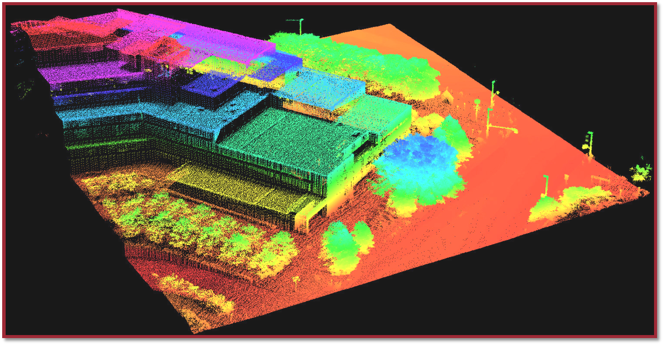

Figure 2: Classification Results of Bare Earth vs. Vegetation using Bayes, LDA, and QDA classifiers

