NSF Highlight
Research Experiences for Undergraduates

- Basic Info and NSF Award Number(s)
PI: Georgios C. Anagnostopoulos, Co-PI: Anthony O. Smith, NSF Award Number: 1560345, Program Officer: Maria Zemankova

- What is your Suggested title for your highlight?
Shape Retrieval on the Wavelet Density Hypersphere

- What is the outcome or accomplishment?

The outcome of the research project was a novel method for 2D/3D shape retrieval including a related optimized software package. The major contributions include:
- Optimized multi-resolution wavelet density estimation software package, open to the research community.
- New shape similarity metric using linear assignment and multiresolution wavelets.
- Hierarchical clustering algorithm on a high-dimensional unit hypersphere.

Undergraduates Glizela Taino and Yixin Lin were able to make a theoretical contribution to the field of shape analysis by successfully implementing the above tasks. The students gained practical experience with topics such as hierarchical clustering, density estimation, wavelets, shape retrieval and algorithm complexity analysis. The results of the research were promising (80-95% on standard benchmarks), which makes the work eligible for publication submission.

4. What is the impact?

The amount of 3D models being generated in today’s marketplace is increasing rapidly due to advances such as 3D printing and computer graphics and is likely to be the next big phase in search. With this large collection of shapes, efficient methods to retrieve these models from large databases must be developed. Unlike traditional text-based search where the query is a descriptive phrase of the object, shape retrieval’s query is actually the shape itself; the geometrical properties of the object are used as a basis for shape similarity. Text based queries cannot fully describe the intricate differences between two shapes, so retrieval methods must leverage the geometry information to retrieve relevant elements from a database.
Our approach delivers a new shape representation based on wavelet density estimation that results in a hypersphere geometry in which the shapes (2D/3D point-set and 3D mesh) become points on a unit hypersphere. This hypersphere has an extremely efficient closed form metric that allows us to quickly compare two shapes. This geometry also promotes efficient hierarchical clustering. The shape categories are clustered in a tree structure on the hypersphere. This allows an arbitrary grouping of the shapes in the database by forming mean shapes (called prototype shapes) effectively reducing the size of the search index enabling faster shape retrieval. A visual example of this hierarchical grouping is shown in Figure 1.
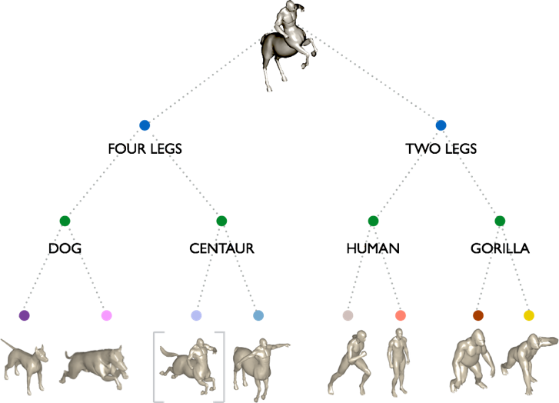
Figure 1: Hierarchical grouping of shapes in a database. The shapes from the database are shown in the bottom row; the query shape is shown at the top. The closest query shape is shown in square bracket on the bottom row. (The closest database shape is retrieved by descending the tree, first to the fourlegs category, then to the centaur category, and finally the most similar shape).

5. What explanation/background does the lay reader need to understand the signiﬁcance of this outcome?
First the reader must understand that using textual descriptions to retrieve the most similar shapes to a query shape is not effective for databases that have hundreds of shapes per category (where the database has multiple categories). Using the geometry is the best way to retrieve the most similar objects at the top of the retrieval list. The concept of forming a mean shape from a cluster of similar shapes, and using this as a representative of that category is important. Instead of comparing a query shape to every shape in the database, we compare only to the mean shapes of each category and are able to retrieve the most relevant objects at the top of the list much faster (similar to a google search where the most relevant items are near the top of the page). Lastly understanding that comparing shapes using only the geometric information is a non-trivial task helps in showing the utility of this research.

