RECONFORGE
  - OSINT & Network Discovery | Cybersecurity Lab Report
  - Week 2 | Cybersecurity and Ethical Hacking
Report Author: Hiba Gourram
Date: 10 November 2026
Environment: Kali Linux 2026.3 in Oracle VirtualBox (NAT Network)
Covered practical modules: W2-PM1, W2-PM3, W2-PM4 and W2-PM5
Report scope: Educational laboratory exercises using example.com and a VirtualBox network. The named external assignment targets were not tested.
I documented the exercises with terminal screenshots, investigation graphs and a Zenmap topology export. The evidence is presented in Section 8.

1. Liability Disclaimer
This document describes educational reconnaissance and network-scanning exercises. Only systems owned by the tester or covered by current, explicit written authorization may be tested. The provided sample authorization letter names a different intern and covers 17–24 August 2026; it does not establish authorization for Hiba Gourram in November 2026. No exploitation, password attacks or unauthorized access was undertaken as part of the documented exercises.

2. Introduction
The purpose of Week 2 was to learn reconnaissance (footprinting), inspect public domain information, explore OSINT tools, and perform network host discovery using Zenmap. This report follows the sample W2-PM-FINAL structure and summarizes the practical evidence collected, observed limitations, and appropriate defensive recommendations.

2.1 Scope and methodology
Module | Environment / target | Method and status
PM1 | example.com | Six-tool reconnaissance practice; assignment target not tested
PM3 | example.com | Maltego domain graph and DNS / email transforms; practice
PM4 | example.com | theHarvester crtsh and all-source searches; practice
PM5 | VirtualBox NAT Network, 10.0.0.0/24 | Zenmap discovery and targeted verification of 10.0.0.1 and 10.0.0.2
The PM4 instructions specify microsoft.com, while PM1 and PM3 specify networkwalks.com. My hands-on practice used example.com instead.

3. Tools Used
Tool | Purpose
WHOIS | Query public domain registration information
WhatWeb | Identify web technologies and web response indicators
Nslookup | Resolve a domain to IP addresses
curl -I | Inspect HTTP response headers
Wafw00f | Detect possible web application firewall
DNSRecon | Enumerate publicly resolvable DNS records
Maltego Graph 4.13.0 | Visualize domain, DNS and email relationships
theHarvester 4.11.1 | Collect source-reported emails / hosts from public datasets
Zenmap / Nmap 7.99 | Network discovery and topology visualization

4. Activities Performed

4.1 PM1: Footprinting & Reconnaissance
I practiced all six reconnaissance commands against example.com using Kali Linux. These results document the laboratory exercises rather than an assessment of networkwalks.com.
Task | Command | Observed result
1. WHOIS | whois example.com | IANA-managed example domain; registrar and name servers displayed
2. WhatWeb | whatweb https://example.com | HTTP 200; Cloudflare; HTML5; page title Example Domain
3. Nslookup | nslookup example.com | Google DNS 8.8.8.8; IPv4 and IPv6 results
4. Curl | curl -I https://example.com | HTTP/2 200, content-type text/html, server cloudflare, cache HIT
5. Wafw00f | wafw00f example.com | Cloudflare WAF reported; two requests
6. DNSRecon | dnsrecon -d example.com | NS, A, AAAA, TXT records; no SRV records reported
Screenshots of the six PM1 commands and their results are included in the evidence section.

4.2 PM3: Footprinting with Maltego
Maltego Graph Desktop 4.13.0 was installed and opened in Kali. A Domain entity was configured as example.com. DNS transforms returned related DNS entities. The “To Email Addresses (PGP)” transform reported 17 entities returned. Those entities are unverified source results and must not be treated as 17 real or active accounts; example.com is a reserved example domain.
During setup I encountered a low-memory allocation warning. I completed and saved the investigation graph.

4.3 PM4: theHarvester
Installed version: theHarvester 4.11.1. The handout’s Baidu-source command was attempted but rejected with “Invalid source”, indicating that baidu is not supported in this installed version. Practice then continued using crtsh and the all-sources option for example.com.
Action | Command / observation
Baidu source attempt | theHarvester -d microsoft.com -l 1000 -b baidu → invalid source (no collection resulted)
Alternative-source practice | theHarvester -d example.com -l 50 -b crtsh
Multiple sources practice | theHarvester -d example.com -l 50 -b all
Limitations | Missing API keys, rejected credentials and source parsing errors; reported hostnames not independently verified
The all-sources run returned to the command prompt and displayed many reported hostnames. I did not independently validate the reported hostnames, so I have not counted them as confirmed live subdomains.

4.4 PM5: Zenmap Network Scanning
Zenmap was available at /usr/bin/zenmap in Kali. After inspecting the VirtualBox network configuration, the system’s active connection was identified on 10.0.0.0/24, with local Kali IP 10.0.0.2 and gateway 10.0.0.1.
Observation | Recorded result
Initial scan | An earlier 10.0.2.0/24 scan reported 256/256 hosts up; implausible and unverified
Current virtual subnet | 10.0.0.0/24
Kali host | 10.0.0.2; MAC 08:00:27:C3:FB:76
Virtual gateway | 10.0.0.1; MAC 52:54:00:12:35:00
Gateway ping | 4 transmitted, 4 received, 0% packet loss
Focused ARP discovery | sudo nmap -sn -PR 10.0.0.1 10.0.0.2 → 2/2 addresses reported up
Topology | Clean two-host Zenmap view created and exported as a PDF
The 2/2 result covers only the two selected addresses. It cannot establish the number of active hosts across the entire /24 subnet. A separate fresh Zenmap window was used to avoid mixing earlier scans in the topology graph.

5. Risk Analysis / Impact
Observation | Interpretation / severity
Public domain records and HTTP metadata | Informational: public details help map internet-facing infrastructure; not by themselves a vulnerability
WAF identified on example.com | Informational: identification alone does not prove comprehensive protection or a weakness
Maltego email entities | Unverified: possible inaccurate or historical records; do not assume active accounts
theHarvester multi-source warnings | Tool/data-quality limitation; incomplete source coverage
Unexpected 256-host result | Measurement reliability issue; do not report as 256 real devices
No exploitation or vulnerability confirmation was performed. A defensible risk rating for real client assets cannot be assigned from these practice observations.

6. Recommendations
- Confirm authorization, scope and ownership before testing an organization’s systems.
- Retain complete timestamped command outputs, screenshots, target names and tool versions.
- Verify OSINT results independently before describing them as confirmed assets or active email accounts.
- Compare network discovery results with gateway and ARP information and the VirtualBox network mode.
- For real domain assets, review publicly exposed DNS/HTTP information and remove unnecessary disclosures where appropriate.
- Use a fresh Zenmap session for the final topology and preserve both the original scan output and exported PDF.

7. Conclusion
Through these Week 2 exercises I practiced WHOIS, WhatWeb, Nslookup, Curl, Wafw00f, DNSRecon, Maltego, theHarvester and Zenmap. I also produced a clean topology showing two responsive addresses in my VirtualBox test network. The distinction between a tool result and independently established fact was important: the 256-host scan was not substantiated, source-reported emails/hosts remain unverified, and example.com exercises are practice rather than the specified client assessments.
The screenshots document the commands and results I observed. The use of example.com rather than the assigned external targets is a limitation of this report; I did not perform external testing under the expired sample authorization.

8. Screenshots and Evidence
The following screenshots are arranged by module and task. The separate Zenmap PDF contains the exported network diagram.

PM1: Footprinting with Kali Tools
Figure 1. WHOIS lookup of example.com; registrar, dates and name servers are visible.
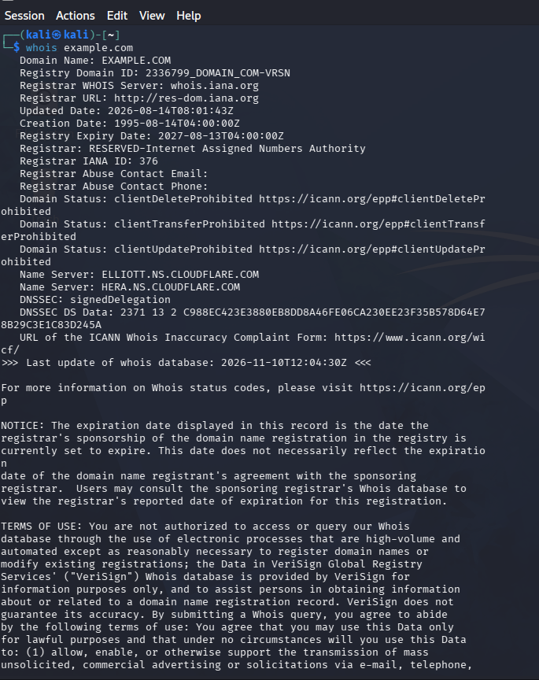

Figure 2. WhatWeb web technology fingerprint of example.com.
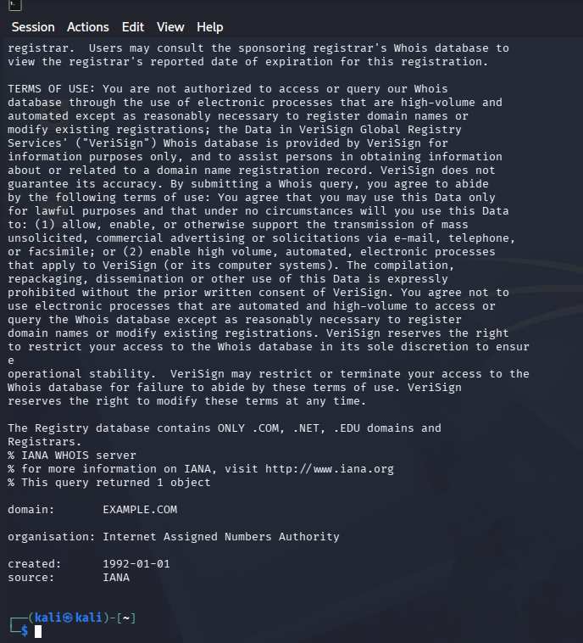

Figure 3. Nslookup DNS resolution for example.com.
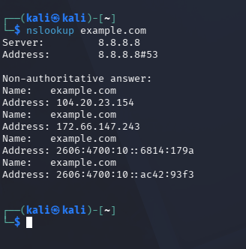

Figure 4. Curl HTTP response headers for https://example.com.
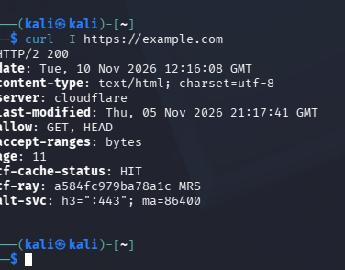

Figure 5. Wafw00f identifies Cloudflare protection for example.com.
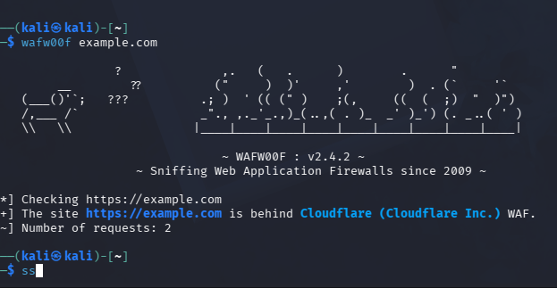

Figure 6. DNSRecon enumeration of example.com DNS records.
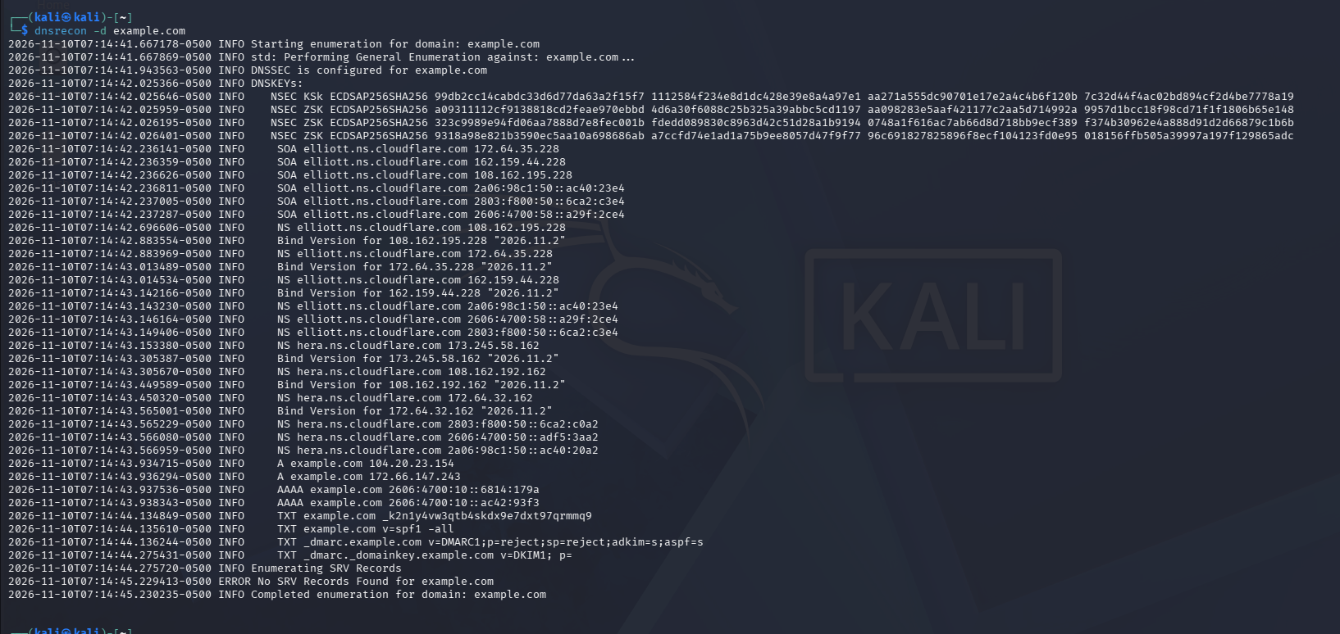

PM3: Maltego Investigation
Figure 7. Maltego desktop setup and initial workspace.
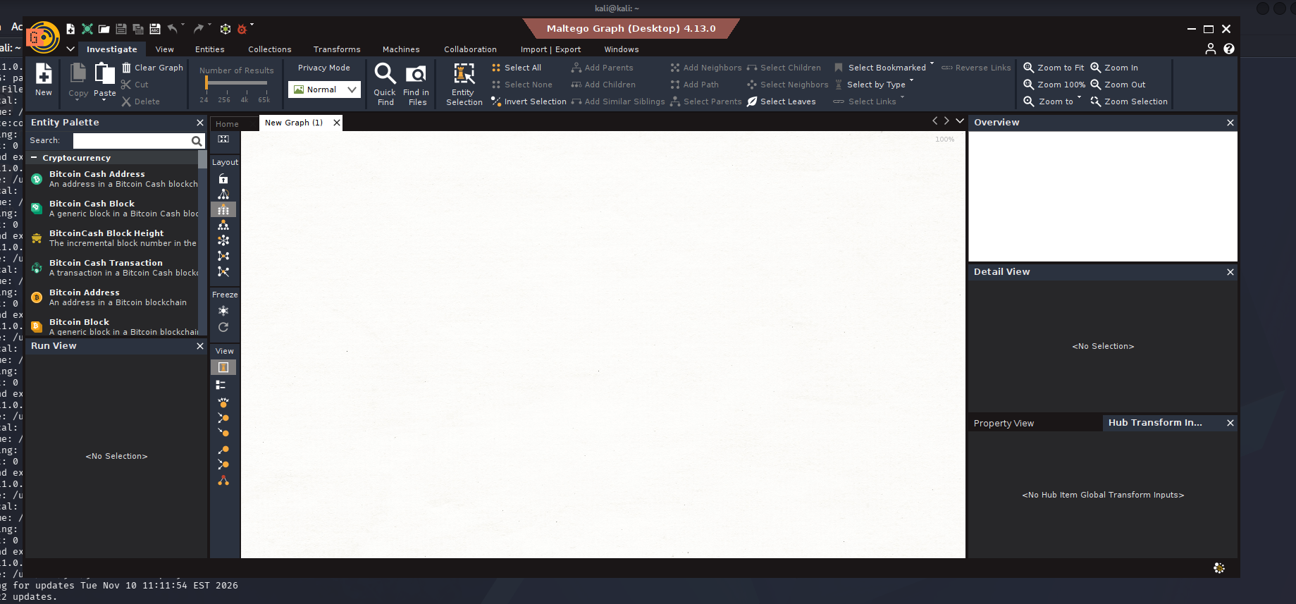

Figure 8. Domain entity configured for example.com.
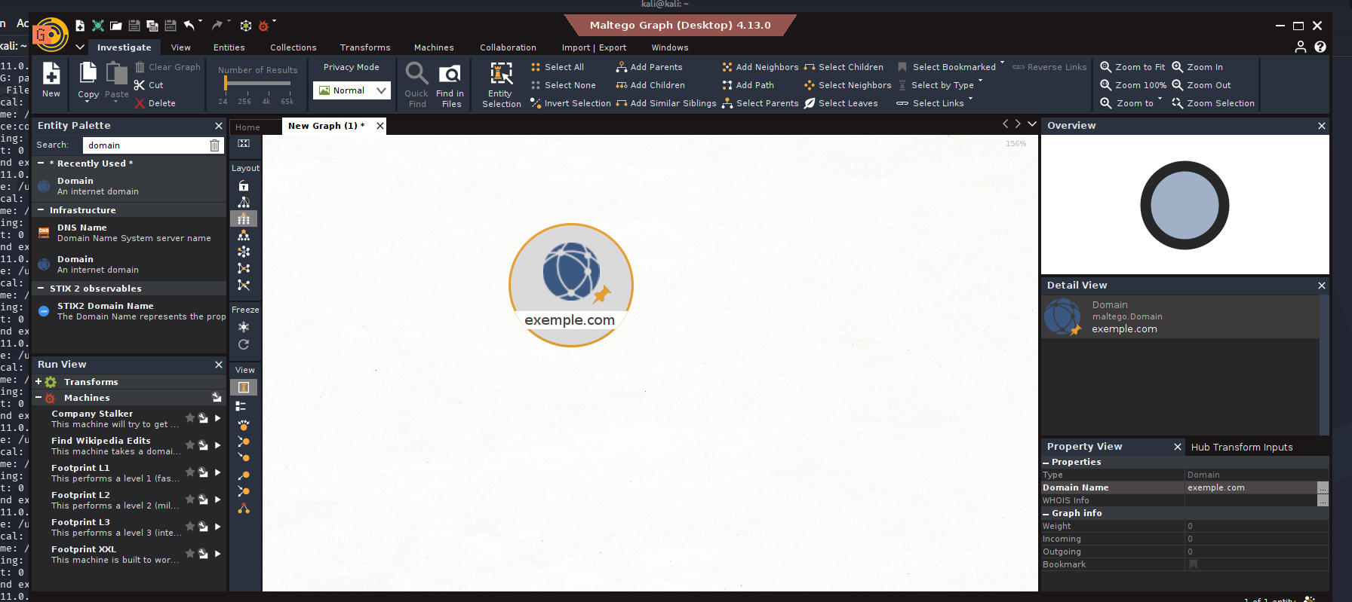

Figure 9. Maltego DNS relationships created with transforms.
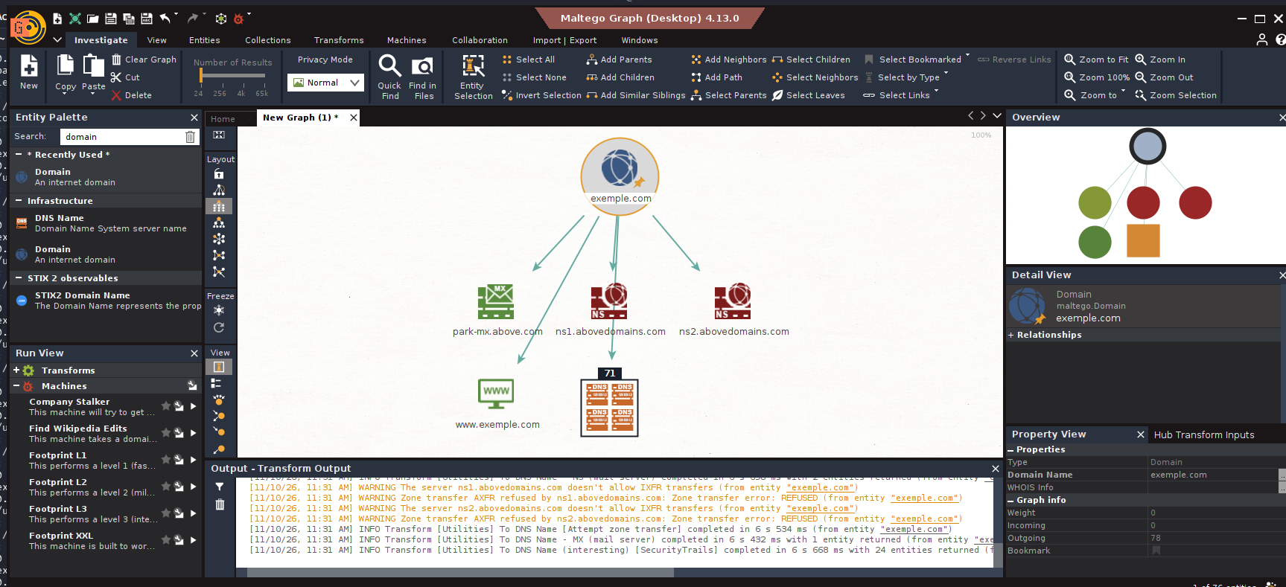

Figure 10. Email-discovery transform graph for example.com; results are not confirmed active addresses.
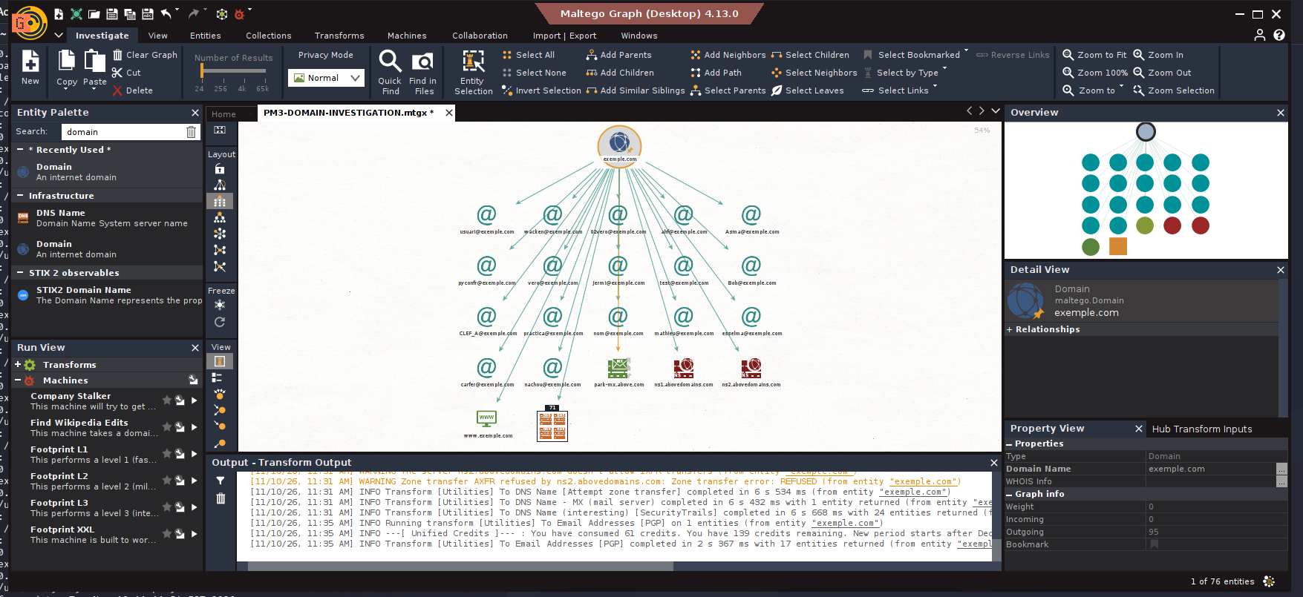

PM4: theHarvester Reconnaissance
Figure 11. theHarvester 4.11.1 help and supported command options.
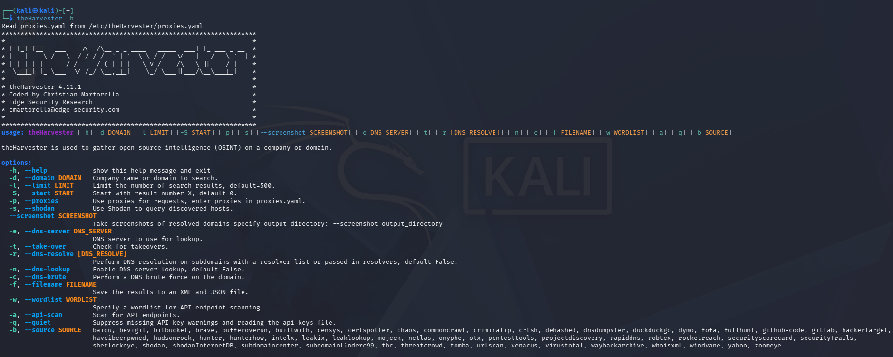

Figure 12. Passive crtsh-source test using example.com as an alternative to unsupported Baidu.
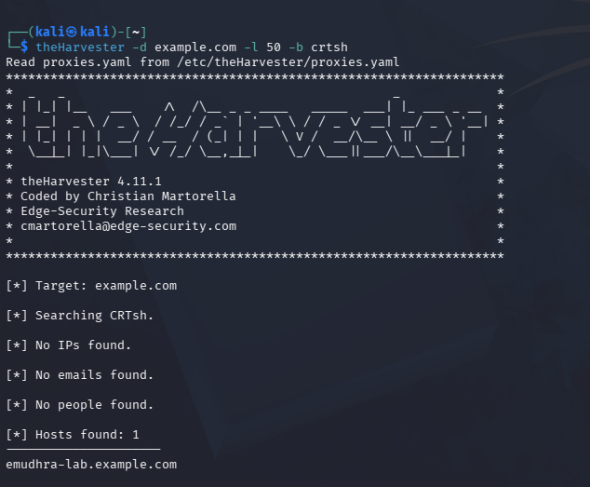

Figure 13. All-sources scan messages noting missing API keys and source errors.
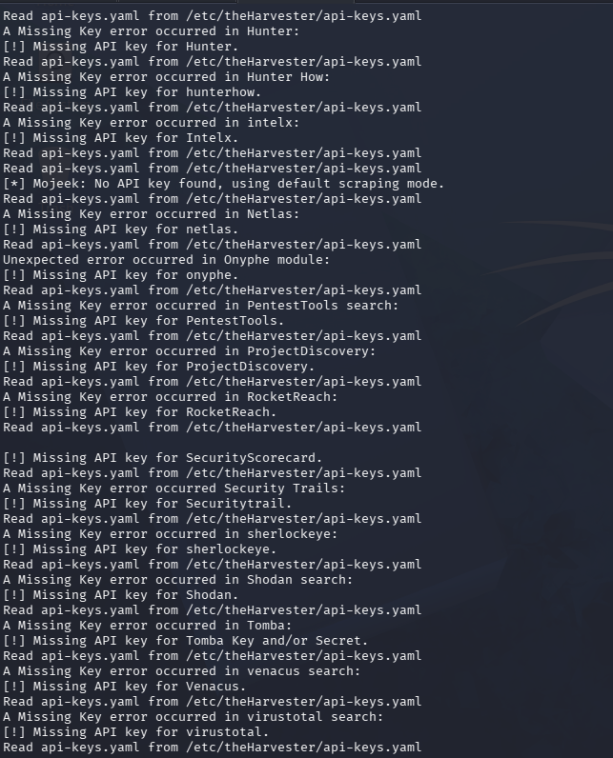

Figure 14. All-sources output for example.com; discovered entries were not independently verified.
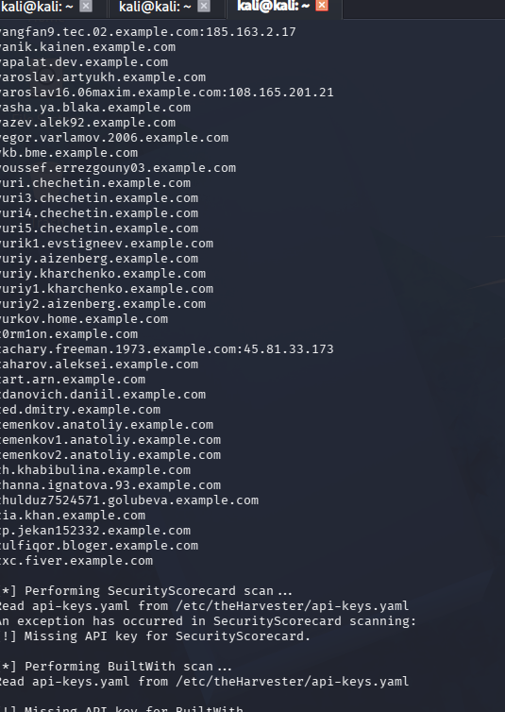

PM5: Zenmap Network Scanning
Figure 15. Kali address and network interface configuration (earlier lab state).
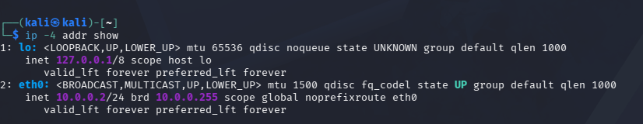

Figure 16. Initial 10.0.2.0/24 discovery reported 256 hosts up; result is unverified.
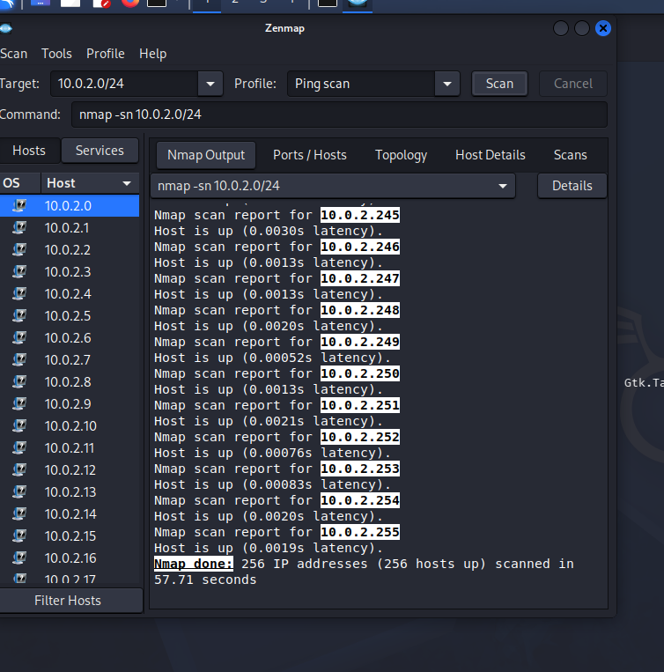

Figure 17. Current 10.0.0.0/24 route and gateway neighbor details.
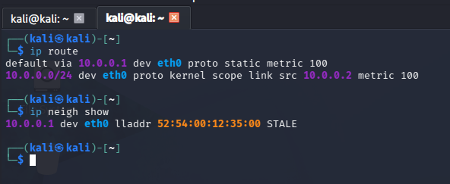

Figure 18. Four ICMP responses from the virtual gateway 10.0.0.1.
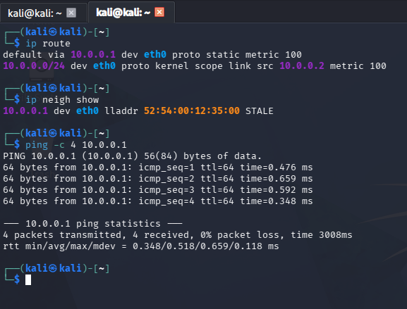

Figure 19. Kali eth0 MAC address and link state.
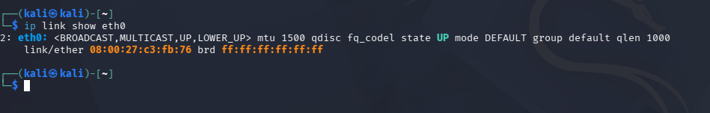

Figure 20. Focused ping discovery confirms 10.0.0.1 and 10.0.0.2 responded.
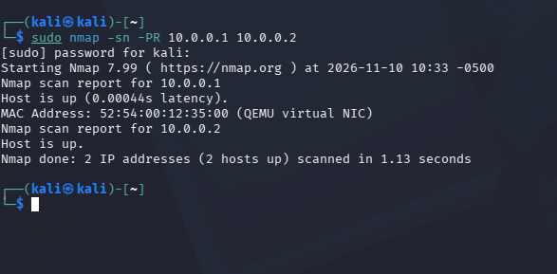

Figure 21. Initial Zenmap topology with overlapping host circles; unreliable for host counting.
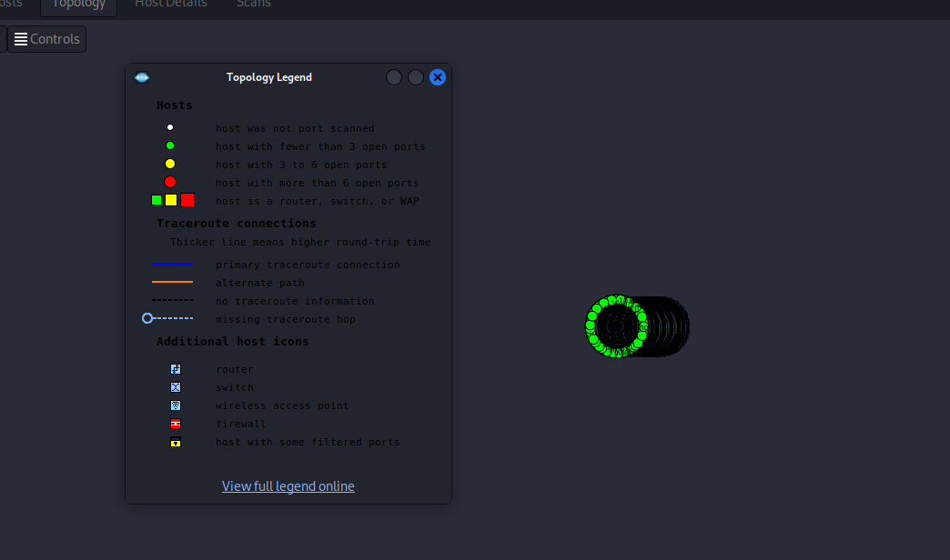

Figure 22. Clean Zenmap topology visualization for the two selected lab addresses.
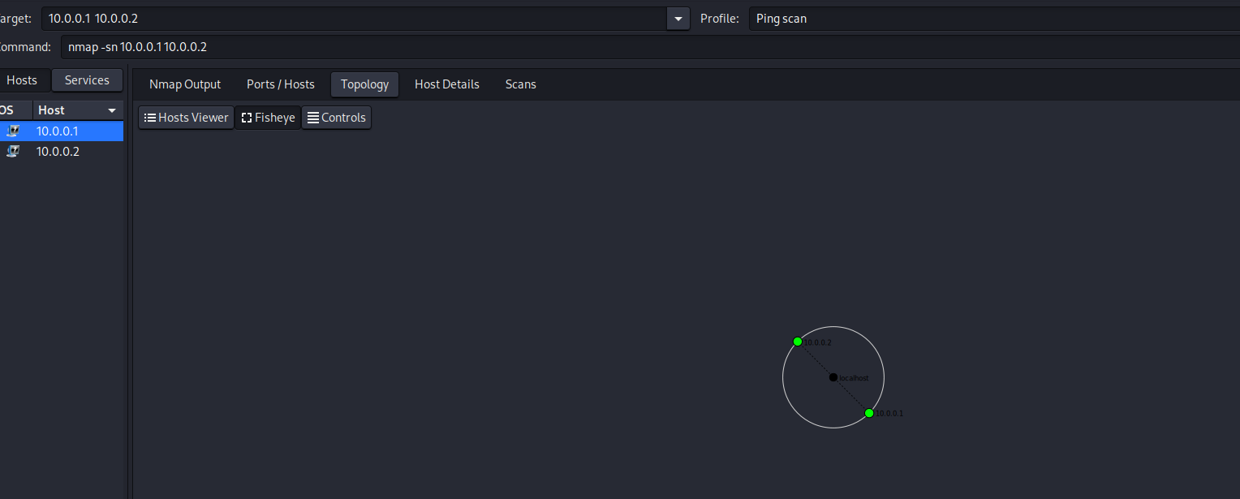

9. Supporting Files and Limitations
Topology PDF: pm5.network.topology.final.pdf. This file contains the exported topology from my virtual network.
Maltego graph: PM3-DOMAIN-INVESTIGATION.mtgx.mtgl. This file contains my saved investigation graph.
Interpretation: The selected two-host discovery and 256-host initial scan are different tests. The two-address result confirms only 10.0.0.1 and 10.0.0.2 responded. It does not establish that only two hosts exist throughout a /24 subnet. The 256-host report from the earlier NAT environment remains unverified.
Authorization: The supplied sample permission letter applied to another tester and an earlier period. No live testing of microsoft.com or networkwalks.com is claimed in this report.

10. Source Materials
- Networkwalks W2-PM1: Footprinting with Kali Tools
- Networkwalks W2-PM3: Footprinting with Maltego
- Networkwalks W2-PM4: theHarvester
- Networkwalks W2-PM5: Zenmap Scanning
- Networkwalks W2-PM-FINAL: Sample Report v2
- Networkwalks Sample Permission Letter: sample only

