TASK

PROBLEM STATEMENT :

script to copy history of every hour in specific file located in s3 bucket

APPROCH 🡪

* First, we need to configure aws with that or different instance (need to keep in mind that user should have full access of S3 so that he can modify S3 bucket at least)
* We need to write a script that will take history and append that to a file in a folder of specific S3 bucket
* Then apply crontab job every hour so that this script will be run every hour

**STEP**

STEP 1 Get Access key and secret key of user who has sufficient authority to create Ami and manage them

STEP 2 Launch the instance. I am using ubuntu for this and I am taking backup of this instance only.

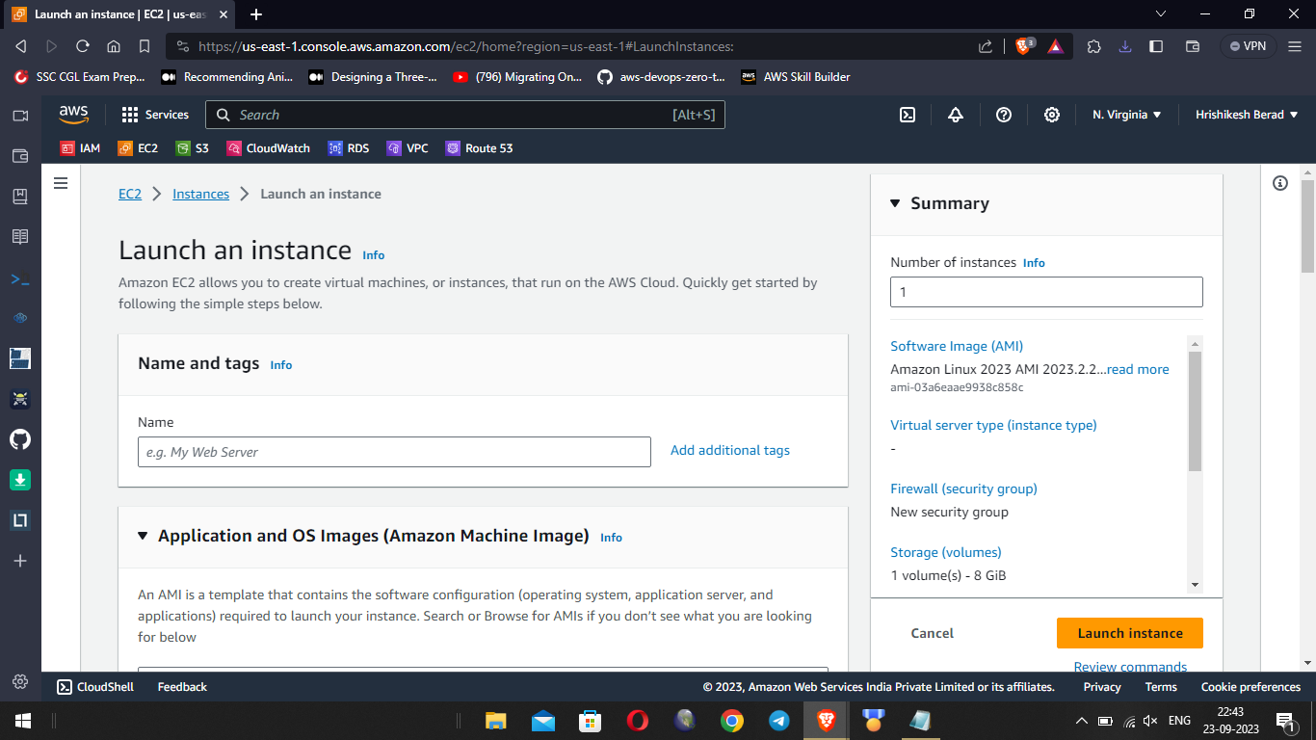

**STEP 3** Get ssh access of instance using public Ip of instance [note: make sure you have private key available in folder where you are taking ssh of instance]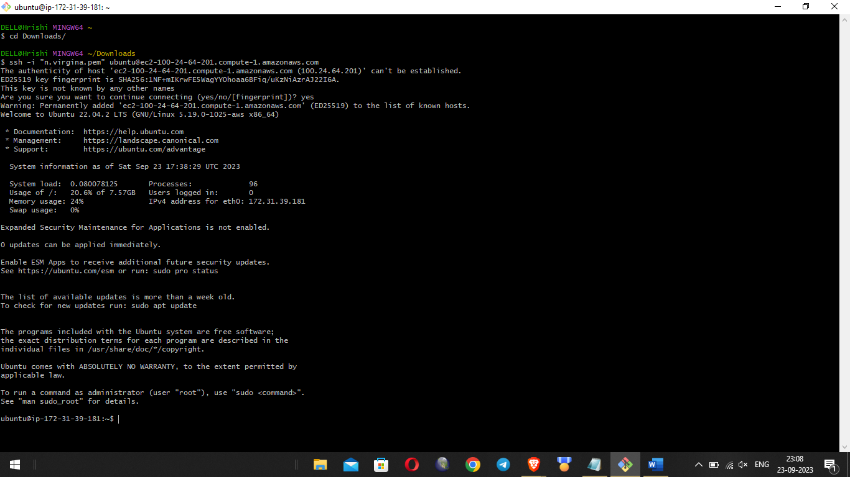

STEP 4 install aws cli in it using command sudo apt-get update && sudo apt-get install awscli

STEP 5 After this we need to configure aws in our instance to do this run command “**aws configure” , enter your access key and secret key**

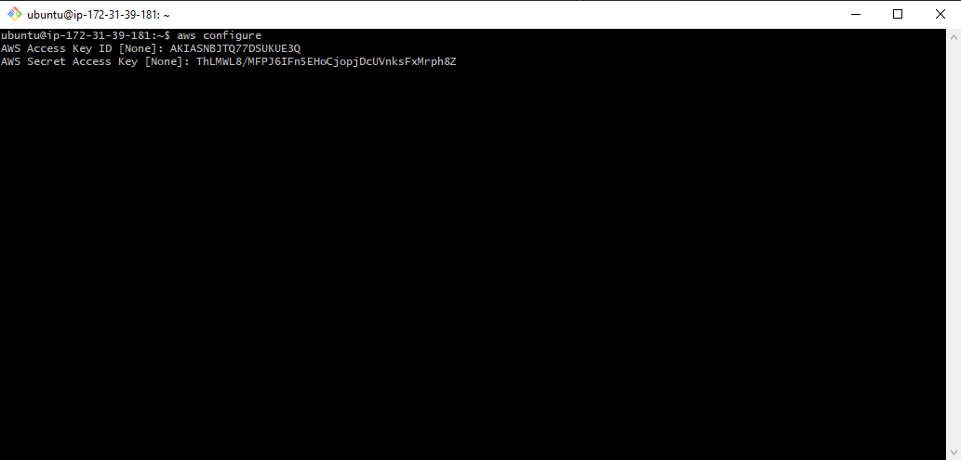

**STEP 6 Create a shell script backup_history.sh to copy your shell history to an S3 bucket.**

**#!/bin/bash**

**S3_BUCKET="aws4373"**

**DEST_FILE="hourly-history/$(date +\%Y\%m\%d\%H).txt"**

**history > /tmp/history.txt**

**aws s3 cp /tmp/history.txt "s3://$S3_BUCKET/$DEST_FILE"**

**rm /tmp/history.txt**

**# Print a message**

**echo "Copied shell history to S3: s3://$S3_BUCKET/$DEST_FILE"**

**STEP 7 make that file executable by running chmod +x backup_history.sh**

**STEP 8 Create a Crontab job to execute this every hour**

**0 * * * * /root/backup_history.sh**

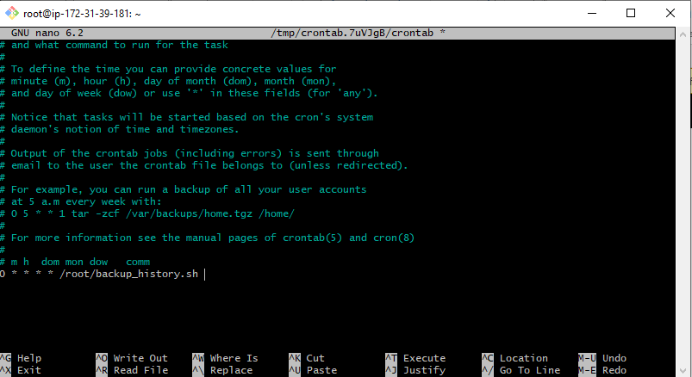

**THAT’S it history will save in S3 every hour**

