ReactJS - Overview

ReactJS is JavaScript library used for building reusable UI components. According to React official documentation, following is the definition −

React is a library for building composable user interfaces. It encourages the creation of reusable UI components, which present data that changes over time. Lots of people use React as the V in MVC. React abstracts away the DOM from you, offering a simpler programming model and better performance. React can also render on the server using Node, and it can power native apps using React Native. React implements one-way reactive data flow, which reduces the boilerplate and is easier to reason about than traditional data binding.

ReactJS - Environment Setup

In this chapter, we will show you how to set up an environment for successful React development. Notice that there are many steps involved but this will help speed up the development process later. We will need **NodeJS**, so if you don't have it installed, check the link from the following table.

|  |  |
| --- | --- |
| **Sr.No.** | **Software & Description** |
| 1 | **NodeJS and NPM**  NodeJS is the platform needed for the ReactJS development. Checkout our [**NodeJS Environment Setup**](https://www.tutorialspoint.com/nodejs/nodejs_environment_setup.htm). |

After successfully installing NodeJS, we can start installing React upon it using npm. You can install NodeJS in two ways

* Using webpack and babel.
* Using the **create-react-app** command.

Installing ReactJS using webpack and babel

**Webpack** is a module bundler (manages and loads independent modules). It takes dependent modules and compiles them to a single (file) bundle. You can use this bundle while developing apps using command line or, by configuring it using webpack.config file.

Babel is a JavaScript compiler and transpiler. It is used to convert one source code to other. Using this you will be able to use the new ES6 features in your code where, babel converts it into plain old ES5 which can be run on all browsers.

Step 1 - Create the Root Folder

Create a folder with name **reactApp** on the desktop to install all the required files, using the mkdir command.

C:\Users\username\Desktop>mkdir reactApp

C:\Users\username\Desktop>cd reactApp

To create any module, it is required to generate the **package.json** file. Therefore, after Creating the folder, we need to create a **package.json** file. To do so you need to run the **npm init** command from the command prompt.

C:\Users\username\Desktop\reactApp>npm init

This command asks information about the module such as packagename, description, author etc. you can skip these using the –y option.

C:\Users\username\Desktop\reactApp>npm init -y

Wrote to C:\reactApp\package.json:

{

"name": "reactApp",

"version": "1.0.0",

"description": "",

"main": "index.js",

"scripts": {

"test": "echo \"Error: no test specified\" && exit 1"

},

"keywords": [],

"author": "",

"license": "ISC"

}

Step 2 - install React and react dom

Since our main task is to install ReactJS, install it, and its dom packages, using **install react** and **react-dom** commands of npm respectively. You can add the packages we install, to **package.json** file using the **--save** option.

C:\Users\Tutorialspoint\Desktop\reactApp>npm install react --save

C:\Users\Tutorialspoint\Desktop\reactApp>npm install react-dom --save

Or, you can install all of them in single command as −

C:\Users\username\Desktop\reactApp>npm install react react-dom --save

Step 3 - Install webpack

Since we are using webpack to generate bundler install webpack, webpack-dev-server and webpack-cli.

C:\Users\username\Desktop\reactApp>npm install webpack –save

C:\Users\username\Desktop\reactApp>npm install webpack-dev-server --save

C:\Users\username\Desktop\reactApp>npm install webpack-cli --save

Or, you can install all of them in single command as −

C:\Users\username\Desktop\reactApp>npm install webpack webpack-dev-server webpack-cli --save

Step 4 - Install babel

Install babel, and its plugins babel-core, babel-loader, babel-preset-env, babel-preset-react and, html-webpack-plugin

C:\Users\username\Desktop\reactApp>npm install babel-core --save-dev

C:\Users\username\Desktop\reactApp>npm install babel-loader --save-dev

C:\Users\username\Desktop\reactApp>npm install babel-preset-env --save-dev

C:\Users\username\Desktop\reactApp>npm install babel-preset-react --save-dev

C:\Users\username\Desktop\reactApp>npm install html-webpack-plugin --save-dev

Or, you can install all of them in single command as −

C:\Users\username\Desktop\reactApp>npm install babel-core babel-loader babel-preset-env

babel-preset-react html-webpack-plugin --save-dev

Step 5 - Create the Files

To complete the installation, we need to create certain files namely, index.html, App.js, main.js, webpack.config.js and, .***babelrc***. You can create these files manually or, using **command prompt**.

C:\Users\username\Desktop\reactApp>type nul > index.html

C:\Users\username\Desktop\reactApp>type nul > App.js

C:\Users\username\Desktop\reactApp>type nul > main.js

C:\Users\username\Desktop\reactApp>type nul > webpack.config.js

C:\Users\username\Desktop\reactApp>type nul > .babelrc

Step 6 - Set Compiler, Server and Loaders

Open **webpack-config.js** file and add the following code. We are setting webpack entry point to be main.js. Output path is the place where bundled app will be served. We are also setting the development server to **8001** port. You can choose any port you want.

**webpack.config.js**

const path = require('path');

const HtmlWebpackPlugin = require('html-webpack-plugin');

module.exports = {

entry: './main.js',

output: {

path: path.join(__dirname, '/bundle'),

filename: 'index_bundle.js'

},

devServer: {

inline: true,

port: 8080

},

module: {

rules: [

{

test: /\.jsx?$/,

exclude: /node_modules/,

loader: 'babel-loader',

query: {

presets: ['es2015', 'react']

}

}

]

},

plugins:[

new HtmlWebpackPlugin({

template: './index.html'

})

]

}

Open the **package.json** and delete **"test" "echo \"Error: no test specified\" && exit 1"** inside **"scripts"** object. We are deleting this line since we will not do any testing in this tutorial. Let's add the **start** and **build** commands instead.

"start": "webpack-dev-server --mode development --open --hot",

"build": "webpack --mode production"

Step 7 - index.html

This is just regular HTML. We are setting **div id = "app"** as a root element for our app and adding **index_bundle.js** script, which is our bundled app file.

<!DOCTYPE html>

<html lang = "en">

<head>

<meta charset = "UTF-8">

<title>React App</title>

</head>

<body>

<div id = "app"></div>

<script src = 'index_bundle.js'></script>

</body>

</html>

Step 8 − App.jsx and main.js

This is the first React component. We will explain React components in depth in a subsequent chapter. This component will render **Hello World**.

**App.js**

import React, { Component } from 'react';

class App extends Component{

render(){

return(

<div>

<h1>Hello World</h1>

</div>

);

}

}

export default App;

We need to import this component and render it to our root **App**element, so we can see it in the browser.

**main.js**

import React from 'react';

import ReactDOM from 'react-dom';

import App from './App.js';

ReactDOM.render(<App />, document.getElementById('app'));

**Note** − Whenever you want to use something, you need to **import** it first. If you want to make the component usable in other parts of the app, you need to **export** it after creation and import it in the file where you want to use it.

Create a file with name **.babelrc** and copy the following content to it.

{

"presets":["env", "react"]

}

Step 9 - Running the Server

The setup is complete and we can start the server by running the following command.

C:\Users\username\Desktop\reactApp>npm start

It will show the port we need to open in the browser. In our case, it is **http://localhost:8001/**. After we open it, we will see the following output.

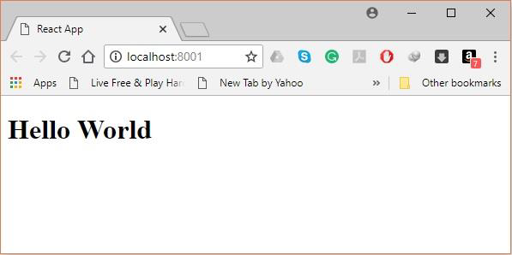

Step 10 - Generating the bundle

Finally, to generate the bundle you need to run the build command in the command prompt as −

C:\Users\Tutorialspoint\Desktop\reactApp>npm run build

This will generate the bundle in the current folder as shown below.

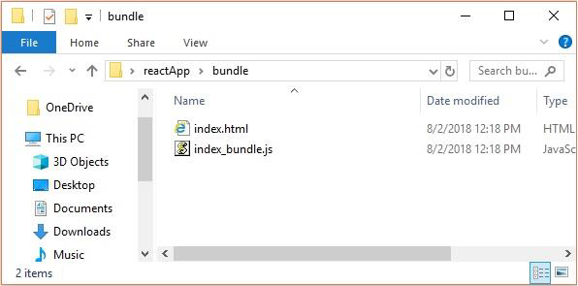

Using the create-react-app command

Instead of using webpack and babel you can install ReactJS more simply by installing **create-react-app**.

Step 1 - install create-react-app

Browse through the desktop and install the Create React App using command prompt as shown below −

C:\Users\Tutorialspoint>cd C:\Users\Tutorialspoint\Desktop\

C:\Users\Tutorialspoint\Desktop>npx create-react-app my-app

This will create a folder named my-app on the desktop and installs all the required files in it.

Step 2 - Delete all the source files

Browse through the src folder in the generated my-app folder and remove all the files in it as shown below −

C:\Users\Tutorialspoint\Desktop>cd my-app/src

C:\Users\Tutorialspoint\Desktop\my-app\src>del *

C:\Users\Tutorialspoint\Desktop\my-app\src\*, Are you sure (Y/N)? y

Step 3 - Add files

Add files with names **index.css** and **index.js** in the src folder as −

C:\Users\Tutorialspoint\Desktop\my-app\src>type nul > index.css

C:\Users\Tutorialspoint\Desktop\my-app\src>type nul > index.js

In the index.js file add the following code

import React from 'react';

import ReactDOM from 'react-dom';

import './index.css';

Step 4 - Run the project

Finally, run the project using the start command.

npm start

JavaScript Expressions

JavaScript expressions can be used inside of JSX. We just need to wrap it with curly brackets **{}**. The following example will render **2**.

import React from 'react';

class App extends React.Component {

render() {

return (

<div>

<h1>{1+1}</h1>

</div>

);

}

}

export default App;

We cannot use **if else** statements inside JSX, instead we can use **conditional (ternary)** expressions. In the following example, variable **i** equals to **1** so the browser will render **true**, If we change it to some other value, it will render **false**.

import React from 'react';

class App extends React.Component {

render() {

var i = 1;

return (

<div>

<h1>{i == 1 ? 'True!' : 'False'}</h1>

</div>

);

}

}

export default App;

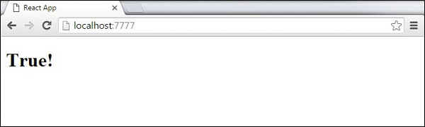

Styling

React recommends using inline styles. When we want to set inline styles, we need to use **camelCase** syntax. React will also automatically append **px** after the number value on specific elements. The following example shows how to add **myStyle**inline to **h1** element.

import React from 'react';

class App extends React.Component {

render() {

var myStyle = {

fontSize: 100,

color: '#FF0000'

}

return (

<div>

<h1 style = {myStyle}>Header</h1>

</div>

);

}

}

export default App;

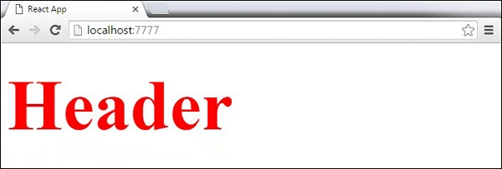

Comments

When writing comments, we need to put curly brackets **{}** when we want to write comment within children section of a tag. It is a good practice to always use **{}** when writing comments, since we want to be consistent when writing the app.

import React from 'react';

class App extends React.Component {

render() {

return (

<div>

<h1>Header</h1>

{//End of the line Comment...}

{/*Multi line comment...*/}

</div>

);

}

}

export default App;

Naming Convention

HTML tags always use **lowercase** tag names, while React components start with **Uppercase**.

**Note** − You should use **className** and **htmlFor** as XML attribute names instead of **class** and **for**.

This is explained on React official page as −

Since JSX is JavaScript, identifiers such as **class** and **for** are discouraged as XML attribute names. Instead, React DOM components expect DOM property names such as **className**and **htmlFor**, respectively.

ReactJS - Components

In this chapter, we will learn how to combine components to make the app easier to maintain. This approach allows to update and change your components without affecting the rest of the page.

Stateless Example

Our first component in the following example is **App**. This component is owner of **Header** and **Content**. We are creating **Header** and **Content** separately and just adding it inside JSX tree in our **App** component. Only **App** component needs to be exported.

App.jsx

import React from 'react';

class App extends React.Component {

render() {

return (

<div>

<Header/>

<Content/>

</div>

);

}

}

class Header extends React.Component {

render() {

return (

<div>

<h1>Header</h1>

</div>

);

}

}

class Content extends React.Component {

render() {

return (

<div>

<h2>Content</h2>

<p>The content text!!!</p>

</div>

);

}

}

export default App;

To be able to render this on the page, we need to import it in **main.js** file and call **reactDOM.render()**. We already did this while setting the environment.

main.js

import React from 'react';

import ReactDOM from 'react-dom';

import App from './App.jsx';

ReactDOM.render(<App />, document.getElementById('app'));

The above code will generate the following result.

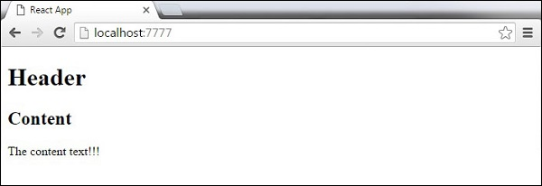

Stateful Example

In this example, we will set the state for owner component (**App**). The **Header** component is just added like in the last example since it doesn't need any state. Instead of content tag, we are creating **table** and **tbody** elements, where we will dynamically insert **TableRow** for every object from the **data**array.

It can be seen that we are using EcmaScript 2015 arrow syntax (=>) which looks much cleaner than the old JavaScript syntax. This will help us create our elements with fewer lines of code. It is especially useful when we need to create a list with a lot of items.

App.jsx

import React from 'react';

class App extends React.Component {

constructor() {

super();

this.state = {

data:

[

{

"id":1,

"name":"Foo",

"age":"20"

},

{

"id":2,

"name":"Bar",

"age":"30"

},

{

"id":3,

"name":"Baz",

"age":"40"

}

]

}

}

render() {

return (

<div>

<Header/>

<table>

<tbody>

{this.state.data.map((person, i) => <TableRow key = {i}

data = {person} />)}

</tbody>

</table>

</div>

);

}

}

class Header extends React.Component {

render() {

return (

<div>

<h1>Header</h1>

</div>

);

}

}

class TableRow extends React.Component {

render() {

return (

<tr>

<td>{this.props.data.id}</td>

<td>{this.props.data.name}</td>

<td>{this.props.data.age}</td>

</tr>

);

}

}

export default App;

**Note** − Notice that we are using **key = {i} inside map()**function. This will help React to update only the necessary elements instead of re-rendering the entire list when something changes. It is a huge performance boost for larger number of dynamically created elements.

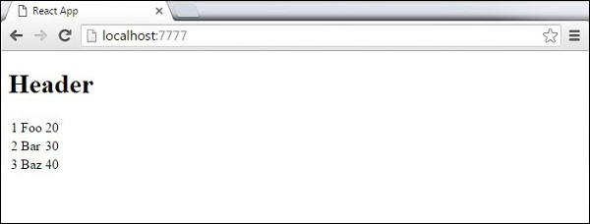

ReactJS - State

**State** is the place where the data comes from. We should always try to make our state as simple as possible and minimize the number of stateful components. If we have, for example, ten components that need data from the state, we should create one container component that will keep the state for all of them.

Using State

The following sample code shows how to create a stateful component using EcmaScript2016 syntax.

App.jsx

import React from 'react';

class App extends React.Component {

constructor(props) {

super(props);

this.state = {

header: "Header from state...",

content: "Content from state..."

}

}

render() {

return (

<div>

<h1>{this.state.header}</h1>

<h2>{this.state.content}</h2>

</div>

);

}

}

export default App;

This will produce the following result.

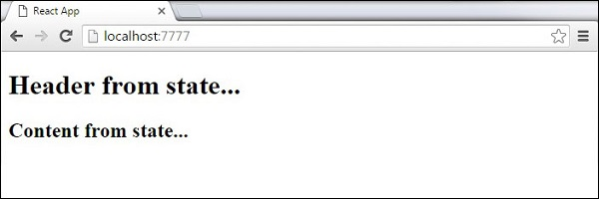

ReactJS - Props Overview

The main difference between state and props is that **props** are immutable. This is why the container component should define the state that can be updated and changed, while the child components should only pass data from the state using props.

Using Props

When we need immutable data in our component, we can just add props to **reactDOM.render()** function in **main.js** and use it inside our component.

App.jsx

import React from 'react';

class App extends React.Component {

render() {

return (

<div>

<h1>{this.props.headerProp}</h1>

<h2>{this.props.contentProp}</h2>

</div>

);

}

}

export default App;

main.js

import React from 'react';

import ReactDOM from 'react-dom';

import App from './App.jsx';

ReactDOM.render(<App headerProp = "Header from props..." contentProp = "Content

from props..."/>, document.getElementById('app'));

export default App;

This will produce the following result.

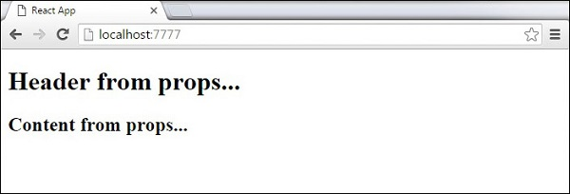

Default Props

You can also set default property values directly on the component constructor instead of adding it to the **reactDom.render()** element.

App.jsx

import React from 'react';

class App extends React.Component {

render() {

return (

<div>

<h1>{this.props.headerProp}</h1>

<h2>{this.props.contentProp}</h2>

</div>

);

}

}

App.defaultProps = {

headerProp: "Header from props...",

contentProp:"Content from props..."

}

export default App;

Output is the same as before.



State and Props

The following example shows how to combine **state** and props in your app. We are setting the state in our parent component and passing it down the component tree using **props**. Inside the **render** function, we are setting **headerProp** and **contentProp**used in child components.

App.jsx

import React from 'react';

class App extends React.Component {

constructor(props) {

super(props);

this.state = {

header: "Header from props...",

content: "Content from props..."

}

}

render() {

return (

<div>

<Header headerProp = {this.state.header}/>

<Content contentProp = {this.state.content}/>

</div>

);

}

}

class Header extends React.Component {

render() {

return (

<div>

<h1>{this.props.headerProp}</h1>

</div>

);

}

}

class Content extends React.Component {

render() {

return (

<div>

<h2>{this.props.contentProp}</h2>

</div>

);

}

}

export default App;

The result will again be the same as in the previous two examples, the only thing that is different is the source of our data, which is now originally coming from the **state**. When we want to update it, we just need to update the state, and all child components will be updated. More on this in the Events chapter.



ReactJS - Props Validation

Properties validation is a useful way to force the correct usage of the components. This will help during development to avoid future bugs and problems, once the app becomes larger. It also makes the code more readable, since we can see how each component should be used.

Validating Props

In this example, we are creating **App** component with all the **props** that we need. **App.propTypes** is used for props validation. If some of the props aren't using the correct type that we assigned, we will get a console warning. After we specify validation patterns, we will set **App.defaultProps**.

App.jsx

import React from 'react';

class App extends React.Component {

render() {

return (

<div>

<h3>Array: {this.props.propArray}</h3>

<h3>Bool: {this.props.propBool ? "True..." : "False..."}</h3>

<h3>Func: {this.props.propFunc(3)}</h3>

<h3>Number: {this.props.propNumber}</h3>

<h3>String: {this.props.propString}</h3>

<h3>Object: {this.props.propObject.objectName1}</h3>

<h3>Object: {this.props.propObject.objectName2}</h3>

<h3>Object: {this.props.propObject.objectName3}</h3>

</div>

);

}

}

App.propTypes = {

propArray: React.PropTypes.array.isRequired,

propBool: React.PropTypes.bool.isRequired,

propFunc: React.PropTypes.func,

propNumber: React.PropTypes.number,

propString: React.PropTypes.string,

propObject: React.PropTypes.object

}

App.defaultProps = {

propArray: [1,2,3,4,5],

propBool: true,

propFunc: function(e){return e},

propNumber: 1,

propString: "String value...",

propObject: {

objectName1:"objectValue1",

objectName2: "objectValue2",

objectName3: "objectValue3"

}

}

export default App;

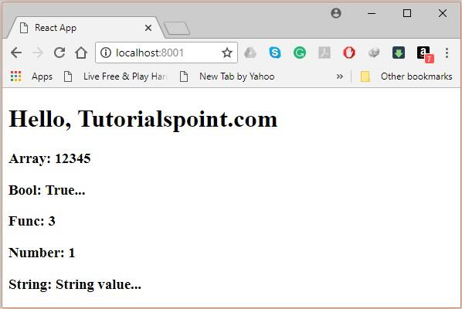

ReactJS - Component API

In this chapter, we will explain React component API. We will discuss three methods: **setState(), forceUpdate** and **ReactDOM.findDOMNode()**. In new ES6 classes, we have to manually bind this. We will use **this.method.bind(this)** in the examples.

Set State

**setState()** method is used to update the state of the component. This method will not replace the state, but only add changes to the original state.

import React from 'react';

class App extends React.Component {

constructor() {

super();

this.state = {

data: []

}

this.setStateHandler = this.setStateHandler.bind(this);

};

setStateHandler() {

var item = "setState..."

var myArray = this.state.data.slice();

myArray.push(item);

this.setState({data: myArray})

};

render() {

return (

<div>

<button onClick = {this.setStateHandler}>SET STATE</button>

<h4>State Array: {this.state.data}</h4>

</div>

);

}

}

export default App;

We started with an empty array. Every time we click the button, the state will be updated. If we click five times, we will get the following output.

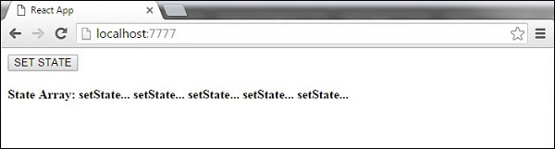

Force Update

Sometimes we might want to update the component manually. This can be achieved using the **forceUpdate()** method.

import React from 'react';

class App extends React.Component {

constructor() {

super();

this.forceUpdateHandler = this.forceUpdateHandler.bind(this);

};

forceUpdateHandler() {

this.forceUpdate();

};

render() {

return (

<div>

<button onClick = {this.forceUpdateHandler}>FORCE UPDATE</button>

<h4>Random number: {Math.random()}</h4>

</div>

);

}

}

export default App;

We are setting a random number that will be updated every time the button is clicked.

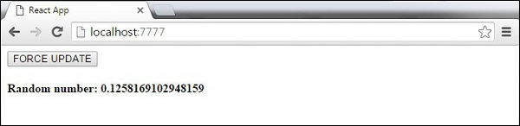

Find Dom Node

For DOM manipulation, we can use **ReactDOM.findDOMNode()**method. First we need to import **react-dom**.

import React from 'react';

import ReactDOM from 'react-dom';

class App extends React.Component {

constructor() {

super();

this.findDomNodeHandler = this.findDomNodeHandler.bind(this);

};

findDomNodeHandler() {

var myDiv = document.getElementById('myDiv');

ReactDOM.findDOMNode(myDiv).style.color = 'green';

}

render() {

return (

<div>

<button onClick = {this.findDomNodeHandler}>FIND DOME NODE</button>

<div id = "myDiv">NODE</div>

</div>

);

}

}

export default App;

The color of **myDiv** element changes to green, once the button is clicked.

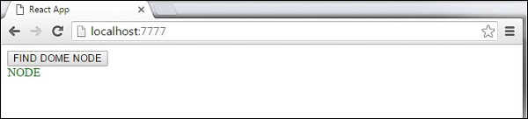

**Note** − Since the 0.14 update, most of the older component API methods are deprecated or removed to accommodate ES6.

ReactJS - Component Life Cycle

In this chapter, we will discuss component lifecycle methods.

Lifecycle Methods

* **componentWillMount** is executed before rendering, on both the server and the client side.
* **componentDidMount** is executed after the first render only on the client side. This is where AJAX requests and DOM or state updates should occur. This method is also used for integration with other JavaScript frameworks and any functions with delayed execution such as **setTimeout** or **setInterval**. We are using it to update the state so we can trigger the other lifecycle methods.
* **componentWillReceiveProps** is invoked as soon as the props are updated before another render is called. We triggered it from **setNewNumber** when we updated the state.
* **shouldComponentUpdate** should return **true** or **false**value. This will determine if the component will be updated or not. This is set to **true** by default. If you are sure that the component doesn't need to render after **state** or **props** are updated, you can return **false** value.
* **componentWillUpdate** is called just before rendering.
* **componentDidUpdate** is called just after rendering.
* **componentWillUnmount** is called after the component is unmounted from the dom. We are unmounting our component in **main.js**.

In the following example, we will set the initial **state** in the constructor function. The **setNewnumber** is used to update the **state**. All the lifecycle methods are inside the Content component.

App.jsx

import React from 'react';

class App extends React.Component {

constructor(props) {

super(props);

this.state = {

data: 0

}

this.setNewNumber = this.setNewNumber.bind(this)

};

setNewNumber() {

this.setState({data: this.state.data + 1})

}

render() {

return (

<div>

<button onClick = {this.setNewNumber}>INCREMENT</button>

<Content myNumber = {this.state.data}></Content>

</div>

);

}

}

class Content extends React.Component {

componentWillMount() {

console.log('Component WILL MOUNT!')

}

componentDidMount() {

console.log('Component DID MOUNT!')

}

componentWillReceiveProps(newProps) {

console.log('Component WILL RECIEVE PROPS!')

}

shouldComponentUpdate(newProps, newState) {

return true;

}

componentWillUpdate(nextProps, nextState) {

console.log('Component WILL UPDATE!');

}

componentDidUpdate(prevProps, prevState) {

console.log('Component DID UPDATE!')

}

componentWillUnmount() {

console.log('Component WILL UNMOUNT!')

}

render() {

return (

<div>

<h3>{this.props.myNumber}</h3>

</div>

);

}

}

export default App;

main.js

import React from 'react';

import ReactDOM from 'react-dom';

import App from './App.jsx';

ReactDOM.render(<App/>, document.getElementById('app'));

setTimeout(() => {

ReactDOM.unmountComponentAtNode(document.getElementById('app'));}, 10000);

After the initial render, we will get the following screen.

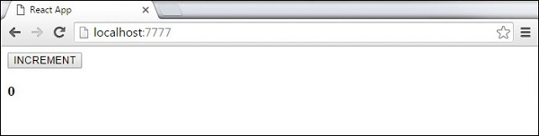

ReactJS - Forms

In this chapter, we will learn how to use forms in React.

Simple Example

In the following example, we will set an input form with **value = {this.state.data}**. This allows to update the state whenever the input value changes. We are using **onChange** event that will watch the input changes and update the state accordingly.

App.jsx

import React from 'react';

class App extends React.Component {

constructor(props) {

super(props);

this.state = {

data: 'Initial data...'

}

this.updateState = this.updateState.bind(this);

};

updateState(e) {

this.setState({data: e.target.value});

}

render() {

return (

<div>

<input type = "text" value = {this.state.data}

onChange = {this.updateState} />

<h4>{this.state.data}</h4>

</div>

);

}

}

export default App;

main.js

import React from 'react';

import ReactDOM from 'react-dom';

import App from './App.jsx';

ReactDOM.render(<App/>, document.getElementById('app'));

When the input text value changes, the state will be updated.

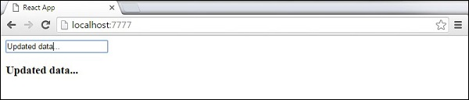

Complex Example

In the following example, we will see how to use forms from child component. **onChange** method will trigger state update that will be passed to the child input **value** and rendered on the screen. A similar example is used in the Events chapter. Whenever we need to update state from child component, we need to pass the function that will handle updating (**updateState**) as a prop (**updateStateProp**).

App.jsx

import React from 'react';

class App extends React.Component {

constructor(props) {

super(props);

this.state = {

data: 'Initial data...'

}

this.updateState = this.updateState.bind(this);

};

updateState(e) {

this.setState({data: e.target.value});

}

render() {

return (

<div>

<Content myDataProp = {this.state.data}

updateStateProp = {this.updateState}></Content>

</div>

);

}

}

class Content extends React.Component {

render() {

return (

<div>

<input type = "text" value = {this.props.myDataProp}

onChange = {this.props.updateStateProp} />

<h3>{this.props.myDataProp}</h3>

</div>

);

}

}

export default App;

This will produce the following result.

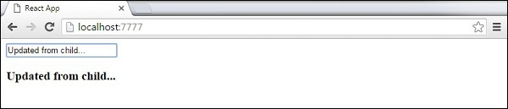

ReactJS - Events

In this chapter, we will learn how to use events.

Simple Example

This is a simple example where we will only use one component. We are just adding **onClick** event that will trigger **updateState**function once the button is clicked.

App.jsx

import React from 'react';

class App extends React.Component {

constructor(props) {

super(props);

this.state = {

data: 'Initial data...'

}

this.updateState = this.updateState.bind(this);

};

updateState() {

this.setState({data: 'Data updated...'})

}

render() {

return (

<div>

<button onClick = {this.updateState}>CLICK</button>

<h4>{this.state.data}</h4>

</div>

);

}

}

export default App;

This will produce the following result.

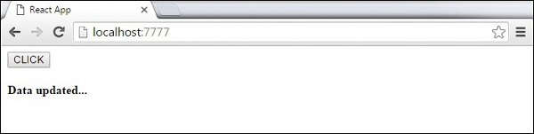

Child Events

When we need to update the **state** of the parent component from its child, we can create an event handler (**updateState**) in the parent component and pass it as a prop (**updateStateProp**) to the child component where we can just call it.

App.jsx

import React from 'react';

class App extends React.Component {

constructor(props) {

super(props);

this.state = {

data: 'Initial data...'

}

this.updateState = this.updateState.bind(this);

};

updateState() {

this.setState({data: 'Data updated from the child component...'})

}

render() {

return (

<div>

<Content myDataProp = {this.state.data}

updateStateProp = {this.updateState}></Content>

</div>

);

}

}

class Content extends React.Component {

render() {

return (

<div>

<button onClick = {this.props.updateStateProp}>CLICK</button>

<h3>{this.props.myDataProp}</h3>

</div>

);

}

}

export default App;

main.js

import React from 'react';

import ReactDOM from 'react-dom';

import App from './App.jsx';

ReactDOM.render(<App/>, document.getElementById('app'));

This will produce the following result.

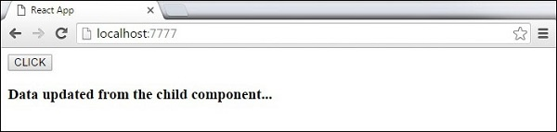

ReactJS - Refs

The **ref** is used to return a reference to the element. **Refs**should be avoided in most cases, however, they can be useful when we need DOM measurements or to add methods to the components.

Using Refs

The following example shows how to use refs to clear the input field. **ClearInput** function searches for element with **ref = "myInput"** value, resets the state, and adds focus to it after the button is clicked.

App.jsx

import React from 'react';

import ReactDOM from 'react-dom';

class App extends React.Component {

constructor(props) {

super(props);

this.state = {

data: ''

}

this.updateState = this.updateState.bind(this);

this.clearInput = this.clearInput.bind(this);

};

updateState(e) {

this.setState({data: e.target.value});

}

clearInput() {

this.setState({data: ''});

ReactDOM.findDOMNode(this.refs.myInput).focus();

}

render() {

return (

<div>

<input value = {this.state.data} onChange = {this.updateState}

ref = "myInput"></input>

<button onClick = {this.clearInput}>CLEAR</button>

<h4>{this.state.data}</h4>

</div>

);

}

}

export default App;

Once the button is clicked, the **input** will be cleared and focused.

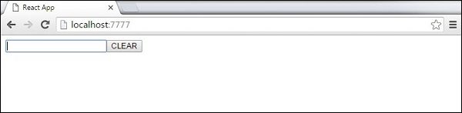

ReactJS - Keys

React **keys** are useful when working with dynamically created components or when your lists are altered by the users. Setting the **key** value will keep your components uniquely identified after the change.

Using Keys

Let's dynamically create **Content** elements with unique index (i). The **map** function will create three elements from our **data**array. Since the **key** value needs to be unique for every element, we will assign i as a key for each created element.

App.jsx

import React from 'react';

class App extends React.Component {

constructor() {

super();

this.state = {

data:[

{

component: 'First...',

id: 1

},

{

component: 'Second...',

id: 2

},

{

component: 'Third...',

id: 3

}

]

}

}

render() {

return (

<div>

<div>

{this.state.data.map((dynamicComponent, i) => <Content

key = {i} componentData = {dynamicComponent}/>)}

</div>

</div>

);

}

}

class Content extends React.Component {

render() {

return (

<div>

<div>{this.props.componentData.component}</div>

<div>{this.props.componentData.id}</div>

</div>

);

}

}

export default App;

We will get the following result for the Key values of each element.

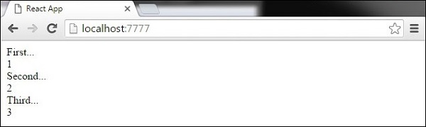

If we add or remove some elements in the future or change the order of the dynamically created elements, React will use the **key** values to keep track of each element.

ReactJS - Router

In this chapter, we will learn how to set up routing for an app.

Step 1 - Install a React Router

A simple way to install the **react-router** is to run the following code snippet in the **command prompt** window.

C:\Users\username\Desktop\reactApp>npm install react-router

Step 2 - Create Components

In this step, we will create four components. The **App**component will be used as a tab menu. The other three components **(Home), (About)** and **(Contact)** are rendered once the route has changed.

main.js

import React from 'react';

import ReactDOM from 'react-dom';

import { Router, Route, Link, browserHistory, IndexRoute } from 'react-router'

class App extends React.Component {

render() {

return (

<div>

<ul>

<li>Home</li>

<li>About</li>

<li>Contact</li>

</ul>

{this.props.children}

</div>

)

}

}

export default App;

class Home extends React.Component {

render() {

return (

<div>

<h1>Home...</h1>

</div>

)

}

}

export default Home;

class About extends React.Component {

render() {

return (

<div>

<h1>About...</h1>

</div>

)

}

}

export default About;

class Contact extends React.Component {

render() {

return (

<div>

<h1>Contact...</h1>

</div>

)

}

}

export default Contact;

Step 3 - Add a Router

Now, we will add routes to the app. Instead of rendering **App**element like in the previous example, this time the **Router** will be rendered. We will also set components for each route.

main.js

ReactDOM.render((

<Router history = {browserHistory}>

<Route path = "/" component = {App}>

<IndexRoute component = {Home} />

<Route path = "home" component = {Home} />

<Route path = "about" component = {About} />

<Route path = "contact" component = {Contact} />

</Route>

</Router>

), document.getElementById('app'))

When the app is started, we will see three clickable links that can be used to change the route.

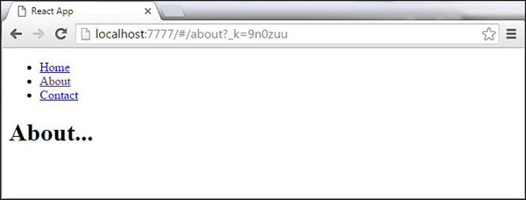

ReactJS - Flux Concept

**Flux** is a programming concept, where the data is **uni-directional**. This data enters the app and flows through it in one direction until it is rendered on the screen.

Flux Elements

Following is a simple explanation of the **flux** concept. In the next chapter, we will learn how to implement this into the app.

* **Actions** − Actions are sent to the dispatcher to trigger the data flow.
* **Dispatcher** − This is a central hub of the app. All the data is dispatched and sent to the stores.
* **Store** − Store is the place where the application state and logic are held. Every store is maintaining a particular state and it will update when needed.
* **View** − The **view** will receive data from the store and re-render the app.

The data flow is depicted in the following image.

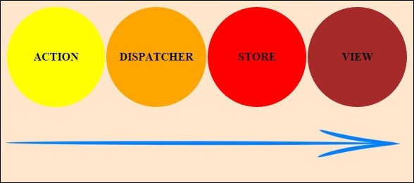

Flux Pros

* Single directional data flow is easy to understand.
* The app is easier to maintain.
* The app parts are decoupled.

ReactJS - Using Flux

In this chapter, we will learn how to implement flux pattern in React applications. We will use **Redux** framework. The goal of this chapter is to present the simplest example of every piece needed for connecting **Redux** and **React**.

Step 1 - Install Redux

We will install Redux via the **command prompt** window.

C:\Users\username\Desktop\reactApp>npm install --save react-redux

Step 2 - Create Files and Folders

In this step, we will create folders and files for our **actions**, **reducers**, and **components**. After we are done with it, this is how the folder structure will look like.

C:\Users\Tutorialspoint\Desktop\reactApp>mkdir actions

C:\Users\Tutorialspoint\Desktop\reactApp>mkdir components

C:\Users\Tutorialspoint\Desktop\reactApp>mkdir reducers

C:\Users\Tutorialspoint\Desktop\reactApp>type nul > actions/actions.js

C:\Users\Tutorialspoint\Desktop\reactApp>type nul > reducers/reducers.js

C:\Users\Tutorialspoint\Desktop\reactApp>type nul > components/AddTodo.js

C:\Users\Tutorialspoint\Desktop\reactApp>type nul > components/Todo.js

C:\Users\Tutorialspoint\Desktop\reactApp>type nul > components/TodoList.js

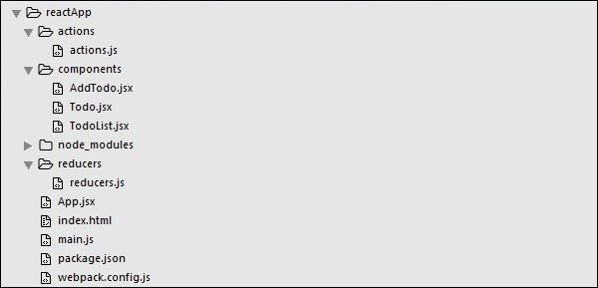

Step 3 - Actions

Actions are JavaScript objects that use **type** property to inform about the data that should be sent to the store. We are defining **ADD_TODO** action that will be used for adding new item to our list. The **addTodo** function is an action creator that returns our action and sets an **id** for every created item.

actions/actions.js

export const ADD_TODO = 'ADD_TODO'

let nextTodoId = 0;

export function addTodo(text) {

return {

type: ADD_TODO,

id: nextTodoId++,

text

};

}

Step 4 - Reducers

While actions only trigger changes in the app, the **reducers**specify those changes. We are using **switch** statement to search for a **ADD_TODO** action. The reducer is a function that takes two parameters (**state** and **action**) to calculate and return an updated state.

The first function will be used to create a new item, while the second one will push that item to the list. Towards the end, we are using **combineReducers** helper function where we can add any new reducers we might use in the future.

reducers/reducers.js

import { combineReducers } from 'redux'

import { ADD_TODO } from '../actions/actions'

function todo(state, action) {

switch (action.type) {

case ADD_TODO:

return {

id: action.id,

text: action.text,

}

default:

return state

}

}

function todos(state = [], action) {

switch (action.type) {

case ADD_TODO:

return [

...state,

todo(undefined, action)

]

default:

return state

}

}

const todoApp = combineReducers({

todos

})

export default todoApp

Step 5 - Store

The store is a place that holds the app's state. It is very easy to create a store once you have reducers. We are passing store property to the **provider** element, which wraps our route component.

main.js

import React from 'react'

import { render } from 'react-dom'

import { createStore } from 'redux'

import { Provider } from 'react-redux'

import App from './App.jsx'

import todoApp from './reducers/reducers'

let store = createStore(todoApp)

let rootElement = document.getElementById('app')

render(

<Provider store = {store}>

<App />

</Provider>,

rootElement

)

Step 6 - Root Component

The **App** component is the root component of the app. Only the root component should be aware of a redux. The important part to notice is the **connect** function which is used for connecting our root component **App** to the **store**.

This function takes **select** function as an argument. Select function takes the state from the store and returns the props (**visibleTodos**) that we can use in our components.

App.jsx

import React, { Component } from 'react'

import { connect } from 'react-redux'

import { addTodo } from './actions/actions'

import AddTodo from './components/AddTodo.js'

import TodoList from './components/TodoList.js'

class App extends Component {

render() {

const { dispatch, visibleTodos } = this.props

return (

<div>

<AddTodo onAddClick = {text =>dispatch(addTodo(text))} />

<TodoList todos = {visibleTodos}/>

</div>

)

}

}

function select(state) {

return {

visibleTodos: state.todos

}

}

export default connect(select)(App);

Step 7 - Other Components

These components shouldn't be aware of redux.

components/AddTodo.js

import React, { Component, PropTypes } from 'react'

export default class AddTodo extends Component {

render() {

return (

<div>

<input type = 'text' ref = 'input' />

<button onClick = {(e) => this.handleClick(e)}>

Add

</button>

</div>

)

}

handleClick(e) {

const node = this.refs.input

const text = node.value.trim()

this.props.onAddClick(text)

node.value = ''

}

}

components/Todo.js

import React, { Component, PropTypes } from 'react'

export default class Todo extends Component {

render() {

return (

<li>

{this.props.text}

</li>

)

}

}

components/TodoList.js

import React, { Component, PropTypes } from 'react'

import Todo from './Todo.js'

export default class TodoList extends Component {

render() {

return (

<ul>

{this.props.todos.map(todo =>

<Todo

key = {todo.id}

{...todo}

/>

)}

</ul>

)

}

}

When we start the app, we will be able to add items to our list.

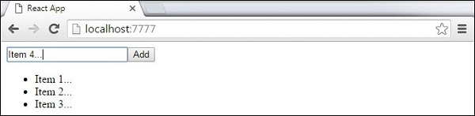

ReactJS - Animations

In this chapter, we will learn how to animate elements using React.

Step 1 - Install React CSS Transitions Group

This is React add-on used for creating basic CSS transitions and animations. We will install it from the **command prompt**window −

C:\Users\username\Desktop\reactApp>npm install react-addons-css-transition-group

Step 2 - Add a CSS file

Let's create a new file style.css.

C:\Users\Tutorialspoint\Desktop\reactApp>type nul > css/style.css

To be able to use it in the app, we need to link it to the head element in index.html.

<!DOCTYPE html>

<html lang = "en">

<head>

<link rel = "stylesheet" type = "text/css" href = "./style.css">

<meta charset = "UTF-8">

<title>React App</title>

</head>

<body>

<div id = "app"></div>

<script src = 'index_bundle.js'></script>

</body>

</html>

Step 3 - Appear Animation

We will create a basic React component. The **ReactCSSTransitionGroup** element will be used as a wrapper of the component we want to animate. It will use **transitionAppear** and **transitionAppearTimeout**, while **transitionEnter** and **transitionLeave** are false.

App.jsx

import React from 'react';

var ReactCSSTransitionGroup = require('react-addons-css-transition-group');

class App extends React.Component {

render() {

return (

<div>

<ReactCSSTransitionGroup transitionName = "example"

transitionAppear = {true} transitionAppearTimeout = {500}

transitionEnter = {false} transitionLeave = {false}>

<h1>My Element...</h1>

</ReactCSSTransitionGroup>

</div>

);

}

}

export default App;

main.js

import React from 'react'

import ReactDOM from 'react-dom';

import App from './App.jsx';

ReactDOM.render(<App />, document.getElementById('app'));

The CSS animation is very simple.

css/style.css

.example-appear {

opacity: 0.04;

}

.example-appear.example-appear-active {

opacity: 2;

transition: opacity 50s ease-in;

}

Once we start the app, the element will fade in.

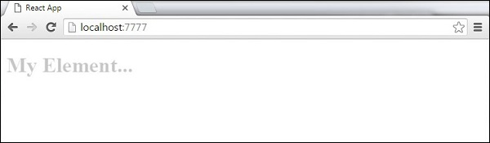

Step 4 - Enter and Leave Animations

Enter and leave animations can be used when we want to add or remove elements from the list.

App.jsx

import React from 'react';

var ReactCSSTransitionGroup = require('react-addons-css-transition-group');

class App extends React.Component {

constructor(props) {

super(props);

this.state = {

items: ['Item 1...', 'Item 2...', 'Item 3...', 'Item 4...']

}

this.handleAdd = this.handleAdd.bind(this);

};

handleAdd() {

var newItems = this.state.items.concat([prompt('Create New Item')]);

this.setState({items: newItems});

}

handleRemove(i) {

var newItems = this.state.items.slice();

newItems.splice(i, 1);

this.setState({items: newItems});

}

render() {

var items = this.state.items.map(function(item, i) {

return (

<div key = {item} onClick = {this.handleRemove.bind(this, i)}>

{item}

</div>

);

}.bind(this));

return (

<div>

<button onClick = {this.handleAdd}>Add Item</button>

<ReactCSSTransitionGroup transitionName = "example"

transitionEnterTimeout = {500} transitionLeaveTimeout = {500}>

{items}

</ReactCSSTransitionGroup>

</div>

);

}

}

export default App;

main.js

import React from 'react'

import ReactDOM from 'react-dom';

import App from './App.jsx';

ReactDOM.render(<App />, document.getElementById('app'));

css/style.css

.example-enter {

opacity: 0.04;

}

.example-enter.example-enter-active {

opacity: 5;

transition: opacity 50s ease-in;

}

.example-leave {

opacity: 1;

}

.example-leave.example-leave-active {

opacity: 0.04;

transition: opacity 50s ease-in;

}

When we start the app and click the **Add Item** button, the prompt will appear.

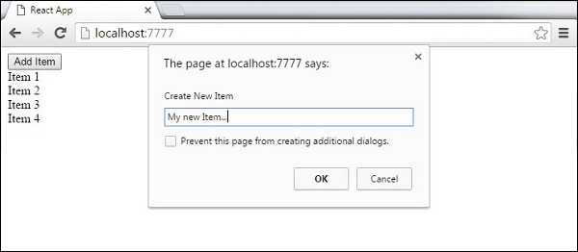

Once we enter the name and press OK, the new element will fade in.

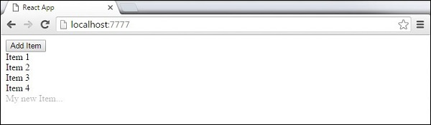

Now we can delete some of the items (**Item 3...**) by clicking it. This item will fade out from the list.

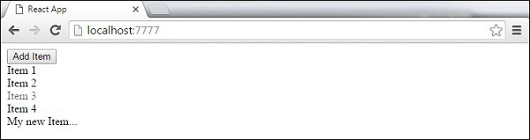

ReactJS - Higher Order Components

Higher order components are JavaScript functions used for adding additional functionalities to the existing component. These functions are **pure**, which means they are receiving data and returning values according to that data. If the data changes, higher order functions are re-run with different data input. If we want to update our returning component, we don't have to change the HOC. All we need to do is change the data that our function is using.

**Higher Order Component** (HOC) is wrapping around "normal" component and provide additional data input. It is actually a function that takes one component and returns another component that wraps the original one.

Let us take a look at a simple example to easily understand how this concept works. The **MyHOC** is a higher order function that is used only to pass data to **MyComponent**. This function takes **MyComponent**, enhances it with **newData** and returns the enhanced component that will be rendered on the screen.

import React from 'react';

var newData = {

data: 'Data from HOC...',

}

var MyHOC = ComposedComponent => class extends React.Component {

componentDidMount() {

this.setState({

data: newData.data

});

}

render() {

return <ComposedComponent {...this.props} {...this.state} />;

}

};

class MyComponent extends React.Component {

render() {

return (

<div>

<h1>{this.props.data}</h1>

</div>

)

}

}

export default MyHOC(MyComponent);

If we run the app, we will see that data is passed to **MyComponent**.

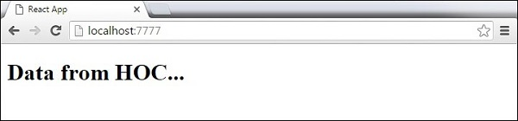

**Note** − Higher order components can be used for different functionalities. These pure functions are the essence of functional programming. Once you are used to it, you will notice how your app is becoming easier to maintain or to upgrade.

ReactJS - Best Practices

In this chapter, we will list React best practices, methods, and techniques that will help us stay consistent during the app development.

* **State** − The state should be avoided as much as possible. It is a good practice to centralize the state and pass it down the component tree as props. Whenever we have a group of components that need the same data, we should set a container element around them that will hold the state. Flux pattern is a nice way of handling the state in React apps.
* **PropTypes** − The PropTypes should always be defined. This will help is track all props in the app and it will also be useful for any developer working on the same project.
* **Render** − Most of the app's logic should be moved inside the render method. We should try to minimize logic in component lifecycle methods and move that logic in the render method. The less state and props we use, the cleaner the code will be. We should always make the state as simple as possible. If we need to calculate something from the state or props, we can do it inside the render method.
* **Composition** − React team suggests to use a single responsibility principle. This means that one component should only be responsible for one functionality. If some of the components have more than one functionality, we should refactor and create a new component for every functionality.
* **Higher Order Components (HOC)** − Former React versions offered mixins for handling reusable functionalities. Since mixins are now deprecated, one of the solutions is to use HOC.