## **QA Regulations**

Ver.1.0

Initially, QA helps design and control the development process in a way that prevents serious issues during the project. To make this happen, QA engineers work on the project together with other team members (product owner, project manager, business analyst, and dev lead) throughout the complete software development cycle. The number and the order of QA activities may vary from project to project, depending heavily on the scope of the work and the project aims.

**Development process**

1. Analysis of requirements
2. Design
3. Implementation
4. Verification or testing
5. Maintenance

**QA process**

1. Review of requirements
2. Test planning / writing test cases
3. Integration testing
4. System testing
5. Security testing
6. Cross-browser testing / cross-platform testing
7. Updating test cases
8. Regression testing

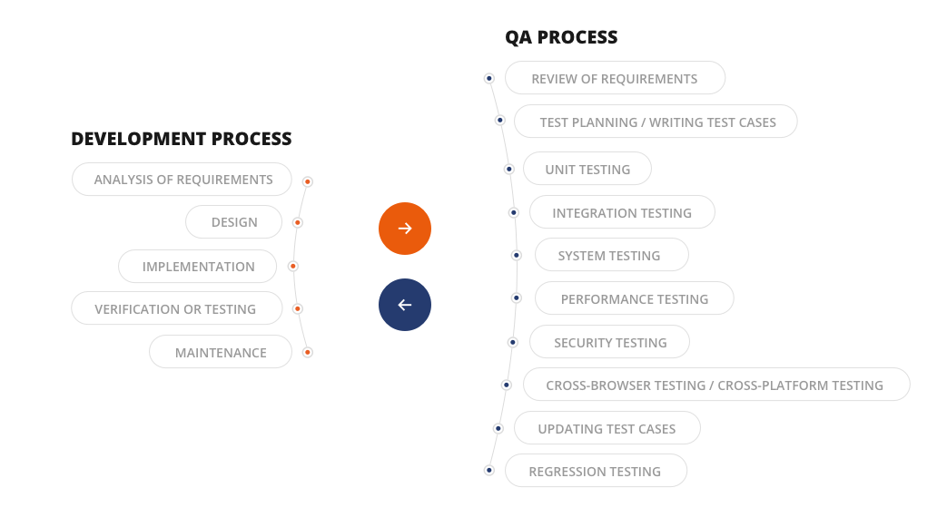

Let’s have a deeper look at QA processes and how they are connected with the development steps.

### **STEP ONE: REVIEW REQUIREMENTS AND DOCUMENTATION.**

QA engineers start their work on the project in parallel with documentation generation. They review the requirements and documentation for:

- completeness

- redundancies

- clarity

- consistency

- executability

The aim is to analyze system architecture and technologies for discrepancies.

**Key benefits for the development process:**

- Errors cost less when detected at an early stage

- Improved documentation means a higher quality project for lower labor input and more accurate estimates.

**STEP TWO: PLAN AND PREPARE TEST CASES**

When the requirements have been established, it is time to start planning test cases, i.e. - describe the actions QA engineers perform to make sure the piece of software functions as planned. Test cases can be written in simple Excel file. Here is an example of test cases:

|  |  |  |  |  |  |  |  |  |
| --- | --- | --- | --- | --- | --- | --- | --- | --- |
| **Tier** | **Component** | **Test Case ID** | **Description** | **Designed Steps** | **Expected Result** | **Status** | **Created By** | **Last Updated** |
| 1 | Search | LB_001 | Verify Search output for … | 1. Navigate to www.google.com  2. Enter any request in the search field hit search  … | 1. Page is loaded  2. Search results are displayed  … | [Passed / Failed / Not Testable /Not Tested/ To be Tested] | Name of Designer | [Date] |

### 

### 

### **STEP THREE: DESIGN TEST CASES**

When the development stage is finished, the QA team starts running the test cases. The main goal of this stage is to check whether the solution is developed properly from the technical perspective and meets the initial product owner’s requirements.

Below are the main QA activities and their aims:

- **Smoke testing** comes first. QA engineers lightly check that the software, or its module, functions as planned. When passed, further investigation begins.

- **Integration testing** – verify that different components work as a single system.

- **Performance testing** that includes:

*Load testing* – check system behavior for normal and expected peak load

*Stress testing* – determine critical load after which the system breaks down

- **Security testing** – ensure the solution has a sufficient protection level.

- **Cross-browser testing**/cross-platform testing – check that the software works smoothly on different browsers (Chrome, Mozilla, Safari) or platforms (Android, iOS, Windows Phone). This is especially important for web and hybrid apps.

- **Regression testing** – detect bugs in the code that was tested previously. Usually needed when adding new features or making any updates to an existing system.

Again, you can choose to automate the testing (e.g., unit testing, regression testing). The general rule: the longer a project lasts, the more it needs automated tests.

### **STEP FOUR: REPORT AND MEASURE**

When a QA engineer discovers a bug, he/she records it in a bug tracking system which is also a project management system. For this we can use one public excel sheet. Here is an example:

|  |  |  |  |  |  |
| --- | --- | --- | --- | --- | --- |
| **Project name** | | | | | |
| **Component** | **Test Case ID** | **Status** | **Priority** | **Issue Link** | **Comments** |
| Search | LB_001 | Failed | Critical | https://github.com/MitocGroup/…./issues... | From Dev, QA, BA |

For more information please see *Issue Tracking process* document

Each issue gets a priority level from urgent to low, which the development team then resolves based on time and people available.

### **STEP FIVE: VERIFYING FIXES**

When a developer fixes an issue he/she informs the responsible QA engineers, who verifies it. The ticket in the bug tracking system is closed when no issues are detected. This rule applies: no bug can be marked as fixed until it is verified.

Some stages of the Development and QA processes can be performed simultaneously to save time, for example: Analysis and Review of requirements, Implementation & Test planning, or even Running different types of tests during development. In these parallel stages the testing activities help measure the success of the corresponding development tasks.

**Step by Step testing**

Time frames between start development and start testing

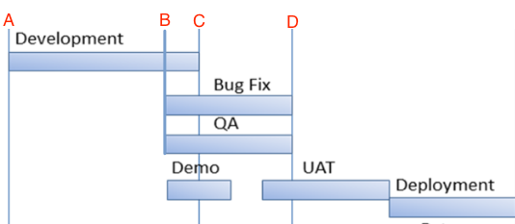

A closed look on each time sequence:

1. New functionality -> developers start their work (From A -> C)
2. QA start writing test cases. Analysing scope of future changes, providing estimates (From B ->)
3. Kick off code for testing (final version of code is pushed to dev environments, could be download on local machine, etc…) (From C->)
4. Cycle for C->D:

**First iteration:**

4.1) QA starts testing.

4.2) First look on functionality - exploratory testing. No blockers, critical should be present in the code.

4.2.1) If blockers present QA should log an issue on GitHub and assign to responsible Developer. **Issue Opened**

4.2.2) Developers fix issues

4.3) QA receive the code - repeat step 4.2

4.4) QA starts testing using Regression library. Depends of the scope and time following testing should be performed:

* **Integration testing**
* **Security testing**
* **Cross-browser testing**/cross-platform testing
* **Regression testing** (Tier based)
* **Performance testing**

4.5) Issues found during testing should be opened and escalated to developers (for more details please refer to a *Issue Tracking process* document)

4.6) Fixed issues should be re-tested and statuses should be updated

4.7) Sign off. Can be provided with following conditions:

* Not all defects are fixed, should be ok for businesses (conditional sing off, template to provide)
* QA Findings - providing when not full cycle was performed
* Sign off (template to provide)

4.8) After code was pushed to PROD - smoke test on PROD environment should be performed

4.9) Updating existing test cases. Supporting of regression library.

5.0) Repeat cycle