Course work

“Pet accessories and toys store”

By: Taras Rybin

# MODEL DESCRIPTION

**LOGICAL SCHEME**

**product:** contains data about products which are selled in the store.

**roduct_category:** contains categories of products.

**pet_types:** contains pet types of products.

**bank_accounts:** contains bank accounts info of customers, suppliers and the store.

**customer:** contains data about customers.

**sales_order:** contains data of orders.  
**sales_line:** contains data of products selected in order.

**invoice:** contains data of payments for orders.

**invoice_line**: contains invoice data for each product of the order.

**finance_transaction**: contains data of all financial transactions made by store.

**inventory_transaction:** contains data of all products quantity changes in storage.  
  
**Create script is stored in courseWorkDBScript.sql  
Functions for main actions are stored in func.sql**

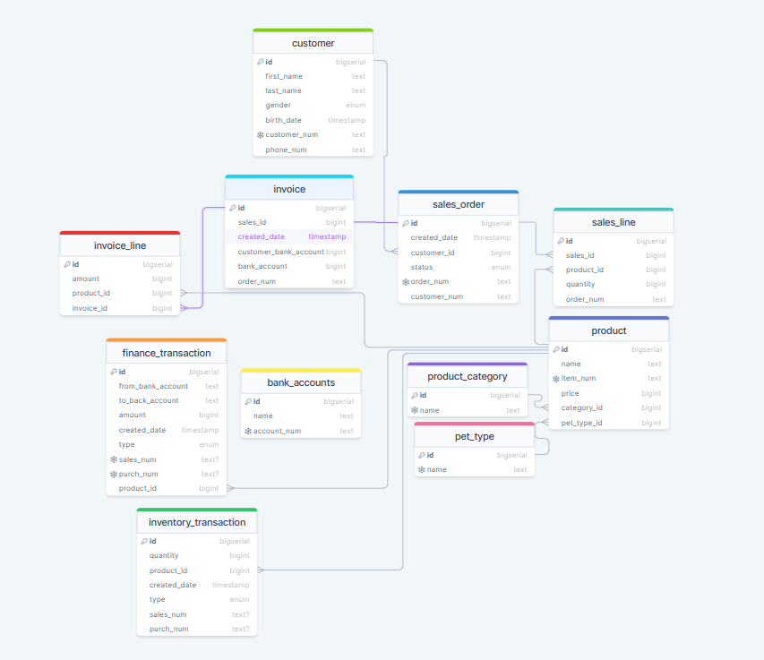

# 2.ETL TO DB DESCRIPTION

1. **DATA LOADING PROCESS**
2. DataSets are stored in *.csv files:   
   products.csv contains a dataset to create product, categories and pet_types data.

sales.csv contains a dataset of sales made in the store.

purchase.csv contains a dataset of the store purchasing gods for future retailing.

customers.csv contains a dataset of customers data

b) To load data from .csv files rerunable python scripts are used: products.py, sales.py, purchase.py, customers.py

c) Recommended order of execution: products.py -> customers.py -> purchase.py -> sales.py

Script does not rewrite the data which already exists in db.

# 3. DATA WAREHOUSE

Tables in DWH: product_dim, product_category_dim, pet_type_dim, customers_dim, bank_accounts_dim, fact_sales, fact_bank_balance, fact_product_sales.

Create script is stored in file DWHTablesScript.sql.

# 4. ETL TO DWH DESCRIPTION

**1.** **DATA LOADING PROCESS**

**To load data into DWH stored procedure is used. Script : procedure.sql.(Rerunable)**

# 5. Power Bi DESCRIPTION

**course_work.pbix**